PART 3 ­ REGIONAL AND DISTRICT RULES»Chapter K: Precinct rules»7 West»

# Waitākere Ranges Heritage Area

The activities, controls and assessment criteria in the underlying Rural Conservation, Countryside Living, Local Centre, Large Lot and Public Open Space – Conservation zones and Auckland­wide rules apply in the following precinct, sub­precincts policy and sub­policy areas unless modified by the activity table, controls and assessment criteria below. Refer to planning maps for the location and extent of the precinct and sub­precincts.

Except for the following rules, the rules for this precinct are those specified for the relevant area within the applicable sub­precinct or policy area or both.

* + 1. The following defined terms apply in this precinct only:
       1. non residential activities means any activity that is not the use of land or buildings by people for living accommodation where those people voluntarily live at the site for a month or more and generally refer to the site as their home and includes baches and holiday homes and other similar private accommodation but excludes temporary activities and prohibited activities
       2. outdoor recreation activity means an organised recreation activity undertaken entirely outdoors with buildings limited to structures ancillary to the activity up to a maximum of 30m2. It excludes activities involving motorsport and gun clubs and does not include temporary activities or home occupations
       3. convenience shop means a shop which sells one or more of the following:

i.

ii. iii. iv.

v.

vi.

food beverages books magazines

stationery items and health care items.

* + 1. Special subdivision areas
       1. Any subdivision of a site located within the Oratia subdivision area boundary shown on Precinct Plan 1. Oratia Special Subdivision Area which is not a discretionary activity under the applicable sub­precinct rules shall be a non­complying activity, provided that:

i.

ii.

on each proposed site, a development area which is of sufficient shape and dimension to accommodate a dwelling, driveway and all ancillary areas can be located outside of a SEA, and

on each proposed site a development area which is of sufficient shape and dimension to accommodate a dwelling, driveway and all ancillary areas can be located outside an area covered by a landscape area overlay.

* + - 1. In the event of any conflict between this rule and any subdivision rule in the relevant sub­precinct the most permissive subdivision rule shall apply.

# 1. Sub­precinct A: Waitākere Foothills

1. **Activity table**

The activities in the Countryside Living zone apply in this sub­precinct unless otherwise modified by the activity table below.

|  |  |  |  |
| --- | --- | --- | --- |
| **Activity** | **Swanson South** | **Ōrātia** | **Other Foothills areas** |
| **Rural** | | | |
| Farming | P | P | P |
| Forestry | NC | NC | NC |
| Conservation Forestry | P | P | P |
| Rural commercial services | NC | NC | NC |
| On­site primary produce manufacturing | RD | RD | RD |
| Quarries, farm or forestry | NC | NC | NC |
| Greenhouses | RD | RD | RD |
| Intensive livestock farming | D | D | D |
| **Accommodation** | | | |
| One dwelling per site | P | P | P |
| Two dwellings per site | P | P | P |
| Home occupation | P | P | P |
| Visitor accommodation | RD | RD | RD |
| **Commerce** | | | |
| Restaurants and cafes | RD | RD | RD |
| Garden centres | D | D | D |
| Markets | RD | RD | RD |
| Show homes | NC | NC | NC |
| Veterinary Clinics | D | D | D |
| Drive­through facilities | NC | NC | NC |
| Non residential activities | RD | RD | RD |
| Filming | P | P | P |
| **Community facilities** | | | |
| Care centre for up to 10 people | D | D | D |
| Care centre for more than 10 people | NC | NC | NC |
| Educational facilities | D | D | D |
| Outdoor recreational activities | RD | RD | RD |
| **Industry** | | | |
| Retail | RD | RD | RD |
| Artisan industries | P | P | P |
| Mineral exploration | NC | NC | NC |

|  |  |  |  |
| --- | --- | --- | --- |
| Signs | P | P | P |
| **Subdivision** | | | |
| Subdivision | C | C | C |

# Land use controls

* 1. **Permitted activities**
     1. **Farming**
        1. The farming activity must be located outside any part of a site subject to the SEA overlay.
        2. Farming located within this overlay will be assessed as a non­complying activity.

# Dwellings

* + - 1. Two dwellings on one site must comply with the following:
         1. the GFA of one of the dwellings must not exceed 65m2 excluding any garaging for motor vehicles
         2. the site must have a minimum net site area of 1500m2
         3. the additional dwelling must be located no more than 6m from the other dwelling on the site.
      2. Dwellings not meeting the above controls will be assessed as non­complying activities.

# Artisan industries

* + - 1. Artisan industries must comply with the following:
         1. no more than five persons are engaged in the production of arts and crafts on the site
         2. no retail sales are carried out from the site on which the artisan industry is located.
         3. maximum of 30 vehicle movements per day.

# Filming activities

* + - 1. Filming activities must comply with the following:
         1. must not involve any filming activity longer than six months from start to finish, irrespective of whether the activity is carried out in different years and
         2. must not require the construction of any building and
         3. car trips to and from the filming activity must not exceed 50 per day.

# Home occupation

* + - 1. Home occupations which involve homestays must comply with the following:
         1. maximum of 10 people inclusive of those who reside on the site
         2. maximum of two heavy vehicle movements per week
         3. the homestay, apart from the parking of one vehicle, is screened from the adjoining sites and the road
         4. Total floor space occupied by the homestay does not exceed 250m2
         5. maximum of 40 vehicle movements per day.
      2. Home occupations which involve an occupation or business but not retail sales must comply with the following:
         1. no more than two heavy vehicle movements per week
         2. the occupation or business, apart from the parking of one vehicle, is screened from the adjoining sites and the road
         3. total floor space occupied by the occupation or business does not exceed 250m2
         4. maximum of 40 vehicle movements per day.
      3. Home occupations which involve an occupation or business that includes retail sales must comply with the following:
         1. no more than two heavy vehicle movements per week
         2. the occupation or business, apart from the parking of one vehicle, is screened from the adjoining sites and the road
         3. except where goods are primarily ordered by mail or electronic transaction and distributed by post or courier, any retail sales are restricted to horticultural and agricultural produce, produced on the site and the hours of operation are between 0700­1900 daily
         4. total floor space occupied by the occupation or business does not exceed 250m2
         5. maximum of 100m2 retail space
         6. maximum of 40 vehicle movements per day.

# Signs

* + - 1. Any sign which complies with the following:
         1. maximum sign area of 0.3 m2
         2. located on the site to which the sign relates
         3. is not illuminated, flashing or moving.
      2. Any sign associated with a non residential activity (excluding Home occupations) specified as a permitted activity in the table above which complies with the following:
         1. maximum sign area of 1.0m2
         2. located on the site to which the sign relates
         3. is not illuminated, flashing or moving
         4. maximum sign height of 2.5m.
      3. Any sign associated with a non residential activity in the Ōrātia Village sub­policy area which complies with the following:
         1. maximum sign area on each building does not exceed 1.5m2 for each activity
         2. free standing signs are limited to one for each of Areas 1, 2 and 3 identified on Precinct Plan 11.

Ōrātia Village sub­policy area and have a maximum sign area of 1.5m2 and a maximum height of

2.5 metres

* + - * 1. is not illuminated, flashing or moving
        2. is located on the site to which the sign relates.
      1. Signs not meeting the above controls will be assessed as restricted discretionary activities.

# Controlled activities

* + 1. **Filming activities**
       1. Filming activities must comply with the following:
          1. must not require the construction of any building and
          2. car trips to and from the filming activity must not exceed 100 per day.

# Restricted discretionary activities

* + 1. **Retail**
       1. Retail must comply with either of the following:
          1. retail sales are:

i.

ii. iii.

limited to sales of products from artisan industries maximum retail floor space is 100m2

maximum of 50 vehicle movements per day.

* + - * 1. retail sales are:

i.

ii. iii. iv.

v.

limited to agricultural and horticultural produce and beverages ancillary to the rural activity on the site

net site area greater than 2ha maximum retail floor space is 100m2

maximum of 50 vehicle movements per day.

# On­site primary produce manufacturing

* + - 1. On­site primary produce manufacturing must comply with the following:
         1. minimum site area of 2ha
         2. maximum of 50 traffic movements per day.

# Greenhouses

* + - 1. Greenhouses must comply with the following:
         1. maximum of 25% of site area
         2. maximum of 100 vehicle movements per day.

# Filming activities

* + - 1. Filming activities must comply with the following:
         1. requiring the construction of any building
         2. car trips to and from the filming activity must not exceed 100 per day

# Visitor accommodation

* + - 1. Visitor accommodation must comply with the following:
         1. be located on a site greater than 20 hectares
         2. the maximum number of guests is restricted to 20 persons
         3. maximum of 50 vehicle movements per day.

# Markets

* + - 1. Markets must comply with the following:
         1. minimum net site area of the site on which the market is located must be 2ha
         2. maximum duration of the market is two days each week
         3. retail sales are limited to beverages, food, agricultural and horticultural produce, and goods produced by artisan industries.

# Non residential activities

* + - 1. Non residential activities (excluding home occupations) are restricted discretionary:
         1. where they involve an increase in scale and/or intensity of an existing lawfully established non residential activity
         2. retail sales are limited to goods from an artisan industry, horticultural or agricultural produce

# Signs

* + - 1. Signs must comply with the following:
         1. Any non­residential sign must:

i.

ii. iii. iv.

have a maximum sign area of 1.5m2

be located on the site to which the sign relates not be illuminated, flashing or moving

have a maximum sign height of 2.5m.

* + - * 1. Any residential sign must:

i.

ii.

have a maximum sign area of 0.3m2

be located on the site to which the sign relates.

* + - 1. Signs not meeting the above controls will be assessed as a discretionary activity.

# Discretionary activies

* + 1. **Non residential activities**
       1. Non residential activities must comply with either of the following:
          1. there are no retail sales or
          2. where there are retail sales, these are limited to

i.

ii.

horticultural and agricultural produce and beverages associated with a rural activity on site goods produced by an artisan industry.

# Restaurants and cafes

* + - 1. Restaurants and cafes must:
         1. not incorporate drive­through sales
         2. be associated with a rural activity (excluding farming) on the site
         3. net site area must be greater than 2ha.

# Development controls

**3.1 Height**

* 1. Building height: 8m
  2. Elevation height: 10m.

# Yards

Table 1

|  |  |
| --- | --- |
| **Yard** | **Dimension** |
| Front, side and rear | 10m where the net site area is larger than 0.4ha  3m where the net site area is 0.4ha  or less |

# Building coverage

* + 1. 1 per cent net site area or 300m2, whichever is the greater.
    2. Buildings that do not comply with clause 3.3.1 above will be assessed as restricted discretionary activities provided the building coverage does not exceed 25 per cent of the net site area.
    3. Buildings where the building coverage exceeds 25 per cent of the net site area will be assessed as non­complying activities.

# Subdivision controls

**4.1 Controlled activities**

* 1. Subdivision in this sub­precinct that meets all the standards below will be assessed as a controlled activity:
     1. the subdivision complies with all Auckland­wide standards for subdivision unless otherwise specified
     2. the subdivision will not lead to any development on land in a SEA.
     3. vegetation clearance arising from the subdivision will be mitigated by the balance areas of native vegetation on the site being permanently protected by suitable covenants or other legal mechanisms
     4. a minimum site area of 4ha, unless the land being subdivided is shown on a policy area map as having an indicated pattern of subdivision, or a maximum number of sites that can be created, in which case the relevant map provisions apply
     5. the subdivision will comply with the indicative layout of site boundaries, or the maximum number of lots able to be created, as shown on the applicable policy area map.
  2. Any subdivision not meeting the controls in 4.1.1(d) will be a restricted discretionary activity.

# Restricted discretionary activities

* + 1. Subdivision (excluding subdivision in the Swanson South policy area)
       1. Subdivision that does not meet the controls in 4.1.1(d) will be a restricted discretionary activity where:

i.

ii.

the subdivision creates sites that generally coincide with the location of proposed site boundaries, or in accordance with the densities identified for each existing site shown on Precinct Plan 2. Ōrātia Policy Area.

any protection and enhancement areas shown on Precinct Plan 2. Ōrātia Policy Area have the required planting established and protected by way of covenant, encumbrance or consent notice.

* + - 1. Subdivision in the Ōrātia policy area that does not meet the controls in 4.1.1(d) and 4.2.1 above will be a restricted discretionary activity where the subdivision has the same or fewer number of sites as shown in Precinct Plan 2. Ōrātia Policy Area for the site concerned, but with different lot boundaries.
      2. Subdivision in the Ōrātia policy area that does not meet the controls in 4.2.1 will be a discretionary activity where the subdivision creates sites at a density exceeding that shown in Precinct Plan 2. Ōrātia Policy Area.
    1. Subdivision in the Swanson South policy area
       1. Subdivision in the Swanson South policy area will be a restricted discretionary activity where:

i.

ii.

iii.

the subdivision creates new sites in accordance with the number shown on the Swanson South policy area map for an existing site

new fences are not within any , or within riparian margins as shown on Precinct Plan 3.

Swanson South Policy Area, except to isolate stock crossings

all stock is permanently removed from the site or from any Indicative Enhancement area to be planted and from any SEA or riparian margin shown on Precinct Plan 3. Swanson South Policy Area, and these areas have been provided with an adequate fence to prevent stock entering these areas

iv.

v.

vi.

vii.

viii. ix.

x.

xi.

all weeds have been (or will be) removed from any Indicative Enhancement area to be planted, riparian margin and SEA as shown on Precinct Plan 3. Swanson South Policy Area

the landowner and any future landowner will maintain any Indicative Enhancement area and riparian margin to be planted and all SEA as shown on Precinct Plan 3. Swanson South Policy Area, and will be kept substantially weed­free for 10 years

any Indicative Enhancement Area or riparian margin will have planting of vegetation as shown on the management plan prepared as part of the subdivision consent application, over an area of 0.125m² per 1m² of the site (excluding any SEA) as shown on Precinct Plan 3.

Swanson South Policy Area

if the sum of the Indicative Enhancement Area or riparian margin is less than the area required to be planted, the difference will made up by planting on any area outside an SEA

any planting which dies prior to effective canopy closure will be replaced

the subdivision of any site in the Swanson South policy area that contains a second dwelling located greater than 15m from a dwelling on the same site will ensure that either the second dwelling is placed on a separate proposed site to the existing dwelling or it is removed

any proposed subdivision will include the formation of a public walkway in general accordance with the indicative public walkways shown on Precinct Plan 3. Swanson South Policy Area and protected by registered right of way as an easement in gross

the subdivision of any site meets the standards of any site specific rules provided for the Swanson South policy area, as set out in Table 1 below.

* + 1. Site specific subdivision activities
       1. Subdivision of Lots 1 and 2 DP 49129 and Lot 5 DP 59154 will be a restricted discretionary activity where:

i.

ii. iii. iv.

v.

vi.

vii.

the minimum sites size is 2ha

the average site size is no less than 4ha, calculated across the entire land area subdivision of the total land area is limited to 24 sites

for each subdivision application, the ability to comply with the 4ha average site size is demonstrated to the council's satisfaction

an ecological assessment and a landscape assessment identifies areas of ecological and landscaping opportunity and enhancement, and any areas where buildings are not to be constructed

a planting plan is prepared taking into account the site’s ecological and landscape assessments and identifying re­vegetation in ecological linkage opportunity areas, enhancement, including weed management of areas of existing SEAs, and planting for stormwater mitigation, visual amenity, and privacy

a public walking trail is provided connecting Forest Hill Road and Gum Road at the time of the first subdivision of Lots 1 and 2 DP49129 and Lot 5 DP59154.

* + - 1. Any subdivision of Lots 1 and 2 DP49129 and Lot 5 DP59154 not meeting the controls in 4.2.3 (a)(i)­(iv) will be a non­complying activity.
      2. In respect of Lot 14 DP 86225 and Lot 1 DP 63568 within the area bounded by Holdens Road, Forest Hill Road, Pine Avenue and Parrs Cross Road (known as the Holdens Triangle), subdivision will be a restricted discretionary activity where:
         1. the subdivision of Lot 14 DP 86225 and Lot 1 DP 63568 is limited to 5 lots in total (i.e. 3

additional lots) excluding any joint access lots

ii.

iii. iv.

v.

vi.

vii.

viii.

ix.

x.

xi.

xii.

the area within Lot 14 DP 86225 that is adjacent to Pine Avenue and which is located outside of the Waitākere Ranges Heritage Area precinct is subdivided into one site with an area of less than 1ha

the minimum size of any other new lot is 1ha, excluding any joint access lots there must be no new road

each proposed site will have practical and legal access to a road

no new driveways are built that are steeper than a slope of 1 in 5 for any distance exceeding 10m

any subdivision ensures that no new buildings are located within 25m of the Holdens Road frontage along the southern boundary of Lot 1 DP 63658

1. no new buildings will be located within 40m of the Holdens Road frontage along the eastern boundary of Lot 14 DP 86225 and Lot 1 DP 63658

access from Holdens Road to any new sites created by the subdivision of Lot 1 DP 63658 will provide a maximum of one additional driveway

landscaping strips no less than 5m in depth are provided along the Holdens Road boundary (with the exception of a vehicle access as provided for above). The strips must consist of densely planted vegetation including species that reach a height of no less than 3m, and may incorporate the existing shelter belt. The planting must be established prior to the issue of a certificate under s. 224(c) of the RMA

the landscaping strips are maintained at a minimum height of 3m and are protected by way of a covenant, encumbrance or consent notice on the title

the application is lodged on the basis that a consent notice will be registered against the titles to all parts of the land, excluding the area within Lot 14 DP 86225 that is adjacent to Pine Avenue, to record that:

* + the density of subdivision provided for under 4.2.3(c)(i) has been used in full
  + there will be no further subdivision of the land previously comprised of Lot 14 DP 86225 and Lot 1 DP 63568. Should any application be made under s. 221(3) of the RMA to vary or cancel the condition specified in the consent notice, the Waitākere Ranges Protection Society Incorporated will be considered an affected party and will be served notice of any such application.
    - 1. Any subdivision of Lot 14 DP 86225 and Lot 1 DP 63568 that complies with the control contained in 4.2.3(c)(i), but does not comply with some or all of the controls contained in 4.2.3(c) will be a discretionary activity.
      2. Any subdivision of Lot 14 DP 86225 and Lot 1 DP 63568 that complies with the controls contained in 4.2.3(c)(i)­(xi) but not meeting the control in 4.2.3(c)(xii) is a non­complying activity.
      3. Any subdivision of Lot 14 DP 86225 and Lot 1 DP 63568 that exceeds the maximum number of lots provided for in clause 4.2.3(c)(i) is a non­complying activity.
      4. In respect of subdivision Lot 2 DP 78994, 43 O'Neills Road, subdivision will be a restricted discretionary activity where:
         1. any subdivision includes a fenced, 20m wide planted strip incorporating the public walkway linkage as shown in Precinct Plan 3. Swanson South Policy Area along the northern boundary of the site which must be protected by a registered right of way as an easement in

gross.

* + 1. Site specific subdivision activities – Swanson South policy area
       1. Where the land being subdivided is listed in the following schedule of site­specific rules and shown on Precinct Plans 5 ­ 9 as having a site­specific rule that imposes a permitted building area:

i.

ii.

the schedule of site­specific rules and permitted building area shown on Precinct Plans 5 ­ 9 apply

the scheme plan of subdivision must show the site nominated for a dwelling and accessory buildings, and their curtilage, to be located within the permitted building area identified on Precinct Plans 5 ­ 9. This rule may be included in a consent notice which council may require to be attached to the title of the new site created and the balance area. The site­ specific assessment criteria must be used in the assessment of the scheme plan of subdivision. Where the site­specific rules refer to a management plan, this must be submitted with the scheme plan and must address the matters referred to.

Table 2

|  |  |  |
| --- | --- | --- |
| **Schedule of site­specific subdivision rules** | | |
| **Address** | **Site­specific rules** | **Site specific matters of control** |
| 37 Awhiorangi Promenade | 1. Any subdivision must ensure that any existing pine trees (Pinus sp) and wattle trees (Acacia sp) are removed from the site in accordance with an approved management plan prior to the issue of a certificate under s. 224 of the RMA 2. Any subdivision must ensure there are no further residential buildings, other than replacements, constructed on the site   containing the existing second dwelling | a. The extent to which any approved management plan provided for the compete removal of any existing pine (Pinus sp) and wattle trees (Acacia sp) from the site |
| 144 Candia Road | 1. Any subdivision must ensure no less than 1ha of the southwest corner of the site is planted and fenced 2. Any scheme plan of subdivision must demonstrate that no further residential buildings need to be erected within the sensitive ridge shown on the overlay. This must be ensured in perpetuity by way of an   encumbrance, covenant or consent notice | a. The extent to which the required area to be planted is planted with species appropriate to the landscape and ecology of the area, fenced and maintained weed free until canopy closure |

|  |  |  |
| --- | --- | --- |
| 27­37 Christian Road 28 Tram Valley Road | 1. For the purposes of this rule, the site includes both 27 Christian Road and 28 Tram Valley Road. These sites are shown on Precinct Plan 9. Swanson South Site 6. 2. Any subdivision must ensure that: 3. no dwelling is situated in the northeast corner of the site i.e. above the 80m above sea level contour 4. no dwelling is situated within 30m of the Christian Road frontage to the site in the southeast corner of the site 5. no dwellings are located on the central ridges and slopes of the sites as shown on Swanson South policy area map 6. a strip of land not less than 30m wide is planted along the road boundary in the southeast corner of the site and protected by way of covenant, encumbrance or consent notice 7. no less than 0.5ha of planting is provided on the sites for every proposed dwelling   c. any subdivision must ensure rights­of­ way are created as easements in gross in favour of the council and formed to its satisfaction, and must provide for:  i. a public walkway on the site along the Christian Road boundary until near the boundary with 25 Christian Road, where the road reserve is wide enough for a walkway so that pedestrians and cyclists can stay  off the road. | 1. The extent to which a proposed dwelling in the south­east corner of the site is set sufficiently back from, and adequately screened from, Christian Road to minimise any adverse visual and landscape effects on the surrounding neighbourhood 2. The extent to which a safe and stable building platform can be identified no less than 30m from the southeast corner of the site 3. The extent to which access to any proposed site in the southeast corner of the site is from the existing farm gate 4. The extent to which any proposed dwellings are situated on the western terraces close to Tram Valley Road, or on the low spur in the centre of the site and within the permitted building area as shown on Precinct Plan 9. Swanson South Site 6. 5. The extent to which any proposed dwellings will be situated to avoid the central ridges and slopes on the site. |
| 32 Christian Road | a. Any subdivision must include a fenced, 20m­wide planted strip incorporating a public walkway linkage as shown on the Swanson South policy area map along the northern boundary of the site, and must be protected by a registered right­of­way as an easement in gross  b Any subdivision must ensure any proposed site has vehicle access from the  existing driveway. | a. The extent to which the required 20m­wide planted strip is established along the northern boundary of the site, and will create a buffer between the site and the adjoining land to the north. |
| 42 Christian Road | 1. Any subdivision must ensure any new dwelling is located within the permitted building area shown on Precinct Plan 5. Swanson South Site 2. 2. Any subdivision must ensure vehicle access to any new dwelling is from O’Neills Road and is protected by a registered right­ of­way as an easement in gross or other   appropriate legal mechanism. |  |

|  |  |  |
| --- | --- | --- |
| 46 Christian Road | 1. Any subdivision must ensure any proposed dwelling is located in the southeast corner of the site and gains vehicle access from O’Neills Road only 2. The management plan for any subdivision must provide for the complete removal of any monkey­apple trees (Acmena smithii), conifers (Pinus spp) and wattles (Acacia   spp). | a. The extent to which the location of any proposed dwelling avoids any adverse effects on the visual or aural amenity values of any adjacent or surrounding sites. |
| 56 Christian Road | a. Any subdivision must ensure that the existing dwelling and studio are on separate  lots. |  |
| 33­35 Coulter Road | a. Any subdivision must ensure any new dwelling is located within the permitted building area shown on Precinct Plan 6. Swanson South Site 3. | a. The extent to which the location of any proposed dwelling avoids the visible face above Coulter Road between the road boundary and the eastern edge of the sensitive ridge, the area within the sensitive ridge, and the area west of the streamside  enhancement area. |
| 40 Coulter Road | 1. Any subdivision must ensure vehicle access to any proposed dwelling is from the existing driveway 2. The management plan for any subdivision must provide for the complete removal of   any monkey­apple (Acmena spp) trees from  the site. | a. The extent to which vehicle access to any existing or proposed site uses the existing driveway. |
| 54 Coulter Road | a. Any subdivision must ensure any proposed dwelling is located within the permitted building area shown in Precinct Plan 4. Swanson South Site 1. | a. The extent to which any proposed driveway avoids the streamside and re­ vegetation enhancement areas shown on the Precinct Plan 3. Swanson South  Policy Area. |
| 61 Coulter Road | 1. Any subdivision must ensure that any new dwelling is located within the permitted building area shown on Precinct Plan 8. Swanson South Site 5. 2. Any subdivision must ensure that any new dwelling has a maximum GFA (excluding any garaging for motor vehicles) of 150m². This requirement must be ensured in perpetuity by way of an encumbrance, covenant or consent notice 3. Any subdivision must prohibit the establishment of any minor household units on the site(s) and this must be ensured in perpetuity by way of an encumbrance,   covenant or consent notice. |  |

|  |  |  |
| --- | --- | --- |
| 70 Coulter Road | 1. Any proposed dwelling must be set back from the Coulter Road boundary and located outside the area shown as sensitive ridge   on the Swanson South policy area map   1. Any subdivision must provide for the complete removal, demolition, or relocation of the existing minor household unit unless the written consent of the neighbours at 66 Coulter Road is obtained prior to the construction of any new dwelling. | a. The extent to which any proposed dwelling in the southwestern part of the site is sufficiently set back from the Coulter Road boundary to be clear of the sensitive ridge and avoids adverse effects on the visual and aural amenity of the neighbours at 66 Coulter Road. |
| 78 Coulter Road | 1. Any subdivision must ensure that there is no increase in the net site area of existing building coverage on the site 2. Any subdivision must ensure that no further dwelling is established in association with the development of any proposed site containing the dwelling and that this is provided for by way of covenant, encumbrance or consent notice 3. The location of any replacement residential building(s) must be restricted to the area adjacent to Coulter Road above the 90 metre contour line 4. No further dwellings must be constructed on the site or the resulting two lots after   subdivision. | a. The extent to which there is no net increase in the existing building coverage on the site resulting from any subdivision. |
| 163 Simpson Road | a. Any subdivision must ensure that:   1. There are no further dwellings within the sensitive ridge on the site 2. The existing minor household unit must be placed on the same site as the existing dwelling 3. Access to the proposed site is from the existing vehicle crossing at Simpson Road in the north eastern part of the site. | 1. The extent to which further residential building within the sensitive ridge is avoided and protected by way of covenant, encumbrance or consent notice 2. The extent to which vehicle access to any proposed site avoids any streamside enhancement area shown on the Swanson South policy area   map. |
| 780 Swanson Road | a. Any subdivision must ensure that any new dwelling is located within the permitted building area as shown on Precinct Plan 7. Swanson South Site 4. | a. The extent to which the subdivision of any proposed site retains the rural character of the western part of the site and any new dwelling is screened from  Swanson Road. |
| 790 Swanson Road  792 Swanson Road | a. Any subdivision of 790 and 792 Swanson Road must require these two sites to have  been amalgamated prior to subdivision. |  |
| 40 Tram Valley Road | a. Any subdivision must ensure that any new dwelling is located within the permitted building area as shown on Precinct Plan 10. Swanson South Site 7. | a. The extent to which any proposed dwelling(s) within any proposed site(s) are located within the cleared areas south of the existing minor household  unit. |

# Discretionary activies

* + 1. Subdivision that does not meet the controls in 4.1.1(d) and 4.2.1 will be a discretionary activity where:
       1. the subdivision creates sites at a density within site(s) boundaries existing as at 14 October 1995 not exceeding that shown on a policy area map
       2. any Protection and Enhancement areas shown on a policy area map within a site have required planting established prior to the issue of a certificate under s. 224(c) of the RMA and are protected by way of covenant, encumbrance or consent notice.
    2. Subdivision of Lot 2 DP78994, 43 O'Neills Road, will be a discretionary activity where the controls set out in 4.2.2 are met.
    3. Subdivision of any site within the area bounded by Holdens Road, Forest Hill Road, Pine Avenue and Parrs Cross Road will be a discretionary activity where:
       1. the average net site area is no less than 1.6ha for each additional site created
       2. the minimum net site areas is 400m2
       3. no new roads are created
       4. each proposed site has practical and legal access to a road
       5. no new driveway is steeper than a slope of 1 in 5 for any distance exceeding 10m.

# Non­complying activities

The following activities shall be non­complying activities.

* + 1. Any subdivision which occurs in an area which is not within a policy area and where the site area for each proposed site is less than 4ha.
    2. Any subdivision in the Swanson South policy area that does not meet the controls contained in 4.1.1(d), 4.2.2 or 4.3.2 provided that the subdivision creates sites at a density within site boundaries existing at 27 February 2002 not exceeding that shown in Precinct 3. Swanson South Policy Area.

# Prohibited activities

* + 1. Any subdivision to which these rules apply which is not a controlled, restricted discretionary, discretionary or a non­complying activity is a prohibited activity.

# Assessment ­ Controlled activities

## 5.1 Matters of control

* 1. The Council will reserve its control to the matters below for controlled activities in this sub­ precinct:
     1. design
     2. layout
     3. operation (including hours and duration).

## Assessment criteria

* + 1. The character, scale, hours of operation and intensity of the activity should be compatible with amenity values, neighbourhood character, and the natural landscape and not result in cumulative adverse effects.
    2. The activity should not compromise rural character.
    3. Purpose built buildings should be compatible with the scale and appearance of other buildings in the neighbourhood.
    4. The activity should not create adverse effects on water quality, native vegetation and fauna habitat.
    5. The activity should not individually or cumulatively lead to pressure for urban expansion nor the fragmentation of rural character and amenity.
    6. The activity must be consistent with the objectives of the WRHAA.
    7. The activity should provide adequate carparking and safe driveway access and sight lines.

# Assessment ­ Restricted discretionary activities

## 6.1 Matters of discretion

The council will restrict its discretion to the matters below for the land use activities listed in this sub­precinct as restricted discretionary:

* 1. General Provisions, clause 2.3 and:
     1. scale and intensity
     2. retention and maintenance of vegetation
     3. screening and landscape treatment
     4. WRHAA
     5. carparking and access.

## Assessment criteria

* + 1. The character, scale, hours of operation and intensity of the activity should be compatible with amenity values, neighbourhood character, and the natural landscape and not result in cumulative adverse effects.
    2. The activity should not compromise rural character.
    3. Purpose built buildings should be compatible with the scale and appearance of other buildings in the neighbourhood.
    4. The activity should not create adverse effects on water quality, native vegetation and fauna habitat.
    5. The activity should not individually or cumulatively lead to pressure for urban expansion nor the fragmentation of rural character and amenity.
    6. The activity must be consistent with the objectives of the WRHAA.
    7. The activity should provide adequate carparking and safe driveway access and sight lines.

# Assessment ­ Development control infringements

## 7.1 Matters of discretion

The council will restrict its discretion to the matters listed below for the relevant modification:

* 1. Yards
     1. location, privacy, screening and planting
     2. WRHAA.
  2. Building coverage
     1. building bulk, screening and landscape treatment
     2. provision of outdoor space
     3. WRHAA.

## Assessment criteria

* + 1. Yards
       1. The extent to which buildings are located:

i.

ii. iii.

a sufficient distance back from the site boundary to avoid more than minor adverse effects on the natural landscape

in a position which maintains opportunities to retain vegetation around the edges of the site

a sufficient distance back from site boundaries of adjoining sites to ensure a minimum level of privacy.

* + - 1. All development must contribute to the achievement of:

i.

ii.

the outcomes of the WRHAA

the relevant future character and amenity statement for the Waitākere Ranges Heritage Area.

* + 1. Building coverage
       1. The extent to which the scale of buildings detracts from the natural landscape, in particular:

i.

ii. iii.

extent of landscape modification, including earthworks and vegetation alteration visual prominence of the building

relationship with neighbouring sites.

* + - 1. All development must contribute to the achievement of:

i.

ii.

the outcomes of the WRHAA

the relevant future character and amenity statement for the Waitākere Ranges Heritage Area.

# Assessment ­ Subdivision controls

* 1. **Controlled activities**

## Matters of control

* + - 1. When assessing controlled activity applications, council will restrict its discretion to:
         1. the design, scale and location of sites
         2. the design, location, construction and alignment of driveways and roads
         3. provision for landscape treatment
         4. protection of natural features
         5. the location, design and construction of infrastructure.

## Assessment criteria

* + - 1. The council will also consider the assessment criteria in 8.2.2 below.

# Restricted discretionary activities

## Matters of discretion

* + - 1. When assessing restricted discretionary subdivision applications, council will restrict its discretion to:
         1. the design, location, construction and alignment of driveways and roads
         2. the design and scale of and the location of building platforms on proposed sites
         3. provision for landscape treatment
         4. provision for works intended to protect and enhance vegetation in areas where the precinct map provides detailed subdivision provisions requiring such works, and other drainage works and other infrastructure works
         5. driveway construction between road carriageways and individual sites
         6. the location of building platforms on Lot 14 DP 86225 and Lot 1 DP 63568.
      2. In addition to the above matters, for subdivisions in respect of Lots 1 and 2 DP 49129, council will restrict its discretion to:
         1. provision for protection and enhancement of vegetation, drainage works and other infrastructure works
         2. provision for re­vegetation and/or protection of any ecological linkage opportunity areas from the establishment of any new buildings or groups of buildings
         3. the mitigation of potential effects on landscape, amenity values and rural character that may arise as a result of the future establishment of buildings or groups of buildings. This mitigation includes constraints on where buildings can be established and their scale
         4. provision for a public walkway through the site using a walking trail or trails.
      3. In addition to the above matters, when assessing restricted discretionary subdivision applications in policy areas, council will restrict its discretion to:
         1. Protection and Enhancement Areas
         2. subdivision boundaries
         3. provision for planting.
      4. In addition to the above matters, when assessing restricted discretionary subdivision applications in the Swanson South policy area, council will restrict its discretion to:
         1. the details of, and information in, the management plan (to be lodged with any subdivision application)
         2. the precise delineation of any SEA and Indicative Enhancement Area within the site
         3. the location of fence lines
         4. planting and the management and removal of weeds in any SEA and Indicative Enhancement Area within the site
         5. the mitigation of impacts on landscape and amenity values that may arise as a result of the future establishment of buildings
         6. the location and formation of indicative public walkway linkages shown on the Precinct Plan 3.

Swanson South Policy Area

* + - * 1. the design and location of proposed building platforms
        2. the possible removal or relocation of any existing second dwellings or other accessory buildings.
      1. In addition to the above matters, when assessing restricted discretionary subdivision applications in the Ōrātia policy area, council will restrict its discretion to:
         1. adverse effects of changes in site boundaries
         2. adverse effects of increases in proposed lot numbers.

## Assessment criteria

* + - 1. General
         1. Design location and scale

i.

ii.

iii.

iv.

Sites should be of a useable shape

Proposed subdivision should identify a stable building platform and stable vehicle access within each proposed lot, and whether these proposals are or are likely to be subject to material damage by erosion, falling debris, subsidence, slippage, or inundation from any source

Any subsequent use that is likely to be made of the land should not accelerate, worsen, or result in material damage to that land, other land, or structure, by erosion, falling debris, subsidence, slippage or inundation from any source

The proposal should contribute to the achievement of the character and amenity of the local area.

* + - * 1. Transportation

i.

ii.

iii.

iv.

The design and placing of roads and driveways should minimise alteration to landform, avoid visible scars on the landscape and take advantage of natural drainage systems

Carriageways of roads and shared driveways should be constructed of materials and to a design strength sufficient to carry the likely wheel loads of travelling and parked vehicles, and which enable the carriage of vehicles at a minimum future maintenance cost

Carriageways on roads and shared driveways should be of a design quality and durability to provide for the safe passage of motor vehicles, cyclists and pedestrians, maintenance of comfortable riding quality and discharge of stormwater

The edges of roads and shared driveway carriageways should be appropriately designed and constructed to:

avoid edge fretting

adequately delineate the edge for driveway or road users

allow safe and ready access to adjoining sites at appropriate locations

v.

vi.

vii.

viii.

The design of any roads should incorporate and provide for amenity features including planting

The materials used in the construction of any road and road markings, should complement the surrounding environment

The road reserve and carriageway width and alignment should allow for the safe and efficient movement of pedestrians, cyclists and motor vehicles, the provision of infrastructure, and planting

viii. Construction works within any road including carriageways, drainage works and other infrastructure works and driveway construction between road carriageways and individual sites should be designed to minimise the necessity for earthworks and clearance and should

be constructed of materials that are visually and aurally appropriate to the neighbourhood character.

* + - * 1. Infrastructure

i.

ii. iii. iv.

The subdivision design should avoid development within the natural environment, retain or link significant vegetation and fauna habitat areas, avoid development on natural landscape elements and heritage features, give regard to natural character, minimise soil erosion, encourage on­site water retention, avoid development on floodplains and use drainage methods that protect and enhance streams

The subdivision design should enable the efficient provision of infrastructure

The subdivision design should integrate with the surrounding landscape character Measures should be incorporated into the subdivision proposal which avoid, remedy or

mitigate any threat to the natural environment that could arise from the introduction of animals as a result of the subdivision.

* + - * 1. Servicing

1. The design, construction and location of stormwater treatment and disposal systems should:
   * ensure maintenance of water quality in receiving natural waters
   * not result in flooding on or downstream of the sitewithin any policy area, and ensure that the amount of impervious surface is minimised to the greatest extent practicable and that stormwater discharge mimics natural over land flow conditions by any appropriate method. An engineer’s report is required to demonstrate how the stormwater runoff from the buildings and impermeable surfaces will be managed and/or contained

ii.

Having regard to the requirements of any [comprehensive catchment resource consent] issued by the council, the stormwater treatment and disposal system should be designed, constructed and located to:

* + serve the whole of the natural upstream catchment area, including potential future development
  + ensure maintenance of minimum standards of water quality in receiving natural waters, including treatment where necessary to provide for removal of contaminants and enhancement of riparian areas
  + ensure sufficient capacity to provide for the safe and efficient disposal of stormwater from the subdivision and future development
  + ensure adequate measures are taken to screen out litter, silt and other contamination
  + a sufficient standard and compatibility with existing stormwater disposal systems to minimise maintenance costs
  + ensure no more that minor adverse effects on other infrastructure or potential building development
  + provide for stormwater disposal from all of the land within each site
  + avoid flooding on or downstream of the site.

iii.

iv.

The design of stormwater systems should incorporate measures to reduce run­off rates where there may be damage caused to natural waterway systems

The design, construction and location of the wastewater treatment and disposal system should have regard to the upstream catchment and effect on the downstream catchment,

including likely future development

1. The design, construction and location of wastewater treatment and disposal systems should:
   * ensure sufficient capacity and treatment to provide for the safe and efficient disposal of wastewater to be generated by development likely on each site, having particular regard to human health and water quality
   * ensure adequate measures to avoid leakage, entry of stormwater and penetration by plant roots
   * be constructed so that there are no more than minor adverse effects on natural features
   * give sufficient regard to suitability in respect of topography, soils, water tables and proximity to natural water courses or water bodies

vi.

vii.

Easements and consent notices should be applied to protect the integrity of wastewater treatment and disposal systems

Stormwater and wastewater treatment and disposal systems should avoid adverse effects on land stability erosion, slippage and inundation within each proposed site and on any other properties.

* + - 1. Subdivision within a policy area
         1. For any subdivision within a policy area:

i.

ii.

iii.

iv.

v.

Protection and Enhancement Areas must be encompassed within proposed sites in a manner which best provides for their future maintenance and protection

Protection and Enhancement Areas must be permanently fenced, if necessary, to exclude stock

Subdivision boundaries must be positioned so that there is no more than one dwelling per site.

Enhancement Areas are, or will be, planted with eco­sourced species appropriate to the landscape and ecology of the area

Bush Improvement Areas are, or will be, planted using native species

* + - * 1. Any Enhancement Areas shown on any policy area map should have planting established and protected by way of covenant, encumbrance or consent notice.
      1. Subdivision within the Ōrātia policy area
         1. In the Ōrātia policy area, the proposal should avoid, remedy or mitigate any adverse effects (including any cumulative adverse effects) generated by any change in lot boundaries on or by an increase in the number of proposed sites on:

i.

ii. iii. iv.

v.

vi. vii. viii.

landscape character amenity values natural features

protection and/or enhancement of vegetation generally as shown on the Precinct Plan 2. Oratia Policy Area.

access

native vegetation and ecological corridors streams and the quality of water they contain

viii. the ability of each proposed site, and the entire policy area catchment affected by any

increase in the number of proposed sites, to treat and dispose of stormwater

ix.

x.

the ability of each proposed site to treat and dispose of wastewater heritage sites, buildings and trees.

* + - 1. Subdivision within the Swanson South policy area
         1. Proposed subdivision should:

i.

ii.

iii.

iv.

v.

vi.

vii.

Avoid, mitigate or remedy any impact on the landscape arising from the existing or future establishment of multiple clusters of buildings, and associated accessways

Avoid the potential for further development of existing building areas that are established in visually sensitive landscapes

Retain the rural character of the environment, taking into account any cumulative effects arising in association with existing buildings on the site and on surrounding sites

Retain the characteristic open spaciousness of the rural environment, rural amenity and the amenity of neighbours

Locate any new residential buildings (assessed by having regard to criteria above) in a more appropriate location than any existing minor household unit or propose to remove any existing poorly placed minor household unit and any other buildings

Where relevant, subdivision should provide for public access to and alongside the coast, streams, lakes and wetlands and for any public walkway linkages shown on the Precinct Plan 3. Swanson South Policy Area.

For any subdivision of any site within the Swanson South policy area the management plan should provide for:

areas of vegetation to be removed

the number, location, grade, size and species of plants to be planted

weed control measures; replacement of any planting which dies prior to effective canopy closure

the management of natural regeneration

viii.

Where any proposed subdivision creates fewer lots than the allocation shown on Precinct Plan 3. Swanson South Policy Area., that subdivision should ensure that an appropriate design layout is provided which:

anticipates future subdivision up to the full allocation shown on Precinct Plan 3.

Swanson South Policy Area.

provide for the future location of building platforms

establish the size of any proposed site(s) appropriate to the landscape character of the area

limit the area of impermeable surface(s) through the use of shared driveways

provides for the protection of any SEA and the establishment of any required planting in any Indicative Enhancement Area(s) over the whole site

provide for the management of stormwater runoff over the whole site

provide for any indicative walkway linkages shown in Precinct Plan 3. Swanson South Policy Area..

* + - 1. Site specific assessment criteria
         1. In the area bounded by Holdens Road, Forest Hill Road, Pine Avenue and Parrs Cross Road (known as the Holdens Triangle), the subdivision of Lot 14 DP 86225 and Lot 1 DP 63568 should:

i.

ii. iii.

iv.

v.

vi. vii.

address the assessment criteria applying to subdivision in the Ōrātia policy area address the objectives and policies for the Ōrātia policy area

locate any proposed building(s) away from Holdens Road so as to protect the rural character of the area and avoid blurring the boundary between the metropolitan area and the rural landscape

locate building platforms away from roads to maintain rural roadscapes

retain the rural character of the environment, taking into account any cumulative effects arising in association with existing buildings on the site

propose plantings which screen proposed building( s) from Holdens Road

protect, restore and enhance heritage features, streams, wetlands and indigenous vegetation within the site.

* + - * 1. On Lots 1 and 2 DP49129 and Lot 5 DP59154 subdivision of the land should:

i.

ii.

iii.

iv.

v.

vi.

be completed in accordance with clause 4.2.3(a)(i)­(iv)

in an area outside of a SEA maintain or enhance rural character through the retention of opportunities for grazing, protection of existing indigenous vegetation and establishment of new planting

retain and/or enhance rural character through the pattern of subdivision and location of buildings platforms

locate buildings in a manner that maintains spacious rural views and the rural landscape

provide for a public walking trail between Forrest Hill Road and Gum Road and for the potential of other walking trails by the manner in which the subdivision is designed

implement infrastructure, including roads and driveways that have a rural scale and character.

# Special information requirements

* 1. For subdivision in the Swanson South policy area a management plan including a topographic site map is also required to accompany an application for resource consent. The management plan must show:
     1. the contours of the site surveyed to one metre intervals
     2. all existing buildings and an indication whether they are to be retained, removed or relocated onto new lots
     3. indicating the boundaries of any SEA and Indicative Enhancement Area provided that first if there is any ambiguity or uncertainty in the policy area maps as to the location and/ or area of the Enhancement Areas or the SEA then by covering letter the applicant must explain why and how the areas shown on the management plan has been chosen by reference to the vegetation and topography of the site; and secondly if there is any formed track running through a proposed Enhancement Area, the track may be excluded from any planting requirements
     4. areas of vegetation to be removed
     5. the number, location, grade, size and species of plants to be planted
     6. the areas of planting calculated under an appropriate planting standard
     7. all existing and proposed internal fences.

# Precinct Plans

## Precinct Plan 1: Ōrātia Special Subdivision Area

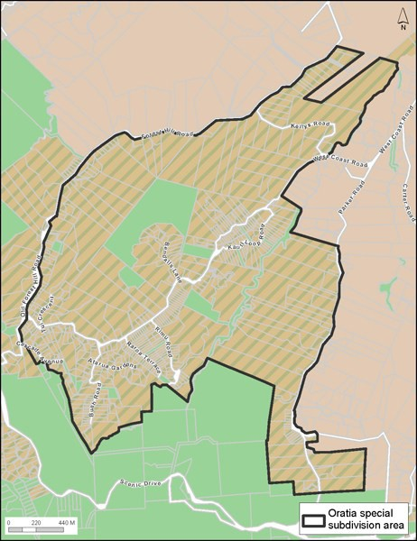

**Precinct Plan 2. Ōrātia Policy Area**

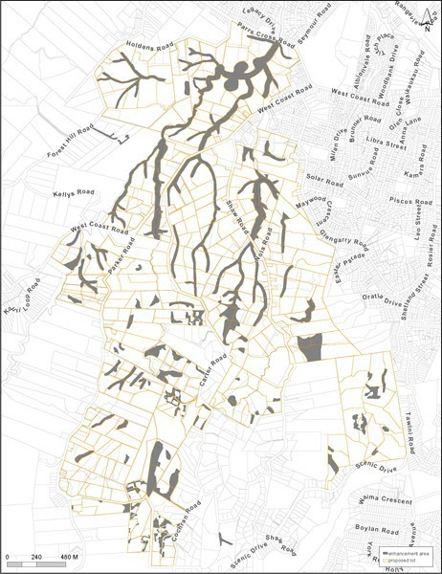

**Precinct Plan 3: Swanson South Policy Area**

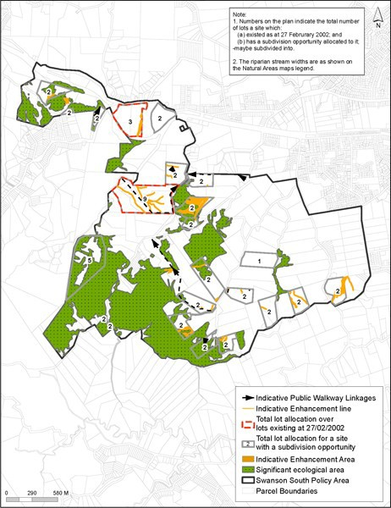

**Precinct Plan 4. Swanson South Site 1**

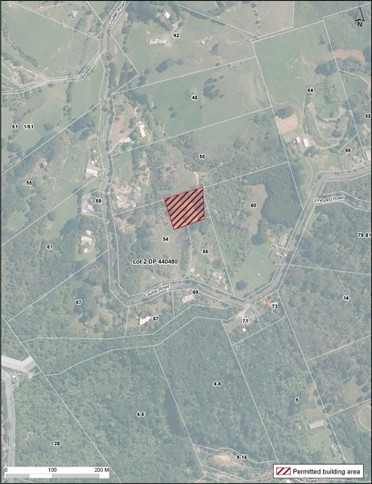

**Precinct Plan 5. Swanson South Site 2**

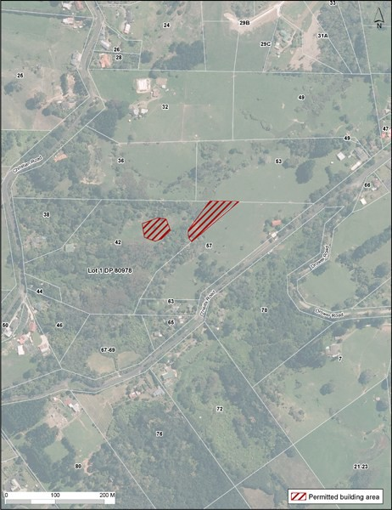

## Precinct Plan 6. Swanson South Site 3

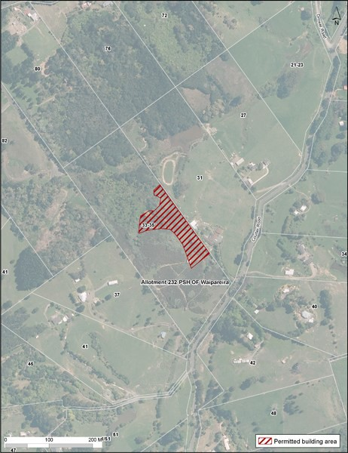

## Precinct Plan 7. Swanson South Site 4

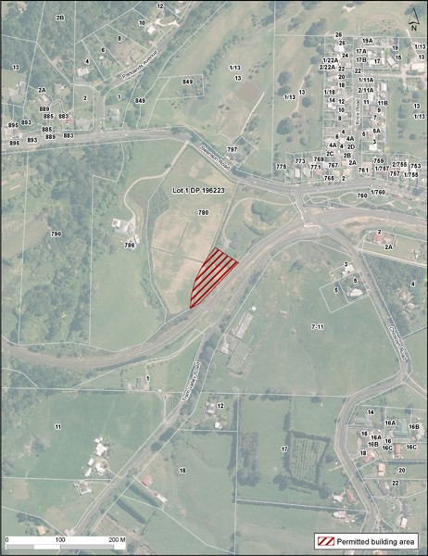

**Precinct Plan 8. Swanson South Site 5**

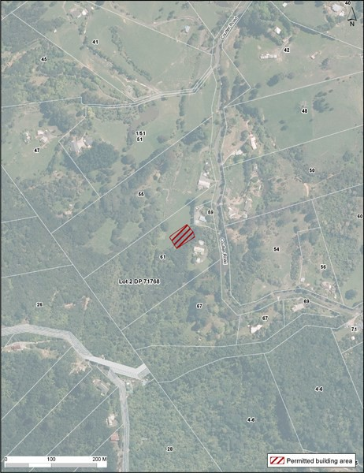

**Precinct Plan 9. Swanson South Site 6**

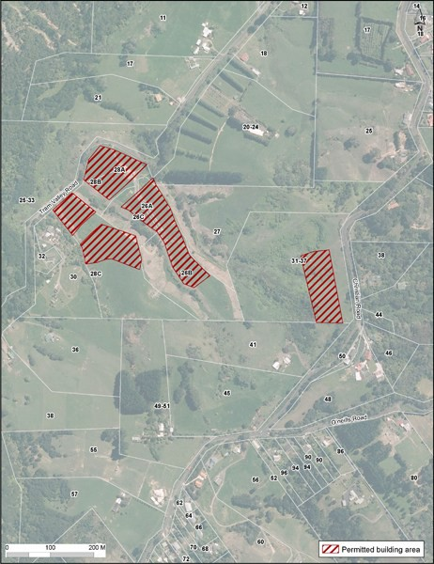

**Precinct Plan 10. Swanson South Site 7**

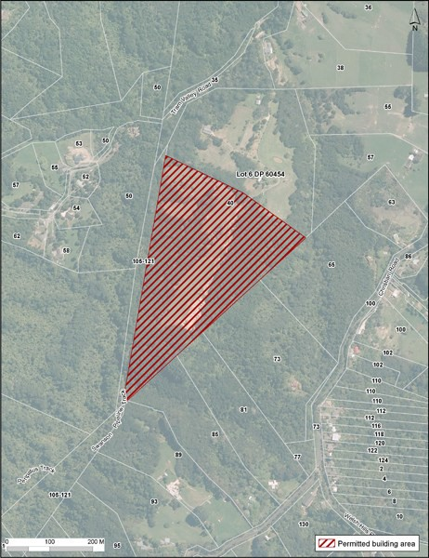

1. **Sub­policy area A: Ōrātia Village**
2. **Activity table**
   1. The activities in the Countryside Living zone and this sub­precinct apply in this sub­policy area unless otherwise modified by the activity table below.

|  |  |
| --- | --- |
| **Activity** | **Activity status** |
| Retail | P |
| Commercial Services | P |
| Restaurants and cafes | P |
| Non residential activities | P |
| Buildings | RD |
| Alterations and additions to buildings | RD |

# Land use controls

* 1. **Permitted activities**
     1. **Non residential activities**
        1. Non residential activities lawfully established prior to 8 December 2009 provided that any increase in floor space for that activity does not exceed 100m2.
        2. Non residential activities not otherwise provided for in the underlying zone or this sub­precinct are also permitted provided that:
           1. if the activity involves a restaurant and cafe it must not include drive through facilities. A restaurant or cafe which does not meet this control will be assessed as a discretionary activity and
           2. if the activity involves retail it is limited to:

i.

ii. iii. iv.

convenience shops

agricultural and horticultural produce goods produced by an artisan industry

retail sales ancillary to a commercial service not exceeding 10% of the floor area occupied by the commercial service activity

* + - * 1. the floor space for each non­residential activity does not exceed 100m2
        2. the total number of non residential activities in a building does not exceed 2
        3. the total number of non­residential activities in the Ōrātia Village policy area does not exceed 18 and
        4. no activity involves motor vehicle repairs, wrecking of motor vehicles, bottle or scrap metal sorting storage or rehandling, rubbish collection storage or rehandling services.

# Restricted discretionary activities

* + 1. **Buildings and alterations and additions to existing buildings:**
       1. The total maximum number of buildings, including existing buildings must not exceed:
          1. Area 1: 2 buildings Precinct Plan 11. Ōrātia Village.
          2. Area 2: 2 buildings Precinct Plan 11. Ōrātia Village.
          3. Area 3: 5 buildings Precinct Plan 11. Ōrātia Village.

2.

3.

4.

5.

6.

7.

8.

9.

10.

11.

12.

13.

The gross floor area for each building in Area 1 must not exceed 150m2

The gross floor area of each new building in Area 2 and Area 3 must not exceed 200m2

In Area 2 a minimum yard of 15m must be provided between any building and any other building within the Ōrātia Village sub­policy area

In Area 1 and Area 3 a maximum yard of 10m must be provided between any building and any other building within the Ōrātia Village Sub policy area

Any building in Area 2 and Area 3 must have a minimum front yard setback of 5m from any road Any building in Area 1 must have a maximum setback of 25m from any road

Any building must have a minimum setback of 5m from the edge of the Ōrātia Village sub­policy area In Area 1 and Area 3 the width of any single façade of a building must not exceed 20m

In Area 2 the width of any single façade of a building must not exceed 12m No more than 40% of an individual building's street frontage may be in glazing No building may exceed a maximum height of 2 storeys.

Buildings and alterations and additions to buildings which do not meet the above controls will be assessed as discretionary activities.

# Subdivision controls

* 1. Subdivision in the Ōrātia Village policy area is a discretionary activity provided that:
     1. it relates to an existing building, its curtilage, landscaping, and infrastructure
     2. land use consent has been granted for a building and associated development, landscaping, curtilage and infrastructure.

# Assessment ­ Restricted discretionary activities

## Matters of discretion

* + 1. The Council will restrict its discretion to the matters below for restricted discretionary land use activities in this policy area:
       1. retention of rural views
       2. retention and maintenance of vegetation
       3. screening
       4. landscape treatment
       5. design and location
       6. duration, hours of operation
       7. infrastructure
       8. vehicle access and car parking.

## Assessment criteria

* + 1. For land use activities that are a restricted discretionary activity, the following assessment criteria apply in addition to the criteria specified for the relevant restricted discretionary activities in the rural conservation zone.
       1. Development and buildings must contribute to high standards of design, a rural village character, pedestrian amenity, and safe and attractive public places by:

i.

ii. iii. iv.

v.

vi. vii. viii.

ix.

design of buildings reflecting the historic productive context of Ōrātia and its packing shed building forms

reusing existing buildings

locating buildings and development to maintain rural views

integrating existing development including adjacent community facilities

encouraging shared vehicle access and shared car parking including the use of on­street car parks where available;

ensuring that car parking is not located between the building(s) and the road limiting the extent of impervious surfaces and utilising permeable paving

viii. creating courtyards, planted orchards or vineyards and open spaces between buildings and

providing a covered pedestrian entry that is visible from the street.

* + - 1. Development should retain existing vegetation and/or incorporate landscape planting (illustrated on a landscape treatment plan) which achieves an orchard or vineyard pattern of fruit trees and vines.
      2. Landscape planting (illustrated on a landscape treatment plan) should mitigate the visual appearance of parking areas, manoeuvring areas and buildings from the street and pedestrian environment, while ensuring that:

i.

ii.

planting plans include fruit trees and vines reflecting the orchard and viticulture history of Ōrātia and

a planted strip is provided between the car parking areas (excluding driveways) and the street, of a suitable size to accommodate oak trees or similar exotic trees typical in the existing context of the Ōrātia lower valley capable of growing to maturity.

* + - 1. Outdoor storage areas should be located, designed and screened to avoid creating adverse visual and odour effects on the amenity of adjacent pedestrians and roads, and adjoining sites.
      2. Building(s), loading, parking, entranceways and footpaths must be designed for ease of access.
      3. Development should provides or maintain opportunities for rural trails to Shaw Road and to the Ōrātia Stream.
      4. Activities should include the appropriate provision of infrastructure to manage water, wastewater, stormwater (detention, quality, mitigation plantings and reuse), and solid waste associated with the activity.
      5. The proposal should contribute to the character and amenity of the Village.

# 5. Precinct Plans

## Precinct Plan 11. Ōrātia Village

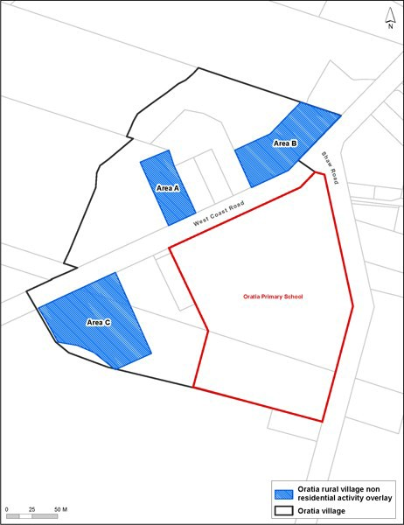

# 2. Sub­precinct B: Waitākere Ranges and bush living

1. **Activity table**
   1. The activities in the underlying Rural Conservation zone apply in this sub­precinct unless otherwise modified by the activity table below.

|  |  |
| --- | --- |
| **Activity** | **Activity**  **status** |
| **Rural** | |
| Farming | P |
| Forestry | NC |
| Conservation forestry | NC |
| Rural commercial services | NC |
| On­site primary produce manufacturing | NC |
| Quarries, farm or forestry | NC |
| **Accommodation** | |
| One dwelling per site | P |
| Two dwellings per site | P |
| Home occupation | P |
| Visitor accommodation | RD |
| **Commerce** | |
| Restaurants and cafes | D |
| Garden centres | NC |
| Markets | NC |
| Show homes | NC |
| Veterinary Clinics | NC |
| Filming activities | P |
| Retail | RD |
| Non residential activities | RD |
| **Community facilities** | |
| Care centre for up to 10 people | D |
| Care centre for more than 10 people | NC |
| Healthcare facilities | NC |
| Educational facilities | NC |
| Outdoor recreational activities | RD |
| **Industry** | |
| Artisan industries | P |
| Mineral exploration | NC |
| Subdivision | D |

# Land use controls

* 1. **Permitted activities**
     1. **Farming**
        1. The farming activity must be located outside any part of a site subject to any of the following overlays:
           1. Significant Ecological Area
           2. High Natural Character
           3. Outstanding Natural Landscape
           4. Outstanding Natural Character.
        2. Farming located within any of these overlays will be assessed as non­complying.

# Dwellings

* + - 1. Two dwellings on one site must comply with the following:
         1. the GFA of one of the dwellings must not exceed 65m2 excluding any garaging for motor vehicles.
         2. the site must have a minimum net site area of 1500m2.
         3. the additional dwelling must be incorporated within, or share a common wall no longer than 3m with the other dwelling on the site.
      2. Dwellings not meeting the above controls will be assessed as non complying activities.

# Artisan industries

* + - 1. Artisan industries must comply with the following:
         1. no more than five persons are engaged in the production of arts and crafts on the site
         2. no retail sales are carried out from the site on which the artisan industry is located
         3. maximum of 30 vehicle movements per day.

# Filming activities

* + - 1. Filming activities:
         1. must not involve any filming activity longer than six months from start to finish, irrespective of whether the activity is carried out in different years and
         2. must not require the construction of any building and
         3. must not exceed 50 vehicle movements per day.
      2. Filming activities not meeting the above controls will be assessed as controlled activity.

# Home occupation

* + - 1. Home occupations which involve homestays must comply with the following:
         1. sites under 2ha are restricted to a maximum of 8 people inclusive of those who reside on the site
         2. sites over 2ha are restricted to a maximum of 10 people inclusive of those who reside on the site
         3. maximum of two heavy vehicle movements per week
         4. the homestay, apart from the parking of one vehicle, is screened from the adjoining sites and the road
         5. maximum of 40 vehicle movements per day.

# Controlled activities

* + 1. **Filming activities**
       1. Filming activities must comply with the following:
          1. must not require the construction of any building
          2. maximum of 40 vehicle movements per day.

# Restricted discretionary activities

* + 1. **Retail**
       1. Retail (excluding permitted home occupations) must comply with the following:
          1. retail sales are limited to sales of products from artisan industries
          2. retail sales are from a floor space no greater than 100m2
          3. any new buildings, including additions to existing buildings, comply with the building coverage controls for the precinct

# Visitor accommodation

* + - 1. Visitor accommodation is limited to:
         1. sites greater than 20ha
         2. a maximum of 20 guests.

# Non residential activities

* + - 1. Non residential activities (excluding permitted home occupations) which involve an increase in scale and intensity of an existing lawfully established non residential activity provided that:
         1. retail sales are limited to produce from an artisan industry or restaurant and cafe (excluding drive through sales)
         2. any new buildings, including additions to existing buildings, comply with the building coverage controls for the sub­precinct (except that on Pt Allot 7A DP3530 Waipareira and Lot 4 DP 370123

– Auckland Waitākere Estate, the building coverage shall be no greater than 400m2 additional to the building coverage existing on 8 December 2009).

# Discretionary activies

* + 1. **Non residential activities**
       1. Non residential activities not meeting the land use controls of the precinct which comply with the following:
          1. any buildings, including additions to existing buildings, comply with the building coverage controls for the sub­precinct
          2. retail sales are limited to restaurant and cafes
          3. retail sales are from a floor space no greater than 300m2.

# Restaurants and cafes

* + - 1. Restaurants and cafes must comply with the following:
         1. shall not incorporate drive­through sales
         2. the gross floor area is 300m2
         3. buildings associated with the activity comply with the building coverage rules of this sub­precinct.

# Development controls

**3.1 Height**

* 1. Building height: 8m.
  2. Elevation height: 10m.
  3. Buildings that do not comply with 1 or 2 are discretionary activities.

# Yards

Table 3

|  |  |
| --- | --- |
| **Yard** | **Dimension** |
| Front, side and rear | 10m except within the Sub­ precinct B boundary.  3m within the Sub­precinct  B boundary. |

* + 1. Buildings set back less than 10m from a site boundary to a minimum of 3m, provided that the building height within 10m of the site boundary does not exceed 8m, will be assessed as a restricted discretionary activity.
    2. Building setbacks less than 3m from a boundary will be assessed as a discretionary activity.

# Building coverage

Table 4

|  |  |
| --- | --- |
| **Building coverage** | **Dimension** |
| All sites except those described below | 15% net site area or 300m2, whichever is the  lesser |
| Properties located on the Precinct Plan 12 ­15. | 10% net site area or  150m2, including 20m2 for a covered car space where one has not been provided, whichever is the greater; and maximum building coverage: 300m2 |

* + 1. Buildings that do not comply with the above standards will be assessed as restricted discretionary activities provided the building coverage does not exceed 15 per cent.
    2. Buildings that do not comply with the above standards and where the building coverage exceeds 15 per cent will be assessed as a non­complying activity.

# Subdivision controls

## 4.1 Discretionary activities

* 1. The following categories of subdivision are discretionary activities:
     1. Sites outside Precinct Plan 12 ­15 areas averaging 4ha over the net site area of the site existing at 14 October 1995, with a minimum 2ha for each individual proposed site, provided that:

i.

ii. iii.

no roads are created by a subdivision

each site has practical and legal motor vehicle access to a road

the subdivision will not lead to any development on land subject to an SEA overlay.

* + 1. Sites located in the Precinct Plan 12 ­15 areas and complying with the following:

i.

ii.

iii.

iv.

v.

vi. vii.

viii. ix.

minimum net site area of 2,000m2 provided:

average site area exceeds 4000m2 measured over the net site area of the site as it existed on 14 October 1995

each proposed new site is able to contain a building platform outside any part of an SEA overlay or

8000m2 where:

a building platform is situated within any part of a SEA overlay

no more than one new site is created per site existing on 14 October 1995

each proposed new site will be provided with a connection to a reticulated wastewater disposal system or

4ha where neither (i) nor (ii) above apply

each proposed site must have practical and legal motor vehicle access to a road

* 1. Any proposed subdivision which is not a discretionary activity under the above rules is a prohibited activity.

# Assessment ­ Restricted discretionary activities

## Matters of discretion

* + 1. Council will restrict its discretion to:
       1. the appropriateness of the activity in a rural area
       2. scale and intensity
       3. retention of vegetation
       4. screening landscape treatment
       5. duration
       6. hours of operation
       7. design and location
       8. car parking and access
       9. sustainable land management practices
       10. infrastructure
       11. provision of rural activities
       12. removal of buildings and other structures, and restoration of the site, on completion of filming activities.

## Assessment criteria

* + 1. Council will assess the proposal against the following assessment criteria. Whether:
       1. the character, scale, hours of operation and intensity of the activity are compatible with amenity values, neighbourhood character, and the natural landscape, and do not result in cumulative adverse effects
       2. the activity compromises rural character
       3. purpose­built buildings are compatible with the scale and appearance of other buildings in the neighbourhood
       4. the activity creates adverse effects on water quality, native vegetation and fauna habitat
       5. the activity would lead, on an individual or cumulative basis, to pressure for urban expansion and the fragmentation of rural character and amenity
       6. the activity creates adverse effects on the residential coherence and the safety of residents of the neighbourhood
       7. the activity achieves the relevant future character and amenity statement of the local area
       8. the site will be restored to an appropriate condition on completion of any filming activity.

# Assessment ­ Development control infringements

## 6.1 Matters of discretion

* 1. The council will restrict its discretion to the matters listed below for the relevant modification:
     1. yards:

i.

ii.

location, privacy, screening and planting. WRHAA

* + 1. building coverage:

i.

ii. iii.

building bulk, screening and landscape treatment provision of outdoor space.

WRHAA

## Assessment criteria

The council will consider the assessment criteria listed for each activity below:

* + 1. Yards
       1. The extent to which buildings are located a sufficient distance back from the site boundary to avoid more than minor adverse effects on the natural landscape
       2. The extent to which buildings are located in a position which maintains opportunities to retain vegetation around the edges of the site
       3. The extent to which buildings are located a sufficient distance back from site boundaries to ensure a minimum level of privacy
       4. All development must contribute to the achievement of:

i.

ii. iii.

the outcomes of the WRHAA

future character and amenity statements

the objectives and policies for the WRHA Precinct.

* + 1. Building coverage
       1. The extent to which the scale of buildings detracts from the natural landscape, in particular:

i.

ii. iii.

extent of landscape modification, including earthworks and vegetation alteration visual prominence of the building

relationship with neighbouring sites.

* + - 1. All development must contribute to the achievement of:

i.

ii. iii.

the outcomes of the WHRAA

future character and amenity statements

the objectives and policies for the WRHA Precinct.

# 7. Precinct Plans

## Precinct Plan 12: Sub­precinct B sites 1

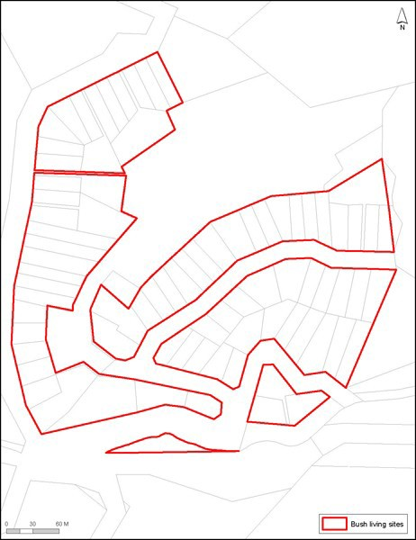

**Precinct Plan 13: Sub­precinct B sites 2**

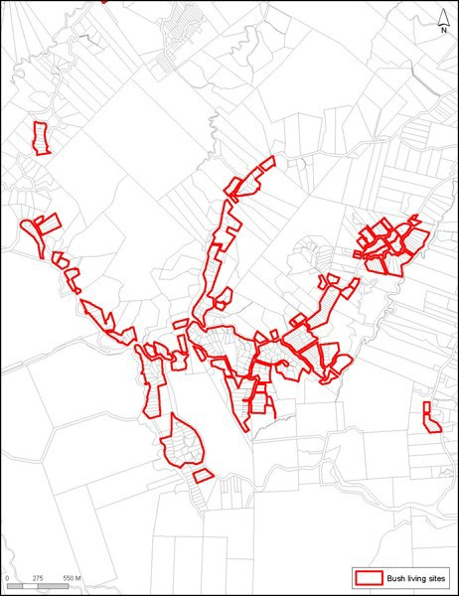

**Precinct Plan 14: Sub precinct­B sites 3**

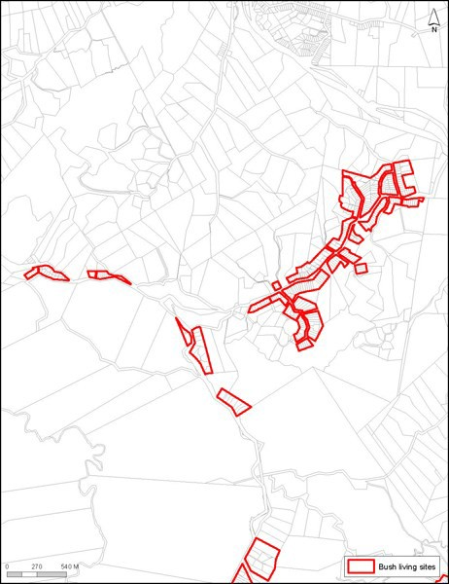

## Precinct Plan 15: Sub­precinct B sites 4

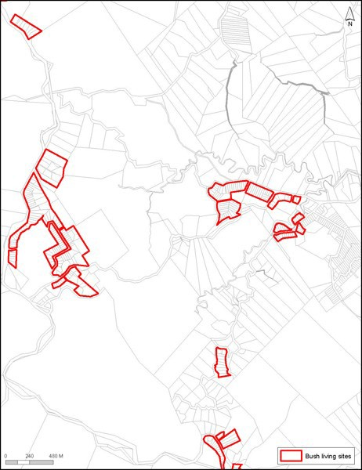

# 3. Sub­precinct C: Titirangi Laingholm

1. **Activity table**

The activities in the applicable underlying zone apply in this sub­precinct unless otherwise modified by the activity table below.

|  |  |
| --- | --- |
| **Activity** | **Activity Status** |
| **Development** | |
| One dwelling per site | P |
| Two dwellings per site | P |

# Land use controls

**2.1 Two dwellings per site**

* 1. Two dwellings on one site must comply with the following:
     1. the GFA of one of the dwellings must not exceed 65m2 excluding any garaging for motor vehicles.
     2. the site must have a minimum net site area of 1500m2.
     3. the additional dwelling must be incorporated within, or share a common wall no longer than 3m with the other dwelling on the site.
  2. Dwellings not meeting the above controls will be assessed as a non complying activity.

# Development controls

**3.1 Building height**

* 1. Building height: 8m.
  2. Elevation height: 10m.
  3. Buildings that do not comply with clause 3.1.1 or 3.1.2 above are discretionary activities.

# Yards

* + 1. Front, side and rear yard: 3m.
    2. Development that does not comply with clause 3.1above is a discretionary activity.

# 4. Policy area 1: Titirangi Laingholm

1. **Activity table**
   1. The activities in the applicable underlying zone apply in this policy area unless otherwise modified by the activity table below.

|  |  |
| --- | --- |
| **Activity** | **Activity status** |
| Subdivision | D |

# Subdivision controls

* 1. Where a building platform, driveway, car parking, access and manoeuvring areas can be located wholly outside an SEA:
     1. the average lot area of all proposed lots must be 2000m2, calculated from the area of the parent lot
     2. where 50 per cent or more of the parent lot is outside an SEA, an area equivalent to the building platform, driveway, car parking, access and manoeuvring areas must be permanently planted with native vegetation
     3. any SEA and all planted areas required under clause 2.1(b) above on the subject site are to be permanently protected by appropriate legal mechanism.
  2. Where any part of a building platform, driveway, car parking, access and manoeuvring areas is located inside an SEA:
     1. the minimum lot area created around an existing dwelling must be 2000m2 provided the parent lot existing has a minimum lot area of 6000m2 and there is no more than one additional lot created which is less than 4000m²
     2. after allowing for any subdivision under rules 2.1(a) and 2.2(a) there shall be a 4000m2 average lot area for each proposed lot
     3. no more than 500m2 of native vegetation may be removed to provide for the building platform, driveway, car parking, access and manoeuvring areas
     4. no new driveway will be steeper than a slope of 1 in 5 for any distance exceeding 10m.
  3. Subdivision that does not comply with the controls in 2.1(a) and (b) above is a non­complying activity.

# 5. Policy area 2: Titirangi Laingholm

1. **Activity table**
   1. The activities in the applicable underlying zone apply in this policy area unless otherwise modified by the activity table below.

|  |  |
| --- | --- |
| **Activity** | **Activity Status** |
| Subdivision | D |

# Subdivision controls

* 1. Where a building platform driveway, car parking, access and manoeuvring areas can be located wholly outside an SEA:
     1. the average net site area of all proposed sites must be 4000m2, calculated from the area of parent site
     2. where 50 per cent or more of the parent lot is outside the SEA, an area equivalent to the total area of the building platform of 15m by 15m, driveway, car parking, access and manoeuvring areas

must be permanently planted with native vegetation

* + 1. all vegetation in the SEA and all of the planted area required under 2.1(b) above are to be permanently protected by appropriate legal mechanism
    2. no new driveway will be steeper than a slope of 1 in 5 for any distance exceeding 10m.
  1. Where any part of the building platform driveway, car parking, access and manoeuvring areas is located inside a SEA:
     1. the minimum lot area created around an dwelling existing must be 4000m2 provided that the parent lot has a minimum lot area of 1.4ha and there is no more than one additional lot created which is less than 1ha area
     2. after allowing for any subdivision under rules 2.1(a) and 2.2(b) there must be an average net site area of no less than 1ha for each additional site created
     3. removal of native vegetation required for any building platform driveway, car parking, access and manoeuvring areas must not exceed 500m2 for every additional lot created.
     4. all of the native vegetation area of the proposed lot not otherwise required for building platform driveway, car parking, access and manoeuvring areas must be permanently protected by appropriate legal mechanism.
     5. no new driveway will be steeper than a slope of 1 in 5 for any distance exceeding 10m.
  2. Subdivision of the following sites must be assessed as a discretionary activity
     1. The maximum number of lots including any existing lot and balance lot but excluding any reserve or access lot, must not exceed total in the table below for the following sites:

Table 5.

|  |  |
| --- | --- |
| **Address** | **Total number of sites** |
| 333 Laingholm Drive (Certificate of Title  91D/282) | 22 |
| 293B Titirangi Road and 31 Woodfern Crescent (Certificates of Title 118D/755 and  118D/756) | 5 |
| 323A Huia Road (Certificates of Title  2094/12 and 1812/ 58) | 11 |
| 205A Godley Road (CT 1994/5) | 4  provided that any development made possible by the subdivision is to be located within an area outside an SEA |
| 175A Laingholm Drive (CT 37B/232) | 3  provided that clearance of native vegetation required for any building platform must not exceed 300m2 for every  lot created excluding that area included in the  existing driveway |

* + 1. Where native vegetation is removed for a building platform, there is to be at least an equivalent area on the parent site permanently planted with native vegetation which is protected by appropriate legal mechanism.
    2. No new driveway will be steeper than a slope of 1 in 5 for any distance exceeding 10m.
  1. Subdivision that does not comply with the requirements in clauses 2.1­2.3 above is a non­complying activity.

# Precinct Plans

## Precinct Plan 16. Titrangi Laingholm Policy Area

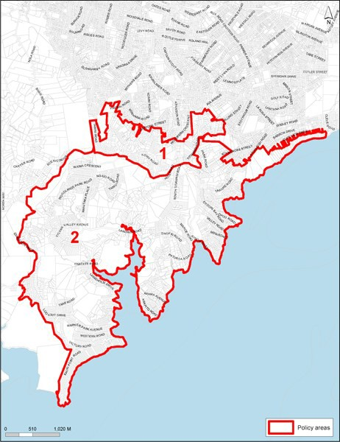

1. **Policy area 3: Titirangi Village**
   1. The activities, controls and assessment criteria in the applicable underlying zone and sub­precinct apply in the following policy area unless otherwise modified below.

# Activity table

|  |  |  |
| --- | --- | --- |
| **Activity** | **Activity Status** | |
|  | **Sub policy Area**  **A (Commercial)** | **Sub policy Area**  **B (Residential)** |
| **Commerce** | | |
| Restaurant | NA | RD |
| Retail | NA | RD |
| **Development** | |  |
| Additions that do not exceed 50m2 | NA | RD |

|  |  |  |
| --- | --- | --- |
| Additions and alterations that exceed 50m2 | NA | D |
| Additions and alterations that do not increase the height or bulk of the  building | P | P |
| Additions and alterations which increase the height or bulk of the building but  not exceeding 8m in height | RD | NA |
| Additions and alterations which increase the height or bulk of the building but  not exceeding 11m in height | D | NA |
| Buildings not exceeding 8m in height | RD | NA |
| Buildings not exceeding 11m in height | D | NA |
| Public deck or terrace on Area A on Figure 1 (Part 4.5.3.14.5) survey plan  SO67597 at 490 South Titirangi Road | RD | NA |
| 18 public car parking spaces on the balance land of survey plan SO67597 at  490 South Titirangi Road | RD | NA |
| Signs | P | NA |

1. **Land use controls**
   1. **Permitted activities**
      1. **Signs**
         1. Signs in sub­policy area A which meet the following controls are permitted:
            1. located below the verandah (canopy), or on the facade of the building up to the height of the first street level storey, or on and within the depth of the verandah (canopy) fascia
            2. not flashing, moving or illuminated.
         2. Signs in sub­policy area A which do not meet the above controls will be assessed as restricted discretionary activities.

# Restricted discretionary activities

* + 1. **Buildings**
       1. Buildings are a restricted discretionary activity provided they do not have residential activities at street level (other than entrances or accessways for residential activities on upper floors) on Titirangi Road.
       2. Buildings which have residential activities at street level (other than entrances or accessways for residential activities on upper floors) on Titirangi Road will be assessed as non complying activities.

# Retail

* + - 1. Retail within sub­precinct B must be located within an existing building and:
         1. limited to the sale of artisan industries goods
         2. the retail floor space is limited to 10 per cent of the floor area of the building or 10m2 whichever is the lesser.

# Development controls

**3.1 Building height**

* 1. In sub­policy area A:
     1. Buildings are to be measured from the road level at the centrepoint of the site’s Titirangi Road frontage.

# Yards

Table 6

|  |  |
| --- | --- |
| **Sub­precinct** | **Yard** |
| B | All yards ­ 3m |

# Key retail frontage overlay

* + 1. Sub­precinct A is subject to key retail frontage control clause 4.9 of the Business Zone rules as shown on Precinct Plan 17. Titirangi Village.

# Verandah

* + 1. Sub­precinct A is subject to clause 4.13 of the Business Zone rules.

# Assessment ­ Restricted discretionary activities

## Matters of discretion

The council will restrict its discretion to the matters below for the activities listed as restricted discretionary in the policy area activity table.

|  |  |  |  |  |  |  |  |  |  |
| --- | --- | --- | --- | --- | --- | --- | --- | --- | --- |
| **Activity** | **Intensity and scale** | **Noise, lighting and hours of**  **operation** | **Traffic** | **Development design** | | **Commercial core** | **Views** | | **Sign design** |
|  |  |  |  | **Sub­ policy Area**  **A** | **Sub­ policy Area**  **B** |  | **Sub­ policy Area**  **A** | **Sub­ policy Area**  **B** |  |
| Restaurant and cafes  and retail | X | X | X | X | X | X |  | X |  |
| Additions and alterations to  buildings |  | X | X | X |  |  | X |  |  |
| Buildings |  |  |  | X |  |  | X |  |  |
| Public deck or terrace on Area A on  Precinct Plan 17. Titirangi Village and survey plan SO67597 at 490 South Titirangi  Road |  |  |  |  |  |  | X |  |  |
| 18 public car parking spaces on the balance land of survey plan SO67597 at 490 South Titirangi  Road |  | X |  |  |  |  |  |  |  |
| Signs |  |  |  |  |  |  |  |  | X |

## Assessment criteria

The council will consider the relevant assessment criteria below for the restricted discretionary activities listed above.

1. Intensity and scale
   1. Buildings, including additions and alterations, are reused and should have a scale, form and character that maintains a residential streetscape in the area.
2. Noise, lighting and hours of operation
   1. Noise and lighting should not adversely affect the amenity of surrounding residential properties.

Consideration will be given to the location of any potentially noisy activities and any proposed measures to mitigate noise including:

i.

ii. iii.

locating noisy activities away from neighbouring residential boundaries adjoining the sub­ precinct

screening or other design features the proposed hours of operation.

1. Traffic and parking
   1. Vehicle access and car parking should be designed and located to maintain a front yard to the street.
   2. Provision should be made for on­site car parking.
2. Development design
   1. In sub­policy area A all development and buildings should contribute to high standards of design, pedestrian amenity, safety and comfort, attractive streets and public places by:

i.

ii. iii. iv.

v.

vi. vii.

encouraging shared public access to be developed on the northern side of Titirangi Road to minimise vehicle crossings

providing a visible pedestrian entry to buildings

providing weather protection over the footpath (eg canopies, verandahs)

providing ground level views from the street frontage through buildings to existing landscape features

modulating and detailing of the building's form

achieving active street frontages and providing for passive surveillance of the street

locating car parking to the rear of the building in a basement or semi­basement below street level.

* 1. In sub­policy area B development should be residential in character and comply with relevant development controls to maintain a residential scale.

1. Commercial core
   1. There should be a clear connection between retail and servicing customers from the site and is limited in extent that does not undermine activities in sub­precinct A.
2. Views
   1. Buildings along Titirangi Road frontage should be designed to maintain views to elevated indigenous forest, Manukau Harbour, Mt Atkinson, Rangiwai Hill and Lopdell House.
   2. The building should be designed so it does not detract from the landmark quality of Lopdell House and does not compromise the visual landscape quality of the Titirangi ridgeline as seen from a distance.
3. Sign design
   1. Signs should:

i.

ii.

be visually appropriate to neighbourhood character

not create a situation hazardous to the safe movement of traffic

iii.

iv.

v.

be at a height which avoids the sign dominating the neighbourhood and nearby buildings or structures

not result in visual clutter, adversely affect the character of the village and obscure building architectural elements including form, finish and detailing

contribute to the character and amenity of the village.

# Assessment – Development control infringements

## Matters of discretion

The council will restrict its discretion to the matters below for the relevant development control infringement.

|  |  |  |  |  |  |
| --- | --- | --- | --- | --- | --- |
| **Infringement** | **Building scale and dominance** | **Outlook and privacy** | **Building interface with the public**  **realm** | **Neighbourhood character** | **Views** |
| Height | X | X |  | X | X |
| Yards |  | X |  | X |  |
| Key retail frontage  and verandahs |  |  | X | X |  |

## Assessment criteria

In addition to the general assessment criteria for development control infringements , the council will consider the relevant criteria below for the development control infringement.

1. Height
   1. Buildings should be designed to:

i.

ii.

iii. iv.

v.

vi.

vii. viii.

protect the visual integrity of Lopdell House as the tallest commercial building as viewed along Titirangi Road

maintain views from Titirangi Road to Manukau Harbour and to the elevated forested areas and located on the northern side of Titirangi Road opposite Lopdell House and to the west of 429 Titirangi Road

maintain views identified in Precinct Plan 17. Titirangi Village enhance the mainstreet form of Titirangi Road

avoid being excessively dominant on the pedestrian environment

require design, materials and colour that assist in integrating the additional height with the village and natural landscaping setting

avoid shadowing of the pedestrian environment on the southern side of Titirangi Road

avoid adverse cumulative effects of building height and a continuum of three­storey buildings on Titirangi Road.

* 1. In addition to the above, refer to the assessment criteria in clauses 7.2.1 in the Business zones rules.

1. Yards
   1. Refer to the assessment criteria in clause 7.2.3 in the Business zones rules.
2. Key retail frontage and verandahs
   1. Refer to the assessment criteria in clause 7.2.2 in the Business zones rules.

# Precinct Plans

## Precinct Plan 17. Titirangi Village Policy Areas

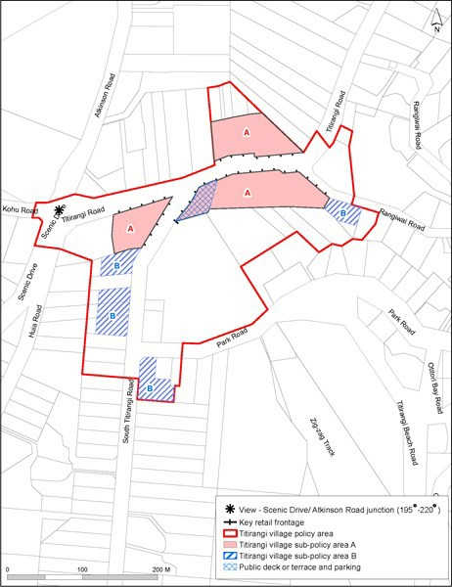

# 4. Sub­precinct D: Waitākere coastal settlements

1. **Activity table**

The activities in the underlying Rural Conservation zone apply in this sub­precinct unless otherwise modified by the activity table below.

|  |  |
| --- | --- |
| **Activity** | **Activity Status** |
| **Rural** | |
| Farming | P |
| Forestry | NC |
| Rural commercial services | NC |
| On­site primary produce manufacturing | RD |
| Quarries, farm or forestry | NC |
| **Accommodation** | |
| One dwelling per site | P |
| Two dwellings per site | P |
| Home Occupation | P |
| Camping Grounds | NC |
| Visitor Accommodation | NC |
| **Commerce** | |
| Restaurants and cafes | NC |
| Markets | NC |
| Show homes | NC |
| Drive­through facilities | NC |
| Non­residential activities | RD |
| Filming | C |
| **Community facilities** | |
| Care centre for up to 10 people | D |
| Care centre for more than 10 people | NC |
| **Industry** | |
| Artisan industries | P |
| Mineral exploration | NC |
| Subdivision | RD |

# Land use controls

* 1. **Permitted activities**
     1. **Farming**
        1. The farming activity must be located outside any part of a site subject to any of the following overlays:
           1. Significant Ecological Area
           2. High Natural Character
           3. Outstanding Natural Landscape
           4. Outstanding Natural Character.
        2. Farming located within any of these overlays will be assessed as non­complying.

# Dwellings

* + - 1. Two dwellings on one site must comply with the following:
         1. the GFA of one of the dwellings must not exceed 65m2 excluding any garaging for motor vehicles
         2. the site must have a minimum net site area of 1500m2.
         3. the additional dwelling must be incorporated within, or share a common wall no longer than 3m with the other dwelling on the site.
      2. Dwellings not meeting the above controls will be assessed as non complying activities.

# Home occupation

* + - 1. Home occupations which involve homestays must comply with the following:
         1. are restricted to a maximum of 8 people inclusive of those who reside on the site
         2. maximum of two heavy vehicle movements per week
         3. the homestay, apart from the parking of one vehicle, is screened from the adjoining sites and the road
         4. maximum of 40 vehicle movements per day.

# Controlled activities

* + 1. **Filming activities**
       1. Filming activities must comply with the following:
          1. must not require the construction of any building
          2. car trips to and from the filming activity must not exceed 100 per day.

# Restricted discretionary activities

* + 1. **Non residential activities**
       1. Non residential activities (excluding permitted home occupations) are limited to an increase in scale and intensity of an existing lawfully established non residential activity provided that retail sales are limited to:
          1. produce from an artisan industry
          2. restaurant and cafes
          3. convenience shops (except in Piha).

# Retail

* + - 1. Retail (excluding permitted home occupations) must comply with the following:
         1. retail sales are limited to sales of products from artisan industries
         2. retail sales are from a floor space no greater than 100m2
         3. any new buildings, including additions to existing buildings, comply with the building coverage controls for the sub­precinct.

# Discretionary activies

* + 1. **Non residential activities**
       1. Non residential activities not meeting the land use controls of the precinct which comply with the following:
          1. any buildings, including additions to existing buildings, comply with the development controls for the sub­precinct
          2. there are no retail sales.

# Restaurants and cafes

* + - 1. Restaurants and cafes must comply with the following:
         1. shall not incorporate drive­through sales
         2. the gross floor area is 300m2
         3. buildings associated with the activity comply with the building coverage rules of this sub­precinct.

# Development controls

**3.1 Height**

* 1. Building height: 6m.
  2. Elevation height: 10m.
  3. Buildings that do not comply with clause 3.1.1 or 3.1.2 above are discretionary activities.

# Yards

Table 7.

|  |  |
| --- | --- |
| **Yard** | **Coastal Settlements** |
| Front, side and rear | 3m |

* + 1. Buildings set back less than 3m from a site boundary will be assessed as a discretionary activity.

# Building coverage

Table 8

|  |  |
| --- | --- |
| **Building coverage** | **Dimension** |
| All sites | 15% net site area or 300m2, whichever is the  lesser |

* + 1. Buildings that do not comply with the above standards will be assessed as restricted discretionary activities provided the building coverage does not exceed 15 per cent.
    2. Buildings that do not comply with the above standards and where the building coverage exceeds 15 per cent will be assessed as a non­complying activity.

# Subdivision controls

## 4.1 Restricted discretionary activities

* 1. The minimum net site area for each proposed site is 4000m2; and
  2. A building platform must be available within each proposed site on an area outside of an SEA and
  3. No new roads may be created by the subdivision.

Any proposed subdivision which is not a discretionary activity under the above rules is a non­complying activity.

# Assessment ­ Restricted discretionary activities

## Matters of discretion

* + 1. Council will restrict its discretion to:
       1. the appropriateness of the activity in a rural area
       2. scale and intensity
       3. retention of vegetation
       4. screening landscape treatment
       5. duration
       6. hours of operation
       7. design and location
       8. car parking and access
       9. sustainable land management practices
       10. infrastructure
       11. provision of rural activities
       12. removal of buildings and other structures, and restoration of the site, on completion of filming activities.

## Assessment criteria

* + 1. Council will assess the proposal against the following assessment criteria. Whether:
       1. the character, scale, hours of operation and intensity of the activity are compatible with amenity values, neighbourhood character, and the natural landscape, and do not result in cumulative adverse effects
       2. the activity compromises rural character
       3. purpose­built buildings are compatible with the scale and appearance of other buildings in the neighbourhood
       4. the activity creates adverse effects on water quality, native vegetation and fauna habitat
       5. the activity would lead, on an individual or cumulative basis, to pressure for urban expansion and the fragmentation of rural character and amenity
       6. the activity creates adverse effects on the residential coherence and the safety of residents of the neighbourhood
       7. the activity achieves the relevant future character and amenity statement of the local area
       8. the site will be restored to an appropriate condition on completion of any filming activity.

# Assessment ­ Subdivision controls

## 6.1 Matters of discretion

* 1. When assessing restricted discretionary subdivision applications, council will restrict its discretion to:
     1. the retention or linkage of vegetation and fauna habitat areas
     2. the avoidance of development on natural landscape elements and heritage features
     3. retention and enhancement of coastal character
     4. integration of the proposed development with surrounding neighbourhood and landscape character
     5. the use of materials and design which is compatible with natural coastal character.

## Assessment criteria

* + 1. The Council will consider the assessment criteria in Clause 8.2.2 in sub­precinct A above.

# 5. Sub­precinct E: Large property management areas

The activities, controls and assessment criteria in the underlying zones, Auckland­wide rules, and overlays apply in this sub­precinct unless modified by the activity table, rules and assessment criteria below.

# Activity table

|  |  |  |  |
| --- | --- | --- | --- |
| **Activity** | **Activity Status** | | |
|  | **Wainamu Policy**  **Area 1** | **Bethells Policy Area**  **2** | **Te Henga Policy**  **Area 3** |
| One dwelling | P | C | P |
| Two dwellings | RD | RD | RD |
| Filming activities | P | P | P |
| Visitor accommodation | P | NA | P |
| Road network activities | P | NA | NA |
| Buildings | P | C | P |
| Farming | NA | P | P |
| Vegetation alteration | P | P | NA |
| Tree alteration | P | P | NA |
| Tree removal | P | P | NA |
| Subdivision | RD | NA | RD |
| Forestry | P | RD | NA |
| Outdoor recreation activities | P | P | P |
| Home occupations | NA | C | NA |
| Restaurants and cafes | NA | D | NA |

1. **Land use controls**
   1. **Permitted activities**
      1. **Dwellings**
         1. Dwellings in the Wainamu Policy Area must be located in the areas nominated on the Precinct Plan

18. Wainamu.

* + - 1. Dwellings in the Te Henga Policy Area must be located in the areas nominated on the Precinct Plan

20. Te Henga.

* + - 1. Dwellings not meeting the above controls will be assessed as restricted discretionary activities.

# Filming activities

* + - 1. Filming activities:
         1. must not involve any filming activity longer than six months from start to finish, irrespective of whether the activity is carried out in different years and
         2. must not require the construction of any building and
         3. car trips to and from the filming activity must not exceed 200 per day
         4. the cumulative number of vehicle movements per day from 2 or more of the policy areas within this sub­precinct shall not exceed 300.

# Road network activities

* + - 1. Road network activities must be limited to the maintenance of existing access roads to and within the Wainamu sub­policy area.

# Buildings

* + - 1. Buildings in the Wainamu Policy Area must have a building coverage of no more than 15 per cent of the net site area or 300m2 whichever is the lesser.
      2. Buildings in the Te Henga Policy Area must have a building coverage of no more than 15 per cent of the net site area or 350m2 whichever is the lesser, provided that no single building may exceed a coverage of 300m².

# Farming

* + - 1. In the Bethells Policy Area farming activities must be:
         1. limited to viticulture and grazing
         2. viticulture must be located in the areas nominated on the Precinct Plan 19. Bethells for horticulture and viticulture
         3. grazing must be located in the areas nominated on the Precinct Plan 19. Bethells as pasture.
      2. In the Wainamu Policy Area farming activities must be:
         1. limited to grazing
         2. located in the areas nominated on the Precinct Plan 18. Wainamu as pasture.
      3. In the Te Henga Policy Area farming activities must be:
         1. limited to grazing
         2. located in the areas nominated on the Precinct Plan 20. Te Henga as pasture.

# Tree alteration

* + - 1. Tree alteration must only occur within either:
         1. those areas nominated on the Precinct Plan 19. Bethells for grazing, horticulture, viticulture, buildings, forestry and farm forestry
         2. those areas nominated on the Precinct Plan 18. Wainamu as Forest – Native (firewood gathering).

# Vegetation alteration

* + - 1. Vegetation alteration must only occur within either:
         1. those areas nominated on Precinct Plan 19. Bethells for grazing, horticulture, viticulture, buildings, forestry and farm forestry
         2. those areas nominated on Precinct Plan 18. Wainamu as Forest –Native (firewood gathering).

# Tree removal

* + - 1. Tree removal must only occur within either:
         1. those areas nominated on Precinct Plan 19. Bethells for grazing, horticulture, viticulture, buildings, forestry and farm forestry
         2. those areas nominated on Precinct Plan 18. Wainamu as Forest –Native (firewood gathering).

# Visitor accommodation

* + - 1. Visitor accommodation must be limited to a maximum of 20 guests.

# Forestry

* + - 1. Forestry must only occur:
         1. within the areas nominated as Forest – Exotic on Precinct Plan 18. Wainamu.
         2. following submission of a management plan to Council including the matters outlined in clause 5.1 below.

# Controlled activities

* + 1. **Forestry**
       1. Forestry activities must be located in the areas nominated on Precinct Plan 18. Wainamu.

# Dwellings in the Bethells policy area

* + - 1. Dwellings shall be a controlled activity in the Bethells policy area provided that:
         1. there is a maximum of five new dwellings in the policy area
         2. they are sited in general accordance with the proposed dwelling locations shown in Precinct Plan

19. Bethells.

* + - 1. Dwellings that are not sited in general accordance with the proposed dwelling locations shown in Precinct Plan 19. Bethells shall be assessed as a restricted discretionary activity.

# Buildings in the Bethells policy area

* + - 1. Buildings are a controlled activity if:
         1. total building coverage in the policy area is no more than 3500m2
         2. no single building may exceed a coverage of 300m2.

# Home occupations in the Bethells policy area

* + - 1. A home occupation in the Bethells policy area is a controlled activity provided that the activity:
         1. only involves a recording studio and dwelling located in the same building
         2. is sited in general accordance with thein Precinct Plan 19. Bethells.

# Restricted discretionary activities

* + 1. **Buildings in the Wainamu policy area**
       1. Buildings in the Wainamu Policy Area with a net site area greater than 300m2 provided that the building coverage does not exceed 15 per cent of the net site area.

# Two dwellings

* + - 1. Two dwellings shall be a restricted discretionary activity in this sub­precinct provided:
         1. they are located in the areas nominated for dwellings on the relevant policy area plans
         2. the GFA of one of the dwellings must not exceed 65m2 excluding any garaging for motor vehicles
         3. the site must have a minimum net site area of 1500m2
         4. the additional dwelling must be incorporated within, or share a common wall no longer than 3m with the other dwelling on the site.

# Buildings in the Bethells policy area

* + - 1. Buildings in the Bethells policy area are a restricted discretionary activity if:
         1. they are erected for the purpose of a controlled activity in the policy area
         2. are not located in accordance with the position nominated for those activities in Precinct Plan 19.

Bethells.

# Forestry in the Bethells policy area

* + - 1. Forestry in the Bethells policy area must be located in the areas nominated in Precinct Plan 19.

Bethells for that activity.

# Discretionary activies

* + 1. **Buildings in the Bethells policy area**
       1. Buildings are a discretionary activity if:
          1. total building coverage in the policy area is no more than 3500m2
          2. no single building may exceed a coverage of 300m2

# Outdoor recreation activities

* + - 1. Any outdoor recreation activities which do not meet the controls incorporated into that definition shall be assessed as a discretionary activity.

# Buildings in the Bethells policy area

* + - 1. Buildings in the Bethells policy area are a discretionary activity if:
         1. total building coverage in the policy area is no more than 3500m2
         2. no single building may exceed a coverage of 500m2.

# Subdivision controls

**3.1 Subdivision in the Wainamu Policy Area**

* 1. Subdivision meeting the following controls is restricted discretionary:
     1. any sites created by the subdivision must coincide with the location of proposed lot boundaries shown in Precinct Plan 18. Wainamu.
     2. the Streamside Enhancement Area shown in Precinct Plan 18. Wainamu. must be planted or seeded with manuka and/or flax prior to the issue of a 224(c) certificate for any subdivision
     3. the Wetland Protection Area shown in Precinct Plan 18. Wainamu. must be made permanently inaccessible to stock by the erection of a stock barrier in the position shown in Precinct Plan 18. Wainamu.
  2. Subdivision meeting the following controls is a discretionary activity:
     1. the subdivision must create the same number of sites shown in Precinct Plan 18. Wainamu
     2. the Streamside Enhancement Area shown in Precinct Plan 18. Wainamu must be planted or seeded with manuka and/or flax prior to the issue of a 224(c) certificate for any subdivision
     3. the Wetland Protection Area shown in Precinct Plan 18. Wainamumust be made permanently inaccessible to stock by the erection of a stock barrier in the position shown in Precinct Plan 18. Wainamu.

# Subdivision in the Te Henga Policy Area

* + 1. Subdivision meeting the following controls is restricted discretionary:
       1. any sites created by the subdivision must coincide with the location of proposed lot boundaries shown on the in Precinct Plan 20. Te Henga.
       2. the Lakeside Enhancement Area shown in Precinct Plan 20. Te Henga has established planting as required by council prior to the issue of a s224(c) certificate for the subdivision.
    2. Subdivision meeting the following controls is a discretionary activity:
       1. the subdivision must create the same or lesser number of sites than shown in Precinct Plan 20.

Te Henga

* + - 1. the Lakeside Enhancement Area shown in Precinct Plan 20. Te Henga has established planting as required by council prior to the issue of a 224(c) certificate for any subdivision.

# Assessment ­ Controlled activities

## 4.1 Matters of control

* 1. The council will reserve its control to the matters below for controlled activities in the Bethells policy area:
     1. visual impact, amenity values and neighbourhood character
     2. landscape treatment
     3. design
     4. appearance (including colour)
     5. sewage/stormwater management
     6. WRHAA.

## Assessment criteria

* + 1. For land use activities that are a controlled activity in this precinct, the following assessment criteria apply in addition to the criteria specified for the relevant controlled activities in the Rural Conservation zone.
       1. Buildings should not be visible from beyond the site particularly from a public place such as a road or beach.
       2. Buildings should not compromise the visual landscape qualities of the area.
       3. The proposed development should not adversely affect amenity values and neighbourhood character.
       4. Buildings should be of a colour and reflectively compatible with local amenity values and the natural landscape, particularly as viewed from beyond the site, from roads and other public places.
       5. The building should be screened if necessary.
       6. The building should not create pressure on the ability of the surrounding natural environment to adequately absorb the effects of wastewater disposal and stormwater drainage.
       7. The development should be consistent with the objectives of the WRHAA.

# Assessment ­ Restricted discretionary activities

## 5.1 Matters of discretion

* 1. Bethells policy area:
     1. The council will restrict its discretion to the matters below for restricted discretionary land use activities in the Bethells policy area:

i.

ii. iii.

visual impact, amenity values and neighbourhood character landscape treatment

design

iv.

v.

vi.

appearance (including colour) sewage/stormwater management WRHAA.

* + 1. In relation to forestry, the council will also consider the following matters:

i.

ii. iii.

the natural functioning of water courses fire safety

protection of mauri and sites of significance to iwi.

* 1. Te Henga policy area:
     1. The council will restrict its discretion to the matters below for restricted discretionary land use activities in the Te Henga policy area:

i.

ii.

location in relation to sensitive ridges landscape treatment.

* 1. Wainamu policy area
     1. The Council will restrict its discretion to the matters below for restricted discretionary dwellings in the Wainamu policy area:

i.

ii. iii. iv.

v.

vi.

location in relation to protection of sensitive ridges landscape treatment

fire safety

impact on natural landscape infrastructure

waahi tapu sites.

* + 1. In relation to restricted discretionary buildings the council will restrict its discretion to:

i.

ii. iii.

natural landscape existing infrastructure

More than minor adverse effects.

* 1. Subdivision:
     1. The council will restrict its discretion to the matters below for restricted discretionary subdivisions in this sub­precinct:

i.

ii. iii. iv.

v.

design, scale and location of proposed sites and driveways landscaping treatment

protection and enhancement of vegetation and natural features drainage works and infrastructure

road/site access.

## Assessment criteria

* + 1. Bethells policy area
       1. For land use activities that are a restricted discretionary activity in the Bethells policy area, the following assessment criteria apply in addition to the criteria specified for the relevant restricted discretionary activities in the rural conservation zone.
          1. Buildings should not be visible from beyond the site particularly from a public place such as

a road or beach.

ii. iii.

iv.

v.

vi.

Buildings should not compromise the visual landscape qualities of the area.

The proposed development should not adversely affect amenity values and neighbourhood character.

Buildings should be of a colour and reflectively compatible with local amenity values and the natural landscape, particularly as viewed from beyond the site, from roads and other public places.

The building should be screened if necessary.

The building should not create pressure on the ability of the surrounding natural environment to adequately absorb the effects of wastewater disposal and stormwater drainage.

* + - 1. In relation to forestry the following assessment criteria also apply.

i.

ii.

iii. iv.

v.

The proposed development should not adversely affect the overall resilience, biodiversity and integrity of the natural environment.

The activity should not adversely affect or contribute to the degradation of the water table or of natural water courses in a way that destroys or reduces their ability to support instream vegetation and fauna.

Adequate provision must be made for fire safety.

The proposed development adversely affects the mauri (life force) of native vegetation and fauna habitat within the natural environment.

The activity should not adversely affect the historical, cultural or spiritual significance of any site or waahi tapu of significance to iwi.

* + 1. Te Henga policy area
       1. For land use activities that are a restricted discretionary activity in the Te Henga policy area, the following assessment criteria apply in addition to the criteria specified for the relevant restricted discretionary activities in the rural conservation zone.

i.

ii.

iii.

iv.

Buildings should not be obtrusively visible on or above sensitive ridgelines from a public place.

Buildings and development should not compromise the visual landscape qualities of sensitive ridgelines, and other natural landscape elements.

Development should not adversely affect the visual, historical, cultural and spiritual significance for iwi of sensitive ridges.

Landscape treatment should be used to mitigate the visual impact of buildings and development.

* + 1. Wainamu policy area
       1. For dwellings that are a restricted discretionary activity in the Wainamu policy area the following assessment criteria apply in addition to the criteria specified for that activity in the rural conservation zone.

i.

ii.

iii.

The proposed development will not adversely affect sensitive ridgelines, amenity values and neighbourhood character.

The proposed development will not adversely affect the overall resilience, biodiversity and integrity of natural areas.

The proposed development will not adversely affect or contribute to the degradation of the water table or of natural water courses in a way that destroys or reduces their ability to

support instream vegetation and fauna or be used as a healthy food source.

iv.

v.

vi.

vii.

viii.

ix.

x.

xi.

xii.

Adequate provision has been made for fire safety.

The proposed development will not adversely affect the mauri (life force) of native vegetation and fauna habitat within natural areas

The proposed activity will not adversely affect the historical, cultural or spiritual significance of any site or waahi tapu of significance to iwi.

More than minor adverse effects from the activity will be adequately avoided, remedied, mitigated

Dwellings and associated development will not detract from the amenity values and the natural landscape.

Dwellings and associated development will not require the clearance of native vegetation and habitat of native fauna, or result in adverse effects on ecosystems.

Dwellings and associated development will not require development in any riparian margin/coastal edge or on any natural landscape element.

Wastewater treatment and disposal systems and stormwater treatment and disposals systems are provided for dwellings and associated development.

Adequate provision is made to ensure that there will be no separation by way of subdivision of a second dwelling from the main dwelling

* + - 1. For restricted discretionary buildings the following assessment criteria shall apply in addition to that criteria specified for that activity in the rural conservation zone.

i.

ii.

iii.

The scale of buildings will not detract from the natural landscape.

Building coverage will not create pressure on existing infrastructure or the receiving ability of the surrounding natural environment from the buildings or the activities to be conducted within them in particular, on water supply, wastewater and stormwater drainage, water tables, proximity to water courses, soils and road access.

More than minor adverse effects can be adequately avoided, remedied, mitigated.

* + 1. Subdivision
       1. For subdivision that is a restricted discretionary activity in this sub­precinct, the following assessment criteria apply in addition to the criteria specified for this activity in the rural conservation zone.

i.

ii.

iii.

iv.

v.

The subdivision design should avoid the need for clearance of native vegetation, retain or link significant vegetation and fauna habitat areas, contain proposals to plant with native vegetation those areas of the site outside of a SEA, avoid development on natural landscape elements and heritage features, minimise soil erosion, encourage on­site water retention, avoid development on floodplains and use drainage methods that protect and enhance streams.

The subdivision should provide formal legal protection for the natural environment, including riparian margins, areas of outstanding natural features or outstanding native vegetation.

Sites should be large enough to ensure that future buildings can comply with the relevant standards of the Unitary Plan.

Sites should be provided with practical vehicle access to a road. Sites should be of a useable shape.

vi.

Subdivision design should enable efficient provision of infrastructure.

# Special information requirements

* 1. A management plan must be submitted to Council for any forestry activity in the Wainamu and Bethells policy areas. The management plan should include the following:
     1. location and dimensions of areas proposed for production planting
     2. location and extent of any archaeological sites or historic sites within the areas proposed for planting and how those sites will be protected
     3. measures to be used to protect any areas of native vegetation
     4. methods to be used to prevent erosion during any planting or harvesting work
     5. the time period over which any planting will take place
     6. measures to be used to protect water flow and quality of any water bodies or wetlands in the vicinity
     7. methods to be employed to inhibit the spread of fire within and in the vicinity of the area to be forested
     8. likely methods to be employed in harvesting operations
     9. anticipated date(s) and time period(s) of harvesting
     10. estimated volumes of timber produced and intended methods of transport of harvested timber for milling
     11. the likely demands placed on roads through the transportation of harvested timber
     12. details of an appropriate rehabilitation programme for the area to be subject to forestry activities
     13. the species to be used
     14. the method of management to be used.

# Precinct Plans

## Precinct Plan 18. Policy Area 1 Waimanu

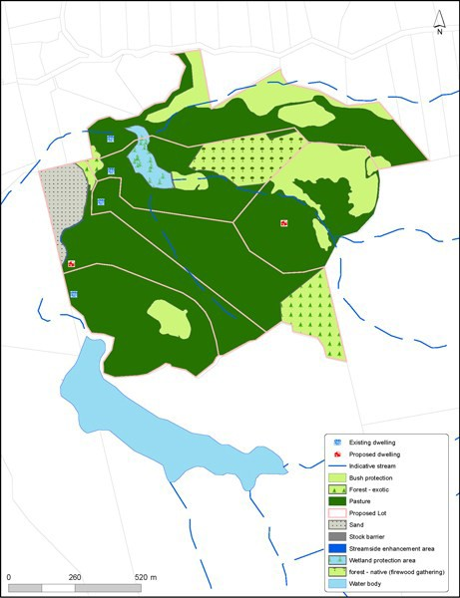

**Precinct Plan 19. Policy Area 2 Bethells**

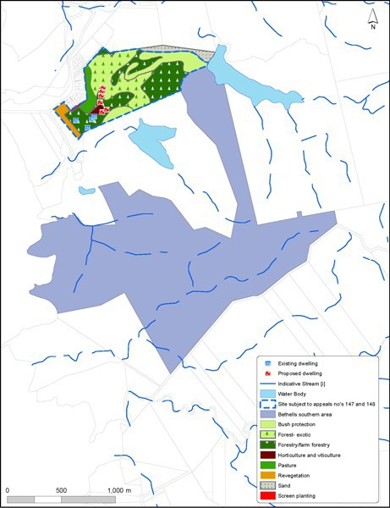

**Precinct Plan 20. Policy Area 3 Te Henga**

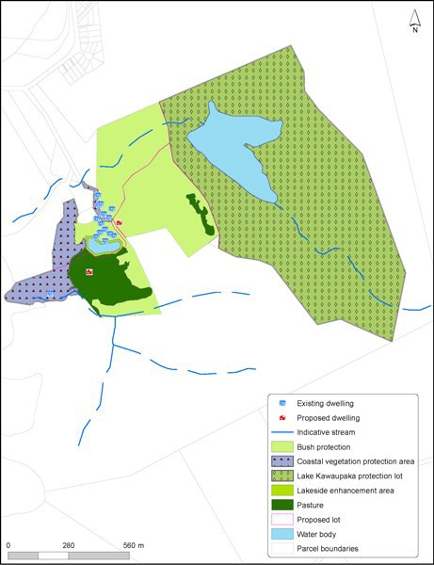

1. **Sub­precinct F: Waitākere Ranges Regional Park**
   1. Please refer to the Auckland Wide Regional Park Precinct Rules for the rules that apply to this sub­ precinct.

# Precinct Plans

## Precinct Plan 21: Waitakere Ranges Heritage Area Precinct Plan.

