PART 3 ­ REGIONAL AND DISTRICT RULES»Chapter K: Precinct rules»6 South»

6.9 Karaka 2

The activities, controls and assessment criteria in the underlying Local Centre, Mixed Housing Suburban and Single House zones and Auckland­wide rules apply in the following precinct unless otherwise specified.

Activity table

The activities in the Local Centre, Mixed Housing and Single House zones apply in the Karaka 2 precinct unless otherwise specified in the activity table below.

Activity | Activity Status
Development
The removal of Norfolk Pine (Auracaria heterophylla) at 55 Dyke Road, Karaka (Lot 9 DP  154764) | NC
The removal of trees over 6 metres in height on the sites at number 6 Dyke Road (Lot 1 DP  123078) and 324 Linwood Road (Lot 1 DP 40523) | D
Buildings in the Local Centre Zone | RD
Subdivision
Subdivision | D
Subdivision not proposing a connection to one centralised wastewater system for the Karaka  2 precinct | NC

Notification

The council will publicly notify resource consent applications for the following activities:

  - a.

b.
Removal of Norfolk Pine (Auracaria heterophylla) at 55 Dyke Road, Karaka (Lot 9 DP 154764)

Removal of trees over 6 metres in height on the sites at number 6 Dyke Road (Lot 1 DP 123078) and 324 Linwood Road (Lot 1 DP 40523).

  - The council will consider resource consent applications for the following activities without the need for public or limited notification except that limited notification may be given to:
    - Buildings in the Local Centre zone

    - Infringement of land use and/or development controls

    - Subdivision in the Karaka 2 precinct.

Land use controls

  - The land use controls in the underlying zones apply in the Karaka 2 Precinct unless otherwise specified below.

Maximum density

    - The number of dwellings on a site must not exceed the limits specified in table 1.

    - Development that does not comply with clause 3.1.1 above is a discretionary activity.

Table 1. Maximum Density.

Precinct | Dwellings
Karaka 2 | 1 dwelling per 300m2 in the Mixed Housing Suburban Zone  1 dwelling per 800m2 in the Single House zone  1 dwelling per 2500m2 for  any unserviced site

Development controls

  - The development controls in the underlying zones apply in the Karaka 2 Precinct unless otherwise specified below.

Height

    - Buildings must not exceed 8m in height.

    - Development that does not comply with clause 4.1.1 above is a discretionary activity.

New community, commercial and residential buildings

    - Community facilities, buildings for commercial services and dwellings must be connected to one centralised waste water system consented and constructed for the Karaka 2 precinct.

    - Development that does not comply with clause 4.2.1 above is a discretionary activity.

Subdivision controls

  - The subdivision controls in the Auckland wide rules ­ subdivision apply in the Karaka 2 precinct unless otherwise specified below.

  - Subdivision that does not comply with clauses 5.1 to 5.4 below is a non­complying activity.

Minimum site size

    - Site sizes for proposed sites must comply with the minimum net site areas specified below:
      - 300m2 in the Mixed Housing Suburban zone

      - 800m2 in the Single House zone

      - 2500m2 for any unserviced site

Wastewater servicing

    - All sites shall be connected to one central wastewater treatment and disposal system. For private systems, legal mechanisms shall be put in place to ensure the on­going operation, maintenance, and monitoring of the system.

    - Where a reticulated wastewater treatment and disposal system is located on a site outside the Karaka 2 Precinct an appropriate easement or other legal mechanism shall be secured to achieve the matters detailed in clause 5.2.1 above.

Street tree planting

    - Where subdivision is proposed on a site with frontage to Dyke Road, Linwood Road or Blackbridge Road, then street tree planting to the satisfaction of Council shall be provided along the length of the road berm adjacent to the site prior to Council issuing a s224(c) certificate.

Access

    - Where subdivision proposes sites with a boundary to Linwood or Dyke Roads, the site’s vehicle access must be to either of those roads. Legal mechanisms may be placed on the certificates of title to achieve this outcome where sites have dual frontages.

Figure 1: Road typologies 1
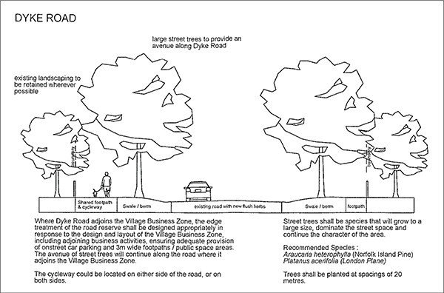

Figure 2: Road typologies 2
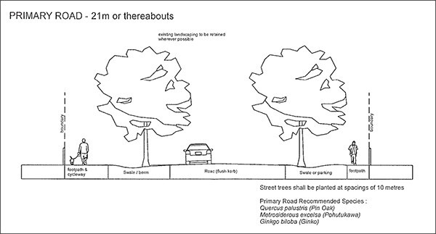

Figure 3: Road typologies 3
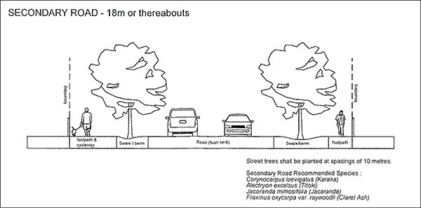

- Assessment ­ Restricted discretionary activities

Matters of discretion
For activities/development that is a restricted discretionary activity in the Local Centre zone of the Karaka 2 precinct, the council will restrict its discretion to the following matters, in addition to the relevant matters specified in clause 6.1 of the Business Zone Rules.

Table 2

Activity | Location and orientation of buildings and public spaces | Location of land uses | Design of buildings and public spaces | Landscaping and screening | Vehicular and pedestrian movement
Buildings in the Local Centre  zone of the Karaka 2 Precinct. | X | X | X | X | X

Assessment criteria
For development that is a restricted discretionary activity in the Karaka 2 precinct, the following assessment criteria apply in addition to the criteria specified in clause 6.2 of the Business Zone rules:

Buildings in the Local Centre Zone
  - Site Planning
    - Buildings on sites adjoining Dyke Road, Linwood Road and the Village Square should provide a continuous building frontage. Setbacks from the road boundary should be avoided to maintain a continuous built form. Frontages should be provided with verandahs to provide shelter and shade to pedestrians using the footpath. The principal pedestrian entries of all buildings should face the road and/or Village Square and be easily accessible and clearly identifiable from the footpath.

    - A Village Square having an area of at least 400m2 should be established prior to the completion of the overall development of the Village Local Centre zoned land in general accordance with the location shown on the Precinct Plan 1. Karaka 2 and with at least one continuous frontage to
Dyke Road. The Village Square should be capable of accommodating a shape factor that fulfills its purpose.

    - Off­street car parking and servicing areas should be located to the rear of the buildings. Most associated parking should be provided on­site, however on­street parking on one or more of the frontage roads is appropriate to serve the Village Centre, preferably in 90 degree angled bays.

    - Accessways to rear parking/service areas should reduce the width and number of vehicle crossings over footpaths, which may involve shared accessways.

    - If buildings cannot be built with frontage to all road boundaries as described in a) above, attractive landscaped areas should be provided between the building and the road frontage. The use of such areas for parking should be avoided because of adverse effects on streetscape and pedestrian amenity, and where car parking is required; this should have a maximum depth of a single aisle.

    - Outdoor service areas for rubbish storage etc shall be concealed from views from public roads by being contained within buildings or appropriate configuration of the building or by a combination of the building, landscape planting and screen fencing.

    - Except where located in the road reserve, areas of car parking shall not adjoin the Village Square.

    - Cycle racks shall be provided at a convenient and sheltered location.

  - Building Form, Public Interface and External Appearance
    - Buildings on sites fronting adjoining Roads and the Village Square should accommodate retail, commercial or community activities at ground floor level with compatible uses (including residential) encouraged to locate above ground floor.

    - Buildings should front the Village Square where practicable and should provide dual frontages to the Square and any adjoining road.

    - When viewed from the road or any public space, buildings should create visual interest through articulation, openings, and design variation.

    - Buildings should exhibit proportions and forms that complement nearby residential development.

    - Buildings should be designed such that that they provide for passive surveillance over roads and open spaces (including the Village Square).

    - Solid blank walls facing a road or open space shall be avoided.

    - Verandahs shall reflect the design and style of the building and accentuate entrances and window treatment.

    - Buildings on corners shall utilise design features to integrate the corner and promote linkages with the surrounding land, including existing or potential development on opposing corners. In these locations there may be opportunities to provide additional building height to create a landmark.

    - The principal pedestrian entry points of all buildings shall be clear and obvious within the building frontage.

    - Buildings should front directly onto, or face, roads and provide pedestrian entries and windows along the road frontage. Buildings adjacent to the Village Square should also front onto the Village Square.

    - Large doors (e.g. for loading or servicing) shall be concealed from view from roads and public open spaces. If they are visible from these spaces, their dominance in the frontage shall be reduced, and they shall be set back from the front face of the building.

    - Signage shall be integrated within the design of the building, rather than free­standing structures and shall not extend above the eaves or parapets of buildings.

  - Village Square, Parking Areas and Landscaping

    - Open spaces (including the Village Square) should be well designed, functional, highly visible and accessible.

    - The Village Square should provide appropriate features (e.g. seating, lighting, landscaping etc.) to support its function as the community focal point of the Village.

    - The Village Square, and the location of buildings that front the Square, should be designed and orientated to ensure good solar access and to avoid the adverse effects of prevailing winds.

    - The Village Square should be constructed of appropriate surface materials to ensure its versatility and all year round use (including for community activities and events).

    - Car parking should be provided in appropriate places, generally within the street or behind buildings, and should be easily accessible and appropriately landscaped.

    - Parking and movement layouts should be designed for safe and effective movement of vehicles through an easily understood layout with appropriate surface markings and signs.

    - Where car parking is provided on sites that adjoin residential areas, it should be screened by buildings, fencing and/or landscaping.

Assessment ­ Discretionary activities

While not limiting the exercise of its discretion, the Council may consider the particular matters specified for the discretionary activities listed below:

Maximum height infringement
    - Visual dominance

    - Available light and shadowing of adjacent land uses

    - Design features and appearance

    - Surrounding rural village character

Subdivision and infringements of land use and development controls
The assessment criteria of clause 6.2 of the Business Zones apply to activities in the Local Centre Zone. For other zones the following criteria apply:
    - The extent to which the design of the proposal or nature of the activity would detract from or diminish the village character and amenity;

    - The extent to which the design ensures that the village business centres develop as attractive community and employment hubs, including an emphasis on the public / private interface and integration with street frontages, such as the building being located in close proximity to the road, and avoiding large open spaces to the road or the building being setback behind a car park.

    - The extent of Landscape design and general site development and layout so as to ensure that buildings and structures will not visually detract from the amenity values of dwelling houses on adjacent properties.

    - Any dwelling house or multi­unit housing located at ground level shall be one component of a mixed use development, with business activities being accommodated on the street frontage of the site within appropriately sized tenancies. Residential accommodation shall be appropriately constructed, located and sited to avoid adverse effects from noise, odour, solid waste, visual appearance and car parking.

    - The use of Local Centre zoned sites entirely for a dwelling house or multi­unit housing is discouraged unless combined with a business because of the potential for significant adverse effects on the local provision of retail, services, other business or community activities and employment opportunities and the road network as additional trips are made to other sites where business activities are located.

6.

7.

8.

9.

10.

11.

12.

13.

14.

15.
The extent to which sufficient car parking is provided for the intended use(s) and whether this is located and/or screened so that it will not adversely affect adjoining village zoned land.

Vehicular access points are designed to provide connectivity within the existing and proposed road network, and are appropriately located and designed to allow safe vehicle and pedestrian movements, refer to Precinct Plan 1.Karaka 2.

Whether the design of subdivision or development provides for the retention of existing mature trees (for example trees over 6 metres in height at the time of development) where practicable to ensure that the landscape amenity values associated with the established trees on the sites, particularly those at 6 Dyke Road (Lot 1 DP 123078) and 324 Linwood Road (Lot 1 DP 40523) is maintained. Covenants will be placed on the resulting titles protecting those retained trees on an ongoing basis.

The extent to which the design of the roads is appropriate for a rural village with flush kerb road edges, swales and opportunities for berm design that include landscaping and / or street tree planting where appropriate or where they are required by the road typologies in Figures 1 ­ 3.

The extent to which the design of subdivision, development and roads provides for the establishment of a slow speed environment within the Village and on Linwood Road, including pedestrian linkages across Dyke, Blackbridge and Linwood Roads.

The extent to which development can be adequately serviced with reticulated wastewater, potable water supply, water supply for fire fighting purposes, and stormwater facilities as indicated in Precinct Plan 1. Karaka 2.

Geotechnical matters, including those included in clause 4.11.3 of the Auckland­wide rules. The undergrounding of any utility lines within or outside the site being subdivided.
Whether subdivision provides appropriate infrastructure in a coordinated manner (including reticulated wastewater treatment and disposal), ensuring that subdivision, development and the provision of infrastructure keep pace with each other.

Whether the subdivision is consistent with Precinct Plan 1. Karaka 2, provides for the establishment of the Village Square and does not preclude the achievement of the structural elements identified therein.

Trees
    - The recommendations of a report prepared by a suitably qualified landscape architect and/or arborist addressing the visual landscape amenity with reference to the precinct policies and whether the trees to be retained are healthy and will not be compromised by the proposed development.

Special information requirements

An application for tree removal activity as described in the activity table above must be accompanied by:

A report prepared by a suitably qualified landscape architect and/or arborist addressing the visual landscape amenity and whether the trees to be retained are healthy and will not be compromised by the proposed development.

Design statement
A design statement must be submitted for the activities specified in the table below. It must contain information on all relevant matters, including as a minimum, the matters specified below. Drawings and illustrations must be proportionate to the complexity and significance of the project. Please refer to the Auckland Design Manual.

Table 3: Design statement requirements

Information requirements Buildings and alterations to buildings not otherwise provided for

A. CONTEXT ANALYSIS
1. Site analysis
a. | Existing site plan | X
b. | Streetscape character | X
2. Neighbourhood analysis
a. | Natural and cultural  environment | X
b. | Movement | X
c. | Neighbourhood character | X
d. | Use and activity | X
e. | Urban structure | X
3. Opportunities and constraints analysis
a. | Opportunities and constraints  diagram | X
B. DESIGN RESPONSE
a. | Concept design | X
b. | Proposed site plan | X
c. | Proposed elevations | X
d. | Solar access | X
e. | Landscape | X
f. | Streets, accessways & lanes | X
g. | Urban Structure | X
h. | Public open space | X

Precinct plan

Precinct Plan 1: Karaka 2 precinct
