PART 3 ­ REGIONAL AND DISTRICT RULES»Chapter K: Precinct rules»6 South»

6.6 Flat Bush

The activities, controls and assessment criteria in the relevant underlying zones rules and Auckland­wide rules apply in the following precinct and sub­precincts unless otherwise specified. Refer to planning maps for the location and extent of the precinct and sub­precincts and areas.

Activity table

The activities in the relevant underlying zones apply in Flat Bush sub­precincts A and B except as specified in the activity table below.

 | Sub­precinct A |  |  |  |  |  | Sub­precinct B
Activity | Area 1 | Area 2 | Area 3 | Area 4 | Area 5 | Area 6 | Area 7 | Area 8 | Area 9
Residential
One or more dwellings (including integrated landuse and subdivision resource  consent) | RD | RD | RD | RD | RD | NA | RD | RD | NA
Development
Alterations and additions to existing dwellings involving habitable room(s) within the Moderate Aircraft Noise  Area | RD | RD | RD | RD | RD | P | RD | RD | NC
Cluster Housing on sites greater  than 20ha | NA | NA | NA | NA | NA | NA | NA | D | D
Community facilities
Educational  facilities | RD | RD | RD | RD | RD | NA | RD | RD | NC
Entertainment  facilities | NC | NC | D | D | NC | NA | RD | RD | NC
Formed Bridle Trails and Mountain  Bike Trails | NA | NA | NA | NA | NA | C | NA | NA | C
Rural
Farming | P | P | P | P | P | P | P | P | P

Commerce
Food and  beverage | D | D | D | D | D | NA | D | D | NA
Offices not exceeding 150sqm Gross Floor  Area | D | D | D | D | D | NA | NC | NC | NA
Offices exceeding 150sqm Gross Floor  Area. | NC | NC | D | D | D | NA | NC | NC | NA
Retail no greater than 150sqm Gross Floor  Area | NC | D | D | D | D | NA | NA | NA | NA
Show homes | P | P | P | P | P | NC | P | NC | NC
Subdivision
Any subdivision activity in Flat Bush Sub­ precinct A that is integrated  with a land use consent that does not comply with the site size identified in Clause 4.1 and the minimum site dimensions identified in  Clause 4.2. | RD | NA | RD | RD | RD | NA | NA | NA | NA

Any subdivision activity on sites that include more than one Area [Areas 1 – 5  ], and which varies from the maximum or minimum average site size requirements specified in  Clause 4.1 | RD | RD | RD | RD | RD | NA | NA | NA | NA
Any subdivision that contains land within  the Area 9 | NA | NA | NA | NA | NA | NA | NA | RD | RD
Any subdivision that contains land within the that does not comply with Clause  4.3 | D | D | D | D | D | D | D | D | D
Any activity (including subdivision) which includes wastewater disposal in  the Area 8 | NA | NA | NA | NA | NA | NA | NA | RD | NA
Any subdivision, building or structure within the  Area 9 | NA | NA | NA | NA | NA | NA | RD | RD | RD
Any subdivision, building or structure within the  Area 6 | RD | RD | RD | RD | RD | RD | NA | NA | NA

Land use controls

2.1 Density

  - The following density requirements shall apply within Flat Bush Sub­precincts A and B.

Table 1

 | Sub­precinct A |  |  |  |  |  | Sub­precinct B
 | Area 1 | Area 2 | Area 3 | Area 4 | Area 5 | Area 6 | Area 7 | Area 8 | Area 9
Minimum density (sqm net site area  per dwelling) | 425 | 300 | 425 | 250 | 425 | NA | 1000 | 2000 | NA
Maximum allowable density within the MANA area (sqm per  dwelling) | 400 | NA | 150 | 180 | 300 | NA | NA | NA | NA
Maximum  density | NA | NA | NA | NA | NA | NA | 1500 | 5000 | NA

  - Any application not meeting the density requirements of clause 2.1.1 shall be a non­complying activity.

Development Controls

3.1 Building height

  - Buildings must not exceed the maximum height in the table below:

Table 2

 | Sub­precinct A |  |  |  |  |  | Sub­precinct B
 | Area 1 | Area 2 | Area 3 | Area 4 | Area 5 | Area 6 | Area 7 | Area 8 | Area 9
Maximum height in  meters | 9 | 9 | 12 | 16 | 9 | 8 | 8 | 8 | 8

Yards

    - Front, side and rear yards shall comply with the table below:

Table 3

 | Sub­precinct A |  |  |  |  |  | Sub­precinct B
 | Area 1 | Area 2 | Area 3 | Area 4 | Area 5 | Area 6 | Area 7 | Area 8 | Area 9
Front Yard in  meters | 3 | NA | 3 | 3 | 3 | 0 | 4 | 6 | 6
Side Yard in  meters | 1.2 | 1.2 | 1.2 | 1.2 | 1.2 | 0 | 3 | 6 | 0

Rear yard1 in  meters | 9 | 9 | 9 | 9 | 9 | 0 | 9 | 6 | 0
1 a single storey building (or part of building) up to a maximum height of 5m with a maximum width of 4m that is no closer than 5m from the rear boundary.

Building coverage

    - Maximum building coverage shall comply with table below:

Table 4

Maximum Building Coverage (as a percent of the site)
 | Sub­precinct A |  |  |  |  |  | Sub­precinct B
 | Area 1 | Area 2 | Area 3 | Area 4 | Area 5 | Area 6 | Area 7 | Area 8 | Area 9
Sites over 400sqm net  site area | 40 | 40 | 40 | 40 | 40 | NA | 30 | 15 | NA
Sites between 200sqm­ 399sqm net  site area | 40 | 45 | 45 | 45 | 45 | NA | NA | NA | NA
Sites under 200sqm net  site area | 50 | 50 | 50 | 50 | 50 | NA | NA | NA | NA

Impervious area

    - Maximum impervious area within the front yard shall comply with table below:

Table 5

Maximum impervious area ( as a percent of the site)
 | Sub­precinct A |  |  |  |  |  | Sub­precinct B
 | Area 1 | Area 2 | Area 3 | Area 4 | Area 5 | Area 6 | Area 7 | Area 8 | Area 9
Maximum impervious area within  front yard | 50 | 50 | 50 | 50 | 50 | NA | 50 | NA | NA

Noise Insulation Requirement for an Attached Dwelling

    - Dwellings (including erection and/or internal or external alteration or addition) in Flat Bush sub­ precincts A and B that have common building elements between another dwelling or dwellings (irrespective of the activity within that dwelling or dwellings), shall only be permitted where they are designed, constructed and maintained in accordance with the following requirements:
      - The Sound Transmission Class of common walls shall be no less than 60 and the Sound Transmission Class of common floors and ceilings shall be no less than 55.

      - The Impact Insulation Class of floors shall be no less than 55.

      - The Verification Method shall be G6/VM1.

      - When assessing Impact Insulation Class, all floors, hallways and stairs in a building outside a dwelling are deemed to be common building elements to that dwelling. The impact requirement shall therefore apply between any other unit or common space and the habitable space of the dwelling irrespective of vertical or horizontal separation.

      - A report is provided from a suitably qualified and experienced acoustic engineer stating that the building has been designed, constructed, and has passed field tests demonstrating compliance with the above.

Asbestos Containing Materials

    - For land identified in Area 1 of Figure 1below, except as provided in clause 3.6.4 below, and excluding grazing, the following activities will be non­complying activities:
      - all land disturbing activities

      - subdivision.

    - For land identified in Area 2 of Figure 1 below, except as provided in clause 4.4 below, and excluding farming, the following activities shall be restricted discretionary activities:
      - Any land disturbance activities required for the installation of services such as electricity, water, telecommunications, sewerage and drainage

      - Any land disturbance activities required for the construction, renovation or demolition of buildings used for or in association with residential, business, recreational, educational or community activities

      - Land disturbance activities involving earthworks in excess of 200m

      - Subdivision.

    - Site investigation and remediation required by clauses 3.6.1 and 3.6.2 above must comply with clause
4.5 ­ Contaminated Land and clause 4.2. ­ Earthworks of the Auckland­wde rules.

    - The restrictions imposed by clauses 3.6.1 and 3.6.2 above will no longer apply to a site where contamination remediation has occurred and been approved by council.

Figure 1. Areas Relating to the Management of Asbestos Containing Materials
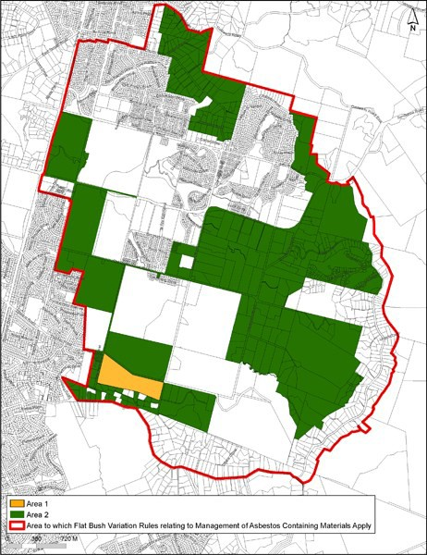

  - Fences

    - Where land within Flat Bush Sub­precinct A or B adjoins Flat Bush Area 6 or 9, then the boundary fencing or walls along the common boundaries shall be limited to a maximum height of 1.2m or up to 1.8m provided that the portion of the fence above 1.2m is at least 75% transparent.

Subdivision controls

The subdivision controls in the Flat Bush precinct are those listed in the Auckland­wide rules – subdivision except as specified below.

4.1 Minimum and average site sizes

  - Minimum and average site sizes shall comply with the table below and the controls which follow:

Table 6

 | Sub­precinct A |  |  |  |  | Sub­  precinct B
 | Area  1 | Area  2 | Area  3 | Area  4 | Area  5 | Area  7 | Area  8
Average Site size in sqm | 325 to  425 | NA | 325 to  425 | 325 to  425 | 325 to  425 | 1200  to 1500 | 5000
Average Site size in sqm  within MANA | 425  to 450 | NA | NA | NA | NA | NA | NA
Minimum site  size in sqm | 325 | NA | 325 | 325 | 325 | 1000 | 2000

  - Average site size in sub­precinct B, Areas 7 and 8 may include land within Area 9.

  - Additional Development Standards to be met in the Flat Bush sub­precinct B, Area 8:
    - Subdivision creating sites will only be permitted on land held in a separate Certificate of title on 27 October 2010 (the existing site).

    - Subdivisions are permitted to be made in stages by reference back to the existing site. Multiple subdivision consent applications may not be used to negate the provision for an average site size or the maximum number of sites that would be permitted by the subdivision of the existing site.

  - Any application not meeting any of the above requirements shall be a non­complying activity.

Minimum Site Dimensions

    - Minimum sites dimensions shall comply with the table below:

Table 7

 | Sub­precinct A | Sub­precinct B
 | Area 1­5 | Area 7 | Area 8
Front Site Minimum Width  in meters | 12.5 | 20 | 25
Front Site Minimum Depth  in meters | 26 | 26 | NA
Front Site Legal Width of  Back Lanes in meters | 7 | NA | NA
Rear sites | NC | NC | NA

    - There shall be no minimum site size within Sub­precinct A ­ Areas 1­5 where subdivision is proposed as part of an integrated land use consent provided that within the MANA the maximum allowable densities set out in Clause 2.1 are complied with.

    - Any application not meeting the above requirements shall be a discretionary activity.

Subdivision Standards Applying to land within Areas 6 and 9

    - The following subdivision standards shall apply to land within Areas 6 and 9:
b. Sub Precinct A­ Area 6

i.

ii.

iii.

iv.

v.
Upon development or subdivision of sites containing land within Area 6, such areas shall be vested in the council for public open space purposes.

All Stormwater Management Areas are indicative only and the exact boundaries are subject to final stormwater modelling.

All land contained within the Area 6 that is vested in council upon subdivision, development or by direct purchase, shall be administered in accordance with the Rules under 4.3.1(b).

In the situation where all or part of the land identified within Area 6 is not required to be vested in council as public open space, the area status shall no longer apply and the land shall be administered in accordance with the provisions of its underlying sub­precinct as determined in Clause 3.3

Where land is no longer required as a Stormwater Management Area within the Flat Bush area the land shall be administered in accordance with the provisions for Area 6.

b. Sub Precinct B­ Area 9

i.

ii.

iii.

iv.

v.
Access to all sites and all building platforms within the subdivision shall be wholly outside Area 9

Where an application for subdivision consent includes two or more adjoining sites, the combined areas may be treated as one site for the sole purpose of subdivision design and configuration, provided that the average site size and minimum site size are in accordance with Clause 4.1.

Land within Area 9 to be set aside for planting and to be secured by consent notice shall be planted and a programme of weed and pest control shall be provided for in the consent notice.

A Riparian Planting Plan shall be provided as part of any application for land modification, development and subdivision.

The developer shall be responsible for the routine maintenance and replacement of any planting they provide for a period of two years from the time of planting.

Movement Network

    - All subdivision shall comply with the following controls:
      - Roads shall be provided in accordance with the indicative alignments in Figure 2 and the Precinct Plan 3. Road Network and shall be constructed to the standards contained within Table 9: Construction Standards for Additional Road Types within the Flat Bush Precinct Plan Area or, where not contained in Table 9, the relevant Auckland Wide rules shall apply.

      - All new subdivisions, roads and sites shall comply with the standards and terms in Table 8: Connected Movement Network and shall be built in accordance with the cross sections in Figures 2 through to Figure 7.

Table 8: Connected movement network

 | Sub­precinct A |  |  |  |  |  | Sub­precinct B
 | Area 1 | Area 2 | Area 3 | Area 4 | Area 5 | Area 6 | Area 7 | Area 8 | Area 9

Maximum Block Length  in meters | 250 | 250 | 250 | 250 | 250 | NA | NA | NA | NA
Maximum Block Perimeter Distance in  meters | 700 | 700 | 700 | 700 | 700 | NA | NA | NA | NA
Maximum cul­ de­sac  lengths (excluding turning circle)  in meters | 0 | 0 | 0 | 0 | 0 | NA | 200 | NA | NA

Table 9: Construction Standards For Additional Road Types Within The Flat Bush Precinct Plan Area

Types of road | Road | Carriage­way | Max. grade | Figure
Collector Road Park Edge with development on one  side in meters | 19.6 | 9.2 | 8.33% | Refer Figure 2
Collector Road Park Edge – Bridge in  meters | 15 | 7 | 8.33% | Refer Figure 3
Collector Road Park Edge ­ with public open space on both  sides in meters | 17.4 | 7 | 8.33% | Refer Figure 4
Flat Bush Local Road  in meters | 18.2 | 7.8 | 12.5% | Refer Figure 5
Flat Bush Local Road  Park Edge in meters | 14 | 7.8 | 12.5% | Refer Figure 6
Flat Bush Special Local Road Park  Edge | 14 | 8.1 | 2.5% | Refer Figure 7
- Alternative road layouts
  - Alternative road layouts may be proposed which demonstrate the implications for the whole sub catchment within which the changes are proposed as identified in Precinct Plan 4. Sub Catchments. and shall be constructed to the standards contained within Table 9: Construction Standards for Additional Road Types within the Flat Bush Precinct Plan area, or where not contained in Table 8.

  - All alternative road layouts shall meet the requirements of clause 4.4.1(b) and shall not alter the position of arterial roads as identified in Precinct Plan 3. Road Network.

  - All alternative road layouts must maintain the position of key specified local road connections between sub catchment areas, as indicated in Precinct Plan 5. Key Road Connections.

  - In the Sub­precinct A, the block depth shall accommodate the minimum site dimension as specified in clause 4.2.

  - Any application not meeting the above requirements shall be a restricted discretionary activity. Unless special circumstances exist, a resource consent application under Clause 4.4.1 (c) may be considered on a limited notified basis within the sub­catchment as shown on Precinct Plan 4. Sub­catchments.

Figure 2. Collector Road Park Edge with development on one side
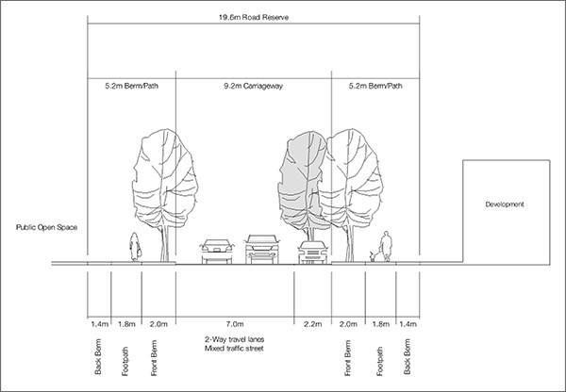

Figure 3. Collector Road Park Edge ­ Bridge
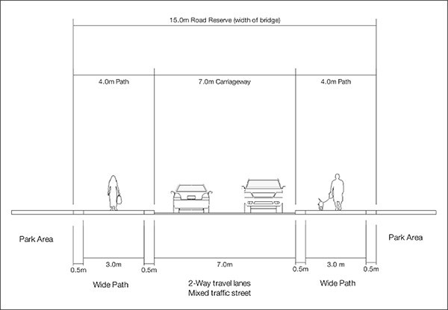

Figure 4. Collector Road Park Edge with public open space on both sides
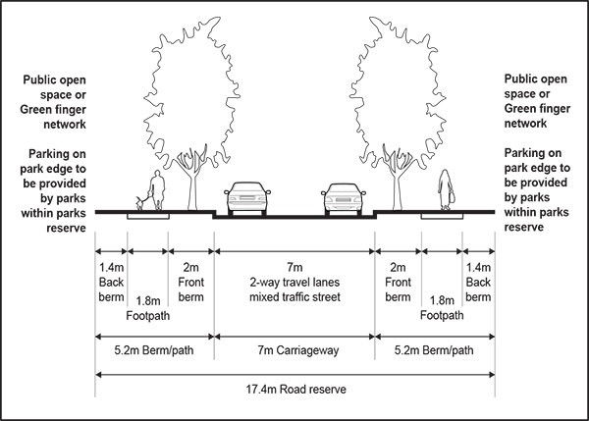

Figure 5. Flat Bush Local Road
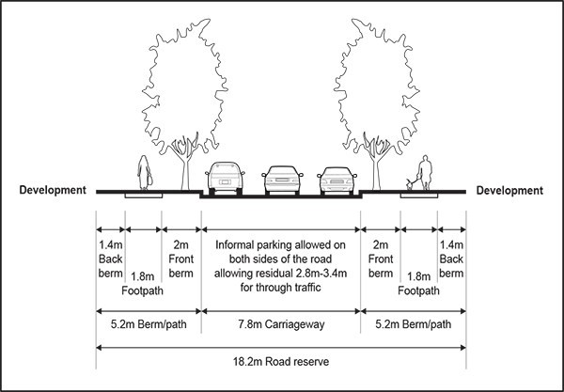

Figure 6. Flat Bush Local Road Park Edge
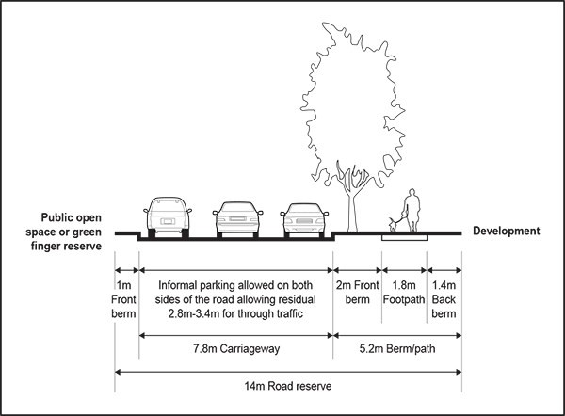

Figure 7.Flat Bush Special Local Road Park Edge
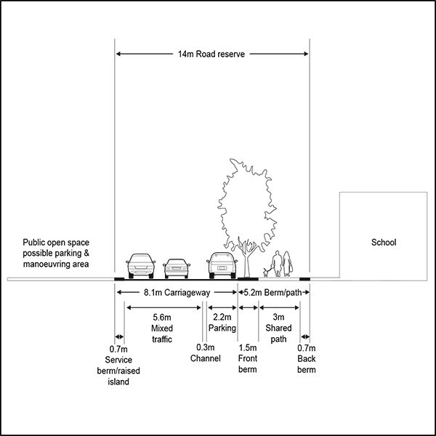

- Assessment ­ Controlled Activities

5.1 Matters of control
The Council will reserve its control to the matters below for the activities listed as controlled in the precinct activity tables:
  - Formed Bridle Trails and Mountain Bike Trails in Area 6 and 9
    - Location and Design

    - Personal Safety and Damage to and Effects on Neighbouring Properties

Assessment Criteria
    - Formed Bridle Trails and Mountain Bike Trails in Areas 6 and 9
      - Location and Design

i.

ii.
The bridle trail should provide for safe and convenient access and address effects on the safe and efficient operation of the adjoining road network.

The access should have a minimal adverse effect on pedestrian access and safety and/or the recreational or environmental functions of the areas.

      - Personal Safety and Damage to and Effects on Neighbouring Properties

i.

ii.
The activity should not result in a dangerous situation to other public open space users or otherwise detract from other users enjoyment of the public open space.

The activity should not cause damage to neighbouring residential properties.

Assessment ­ Restricted discretionary activities

Matters of Discretion
For activities/development listed as restricted discretionary activities in the Flat Bush precinct activity tables,
the council will restrict its discretion to the matters in the table below, in addition to the matters specified for the relevant underlying zones:

Table 10

Activity | Existing Native vegetation, riparian planting, ecosystem and Natural Landscape  Quality | Placement of buildings infrastructure and other structures | Design and external appearance | Servicing ­ Wastewater disposal and discharge of contaminants | Site stability
Restricted Discretionary Activity within  Area 8 | X | X | X | X | X
Restricted Discretionary Activity within  Area 9 | X | X |  |  | X
All other Restricted Discretionary activities in Sub  Precinct A and B | X | X | X | X | X

Assessment Criteria
For activities/development listed as restricted discretionary activities in the Flat Bush precinct activity tables, the following assessment criteria apply, in addition to the criteria specified for the relevant restricted discretionary activities in the relevant underlying zones:
- Existing Native vegetation, riparian planting, ecosystem and Natural Landscape Quality
  - The development should not alter the existing topography of the site or affect existing natural features or existing native vegetation.

  - The development should not negatively impact the ability in the future to protect land within Area 9 from development and undertake native riparian planting.

  - The development should propose a Riparian Planting Plan for Area 9 that should add ecological and amenity values as public open space.

  - The proposal should not impact in any way on the freshwater and terrestrial ecosystems including the quality of the water and riparian vegetation, areas of native forest and wetlands or on the natural habitats of birds, aquatic species and wildlife found within Areas 6 or 9.

  - The proposal should not impact on the natural landscape quality of Areas 6 or 9.

  - The proposed planting should be sufficiently robust to survive in the proposed location.

  - The pest and weed management programme for the area should protect the planting from damage and ensure plant survival.

  - A refundable bond may be required to ensure that the riparian planting undertaken in accordance with the approved riparian planting plan survives for a two­year period from the time of planting.

- Placement of buildings infrastructure and other structures
  - The design and external appearance of a building or structure in terms of scale, form, materials and colour should respect the natural character and aesthetic qualities of the sub­precinct.

  - The proposed building or structure should make a positive contribution to the built form of the surrounding streetscape and to any existing buildings on the public open space.

  - The placement of buildings and structures should avoid Area 9.

- Design and external appearance
  - The proposed building or structure should be sympathetic to the surrounding natural landscape qualities and characteristics.

  - The car parking and access for the proposed building or structure should be safe and convenient while still maintaining an acceptable aesthetic quality.

  - The proposed activity should not generate noise levels that adversely affect the amenity of adjoining properties and whether any mitigation measures are proposed to reduce noise effects on these properties.

  - The development must satisfactory provide for attenuation of aircraft noise.

  - The design and external appearance of buildings including the scale, articulation, orientation and spacing should complement the existing buildings in the vicinity.

  - The bulk or repetitive form of buildings should not detract from the visual amenities of the neighbourhood.

  - The car parking should be safe and convenient while still maintaining an acceptable aesthetic quality as viewed from the street in particular the hard paved areas associated with parking and garaging should not dominate the streetscape.

- Servicing ­ Wastewater disposal and discharge of contaminants
  - The site should have sufficient area available to accommodate an adequate wastewater disposal system which should not create an erosion, land instability or water pollution problem and that should not adversely affect the stormwater treatment and discharge systems on the site, or adversely affect public health and safety.

  - Adequate provision should be made on site for rubbish storage and servicing and the areas should be adequately screened from view from public places and neighbouring sites.

  - The proposal should not generate any dust, smoke, fumes or other discharges to air which would potentially detract amenity values of the area.

- Site stability
  - The building, structure or activity should not adversely affect the stability of the site or adjacent sites.

Assessment ­ Discretionary activities

Matters of discretion
While not limiting the exercise of its discretion, the council may consider the particular matters specified for the

discretionary activities listed below:
- Retail activity in the Flat Bush Sub­Precinct A
  - Two or more consented retail sales premises located adjacent or generally opposite to each other are a ‘retail cluster’ for the purposes of this criterion.

  - In assessing the appropriateness of allowing a retail cluster to be located in residential sub­ precincts, consideration will be given to:

i.

ii. iii.

iv.

v.
The number of retail premises in each retail cluster.

The scale of the individual premises should be no more than 150sqm.

Retail should not be a dominant activity in the immediate vicinity or just one element within an otherwise residential environment.

The role of town centre and neighbourhood centres should not be undermined.

A limitation on the total size of the retail cluster to 500sqm and a distance of 400m to the next nearest retail cluster should be maintained.

- Flat Bush Cluster Housing in Flat Bush Sub­Precinct B, Area 8 and 9
- Ownership
  - The subdivision application should provide for an appropriate structure for the future ownership and management of communal land and facilities including land within Area 9 and having regard to the native riparian planting requirement and on­going maintenance responsibilities.

Assessment ­ Land use control infringements

Matters of discretion
In addition to the general matters set out in clause 2.3 of the general provision and the specific matters set out for the infringement of controls relevant underlying zones, the council will restrict its discretion to the matters below for the relevant control infringement.
- Construction of more than one dwelling within Flat Bush sub­precincts A or B
  - Subdivision as part of an integrated land use consent.

- Contaminated land
  - In addition to the matters set out in clause 4.5 of the Auckland­wide Rules restricted discretionary assessment criteria, the council will restrict its discretion to the further matters listed below for
the relevant control infringement:

i.

ii. iii. iv.
v.

vi.
site assessment means of remediation;
management of remediation; validation;
management plan; and monitoring.

- Subdivision
  - Road Standards

  - Provision of Back Lanes

  - Legibility of Network, Safety, Block Pattern and Neighbourhood Identity

  - Movement Network: Maximum Block Length and Maximum Block Perimeter Distance

  - Variations in the maximum or minimum allowable average site sizes after adjustment of the

boundaries between adjoining sub­precincts and areas

  - Design and Layout of Subdivision, Staging, Design and External Appearance

  - Impact of Previous Subdivision within Area 8

  - Movement network

Table 11

 | Matters for Discretion
Activity | a | b | c | d | e | f | g | h
Land modification, Development and  Subdivision | X | X | X | X | X | X |  | X
Land modification, Development and Subdivision of land in Areas 7 and/  8 containing  Area 9 land |  |  |  |  |  | X |  | X
Land modification, Development and Subdivision  in Area 9 |  |  |  |  |  | X | X
Alternative Road network in  Sub­Precinct  A |  |  | X |  |  |  |  | X
Alternative Road network in  Sub­Precinct  B |  |  | X |  |  |  |  | X

Assessment Criteria
In addition to the general assessment criteria in clause 2.3 of the general provisions and the specific assessment criteria for the infringement of controls in the relevant underlying zones, the council will consider the relevant assessment criteria below for the infringement listed:
    - Construction of more than one dwelling within Flat Bush sub­precincts A and B (including integrated land use and subdivision):
      - Subdivision as part of an Integrated Land use

i.

ii.
The proposed subdivision should follow rational boundaries with regard to access, privacy, amenity etc.

Acceptable levels of private outdoor living should be achieved for each dwelling.

iii.
Restrictions should be included in the proposal such as, limitations on placements of windows, no build yard areas and maximum heights to ensure that privacy and avoiding domination of buildings is achieved.

    - Contaminated land
      - Site assessment
        - The site assessment should be undertaken to the satisfaction of council.

      - Means of remediation
        - The means of remediation including, the possibility of a requirement for the removal off­site of asbestos containing materials.

iii.

Management of remediation

- The duration, timing and methodology for remediation.

iv.
Validation

- The effectiveness of remediation including the provision of a remediation validation report

- Management plan
  - On­going management including the provision of a site management plan relating to any remaining asbestos containing materials on the site and related health and safety issues.

vi.

Monitoring

  - The options outlined in the management plan(s) for monitoring, including health and safety.

  - The options for institutional controls associated with remediation.

    - Subdivision
      - Road Standards

i.

ii.
Cycleways should provide continuous routes between subdivisions.

Subdivisional road and site layout and dimensions should optimise the orientation of the sites to the sun in terms of their likely future development.

      - Provision of Back Lanes that connect roads and/or provide alternative access to the rear of residential sites:

i.

ii.
Back lanes should be limited in length to ensure that long repetitive lanes are avoided.

Building line restrictions should be introduced in relation to rear lanes to ensure that adequate opportunities are provided for landscaping and to limit repetitive building forms.

      - Legibility of Network, Safety, Block Pattern and Neighbourhood Identity

i.

ii.

iii.

iv.
Whether changes to the park edge local roads have an adverse impacts on the design, amenity and usability of the adjacent public open space and result in substantially greater earthworks and retaining structure s adjacent to the open space than would otherwise be required.

The proposal should not impact in any way on the clarity, legibility and connectivity of the roading network with particular regard to any ‘domino effect’ which might result from considering properties in isolation without regard to the wider neighbourhood in each sub­ catchment as shown on Precinct Plan 4. Sub­catchments

The proposal should achieve straight roads that maximise legibility to reveal the topography and strengthen visual connection to the wider landscape.

The proposed layout should promote good connectivity by all modes of travel including short walking routes to potential bus routes and other community infrastructure such as schools,

neighbourhood centres and public open space.

v.

vi.

vii.

viii.

ix.

x.

xi.
The proposal should achieve a neighbourhood identity by maximising connections to landscape features and to other features such as schools, neighbourhood centres, public open space and community facilities.

The proposed layout should contribute to a clear and legible understanding of the neighbourhood within the wider context.

The proposed road layout should create flexibility for a range of potential activities and residential densities to occur in appropriate places now and in the future.

Vehicle access should to be restricted (including on arterial routes) to achieve spatial outcomes that reinforce a sense of place and achieve a high quality public realm.

The proposed block pattern should result in the opportunity to create regular shaped sections with the inherent flexibility to be developed for a range of potential activities and residential densities now and into the future.

The proposed street design and layout should provide for consistency of treatment down lengths of street and appropriate integration to adjoining areas.

The proposal should not impact in any way on the clarity and legibility of the roading network with particular regard to the sub­catchment within which the proposed subdivision is located, as shown in Precinct Plan 4. Sub­catchments.

iv.

Movement Network: Maximum Block Length and Maximum Block Perimeter Distance

- The proposed road layout should provide for convenient and safe access for pedestrian, cycle and vehicle users.

- The proposed road layout should provide for a clear and easily understood network that is easy to navigate through for all users.

- The proposed road layout should not be constrained by topography, trees or bush to be retained and/or fragmented land ownership and/or existing buildings.

- Variations in the maximum or minimum allowable average site sizes after adjustment of the boundaries between adjoining sub­precincts and Areas
  - This assessment is intended to apply where the area boundaries, as defined on the relevant planning maps, have been modified. In such instances the council will assess whether the proposed subdivision yields the same number of sites as it would have in the case of a subdivision which complied with the maximum or minimum subdivision clauses had the Area boundary(s) remained unaltered.

  - Whether the target densities of each of the adjoining precincts are being generally achieved.

  - The extent to which the average site size in each of the adjoining precincts differs from the requirements of Clause 4.1.

vi.

Design and Layout of Subdivision, Staging and Design

  - In the case of a staged subdivision, each stage of subdivision should comply with the development and performance standards (including density) of the sub­precinct. Council may, by way of either
a consent notice or a condition of consent, require that any such density shortfall or surplus be made good in, or be carried forward to, subsequent stages of the subdivision.

  - The subdivision design should provide an adequate buffer between the proposed sites and the conservation and stormwater management area.

  - The design and layout of the subdivision protects land in the conservation and stormwater

management area from inappropriate development.

  - The subdivision provides an appropriate structure for the future ownership and management of land within the conservation and stormwater management area having regard to the native riparian planting requirement and on­going maintenance responsibilities.

  - The proposal should achieve neighbourhood identity by maximising connections to landscape features and to other features such as schools, neighbourhood centres, public open space and community facilities.

vii.

Impact of previous subdivision within Area 8 where the site previously subdivided under sub­precincts A and B has reduced the average site size of the original subdivision below the average density of one per 5000sqm.

  - The proposed subdivision should not detract from the character of the area.

  - The proposed subdivision should have sufficient open space within the conservation and stormwater management area to offset the effects of further subdivision on the site.

  - The proposed subdivision should allow sufficient space for wastewater disposal outside of the conservation and stormwater management area.

  - The proposed subdivision should make use of existing infrastructure including private ways, roads, reticulated water, wastewater disposal and power.

viii.

Movement Network

  - There are significant factors or constraints, which mean that roads cannot be provided in accordance with council's road design standards. In relation to collector roads, only minor changes due to significant topographical, geotechnical or other environmental factors are anticipated.

  - The proposed road layout should respect and relate to the existing contour and avoid permanent features such as steep cut faces and retaining structures which are highly visible.

  - The layout should promote good vehicular and pedestrian connectivity within the area including to community infrastructure such as bus stops, schools, neighbourhood centres, public open space and community facilities.

  - The proposal should achieve an acceptable low impact stormwater management solution having regard to integrating good urban design and stormwater management solutions.

  - The road serves only a small number of dwellings or is for a short length.

  - An alternative design of the road addresses traffic and pedestrian volumes, safety and amenity and access for emergency vehicles.

  - On­street car parking is catered for.

  - A footpath is required or is desirable on both sides of the road.

  - Visual and physical differentiation is required and, if so, the modified section of road links appropriately with adjoining sections of road.

Special information requirements

  - A riparian planting plan shall be provided as part of any application for land modification, development and subdivision.

Precinct plans

Precinct Plan 1: Flat Bush Precinct
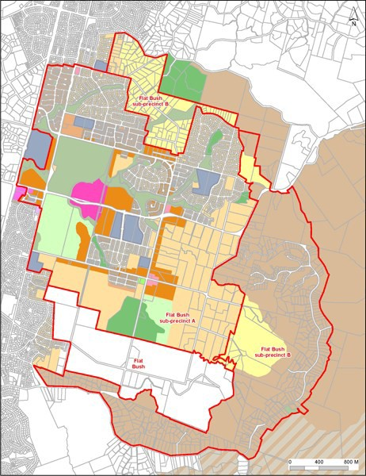

Precinct Plan 2: Flat Bush Sub­Precinct Areas
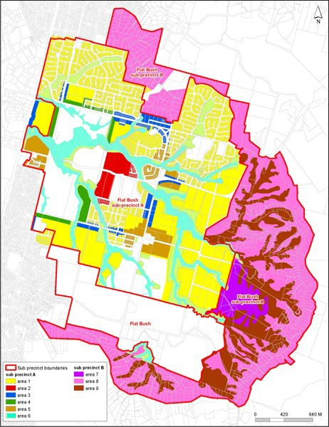

Precinct Plan 3. Road Network
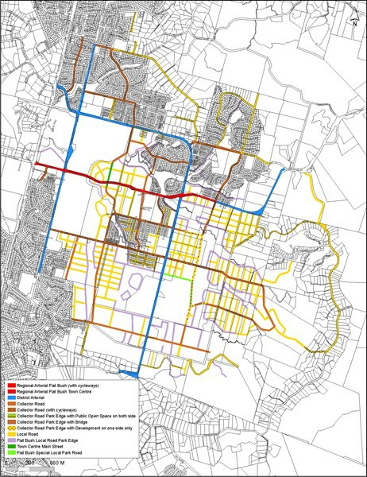

The Proposed Auckland Unitary Plan (notified 30 September 2013)

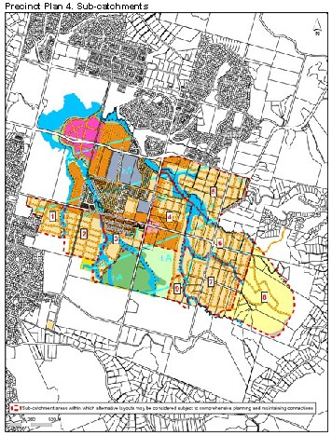

The Proposed Auckland Unitary Plan (notified 30 September 2013)

Precinct Plan 5. Key Road Connections
