PART 3 ­ REGIONAL AND DISTRICT RULES»Chapter K: Precinct rules»6 South»

6.5 Clevedon

- Activity table

The activities in Auckland­wide – subdivision apply in the precinct unless otherwise specified in the activity table below.

Clevedon Precinct subdivision – Activity Table
Activity | Activity Status
Subdivision in sub­precincts 1A, 1B and 2 and 3 that complies with an approved framework  plan | RD
Subdivision in sub­precincts 1A, 1B and 2 and 3 that does not comply with an approved  framework plan, or prior to the approval of a framework plan | NC
A framework plan, amendments to an approved framework plan or a replacement framework  plan in sub­precincts 1A, 1B and 2 and 3 complying with clause 5.1.7 below | RD
A framework plan, amendments to an approved framework plan or a replacement framework  plan in sub­precincts 1A, 1B and 2 and 3 not complying with clause 5.1.7 below | NC
Subdivision in Clevedon sub­precinct 4 | NC
Subdivision that does not comply with one or more of the subdivision controls set out in  clauses 5.1 and 5.2, except clauses 5.1.1 and 5.2.2 (site area) | RD
Subdivision that does not comply with clauses 5.1.1 and 5.2.2 | NC
Subdivision that does not comply with clause 5.1.6 wastewater servicing until 31 July 2017 | Pr
Subdivision that does not comply with clause 5.1.6 wastewater servicing after 31 July 2017 | NC

The activities in the Single House zone apply in sub­precincts 1A and 1B unless otherwise specified in the activity table below.

Clevedon sub­precinct 2 – Activity Table
Activity | Activity Status
 | Clevedon sub­  precinct 1A | Clevedon sub­  precinct 1B
Development
Bridle trails and walkways | RD | RD
Community
Veterinary clinics staffed by more than two persons | D | D
Laboratories staffed by more than two persons | D | D
Hospitals | D | D
Education facilities | NC | D
Rural
Farming (until a connection to a public waste water reticulation system is  made available) | P | P
Farming (when a connection to a public waste water reticulation system is  available) | RD | RD
Greenhouses with a gross floor area of less than 40m2 | P | P

Produce stall with a gross floor area less than 15m2 used only for the direct sale of farm produce grown on the site, or for the co­operative sale of farm  produce grown on nearby properties. | P | P
Earthworks
Any modifications to the Stormwater Management Areas to construct building platforms or buildings or private wastewater systems and associated  earthworks and fill | D | D

The activities in the Neighbourhood Centre zone apply in sub­precinct 2 unless otherwise specified in the activity table below.

Clevedon sub­precinct 2 – Activity Table
Activity | Activity Status
Development
Accessory buildings | P
Buildings | RD
Additions and alterations to any building | RD
Bridle trails and walkways | RD
Accommodation
One dwelling per site | RD
Workers accommodation | NC
Retirement villages up to 15 persons inclusive of owner, family and staff | RD
Retirement villages more than 15 persons | D
Commerce
Retail activities on sites fronting Papakura Clevedon Road less than 250m2 gross floor area  per site | P
Retail activities less than 250m2 gross floor area per site | D
Service stations | D
Offices | RD
Visitor accommodation | D
Community
Community facilities | RD
Hospitals | P
Laboratories | P
Information facilities | RD
Education facilities | RD
Entertainment facilities | P
Public amenities | P
Markets (other than temporary activities) | P
Rural
Farming (until a connection to a public waste water reticulation system is made available) | P

Farming (when a connection to a public waste water reticulation system is available) | NC
Garden centres | D
Greenhouses with a gross floor area more than 40m2 | RD
Rural commercial services | RD
Industry
Industrial activities on sites not fronting Papakura Clevedon Road | RD
Earthworks
Any modifications to the Stormwater Management Area to construct building platforms or  buildings or private wastewater systems and associated earthworks and fill | D

The activities in the Countryside Living zone apply in sub­precinct 3 unless otherwise specified in the activity table below.

Clevedon sub­precinct 3 – Activity Table
Activity | Activity Status
Rural
Equestrian centres | RD
Greenhouses with a gross floor area more than 40m2 | RD
Produce stall | P
Accommodation
Second dwelling per site | RD
More than two dwellings per site | NC
Visitor accommodation | RD
Retirement villages | D
Commerce
Show homes | NC
Community
Community facilities | NC
Recreational trails, walkways, cycleways, bridle trails and fitness trails | RD
Industry
Industrial activities on sites fronting Papakura Clevedon Road | D
Earthworks
Any modifications to the Stormwater Management Area to construct building platforms or  buildings or private wastewater systems and associated earthworks and fill | D

The activities in the Single House zone apply in sub­precinct 4 unless otherwise specified in the activity table below.

Clevedon sub­precinct 4 – Activity Table
Activity | Activity Status
A framework plan, amendments to an approved framework plan, or a replacement framework  plan complying with clause 3.3 below | RD
A framework plan, amendments to an approved framework plan or a replacement framework  plan not complying with clause 3.3 below | NC
Any land use, development or subdivision activity complying with an approved framework plan | RD
Any land use, development or subdivision activity not complying with an approved framework  plan, or prior to the approval of a framework plan, with the exception of farming (see below) | NC
Care centres | P
Education facilities | P
Community facilities and healthcare facilities (excluding hospitals and medical laboratories)  not exceeding 200m2 GFA within the entire sub­precinct | P
Community buildings not exceeding 150m2 GFA for the entire sub­precinct | P
Funeral directors' premises | P
Retail accessory to the church not exceeding 100m2 within the entire sub­precinct | P
Rural
Farming (until a connection to a public waste water reticulation system is made available) | P
Development
Buildings | RD
Earthworks
Any modifications to the Stormwater Management Area to construct building platforms or  buildings or private wastewater systems and associated earthworks and fill | D

Notification

  - The Council will consider restricted discretionary resource consent applications for framework plans (including amendments to an approved framework plan or a replacement framework plan) without the need for public notification. However, limited notification may be undertaken, including notice being given to any land owner within the sub­precinct who has not provided their written approval.

Land use controls

  - The land use controls in the underlying Single House, Neighbourhood Centre, Countryside living or and Civic and Community zones and the Auckland­wide rules apply in the precinct unless otherwise specified below.

Dwellings

    - The number of dwellings on a site must not exceed the limits specified below:

Table 1

Sub­precinct | 1 dwelling per
1A | 1 dwelling per 500m2 net  site area

1B | 1 dwelling per 800m2 minimum and 2000m2 maximum with an average of 1400 m2 net site area
2 | 1 dwelling per 4ha average  net site area

    - Development that does not comply with clause 1 above is a non­complying activity.

Accessory buildings

    - Accessory buildings must not exceed the GFA limits specified in the table below:

Table 2

Sub­precinct | Maximum gross floor  area
1A, 1B, 2 | 40m2
3 | 100m2

Framework Plan ­ Clevedon sub­precinct 4

    - A resource consent application for a framework plan, amendments to a framework plan, or a replacement framework plan must:
      - apply to the whole of sub­precinct 4 shown on Precinct Plan 1. Clevedon Precinct.

      - comply with:

i.

ii.
the general rules and information requirements applying to framework plans specified at
clauses 2.6 and 2.7 of the general provisions.

the special information requirements for framework plans specified in clause 9, special information requirements below.

      - seek consent for the following land uses:

i.

ii.

iii.
The location and indicative design of all buildings and activities proposed for the sub­precinct

The location and design of all roads, including Indicative roads, that lie within or are required to access the sub­precinct

Proposed pedestrian and cycle linkages, including service vehicles.

Development controls

  - The land use controls in the underlying Single House, Neighbourhood Centre, Countryside living or Civic and Community zones and the Auckland­wide rules apply in the precinct unless otherwise specified below.

Building height

    - Buildings in sub­precinct 2 and 3 must not exceed 8m in height except that:
      - Church spires in the Clevedon sub­precinct 4 must not exceed 12m in height

      - Accessory buildings in all sub­precincts must not exceed 4m in height.

      - Satellite dishes and antennae shall not be visible from the street frontage.

Yards

    - Yards must comply with the following: Table 3
Sub­precinct | 1A and 1B | 2 | 3
Front yard | 6m | 10m (see exceptions  below) | 6m
Side yard | One yard of 2m and one  yard of 3m | 6m (see exceptions  below) | One yard of 2m and one  yard of 3m
Rear yard | 8m (see exceptions  below) | 8m (see exceptions  below) | 8m

    - For corner sites in the Clevedon sub­precinct 1A and 1B the front yard setback may be reduced to 3m for one yard only.

    - For sites adjoining a Stormwater Management Area or public open space the yard facing the Stormwater Management Area or public open space must be a minimum of 6m.

    - Except:
      - Any yard fronting Monument Road, Papakura Clevedon Road, Clevedon Kawakawa Bay Road, Twilight Road and North Road except sites within sub­precinct 2 must be 20m.

      - In relation to dwellings on sites adjoining sub­precinct 2 where the site is in sub­precinct 1A and 1B, 3, or 4, the yard facing sub­precinct 2 must be at least 5m.

      - All household units on rear sites within sub­precinct 1B shall have a minimum building separation of 12m.

Building coverage and impermeable area

Table 4

Sub­precinct | 1A (On sites between 500m2 and  799m2) | 1A And 1B (On sites 800m2 or greater) | 3 | 4
Building coverage | 35% | 30% | 10% | 40%
Impervious area  threshold | 45% | 40% | Refer to zone | 50%

Figure 1: Yards and Building Height
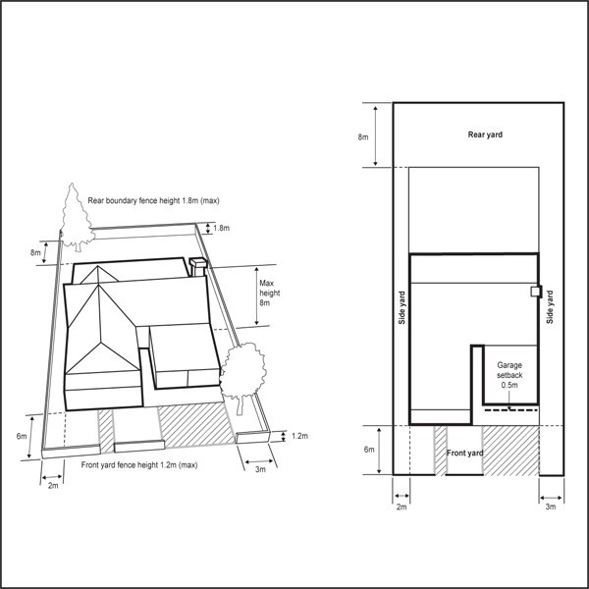

Figure 2: Built Form Orientation and Height Controls
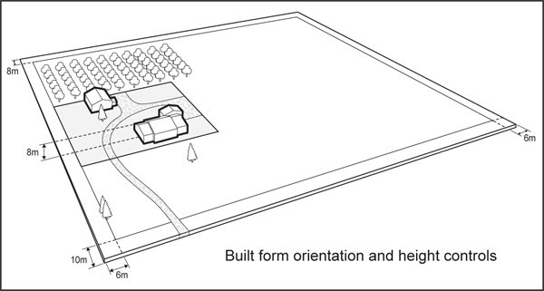

Figure 3: Site Coverage and Setbacks
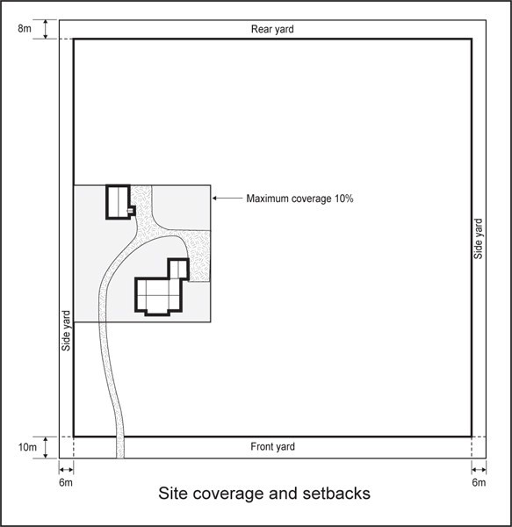

Verandahs

    - The control below applies to sites within sub­precinct 2 with frontage to Papakura Clevedon Road, North Road, and Clevedon Kawakawa Road.

    - A verandah must be provided along the full extent of the site frontage where a new building or alterations to existing buildings that substantially changes the appearance of the facade is proposed.

    - The verandah must:
      - have a minimum height of 3m and a maximum height of 4m above the footpath

      - be setback a minimum of 600mm from the kerb line

      - have a minimum depth of 2.5m

      - be related to its neighbours as to provide continuous pedestrian cover.

Wastewater – sub­precinct 1A, 1B, 3 and 4

    - All activities requiring wastewater servicing must be connected to a public reticulated sewerage system.

    - Any activity that does not comply with clause 4.5.1 above is a non­complying activity.

Fencing ­ sub­precincts 1A, 1B, 3 and 4

    - No fence, wall or screen located between the primary building, a public open space and stormwater management area shall exceed a height of 1.2m.

Roofs

    - Roofs must not be made of uncoated galvanised material.

Buildings fronting the street

    - A new building must adjoin the site frontage for 75% its length.

Building entrances

    - The main pedestrian entrance to a building must be on the site frontage.

Water Supply

    - All activities must comply with the following:
      - Provision must be made for minimum water storage per household of 50,000 litres where no home sprinklers are installed, or 30,000 litres where home sprinklers are installed;

      - Water conservation devices in all proposed buildings must, as a minimum, include:

i.

ii. iii.
Dual flush 11/5.5 litre toilets or 6/3 litre flush toilets with standard fixtures; Showerhead flow restrictors; and
Aerator taps

      - Provision must be made for sufficient water supply and access to water supplies for fire fighting consistent with NZ Fire Service Fire Fighting Water Supplies Code of Practice SNZ PAS 4509:2008;

      - Within sub­precinct 1A and 1B water storage tanks must be screened from the street frontage and Public Open Space zones.

      - Where a site is serviced by a reticulated potable water supply, clause 4.10.1 (a) and (d) shall not apply.

    - Any activity that does not comply with clause 4.10.1 above will be considered as a non­complying activity

Subdivision controls

5.1 General subdivision controls

  - The subdivision controls in the Auckland­wide rules – Subdivision apply unless otherwise specified below.

Minimum site size sub­precinct 1B

      - The minimum net site area is 800m2 and the maximum net site area is 2,000m2.

      - The minimum average net site area is 1,400m2.

      - Where an application for subdivision consent incorporates two or more adjoining existing sites, the total area of the land subject to the application may be treated as one sites for the sole purpose of subdivisional configuration and design. “Existing site” means all the land held in a separate Certificate
of Title on 19 October 2012.

Minimum site frontage

      - The minimum site frontage must be as follows: Table 5
Sub­precinct | Minimum site frontage
Sub­precinct 1A | 16m
Rear sites in sub­precinct 1A on sites existing on 19 October 2012 | 3m
Sub­precinct 1B | 20m
Sub­precinct 2 | 10m
Sub­precinct 3 | 25m

      - A reduction in the minimum area of sites zoned Neighbourhood Centre may be allowed where:
        - A service lane at least 5m wide is provided at the rear of the site, and/or

        - The road frontage of the site has been set back for parking purposes, provided that setbacks exceeding 6m in depth will not be eligible for any further pro­rata reductions in area.

      - There is no minimum net site area for sites in the Neighbourhood Centre zone when building precedes subdivision provided, that the location of the boundaries ensures compliance with the development controls of the zone.

Site layout

      - The layout of the sites within the street blocks in the Clevedon sub­precinct 1Aand 1B must be configured so that all future buildings can be designed to face and front the street.

Stormwater management areas

      - The controls below apply to the Stormwater Management Areas shown on the Precinct Plan 1.
Clevedon Precinct.

      - All Stormwater Management Areas within the precinct must assume the zoning of their adjoining sub­ precinct. Where the Stormwater Management Area has more than one adjoining sub­precinct, the midpoint of the stream or gully must be taken as the boundary between the sub­precincts.

      - The Stormwater Management Areas may be developed in accordance with the underlying zoning provided that hydrological and other evidence submitted with the resource consent application demonstrates that the subject land is no longer required for the purposes of stormwater management.

All building platforms within the subdivision must be wholly outside the Stormwater Management Area.

      - All riparian yards within the Stormwater Management Area must be planted in accordance with a re­ vegetation plan/programme approved through a resource consent application. The plan/programme must contain a:
        - Pre­planting site assessment

        - Planting plan assessment

        - Annual monitoring programme.

      - All planting identified in the approved re­vegetation plan/programme must be secured by way of consent notice on the certificate of title, which must include the requirement for a programme of weed and pest control.

      - The subdivision developer must be responsible for the implementation of the revegetation plan/programme for a period of 2 years from the time of planting.

Street trees

      - For residential subdivision, street trees shall be planted at a minimum average rate of 1 tree per 20m of road frontage to ensure 1 tree per 20m along both sides of the road.

      - All species selected for street planting shall be approved by the Council.

Wastewater servicing

      - All sites, excluding sites created in the Clevedon sub­precinct 3, capable of accommodating future buildings shall be connected to a public reticulated sewerage system which is designed and configured to service the upstream catchment in its ultimate land use.

      - Where lots are created in the Clevedon sub­precinct 3, any on­site wastewater servicing shall be situated outside of the 1% AEP floodplain, shown as Stormwater Management Area in Precinct Plan 1. Clevedon Precinct. Sub­precinct 3 land identified for effluent disposal shall include provision for a nominated wastewater disposal method appropriate to the site characteristics.

Framework plan – sub­precincts 1A, 1B , 2 and 3

      - A resource consent application for a framework plan, amendments to an approved framework plan or a replacement framework plan must:
        - apply only to the land within the sub­precinct(s) that the applicant is the owner of, or to sites in multiple ownership where the landowners make a joint application.

        - comply with:

i.

ii.
the general rules and information requirements applying to framework plans specified at
clauses 2.6 and 2.7 in the general provisions

the special information requirements for framework plans specified in clause 9, special information requirements below.

        - seek consent for the following:

i.

ii.

iii.
the layout of roads and services showing connections with existing networks and capability for future connections

a variety of site sizes and location of building platforms outside of Stormwater Management Area as shown on Precinct Plan 1. Clevedon Precinct.

the layout and alignment of bridle trails and walkways.

Access

      - Where accessways are provided they must generally be a minimum of 8.0m.

Building platform

      - Any new site created and any vacant net site area must contain a building platform in the form of a rectangle with a minimum area of 150m2 and a minimum dimension of 10 metres and which is located clear of yards and any other areas on which building is prohibited.

Cluster housing subdivision controls sub­precinct 3

    - All sites proposed for a dwelling must be clustered together in one or more groups that share a common access way, see figure 4 below.

    - “Existing site” means all the land held in a separate Certificate of Title on 19 October 2012.

Figure 4: Clevedon precinct sub­precinct 3
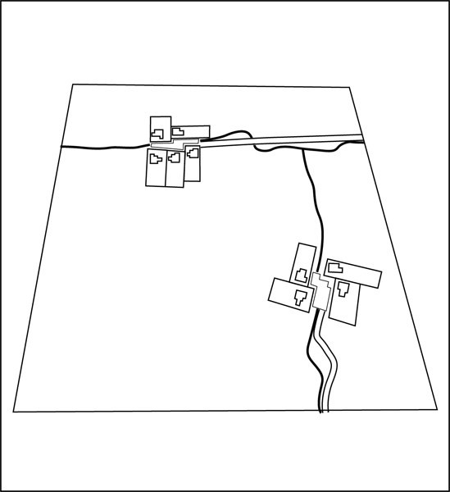

    - Maximum Density

Table 6

Location Maximum density

Land outside “Areas of Increased Subdivision Opportunity” shown on Precinct Plan 3. Increased  subdivision potential) | 1 dwelling per 4ha
Land shown as “Areas of Increased Subdivision Opportunity” shown on Precinct Plan 3. Increased  subdivision potential) | 1 dwelling per 2ha

      - Where there is an existing site, the calculation of average site density must be based on the gross site area subject to the subdivision.

Net site area

      - The net site area must:
        - be at least 2,500m2 and a maximum of 6000m2 exclusive of any area used for access.

        - contain a building platform

        - contain sufficient land for effluent disposal.

Maximum number of houses in a cluster

      - Housing clusters must have no more than 5 dwellings.

Buffers within a housing cluster

      - A minimum of 50m separation must be provided between building frontages within clusters to allow sufficient space for the creation of a central communal area.

Buffers between housing clusters

      - Housing clusters must be separated by a planting buffer from the adjoining clusters.

      - Within the area of increased subdivision opportunity shown on Precinct Plan 3. Increased Subdivision Potential a minimum of 150m separation must be provided between any two closest buildings between housing clusters.

Additional stormwater controls

      - Within the area of increased subdivision opportunity shown on Precinct Plan 3. Increased Subdivision Potential:
        - There must be no modification to the 100 year flood plain to accommodate building platforms and wastewater collection and disposal fields.

        - All building platforms and wastewater collection and disposal fields must be located outside of 100 year flood plain.

Further subdivision controls for sub­precinct 3

      - Subdivision can be made in stages by making reference back to the existing site.

      - In respect of any site within a subdivision that would be capable of further subdivision under these controls, further subdivision must not be undertaken of that site that would result in the total permitted density being exceeded with respect to the existing site. This requirement must be secured by a suitable legal instrument which must be registered on certificates of title to ensure ongoing compliance with this control.

      - Where an application for subdivision consent is for an existing site that contains land both inside and outside of the Clevedon Precinct , the area of land contained within the Clevedon Precinct area must be considered the “existing site” or “parent site”. The land outside of the Clevedon Precinct area must not be used in the calculation of the average site size for subdivision.

      - Applicants may wish to refer to the Auckland Council Technical Publication No. 58 (TP 58) in complying with the requirements of this control.

      - Where an application for subdivision consent incorporates two or more adjoining existing sites, the total area of the land subject to the application may be treated as one site for the sole purpose of subdivisional configuration and design.

      - Subdivision that does not comply with clauses 5.2.7.1­4 above is a non­complying activity.

Roading Network

The following rules apply to the Roading Network shown in Precinct Plan 2: Road Network:
    - Roads shall be provided in accordance with the indicative alignments and road types in Precinct Plan 1: Clevedon Precinct and Precinct Plan 2: Road Network and the Unitary Planning Maps except that
the alignment of indicative proposed roads depicted on the network plan shall be determined at the time of subdivision and addressed within a Comprehensive Subdivision Plan.

    - Roads provided to the east of the Business zoned land shall incorporate public parking as shown on the Proposed Local Road ­ East of Clevedon Business zone local road cross section below.

    - Roads shall be designed and constructed in accordance with council's latest engineering standards and codes of practice unless otherwise provided for in the assessment criteria and the Clevedon Design Guide document found in 2.1 of Part 6 ­ Non Statutory Documents.

    - Road levels shall enable integration with existing or potential roading layouts on adjoining sites.

    - All intersecting carriageways shall meet at 90 degrees.

    - The corner radius on road intersections shall be 7m, except where a Local Road or a Proposed Local Road ­ East of Clevedon Business zone intersects with a District Arterial Road, where the corner radius shall be 10m or where Council requires that a larger radius is required to address particular safety or traffic flow considerations.

    - All new roads shown in the Precinct Plan 1. Clevedon Precinct and Precinct Plan 2. Road Network shall be built in accordance with the cross sections below or standard cross sections (for cul­de­sacs) provided for within this Plan, except that the Council may approve changes to the cross­sections:
      - arising from the nature of topography or other significant constraints; or

      - where required to give effect to structure plan objectives including integration with an adjoining land use activity located on adjoining business, rural or reserve land.

Figure 5: Proposed Local Road
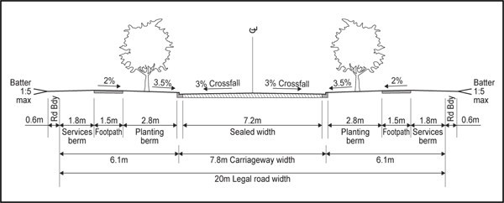
Note: Engineering elements relating to cross falls and design are guidelines to be confirmed through the

consenting process.

Figure 6: Proposed Typical Rural Interface Local Road
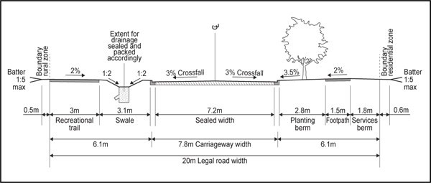
Note: Engineering elements relating to cross falls and design are guidelines to be confirmed through the consenting process.

Figure 7: Proposed Road­ East of Clevedon sub­precinct 2
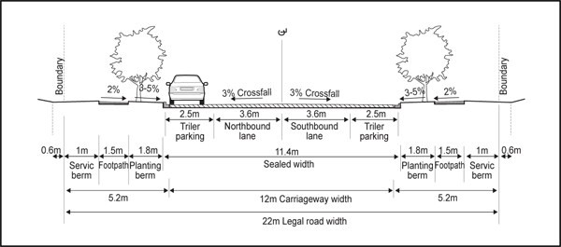
Note: Engineering elements relating to cross falls and design are guidelines to be confirmed through the consenting process.

Figure 8: Proposed Road­ West of Clevedon sub­precinct 2

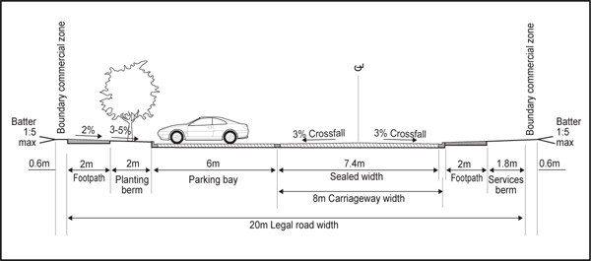
Note: Engineering elements relating to cross falls and design are guidelines to be confirmed through the consenting process.

Assessment ­ Restricted discretionary activities

6.1 Matters of discretion
For activities/development that is a restricted discretionary activity in the precinct, the council will restrict its discretion to the following matters, in addition to the matters specified for the relevant restricted discretionary activites in the Single House, Neighbourhood Centre, Countryside Living or Civic and Community zones.

Table 7

Activities / matters of discretion | Framework plan | Character | Design, location, layout amenity  & scale | Intensity  /hours of operation | Car parking, access, circulation & manoeuvring | Traffic generation | Signs and lighting | Servicing
Framework plan | X |  | X | X | X | X | X | X
Buildings (excluding accessory buildings and alterations and additions in sub­  precinct 2 |  | X | X |  | X |  | X
Accessory  buildings |  |  | X
Buildings and activities listed at restricted discretionary not  listed above |  |  | X |  | X |  | X | X
Equestrian centre  sub­precinct 3 |  |  | X | X | X | X | X | X

Farming when a connection to the public waste water system is made available sub­precinct 1A  and 1B |  |  |  |  |  |  |  | X
Greenhouses in sub­precinct 1A  and 1B |  |  | X
Offices sub­  precinct 2 |  |  | X |  | X | X
One dwelling per site in sub­  precinct 2 |  |  | X
Community facilities, education facilities sub­  precinct 2 |  |  | X | X | X | X |  | X
Industrial activities in sub­  precinct 2 |  |  | X | X | X | X | X | X
Second dwelling per site sub­  precinct 3 |  |  | X |  |  |  |  | X
Rural commercial services sub­  precinct 2 |  |  | X | X | X | X | X | X
Visitor accommodation  sub­precinct 3 |  |  | X | X | X | X | X | X

  - For framework plans (including amendments to approved framework plans and replacement framework plans), the general matters of discretion for framework plans specified in clause 2.6 general provisions also apply.

Assessment Criteria
For development that is a restricted discretionary activity in the precinct, the following assessment criteria apply in addition to the criteria specified for the relevant restricted discretionary activities in the Single House, Neighbourhood Centre, Countryside living or Civic and Community zones:
    - Framework Plan, amendments to an approved framework plan or a replacement framework plan within Clevedon sub­precinct 4
      - The proposed buildings should maintain and enhance the character of Clevedon precinct and should be consistent with the Clevedon Precinct Design Guide found in clause 2.1 of Part 6 ­ Non­ statutory documents.

      - The areas used for storage and loading/unloading of goods should be adequately screened from public streets, public open space and any Stormwater Management Areas.

      - The design should make provision for street tree planting that will enhance the amenity of the sub­ precinct.

      - The design and layout of buildings should take into account the visual prominence of this site, thereby providing an appropriate transition between rural and village interface and creating a landmark or a gateway to Clevedon.

      - the general assessment criteria for framework plans specified in clause 2.6 general provisions shall also apply.

      - refer to assessment criteria at 6.1.2.3 below

      - the location and design of roads shall be consistent with Precinct Plan 1. Clevedon Precinc and Precinct Plan 2. Road Network and the found in clause 2.1 of Part 6 ­ Non­statutory documents.

      - Show the proposed street and site layout pattern and possible development of sites, including (contour, shape and orientation) should reinforce or enhance the street pattern.

    - Character
      - The proposed building should maintain and enhance the character of the Clevedon precinct, in accordance with the Clevedon Precinct Design Guide found in clause 2.1 of Part 6 ­ Non­statutory documents.

    - Design, location, layout amenity and scale
      - The scale and physical development of the site should be generally consistent with the scale of development expected by the development controls and objectives and policies applying within the precinct.

      - Having regard to the Clevedon Precinct Design Guide found in clause 2.1 of Part 6 ­ Non­statutory documents:

i.

ii.
The design of buildings including their bulk and scale should not generate adverse effects on the amenity of the Clevedon precinct.

Buildings and structures, including any outdoor areas associated with the activity should be sited and designed in a manner that avoids adverse effects on amenity including visual dominance, privacy, shading of adjoining properties and blend in with the existing rural character. Design measures may include, landscaping, setbacks and fencing or walls.

      - There should be a variety in building design including articulation and utilisation of a range of building materials, and the buildings should avoid unrelieved blank walls or facades to all external boundaries of the site.

      - The siting of buildings in sub­precinct 1A, 1B, 3 and 4 should provide sufficient setbacks so that landscaping can be established between the buildings and the external site boundaries.

      - Car parking should be located and configured so that it does not dominate the site when viewed from the road, and is not situated within yard setbacks specified in development controls.

      - In sub­precinct 2 the design should make provision for street tree planting that will enhance the amenity of the business area.

      - The building should maximise active retail frontage or display windows and should avoid unrelieved or blank walls fronting the street within sub­precinct 2.

      - The building should provide a verandah or similar structure (where possible) to provide weather protection for pedestrians in sub­precinct 2.

      - The frontage and entranceway of the site should be low­key and in keeping with the rural environment. This means avoiding the use of urbanising elements such as boundary walls, lighting, signage, entrance features and landscaping to attract attention to the activity.

      - Proposed for waste storage and refuse, loading and delivery areas in sub­precinct 2 and 4 should

be positioned on the site and designed so that they are not visible from a public road or surrounding properties, public open space and stormwater management areas.

      - The activity should be compatible with the surrounding rural environment and the activity should not conflict with adjoining rural land uses.

      - Any noise mitigation measures should protect the acoustic environment of adjoining properties.

      - The accessory building should not detract from streetscape values, cause dominance or intrusion on adjoining properties and should be in keeping with the style of buildings on­site.

      - Landscaping should be incorporated to:

i.

ii.

iii. iv.
v.

vi.
Create a well vegetated environment and be compatible with the surrounding neighbourhood, and the specific planting character of the adjoining streetscape and contribute positively to the streetscape and any adjoining open space.

Visually relieve the bulk of the proposed buildings and mitigate large areas of impermeable surfaces including carparking areas.

Help provide summer shade, windbreaks and access to winter sun. Provide visual privacy between the building and the adjoining properties.
Screen other structures and infrastructure, including any above ground water storage tanks are well integrated into the landscape concept for the site.

Retain and incorporate existing mature trees on the land including significant vegetation, especially those near property boundaries.

    - Intensity of use / hours of operation
      - The numbers of people using the site should be satisfactorily accommodated on the site and any adverse effects on the Clevedon sub­precinct 1A and 3 are avoided, remedied or mitigated.

      - The parking required to support the number of people using the site should be contained on site and adverse effects resulting from parking on the street should be avoided.

      - The hours of operation should take into account the effects of noise on surrounding properties from those using or congregating on the site and mitigate adverse effects.

      - The traffic generation (during the day and at night) resulting from the intensity of use of the site should not adversely impact upon residential amenity values.

      - If persons are to reside on the site a defined outdoor space should be provided to create on site amenity for residents.

      - The hours of operation proposed and the range of proposed activities on a site are such that adverse effects on adjoining residential properties should not be generated through noise, traffic movements, headlight and glare at night and associated activities such as rubbish collection.

    - Car parking, access, circulation & manoeuvring
      - The position of vehicle entries and exits to or from the site should not result in adverse effects upon the safety and efficiency of the road network and footpaths.

      - The development should provide a legible, safe and efficient internal circulation pattern

      - Carparking, loading and unloading areas should be sited and designed to avoid or mitigate any adverse effects on the privacy of adjoining properties.

      - The vehicle entrance and exit points onto roads that front residential areas should be limited to mitigate the effects of traffic entering and leaving the site and will not adversely impact upon pedestrian safety and the safe operation of the roading network traffic generation.

    - Traffic generation
      - The traffic generation (during the day and at night) resulting from the intensity of use of the site should avoid or mitigate adverse effects on the safe and efficient operation of the roading network
(e.g. carrying capacity and traffic safety).

    - Lighting and signs
      - The position, extent and operation of outdoor lighting associated with the activity in sub­precinct 2 and 4 should not create adverse environmental effects on adjoining sites.

      - The scale, extent and number of signs on the site in sub­precinct 2 and 4 should not detract from the amenity of the precinct and should be sensitive to the character of the area.

      - Signs should be designed as an integrated architectural element of the building and should not detract from the amenity of the precinct.

    - Servicing
      - The onsite stormwater management should avoid any adverse impact on the flood plain/overland flow path located within the site.

      - The proposed site and buildings in sub­precinct 1A, 1B, 2 and 4 can be connected to a public reticulated sewerage system.

Assessment ­ Restricted discretionary activities – subdivision

7.1 Matters of discretion
For subdivision that is a restricted discretionary activity in the precinct, the council will restrict its discretion to the following matters, in addition to the matters specified for the relevant restricted discretionary activities in the underlying zones and Auckland­wide rules:
  - A framework plan, amendments to an approved framework plan or a replacement framework plan
    - The general matters of discretion for framework plans specified in clause 2.6 of the general provisions shall apply.

  - Subdivision in compliance with a framework plan
    - Compliance with subdivision controls

    - Site suitability and stability

    - Servicing

    - Transport

    - Site frontage.

  - Land use or development in compliance with a framework plan
    - The council will restrict its discretion to the matters specified in the underlying zones and Auckland­wide rules for an application for any land use or development complying with an approved framework plan.

Assessment Criteria
For development that is a restricted discretionary activity in the precinct, the following assessment criteria apply in addition to the criteria specified for the relevant restricted discretionary activities in the underlying zones and Auckland­wide rules:
    - Framework plan, amendments to an approved framework plan or a replacement framework plan
      - The framework plan should:

i.

ii.
Address all relevant matters contained within the objectives and policies relating to the Clevedon Precinct.

Be consistent with Precinct Plan 1. Clevedon Precinct and Precinct Plan 2. Road Network

and the Clevedon Design Guidelines found in clause 2.1 of Part 6 ­ Non­statutory documents.

iii.

iv.

v.

vi.

vii.

viii.

ix.

Be a coherent design and integrate with the surrounding environment and context of surrounding land, natural features and development.

Show the proposed street and site layout pattern and possible development of sites, including (contour, shape and orientation) should reinforce or enhance the street pattern.

Ensure a coherent spatial structure is formed by the relationship of buildings to the street and one building to another.

Ensure retention of existing trees and shelterbelts where they may contribute to maintenance of rural amenity.

Further enhance the character of the rural sub­precinct and responds sensitively to cultural, natural and landscape values of Clevedon.

Protect view corridors shown on the Precinct Plan 1. Clevedon Precinct and Precinct Plan
    - Road Network and create strong visual connections to the new open areas or spaces that are existing or have been proposed, including bridle trails and pedestrian linkages.

Address the matters detailed at clause 9 below, special information requirements.

    - The general assessment criteria for framework plans specified in clause 2.6, general provisions shall also apply.

- Subdivision in compliance with a framework plan
  - Compliance with subdivision controls
    - Subdivision control infringements should be assessed together with any adverse effect arising from that non­compliance.

  - Site stability and suitability
    - Building platforms specified on the application plan should be located away from the 100 year flood plain and capable of supporting a dwelling.

  - Servicing

i.

ii.

iii.
New sites within Clevedon sub­precinct C should have sufficient area available to accommodate an adequate sewage and wastewater.

New sites within sub­precinct 1A, 1B and sub­precinct 2 and 4 should be capable of connecting to a public reticulated sewerage system.

The proposed stormwater management techniques should be appropriate to avoid or mitigate the adverse effects of stormwater runoff on neighbouring properties, waterways and on land stability.

  - Transport

i.

ii.

iii.
Any internal private way, right of way or public road should be located at a grade, width, alignment and with a finished surface that avoids or mitigates adverse effects on the rural or village character of the site.

The streetscape and appearance of the road should contribute towards those structure plan policies and objectives relating to maintenance of rural and village character, while still meeting functional requirements.

Modifications to cross sections in respect of the treatment of berms and parking that are required to ensure better integration with existing or planned land use activities located on adjoining business, reserve or rural land.

iv.

v.

vi.
Walkways and bridle trails shown on the plan of subdivision should be in general accordance with the Precinct Plan 1. Clevedon Precinct, are at a practical grade and alignment and link to any other trails shown or formed on adjacent properties.

Where the trail is to be provided in conjunction with a road, the Council may require widened berms and other amenity features along the trail route.

Where trails are proposed and are required as a condition of approval for a resource consent (including subdivision) the following design standards should apply:

- For bridle trails independent of road the minimum width between boundaries should be 5m and an appropriate surface formation width of 3m and water tables and culverts should be provided as required for stormwater control.

- For bridle trails along road berms the minimum legal width should be 3m and the minimum 2m appropriate surface formation should be provided.

- The bridle trails should be located and constructed at a practicable alignment and grade.

- All bridle trails should be marked by way of bollards, fencing or any other suitable method considered appropriate for local conditions.

vii.

viii.

ix.

x.

xi.

xii. xiii.

xiv.

Where the walkway is provided by means of a pedestrian accessway independent of the road, the legal width of the access way at any point should be at least 6m unless in the opinion of the council a reduced width provides the required level of access and must be constructed in accordance with NZS HB8630:2004 – Design of Walking Tracks.

Where walkways are to be held in private ownership, construction, maintenance, management of stock and public access to the trails should be made available through a detailed Trail Management Plan.

Roads should be provided in general accordance with the indicative alignments and road types in Precinct Plan 1. Clevedon Precinct and Precinct Plan 2. Road Network, and the Unitary Plan maps except that the alignment of indicative proposed roads depicted on the network plan shall be determined at the time of subdivision and addressed within a framework plan.

Roads should be provided to the east of the Clevedon sub­precinct 2 and should incorporate public parking as shown on the Proposed Road ­ East of Clevedon sub­precinct 2 local road cross section as specified.

Road levels should enable integration with existing or potential roading layouts on adjoining sites.

All intersecting carriageways should meet at 90 degrees.

The corner radius on road intersections should be 7m, except where a road or a proposed road east of Clevedon sub­precinct 2 intersects with a district arterial road, where the corner radius must be 10m or where the council requires that a larger radius is required to address particular safety or traffic flow considerations.

All new roads shown on Precinct Plan 1. Clevedon Precinct should be built in accordance with the cross sections below or standard cross sections (for cul­de­sacs) provided for within the Code of Practice, except that the council may approve changes to the cross­sections:

- arising from the nature of topography or other significant constraints, or

- where required to give effect to structure plan objectives including integration with an adjoining land use activity located on adjoining business, rural or reserve land.

  - Minimum site frontage
    - The area, dimensions and shape of each proposed site should be such that:
      - the site is adequate to contain the activity and any accessory buildings and structures.

      - the frontage and access to the site is adequate for legal and practicable access for the proposed activity.

      - the reduction in the minimum site frontage relates to existing fence lines, topography or other landscape features.

- Land use or development in compliance with a framework plan
  - When considering a restricted discretionary application for any land use or development complying with an approved framework plan, the relevant assessment criteria in the underlying zones and the Auckland­wide rules apply.

Assessment ­ Development control infringements

Matters of discretion
In addition to the general matters set out in clause 2.3 of the general provisions, the council will restrict its discretion to the matters below for the relevant development control infringement.

Table 8

Infringement / matters of  discretion | Design, location, layout  amenity & scale | Servicing | Heritage
Building height | X |  | X
Yards | X
Building coverage and  impermeable areas | X | X
Fences | X
GFA | X
Verandahs | X
Buildings fronting the  street | X

Assessment Criteria
In addition to the general assessment criteria in clause 2.3 of the general provisions, the council will consider the relevant assessment criteria below for the development control infringement.
- Design, location, layout amenity & scale
  - The additional height of building, building coverage and building separation distance, and other structures should be compatible with the height and visual character of the streetscape, surrounding area and the character of the Clevedon precinct.

  - Having regard to the Clevedon Precinct Design Guidelines found in clause 2.1 of Part 6 ­ Non­ statutory documents, whether the or building frontage or increased height will contribute to good architectural design consistent with the intended function of the building.

  - Whether the infringement is minor and whether it is offset by other factors that mitigate any adverse effects, e.g. additional planting, design elements.

  - A reduction in yards in sub­precinct 1A, 1B, 3 and 4 should not:

i.

ii.
cause adverse effects on on­site amenity and the privacy of adjoining neighbours and the function and safety of vehicle access.

detract from the character of the streetscape or qualities of the precinct.

iii. iv.

v.
iii affect the function and safety of vehicle access.

The design of the verandah should be of a sufficient width, should provide continuous shelter for pedestrians and should add to the overall composition of the façade of the building and ensure that an integrated streetscape is achieved.

Fences that do not comply with the fences control will need to demonstrate that the design and external appearance resulting from the boundary treatment makes a positive contribution when viewed from any adjoining Public Open Space zone or Stormwater Management Area.

- Servicing
  - The increase in impermeable surfaces should not increase stormwater flows from the site that will adversely affect adjoining properties or the downstream catchment.

  - Alternative methods are proposed to control stormwater flows.

- Heritage
  - The proposed height of buildings and other structures should be compatible with any special character (including view corridors) and any relevant heritage values of the area.

Special information requirements

Applications for a framework plan, amendments to an approved framework plan, or a replacement framework plan must be accompanied by the following information:
- For Clevedon sub­precinct 4:
  - The location and indicative design of all buildings and activities proposed for the sub­precinct

  - The location and design of all roads, including Indicative roads, that lie within or are required to access the sub­precinct

  - An Integrated Transport Assessment

  - Proposed pedestrian and cycle linkages, including service vehicles

  - Design details (including representative site layouts and sketches) for building platform location and design, the design of building height, materials and finish, and associated site access, carparking and landscape treatment

  - Design details (including representative site layouts and sketches) for sign location, size, design and height

  - A streetscape and landscape treatment plan, in sufficient detail to enable establishment of a coherent design throughout the sub­precinct. Such landscaping plan must show and explain:

i.

ii.
those trees and groups of trees that are proposed to be retained

the form (including density, species, depth and height) of planting that is proposed to be undertaken within the sub­precinct

  - Detail on how development will avoid or mitigate adverse effects arising from the flood plain
/overland flow path identified within the sub­precinct, as part of an integrated Stormwater Management Plan

  - The likely staging of the development

  - Connection to a public reticulated sewerage system for all buildings which has been designed and configured to service the upstream catchment in its ultimate land use.

- For Clevedon sub­precincts 1A, 1B, 2 and 3:
  - the exact boundaries of the sub­precinct which must be in general accordance with those shown in Precinct Plan 1. Clevedon Precinct)

  - A connected roading pattern, the location and design of all roads, that lie within or are required to access the sub­precinct and confirmation of the final alignment of any indicative proposed roads depicted within Precinct Plan 2. Road Network.

  - The layout of roading and services showing connections with existing networks and capability for future connections.

  - A variety of site sizes and location of building platforms outside of Stormwater Management Area as shown on Precinct Plan 1. Clevedon Precinct.

  - The position and size of reserves including esplanade reserves and stormwater and drainage reserves.

  - Alignment of roading and reserves with view corridors as shown on the Precinct Plan 1. Clevedon Precinct.

  - The layout and alignment of bridle trails and walkways.

  - The identification and protection of historic heritage, whether or not identified as a historic heritage overlay on the Unitary Plan maps.

  - A streetscape and landscape treatment plan, in sufficient detail to enable establishment of a coherent design throughout the sub­precinct. Such landscaping plan must show and explain:

i.

ii.
those trees and groups of trees that are proposed to be retained.

the form (including density, species, depth and height) of planting that is proposed to be undertaken within the sub­precinct.

  - Detail on how development will avoid or mitigate adverse effects arising from the flood plain
/overland flow path identified within the sub­precinct, as part of an integrated Stormwater Management Plan.

  - The likely staging of the development.

  - Evidence of liaison with any adjoining landowners or affected owners and the council in respect of proposed roads, service and trail way connections between properties to ensure integration within the Precinct Plan area.

  - A Management Plan for the entire site. The Management Plan shall set out the details of the future ownership of the sites, design, maintenance and use of the:

i.

ii. iii. iv.
Buffer areas;

Central communal open space; Residential access road(s); and
Any sections of bridle trails and walkways proposed. Where trails are proposed to be held under private ownership, this shall be supported by a Trail Management Plan and shall provide detail on:

    - management of public access to the trails including information on hours of access, circumstances and reasons where public access to the trails has been restricted;

    - connectivity between sections of the trails with adjoining properties;

    - Promote consistent treatment for signage, surface formation, information, etc across all sections of the trails.

v. An appropriate legal mechanism for securing the above.

Precinct plans

Precinct Plan 1: Clevedon Precinct
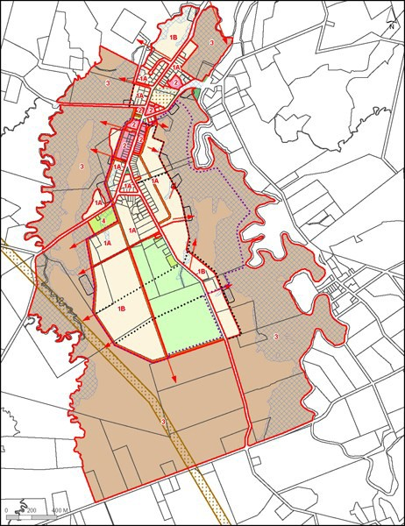

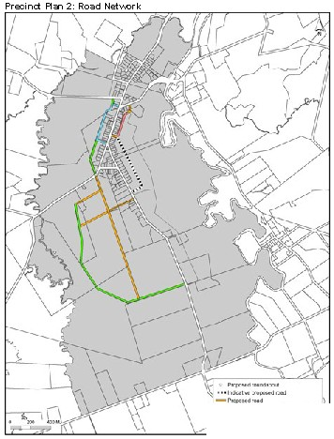

-P «4'H4• +><1tlubf<"'IIO<l)
-J>o-v....,,....,•...,...VO..ft(t'H -,_
owl oot••t....oud

Precinct Plan 3: Increased subdivision potential
