PART 3 ­ REGIONAL AND DISTRICT RULES»Chapter K: Precinct rules»6 South»

6.24 Runciman

The activities, controls and assessment criteria in the underlying Countryside Living zone and Auckland­wide rules apply in the following precinct and sub­precincts unless otherwise specified. Refer to planning maps for the location and extent of the precinct and sub­precincts.

Refer to clause 7 below for definitions that are specific to this precinct.

Activity table

The activities in the Countryside Living zone apply in the Runciman precinct unless otherwise specified in the activity table below.

Subdivision | Sub­ precinct A | Sub­ precinct B
Subdivision which complies with clauses 3.1, 3.2, 3.3 and 3.5 below | RD | RD
Subdivision which complies with clauses 3.1, 3.2, 3.4 and 3.5 below | NA | RD

Notification

  - The council will consider applications for restricted discretionary activities without public or limited notification except where special circumstances exist. Council will publicly notify resource consent applications for non­complying activities. Resource consent applications for discretionary activities will be assessed for notification against the normal tests of the RMA.

Subdivision

The subdivision controls in the Auckland wide rules ­ Subdivision apply in the Runciman precinct unless otherwise specified below.

Minimum site size for all Countryside Living subdivision

    - The minimum net site area for any new site in the Runciman precinct (including around an existing dwelling) must be 2500m2.

    - Subdivision that does not comply with clause 1 above is a non­complying activity.

General subdivision controls for all Countryside Living subdivision

    - A consent notice must be registered against the title requiring the dwelling to be located within the specified building area.

    - The subdivision application must provide a scheme plan that designs and locates all the site’s subdivision entitlements (including lot layout, access, boundaries and specified building areas), and areas for protection, and identify and provide for all the environmental benefit requirements below. For the avoidance of doubt, this plan may include stages for the section 224c Certificate.

    - A consent notice must be registered against all new Certificates of Title (including that for any balance site) to record that subdivision entitlements have been utilised.

    - Unprotected remnant indigenous vegetation or unprotected freshwater wetlands located within the site must be protected, enhanced and certified in accordance with clause 3.5 below.

    - Riparian corridors within the site (shown on Precinct Plan 4) must be planted with indigenous vegetation, protected, restored and certified in accordance with clause 3.5 below, and meet the minimum standards specified in Table 1 below.

Note: Where a site has existing mature indigenous species or mature exotic species adjacent to a stream (where the species are not pest plants) this existing vegetation may be used as credit to meet the requirements under Table 1.

Table 1

A. Riparian Corridor | B. Minimum Planting  Width measured horizontally from the edge of the stream
Where any freshwater stream identified on Precinct  Plan 4 forms a property boundary. | An average of 20m and a minimum of 10m on one  side
Where any freshwater stream identified on Precinct Plan 4 is within the property. | An average of 20m on each side and a minimum of 10m on each side (or to the property boundary where the width between the stream and the property  boundary is less than the above)
The final location of a stream identified on Precinct Plan 4 must be confirmed by onsite survey at the time of subdivision application.

    - Protective fencing, as required under clause 3.5 below, will only be required where grazing animals on sites is proposed.

    - Any feature proposed for protection will not be eligible for compensation in accordance with the Act nor shall it qualify as a Financial or Development Contribution (including reserve contribution).

    - Land for the Proposed Walking / Cycle / Bridle Trails within the site generally identified on Precinct Plan 2 must be vested in council, or made available for use by the public through easement or alternative legal instruments.

    - Subdivision that does not comply with clauses 1­8 above is a non­complying activity.

Specific subdivision controls for restricted discretionary activity Countryside Living subdivision in sub­precincts A and B

    - The site must have an area of 5ha or greater.

    - The maximum density of subdivision must be no greater than one new site per 2.5ha of the site.
Maximum density is calculated from the gross area of the site.

    - After the first new site, subsequent sites are only available on the basis of the grouping of at least 75% of the resulting sites’ specified building areas together in a cluster in accordance with clause 4 below.

    - Cluster sites:
      - Sites must be agglomerated in clusters of up to four sites and thereafter in a subsequent cluster(s) utilising the remaining entitlements. For the avoidance of doubt, an existing dwelling may be located within a cluster.

      - Sites must be contiguous with another site(s) within the cluster.

      - All specified building areas must be located within 75m radius from the cluster’s centre.

      - There must be a minimum separation distance of 150m between a specified building area in one cluster and the nearest specified building area in another cluster. This rule does not apply to a complying cluster that is proposed to straddle a property boundary.

      - Specified building areas within a cluster must be located outside the Road Corridor Setbacks identified on Precinct Plan 1.

      - Each cluster(s) must be serviced by a single private way or road. For the avoidance of doubt, several clusters can share the single private way or road.

      - Where located within the Bush Park Concept Plan Development Areas (refer to Precinct Plan 5), specified building areas shall be located in the identified development areas.

    - Specified building areas of sites not within a cluster must be:
      - separated by at least 100m from the edge of another specified building area or an existing dwelling

      - located in the identified development areas if the site is located in a Bush Park Concept Plan Development Area (refer to Precinct Plan 5).

    - Subdivision that does not comply with clauses 3­5 above is a discretionary activity.

    - Subdivision that does not comply with clauses 1­2 above is a non­complying activity.

Alternative subdivision controls for restricted discretionary activity Countryside Living subdivision of sites with an area greater than 20ha in sub­precinct B

    - As an alternative to the subdivision controls in clause 3.3 above, for restricted discretionary activity subdivision of sites with an area greater than 20ha in sub­precinct B, the following subdivision controls can apply:
      - The site must have an area of 20ha or greater and be located within the flatter open visible landscape area identified as sub­precinct B.

      - The maximum density of subdivision must be no greater than one new site per 1.5ha of the site.
Maximum density is calculated from the gross area of the site.

      - Sites are only available on the basis of the grouping of at least 80% of the resulting site’s specified building areas together in a cluster in accordance with clause 4 below.

      - Cluster sites:

i.

ii. iii. iv.

v.

vi.

vii.
Sites must be agglomerated in clusters with a minimum of four sites and thereafter in a subsequent cluster(s) utilising the remaining entitlements with the maximum size of a
cluster being 15 sites. For the avoidance of doubt, an existing dwelling may be located within a cluster.

Sites must be contiguous with another site(s) within the cluster.
All specified building areas must be located within 155m radius from the cluster’s centre. There must be a minimum separation distance of 125m between a specified building area in
one cluster and the nearest specified building area in another cluster. This rule does not apply to a complying cluster that is proposed to straddle a property boundary.

Specified building areas within a cluster must be located outside the Road Corridor Setbacks identified on Precinct Plan 1.

Each cluster(s) must be serviced by a single private way or road. For the avoidance of doubt, several clusters can share the single private way or road.

In addition to the matters identified in clause 3.4, the applicant must present a cluster development plan to the council and must submit a detailed assessment of landscape and visual effects, along with a detailed landscape mitigation plan by a suitably qualified and experienced person as part of the subdivision consent application.

      - Specified building areas of the sites not within a cluster must be separated by at least 125m from the edge of another specified building area or an existing dwelling.

      - Subdivision that does not comply with clause 1(e) above is a discretionary activity.

      - Subdivision that does not comply with clauses 1(a)­1(d) above is a non­complying activity.

Protection, certification and planting requirements

Protection
    - For the purpose of clause 3.2 above “Protected” requires the following.
      - Legal protection in perpetuity of any area of existing remnant indigenous vegetation, freshwater wetland and any required enhancement or restoration plantings. An agreement to the satisfaction of Council regarding an encumbrance, bond, consent notice, covenant or vesting as reserve must be entered into before the issue of the Section 224(c) Certificate under the Act. The legal protection mechanism must be in accordance with the relevant terms of the Reserves Act 1977 or the Queen Elizabeth II National Trust Act 1977. The legal instrument must provide protection in perpetuity, and must include enforcement and penalty provisions. Legal protection shall be prepared and implemented at the applicant's expense.

      - The area of required enhancement or restoration plantings to be protected is maintained free of livestock through appropriate stock proof fencing or where livestock access is prevented by topographical or natural features.

      - In every case where enhancement or restoration planting is required as a condition of the subdivision consent, the release of a s224(c) Certificate will only be issued after the required works have been undertaken and the planting has satisfied the required consent conditions.

      - In every case where legal protection is to be placed on any area of required enhancement or restoration plantings, the release of a s224(c) Certificate will only occur after all invasive plant pests are eradicated from the area, both at time of planting and/or completion of the protective fencing. “Invasive plant pests” are those plant species listed as “total control pests”’, “containment pests”, or “surveillance pests” in the Auckland Council’s or Waikato Regional Council’s proposed or operative Regional Pest Management Strategy.

      - In every case where legal protection is to be placed on any area of required enhancement or restoration plantings, the release of a s224(c) Certificate will only occur after the effective implementation of a animal pest management plan. Animal pests” are those animal species listed as “total control pests”’, “containment pests”, or “surveillance pests” in the Auckland Council’s Regional Pest Management Strategy.

      - A condition of consent must be recorded as a consent notice and must be placed on the certificate of title containing the area of required enhancement or restoration plantings, requiring the ongoing control of animal and plant pests in accordance with an approved management plan.

Certification prior to s 224(c)
    - A report from an appropriately qualified and experienced ecologist that certifies that the enhancement and/or restoration requirements of the relevant standards in clause 3.2 have been achieved must be provided to the council prior to the issue of any section 224(c) certificate pursuant to the Resource Management Act 1991.

Rules for restoration and/or enhancement planting
    - Where restoration and/or enhancement planting is proposed and/or required in accordance with clause
3.2 above it must be illustrated on a planting plan prepared by an appropriately qualified independent person, and must comply with the following.
- The planting of indigenous vegetation must be:
  - an average density of 1.4 metre centres (5,100 stems per hectare) reducing to 1 metre centres (10,000 stems per hectare) in kikuyu and WETLAND environments, and riparian margins

ii.

iii.
sourced from the ecological district and to be appropriate for the soil, aspect, exposure and topography

reflect the composition of former natural vegetation likely to have occupied the site and include appropriate native species that will enable natural processes of succession.

- The planting plan must identify.

i.

ii. iii. iv.
v.

vi. vii. viii. ix.
The ecological district of the site.

The characteristics of the soil (i.e. clay, silt, loam). Soil drainage.
Topography of the area to be planted. Aspect of the area to be planted.
Exposure of site to wind, frost, sunlight and salt spray. Presence of plant and animal pests.
Extent of natural feature.

Any restrictions on planting, such as safety or existing access issues.

- The planting plan must contain:

i.

ii.

iii.

iv.
Location and extent of planting.

Site preparation for planting, including stock­proof fencing of planting areas, weed and animal pest control.

Site planting, including species to be planted, size and spacing of plants and where they are to be planted, requirements for replacement of pest plants with appropriate indigenous species and measures to minimise reinvasion of pest plants.

Maintenance plan of planting, including releasing plants, fertiliser, plant and animal pest control and mulching and replacement of plants which do not survive, and a management plan for animal and plant pest control.

Matters to be addressed in planting plans implemented prior to the issue of a section 224(c)
    - Any planting plan provided to Council for certification prior to the issue of a section 224(c) certificate must address the following matters.
      - The maintenance of plantings

i.

ii.

iii. iv.

v.
Must include the establishment of secure fencing.

Must occur until the plantings have reached a sufficient maturity to be self­sustaining, and have been in the ground for at least 3 years for wetlands, and have reached 80% canopy closure for other ecosystem types. The survival rate shall ensure a minimum 90% of the original density and species.

Must include the ongoing replacement of plants that do not survive.

Must ensure that all invasive plant pests are eradicated from the planting site both at the time of planting and on an ongoing basis and plants released from kikuyu as necessary to ensure adequate growth.

Must ensure animal pest control occurs.

      - The assessment of whether the above has been achieved must be undertaken by an appropriately qualified independent ecologist.

Assessment ­ Restricted discretionary activities

Matters of discretion
The council will restrict its discretion to the matters below for the activities listed as restricted discretionary in the precinct activity table.
  - Size, design, layout, and location of sites, specified building areas , vehicle access, pattern of development, and amenity planting and landscaping.

  - Protection, restoration and enhancement of indigenous vegetation, wetlands and Riparian corridors and the nature of restoration, mitigation and enhancement.

  - Management of Steep Slopes greater than 15 degrees.

  - Wastewater disposal.

  - Stormwater management.

  - Power, telephone and utility service.

  - Provision of trails (refer to Precinct Plan 2).

  - Protection and enhancement of archaeological sites and cultural resources.

  - Amenity and mitigation planting.

Assessment criteria
For subdivision that is a restricted discretionary activity in the Runciman precinct, the following assessment criteria apply in addition to the criteria specified for the relevant restricted discretionary activities in the Countryside Living zone.

Each subdivision proposal must be assessed against the relevant matters detailed below.
- Design, layout, and location of sites and specified building areas, pattern of development and amenity planting and landscaping should:
  - respond to the topography and characteristics of the land being developed and result in non uniform patterns of development along ridgelines (as shown on Precinct Plan 1) as viewed from public roads and provide a good level of amenity for future dwellings

  - recognise and provide for existing buildings and vehicle access

  - separate specified building areas from remnant indigenous vegetation, wetlands and riparian corridors so as to avoid adverse effects on the continued ecological value and functioning of these features, and minimises the fragmentation of these features from the development of vehicle access

  - result in amenity planting and landscaping softening the visual effects of clusters and vehicle access (appropriate protection mechanisms should apply to the amenity planting and landscaping as part of any subdivision application)

  - protect notable trees

  - ensure proposed access, private way and roading (and extent of earthworks) are appropriate to maintain a rural character, and avoid the introduction of elements that create an urbanised character. Design outcomes should include:

i.

ii.
narrow gently curving accessways, grass swales and the absence of kerbs, channels, street lighting and extensive hard surfacing

entries, gates and fences that blend with existing rural character by using a simple range of materials that are common in the area, avoiding materials and elaborate designs that are borrowed from an urban context

iii. iv.
gates and entranceway fencing setback from the road fence heights that are similar to rural farm fencing.

  - provide safe and stable vehicular access to the specified building area(s). Gradient of access, width (and use of passing bays as appropriate), sight distances, formation and finished surface (including extent and appropriateness of tar seal, concrete, compacted metal or other surface to the approval of council), and the extent of any cutting, filling and earthworks should be appropriate.

  - provide appropriate maintenance obligations for any private ways

  - for rural countryside living subdivision on sites with an area greater than 20ha in sub­precinct B the design of the subdivision should:

i.

ii.
maintain distinct boundaries and a separate identity for each cluster, providing a clear open space between clusters when viewed from a public road

complement the design and layout of subdivision by:

    - the use of specimen trees along fence lines, driveways, roads and private way

    - the use of small scale woodlots and copses within fields.

  - mitigate the effects of design and layout of subdivision by using amenity planting and landscaping undertaken in a comprehensive manner to screen or soften the visual effects of clusters, roads, private ways and driveways.

- Protection, restoration and enhancement of indigenous vegetation, wetlands and riparian corridors and the nature of restoration, mitigation and enhancement should:
  - include protective fencing of a sufficient standard to prevent grazing animals from entering protected natural areas and of such structure and material, as well as maintenance, to provide for a permanent ongoing means of protection

  - ensure riparian enhancement and restoration planting has regard to regional riparian zone planting guidelines and/or regional ecological restoration planting guidelines

  - avoid the establishment of fish barriers and/or remedy existing fish barriers.

- Management of steep slopes greater than 15 degrees should avoid the risk of erosion and instability on slopes steeper than 15 degrees. A management plan for slopes steeper than 15 degrees which are subject to significant risk of erosion and instability should be prepared. This management plan should evaluate the retirement of land from farming activities and its revegetation.

- Wastewater disposal should ensure the site has sufficient area available to accommodate an appropriate sewage and wastewater disposal system which will not create an erosion or instability problem or water pollution and/or:
  - where it is proposed to serve a cluster by a waste water treatment system, ensure wastewater treatment is of an appropriate technical standard and has sufficient capacity to service the requirements of the subdivision

  - provide ongoing ownership by means of a properly Incorporated Legal Society or other entity which will have the physical and financial responsibility for repairing and maintaining the plant or facility, subject to rules and provisions for ongoing performance and maintenance to council’s satisfaction; and

  - include requirements for maintenance of the plant or facility to ensure its continued effective functioning.

- Stormwater management should adopt stormwater management techniques that avoid or mitigate the adverse effects of stormwater runoff on neighbouring properties, waterways and on land stability.

- Power, telephone and utility services should be provided to land in the subdivision.

- Land provided for trails should have a practical grade, width and alignment and link to any trails shown or formed on adjacent properties.

- Archaeological sites and cultural resources should be protected and enhanced.

- Amenity planting and landscaping should provide landscape rehabilitation, screen and soften the adverse visual effects of buildings, roads, access ways and driveways resulting from development and subdivision, and should maintain and/or enhance rural character and amenity.

Assessment ­ Discretionary activities

  - While not limiting the exercise of its discretion, the council may consider the particular matters specified for the discretionary activities listed below.

  - When assessing an application for any resource consent seeking non­compliance with clause 3.3.4(c) above the council will have regard to the matters set out below.
    - Design of the subdivision should:

i.

ii.

iii. iv.
respond to existing topography constraints and other natural features of the site

locate specified building areas in a contiguous group within an appropriate location on the site, such that open spacious areas are retained and clearly discernible, as viewed from a public road, between clusters

maintain distinct boundaries and a separate identity for each cluster

mitigate the design and layout of subdivision, including where reduced separation distances are proposed by using amenity planting and landscaping undertaken in a comprehensive manner to provide landscape rehabilitation or to screen or soften the visual effects of clusters, future dwellings, roads, private ways and driveways. Landscaping opportunities should include but are not limited to:

      - the use of specimen trees along fence lines, driveways, roads and private ways

      - the use of woodlots and copses within fields.

  - When assessing an application for any resource consent seeking non­compliance with clause 3.3.4(d) the council will also have regard to the matters identified below.
    - Design of the subdivision should:

i.

ii.

iii. iv.
respond to existing topography constraints and other natural features of the site

locate specified building areas within an appropriate location on the site, such that open spacious areas are retained and clearly discernible, as viewed from a public road

maintain distinct boundaries and a separate identity for any adjacent cluster

mitigate reduced separation distances by using amenity planting and landscaping to provide landscape rehabilitation or to screen or soften the visual effects of future dwellings, roads, private ways and driveways.

Special information requirements

  - An application for subdivision activity in the Runciman precinct must include a landscape and scheme plan illustrating:
    - natural and physical resources illustrated on Precinct Plan 3

    - contours including steep slopes greater than 15 degrees

    - matters illustrated on Precinct Plans 1­4 (as relevant)

    - existing indigenous vegetation and existing freshwater wetlands

    - streams and riparian corridors as identified on Precinct Plan 4 and confirmed by onsite survey

    - all relevant significant environmental benefits in accordance with clause 3.2 above

    - all amenity and mitigation planting in accordance with assessment criteria in clause 4.2.2 above

    - all sites, specified building areas and clusters, where relevant

    - vehicle access

    - any walking / cycle / bridle trail(s) where relevant (refer to Precinct Plan 2).

Definitions

Remnant indigenous vegetation
An area of existing regenerating or mature indigenous vegetation that is representative of the natural ecological diversity and pattern of the relevant ecological district.

Specified building area
A particular type of nominated building site applying to a dwelling (or other specific type of building) and its accessory buildings. A specified building area may arise out of considerations of safety, flooding, visibility, rural amenity, separation from indigenous vegetation, or other site­specific criteria relating to the suitability of the site for a dwelling and buildings. A specified building area may be recorded on a consent notice attaching (as a condition of subdivision consent) to a title.

Precinct plans

Precinct plan 1: Landscape and visual absorption capacity plan
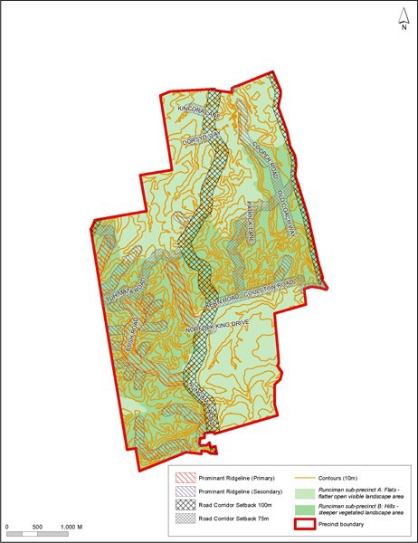

Precinct plan 2: Reserves and connections
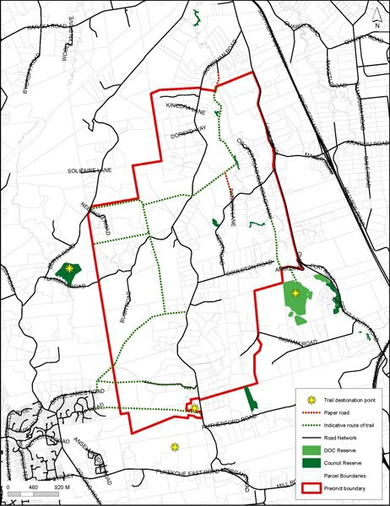

Precinct plan 3: Natural and physical resources
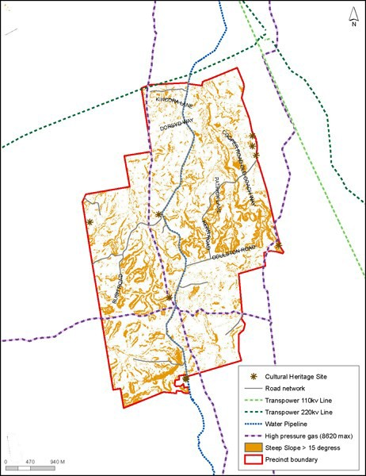

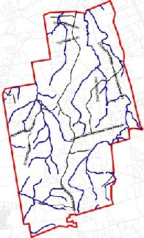Precinct plan4: RipCW"ian corridors

..... "." .,...
-. -
...... ......
---

Precinct plan 5: Bush Park concept plan development areas
