PART 3 ­ REGIONAL AND DISTRICT RULES»Chapter K: Precinct rules»6 South»

6.19 Papakura

- Development controls

1.1 Desirable pedestrian access

  - Buildings must provide pedestrian access along the approximate alignment of desirable pedestrian links shown on Figure 1.

Figure 1: Desirable pedestrian access
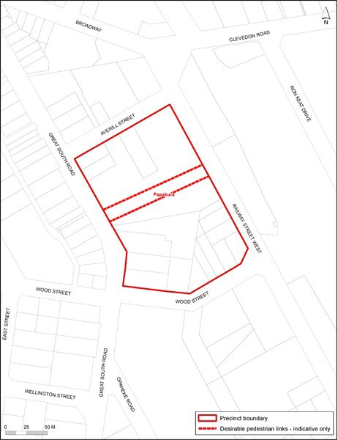

- Subdivision controls

2.1 Desirable pedestrian access

  - Any subdivision of land must provide pedestrian access along the approximate alignment of desirable pedestrian links shown on Figure 1.

Assessment ­ Development control infringements

Matters of discretion
    - The council will restrict its discretion to the matters below for the relevant development control infringement:
      - desirable pedestrian access

Assessment criteria
    - In addition to the general assessment criteria for development control infringements in clause 2.3 of the General Provisions of the Unitary Plan the council will consider the relevant criteria below for the development control infringement.
      - The application should demonstrate that:

i.

ii.
adequate alternative pedestrian access to the railway station is provided through the precinct area or

the development does not trigger the necessity to provide a through site link, or that a through site link is unnecessary to achieve the objectives of the precinct

Special information requirements

  - A resource consent application for new buildings or subdivision of land within the Papakura precinct must be accompanied by an assessment of pedestrian flows.

  - The assessment must be carried out by a suitably qualified and experienced person, and confirm whether the new building or subdivision of land provides desirable pedestrian access along the alignment of desirable pedestrian links shown on Figure 1, including (if necessary) modelling pedestrian flows in the area.

