6.17 Manukau

The activities, controls and assessment criteria inthe underlying Metropolitan Centre zone and the Auckland· wide rules apply inthe following precinct unless otherwise specified below. Refer to the planning maps for the location and e>dent of the precinct.

- Development controls

The development controls inthe Metropolitan Centre zone apply inthe Manukau precinct unless otheMiise specified below:

1.1 Sunli!tlt a.rrission

  - Buildings and structures shall not cast anyshadcw inthe area contained within the sunlight admission control line as defined in Figure 1beblueen the hours of 10ai'T'I-2pm beblueen September 23 and March 21 (standard time) each year.

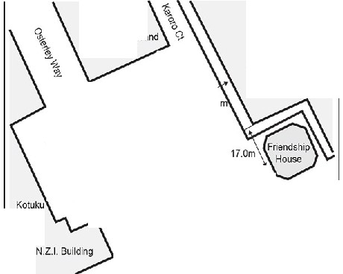Figure 1: Manuk:au Squ e sunlight admission

Coopers & Lybrand
Building

\,....

\13.7m
Shopt ng Mall

.,..,...
\' ......

..

"'_.,, \.....1.
.
7.0

\
,, '.
,, \
.
.
'
'
\ '' /
' \ .

'\ ,,, '•.....'-, Om
'
\ .,,
V' \• '•

House
10.01...-\ '.
*" '' 'llZ.>,) '

\ <;ru\(\e'l
'

\

.,.__ Sunlight admission controlline

Assessment ­ Development control infringements

Matters of discretion
In addition to the general matters set out in clause 2.3 and the specific matters set out for the infringement in the Metropolitan Centre zone, the council will restrict its discretion to the matter below for the relevant development control infringement:
  - sunlight admission.

Assessment criteria
In addition to the general assessment criteria set out in clause 2.3 and the specific assessment criteria for the infringement in the Metropolitan Centre zone, the council will consider the relevant assessment criteria below
- Sunlight admission
  - The extent to which sunlight to the area within the sunlight admission control line is obscured by buildings, at the time of year specified in the development control.

Special information requirements

  - An application for new buildings, accessory buildings or additions and alterations must be accompanied by:
    - sufficient information to enable an accurate assessment of compliance with clause 4.5.1.2.2.2.

