PART 3 ­ REGIONAL AND DISTRICT RULES»Chapter K: Precinct rules»6 South»

6.11 Kingseat

The activities, controls and assessment criteria in the underlying Single House, Mixed Housing Suburban, Local Centre, Light Industry, and Public Open Space (Informal Recreation and Sport and Active Recreation) zones
and Auckland­wide rules apply in the following precinct and sub­precincts unless otherwise specified. Refer to planning maps for the location and extent of the precinct and sub­precincts. Refer to Appendix 11.6.2.2 Schedule of Protected Heritage Places and 11.6.2.3 Schedule of Protected Trees.

Activity table

The activities in the relevant underlying zone(s) apply unless otherwise specified in the activity table below.

Activity table ­ Kingseat precinct
Activity | Activity status
 | Sub­ precinct A | Sub­precinct B |  |  |  |  | Sub­ precinct C | Sub­ precinct D
 |  | Area 1 | Area 2 | Area 3 | Area 4 | Area 5
Marae complex and  Kokiri centres | P | P | NA | NA | NA | NA | NA | NA
Retail selling predominantly convenience goods  up to 400m2 GFA | RD | NA | NA | NA | NA | NA | NA | NA
Veterinary clinics and health facilities not exceeding 400m2  total GFA | P | NA | NA | NA | NA | NA | NA | NA
The selling of hand  crafts | P | NA | NA | NA | NA | NA | NA | NA
Conference facilities up to 400m2 total  GFA | P | NA | NA | NA | NA | NA | NA | NA
Restaurants and  cafes | P | NA | NA | NA | NA | NA | NA | NA
Fitness centres within buildings up to  400m2 total GFA | P | NA | NA | NA | NA | NA | NA | NA
Internal alteration to the buildings existing as at 31 May 1994, where there is no change in site coverage or building  height | P | NA | NA | NA | NA | NA | NA | NA

Repair, redecoration and insignificant alteration to the buildings existing as at 31 May 1994, carried out with materials similar in appearance to those  originally used | P | NA | NA | NA | NA | NA | NA | NA
Manufacturing not exceeding 400m2  total GFA | P | NA | NA | NA | NA | NA | NA | NA
Equestrian centres | NC | NA | NA | NA | NA | NA | NA | NA
Education facilities | RD | NA | NA | NA | NA | NA | NA | NA
Hospital (but not including a Psychiatric Hospital as defined in the Mental Health Act  1969) | RD | NA | NA | NA | NA | NA | NA | NA
Visitor  accommodation | D | NA | NA | NA | NA | NA | NA | NA
Retirement villages, Supported residential care and boarding  houses | D | NA | NA | NA | NA | NA | NA | NA
Cafe up to 100m2 of GFA within existing buildings as at 31  May 1994 | RD | NA | NA | NA | NA | NA | NA | NA
Entertainment facilities up to 400m2 total GFA within existing protected Heritage Places (Buildings A57, A58 A59 and A61 on map  3) | RD | NA | NA | NA | NA | NA | NA | NA
Entertainment facilities up to 400m2  total GFA | RD | NA | NA | NA | NA | NA | NA | NA
More than two dwellings within existing Protected  Heritage Place | RD | NA | NA | NA | NA | NA | NA | NA
More than two dwellings within an  existing building | RD | NA | NA | NA | NA | NA | NA | NA
New buildings | RD | NA | NA | NA | NA | NA | NA | NA

Outdoor eating places within existing Protected Heritage Places (Buildings A57, A58 A59 and  A61 on Kingseat  Precinct Plan 3) | RD | NA | NA | NA | NA | NA | NA | NA
Outdoor eating  places | RD | NA | NA | NA | NA | NA | NA | NA
Public amenities within existing Protected Heritage Places (Buildings A57, A58 A59 and  A61 on Kingseat  Precinct Plan 3) | RD | NA | NA | NA | NA | NA | NA | NA
Public amenities | RD | NA | NA | NA | NA | NA | NA | NA
Home occupation within existing Protected Heritage Places (Buildings A57, A58 A59 and  A61 on Kingseat  Precinct Plan 3) | RD | NA | NA | NA | NA | NA | NA | NA
Offices within existing Protected Heritage Places (Buildings A57, A58 A59 and A61 on Kingseat Precinct  Plan 3) | RD | NA | NA | NA | NA | NA | NA | NA
Offices | RD | NA | NA | NA | NA | NA | NA | NA
Industrial laboratories within existing Protected Heritage Places (Buildings A57, A58 A59 and A61 on Kingseat Precinct  Plan 3) | RD | NA | NA | NA | NA | NA | NA | NA
Industrial  laboratories | RD | NA | NA | NA | NA | NA | NA | NA
Any permitted activity seeking to operate outside the hours specified in the Performance  Standards | RD | NA | NA | NA | NA | NA | NA | NA

Unless provided for as a permitted activity, any application to modify, demolish or remove any part of Buildings A62 to A67 on Kingseat Precinct  Plan 3 | RD | NA | NA | NA | NA | NA | NA | NA
Development
More than a single dwelling on a site within the Single  House zone | NA | D | NA | NA | NA | NA | NC | NC
One dwelling on sites no less than  500m2 | NA | P | P | P | NC | NA | NC | NC
More than one dwelling on a site less than 300m2 in  net site area | NA | NC | P | P | NC | NA | NC | NC
Subdivision
Subdivision in sub­ precinct B area 1, and sub­precincts C and D that do not  comply with minimum site sizes and frontage requirements  in clause 4.2 above | NA | D | NA | NA | NA | NA | D | D

Land use controls

  - The land use controls in the Single House zone apply in the Kingseat precinct unless otherwise specified below.

  - The land use controls for the Mixed Housing Suburban zone apply in sub­precinct B Areas 2 and 3 unless otherwise specified below.

  - The land use controls for the Local Centre zone apply in sub­precinct B Area 4 unless otherwise specified below.

  - The land use controls for the Light Industry zone apply in sub­precinct B Area 5 unless otherwise specified below.

Density

    - More than one dwelling on a site within sub­precinct B Areas 2 and 3 is a permitted activity provided that the number of dwellings must not exceed one dwelling per 450m2 net site area. Development exceeding one dwelling per 450m2 and no greater than one dwelling per 300m2, is a discretionary activity.

Development controls

  - The development controls in the Single House zone apply in the Kingseat precinct unless otherwise

specified below.

  - The development controls for the Mixed Housing Suburban zone apply to sub­precinct B Areas 2 and 3 unless otherwise specified below.

Height

    - Within the Kingseat precinct buildings must not exceed 8m in height within the Single House Zone except as set out below.

    - Buildings in sub­precinct A must not exceed 12m in height.

Height in relation to boundary

    - This rule in the Single House zone does not apply to internal boundaries within sub­precinct A.

Yards

Yards must comply with the following: Table 1
Yard | Single House zone
Front | 5m for sub­precincts A, B (Area 1) and C
 | 10m for sub­precinct D
Rural or Coastal Zone | 20m from the boundary of Rural Coastal and Rural Production Zones
Rural Trail* | 10m from the boundary of the Rural Trail
Coastal protection yard | 30m from existing or proposed Esplanade Reserve or 50m from Mean High  Water Springs whichever is the greater

* identified on Precinct Plan 2

Building coverage

    - Within the Kingseat precinct, building coverage must comply with the following maximum total.

    - Building coverage per site must be 35% of the net area within the Single House zone except as set out below:

Table 2

Sub­precinct | Maximum building coverage per site
Sub­precinct A | 50 per cent
Sub­precinct C | 25 per cent
Sub­precinct D | 20 per cent

Main frontage control

    - In the Kingseat precinct all residential development on the “main frontage control line” (Precinct Plan 6: Special control) must not have habitable rooms at ground level.

Building line setback

    - In the Kingseat precinct, road widening from the current legal road width (as at 23 September 2010) will be required in the locations shown and in the dimensions specified in Precinct Plan 7. Where road widening is identified in Precinct Plan 7 and where the construction of a building precedes subdivision,

buildings must be located outside of the building line.

Historic heritage alert setback

    - Within the Kingseat precinct where any earthworks, including any land disturbance required for access way, formation work, or building, or planting of indigenous vegetation is proposed, or where specified building area associated with the proposed subdivision are proposed, within the width of 100m from the Mean High Water Springs:
      - The person(s) undertaking the proposed activity (including subdivision) must provide the council with a report from a qualified archaeologist, identifying whether any archaeological site is within the Historic Heritage Alert setback of the proposed subdivision, and stating whether any archaeological site will be damaged, modified or destroyed by such activities

      - Where a report of the type described above (refer clause 3.1.a above) has been previously received by council then a further report will not be required

      - Where a person proposes to undertake such activity and instigates a survey of a property or properties by a qualified archaeologist and no archaeological sites are recorded the (Kingseat) Historic Heritage Alert setback provisions will cease to apply.

Car parking

    - Kingseat sub­precinct B Area 4: Local Centre
      - Within the Kingseat Local Centre zone standard parking requirements will apply to activities only at the ground floor of the local centre with no parking requirements for activities within the first floor or above.

    - Kingseat sub­precinct A
      - The following parking standards apply:
        - One parking space for every 40m2 of gross floor area (GFA).

      - Except that:

i.

ii. iii.
No parking is required for sites with total buildings having equal to or less than 400m2 GFA. One parking space per site for sites with total buildings more than 400m2 and 1500m2 GFA. Two parking spaces for any site having a building greater than 1500m2 GFA.

Subdivision controls

  - The subdivision controls in the Auckland­wide rules ­ subdivision apply in the Kingseat precinct unless otherwise specified below.

Kingseat precinct plan and sub­precinct A plan

    - All subdivision within the precinct must be general accordance with Precinct Plans 1 and 2.

    - All subdivision within the former Kingseat Hospital Site must be in general accordance with Precinct Plans 4 and 5.

Minimum site size, road frontage, size requirements

    - Any new site within sub­precinct B Area 1 must:
      - have a minimum net area of 500m2

      - have road frontage of no less than 50m

      - not be a rear site

      - have a minimum distance of 20m between any specified building area and the boundary of an adjoining rural or coastal area.

    - Any new site within sub­precinct C must:
      - have a minimum net area of 1500m2

      - have a minimum distance between any specified building area and the boundary of another zone of 20m.

    - Any new site within sub­precinct D must:
      - have a minimum net area of 2500m2

      - have a minimum distance between any specified building area and the boundary of an existing or proposed esplanade reserve of 30m

      - where adjoining an existing or proposed esplanade reserve revegetate 25% of the area of the new site with indigenous vegetation and protect this area through consent notices (subject to requirements of the Historic Heritage Alert Setback).

Wastewater and servicing

    - Any site located within the Kingseat precinct irrespective of the above provisions, must be connected to a public reticulated wastewater treatment and disposal system.

    - Any site located within the Kingseat precinct, irrespective of the above provisions, must be connected to a public reticulated water supply and network.

Rural trail

    - In the Kingseat precinct, subdivision must provide a 10m wide strip of land on the boundary with a rural and coastal zone in accordance with the location of the annotation ‘Rural Trail’ on Precinct Plan 2. The Rural Trail must be vested as local purpose access.

Average minimum density

    - The average minimum density in sub­precinct B Area 1 is 10 dwellings per hectare

Design and layout business ­ Local Centre

    - Whether subdivision within the Local Centre establishes, or does not preclude the establishment and development of a Village Square of at least 1,600m2 in area with at least one continuous frontage to the Main Frontage Control Line shown on Precinct Plan 6 and as described in clause 7.1(a) below.

Assessment ­ Restricted discretionary activities

Matters of discretion
  - For restricted discretionary activities in the Kingseat precinct, the council will restrict its discretion to the following matters, in addition to the matters specified for the restricted discretionary activities in the underlying zone:
    - Servicing, Water, wastewater disposal and discharge of contaminants.

    - Stormwater management and riparian planting, earthworks, silt and sediment control.

    - Remediation of soil contamination.

    - Geotechnical matters including site stability and flooding.

    - Proximity to national grid transmission lines (refer Planning Maps).

    - Density, design and layout, site planning, building form, public interface and external appearance, open spaces, parking areas, landscaping and amenity planting.

    - Design, function and ongoing continuance of the local centre.

    - The extent of retention, protection and enhancement and adverse effects on natural features including existing native (and significant exotic) vegetation, riparian planting, ecosystems and stream and riparian environments and their natural landscape quality ecological and landscape values.

    - The coastal environment should be protected or enhanced where appropriate.

    - The retention and promotion of the function of key open spaces and vegetated areas, and the entrance feature roadway, notable and significant trees and historic heritage places, other existing trees and landscape quality and heritage values of the former Kingseat Hospital Site.

    - Protection and/or enhancement of archaeological sites, and cultural and heritage resources and coastal environment.

    - Effects of key roading layout and its functions and connectivity, including the physical integration of the sub­precinct A plan with the Local Centre zone for the local centre.

    - Noise attenuation and hours of operation.

    - Consistency with the Precinct Plan 1.

    - Consistency with any relevant sub­precinct plan.

    - Consistency with design elements.

Table 3

Activity | a | b | c | d | e | f | g | h | i | j | k | l | m | n | o | p
Any RD for subdivision within the Kingseat Precinct (All  sub­precincts) | X | X | X | X | X | X | X | X | X | X | X | X | X | X | X | X
Any RD for subdivision within the former Kingseat hospital site (sub­ precinct A and sub­  precinct B Area 2) | X | X | X | X | X | X | X | X | X | X | X | X | X | X | X | X
Any RD for more than one dwelling on a site within sub­precinct B  Area 1 | X | X |  |  |  | X |  | X | X | X | X | X | X | X | X | X
Any RD for activities within sub­precinct A  and B | X | X |  |  |  | X | X | X | X | X | X | X | X | X | X | X

Assessment criteria
- The council will consider the relevant assessment criteria below for the restricted discretionary activities listed above in regard to:
  - Servicing, Water, wastewater disposal and discharge of contaminants are provided for and adverse effects avoided, remedied or mitigated.

  - Stormwater management and riparian planting, earthworks, silt and sediment control being provided for.

  - Remediation of soil contamination and verification of effective completion of works

  - The extent to which geotechnical matters including site stability and flooding have been considered and addressed.

  - The extent to which development impact upon or is adversely effected by the proximity to national grid transmission lines (refer Planning Maps).

  - Density, design and layout, site planning, building form, public interface and external appearance, open spaces, parking areas, landscaping and amenity planting should promote the protection, retention and enhancement of the natural and heritage environment and amenity and character.

  - The design of the town centre and other areas and activities, should promote, maintain and enhance the function and the ongoing continuance of the town centre.

  - The existing native (and significant exotic) vegetation, riparian planting, ecosystems and stream and riparian environments and their natural landscape quality ecological and landscape values should be protected, retained and enhanced.

  - The coastal environment should be protected or enhanced where appropriate.

  - The function of key open spaces and vegetated areas, and the entrance feature roadway, existing trees and landscape quality and heritage values of the former Kingseat hospital site are protected, retained and enhanced.

  - The archaeological sites, and cultural and heritage resources are protected, retained or enhanced.

  - Effects of key roading layout and its functions and connectivity, including the physical integration of the sub­precinct A plan with the Local Centre zone for the local centre

  - Noise attenuation and the hours of operation.

  - Consistency with Precinct Plan 1.

  - Consistency with any relevant sub­precinct plan.

Assessment ­ Design

  - In considering the relevant assessment criteria a) to o) in regard to the Residential and Light Industry zones of the Kingseat precinct, in addition to matters in the Auckland­wide ­ Subdivision rules and section 2.9.9 of the General Provisions rules, the council will also consider whether the subdivision is in general accordance with the relevant subdivision design assessment criteria as outlined below.

Design elements
- Design Element 1: Movement Reserve and Access Networks
  - Layout design, and the design of, walking, cycling, public transport and vehicular and open space networks, should support an integrated movement network, avoid conflicts between users, provides safe and convenient access and achieve accessibility to, and connectivity between, local centre, residential neighbourhoods, parks and reserves, the coastal edge and the rural hinterland (through a rural trail).

  - Cul–de–sac roads should be avoided unless topographical constraints exist that prevent an interconnected road network.

  - Roading, development patterns and earthworks should respond to, and reinforce, identified topographical features, landscape patterns and any heritage and/or character values. A Low Impact Design approach to development should be promoted.

  - Layout design should retain existing mature trees (including those protected trees in Appendix 3.4), preferably in reserves or road reserves, where these contribute to amenity.

  - The road, reserve and access networks should make adequate provision for Low Impact Design

stormwater management controls and have regard to the impact of road gradient on options for stormwater management.

- Design Element 2: Block Size, Site Type and Orientation
  - Blocks should:

i.

ii. iii.
be of a scale and shape to achieve a permeable street layout designed to enable good solar access for future dwellings
primarily front onto, and be accessed directly from, a legal road and rear and through sites should generally be avoided.

  - Corner sites should be designed to maximise opportunities to accommodate private outdoor space on­site, without the need for high front fences.

  - A variety of sites sizes should be provided. Larger sites should generally be located furthest from the local centre, neighbourhood parks, and principally within the sub­precinct C, and sub­precinct D.

  - Sites intended for medium density housing should be of an appropriate size, shape and orientation and should have adequate frontage with a road to support the development of medium density housing in accordance with the design assessment criteria.

  - Within the sub­precinct C and D, sites must be larger and provide an appropriate low density and spacious interface with the coast and rural hinterland. More intensive forms of residential development, including medium density housing, should be avoided in these areas

  - Sites within the former Kingseat hospital site should be designed to incorporate existing elements (protected buildings, structures, trees and areas) of the former Kingseat hospital site.

  - Sites within the sub­precinct C should always gain access from internal roads within the precinct and address the road frontage with the principal building façade.

  - Sites should avoid inappropriate road connections to the Rural Coastal and Rural production Zones (Manukau Harbour Management Area).

  - Specified Building Areas within the sub­precinct C should be sited at least 20m back from any boundary with Rural Coastal and Rural Production zoned land, and 10mfrom the rural trail network.

  - The sub­precinct C will comprise residential development that is one site deep, with road frontage to the Single House zone side only sites within the sub­precinct C will generally be wider than they are deep to provide a spacious aspect to the surrounding rural area.

  - Within the sub­precinct D, subdivision layout and design should seek to minimise the need for earthworks and retaining structures, and promote a Low Impact Design approach to development.

- Design Element 3: Roads and Accessways
  - In addition to requirement of the Unitary Plan, road cross sections, including adjoining public road areas, should be appropriate to the nature of the service they provide, and also reflect urban design legibility considerations. Road cross sections should also provide opportunities for the establishment of effective low impact design stormwater management devices.

  - On­street parking should be provided clear of traffic lanes, clearly demarcated from the moving lanes, and positioned with regard to probable driveway positions on adjacent sites. Parking should be provided informally on minor roads.

  - Cyclists should generally be accommodated on the carriageway, although, if a school is to be established within Kingseat, specific design will be required for roads in proximity to the school.

  - Local traffic management measures such as road narrowing, tightened intersection corners, chicanes, raised table pedestrian crossing points and material differentiation should be applied to limit the speed of vehicles on local roads to enhance safety, movement and amenity for pedestrians and cyclists.

  - Generous avenue planting (where appropriate) and street tree planting should be provided on all roads. A street planting plan is to be submitted to council for approval with subdivision resource consent applications.

  - Key intersections should be designed to recognise a ‘gateway’ function and be sited in general accordance with the ‘gateway’ locations shown on Precinct Plan 2.

- Design Element 4: Pedestrian, Cycle and Horse Links and Routes
  - Within the centre, pedestrian, and cycle links and routes (excluding the rural and coastal trails) should be primarily accommodated within a road reserve.

  - Green corridors links should provide for at least 6m wide corridors (accommodating 2m wide footpaths or 3m wide shared surfaces), be of easy gradient (without steps and not exceeding a gradient of 1:12), include clear and coherent signage, and incorporate appropriate landscaping and lighting.

  - Links should avoid running along the rear of sites. Off­street cycle and pedestrian routes and bridle paths/trails should be safe, barrier­free, be appropriately surfaced, and be located above the average yearly storm event level. The treatment and design should, in each case, reflect the role and function of paths and the character of the surrounding area.

  - The rural and coastal trail network should provide for active and passive recreation opportunities.
The trails should be designed to manage potential conflicts between users, in particular potential conflicts between horses and cyclists. The trails and any associated works or tracks should be so designed as to avoid direct public access, including equine, to the foreshore and coastal marine area, and provide a sufficient separation between the trail and the foreshore to avoid potential adverse effects from trail activities upon the coastal environment and on archaeological sites.

- Design Element 5: Reserves
  - Reserves should be distributed throughout the Kingseat Precinct in accordance with the locations and types shown on Kingseat Precinct Plan 2 and any other relevant precinct plan, and as described further in the explanation below, to provide a variety of recreation opportunities and to provide amenity around the town.

  - Clear sight lines into all areas of reserves should generally be available from public roads (as a first priority) or nearby dwellings. Neighbourhood parks should generally be fronted by at least two public roads.

  - Harbourside parks should be provided in general accordance with Precinct Plan 2.

  - Reserves should be located and designed to retain any existing significant vegetation and/or heritage features/areas.

- Design Element 6: Stormwater Management, Wastewater and Water
  - Stormwater detention treatment devices and associated reserves and linkages should be appropriately located, consistent with an approved Integrated Catchment Management Plan and Stormwater Network Consent, relevant engineering standards, relevant technical publications and approved by the council.

  - Where possible, stormwater reserves should be developed as a connected system with pedestrian access, creating green corridors to enhance the ecology of the area and providing a visual connection of green networks to the surrounding rural and coastal areas.

  - Those streams identified on Precinct Plan 2 should be retained and enhanced by a vegetated planted buffer (10m minimum) on both sides of the channel. The appropriateness of the stream geometry and stream profile will need to be considered, with a suitable stream and flood profile developed.

  - Stormwater ponds should, where possible, be off­line to minimise potential effects on stream ecology, and should promote Low Impact Design principles and complement the surrounding landscape.

- Design Element 7: Interface Design
  - Reserves/parks should be bounded by public roads on at least two sides unless there are topographical constraints.

  - Where a road boundary is not practical, the site layout should ensure that the fronts of houses face onto the reserve across driveways as a next preference, and these driveways should remain unfenced so a clear line of sight and physical access is maintained.

  - The principal pedestrian entries to all buildings should face a road or open pedestrian space and be easily accessible and clearly identifiable from the footpath.

- Design Element 8: Adaptive Re­use Overlay Sub­Precinct A
  - Subdivision and Development within the Adaptive Re­use Overlay Area sub­precinct A should:

i.

ii.
be designed to incorporate existing elements (existing buildings and trees) within the former Kingseat hospital site

allow for a high degree of pedestrian access, and provide safe and attractive pedestrian routes.

  - Outdoor storage should be avoided or concealed from view from public roads or public spaces by internalisation, or appropriate configuration of the building (preferred), or by screen fencing.

  - Solid blank walls facing a road or internal public space must be avoided.

  - The principal pedestrian entry points of all buildings should be clear and obvious within the building frontage.

  - Car parking should be provided in appropriate places that are easily accessible and appropriately landscaped.

  - Internal public spaces should have active edges, should be overlooked by windows from adjoining buildings and should be visible from roads.

  - Public spaces should be safe and designed according to Crime Prevention Through Environmental Design (CPTED) guidelines with building edges and soft landscaping designed (and species selected) to avoid creating a sense of entrapment.

  - Where car parking is provided on sites that abut residential areas, it should be screened by buildings, fencing and/or landscaping.

  - Vehicular movement in and around open spaces should give equal priority to pedestrians and cyclists.

  - Any subdivision or development within the sub­precinct A should take into account the Concept Plan as shown on sub­precinct A on Precinct Plan 4 and Precinct Plan 5 for the former Kingseat hospital site.

  - The effects of the retention and reuse of existing buildings and maintenance of their heritage value, including the extent to which the proposal maintains or enhances the character of the former Kingseat hospital site, should consider.

  - The promotion of the function and retention of key open spaces and vegetated areas, and entrance feature roadway.

  - The manner in which new buildings will achieve integration and sensitivity to the heritage buildings and their surrounding environment and relate, in their location, scale, bulk, mass and extent, by means of:

i.

ii.

iii.
open spaces and the creation of a sense of communal access and use both within, and to the area surrounding the adaptive overlay areas

the creation of relationship and distinctions (where appropriate) between buildings, activities and public spaces (streets and parks and communal areas) through innovative and sensitive design including the use of scale, design elements and materials that reflect and promote functions, heritage, character and amenity values

a sense of community and human scale.

  - The retention, protection and enhancement of stream and riparian environments and vegetated areas, and their ecological and landscape values (notably the stream/overland flow and vegetated area immediately south of the local centre).

  - The key roading layout and its function, including its physical integration with the business zone (local centre) and adjoining sites, while avoiding adverse affects upon the stream and open space environment.

  - The promotion of opportunities for facilities available for a variety of community re­use and regeneration and employment.

  - Scale and type of activities should not undermine the vibrant, sustainable development of the local centre, and/or its on­going vitality, function or purpose.

Typical road cross sections
    - Please refer to Appendix 11.6.2.1.

Assessment ­ Subdivision

  - Design assessment criteria for development in the Kingseat Structure Plan area Business zone under several “Design Elements” against which development proposals will be assessed at resource consent stage.

Design element 1: Site planning
    - Buildings on sites adjoining the Main Frontage Control Line (as detailed on Precinct Plans 2 and 6) should provide a continuous building frontage along boundaries with:
      - Kingseat Road

      - Linwood Road

      - McRobbie Road

      - At least two sides of the Village Square.

    - Setbacks from the road boundary should be avoided to maintain a continuous built form and buildings must be two storeys on the Centres main street corners, and two storeys encouraged elsewhere along this frontage.

    - A Village Square having an area of at least 1,600m2 should be established in general accordance with the location shown on Precinct Plan 2 and have at least one continuous frontage to the Main Frontage Control Line. The area of the Village Square must be defined as excluding any roads or service lanes, or verandahs. The Village Square must be vested.

4.

5.

6.

7.

8.

9.

10.

11.

12.

13.

14.
The building frontage should be provided with verandahs to provide shelter and shade to pedestrians using the footpath or square.

Buildings within the Local Centre zone should generally adopt a perimeter block layout where buildings address the street and parking and servicing areas are located internally.

The Village Square should be capable of accommodating a shape factor of a square or rectangle with side lengths not exceeding a ratio of 2:1.

No vehicular access ways/service lanes should be provided within the Main Frontage Control Line. An exception to this may be allowed if an alternative access (e.g. a service lane) providing access to the Village Square is required.

The layout of streets, buildings and blocks should allow for a high degree of pedestrian access, and provide safe and attractive pedestrian routes. Pedestrian access from rear car parking areas is anticipated to the street network with routes through the Main Frontage Control Line.

Accessways to rear parking/service areas should reduce the width and number of vehicle crossings over footpaths, which may involve shared accessways.

The principal pedestrian entries to all buildings should face a road and be easily accessible and clearly identifiable from the footpath

If buildings cannot be built with frontage to all road boundaries (other than within the Main Frontage Control Line where this is required), attractively landscaped areas should be provided between the building and the road frontage. The use of such areas for parking should be limited to avoid adverse effects on the streetscape and pedestrian amenity, and where car parking is required, this should have a maximum depth of a single aisle.

Outdoor storage should be avoided or concealed from view from public roads by internalisation, or appropriate configuration of the building (preferred), or by screen fencing.

Except where located in the road reserve, areas of car parking should not adjoin the Village Square. Initial development of the local centre should occur on those parts of sites subject to frontage controls.

Design element 2: Building form, public interface and external appearance
- Buildings on sites adjoining the Main Frontage Control Line should accommodate retail, commercial or community activities at ground floor level with compatible uses (including residential) encouraged above ground floor.

- Buildings which adjoin the Village Square should be of sufficient (and consistent) height to provide a sense of enclosure to that space and should generally be at least two stories in height

- When viewed from the road or any public space, buildings should create visual interest through articulation, openings, and design variation.

- Buildings should be designed such that they provide for passive surveillance over roads and open spaces (including the Village Square).

- Buildings should be designed such that that they provide for passive surveillance over roads and open spaces (including the Village Square).

- Solid blank walls facing a road or open space should be avoided.

- Verandahs should reflect the design and style of the building and accentuate entrances and window treatment.

- Buildings on corners should utilise design features to address and emphasise the corner.

- The principal pedestrian entry points of all buildings should be clear and obvious within the building

frontage.

10.

11.

12.
Buildings should front directly onto, or face, roads and provide pedestrian entries and windows along the road frontage. Buildings adjacent to the Village Square should front onto the Village Square, with the principal pedestrian entrance for such buildings being provided from the Village Square frontage.

Large doors (e.g. for loading or servicing) that are not principal building entrances should be concealed from view from roads and open spaces. If they are visible from these spaces, their dominance in the frontage should be reduced, and they should be set back from the front face of the building.

Signage should be integrated with the design of the building, rather than freestanding, and should not extend above the eaves or parapets of buildings (refer to Auckland­wide rules – Signs).

7.3 Design element 3: Open spaces (including the village square), parking areas and landscaping

1.

2.

3.

4.

5.

6.

7.

8.

9.

10.

11.

12.
Open spaces (including the Village Square) should be well designed and highly visible and accessible. Open spaces (including the Village Square) should be well designed and highly visible and accessible.
Car parking should be provided where in appropriate places, generally within the street or behind buildings, and should be easily accessible and appropriately landscaped.

Open spaces should have active edges, should be overlooked by windows from adjoining buildings and should be visible from roads.

Open spaces should be safe and designed according to Crime Prevention Through Environmental Design (CPTED) guidelines with building edges and soft landscaping designed (and species selected) to avoid creating a sense of entrapment.

Open spaces should provide for the safe and convenient movement of pedestrians and cyclists clear of motor vehicle traffic, car parking and manoeuvring areas.

Parking and movement layouts should be designed for safe and effective movement of vehicles through an easily understood layout with appropriate surface markings and signs.

Where car parking is provided on sites that abut residential areas, it should be screened by buildings, fencing and/or landscaping.

Vehicular movement in and around open spaces should give priority to pedestrians and cyclists.

The Village Square should provide appropriate features (e.g. seating, lighting, landscaping etc.) to support its function as the ‘heart’ of the town of Kingseat.

The Village Square should be orientated to ensure good solar access and to avoid the adverse effects of prevailing winds. The Village Square should be well connected to pedestrian and cycle routes.

The Village Square should be constructed of appropriate surface materials to ensure year round use.

Former Kingseat hospital site and consistency with the sub­precinct A plan
    - The council in considering the relevant assessment criteria in a) to n) above for subdivision activities within the former Kingseat hospital site, the council will also consider whether the design and layout of subdivision including the location of roads, accesses and Specified Building Area has had particular regard to:
      - The overall character of the site including the heritage, environmental and amenity values, and the protected buildings and trees, and the integration of new subdivision and resulting development with these features;

      - The extent to which existing trees that contribute to the visual amenity and treed character of the site are recognised and retained within a proposed subdivision;

      - The extent to which proposed landscaping contributes to the treed character of the site and

maintains its future visual amenity, including its effectiveness in offsetting the effects arising from the removal of existing trees from the site.

      - The achievement of the structural elements shown on Precinct Plan 2, Precinct Plan 4 and Precinct Plan 5.

      - Those matters contained in heritage and character provisions in the Unitary Plan;

      - The extent to which the proposed subdivision is in accordance with the sub­precinct A plan as shown on Precinct Plan 4 for the former Kingseat hospital site including whether within the Kingseat precinct plan area the activity would avoid more than minor adverse effects, including cumulative adverse effects, on the development and/or viability, vitality or function of the Kingseat local centre.

      - Whether proposals to reuse buildings appropriately protect and/or enhance the external appearance, character and heritage values of the historic heritage place, and the layout of access, outdoor living courts and other accessory structures and buildings does not undermine the character and amenity of the areas and vegetation within which the building is located.

      - Whether existing trees that provide a high level of amenity are appropriately incorporated within the proposed development.

      - Whether the subdivision and development within the adaptive re­use areas in sub­precinct A will promote opportunities for community re­use and regeneration and employment.

      - Whether within the Kingseat precinct plan area the activity would avoid more than minor adverse effects, including cumulative adverse effects, on the development and/or viability, vitality or function of the Kingseat local centre.

Height (More than one dwelling within an identified area)
    - The council in considering a discretionary activity application for more than one dwelling within the single housing zone on identified sites within sub­precinct B (Areas 2 and 3) in addition to the relevant assessment criteria above, should also consider where proposed buildings are in excess of 8m, and are in the vicinity of protected heritage buildings and/or the Central Field, the extent to which a visual relationship is retained between the different built heritage elements

Archaeological place (Sites) historic heritage set back
    - In considering a discretionary activity application to damage, modify or destroy an archaeological site where an archaeological site is within the Historic Heritage Set back (100m of Mean High Water Springs), the council will have regard to the following assessment matters to ensure that adverse effects are avoided, remedied or mitigated:
      - The nature, form and extent of the activity and the likelihood of damage, modification or destruction of the archaeological site.

      - The result of consultation with Mana Whenua.

      - The significance of the archaeological site, which is to be assessed on the uniqueness of the site, representative nature of the site, its condition and the importance attached to the site by Mana Whenua and the landowner.

      - The findings of any archaeological assessment carried out and contained in a report by a qualified archaeologist. Such a report must identify and provide: an assessment of effects, and proposals for avoidance or mitigation of effects, where applicable; the provisions of any relevant management plan where appropriate; and whether the proposal meets the provisions of the ICOMOS New Zealand Charter for the Conservation of Places of Cultural Heritage Value.

      - Alternative methods and locations available for applicants to carry out the works or activities.

      - The manner in which landowners, the community and Mana Whenua source or provide funding and methods of voluntary protection for the management of archaeological sites including the use of covenants.

Historic heritage places (former Kingseat hospital site)
    - All applications that involve the modification, alteration or demolition of any protected building, structure, area or tree existing on the former Kingseat hospital site, or any new building or structure located within 10m to 15m of historic Heritage places must comply with the rules below.

    - That area of a protected building located between 15m from the front façade facing the central roadway, and 10m from all other facades of a protected building and located within the former Kingseat hospital site as identified in the Precinct Plan 2, or the sub­precinct A plan in Precinct Plans 4 and 5 must include an independent study of the protected item, carried out by an appropriately qualified person:
      - that in consideration of any protected building, structure, area or tree, considers:

i.

ii.
its structural condition and the ability for it to be converted to a new use

its contribution to the overall heritage and/or character of the former Kingseat hospital site.

      - that in consideration of any new building located within the Heritage setbacks, considers:

i.

ii.
the adverse impacts upon the heritage value of the scheduled or protected building in the vicinity

the adverse impacts upon the overall heritage and/or character of the former Kingseat hospital site.

    - Sufficient information must be submitted to ensure that these matters can be fully evaluated. The application will be assessed having regard to the matters in the historic heritage provisions of the Overlay objectives and policies ­ Historic heritage section and the matters below:
      - Protection of any protected building
        - The protected building must be generally retained in its present form in a manner that preserves its heritage values including:
          - the internal fabric –and where is considered as having ‘exceptional’ or ‘considerable’ significance must be generally retained unless exceptional circumstances require its removal

          - the fabric identified as having ‘some’ considerable significance must be retained where possible, and any change should recognise such significance

          - proposals that remove any accretions or features that detract from the heritage values will be favourably considered.

      - New Buildings within heritage set back (former Kingseat hospital site):
        - New buildings must be of an appropriate scale (including height irrespective of the permitted zone height and overall bulk), and located, so that:
          - where close to any protected building, they should not be taller than the protected buildings, and preferably one storey lower than the protected building

          - views of the protected building from the central roadway and central field are provided for

          - open space around and in the vicinity of the central, northern and eastern fields, and central roadway of the former Kingseat hospital site is promoted and retained where possible.

      - With subdivision and development (including mixed housing more than one building on a site), the design and layout of subdivision and development must have particular regard to:

i.

ii.
the protection and/or enhancement of any protected building, trees, structures or areas the overall character and amenity of the former Kingseat hospital site derived from the

protected buildings, structures, trees and areas, and the integration of new subdivision and development with these features

iii.

medium density housing must give recognition to an appropriate scale of development within close proximity to protected buildings, that promotes:

- the retention of heritage values and character of the buildings

- associated open space surrounding the protected buildings and complementary landscape heritage character

- views of the protected buildings from the central, northern and eastern fields, and central roadway of the former Kingseat hospital site

- open space around the central, northern and eastern fields area.

8. Precinct plans

Precinct plan 1: sub­precincts and areas
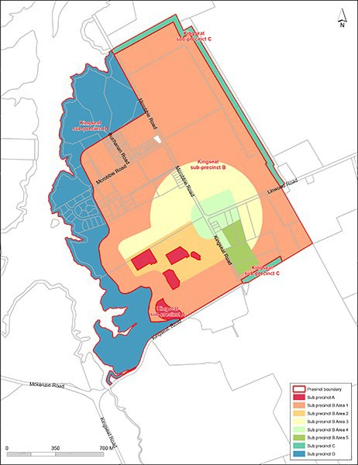

Precinct plan 2
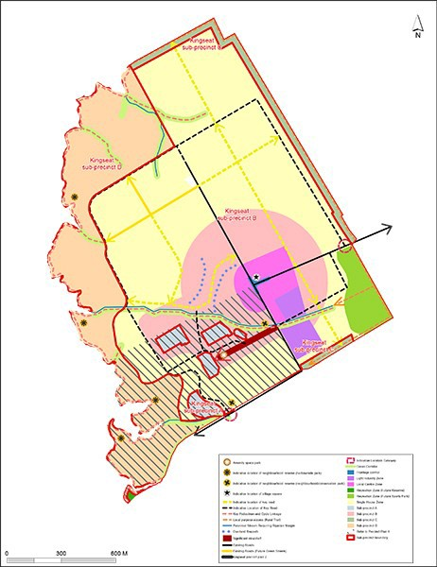

Precinct plan 3: Protected heritage places and notable trees
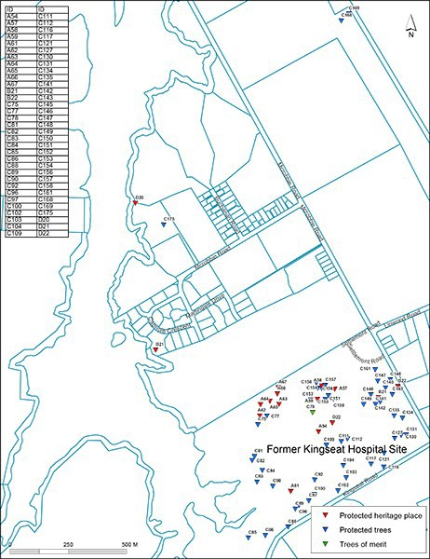

Precinct plan 4
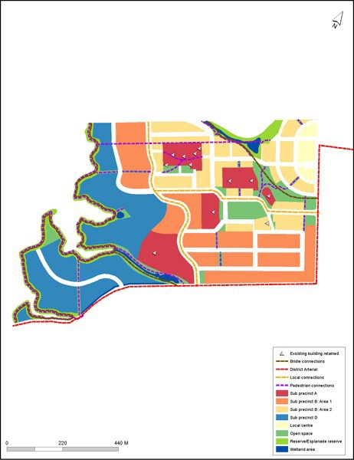

Precinct plan 5
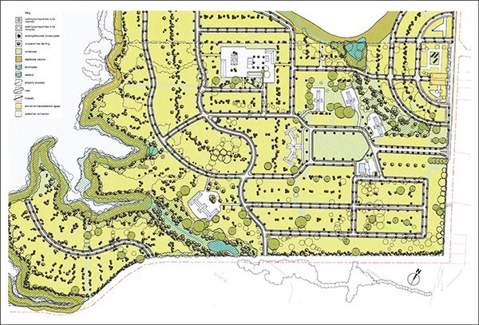

Precinct plan 6: special controls
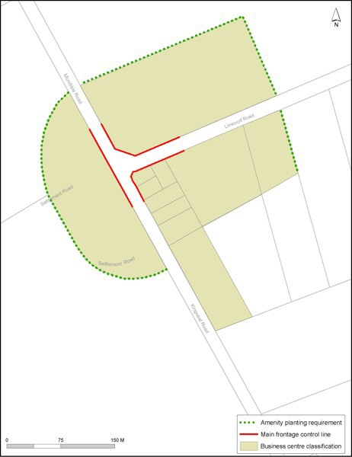

Precinct pli'n 7: Road Wdening
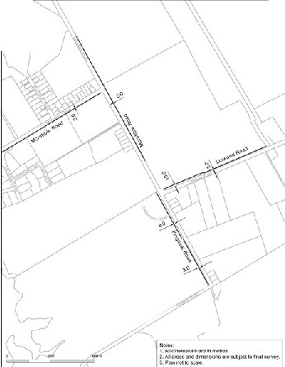I \
I •
\
\
\
I

Precinct plan 8: Zoning
