PART 3 ­ REGIONAL AND DISTRICT RULES»Chapter K: Precinct rules»5 North»

HMNZ Dockyard

    - The activities, controls and assessment criteria in the Light Industry zone apply in the HMNZ Dockyard precinct unless otherwise specified below. Refer to planning maps for the location and extent of the precinct.

Activity table

Activity | Status
Commerce
Retail | NC
Industry
Manufacturing | P
Repair and maintenance services | P
Marine industry | P
Accommodation
Dwellings, home occupations, visitor accommodation, boarding houses, retirement  villages, supported residential care | NC
Development
Alterations and additions to buildings that do not increase the GFA of the building | P
Alterations and additions to existing buildings that increase the GFA of the building and  where the building is used for a permitted activity | D
Demolition of buildings | D
Buildings used for permitted activities | D
Buildings used for controlled, restricted discretionary, discretionary or non complying  activities | NC

- Landuse controls

All permitted activities must comply with the land use controls of the Light Industry zone and the land use controls in clause 2.1 below, unless the land use controls in this precinct vary or change those controls, in which case only the precinct land use controls apply.

2.1 Manufacturing

  - Manufacturing must be carried out:
    - within existing workshops, or

    - within open areas that are defined on Precinct plan 1: Open areas for manufacturing.

Development controls

  - The development controls in the Light Industry zone apply in the HMNZ Dockyard precinct unless otherwise specified below.

  - Development that does not comply with the development controls below is a discretionary activity.

Building height

    - Buildings must comply with a building height envelope control which provides a graduated height limit of 12.5m increasing to 18m at or within 10m of the foot of the Calliope Road cliff. The HMNZ Dockyard precinct building height envelope is illustrated in Figure 1: Building height control.

    - Building height in the precinct will be measured from the finished surface level of the dockyard reclamation ­ as at May 2009.

Figure 1: Building height control
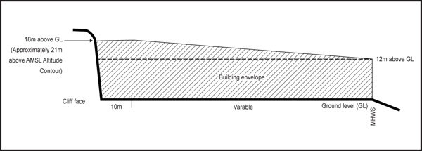

  - Yards

    - 5m for sites adjoining Calliope Road service lane.

    - The required security fence and control gate are exempt from this control.

    - The coastal protection yard does not apply in this precinct.

4. Precinct plan

Precinct Plan 1: Open areas for manufacturing

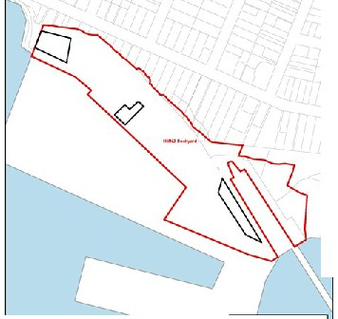

I

o<"l-- ..............wl nt•
c:J ,....ioo.ll.oouo.bt
f'4W !)o).r(.eoo.e

