PART 3 ­ REGIONAL AND DISTRICT RULES»Chapter K: Precinct rules»5 North»

5.11 Devonport Peninsula

The activities, controls and assessment criteria in the underlying zone and Auckland­wide rules apply in the Devonport Peninsula Precinct and sub­precincts unless otherwise specified. Refer to planning maps for the location and extent of the sub­precincts.

Activity table

  - The activities in the Mixed Housing Suburban zone apply in the Devonport Peninsula precinct unless otherwise specified in the activity table below.

  - The Auckland­wide ­ Subdivision activities specified in clause 5.1 apply in addition to the activities specified in the activity table below.

  - For land use, development and subdivision prior to the approval of a framework plan refer to the Mixed Housing Suburban zone and the Auckland­wide ­ Subdivision rules.

Activity | Activity status
Land use, development and subdivision activities for framework plans
Alterations and additions to buildings existing at the date of notification of the Unitary  Plan complying with an approved framework plan | P
A framework plan, amendments to an approved framework plan or a replacement  framework plan complying with clauses 3.2­3 below | RD
A framework plan, amendments to an approved framework plan or a replacement  framework plan not complying with clauses 3.2­3 below | NC
Any land use, development or subdivision activity complying with an approved framework  plan | RD
Any land use, development or subdivision activity prior to the approval of a framework  plan or which does not comply with an approved framework plan | NC
Residential
Integrated residential development | RD

Notification

  - For land use, development and subdivision prior to the approval of a framework plan refer to the Mixed Housing Suburban zone.

  - The council will consider restricted discretionary activity resource consent applications for framework plans (including amendments to an approved framework plan or a replacement framework plan) without the need for public notification, however limited notification may be undertaken, including notice being given to any owner of land within the precinct who has not provided their written approval.

Land use controls

  - The land use controls in the Mixed Housing Suburban zone apply in the precinct unless otherwise specified below.

  - Where an applicant elects to prepare a new, or amended or replacement framework plan, the resource consent application must:
    - Apply only to land within a sub­precinct that the applicant is the owner of, or to sites in multiple ownership where the landowners make a joint application.

    - Comply with the maximum building coverage, maximum building height and minimum building setback development controls specified in clause 4 below.

    - Comply with the general rules and information requirements applying to framework plans specified in clause 2.6 of the general rules and special information requirements ­ Framework plans. Seek consent for the following land uses:

i.

ii. iii. iv.
v.
subdivision

roads (including street and pedestrian connections) open space
more than four dwellings on a site building footprints.

  - The maximum density controls do not apply to framework plans or development that complies with an approved framework plan.

Development controls

  - For land use, development and subdivision prior to the approval of a framework plan, the development controls in the Mixed Housing Suburban zone and the Auckland­wide rules for subdivision applying in the Mixed Housing Suburban zone apply in the precinct unless otherwise stated below.

  - Where an application is made for a framework plan, amendments to an approved framework plan, or a replacement framework plan the following development controls apply in addition to the Mixed Housing Suburban zone development controls.

Building coverage

    - Maximum building coverage of 40 per cent of each sub­precinct excluding roads.

Landscaped area

    - Minimum landscaped area of 30 per cent of each sub­precinct excluding roads.

Building height

    - Buildings must not exceed the heights as set out below:

Table 1

Building height area | Maximum height  (metres) | Maximum  height (storeys)
Area 1 | 14.5m | 4 storeys
Area 2 | 11m | 3 storeys
Area 3 | 8m | 2 storeys

Building setbacks

    - Where development in Area 1 and Area 2 adjoins the Public Open Space zone, buildings must be set back as follows:
      - Where the building is between one and four storeys, the building must be set back at least 3m from side or rear boundaries.

      - This rule does not apply to the internal site boundaries within the sub­precinct.

Height in relation to boundary

    - Clause 7.3 of the Mixed Housing Suburban zone only applies to the external interface of the sub­ precinct where the boundary adjoins any other property zoned Mixed Housing Suburban. This control

does not apply to the internal site boundaries within the sub­precinct.

Building length

    - The Maximum Building Length rule in the Mixed Housing Suburban zone shall not apply.

Development control infringements

  - Clause 3.2 above applies where an application for a framework plan, amendments to an approved framework plan, or a replacement framework plan involves a development control infringement.

  - The status set out in clause 3 above for development control infringements applies.

  - The matters of discretion and assessment criteria applying to development control infringements in clause 7 below apply.

Assessment ­ Restricted discretionary activities

Matters of discretion
    - Framework plans, amendments to approved framework plans or replacement framework plans
      - The council will restrict its discretion to the general matters of discretion for framework plans contained in clause 2.6 of the general rules and special information requirements ­ Framework plans, and the following matters:

i.

ii. iii. iv.
v.
the location, physical extent and design of street connections and pedestrian connections the location, physical extent and design of open space
buildings

staging of development and the associated resource consent lapse period

in sub­precinct E ­ Vauxhall Road only, natural and historical character features.

    - Land use, development or subdivision complying with an approved framework plan
      - For an application for any land use, development or subdivision activity complying with an approved framework plan, the council will restrict its discretion to:

i.

ii.
the general matters of discretion for framework plans contained in in clause 2.6 of the general rules and special information requirements ­ Framework plans, as if any reference in those matters to a "framework plan" were a reference to the proposal

the relevant matters specified in the Mixed Housing Suburban zone or Auckland­wide rules.

    - Integrated residential development
      - Refer to the matters of discretion for four or more dwellings in the Mixed Housing Suburban zone.

Assessment criteria
    - Framework plans, amendments to approved framework plans or replacement framework plans
      - When considering a restricted discretionary application for a framework plan, amendments to an approved framework plan or a replacement framework plan, the council will consider the proposal against the following criteria:
        - General
          - The location, physical extent and design of street connections and pedestrian connections
            - Street connections should be provided in the general locations identified on the relevant sub­precinct plan to achieve a legible street network and a logical block pattern.

            - Pedestrian connections should be provided in the general locations identified on the relevant sub­precinct plan, if within the control of the applicant, to enhance

accessibility and legibility.

            - Street connections and pedestrian connections identified on the relevant sub­ precinct plan should be designed to:
              - integrate with existing and proposed public open space;

              - provide for well­connected, legible and safe vehicular and pedestrian routes;

              - enhance views to surrounding public open space where possible;

              - be maintained for public use.

          - The location, physical extent and design of open space
            - The development shall incorporate a suitable area(s) of public open space relative to the scale and outlook of adjacent proposed buildings that provides for the use and enjoyment of the general public and/or residents on the site.

            - The public open space shall be located to provide a good standard of amenity, sunlight access and a high level of accessibility.

            - Wherever possible, and appropriate, existing mature trees should be retained, particularly where it would assist to break up the appearance of 3 – 4 level buildings as viewed from the perimeter of the relevant sub­precinct.

          - Buildings
            - Building footprints, profile and height (as opposed to detailed building design) should establish an integrated and legible built form and spatial framework across the relevant sub­precinct while also:

            - enhancing the form and function of existing and proposed streets, lanes and public open space;

            - locating buildings to maximise outlook across public open space areas; and

            - ensuring a mix of building heights and a variation of built form when viewed from streets, public open space and residentially zoned areas. In particular, views of higher buildings should be broken up by buildings of a lesser height to reduce dominance and bulk.

          - Staging of development and the associated resource consent lapse period
            - The staging of development should ensure that the development functions and is viewed from external boundaries as an integrated development. Details of how the development will be staged will be provided. The council may impose conditions enabling a longer lapse period, having regard to s125 of the RMA and the need for unimplemented resource consents to generally reflect the planning strategy contained in the Unitary Plan.

      - Sub­Precinct E ­ Vauxhall Road Only:
        - Natural and Historical Character Features
          - Existing trees identified on Precinct Plan 5 should be retained and incorporated into the integrated development of the site.

          - Development should seek to retain key historical Navy buildings and site elements where possible.

    - Land use, development or subdivision complying with an approved framework plan
      - For an application for any land use, development or subdivision activity complying with an approved framework plan, the council will consider:
        - the general assessment criteria for framework plans contained in clause 2.6 of the general

rules and special information requirements ­ framework plans, as if any reference in those matters to a "framework plan" were a reference to the proposal

ii.

the relevant assessment criteria specified in the Mixed Housing Suburban zone or Auckland­ wide rules.

    - Integrated residential development
      - Refer to the assessment criteria for four or more dwellings in the Mixed Housing Suburban zone.

Assessment ­ Development control infringements

7.1 Matters of discretion
  - The council will restrict its discretion to the matters set out in the Mixed Housing Suburban zone for the relevant development control infringement.

Assessment criteria
    - The council will consider the relevant assessment criteria in the Mixed Housing Suburban zone for the infringement listed.

8. Precinct plans

Precinct plan 1: Devonport Peninsula sub­precinct A
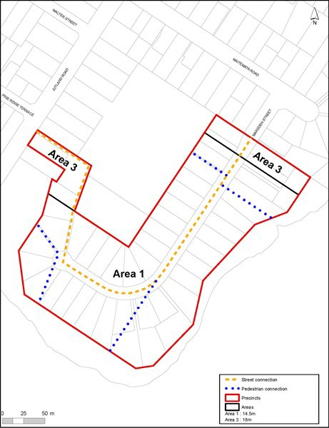

Precinct plan 2: Devonport Peninsula sub­precinct B
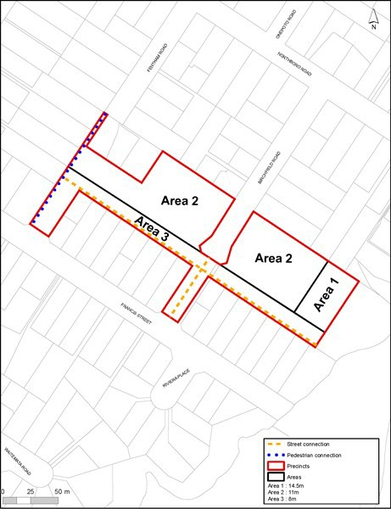

Precinct plan 3: Devonport Peninsula sub­precinct C
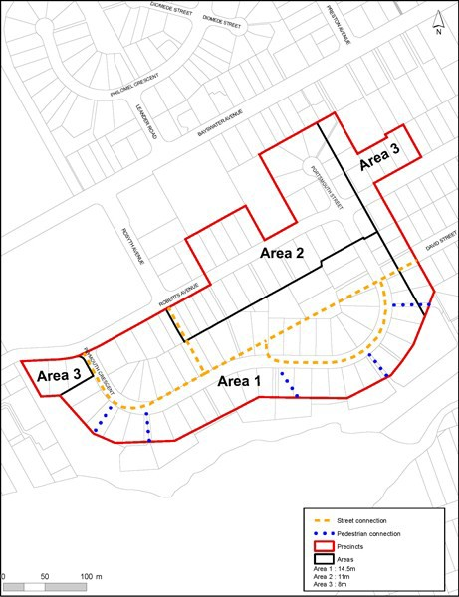

Precinct plan 4: Devonport Peninsula sub­precinct D
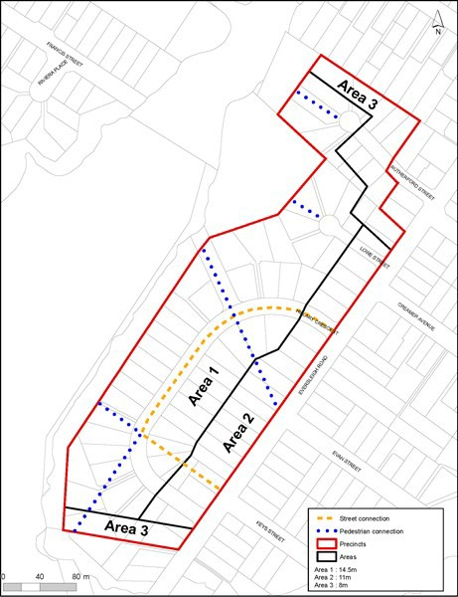

Precinct pli'n 5: Oevonport Peninsula sub-prednct E

'••
•
•
Are.'l 1

•.. ..
•• ••.••
•• •••

• ••
•
••

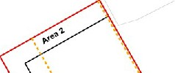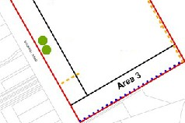-.-

.........,_..

···.-,.-..-._-·

...
•
.......
8::- ..
-"'··.-..,.

Precinct plan 6: Devonport Peninsula sub­precinct F
