PART 3 ­ REGIONAL AND DISTRICT RULES»Chapter K: Precinct rules»5 North»

Devonport Naval Base

    - The activities, controls and assessment criteria in the Mixed Use zone apply in the Devonport Naval Base precinct unless otherwise specified below.

Activity table

Activity | Activity Status
 | Sub­precinct A | Sub­precinct B
Commerce
Offices | P | P
Community
Community facilities | NC | P
Education facilities | P | P
Healthcare facilities | P | NC
Hospitals | P | NC
Development
Demolition of buildings | D | D
Alterations and additions to buildings that do not increase the GFA of the  building | P | P
Alterations and additions to buildings that increase the GFA of the building and where the building is used for a  permitted activity | D | D
Buildings used for a permitted activity | D | D

- Development controls

  - The development controls in the Mixed Use zone apply in the Devonport Naval Base precinct unless otherwise specified below.

Building height

    - Buildings must not exceed the height limits set out in Table 1 below:

Table 1

Sub Precinct | Height
Sub­precinct A | 9m
Sub­precinct B | Buildings must comply with a building height envelope control which provides a graduated height limit of 9m, increasing to 18m at or within 10m of the foot of the Calliope Road cliff, or to a limit of 12.5m, whichever is the greater. This control is shown in Figure 1: Building height control.  Building height in sub­precinct B will be measured from the finished surface level of the Philomel/Dockyard reclamation ­ as at May 2009.

Figure 1: Building height control
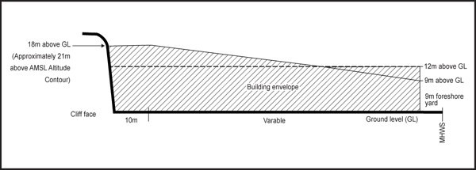

  - Height in relation to boundary

    - Buildings must not project beyond a 45 degree recession plane measured from a point 2.5m vertically above ground level where the precinct adjoins a site in another zone.

    - This control does not apply to the precinct boundary between the Devonport Naval Base and HMNZ Dockyards precincts.

Yards

Table 2

Sub precinct | Yard
Sub­precinct A | Calliope Road: 3m Cliff Top yard: 10m (defined as where the gradient of the slope  reaches a gradient steeper than 1 in 3)  All other boundaries: 1.5m
Sub­precinct B | Spring Street: 5m Coastal protection yard:  9m

Building length

    - Where sites adjoining sub­precinct A are zoned residential, those parts of any building which exceed a height of 5m and are within 10m of the zone boundary are to be wholly confined within the arms of a 130 degree angle formed by two lines intersecting at any point on an adjacent residential boundary, such that each line forms an angle of 25 degrees with that boundary.

Assessment ­ Development control infringements

3.1 Matters of discretion
  - The council will restrict its discretion to the matters below when assessing a development control infringement:
    - dominance and shading

    - neighbourhood character.

Assessment criteria
    - Dominance and shading

      - infringing the height, height in relation to boundary or building coverage controls should not result in the building dominating or unreasonably shading adjoining properties, particularly their outdoor living areas

      - consideration will be given to whether the building can be designed or located to minimise dominance or over­shadowing of outdoor living space on neighbouring sites by providing variations in building heights, breaks in building massing or locating buildings in a way that maximises sunlight access to neighbouring sites while achieving a good standard of on­site amenity.

    - Neighbourhood character
      - the height, scale and form of buildings should generally accord with the existing or planned future form and character of the surrounding neighbourhood, having regard to the level of development enabled by the development controls of the zone

      - development that does not comply with the yards will need to demonstrate that the proposed setback is consistent with the pattern of development in the surrounding neighbourhood. This is particularly important where the development is in close proximity to an identified historic character or historic heritage area.

