PART 3 ­ REGIONAL AND DISTRICT RULES»Chapter K: Precinct rules»3 City Centre»

3.9 Queen Street Valley

The activities, controls and assessment criteria in the underlying City Centre zone and Auckland­wide rules apply in the following precinct, unless otherwise specified below.

Refer to planning maps for the location and extent of the precinct.

Activity table

  - The activities in the City Centre zone apply in the Queen Street Valley precinct unless otherwise specified in the activity table below.

Activity table – Queen Street Valley precinct
Activity | Activity Status
Development
Minor cosmetic alterations to a building that does not change its external design and  appearance | P
New buildings, and alterations and additions to buildings not otherwise provided for | RD
The total demolition or substantial demolition (more than 30% by volume), or any demolition of  the front façade of a building constructed prior to 1 January 1940 | RD

Notification

  - An application for the total demolition, substantial demolition (more than 30 per cent by volume) or any demolition to the front facade of a building constructed prior to 1940 will be subject to the normal tests for notification under the relevant sections of the RMA.

Development controls

The development controls in the City Centre zone apply in the Queen Street Valley precinct unless otherwise specified below.

Frontage height and setback

Purpose: manage the scale of development to maintain and enhance pedestrian amenity, and to avoid buildings dominating public open space.
    - For frontages shown as frontage type A on precinct plan 1:
      - The height of the building frontage must be at least 19m above MSL and must not exceed 28m above MSL.

      - Above the frontage height, the building must be setback from the site frontage at least 5m.

    - For frontages shown as frontage type B on precinct plan 1:
      - The height of the building frontage must be at least 19m above MSL and must not exceed 28m above MSL.

      - Above the frontage height, the building must not project beyond a 65 degree recession plane measured at all points along the site frontage for a depth of at least 5m.

      - The building setback must be an emphatic or a stepped profile of at least two stories and must not be a literal regression of the 65 degree angle.

    - For frontages shown as frontage type C on precinct plan 1:
      - The height of the building frontage must be at least 13m above MSL and must not exceed 19m above MSL.

      - Above the frontage height, the building must not project beyond a 65 degree recession plane measured at all points along the site frontage for a depth of at least 5m.

      - The building setback must be an emphatic or a stepped profile of at least two stories and must not be a literal regression of the 65 degree angle.

    - Floor space within the area shown on figures 1­3 below is exempt from the calculation of gross floor area for a depth not exceeding 20m from the frontage of the site, if the floor space is located on a storey that adjoins the site frontage or is within 4m of the maximum frontage height specified in clauses 1­3 above. Additionally:
      - A maximum of six stories for frontage types A and B and four stories for frontage type C shown on precinct plan 1 are exempt from the calculation of gross floor area. The exempt stories must be within 4m of the minimum or maximum frontage height specified in clauses 1­3 above.

      - Floor space is not exempt if the building does not comply with the minimum frontage height specified in clauses 1­3 above.

      - The building must not exceed the MTFAR applying to the site.

    - Buildings on sites with two frontages do not need to comply with clauses 1­3 above for that part of the building:
      - Located within 8m of the intersection of the two frontages.

      - Three stories above the maximum frontage height specified in clauses 1­3 above where the maximum floor to floor height is 4m.

Figure 1: Frontage height and setback ­ type A
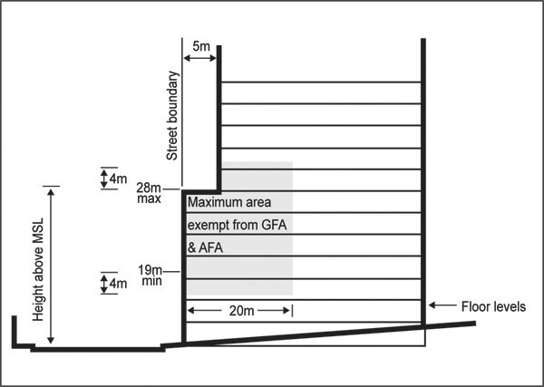

Figure 2: Frontage height and setback ­ type B
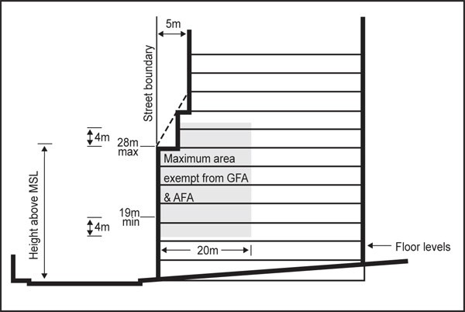

Figure 3: Frontage height and setback ­ type C
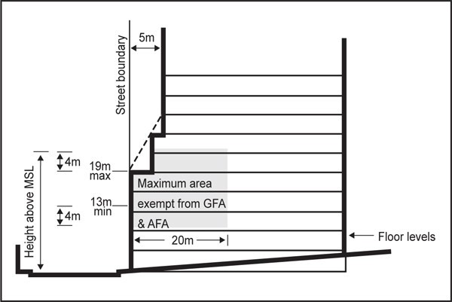

Figure 4: Setback exemption for corner sites
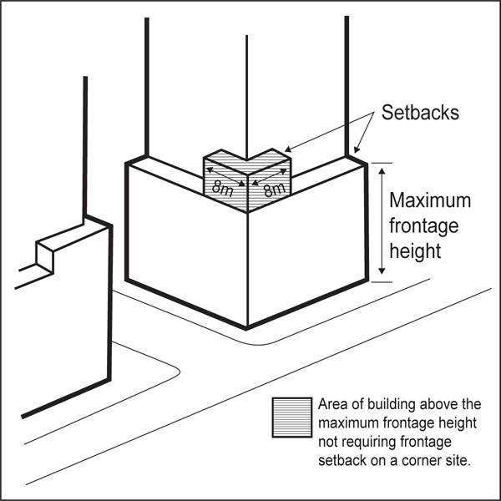

- Assessment ­ Restricted discretionary activities

4.1 Matters of discretion
For development that is a restricted discretionary activity in the Queen Street Valley precinct, the council will restrict its discretion to the following matters, in addition to the matters specified for the relevant restricted discretionary activities in the City Centre zone.
  - New buildings, and alterations and additions to buildings and structures not otherwise provided for
    - Building design and external appearance.

  - The total demolition or substantial demolition (more than 30 per cent by volume), or any demolition of the front façade of a building constructed prior to 1 January 1940
    - The effects of building demolition on built form and streetscape character.

Assessment criteria
For development that is a restricted discretionary activity in the Queen Street Valley precinct, the following assessment criteria apply in addition to the criteria specified for the relevant restricted discretionary activities in the City Centre zone.
    - New buildings and alterations and additions to buildings and structures not otherwise provided for

      - Building design and external appearance ­ creating a positive frontage

i.

ii.
The design of buildings at ground level should contribute to the continuity of pedestrian interest and vitality. However, frontages entirely of glass (curtain walling or continuous shopfront glazing) should not be used at street level as they detract from the streetscape.

Where feasible, restoration of original ground level detail should be included in plans for buildings adjoining heritage buildings or for alterations to heritage buildings.

      - Building design and external appearance ­ variation in building form / visual interest
        - Building levels aligned to the street boundaries should incorporate design elements which acknowledge the existing human scale and character of the precinct. In particular:
          - Frontage height and design should have regard to existing buildings in the vicinity and maintain a consistent scale. This does not mean a rigid adherence to a single height but it does mean a respect for the general appearance of the surrounding blocks.

          - The design of frontages should include vertical and horizontal details which avoid dominance of frontage elements larger than historically present. Where existing sites are amalgamated, the frontage design should have regard to the existing “grain” of development and convey a residual sense of the original subdivision pattern.

          - The consistency of the existing character in a cohesive streetscape should be maintained with new buildings acknowledging the scale, sense of proportion and level of intricacy of adjacent heritage and special character buildings in the precinct. However, new buildings should be sympathetic to those buildings and should not replicate or imitate the architectural detailing or style.

      - Building design and external appearance ­ materials and finishes
        - Materials used in new buildings should have regard to existing buildings, but new and contemporary interpretations in form and detail may be used.

    - The total demolition or substantial demolition (more than 30 per cent by volume), or any demolition of the front façade of a building constructed prior to 1 January 1940
      - Effects of building demolition on built form and streetscape character
        - The demolition or removal of a pre­1940's building within the precinct should not significantly adversely affect the built form and streetscape character of the precinct. In particular, consideration will be given to:
          - whether the existing building forms part of a cohesive group of buildings in terms of similarity of age, scale, proportion or design and the extent to which the building’s demolition would detract from the shared contribution that group makes to streetscape, the unique character or the history and context of the precinct.

          - whether the existing building is a remnant example of a building type that reflects the history of the area.

          - the contribution the individual building makes to the context, character or cohesiveness of the streetscape or precinct.

          - the contribution the building makes to adjoining or nearby scheduled historic heritage buildings, either through the context and the relationship of the building to the scheduled historic heritage building or through the building’s mass, height or rhythm of facades, and whether its demolition would adversely impact on the historic heritage values of the building.

          - whether reasonable use of the site can be achieved through adaptive re­use of the building rather than through its demolition and replacement.

ii.

Notwithstanding the above, other factors will be considered and balanced when assessing an

application for the demolition of a pre­1940's building, including whether the building is beyond rehabilitation in terms of poor structural or physical condition, and the costs of the repair work or upgrading necessary to extend the useful life of the building are prohibitive, (in comparison to the costs of a new building of similar size).

Assessment ­ Development control infringements

Matters of discretion
In addition to the general matters set out in clause 2.3 of the General Provisions rules, the council will restrict its discretion to the matters below for the relevant development control infringement.
Infringement | Building scale and dominance/ visual effects | Effects on public open space and pedestrian  access
Frontage height & setback | X | X

Assessment criteria
- Frontage height & setback
  - Development should be of a scale and form appropriate to the setting

  - The scale of the development should be consistent with the current and future character of Queen Street valley as established through the objectives and policies for the Queen Street valley precinct

  - Pedestrian amenity should be maintained or enhanced

Precinct plans

Precinct plan 1: Frontage types
