PART 3 ­ REGIONAL AND DISTRICT RULES»Chapter K: Precinct rules»3 City Centre»

3.11 Viaduct Harbour

The activities, controls and assessment criteria in the underlying General Coastal Marine and City Centre zones and Auckland ­wide rules apply in the following precinct and sub­precincts, unless otherwise specified.

Refer to the planning maps and precinct plans for the location and extent of the precinct and sub­precincts.

Activity table

  - Within sub­precinct B, activities marked # in the activity table are limited to the area of the Eastern Viaduct shown on precinct plan 1.

  - Those activities in the CMA marked with * apply when the activity is on a CMA structure.

  - The activities in the General Coastal Marine and City Centre zones apply in the Viaduct Harbour precinct unless otherwise specified in the activity table below.

Activity table – Viaduct Harbour precinct
Activity | CMA (rcp) | Land (dp)
Works in the CMA
Reclamation or drainage | D | NA
Declamation# | RD | RD
Maintenance dredging | RD | NA
Capital works dredging | RD | NA
General activities
Commerce
Maritime passenger operations, excluding freight movement and storage# | P* | P
Parking accessory to marine and port activities, maritime passenger  operations and events on CMA structures | P* | NA
Parking that is not accessory to marine and port activities and maritime  passenger operations and events on CMA structures | NC* | NA
Short­term parking (non accessory) within sub­precinct B | NA | RD
Aquaculture activities | Pr | NA
Industry
Marine and port activities except as otherwise specified | RD | RD
Industrial activities not specified as a permitted or restricted activity | D* | D
Community
Marinas | P | P
Community facilities# | P* | P
Public amenities | P* | P
Activities within sub­precinct B listed in the City Centre zone activity table  and not specified in this activity table | NC | NC
Development
Marine and port facilities within sub­precinct A or B | NA | RD

Marine and port facilities located outside of sub­precinct A and B | P | P
Marine and port accessory structures and services, excluding new pile  moorings | P | P
Demolition | P* | NA
Wave attenuation devices | RD | RD
Observation areas, viewing platforms, boardwalks and boat launching facilities | RD | RD
Pile moorings existing at the date of notification of this Unitary Plan including  occupation and use by the vessel to be moored | P | NA
New pile moorings established after the date of notification of this Unitary  Plan including occupation and use by the vessel to be moored | RD | NA
Maimai | NC | NC
A bridge across the Viaduct Harbour | RD | RD
Minor cosmetic alterations to a building that does not change its external  design or appearance | P* | P
New buildings, and alterations and additions to buildings not otherwise  provided for | RD* | RD
Buildings within the CMA not listed as a permitted, restricted discretionary or  non­complying activity | D | NA

Land and water use controls

The land and water use controls in the General Coastal marine zone apply to the CMA in the Viaduct Harbour precinct and the land use controls in the City Centre zone apply to land in the Viaduct Harbour precinct unless otherwise specified below.

Ground floor activities

    - On every frontage within the precinct identified as 70 per cent on Map 7 of the City Centre zone rules, any of the following activities must occupy at least 70 per cent of the length of the ground floor of the building for a depth of at least 10m, excluding vehicle and pedestrian access:
      - retail (excluding show homes, trade suppliers, service stations and motor vehicle sales)

      - maritime passenger operations

      - entertainment facilities

      - commercial services (excluding all nested definitions).

    - The total width of pedestrian entrances or lobbies along the site frontage of any one site must not exceed 10m.

Events

    - The general noise level under clause 6.5 of the Auckland­wide ­ Temporary activities rules may be exceeded for a cumulative duration of not more than 6 hours within any 24 hour period for a noise event.

    - The maximum noise levels must not exceed:

      - For no more than 3 of the 15 noise events and for a cumulative duration of not more than 3 of the total 6 hours permitted in clause 1 above (exclusive of one sound check of no more than one hour duration prior to each event):

85dBA L10
90dBA L01
80dB L10 at 63 Hz

80dB L10 at 125Hz
(high noise level)
      - At all other times during the 15 noise events:

75dBA L10
80dBA L01
80dB L10 at 63 Hz 80dB L10 at 125Hz
(medium noise level)
    - Except as provided elsewhere in this clause, noise levels must be measured in accordance with the requirements of NZS6801:1991 "Measurement of Sound" and must be assessed in accordance with NZS6802:1991 "Assessment of Environmental Sound" except that Clause 4.4 must not be used.

    - Within Waitemata Plaza and Market Square as shown on precinct plan 4 the following additional restrictions apply:
      - there must be no noise events, and

      - there must be no more than 2 noise events in any 4 week period, and

      - of the total 15 noise events there must be no more than 6 in any one calendar year and the general noise level under clause 6.5 of the Auckland­wide ­ Temporary activities rules must not be exceeded for a cumulative duration of more than 3 hours for any one noise event.

    - For the purpose of the restrictions in clause 4 above, Waitemata Plaza and Market Square are counted as a single venue.

    - Noise levels exceeding the standard in clause 6.5 of the Auckland­wide ­ Temporary activities rules including sound checks, must start no earlier than 9am and must finish no later than 10:30 pm Sunday to Thursday inclusive, 11pm Friday and Saturday and 1am New Year's Day.

    - Not less than 4 weeks prior to the commencement of the noise event, the organiser must notify the council in writing of:
      - the names and types of the acts and whether they are anticipated to be within the medium noise level or high noise level as defined in clause 2 above.

      - the person(s) and procedures for monitoring of compliance with noise levels

      - the nominated alternative date in the event of postponement due to the weather.

    - The council will keep a record of all noise events held and provide this information upon reasonable request.

    - Consultation must be undertaken with the majority freehold land owner within the Viaduct Harbour precinct.

Parking

    - There must be no parking on Hobson Wharf except for parking accessory to marine and port activities, including any short­term servicing requirements.

Development controls

The development controls in the City Centre and General Coastal Marine zone apply in the Viaduct Harbour precinct unless otherwise specified below.

3.1 Building height

Purpose: manage the height of buildings to achieve policy 4 of the Viaduct Harbour precinct.
  - Buildings must not exceed the heights specified on precinct plan 2.

  - The height of buildings and structures on land will be measured in accordance with clause 4.7 of the City Centre zone rules.

Site intensity

Purpose: manage the scale, form and intensity of development to maintain character of the precinct.
    - Buildings must not exceed the floor area ratios shown on precinct plan 3.

Building coverage

Purpose: manage the scale of development within Waitemata Plaza and Market Square to maintain their open space character.
    - Buildings, temporary tents, marquees, air supported canopies, structures and tables and seating must not occupy more than 20 per cent in area of Waitemata Plaza or Market Square as shown on precinct plan 4.

Vehicle access restriction

Purpose: ensure safe and efficient access from and to Sturdee Street and Fanshawe Street.
    - Vehicular access from and to Sturdee Street and Fanshawe Street (except 7­9 Fanshawe Street, being the land in Certificate of Title 7B/1437), must be for left turn manoeuvres only, provided that nothing in this clause will limit the Council's powers in relation to roads under the Local Government Act 1974
and, in particular, its powers to construct median strips in roads where it considers that such works are necessary for traffic safety reasons.

Special yard A

Purpose: ensure that buildings do not restrict public access along the water’s edge.
    - Buildings must not locate within the special yard shown on precinct plan 4.

    - The yard applies from average ground level of the land affected to a height of 3m.

    - The yard must have a minimum width of 7m.

Special yard B

Purpose: maintain unobstructed pedestrian access between Customs Street West and the waters edge in Waitemata Plaza.
    - Buildings, tents, marquees, air supported canopies, tables, seating and structures must not located within 10m of special yard B shown on precinct plan 4.

Public spaces and accessways

Purpose: manage public spaces and accessways to achieve policies 2, 3, 7 and 8 of the Viaduct Harbour precinct.
    - The pedestrian accessway on the southern side of the eastern viaduct shown on precinct plan 4 must be not less than 10m wide.

    - All public accessways within sub­precinct B must be available to the public at all times except when written approval has been obtained from the council to temporarily restrict access for security, safety or operational needs associated with port activities or events or where restricted for operational or safety reasons specified in the conservation covenants applying to the area.

    - Buildings or structures must not locate within the accessways. This control does not apply to verandahs or lawful temporary buildings or structures.

    - Development that does not comply with clauses 1­3 above is a non­complying activity.

Viewshafts

Purpose: manage development to maintain significant views of the water and adjacent areas within, and to, the Viaduct Harbour precinct.
    - Buildings or structures must not locate within those areas of land identified as landward viewshafts on precinct plan 4. This control does not apply to verandahs or lawful temporary buildings or structures.

    - Buildings and structures must not locate within or over those parts of CMA structures and waterspace identified as viewshafts CMA and viewshaft horizontal plane 5m above existing wharf deck level on precinct plan 4. This control does not apply to lawful temporary buildings or structures.

    - Development that does not comply with clauses 1­2 above is a non­complying activity.

Assessment ­ Restricted discretionary activities

4.1 Matters of discretion
For the activities and development listed below that are restricted discretionary activities in the Viaduct Harbour precinct, the council will restrict its discretion to the following matters, in addition to the matters specified for the relevant restricted discretionary activities in the General Coastal Marine and City Centre zones.
  - Declamation
    - construction or works methods, timing and hours of operation

    - location, extent, design and materials used

    - effects on coastal processes, ecological values, water quality and natural character

    - effects on public access, navigation and safety

    - effects on existing uses and activities

    - consent duration and monitoring.

  - Maintenance dredging and capital works dredging
    - Refer to the matters of discretion in clause 5.1 of the General Coastal Marine zone.

  - Wave attenuation devices
    - Refer to the matters of discretion in clause 5.1 of the General Coastal Marine zone.

  - Marine and port activities and Marine and port facilities
    - Refer to the matters of discretion in clause 5.1 of the General Coastal Marine zone.

  - Short­term parking (non­accessory)
    - location, extent, design and materials used

    - effects on existing uses and activities

    - amenity, effects on views and visual amenity.

  - Observation areas, viewing platforms, boardwalks and boat launching facilities
    - Refer to the matters of discretion in clause 5.1 of the General Coastal Marine zone.

  - A bridge across the Viaduct Harbour
    - construction or works methods, timing and hours of operation

    - location, extent, design and materials used

    - effects on coastal processes, ecological values, water quality and natural character

    - effects on public access, navigation and safety

    - effects on existing uses and activities

    - amenity, effects on views and visual amenity

    - consent duration and monitoring.

  - New buildings, and alterations and additions to buildings not otherwise provided for
    - effects on public access, navigation and safety.

  - New pile moorings established after the date of notification of this Unitary Plan including occupation and use by the vessel to be moored
    - Refer to the matters of discretion in clause 5.1 of the General Coastal Marine zone.

Assessment criteria
For development that is a restricted discretionary activity in the Viaduct Harbour precinct, the following assessment criteria apply in addition to the criteria specified for the relevant restricted discretionary activities in the General Coastal Marine and City Centre zones.
    - Declamation
      - The adverse effects of declamation should be avoided, remedied or mitigated in respect of the effects of the final land/water configuration on:

i.

ii. iii.
the marine environment (including coastal processes, water quality, sediment quality and ecology) of the coastal marine area

hydrogeology (ground water) and hydrology

sediment accumulation and the need for ongoing maintenance dredging of the coastal marine area.

      - Declamation works, including the construction of seawalls, should avoid, remedy or mitigate the adverse effects of construction, particularly through the management of silt, contaminated soils and groundwater, and other contaminants

      - Declamation should be located and designed so that the adjacent land area can provide adequate public open space adjacent to, and public access along the water’s edge whether on land or on the adjacent water space.

    - Maintenance dredging and capital works dredging
      - The assessment criteria in clauses 5.2.1 and 5.2.11 of the General Coastal Marine zone rules apply in addition to the criteria below.

      - The dredging should be necessary to achieve the outcomes sought by the objectives and policies for the Viaduct Harbour precinct.

    - Wave attenuation devices
      - The assessment criteria in claues 5.2.1 and 5.2.16 for CMA structures & buildings in the General Coastal Marine zone rules apply in addition to the criteria below.

      - The location and design of the wave attenuation device should consider existing activities including marine related industries, other marina activities and/or adjoining residential/coastal activities.

    - Marine and port activities and marine and port facilities
      - The assessment criteria in clause 5.2 of the General Coastal Marine zone rules apply.

    - Short­term parking (non accessory) within sub­precinct B shown on precinct plan 1
      - The short­term parking should be located and designed to:

i.

ii. iii.
maintain safe public access to and along the edge of the CMA and the perimeter of existing wharves

avoid or mitigate and adverse amenity effects on public access areas and residents avoid or mitigate effects on existing marine and port facilities.

    - Observation areas, viewing platforms, boardwalks and boat launching facilities
      - The assessment criteria in clauses 5.2.1 and 5.2.16 for CMA structures and buildings in the General Coastal Marine zone rules apply in addition to the criteria below.

      - The design and finish should complement and enhance the coastal environment, open spaces and pedestrian linkages.

    - A bridge across the Viaduct Harbour
      - The bridge should contribute to a high quality maritime and urban environment and meet the

following outcomes:

(i).

(ii).
The bridge design avoids significant visual intrusion into views from public areas across the harbour, or from the harbour out to the wider Waitemata harbour.

The bridge contributes to the pedestrian character and amenity of the Viaduct Harbour and Wynyard precincts by:

        - providing safe and pleasant pedestrian and cycle access east and west across the Viaduct Harbour

        - having a landscape design, character and quality which integrates with existing pedestrian priority areas and other accessways around the Viaduct Harbour

        - not causing significant adverse effects on the use and enjoyment of Te Wero Island as an area of pedestrian­oriented public space

        - ensuring the operation or use of the bridge, or lighting will not cause significant adverse effects on the operation of nearby activities or on the amenity values of surrounding land or water uses.

(iii).

The bridge is designed and operated to provide for:

- vessel access to and from the inner Viaduct Harbour without undue delay

- navigation and berthage by the existing range of vessels in the inner Viaduct Harbour

- any reduction in berthage area to be minimised as far as practicable

- convenient and easily accessible systems for communicating with vessel users regarding scheduled and unscheduled bridge opening/closing

- appropriate lighting, navigation aids, safety systems and fail­safe mechanisms

- a minimum clearance height of 3m above mean high water springs for a 10m wide navigable channel.

(iv).

(v).

The ongoing viable use of the Viaduct Harbour (particularly the Wynyard Precinct mixed use sub­ precinct) to accommodate marine and port activities and marine events, such as boat shows and internationally recognised boating events such as the America’s Cup event, is maintained.

The bridge has a high quality design that:

- enhances the character of the Viaduct Harbour

- is simple and elegant

- is appropriate within the context of the Viaduct Harbour locality and Auckland’s coastal setting

- has an appropriate relationship with the Viaduct Lifting Bridge identified in the Historic Heritage overlay

- utilises high quality and low maintenance materials and detailing.

(vi).

(vii).

8.
The bridge is designed in a manner which may provide in the future for enhanced connectivity for the public between the Wynyard precinct and the city centre.

The bridge has no more than minor adverse effects on coastal processes including sedimentation within the Viaduct Harbour.

New buildings, and alterations and additions to buildings not otherwise provided for

- The assessment criteria in clause 6.2.1 of the City Centre zone rules apply in addition to the criteria below.

- The building should avoid or mitigate effects on public access, navigation and safety.

- New pile moorings established after the date of notification of this Unitary Plan including occupation and use by the vessel to be moored
  - The assessment criteria in clause 5.2 of the General Coastal Marine zone apply in addition to the criteria below.

  - The new pile moorings should avoid or mitigate effects on public access, navigation and safety.

Assessment ­ Development control infringements

5.1 Matters of discretion
In addition to the general matters set out in clause 2.3 of the general provisions, and the specific matters set out for the infringement in the City Centre and the General Coastal Marine zones, the council will restrict its discretion to the matters below for the relevant development control infringement.
  - Building height
    - building scale and dominance/ visual effects

    - effects on current or planned future form and character

    - pedestrian amenity and function.

  - Site intensity
    - building scale and dominance/ visual effects

    - effects on current or planned future form and character

    - effects on the transportation network (including safety and efficiency.

  - Building coverage
    - building scale and dominance/ visual effects

    - public use amenity and function of the Waitemata Plaza.

  - Vehicle access restriction
    - effects on the transportation network (including safety and efficiency)

    - pedestrian amenity and function.

  - Special yards A and B
    - effects on public open space and pedestrian access.

Assessment criteria
In addition to the assessment criteria in clause 2.3 of the general provisions, and the specific assessment criteria for the infringement in the City Centre and the General Coastal Marine zones, the council will consider the relevant assessment criteria below for the infringement listed.
    - Building height
      - Building height may be exceeded where it would provide an attractive and integrated roof form that also meets the purpose of the control.

      - Where building height is exceeded, policy 4 of the Viaduct Harbour precinct and policy 17 of the City Centre zone should be considered.

    - Site intensity
      - Development should be of a scale and form appropriate to the setting.

      - The scale of the development should be consistent with the current and future character of Viaduct Harbour as established through the objectives and policies for the Viaduct Harbour precinct.

      - Adverse effects on the transportation network should be avoided, minimised or mitigated.

      - Development should not compromise marine and port activities.

    - Building coverage
      - The scale and form of development within Waitemata Plaza and Market Square should maintain their open space character.

    - Vehicle access restriction
      - Access from and to Sturdee Street and Fanshawe Street should be safe and efficient.

      - Unobstructed operation of the transportation network should be safe and efficient.

    - Special Yards A and B
      - Unobstructed public access to and along the water’s edge should be maintained.

Special information requirements

  - An application for marine and port facilities on land within the Viaduct Harbour area shown on precinct plan 1 must be accompanied by a site management plan detailing operational procedures and physical measures to be put in place to avoid, remedy or mitigate public safety effects.

Precinct plans

Precinct plan 1: Location of sub­precincts
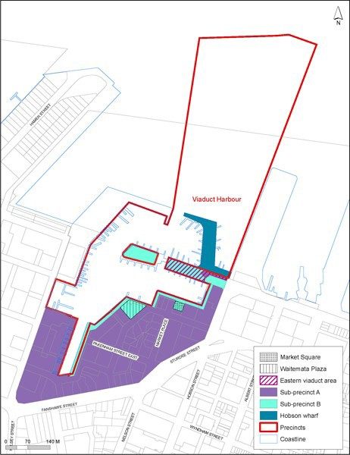

Precinct plan 2: Building height
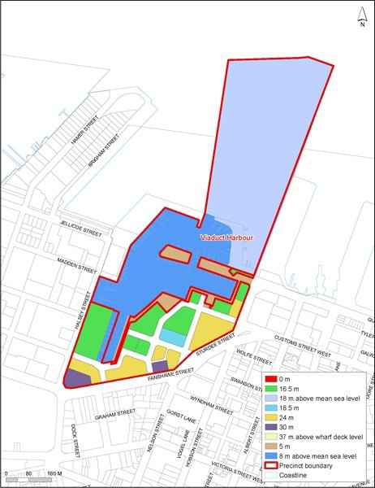

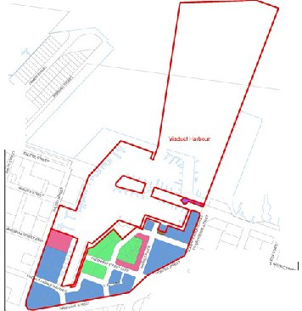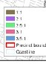Precinct Site

'

.......
· .
"o'f l.. ,--

....,
•

- . 1
I

.II

.._ ...
I - I

•- •
....,..

Precinct plan 4: Pedestrian accessways and viewshafts
