PART 3 ­ REGIONAL AND DISTRICT RULES»Chapter K: Precinct rules»2 Central»

2.5 Cornwall Park

- Activity table

The activities allowed in the Cornwall Park precinct are those listed in the Public Open Space ­ Conservation, Informal Recreation and Sport and Active Recreation zones, except as specified in the activity table below.

Activity table – Cornwall Park sub­precincts
Activity | A | B | C | D | E | F | G
Land use
Accessory buildings | RD | P | P | P | P | P | P
Accommodation
Existing caretaker’s, park ranger, or groundsman’s  accommodation | NC | NC | P | NC | NC | NC | NC
Commerce
Food and beverage, excluding  drive­through restaurants | NC | P | P | P | P | P | P
Community
Education facilities | NC | NC | NC | NC | P | P | P
Offices | NC | NC | NC | NC | P | NC | P
Infrastructure
Stormwater management  devices | NC | P | P | P | P | P | P
Rural
Farming | P | P | P | NC | P | P | NC
Development
Buildings, structures and works associated with a permitted activity unless otherwise  specified | P | P | P | P | P | P | P
Parks infrastructure | RD | P | P | P | P | P | P
Rock walls | RD | P | P | P | P | P | P
Vegetation planting | RD | P | P | P | P | P | P
Water body/water feature | NC | D | D | D | NC | NC | NC

Land use controls

2.1 Food and beverage

  - Food and beverage activities must be limited to restaurants and cafes that are accessory to a permitted activity.

  - Food and beverage activities must not be located within 50m of a residential zone.

  - Food and beverage activities that are located within 50m of a residential zone are a restricted

discretionary activity, provided that the other controls specified above are met.

Offices

    - Offices must be accessory to the management of Cornwall Park.

Farming

    - Farming activities in sub­precinct A must only relate to the farming of light animals i.e. sheep.

    - Farming of heavy animals (i.e. cattle, horse and deer) in sub­precinct A is a restricted discretionary activity.

Parks infrastructure

    - Parks infrastructure activities must be limited to boardwalks and pedestrian bridges more than 1m above natural ground level, except that in sub­precincts B and C, elevated boardwalks, observation areas and related structures are also permitted.

Rock walls

    - Rock wall activities also include the maintenance and repair of existing rock walls.

Development controls

  - The development controls in the Cornwall Park precinct are those listed in the Public Open Space ­ Conservation, Informal Recreation and Sport and Active Recreation zones, except as specified below.

Earthworks

    - Any earthworks undertaken within an area identified in precinct plan 2 is a permitted activity provided prior investigation demonstrates evidence that the earthworks will not disturb an archaeological or geological feature.

    - For the purposes of this control, demonstrable evidence means the recovery of information from an archaeological site using accepted archaeological techniques such as sampling via bore holes, survey, recording or remote sensing.

    - In the event that archaeological features are uncovered, works are required to cease immediately and the relevant statutory authorities must be notified.

Maximum height

    - The maximum height of any building in sub­precinct A must not exceed 5m and the height of exterior lighting, fittings and supports in sub­precinct A must not exceed 8m.

    - The maximum height of any buildings must not exceed 8m in sub­precincts B, C, E, F and G and a height of 10m for any exterior lighting, fittings and supports.

    - The maximum height of any elevated boardwalk in sub­precincts B and C must not exceed 15m.

    - The maximum height of any building or structure in sub­precinct D must not exceed 10m.

Yards

    - Front yard
      - 5m or the average of the setback of buildings on adjacent front sites, whichever is lesser. Where an adjacent site(s) is vacant no front yard is required.

    - Side and rear yards
      - 5m for any boundary which adjoins a site in a Residential, Future Urban or Special Use zone.

      - 3m for any boundary which adjoins a site in any other zone.

Building and site coverage

    - The GFA of individual buildings must not be more than 250m2.

    - The maximum permitted site coverage or cumulative total area of buildings must not exceed 10% of the net site area.

Parking

    - The location and size of formed and sealed parking areas and associated vehicle access must be in accordance with precinct plan 3.

    - There are no minimum parking requirements for existing or new activities undertaken within the area of the precinct plan.

Assessment ­ Restricted discretionary activities

Matters of discretion
The council will restrict its discretion to the matters below for the activities listed as restricted discretionary in the activity table.

Table 1

Activity/matters of discretion | Intensity and scale | Traffic and access | Site layout, landscaping and design | Effects on heritage and the natural  environment and integration of matauranga  and tikanga | Loss of public access to or exclusive use of public open space | Incorporated concept plan and adopted reserve management plans
Food and beverage | X | X |  |  | X | X
Farming of heavy  animals |  |  |  | X | X | X
Accessory buildings | X | X | X | X |  | X
Parks infrastructure |  |  | X | X |  | X
Rock walls |  |  | X | X |  | X
Vegetation planting |  |  |  | X |  | X

Assessment criteria
1. For development that is a restricted discretionary activity in the Cornwall Park precinct, the assessment criteria specified for the relevant restricted discretionary activities in the Public Open Space zones apply.

Precinct plans

Precinct plan 1: Cornwall Park precinct archaeology features
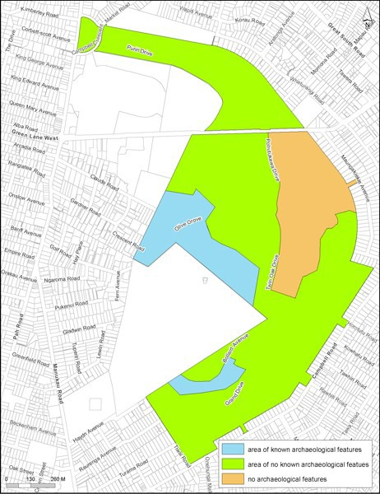

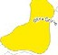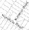Precinct plan 2: CornI Park prednct geoheritage sites

•
• •

..,..f!
\

- l
• •
• •
J - •
.
........
i
8
!
.a
,
•

/
/

"'"' .......,,i

._••• .

....,...."."'

•................_..

-"'.

_...

.--....."..."...'.-....·.
-·----:---.--

·.. _ _

'1- >- >....._........-
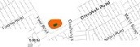......... .... ......._.,

_.......
...
_,.

.-., '•

- ....$'........... ...--

Precinct plan 3: Cornwall Park precinct ­ landuse
