PART 3 ­ REGIONAL AND DISTRICT RULES»Chapter J: Overlay rules»3 Special Character»

3.4 Special Character Residential North Shore

- Activity table

The following table specifies the activity status of activities in the Special Character Residential North Shore overlay. Refer to appendix 10.5 for the special character statement.

Activity | Activity status
Restoration, repair and internal alterations to buildings | P
The construction of a deck provided:  - it is located at the rear of the building and does not extend towards the side boundary any further than the rear corner of the building on either side  - the floor level no higher than 1m above the existing ground level  - it does not have a balustrade | P
External alterations or additions to buildings within Area 1 in Map 1 in clause 8 below | C
External alterations and additions to buildings not otherwise provided for | RD
Construction of up to five dwellings on a site refer Map 1 in clause 8 below | C
Construction of up to five dwellings on a site not otherwise provided for | RD
Construction of more than five dwellings on a site | D
Total or substantial demolition (more than 30 per cent by volume) or removal of a dwelling or  the relocation of a dwelling within the site | RD

Notification

  - An application for the total or substantial demolition, removal or relocation of a dwelling will be subject to the normal test for notification under the relevant sections of the RMA.

Land use controls

3.1 Density

Table 1:

Overlay area | One dwelling per
Area A | 450m²
Area B | 500m²
Area C | 600m²

Refer to the Special Character area maps 2 ­ 5 in clause 8 below.

Development controls

  - Building height

    - Permitted building height 8m.

    - Building height between 8m and 9m is a restricted discretionary activity.

    - An application for a building to exceed 9m is a discretionary activity.

Height in relation to boundary

    - The Single House zone height in relation to boundary control applies, refer to development controls clause 6.3, except in the Devonport part of the overlay area, being south of Ngataringa Bay and Seabreeze Road, where:
      - buildings must not project above the recession plane shown in Figure 1 below as measured from any point 2.75m above natural ground level

      - any boundary adjoining a road or public open space must be treated as the north boundary with a 37­degree recession plane applying

      - a gable end or dormer may project above the recession plane where it does not exceed 1.5m².
Only two gable ends or dormers are allowed on a single boundary. The protruding part of the dormer will be assessed as the projection of the vertical face of the dormer measured parallel to the boundary to which the recession plane applies

      - an application to infringe this height in relation to boundary control is a discretionary activity.

Figure 1: Height in relation to boundary
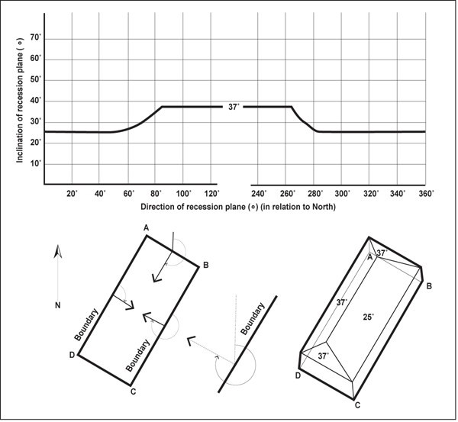

Instructions
At any point on each of the site boundaries draw lines across the site perpendicular to the property boundary. These lines represent the direction of the recession plane. Measure the angle between north and the perpendicular lines drawn. Refer to the graph above to ascertain the inclination of the recession plane.

In the example shown:

BOUNDARY | DIRECTION | INCLINATION
AB | 210 degrees | 37 degrees
BC | 300 degrees | 25 degrees
CD | Road | 37degrees
DA | 120 degrees | 37 degrees

Yards

Table 2:

Yard | Dimension
Front | The same as the two adjoining dwellings or  The average setback of the adjoining two dwellings, where they are different, or  3m
Arterial | 6m
Rear | 3m
Side | 1.2m

    - Garages must be set back 1.5m from the road boundary.

Building coverage

Table 3:

Site | Maximum Building  coverage
Sites 300m² or smaller | 45%
Sites larger than 300m² | 35%

Fences

Table 4:

Fence height | Circumstances
1.2m | In the front yard, the fence must not comprise:  - concrete block, unplastered  - traditional corrugated steel ­ standard profile or ‘baby’ profile ­ fixed with the corrugations in any orientation other than vertically  - profiled sheets, other than corrugated steel fixed as described above  - flat sheet materials  - any composite fence using the above excluded materials
1.5m | Fence posts and gates at property corners
1.2m | Where a wall retaining natural ground level existing on 22 March 2007. Provided a setback of at least 0.5m from the rear face of the existing retaining wall is used to allow  a full half­metre of space for planting or hedging

Building length

    - Parts of any building greater than 5m high must be within the arms of a 130­degree angle formed by two lines intersecting at any point on the adjacent boundary such that each line forms an angle of 25­

degrees with the boundary, refer to Figure 2 below.

    - Where two or more dwellings are proposed, the delineated area boundary associated with each dwelling must be treated as a site boundary. For terrace housing this control only applies to external boundaries of a terrace housing development and does not apply to the site frontage of a terrace housing development.

Figure 2: Building length
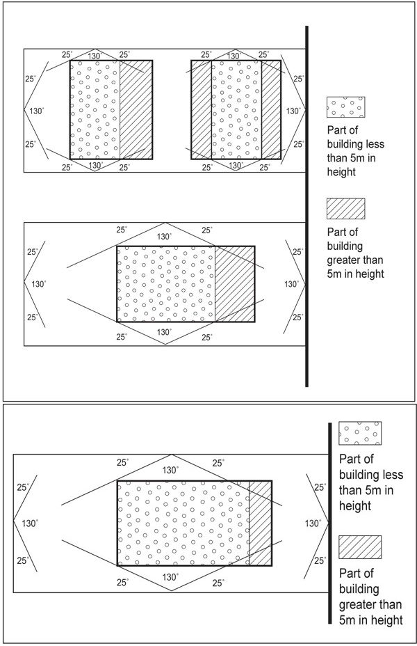

- Assessment ­ Controlled activities

5.1 Matters of control
The council will reserve its control over the matters listed below for the controlled activities listed in the activity table.
  - External alterations and additions to buildings in Area A, refer Figure 3: Stanley Point
    - architectural design

    - context and character

    - retention of historical site element.

  - Accessory buildings and dwellings in Area A, refer Figure 3: Stanley Point
    - architectural design

    - retention of historical site element.

Assessment criteria
    - Architectural design
      - Alterations or additions should use materials that are the same or similar to existing materials of buildings.

      - Any additions and alterations should retain as much original fabric as possible.

      - Alterations and additions should not detract from the continuity of the front façade alignment of buildings on the street.

      - New buildings and relocated buildings clearly visible from public vantage points such as reserves and beaches beyond the site should be compatible with the surrounding neighbourhood context. Special attention should be paid to the bulk, scale, form, detail and use of materials.

    - Context and character
      - Additions and alterations should not adversely affect the group significance or coherence of the streetscape.

      - Alterations to post­1940s buildings should be designed to avoid dominance of, or contrast with the wider street character.

    - Retention of historical site elements
      - Any proposed additions/alterations to buildings built before 1940 should retain the architectural and historical form, including the original roof form, proportions and style of the building and other design characteristics such as design detailing, original fabric and materials, finishes, proportions, and window size, proportion and location within walls.

Assessment ­ Restricted discretionary activities

6.1 Matters of discretion
The council will restrict its discretion to the matters listed below for the restricted discretionary activities listed in the activity table and for specific development control infringements.

  - External alterations and additions to buildings
    - architectural design

    - context and character

    - retention of historical site elements.

  - Demolition or removal or buildings or the relocation of a building within a site
    - architectural design

    - building condition

    - context and character

    - car parking.

  - Accessory buildings and dwellings
    - architectural design

    - context and character

    - car parking.

  - Development control infringement – density
    - retention of historical site elements.

  - Development control infringement – height between 8m and 9m
    - architectural design

    - context and character

    - retention of historical site elements.

  - Development control infringement – fencing
    - context and character

    - retention of historical site elements.

Assessment criteria
All demolitions, alterations and additions to existing buildings and new buildings in the special character residential overlay area will be assessed having regard to the relevant special character statement for the overlay area (including fencing) in Appendix 10.5.
    - Architectural design
      - Alterations or additions should use materials that are the same or similar to existing materials of buildings. Traditional materials such as corrugated steel sheet, timber shingles, timber weatherboards, and timber joinery are considered generally appropriate, especially where these materials match or are very similar to the original materials, and are used in the same manner as those of the subject house.

      - Original fabric should be retained wherever possible.

      - Any additions and alterations should retain as much original fabric as possible.

      - Alterations and additions should not detract from the continuity of the front façade alignment of buildings on the street.

      - New and relocated buildings should be sympathetic and compatible in architectural style, form, bulk, proportion, with the character of the area.

      - New buildings and relocated buildings should use material that are the same or similar to the materials of traditional surrounding buildings.

      - New buildings and relocated buildings should not detract from the continuity of the front façade alignment of buildings on the street.

      - External additions and alterations maintain the predominance of the roof form, and leave dominant the original form and lines of the existing roof.

      - Garages and carports should not obscure the visibility of the site from the surrounding public realm. Where possible they should be located at least 1m behind the front façade.

      - The degree to which the appearance of the house contributes to the character and amenity of the area.

      - For new or relocated buildings the form, mass, proportions and materials should be compatible and sympathetic to the characteristics of the era of the street, including the built form, landscape and street patterns.

      - New buildings and relocated buildings that are clearly visible from public vantage points such as reserves and beaches beyond the site should be compatible with the surrounding neighbourhood context. Special attention should be paid to the bulk, scale, form, detail and use of materials.

      - Fences or walls or a combination should not obscure the architectural character of the existing building on the site, and should be visually permeable to maintain the traditional visual link and relationship between the house and the street.

    - Building condition
      - Pre­1940 houses should only be demolished or removed where they are in such poor structural or physical condition or so substantially altered that restoration is not practicable.

      - Older houses and some built after 1940 deserve recognition for their townscape, streetscape, architectural and collective values in contributing to special character. Effects on these values should be assessed on an individual and wider context basis.

      - Evidence should be provided by the owner with compelling reasons articulating why demolition or removal is necessary.

      - Whether adverse effects on neighbourhood and streetscape character have been mitigated by actively pursuing re­use options.

      - Relocation within the same community as the original site will be considered favourably.

    - Context and character
      - Additions and alterations should not adversely affect the group significance or coherence of the streetscape. Particular care should be exercised where the proposal is adjacent to or in the vicinity of any places listed on the historic heritage schedule.

      - Alterations to post­1940s buildings should be designed to avoid dominance of, or contrast with, the wider street character.

      - Alterations to buildings clearly visible from public vantage points such as reserves, beaches, the waterfront and other roads beyond the site should fit compatibly within the context of surrounding buildings and the neighbourhood and should avoid dominance of or contrast with the character of that context. Special attention must be paid to the bulk, scale, form, use of materials and consistency with the style of the original building.

      - Applicants should be able to show that the proposal has been chosen through consideration of design alternatives to minimise the adverse effects on the streetscape, heritage values and neighbourhood character.

      - Proposals should be designed to avoid cumulative adverse effects.

      - The proposal should conserve and enhance significant landscape planting, especially mature trees.

      - Any new or relocated building should minimise alteration to the character of the area through placement of the building on the site, and the use of appropriate form and maintenance of the existing façade lines of neighbouring houses.

      - For buildings relocated within their own site, the new location should retain a compatible setting

for the building in accordance with the character of the street and other buildings in the vicinity. This includes maintenance of the existing façade lines of neighbouring houses.

      - New or relocated buildings should not detract from the continuity of the front façade alignment of the buildings to the street.

      - Materials used should be sympathetic and have a relationship to the traditional character of the buildings on the street.

    - Retention of heritage historic site elements
      - Any proposed additions/alterations to pre­1940 buildings should retain the architectural and historic form, including the original roof form, proportions and style of the building and other design characteristics such as design detailing, original fabric and materials, finishes, proportions, and window size, proportion and location within walls.

      - Alterations to the rear of houses in the overlay area should be generally compatible with the style of the original house in terms of form, use and materials and detailing, and should be sympathetic to the built heritage of the area. While this criterion offers greater flexibility in the type of change that may be acceptable at the rear to allow for modern living requirements and for a relationship with the outdoors, the design should still reflect the style of the subject building.

      - Proposals should include initiatives to recover original built form and lost details, particularly at the front of the buildings.

      - Where a site contains a listed heritage item and the reduction of delineated area would assist in protecting the building, provided that the average delineated area complies with the minimum delineated area requirement when averaged across all units in the development.

      - The scale and form of fences and walls should reflect the historic form of development along the street, and should not detract from the continuity or harmony of existing fences along the street.

    - Vehicle access and car parking
      - The provision of vehicle access and car parking should complement the character of the neighbourhood, having regard to location, design, detailing, use of materials and landscaping.

Assessment ­ Development control infringements

7.1 Matters of discretion
In addition to the matters of discretion set out in clause 11.1.1 of the Residential zone rules, the council will restrict its discretion to the matters listed below. Refer to clause 6.2 above for the relevant assessment criteria identified below.
  - Height
    - architectural design

    - context and character

    - retention of historical elements.

  - Fencing
    - context and character

    - retention of historical elements.

An infringement of the clause 4.6 above will be considered as an infringement of the height in relation to boundary rule for the purpose of clause 6.3 Residential zone rules.

Special Character area maps

Map 1
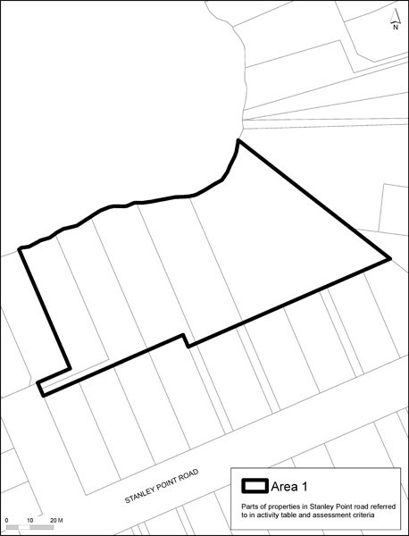

Map 2: Sites for density controls
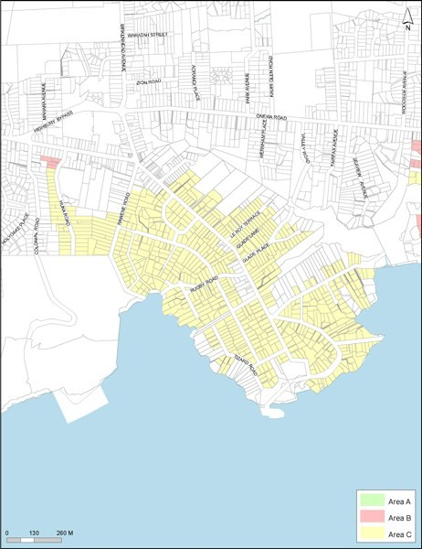

Map 3: Sites for density controls
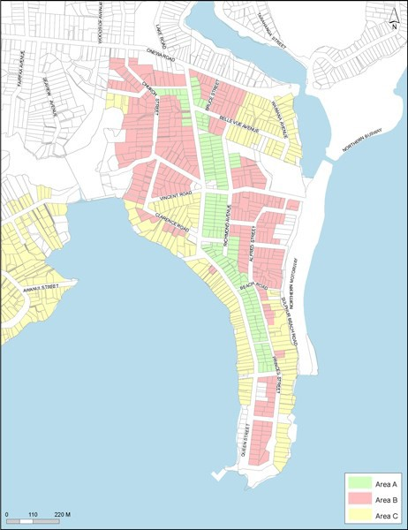

\1
''

'v
\ \':\:
't .
/"' /
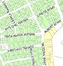-· · / 1>-: -
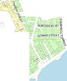,./ > '
'
'
l 1
'
\ I
I
!
I

'; II

A'NV

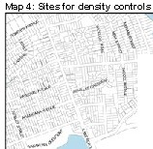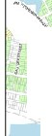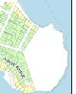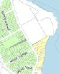

Map 5: Sites for density controls
