PART 3 ­ REGIONAL AND DISTRICT RULES»Chapter J: Overlay rules»3 Special Character»

3.3 Special Character Residential Isthmus A, B and C

- Activity table

The following table specifies the activity status of activities in the Special Character residential Isthmus overlay. Refer to Appendix 10.4 for the relevant the special character statements and clause 8 below containing Special Character area maps for the location and extent of Isthmus A, Isthmus B and Isthmus C areas.

Activity | Activity status
 | Isthmus A | Isthmus B | Isthmus C
Development
Restoration, repair and internal alterations to buildings | P | P | P
The total or substantial demolition or removal (more than 30 per cent by volume) of any building (excluding accessory buildings) constructed on the site prior to 1940 and in the case of:  - Isthmus A applies to all sites  - Isthmus B and C applies only on identified sites, subject to demolition controls, shown in the maps in clause 8.1 and 8.2 below | RD | RD | RD
Relocation of buildings within a site | RD | RD | RD
Construction of new and accessory buildings | RD | RD | RD
External alterations and additions to buildings | RD | RD | RD
Earthworks greater than 5m3 | N/A | N/A | D

Notification

  - An application for the total or substantial demolition of a building constructed prior to 1940 and
identified in the maps in clause 8.1 and 8.2 below or the relocation of a building on a site will be subject to the normal test for notification under the relevant sections of the RMA.

Land use controls

Density
    - The number of dwellings on a site must not exceed the limits specified below:

Table 1:

Overlay area | One dwelling per
Isthmus A | site
Isthmus B1 and B3 | 1000m2
Isthmus B2 | 600m2
Isthmus C1 | 400m2 or 500m2 where the site does not comply with shape factor (net site  area)
Isthmus C2 and C3 | 600m2
Isthmus C2a (refer Figure 1  below) | 1000m2

Figure 1: Defined sites for density controls in Isthmus C2a
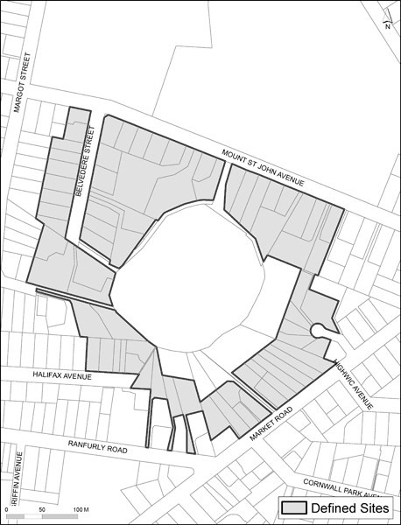

- Development controls

4.1 Maximum building height

Table 2:

Sub­overlay | Building Height
 | up to 8m | 8 ­ 10m | 10 ­ 12m | greater than 12m
Isthmus A | P | RD | D | D
Isthmus B1 | P | P | RD | D
Isthmus B2 and B3 | P | RD | D | D
Isthmus C1, C2 and C3 except sites with a contiguous boundary with open space on a  volcanic cone | P | D | D | D

Additional Isthmus C building height controls
Refer to the Volcanic viewshafts and height­sensitive areas overlay which may have more restrictive building height controls.
  - Buildings on sites which have a contiguous boundary with open space on a volcanic cone must not exceed the maximum building height being the lesser of either:
    - 8m or

    - a line between the highest points of the roofs of the nearest two dwellings on sites which also have a contiguous boundary with open space on a volcanic cone

  - Buildings on 14A Pickens Crescent Mt Albert (Lot 1 DP 394305; CT 377258) must not exceed 7.3m

  - Buildings on 47A Mount St John Avenue Epsom (Lot 1 DP 359371; CT 241868) must not exceed RL
103.37 being below the 7.3m height limit, chimneys or similar structures must not exceed the height limit

  - Infringement of the building height controls will be considered a discretionary activity.

Height in relation to boundary

Isthmus A and Isthmus C1
    - Buildings must not project above a 45­degree recession plane measured from any point 3m above the ground level along any boundary of the site other than a road boundary.
      - For corner sites this rule applies to whichever is the longer of the two boundaries

      - This rule does not apply to the sites identified in Figure 2 below.

Isthmus B and Isthmus C2 and sites in Isthmus A identified in Figure 2
    - Buildings must not project beyond the applicable recession plane identified in Figure 3 and 4 below measured from any point 2m above the ground level of any boundary adjacent to land zoned residential or open space, except in Isthmus C2 where buildings must not project above the 45­degree recession plane measured 2m above the ground level along any boundary of the site adjoining an open space.

    - Buildings must not project beyond a building envelope contained by the 55­degree recession plane from points 2m above any boundary adjacent to the road identified in Figures 3 and 4 below.

    - It is a discretionary activity to infringe this rule.

Height in relation to boundary for sites identified in Figure 2

    - Buildings must not project beyond the applicable recession plane shown in Figures 3 and 4 measured from any point 2m above the ground level of any boundary of the site other than a boundary adjoining a road or Open Space zone.

    - Where boundaries adjoin the road, they must not project beyond a building envelope contained by the 55­degree recession plane from points 2m above any boundary adjacent to the road as shown in Figures 3 and 4.

Figure 2: Defined sites for height in relation to boundary controls in Isthmus A
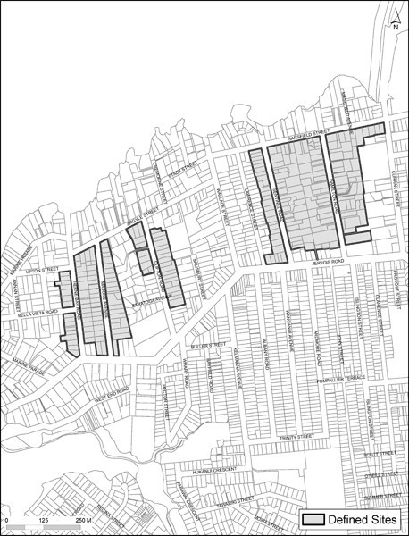
Figure 2a

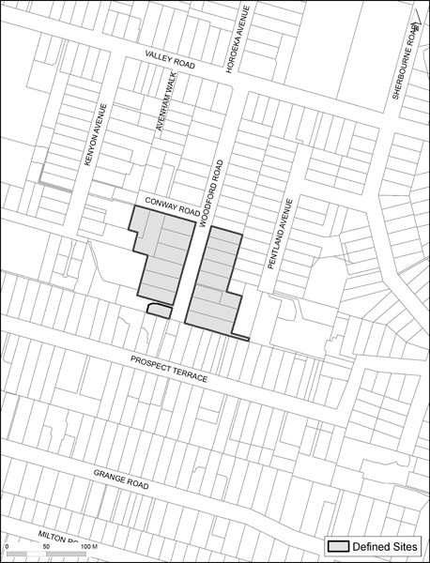
Figure 2b

Figure 3: Recession plane indicator
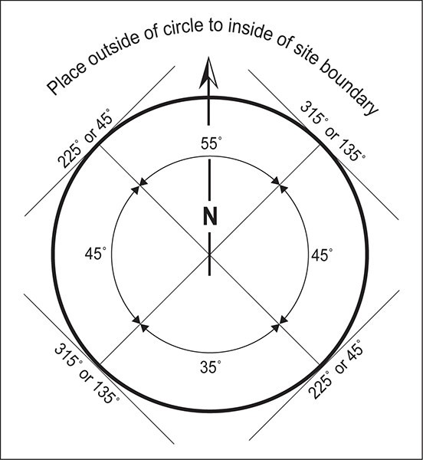
Note: North is true north. Bearings on the circle increase in a clockwise direction.

Figure 4: Recession plane cross section
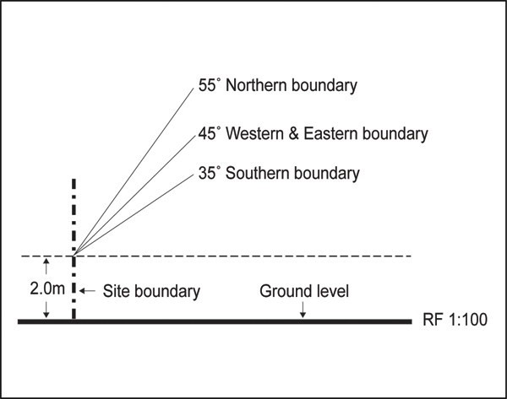

  - Exceptions/qualifications to height in relation to boundary for Isthmus A and Isthmus C1

    - Where the land immediately beyond the site boundary forms part of one or more entrance strips or access site, the control may be taken from the farthest boundary of that entrance strip or access site.

    - If the width of an adjoining entrance strip or access site is greater than 3m, then the control will be taken at a parallel line 3m out from the site boundary.

    - The exception cannot be applied along more than 60 per cent or 20m, whichever is greater, of the length of the site boundary where it adjoins an entrance strip or access site.

    - As shown on Figure 5, where the exception is applied to a site with a continuous series of boundaries adjoining one or more entrance strips or access site, then the exception cannot be applied along more than 60 per cent or 20m, whichever is greater, of the cumulative length of those boundaries. The exception can be applied in one continuous length or it can be broken up into parts.

Figure 5: Irregular shaped sites adjacent to entrance strips or access lots
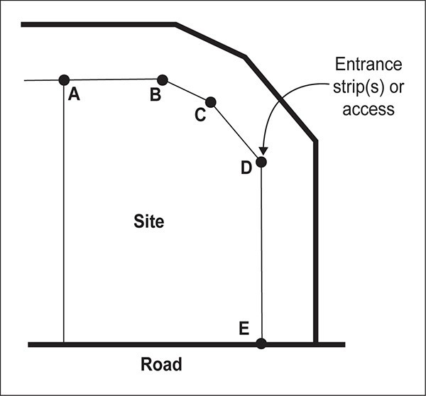

    - As illustrated in Figure 6, where a common wall:
      - exists between two buildings on adjacent sites

      - is proposed between an existing building and a proposed building on an adjacent site

      - is proposed between two buildings on adjacent sites

then the building in relation to boundary control will not apply along the length of that common wall.

Figure 6: Common wall boundary
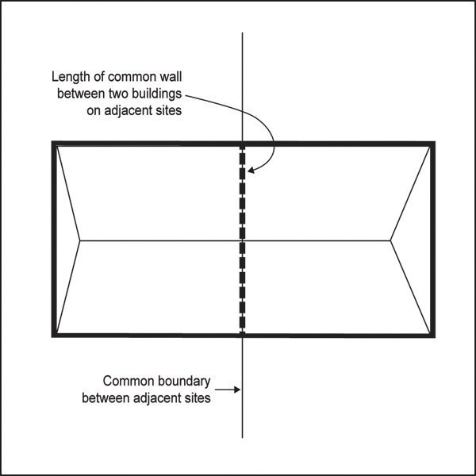

    - Where a site has a common boundary with land in the Industrial, Centres and Mixed Use, General Business and Business Park zones, the height in relation to boundary control does not apply at the common boundary.

    - A retaining wall within 3m of any site boundary must not exceed:
      - a height above ground level equal to the shortest horizontal distance between that part of the retaining wall and any boundary of the site

      - a height above ground level of 1m, whichever is greater.

8.

9.

10.
Height for the purpose of this control will be measured from the ground level at the point on the site boundary to which the above measurement is taken.

Where a site has a common boundary with public open space, the height in relation to boundary control specified in clause 4.4.2 above will apply to the common boundary.

A gable end or dormer may project beyond the recession plane where it is:

- no greater than 1m in height and width measured parallel to the nearest adjacent boundary

- no greater than 1m in depth measured horizontally at 90­degrees to the nearest adjacent

boundary.

11.
No more than two gable end or dormer projections are allowed for every 6m length of site boundary.

Building coverage, landscaped area and paved surfaces

Table 3:

Sub­overlay | Site Size | Maximum Building  coverage (%) | Minimum  landscaped area (%) | Maximum paved area  (%)
Isthmus A and C1 | Up to 200m2 | 55% | 28% | 17%
Isthmus A | 201m2 ­ 499m2 | 35+ [(500 ­ site area) x  0.06 recurring] | 40 ­ [(500 – site area)  x 0.04] | 25 ­ [(500 – site area) x  0.026 recurring]
Isthmus A | 500m2 and  over | 35% | 40% | 25%
Isthmus B1 |  | 25% | 50% | 25% or an additional 10% where it is offset by an equivalent reduction in building coverage below  the maximum specified
Isthmus B2, C2 and  C3 |  | 30% | 45%
Isthmus B3 |  | 25% | 50%

    - It is a discretionary activity for development to exceed the building coverage, landscape area and paved area rules.

Figure 7: Coverage and surface controls
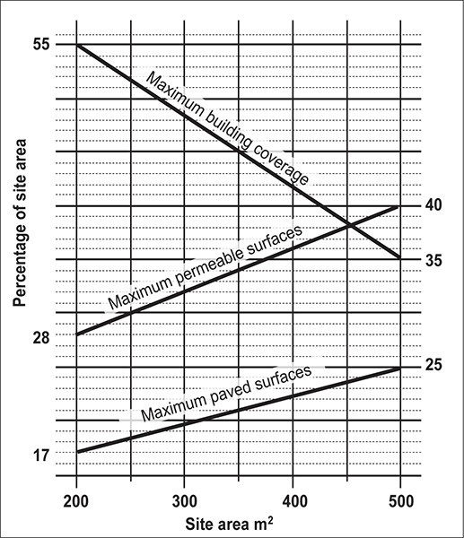

  - Yards

Isthmus A
    - Buildings must not locate between the road boundary and the average existing setback of dwellings on adjacent sites, being:
      - the three sites on each side of the subject site or

      - the six sites on one side of the subject site.

    - The front yard must comprise at least 50 per cent landscaped area.

Isthmus B and C2
    - Front yard 6m, except if located on a corner site 3m.

    - A 6m yard must be provided where a site adjoins an open space zone.

    - The front yard must comprise at least 60 per cent landscaped area.

Isthmus C1 and C3
    - Buildings must not locate between the road boundary and the average existing setback of dwellings on adjacent sites, being:
      - the three sites on each side of the subject site or

      - the six sites on one side of the subject site.

    - The front yard must comprise at least 60 per cent landscaped area.

    - It is a restricted discretionary activity to infringe the yard controls.

Fences, walls or other structures

Isthmus A
    - Fences, walls or other structures must not locate in the front yard, other than a picket fence up to 1.2m in height.

Isthmus B and C2
    - Fences, walls and other structures in the front yard must not exceed 1.4m in height.

    - The height of the fence, wall or structure may be 1.8m where it is at least 40 per cent visually permeable.

Isthmus C1
    - Fences, walls or other structures must not locate in the front yard, other than a picket fence or basalt stone wall up to 1.2m in height.

    - It is a restricted discretionary activity to infringe the fences, walls and other structures control.

Assessment ­ Restricted discretionary activities

Matters of discretion
The council will restrict its discretion to the matters specified for restricted discretionary activities in the assessment criteria in clause 5.2 below.

Assessment criteria
- Total or substantial demolition or removal of a building constructed prior to 1940 Isthmus A
  - The intrinsic character and value of the existing building and the contribution it makes to the historical form and pattern of the streetscape and neighbourhood.

  - Whether the demolition or removal of the building itself will detract from the special character of the streetscape and neighbourhood as a whole. To demonstrate this, a site and context analysis shall be submitted which shows the extent to which the existing building shares the dominant original form and design features with other buildings in the street (refer to the ADM for the Architectural Design Guidelines for Isthmus A and B zones for more detail on the requirements for a site and context analysis).

  - Whether the building has retained its basic original (or restored) design features relating to the overall form, mass, proportion and materials (i.e. its integrity) so that restoration/renovation of the building is practicable and reasonable, such that it makes a positive contribution to the historical form and pattern of the streetscape and neighbourhood. When determining what is practical and reasonable, regard shall be had to:

i.

ii.
achieving current Building Code compliant standards providing modern day living/amenity standards.

  - In the event that there is a concurrent application for a replacement building, whether its design, quality, purpose and amenities would positively contribute to the neighbourhood character in accord with the assessment criteria in clause 11 below.

- Total or substantial demolition or removal of a building constructed on the site prior to 1940 on sites in the Isthmus B and C identified on the map in section 8 as subject to the control
  - The intrinsic character and value of the existing building (irrespective of age) and its contribution to streetscape character.

  - The value of the building by reference to its architectural style, whether as an exemplar of the type or as being representative of type.

  - The integrity of the building in its current state, having regard to its architectural form and style and the authenticity of its component parts.

  - Its relationship to other adjacent buildings and whether it contributes to a group in such a way that its loss would result in the loss of a character value attributable to the group.

  - Its contribution to streetscape character by reference to surrounds within the site, and/or to the public street, and/or to relationships to open space shared with adjacent buildings.

  - The practicability and cost of any necessary rehabilitation, and the inability to achieve reasonable amenity for occupants and reasonable compliance with any requirement of the Building Act.

  - In the event that there is a proposed replacement building, its design, quality, purpose and amenities and the contribution that such building might make to the qualities of streetscape character.

  - Whether the building is being removed for relocation and reuse elsewhere.

- Additional criteria for the substantial demolition or relocation of a building constructed prior to 1940 Isthmus C identified on the maps in section 8 as subject to the control
  - The nature and extent of any disturbance to the biophysical components that contribute to streetscape character such as landform or vegetation cover.

- External additions and alterations to and relocation of existing buildings, Isthmus B
  - The intrinsic character and merits of the existing building (irrespective of age), and its contribution to streetscape character.

  - The effect of the alteration or addition on the integrity and authenticity of the original building.

  - Whether the alteration or addition has regard to, or complements the form, style and materials of the existing building.

  - The effect of the alteration or addition on the established relationship to the street, in particular, whether the change contributes positively to the street.

  - Whether the alteration or addition is designed to have regard to landscape elements, including structural and built elements and existing established trees and hedges which make a significant contribution to streetscape value or if, where this is not practical, replacement planting or a replacement structural/built element is proposed.

  - Shifting the building to make more efficient use of the site for a complying subdivision or for a development that complies with the minimum density for the overlay.

- External additions and alterations to and relocation of existing buildings, Isthmus A and C
  - Where the external alteration involves the demolition or removal of less than 30 per cent by volume of an existing building constructed prior to 1940, whether the demolition or removal will detract from the continuity and streetscape as a whole.

  - Where the external alteration involves the demolition or removal of less than 30 per cent by volume of an existing building constructed on the site prior to 1940, whether any legacy qualities and original design features of the existing building remain.

- Additional criteria for external additions and alterations to and relocation of existing buildings, Isthmus A and C1
  - Alterations to expand the building within a roof­space shall respect, and leave dominantly visible, the form and lines of the existing roof.

  - Where decoration and architectural features are used, such features shall follow the characteristic form and detail of the existing building on the site, or if the original features have been removed/altered, other buildings of the same period in the street.

  - Changes to the frontage of an existing building shall not detract from the legacy character of the whole fabric, design, or the character of original detailing of the facade, and shall not detract from the continuity of façade alignment of the buildings in the street.

  - Materials used shall be the same or similar as the existing materials of the building so that the new building work is consistent with the traditional character and material of existing buildings on the site and in the street.

  - Any existing traditional fencing along the road frontage boundary shall be preserved or reinstated at the completion of development.

  - For parts of buildings highly visible to the street or public place new windows and doors shall be consistent with the proportions and detail of the windows and doors traditionally present in buildings of the style and with the overall window to wall ratio, to ensure visual cohesion.

- Additional criteria for external additions and alterations to and relocation of existing buildings in the Isthmus A
  - The form, mass, proportion and scale of the external additions and alterations shall be compatible with the prevailing architectural style of the existing building on the site. In addition a site and context analysis may need to be submitted which shows the extent to which the form, mass, proportion and materials of the additions and alterations are sympathetic to the original architectural style predominant in the street. The provision of this analysis is dependant on the size and scale of the development proposed.

  - Where garages or carports are to be adjoined to the existing building on the site, they shall be designed primarily to allow good visibility of the residential building from the street. Where visibility of the building will be significantly obscured, consideration shall be given to alternative designs
and locations on the site for garages and carports or provision of a car pad.

- Additional criteria external additions and alterations to and relocation of existing buildings in the Isthmus C
  - The scale, form, mass, proportion and colour of the external addition or alteration shall be compatible with the original architectural style of the existing building on the site.

  - The addition or alteration or associated site­works shall avoid physical effects on the natural volcanic landform, including cumulative effects.

  - The additions and alterations which are visible from the street or any other public place shall not detract from the architectural character of period housing or landscape qualities that are predominant in the street.

- Additional criteria external additions and alterations to and relocation of existing buildings in the Isthmus C1
  - Where garages or carports are to be adjoined to the existing building on the site, they shall not obscure the visibility of the building from the street. Consideration shall be given to alternative

locations on the site for the garage or carport where visibility of the building will be obscured, unless such alternative locations create adverse visual effects on a volcanic landform.

  - The addition or alteration shall minimize adverse visual effects on the volcanic landscape by minimising alteration to the natural landform, and by appropriate placement of additions or alterations on the site, judicious use of traditional forms, design detailing, colour and landscaping.

10.

Additional criteria external additions and alterations to and relocation of existing buildings in the Isthmus C2 and C3

- Materials used shall be the same or similar to the existing materials of the building.

- The additions and alterations shall not detract from the architectural character of period housing or landscape qualities that are predominant in the street.

- The additions and alterations shall be located so that larger trees on the site and/or on adjoining land are retained, where this is not practical, replacement planting, particularly of indigenous trees where appropriate, shall be required. Indigenous planting will be required in the yard, refer to development controls 4.6 above.

- The addition or alteration shall minimize adverse visual effects on the landscape context by avoidance of visually obtrusive excavation, and by appropriate placement of additions on the site and judicious use of traditional forms, design detailing, colour and landscaping.

11.

Construction or relocation of a new building or accessory building, Isthmus A

- The form, mass, proportion and scale of the building shall be compatible with the original architectural style predominant in the street, and shall not ignore, compete with, or dominate that character.

Note: To demonstrate this, a site and context analysis shall be submitted which shows how the new building respects and responds positively to the special character of the street in terms of form, mass, proportion and use of materials.
- Materials used shall be in sympathy and shall have a clear relationship to the traditional character and materials of buildings along the street.

- Parts of a building which are highly visible to the street shall maintain a window to wall ratio visible from the street that is similar to that predominant on the surviving original character buildings in the street.

- Buildings shall be located on a site so that the siting of the building reflects the original subdivision and development patterns existing in the street, particularly in situations where development is occurring on an amalgamated site. This ensures the 'grain' of the area (in terms of the size, spacing and rhythm of street­front buildings) is maintained.

- Buildings shall also be located on a site so that they do not detract from the continuity of the front façade alignment of residential dwellings in the street.

- Any existing traditional fencing along the front boundary shall be preserved or reinstated at the completion of development.

- Buildings shall preserve the sense of original visual frontage access and interactivity between houses and the street, and shall not present blind or near­blind facades to the street.

- Buildings shall maintain the predominance of traditional pitched roof forms in the vicinity of the site.

- Garages and carports shall allow good visibility of the existing building from the street, and shall, where possible, be located to the rear of, underneath (where appropriate in terms of topography), or alongside, the building on the site (particularly in relation to double garages/carports). The

council may consent to the location of a garage or carport in the front yard where it is satisfied that:

i.

ii.

iii.
no practical location is available elsewhere on the site

any structure associated with the parking provisions is minimal in scale, (which in most circumstances will exclude a double­width garage or double­width carport) and is designed in a manner which is coherent with the original architectural character of any buildings on the site

the garage or carport will not significantly obscure the visibility of the existing building from the street.

12.

Construction or relocation of a new building or accessory building, Isthmus B

- The design of a proposed new building will complement the existing patterns of bulk and location, and the relationship to the street in the vicinity of the site.

- If a new/relocated building is significantly larger than existing adjacent buildings, its architectural design acknowledges the predominant scale of those existing buildings, through its massing and formal arrangement on the site. In the case of non­residential buildings, it is acknowledged that such formal arrangement may not be appropriate.

- Whether the Unitary Plan's bulk and location controls prevent the achievement of an architectural scale which might otherwise be appropriate to the locality or to the prevailing scale, or whether some relaxation of such controls will enable development of more appropriate form and scale

- The design of a new building in a contemporary idiom can be shown by analysis to have qualities which are sympathetic to existing established architectural forms and scale, in such a way as to make a positive contribution to streetscape.

- A new/relocated building is designed to have regard to landscape elements, including structural and built elements and existing established trees and hedges which make a significant contribution to streetscape value or if, where this is not practical, replacement planting or a replacement structural/built element is proposed.

13.

Construction or relocation of any new building or accessory building in Isthmus C

a. Materials used must be in sympathy and have a clear relationship to the traditional character and materials of existing buildings along the street.

14.

Construction or relocation of any new building or accessory building in Isthmus C2 and C3

- The scale, form, mass, proportion and materials of the building must be compatible with the original architectural style of the existing building on the site in the case of accessory buildings, or the original architectural style predominant in the street, and must not ignore, compete with, or dominate that character.

- New buildings must not detract from the consistency and harmony of building forms in the street or detract from the coherence of the streetscape.

- Buildings must contribute positively to the special character and coherence of the streetscape and visual pattern ­ the size, space and rhythm of street­front buildings ­ to at least the same or similar extent as any existing building to be removed from the site.

- The building must be located so that larger trees on the site and/or on adjoining land are retained.
Where this is not practical, replacement planting, particularly of indigenous trees where appropriate, must be required. Indigenous planting should be incorporated into Yard required by Rule 4.6 above.

- Any building or site­works must avoid physical effects on the natural land­form, including cumulative effects.

- Any new or relocated building must minimise adverse visual effects on the landscape context by avoiding visually obtrusive excavation, and by appropriate placement of the building on the site and judicious use of appropriate traditional forms, design detailing, colour and landscaping.

- For properties in Isthmus C2 pitched roofs, in gabled and/or hipped forms, must be used to mitigate adverse visual effects on the natural environment, including cumulative effects caused by adjacent houses being viewed in combination. In using gabled and hipped roof forms, it will not be possible to exploit the maximum allowable height over the entire footprint, as would be possible for a house with a mono­pitch roof constructed on a uniform slope, or a flat­roofed house constructed on an existing terrace.

- For those properties in Isthmus C3 pitched roofs, in gabled and/or hipped forms, must preferably be used to mitigate adverse visual effects on the natural environment, including cumulative effects caused by adjacent houses being viewed in combination. In using gabled and hipped roof forms it will not be possible to exploit the maximum allowable height over the entire footprint, as would be possible for a house with a mono­pitched roof constructed on a uniform slope, or a flat roofed house constructed on an existing terrace.

15.

Construction or relocation of any new building or accessory building in Isthmus C1

- The scale, form, mass, proportion and colour of the building shall be compatible with the original architectural style predominant in the street, and shall not ignore, compete with, or dominate that character.

- Buildings shall contribute to the special character and coherence of the streetscape to the same or similar extent as the existing building to be removed from the site

- Parts of a building which are highly visible to the street shall maintain a window to wall ratio visible from the street that is similar to that predominant on the surviving original character buildings in the street.

- Buildings shall be located on a site so that the siting of the new building reflects the original subdivision and development patterns existing in the street, particularly in situations where development is occurring on an amalgamated site. This ensures the visual pattern of the area (in terms of the size, spacing and rhythm of street­front buildings) is maintained.

- Buildings shall also be located on a site so that they do not detract from the continuity of the front façade alignment of residential dwellings in the street.

- Any new or relocated building shall be visually compatible with the form of the cone, and minimise adverse effects on the volcanic landscape by minimising alteration to the landform, and by appropriate placement of the building on the site, and the use of appropriate form, colour and landscaping.

- Any existing traditional fencing along the front boundary shall be preserved or reinstated at the completion of development.

- Buildings shall preserve the sense of original visual frontage access and interactivity between houses and the street, and shall not present windowless or near­windowless facades to the street.

- Buildings shall maintain the predominance of pitched roof forms in the vicinity of the site.

- Buildings and site­works shall avoid physical effects on the natural volcanic land­form, including cumulative effects.

- Garages and carports shall not obscure the visibility of the existing dwelling from the street.
Alternative locations shall be preferred, provided that these do not give rise to adverse visual effects on the volcanic landscape.

Assessment ­ Development control infringements

6.1 Matters of discretion
The council will restrict its discretion to the matters set out below:
  - fences, walls and other structures

  - earthworks.

Assessment criteria
    - Fences, walls and other structures ­ Isthmus A and B
      - The wall, fence or other structure maintains the traditional spaciousness and landscape qualities of the front yard that are appreciated from the street.

      - Where there are period walls or fences along a street, the scale and form of proposed walls, fences and other structures does not destroy or detract from the continuity or harmony of existing period walls or fences along the street.

      - Where there are no period walls or fences along a street, the scale and form of proposed walls, fences and other structures is consistent with existing walls, fences or structures in the street and/or immediate neighbours.

      - On roads classified as arterial roads, a solid structure can be considered for noise attenuation purposes. The design must include modulation of solid elements, planting bays and climbing plants to mitigate adverse visual effects on the subject property or the wider streetscape.

    - Additional criteria fences, walls or other structures ­ Isthmus C1
      - The wall, fence or other structure does not obscure the architectural character of the existing building on the site, and maintains the traditional visual link and the interactive relationship between the building and the street.

      - Materials used are sympathetic to the existing building on the site and to adjacent period buildings and do not detract from the special character of the streetscape.

      - The scale and form of walls, fences and other structures reflects the historic form and pattern of development along the street and does not destroy or detract from the continuity or harmony of existing fences along the street.

    - Earthworks in Isthmus C
      - Earthworks will not detract form the natural character of the cone, cliff or landscape on which they are situated; and

      - The extent of alteration to the natural landform is minimised by appropriate site utilisation, building design and construction methods; and

      - Retaining walls are avoided; and

      - Visual effects of any visible excavation are mitigated by planting.

Special information requirements

  - Alterations and additions to existing buildings and new buildings in the special character residential overlay area must have regard to the relevant special character statement for the overlay area.

  - A site and context analysis must be submitted showing the extent to which the existing building shares original design features with other buildings in the street.

  - In addition, a site and context analysis may need to be submitted showing the extent to which the form, mass, proportion and materials of the additions and alterations are sympathetic to the original architectural style predominant in the street. Providing this analysis is dependent on the size and scale

of the development proposed.

Note: The council holds a set of aerial photos from 1940 which may assist council and applicants to determine the age of buildings and parts of buildings subject to application for demolition. Upon request these aerial photos can be viewed free of charge.

Special Character area maps

  - Isthmus B1, B2 and B3

Map 1
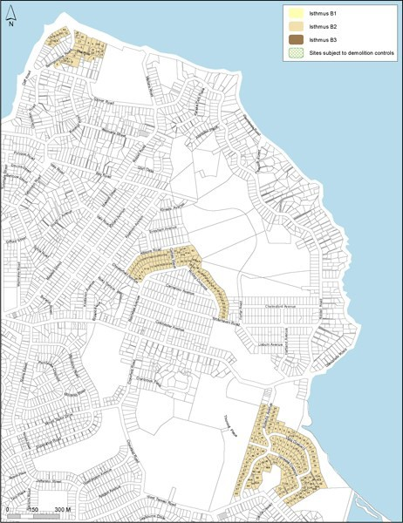

Map 2
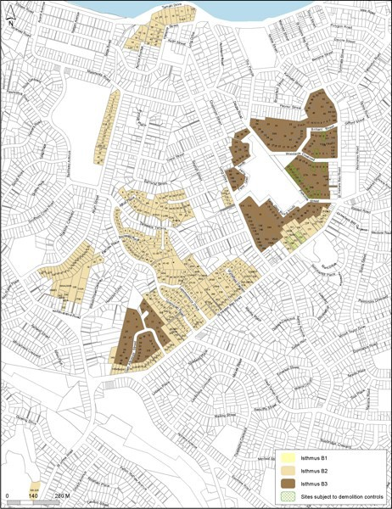

Map 3
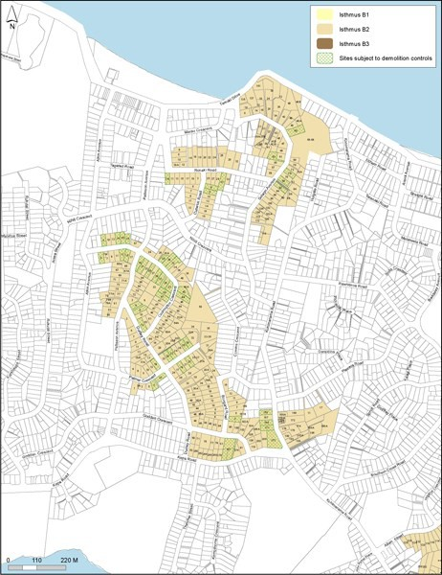

Map 4
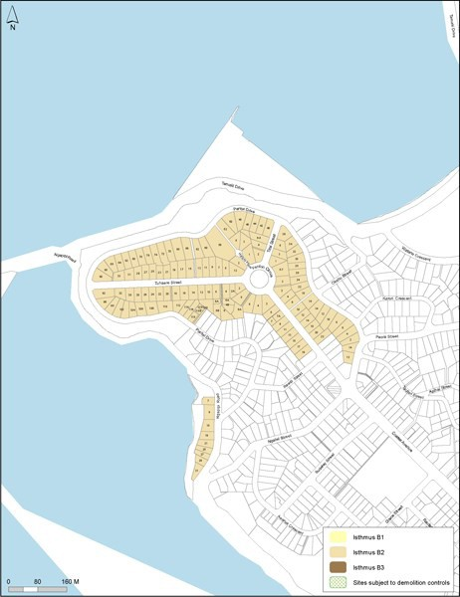

Map 5
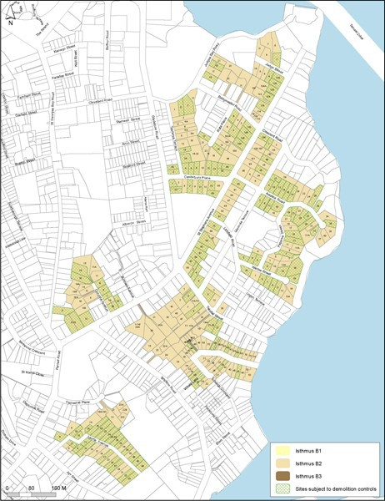

Map 6
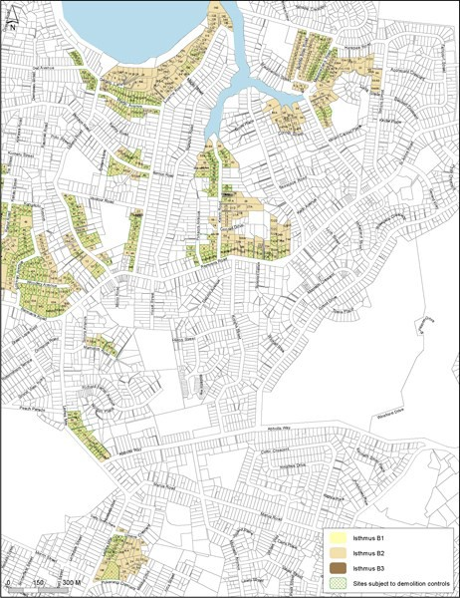

Map 7
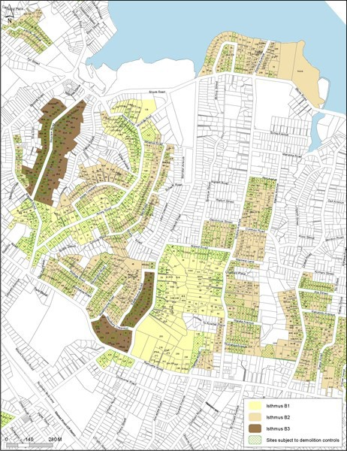

Map 8
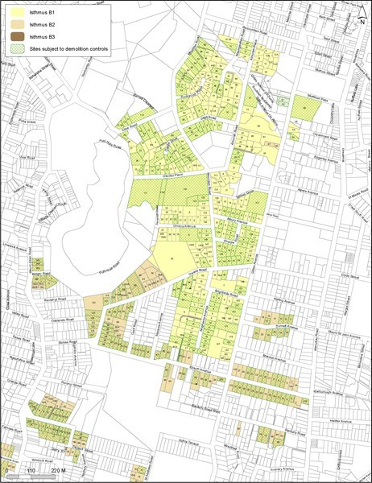

Map 9
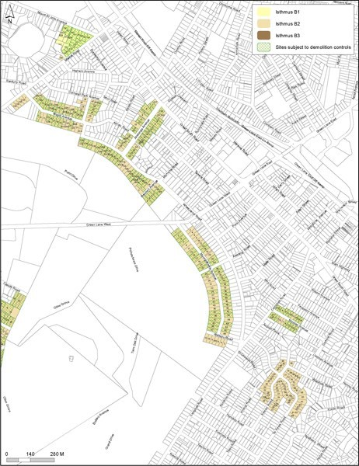

Map 10
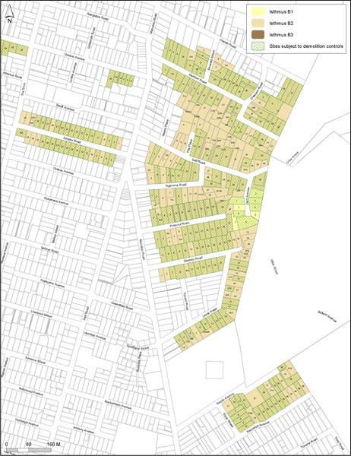

Map 11
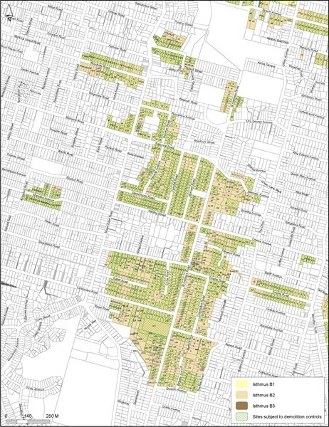

Map 12
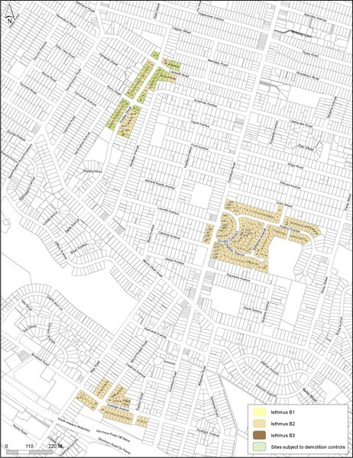

Map 13
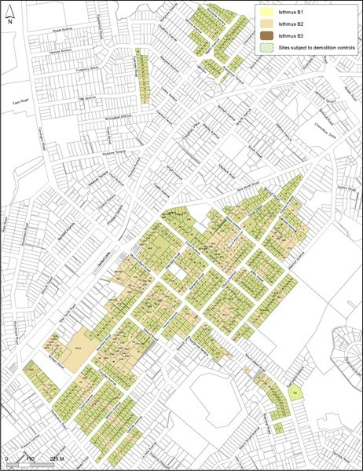

Map 14
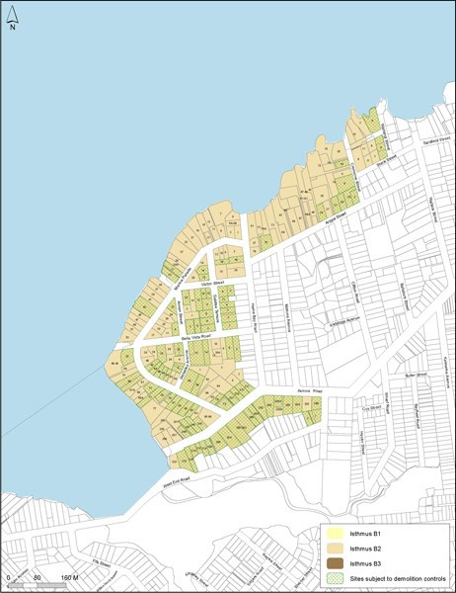

Map 15
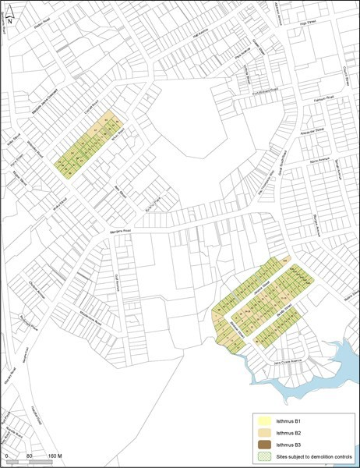

  - Isthmus C

Map 1
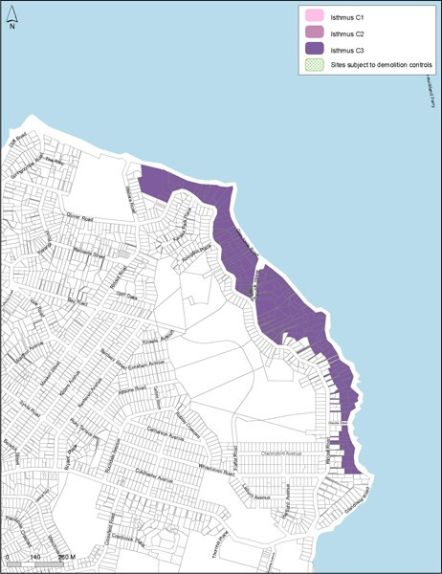

Map 2
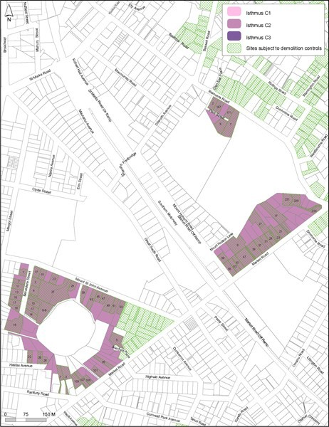

Map 3
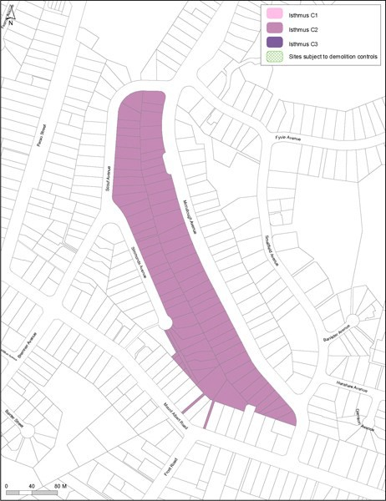

;

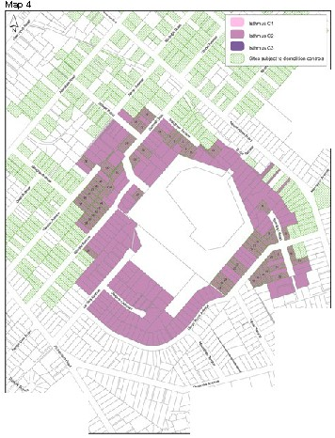

/
-
• 0'. ,•X.M
·-' ..-..
\ '
\
\

,.

·--
'
.......c,
    - 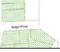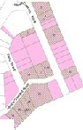W••uoO::· I
•_....c.:

I 1
., 1

..-·"' ' I
l
l
-- ' I
'
1

J '

j

•-.. .:v

Page 40 of 40

