PART 3 ­ REGIONAL AND DISTRICT RULES»Chapter J: Overlay rules»3 Special Character»

3.1 Special Character Business

- Activity table

The following table specifies the activity status of activities in the Special Character business overlay. Refer to Appendix 10.1 for Special Character statements and clause 6 below for the Special Character Area maps for each area identifying character­defining and character­supporting buildings.

Activity | Activity status
Development
Character defining or character­supporting buildings:  - external redecoration and repair  - alterations to the rear, except on corner sites  where the works use a similar design and materials to the existing building | P
Character­defining or character­supporting buildings:  - external redecoration and repair  - alterations not provided for above | RD
Character­supporting buildings:  - total or substantial demolition (more than 30 per cent by volume) or  - any demolition of the front facade | RD
Character­defining buildings:  - total or substantial demolition (more than 30 per cent by volume) or  - any demolition of the front façade | D
New buildings | RD
Alterations to buildings, not identified as character­defining or character­supporting  buildings, where the alteration is permitted in the underlying zone | P

Note: For the earthworks and vegetation management provisions that relate to this overlay refer to Auckland­ wide ­ Earthworks and Vegetation management rules.

Notification

  - An application for the total or substantial demolition of a character­supporting building will be subject to the normal test for notification under the relevant sections of the RMA.

Development controls

Building height
    - Buildings in the Special Character business overlay ­ Howick, must not exceed the height limits shown on Figure 1 below.

    - Buildings that do not comply with this control are a discretionary activity.

Figure 1: Howick Town Centre and surrounds height controls
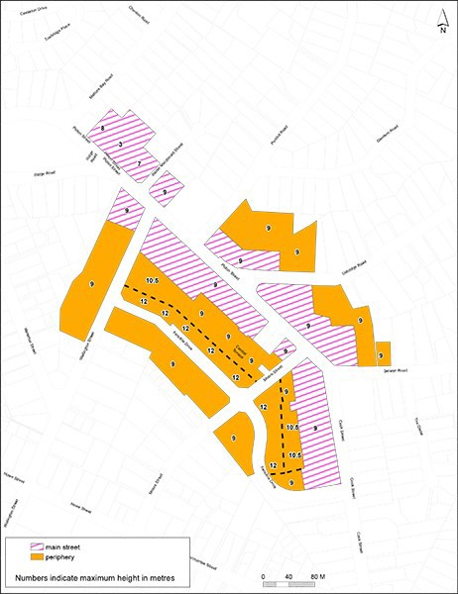

- Assessment ­ Restricted discretionary activities

4.1 Matters of discretion
The council will restrict its discretion to the matters below for the restricted discretionary activities listed in the activity table and for specific development control infringements:
  - the total or substantial demolition of a character­supporting building

  - alterations, redecoration and repair to buildings identified as character­defining or character­supporting

  - new buildings.

Assessment criteria
    - Total or substantial demolition of a character­supporting building
      - Any proposal to demolish or remove a character­supporting building, or part of the building should not significantly adversely affect the built special character of the area. Consideration should include the contribution the individual building makes to the context, character or cohesiveness of the streetscape or area.

      - Total or substantial demolition should not adversely impact on the special character values of the

area. The contribution the building makes to adjoining or nearby scheduled buildings and other character­defining or supporting­buildings, either through the context and the relationship of the building or through the building’s mass, height or rhythm of facades should be considered.

      - Whether the existing building forms part of a cohesive group of buildings in terms of similarity of age, scale, proportion or design and the extent to which the building’s demolition would detract from the shared contribution that group makes to streetscape, the unique special character or the history and context of the area.

      - Whether the existing building is a remnant example of a building type that reflects the history of the area.

      - Whether the building is beyond rehabilitation to a state which would display its special qualities, architectural qualities or special characteristics of the streetscape and the surrounding area.

      - Whether the costs of restoration are excessive in comparison to the costs of a new building of similar size and quality.

    - Alterations, redecoration and repair to buildings identified as character­defining or character­supporting
      - In the case of character­defining buildings, alterations and additions should:

i.

ii.

iii.

iv.

v.

vi.
at the street elevation of the building avoid or maintain an appearance similar to the original

be positioned and designed to retain the continuity of the front facade alignment of the building or adjoining buildings and the established horizontal or vertical modulation

be of a design and materials which are similar or in sympathy to those originally used and do not detract from the architectural character and detailing of the building

be in keeping with the architectural form, proportions and style of the existing building(s) on the site

retain as much of the existing building facade as practicable by refurbishing, restoring and adapting parts of the existing building rather than replacing them

use a colour scheme which is compatible with the age and detailing of the building, and it should be derived from research into the original colour scheme of the building

      - In the case of character­supporting buildings, the additions and alterations should:

i.

ii.

iii.

iv.

v.
on the road facing facade of the building be sympathetic to the existing building, and any other surrounding scheduled, character­defining or character­supporting buildings, and surrounding architectural styles

be positioned and designed to retain the continuity of the front facade alignment of the building or adjoining buildings, and the adjoining established horizontal or vertical modulation

be compatible with the prevailing architectural style of the existing building in form, mass, proportion and materials

use materials which are sympathetic to the traditional character and material of the building

where it is proposed to combine buildings, establish a finished appearance/facade that retains visual evidence of the previous pattern of development by vertical modulation.

    - New buildings
      - Buildings should:

i.

ii.
reflect and give regard to the special character statement for the area

be compatible or designed to respond to the architectural form, bulk, proportions, materials and colour of the existing buildings on the site and/or any surrounding scheduled, character­ defining or character­supporting buildings

iii.

iv.

v.

vi.

vii.

viii.
be compatible or designed to respond to the characteristics of the era of the adjoining street, including the built form, landscape and street patterns

be designed and located in a manner that respects original physical features of the special character area

be positioned to retain the continuity of the front facade alignment of the adjoining buildings

be constructed with materials that are of a high standard of quality and durability and are compatible and respond to the architectural character and detailing of the existing adjacent scheduled, character­defining or character­supporting buildings

be designed to respond to the established horizontal or vertical modulation evident on the front façade of the existing adjacent scheduled, character­defining or character­supporting buildings

where it is proposed to combine buildings and/or sites, establish a finished appearance/facade that maintains visual evidence of the previous pattern of development by vertical modulation.

Special information requirements

  - Alterations and additions to existing buildings and new buildings in the Special Character Business overlay must have regard to the relevant Special Character statement.

Special Character area maps

  - Balmoral

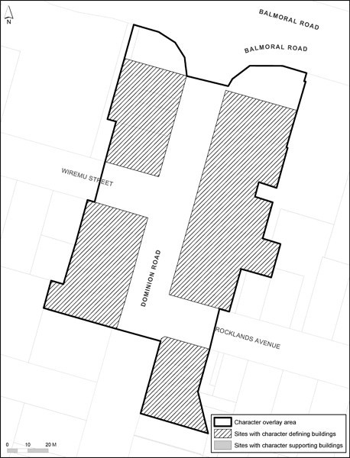

  - Eden Valley

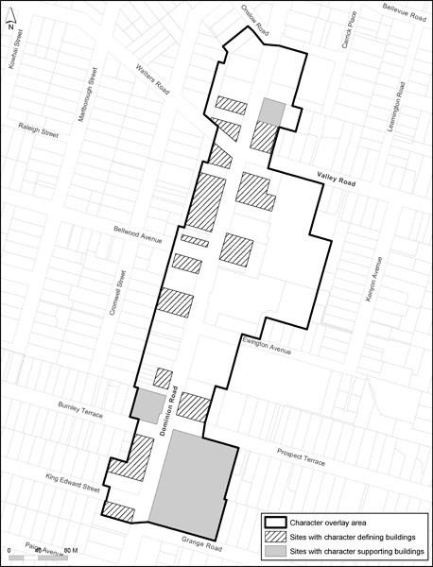

  - Ellerslie

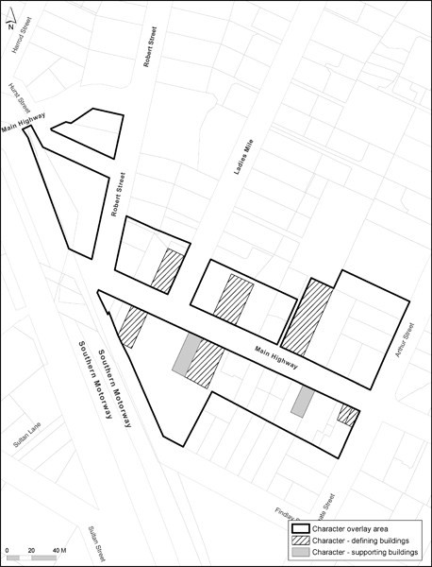

  - Grey Lynn

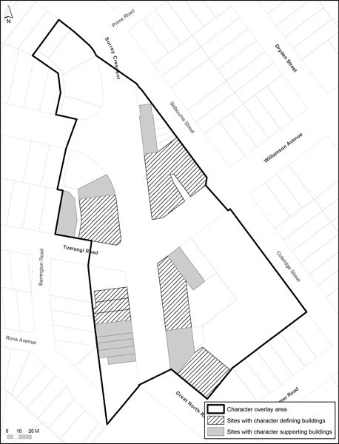

  - Howick

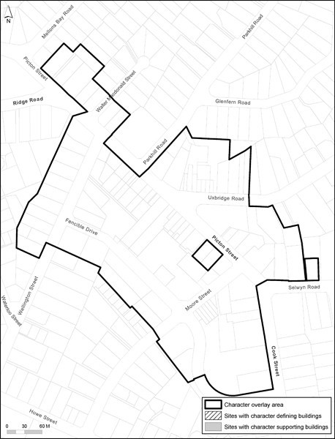

Kingsland

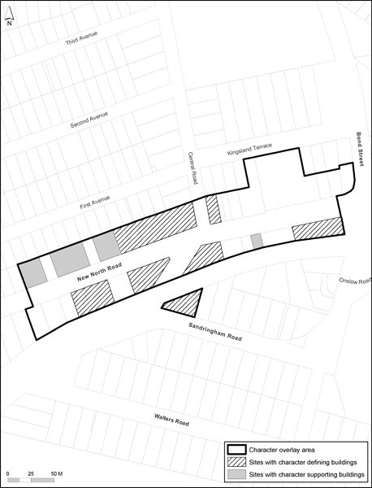

Mt Eden Village

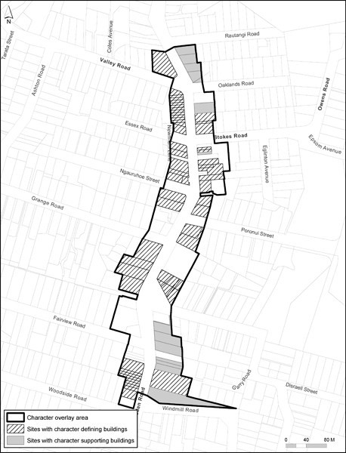

  - Newmarket

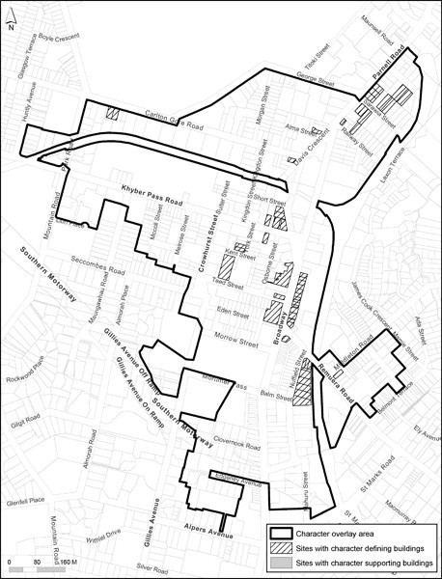

  - Parnell

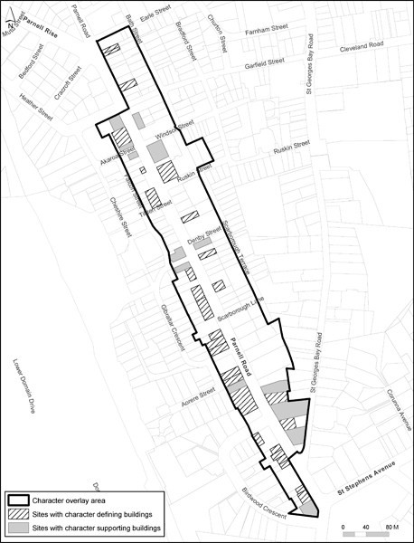

  - Ponsonby

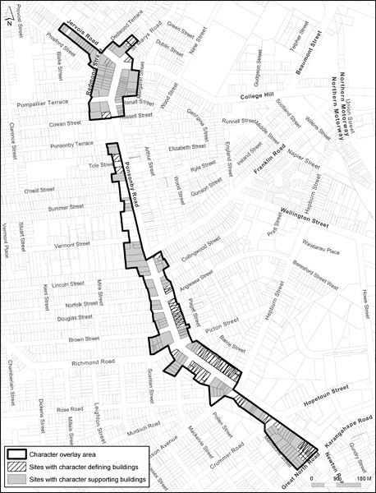

  - Sandringham

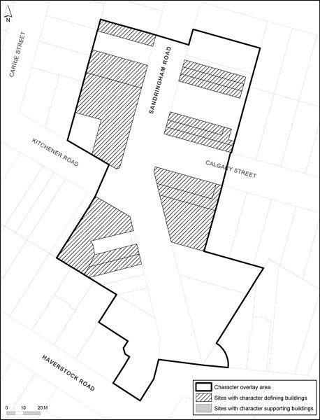

  - Upper Symonds Street

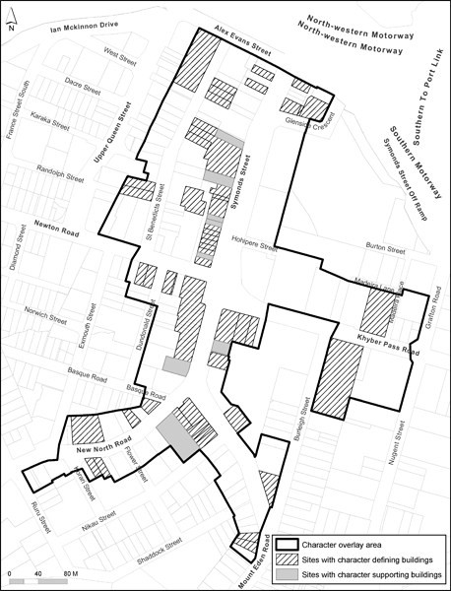

6.13 West Lynn

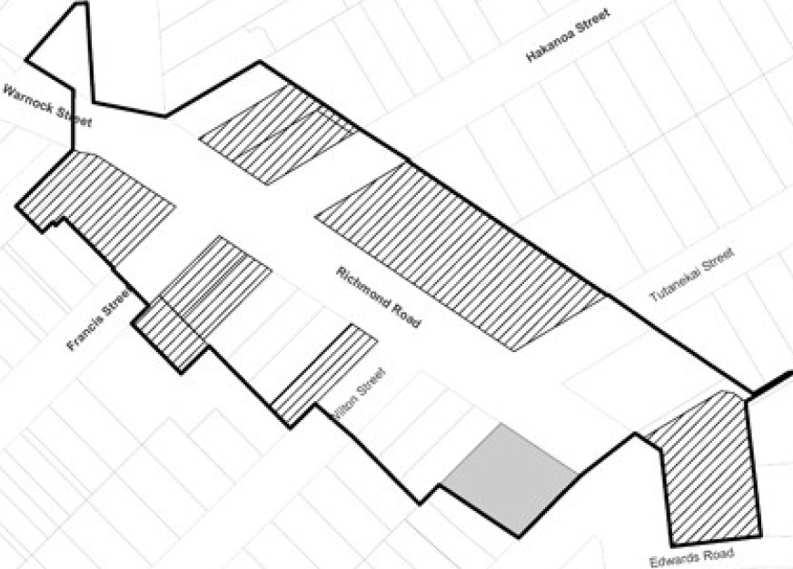

c:J CMfacler ovefb)' 111e.a
Slllr!s wilh ch:lmd;er d"'""''l' bwldng•
Site$ wilh c;hnmQc or lnu butil:ln P

6.14 Helensville

