PART 3 ­ REGIONAL AND DISTRICT RULES»Chapter I: Zone rules»

# 4 City Centre zone

## Activity table

The following table specifies the activity status of activities in the City Centre zone.

|  |  |
| --- | --- |
| **Activity** | **Activity status** |
| **Accommodation** | |
| Boarding houses | P |
| Dwellings | P |
| Retirement villages | P |
| Supported residential care | P |
| Visitor accommodation | P |
| **Commerce** | |
| Commercial services | P |
| Entertainment facilities | P |
| Offices | P |
| Retail | P |
| Conference facilities | P |
| Service stations | NC |
| **Community** | |
| Artworks | P |
| Care centres | P |
| Community facilities | P |
| Education facilities | P |
| Emergency services | P |
| Healthcare facilities | P |
| Hospitals | P |
| Information facilities | P |
| Recreation facilities | P |
| Major recreation facilities | P |
| **Industry** | |
| Industrial laboratories | P |
| Manufacturing | P |
| Repair and maintenance services | P |
| Warehousing and storage | P |
| **Mana Whenua** | |
| Marae complex | P |

|  |  |
| --- | --- |
| **Activity** | **Activity status** |
| **Development** | |
| New buildings | RD |
| Demolition of buildings | RD |
| Drive­through facilities | NC |
| Minor cosmetic alterations to a building (including special character buildings identified  on Map 1) that do not change its external design and appearance | P |
| Internal alterations to buildings | P |
| External alterations and additions to a special character building identified on Map 1 | RD |
| Alterations and additions to buildings not otherwise provided for | RD |
| Conversion of a building or part of a building to dwellings | RD |
| Conversion of a building or part of a building to visitor accommodation or boarding houses | RD |
| The total or substantial demolition (more than 30 per cent by volume), or any demolition  of the front facade of a special character building identified on Map 1 | RD |

## Notification

* 1. An application for the substantial demolition or any demolition to the front facade of an identified special character building will be subject to the normal tests for notification under the relevant sections of the RMA.
  2. An application to infringe the following development controls will be subject to the normal tests for notification under the relevant sections of the RMA:
     1. general building height controls shown on Map 3
     2. maximum tower dimension and tower separation.

## Land use controls

**3.1 Retail**

* 1. The land use activity status of retail outside of the core retail area shown on Map 2 will be determined in accordance with the table below:

Table 1

|  |  |
| --- | --- |
| Retail (excluding department stores and integrated shopping malls)  less than 1000m² GFA per site | P |
| Retail (excluding department stores and integrated shopping malls)  between 1000m² and 5000m² GFA per site | RD |
| Retail (excluding department stores and integrated shopping malls)  over 5000m² GFA per site | D |
| Department stores and integrated shopping malls over 1000m² GFA  per site | D |

## Development controls

* 1. **General building height**

Purpose: manage the height of buildings within the city centre to ­

* + - enable the tallest buildings within the core central business district and transition heights down to neighbourhoods adjoining the city centre and to the harbour edge
    - respect the valley and ridgeline form of the city centre
    - avoid adverse dominance, shading and/or visual amenity effects of building height on streets and public open spaces.

1. The height of a building must not exceed the limits shown on Map 3.
2. Where height limits shown on Map 3 and Map 4 overlap, the lowest height applies as the first level of control.

## Admission of sunlight to public places

Purpose: manage the scale of development around identified public open spaces to ensure they receive adequate sunlight generally between the hours of 10am and 2pm when those spaces are most used.

1. The height of a building within a defined sunlight admission cone shown on Map 4 must not exceed the allowable building heights detailed on the relevant diagrams in appendix 7.3.
2. Where part of an existing building does not comply with this control, any reconstruction, alteration or addition to the building must not increase the degree of non­compliance with this control.
3. A building that does not comply with this control is a non­complying activity.

## Aotea Square height control plane

Purpose: manage the scale of buildings ­

* + - to ensure that Aotea Square receives adequate sunlight when the space is most used
    - to maintain views from Aotea Square to landmark buildings and views to Aotea Square
    - so that tall buildings do not dominate the open character of Aotea Square.

1. The height of a building subject to this control must not exceed the height plane shown on Figure 5 in

appendix 7.3.

## Harbour edge height control plane

Purpose: manage the scale of buildings at the western end of Quay Street to ­

* + - provide a transition in building height from the core central business district to the waterfront
    - maximise views between the harbour and the city centre.

1. The height of a building subject to this control must not exceed the height plane shown in Figure 1 ­ Harbour edge height control plane. The height plane starts at a line 40m above the centre line of Quay Street and continues as a tilted plane at 45 degrees to the horizontal from that line in a southerly direction.
2. For the purpose of this control, the centre line of Quay Street extends between the eastern boundary of Britomart Place and the western boundary of Lower Hobson Street and is defined by a straight line passing through the coordinates specified in Figure 2 ­ Harbour edge height control co­ordinates.
3. A building that does not comply with this control is a discretionary activity.

### Figure 1: Harbour edge height control plane

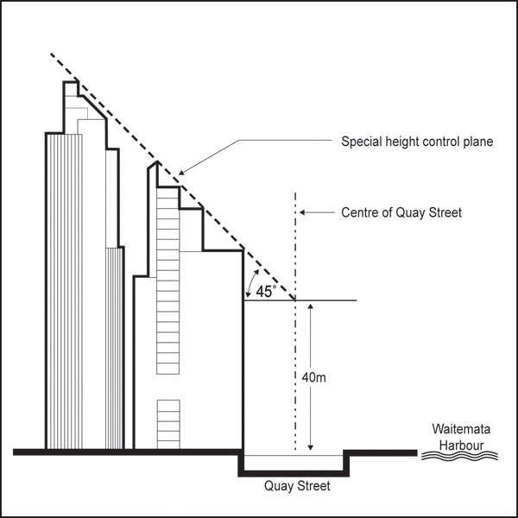

**Figure 2: Harbour edge height control co­ordinates**

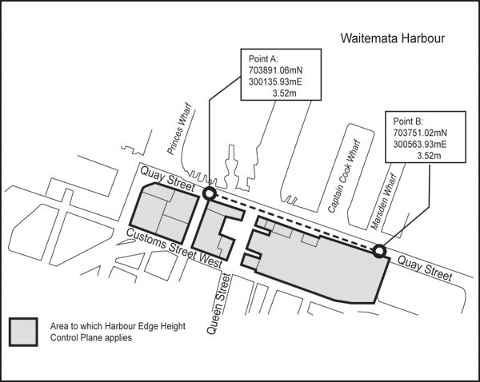

* 1. **Railway station building and gardens view protection plane**

Purpose: manage the scale of development to protect the view of the railway station buildings and gardens when viewed from Beach Road.

1. The height of a building, including any structures on the roof of a building, subject to this control must not exceed the height limits specified on Figure 3 ­ Railway station buildings and garden view protection plane. This figure defines achievable reduced level (RL).
2. A building that does not comply with this control is a non­complying activity.

### Figure 3: Railway station buildings and garden view protection plane

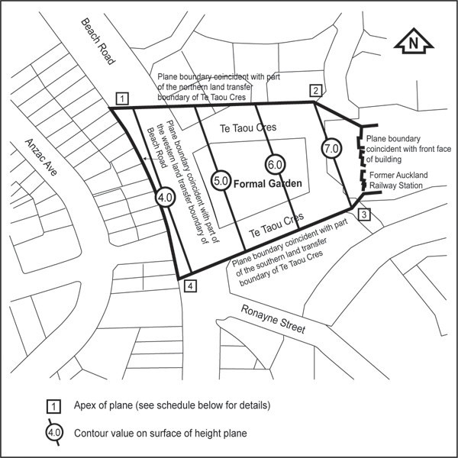

Maximum allowable building height above mean sea level (L&S Auckland Datum 1946) Table 2: Coordinate schedule

|  |  |  |  |  |  |
| --- | --- | --- | --- | --- | --- |
| **Point** | **Mt Eden circuit** | | **Height** | **New Zealand map grid** | |
| 1 | 703359.74 | 300824.91 | 3.72 | 6482240.75 | 2668580.94 |
| 2 | 703370.51 | 300995.42 | 7.00 | 6482248.03 | 2668751.85 |
| 3 | 703280.48 | 301025.99 | 7.00 | 6482157.38 | 2668780.37 |
| 4 | 703223.73 | 300874.12 | 3.76 | 6482103.75 | 2668627.36 |

Notes:

Coordinates in terms of Geodetic Datum 1949 Circuit origin: Mt Eden 700.000mN 300.000mE

## Dilworth terraces view protection plane

Purpose: manage the scale of development to protect the view of the Dilworth Terraces from the eastern end of

Quay Street.

1. The height of a building, including any structures on the roof of a building, subject to this control must not exceed the height limits specified on Figure 4 ­ View protection plane for Dilworth Terraces. This figure defines achievable RL.
2. A building that does not comply with this control is a non­complying activity.

### Figure 4: View protection plane for Dilworth Terraces

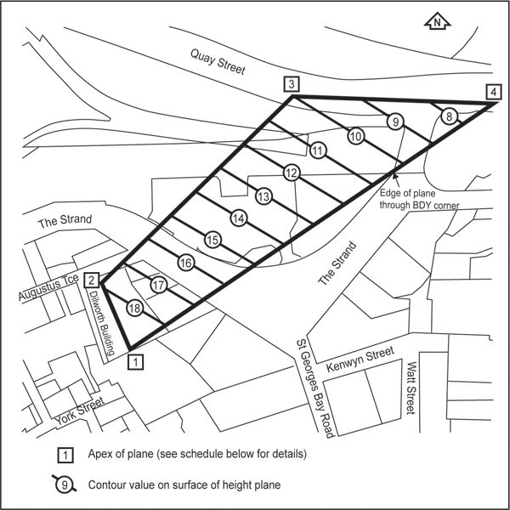

Showing maximum allowable building height above mean sea level (L&S Auckland Datum 1946) Table 3: Coordinate schedule

|  |  |  |  |  |  |
| --- | --- | --- | --- | --- | --- |
| **Point** | **Mt Eden circuit** | | **Height** | **New Zealand map grid** | |
| 1 | 703084.81 | 301376.49 | 19.22 | 6481954.55 | 2669126.81 |
| 2 | 703159.11 | 301348.15 | 17.86 | 6482029.42 | 2669100.00 |
| 3 | 703358.54 | 301547.57 | 10.00 | 6482213.80 | 2669303.46 |
| 4 | 703351.85 | 301744.18 | 7.00 | 6482213.80 | 2669510.92 |

Notes:

Coordinates in terms of Geodetic Datum 1949 Circuit origin: Mt Eden 7000.000mN 300.000mE

## Measuring building height

Purpose: require height to be measured using the rolling height method where the maximum height varies across the site (contours) or average street level method where a general height limit is specified.

1. Building height will be the same as the definition of height when measuring the:
   1. height planes for admission of sunlight to public places and the special height limits (refer Map 4), and
   2. height of buildings within the blocks bounded by Hobson Street, Fanshawe Street, Halsey Street, Victoria Street West, and Union Street.
2. Unless otherwise stated all other heights will be measured as the vertical distance between mean street level and a horizontal plane above that level (being the specified height limit).
3. For the sites fronting Nelson Street within the block bounded by Union Street to the south and Cook Street to the north, height may be determined from the mean street level of Nelson Street to a maximum depth of 26m from the site boundary with Nelson Street.

## Rooftops

Purpose: ensure the roofs of buildings are uncluttered when viewed from the street and surrounding buildings.

1. Rooftop projections including towers, turrets, chimneys, lift towers, machinery rooms and water towers that exceed the height of all parts of a parapet surrounding the roof on which the projections are located, must be enclosed in a maximum of three structures and integrated within the overall roof design.
2. All floor space forming part of rooftop projections that meet the requirements of this control is excluded from the calculation of gross floor area for the development.
3. For the purpose of this rule, rooftop includes the roof of building podiums in addition to its ordinary meaning.
4. For the purpose of this control, rooftop projections do not include:
   1. any part of a building included in the definition of gross floor area
   2. any roof top ornamental projections including finials, pediments and cornices integral to the design of the building
   3. telecommunications antennas and aerials.

## Basic floor area ratio (FAR)

Purpose: manage the scale of development in the city centre.

1. The basic FAR applying to any site in the city centre is as shown on Map 9.
2. A building that exceeds the basic floor area ratio specified for the site without providing a bonus feature is a non­complying activity.

## Bonus floor area ratio (FAR)

Purpose: encourage developments to be designed, contain activities or provide features that provide a benefit the public.

1. In addition to the basic floor area, bonus floor area is available where development incorporates one or more of the features listed in Table 4.
2. The area of a feature for which a bonus is obtained cannot be claimed for twice.
3. Floor space approved for publicly accessible open space and through­site links are exempt from the calculation of gross floor area.
4. To qualify for the bonus, the bonus feature must comply with the bonus rules. A bonus feature that does not comply with the relevant rules is a discretionary activity.
5. The amount of bonus floor area available per m2 of feature provided and the locations within which they apply are set out in Table 4 except that the methods for calculating the amount of bonus floor area available per m2 of feature provided for works of art, historic heritage and historic character floor space, and through­site links are detailed in clauses 4.19, 4.14, 4.15 and 4.17­4.1.8 respectively.
6. Table 4 lists the bonus features as permitted, controlled or restricted discretionary activities.
7. The bonus areas referenced in Table 4 are shown on Map 10.

Table 4: Bonus floor area

|  |  |  |  |  |  |  |  |  |  |  |  |  |  |  |  |  |
| --- | --- | --- | --- | --- | --- | --- | --- | --- | --- | --- | --- | --- | --- | --- | --- | --- |
| **Bonus feature** | **Activity Type** | **Bonus floor area available per m2 of**  **feature p\provided** | | | | | | | **Maximum floor area ratio limit to**  **bonuses on a site** | | | | | | | |
| **Bonus area (see Figure 6B and Figure 27**  **­ Site intensity** | **1a** | **1b 1c** | **2** | **3** | **4** | **5** | **6** | **1a** | **1b** | **1c** | **2** | **3** | **4** | **5** | **6** |
| **Historic heritage and historic character buildings** | | | | | | | | | | | | | | | | |
| Securing historic heritage and historic character building floor  space | RD | Refer clauses 4.13 | | | | | | | 4:1 | 4:1 | 4:1 | 4:1 | 4:1 | 1.5:1 | 1.5:1 | 1:1 |
| Transferring historic heritage and historic character building floor  space | C | Refer clauses 4.12 | | | | | | | NA | NA | NA | NA | NA | NA | NA | NA |
| **Activities** | | | | | | | | | | | | | | | | |
| Dwellings | RD | ­ | 2m2 | 2m2 | 2m2 | 2m2 | 2m2 | 2m2 | ­ | 2:1 | 2:1 | 2:1 | 2:1 | 1:1 | 1:1 | 1:1 |
| **Public amenities** | | | | | | | | | | | | | | | | |
| Publicly accessible  open space | RD | 8m2 | 6m2 | 6m2 | 4m2 | 4m2 | 3.5m2 | 3m2 | 3:1 | 3:1 | 2:1 | 3:1 | 3:1 | 2:1 | 1:1 | 1:1 |
| Through­site  links * | RD | Refer clause 4.17 | | | | | | | 1:1 | 1:1 | 1:1 | 0.5:1 | 0.5:1 | 0.5:1 | 1:1 | 0.5:1 |
| Works of art | RD | Refer clause 4.19 | | | | | | | 1:1 | 1:1 | 1:1 | 1:1 | 1:1 | 1:1 | 1:1 | 1:1 |
| **Light and outlook** | | | | | | | | |  | N/A | N/A |  |  |  |  |  |

|  |  |  |  |
| --- | --- | --- | --- |
| Light and  outlook | P | Refer clause 4.11 |  |

*See clause 4.18 for the additional bonus floor space available for through site links on identified blocks.

## Bonus floor area ratio ­ light and outlook

Purpose: provide additional floor area where buildings are setback from site boundaries to encourage:

* + - slender buildings that are not overly bulky in appearance
    - sunlight access to streets and nearby sites
    - sunlight and outlook around buildings
    - views through the city centre.

1. Bonus floor area is available as a permitted activity for light and outlook as calculated below.
2. A bonus will be awarded where that part of a building to which calculated floor area relates is reduced

in coverage as set out in table 5 except for sites in bonus areas 1b and 1c with a MTFAR of 8:1 or 10:1 (refer to clause 4.20).

1. For the purpose of this rule, calculated floor area is the average floor area is calculated by averaging the area of that floor or part of a floor immediately below a horizontal plane of a set height above mean street level and all floors above that plane. The height of the horizontal plane must be:
   1. for bonus areas 1a and 2: 28m above mean street level
   2. for bonus areas 3, 4, 5 and 6: 12.5m above mean street level.
2. To qualify for the bonus, the building must comply with the following requirements:
   1. no part of a building above the applicable horizontal plan specified in (d) and (e) must project through the following setbacks:

i.

ii.

6 m measured from any site frontage

6m measured from any side or rear boundary of the site.

Table 5: Calculating the light and outlook bonus

|  |  |
| --- | --- |
| **Bonus area 1a** | |
| Where: | Bonus FAR equals |
| a. CFA<0.25  SA | 4:0:1 |
| b. 0.25<CFA≤0.75  SA | 5.75­(7xCFA):1  SA |
| c. CFA>0.75 | Nil |
| **Bonus area 2, 3, 4, 5, and 6** | |
| Where: | MTFAR equals |
| a. CFA<0.3  SA | 1:5:1 |
| b. 0.3≤CFA≤0.8  SA | 2.4­(3xCFA):1  SA |
| c. CFA>0.8  SA | Nil |

## Bonus floor area ­ use or transfer of historic heritage and special character floor space bonus

Purpose: encourage the retention and enhancement of scheduled historic heritage and identified special character buildings by enabling those buildings to sell or transfer their unrealisable floor space to another site.

1. The use or transfer of bonus floor space obtained by the conservation of a scheduled heritage building or the protection of a identified special character building is a controlled activity.
2. The historic heritage or special character building floor space bonus may be used in whole or in part on the site of that building where that site is located within the City Centre zone or transferred in whole or in part from the site of the scheduled building to one or more sites within the City Centre zone, subject to compliance with the following:
   1. upon use of historic heritage or special character building floor space within the donor site or transfer of historic heritage or special character building floor space, the registered covenant on the title of the donor site must be amended to show the corresponding reduction of the historic heritage or special character building floor space bonus
   2. the amount of any historic heritage or special character building floor space bonus transferred from a recipient site and any remaining floor space bonus must be recorded by covenant registered against the title of the recipient site.
3. The transfer of all or part of the historic heritage or special character building floor space bonus may be postponed and used at a later date subject to securing the necessary resource consent under this control.

## Bonus floor area ­ securing historic heritage and special character floor space bonus

Purpose:

* + - to ensure that a conservation plan is prepared and able to be implemented prior to awarding transferable floor space to scheduled historic heritage buildings.
    - to ensure that a character plan is prepared and able to be implemented prior to awarding transferable floor space to identified special character buildings.

1. Securing bonus floor space for the conservation of a scheduled heritage building or the protection of identified special character buildings is a restricted discretionary activity.
2. The amount of floor space claimed must be assessed in accordance with the method of calculation set out below.
3. For scheduled historic heritage buildings, the applicant must prepare a conservation plan in accordance with the requirements of historic heritage overlay rules and demonstrate that a programme of works will be undertaken including a maintenance plan to guide on­going regular maintenance and cleaning.
4. For identified special character buildings, the applicant must prepare a character plan that details how the significant features of the building that contribute to streetscape amenity will be retained and enhanced. The plan must demonstrate that a programme of works will be undertaken, including a maintenance plan to guide on­going regular maintenance and cleaning.
5. The applicant must pay a bond to ensure that the works will be completed in accordance with the conservation plan or character plan.

## Bonus floor area ­ bonus floor space calculation for scheduled heritage buildings

Purpose: calculate the transferable floor area available to scheduled historic heritage buildings based on the lost development potential arising as a result of the building being scheduled and the relative costs of conservation.

1. The following formula must be used to determine bonus floor space for identified historic heritage buildings:

(AxB)­C+(CxD)

100

A = Area of historic heritage floor plate

B = MTFAR applying to the site. For sites with no MTFAR: 2.5 C = Gross Floor Area of the scheduled building

D = Heritage schedule point ranking

1. ‘Historic heritage floor plate’ means that part of a site which is covered by a scheduled building including a curtilage of a minimum depth of 2m contained within the legal boundaries of the site and surrounding the scheduled building except that as part of the application for securing historic heritage floor space the depth of the curtilage may be increased where the council is satisfied that the increased depth would enhance the visual integrity of the scheduled building.
2. The ‘equivalent schedule point ranking’ must be determined as follows:
   1. Category A scheduled buildings: 110 points
   2. Category B scheduled buildings: 74 points.
3. In determining the amount of GFA allowed on the balance of a site or residual site area but not contained within the historic heritage floor plate, that portion of the site area occupied by the historic heritage floor plate must not be included for the purpose of calculating the BFAR.
4. Where a scheduled building is incorporated in a development or a new development is proposed on the residual site area and the scheduled building is subject to an approved conservation plan, the gross floor area of the scheduled building is excluded from floor area ratio calculations.
5. Where any public amenity bonus element has been granted on the historic heritage floor plate, this bonus floor space, subject to compliance with all other requirements of the Unitary Plan, may be included in the permitted floor area for the development on the residual site.

## Bonus floor area ­ bonus floor space calculation for identified special character buildings

Purpose: calculate the transferable floor area available to identified special character buildings based on the lost development potential arising as a result of the building being retained as special character and the relative costs of protection.

1. A floor space bonus may be granted when the significant features of identified special character buildings that contribute to streetscape amenity are protected. The bonus comprises the sum of the following two items:
   1. recognition of the loss of development potential that arises as a consequence of the special character building being retained
   2. recognition of the cost of protection

The sum of (a) and (b) above is calculated by the following formula:

(AxB)­C+(Cx49)

100

A = Area of the identified special character building floor plate B = MTFAR applying to the site. For sites with no MTFAR: 2.5 C = Gross floor area of the identified special character building

1. ‘Character building floor plate’ means that part of a site which is covered by an identified special

character building including a curtilage of a minimum depth of 2m contained within the legal boundaries of the site and surrounding the building except that as part of the application for securing special character floor space the depth of the curtilage may be increased where the council is satisfied that the increased depth would enhance the visual integrity of those parts of the buildings that are identified as significant features.

1. In determining the amount of GFA permitted on the balance of a site or residual site area but not contained within the identified special character building floor plate, that portion of the site area occupied by the special character building floor plate will not be included for the purpose of calculating the basic FAR.
2. Where any public amenity bonus element has been granted on the identified special character building floor plate, this bonus floor space, subject to compliance with all other requirements of the Unitary Plan, may be included in the permitted floor area for the development on the residual site.
3. Where an identified special character building is incorporated in a development or a new development is proposed on the residual site area and the special character building is subject to an approved character plan, the gross floor area of the special character building is excluded from floor area ratio calculations.

## Bonus floor area ­ public open space

Purpose: provide additional floor area where a high quality public open space is incorporated into the development.

1. The council will consider as a restricted discretionary activity an application to obtain bonus floor space for the provision of a public open space.
2. In order to qualify for the bonus, the public open space must comply with the following requirements:
   1. the public open space will be readily accessible to the public 24 hours a day, seven days a week, except where required to be closed from time to time for public safety or maintenance reasons, and signposted accordingly
   2. the public open space must contain a minimum horizontal dimension of 10m measured at right angles to its perimeter with a minimum area of 200m².
3. The public open space must exclude any area nominated as a through­site link.
4. The public open space must be kept clear and unobstructed from the ground or floor level upwards except that any part of a building may project by not more than 1.5m over the public open space if not more than 10 per cent of the plaza is so covered.
5. The public open space must connect at grade with the street, with vertical differences traversed by ramps or escalators.
6. Where required by clause 4.28, a verandah must be provided along the street for the full length of the public open space.
7. This control does not exempt or off­set the payment of development contributions for public open space.

## Bonus floor area ­ through­site link

Purpose: provide additional floor area where a high quality through­site link is incorporated into a development that will enhance the pedestrian amenity of the city centre.

1. The council will consider any application to obtain bonus floor space for the provision of a through­site link as a restricted discretionary activity.
2. The through­site link bonus applies to lanes, arcades and covered links.
3. For the purpose of this control, lanes, arcades and covered links are defined as follows.
   1. lanes are uncovered external spaces that provide permanent pedestrian connections at all times
   2. arcades are enclosed pedestrian routes within buildings which feature active uses, such as retail, along their length
   3. covered links are enclosed pedestrian routes within buildings, that are not arcades.
4. To qualify for the bonus, all forms of through site link must:
   1. be a separately defined, continuous and clearly identifiable public walkway taking the most direct route, which is designed specifically to traverse a site to connect roads or other public places or other through­site links and provides a shorter and more convenient route than the existing alternative
   2. have an access easement registered on the title to which the link applies to ensure preservation of the link and its ongoing maintenance by the owner of the title
   3. be universally accessible along their entire length.
5. A through­site link may be a combination of lanes, arcades and covered links along its length. The particular length of the link must comply with the requirements below as they apply to that length.
6. To qualify for the bonus, lanes, arcades and covered links must comply with the rules below.

### Lanes

7.

8.

9.

Lanes must be fully pedestrian or have only limited vehicular access and be kept clear and unobstructed from the ground or floor level upwards.

Lanes must be publicly accessible 24 hours a day, seven days a week.

Lanes must maintain a minimum unobstructed width of 3.5m. The unobstructed width of the lane must be free of any buildings and fixtures that disrupt the passage of pedestrians.

### Arcades

10.

11.

12.

Arcades must be pedestrian­only and covered.

Arcades must be publicly accessible, the minimum hours of operation being 7am to 7pm Monday to Friday, excluding public holidays, and such other times when the site is open for business or for its principal purpose.

Arcades must maintain a minimum unobstructed width of 3.5m. The unobstructed width of the arcade must be free of any buildings and fixtures that disrupt the passage of pedestrians.

### Covered links

13.

14.

15.

Covered links must be pedestrian only and covered.

Covered links must be publicly accessible, the minimum hours of operation being 7am to 7pm Monday to Friday, excluding public holidays, and such other times when the site is open for business or for its principal purpose.

Covered links must have a minimum unobstructed width of 3.5m. The unobstructed width of the covered link must be free of any buildings and fixtures that disrupt the passage of pedestrians.

### Method of calculation

16.

The through­site link bonus, be it a lane, arcade or covered link, or those in combination is calculated in accordance with the formula below:

* 1. The bonus floor area achievable per square metre of through­site link provided is expressed by the ratio L1:L2 where:

i.

ii.

L1 = the shortest distance between points A and B measured along the road boundary L2 = the shortest pedestrian route between points A and B (refer Figure 5 below).

* 1. Except that subject to the maximum FAR limit for a through­site link bonus set out in figure 12:

i.

ii.

the bonus floor area available per square metre of through­site link provided will not exceed 10m² (i.e. where L1:L2 = 10:1)

the bonus floor area available per square metre of through­site link provided will be no less than 5m² (i.e. where L1:L2 = 5:1 or less) provided that through site links that attain less than 2m² will not be eligible for a bonus.

* 1. For the purpose of these measurements the following apply:
     1. road boundary includes the shortest distance between points at either end of a pedestrian access which is protected by a registered easement or similar form of dedication (see Figure 15 ­ Escalator plan distance)
  2. no part of a through­site link is counted more than once for the measurement of L2
  3. where either an escalator is included in a through­site link, the calculation of L2 includes the plan distance of the escalator (refer Figure 6 below)
  4. Where stairs are included in a through­site link their actual travel distance applies (refer Figure 7 below)
  5. the maximum width of the through­site link will be regarded as 6m.

### Figure 5: Calculating through­site link bonus

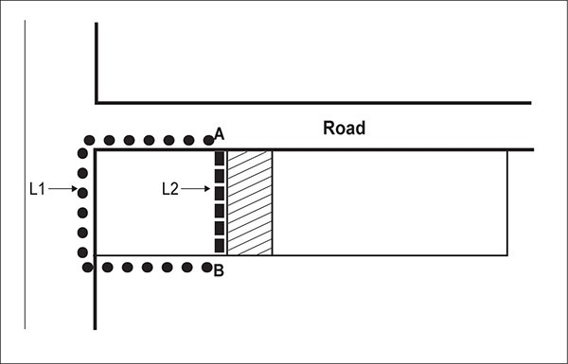

**Figure 6: Escalator plan distance**

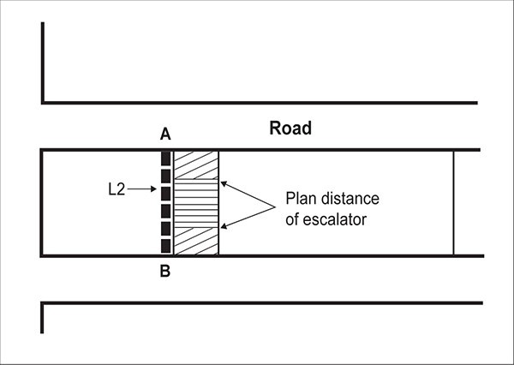

**Figure 7: Escalator plan distance measurement**

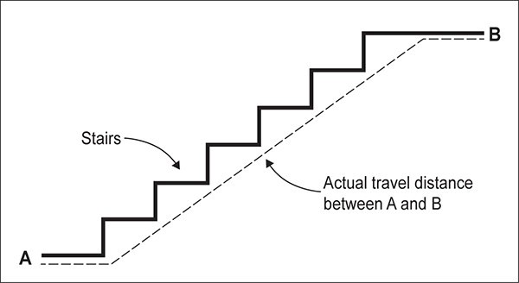

* 1. **Bonus floor area ­ through­site links through identified blocks**

Purpose: provide additional floor area where a through­site link is incorporated into a development that will significantly improve the permeability and accessibility of the block.

1. Where a through­site link is provided through a block identified on Map 11, the above rules apply, except that:
   1. an additional 0.5:1 will be awarded to any through­site link on the blocks identified on Map 11 and will apply in addition to the bonus calculated above using the ratio of L1:L2.

## Bonus floor area ­ works of art

Purpose: provide additional floor area where a high quality work of art is incorporated into the development that will enhance the cultural richness of the city centre.

1. Securing bonus floor space for the provision of works of art is a restricted discretionary activity.
2. To qualify for the bonus:
   1. works of art must be located so they are accessible or visible to the public 24 hours a day, seven days a week
   2. a covenant must be registered on the title to which the work of art applies to ensure preservation of the work of art and its ongoing maintenance by the owner of the title
3. The bonus floor area available is assessed at the following ratio:
   1. Five per cent extra floor area for each one per cent of total construction cost spent on the commission and execution of the work of art.
   2. For calculating the extra floor area which can be claimed, five per cent will be taken off the total floor area which has resulted from the calculation of the floor area permitted by the basic floor area ratio for the site.
   3. For the purpose of this rule, ‘total construction cost’ means the total cost of completing the development (or in the case of an existing development, the replacement cost of that development) for which extra floor area is claimed to an initial tenantable condition, including all external and internal structural walls of the building to a finished standard (but excluding non­ structural partitioning and furnishings); all building services; floor coverings; and all site works but not including land cost or the cost of the proposed work of art.
   4. A certificate prepared and signed by a registered quantity surveyor or registered architect must be supplied to the council to verify total construction cost as defined in 3(c) above, land cost and

cost of the proposed work of art.

* 1. A fraction of the one per cent of total construction cost, either more or less, may be spent on the commission and execution of the work and where this occurs the amount of extra floor area granted will be increased or reduced in the same proportion.

## Maximum total floor area ratio (FAR)

Purpose: manage the overall scale of development in the city centre.

1. The basic FAR plus the accumulation of any bonus FAR must not exceed the MTFAR identified on Map 9.
2. A building that exceeds the MTFAR is a non­complying activity.
3. The MTFAR achievable in bonus areas 1a, 2 and 3 is limited by the ratio of average floor area to site area to the extent shown in Table 6 and Figure 17 ­ MTFAR bonus areas 1a, 1b and 2 and Figure 18 ­ MTFAR bonus area 3.

Table 6:

|  |  |
| --- | --- |
| **Bonus area 1a** | |
| Where: | Bonus FAR equals |

|  |  |
| --- | --- |
| a. CFA<0.25  SA | 4.0:1 |
| b. 0.25<CFA≤0.75  SA | 5.75­(7xCFA):1  SA |
| c. CFA>0.75 | Nil |
| **Bonus area 2, 3, 4, 5, and 6** | |
| a. CFA<0.3  SA | 1:5:1 |
| b. 0.3≤CFA≤0.8  SA | 2.4­(3xCFA):1  SA |
| c. CFA>0.8  SA | Nil |

### Figure 8: MTFAR bonus areas 1a, 1b and 2

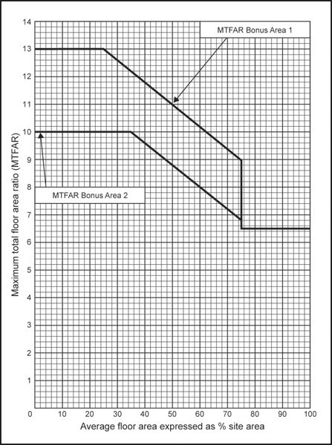

### Figure 9: MTFAR bonus area 3

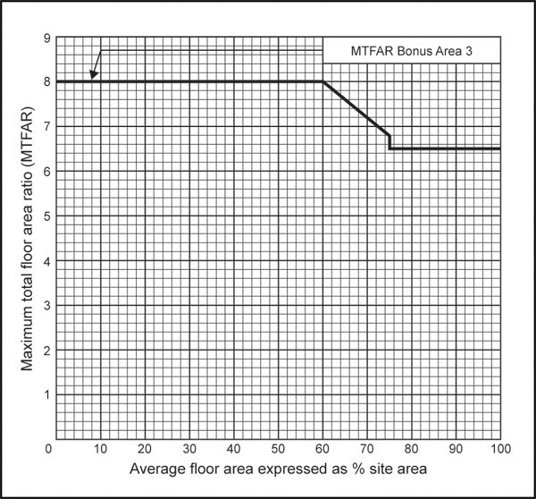

1. For the purpose of this rule, average floor area is the average of the horizontal areas measured at 1.5m above all floor levels from the external faces of the building, including all voids and the thickness of external and internal walls.
2. Basement space is exempt from the AFA calculation.
3. Public amenities meeting the bonus rules are exempt from the calculation of AFA.
4. For sites with a gross site area of 2000m2 or less, where the horizontal area at any floor level totals less than 20 per cent of the site area, then the horizontal area at that level will be taken as 20 per cent of the site area for the purpose of calculating AFA.
5. For sites with a gross site area greater than 2000m2, where the horizontal area at any floor level totals less than 400m2, then the horizontal area at that level will be deemed to be 400m2 for calculating AFA.
6. A void forming an integral part of an entrance lobby/foyer, being a primary means of public access to a building, which is open to the public and accessed directly from a public place, will be exempt from the AFA calculation.

## Building in relation to boundary

Purpose: retain the spacious landscaped character and maximise sunlight admission to public open spaces in the areas that the control applies.

1. A building located on a site identified as being subject to this control on Map 9 must comply with the indicators set out in appendix 7.3 except that:
   1. this control only applies to the shared boundaries of identified sites or where the boundary of an identified site adjoins public open space zones
   2. the effective site boundary for the purpose of this control may be taken as the furthest pedestrian accessway, entrance strip or access site, where a site adjoins such accessway, entrance strip or access site, or adjoins a series of contiguous entrance strips or access sites.

## Streetscape improvement and landscaping

Purpose: maintain landscaped qualities in the areas that the control applies.

1. For those sites identified on Figure 10:
   1. not less than 50 per cent of that part of the site other than rear sites, between the street and a parallel line 6m therefrom must be landscaped, and
   2. no part of any building or parking and manoeuvring space may be located within an area between the street and a line 3m parallel there from:

i.

ii.

iii.

For the relevant sites identified on Figure 10, at least 30 per cent of the net site area must be landscaped.

For the relevant identified on Figure 10, at least 10 per cent of the net site area must be landscaped. The landscaping must include a special amenity yard between the north­eastern boundary and a parallel line 8m there from, as shown on Figure 10, in which no part of any building or parking may be located.

The landscaping required above must incorporate both low level shrubs and specimens of trees capable of reaching a minimum height at maturity of 8m and must be at least 1.5m high at the time of planting.

* 1. the following applies in relation to the site that adjoins and is to the south of the St Andrew’s Presbyterian Church site:

i.

ii.

No part of any building, or parking and manoeuvring space, or service area may be located on the site between the road boundary and a parallel line 8m there from.

At least 50 per cent of the 8m set­back area must be landscaped.

### Figure 10: Streetscape improvement and landscaping

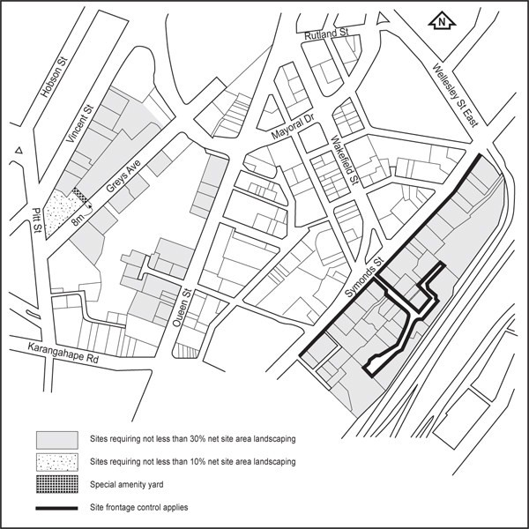

* 1. **Maximum tower dimension, setback from the street and tower separation**

Purpose: ensure that high­rise buildings ­

* + - are not overly bulky in appearance
    - provide adequate sunlight access to streets
    - provide a consistent human­scaled edge to the street
    - provide adequate sunlight and outlook around buildings
    - enable views through the city centre
    - mitigate adverse wind effects.

1. On every site identified as special height area on Map 3:
   1. the maximum plan dimension of that part of the building 28m above mean street level must not exceed 50m
   2. the part of a building above 28m must be located at least 6m from all boundaries of the site.
2. The maximum plan dimension is the horizontal dimension between exterior faces of the two most separate points of the building (refer Figure 11).

### Figure 11: Maximum plan dimension

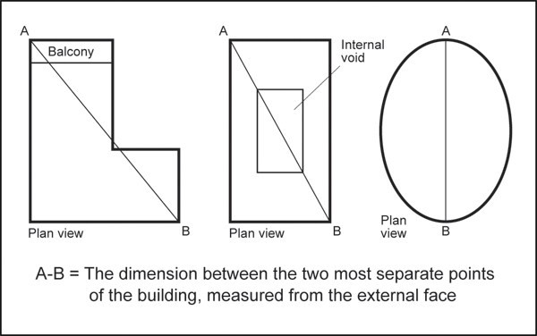

* 1. **Building frontage alignment and height**

Purpose: ensure streets are well defined by buildings and provide a sense of enclosure to enhance pedestrian amenity.

1. On every frontage identified on Map 5, a new building or addition to an existing building must comply with the following:
   1. The building must adjoin the entire length of the frontage excluding vehicle and pedestrian access and public open spaces.
   2. For frontages identified as ‘19m’, the building must have minimum height of 19m for a minimum depth of 6m from the frontage.
   3. For frontages identified as '13m', the building must have minimum height of 13m for a minimum depth of 6m from the frontage.
2. Compliance with this control is not required along that part of a building frontage where a public open space bonus meeting the rules of this zone is provided.

## Ground floor and entrances at street frontage level

Purpose: avoid blank walls at ground floor, particularly on sloping sites.

1. The ground floor of a new building must be at the same level of the adjoining street for a minimum depth of 10m. Except where the adjoining street slopes along the frontage, the ground floor must be no more than 1.2m above or below the level of the frontage.
2. Entrances to the ground floor of a building must be at grade with the adjoining street.
3. The level of the frontage must be measured at every point along that boundary.

### Figure 12: Ground floor level

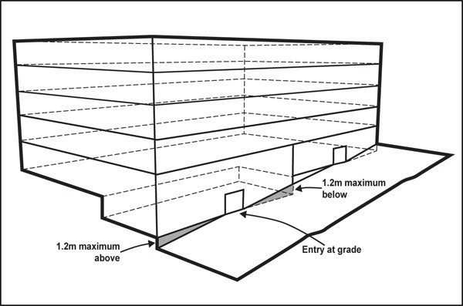

* 1. **Glazing**

Purpose: ensure that pedestrians can see activities occurring within the ground floor of buildings fronting the street to provide interest for pedestrians and enable passive surveillance of the street.

1. On every frontage identified as 50 per cent, on Map 6, the ground floor of a building must have clear glazing for at least 50 per cent of its width and 75 per cent of its height.
2. On every frontage identified as 75 per cent, on Map 6, the ground floor of a building must have clear glazing for at least 75 per cent of its width and 75 per cent of its height.
3. Vehicle and pedestrian access is excluded when calculating the glazing requirement above.

## Ground floor activities

Purpose: ensure the ground floor of buildings on main pedestrian streets contain active uses that provide interest and vitality for pedestrians and enable passive surveillance of the street.

1. On every frontage identified as 100 per cent on Map 7, either retail (excluding show homes, trade suppliers, service stations and motor vehicle sales), commercial services (excluding all nested definitions) or entertainment facilities must occupy 100 per cent of the ground floor of the building for a depth of at least 10m.
2. On every frontage identified as 70 per cent on Map 7, either retail (excluding show homes, trade suppliers, service stations and motor vehicle sales) and commercial services (excluding all nested definitions) or entertainment facilities must occupy at least 70 per cent of the ground floor of the building for a depth of at least 10m.
3. On every frontage identified on Map 7, the total width of pedestrian entrances or lobbies along the frontage must not exceed 10m.

## Verandahs

Purpose: provide pedestrians with weather protection on main streets.

1. A new building, external alteration or substantial internal alteration to an existing building, excluding minor cosmetic alterations or repairs which do not change its design and appearance, on a site identified on Map 8 must provide a continuous verandah along the full width of its building frontage.
2. For the purpose of this rule, substantial internal alterations means the alteration or reconstruction of an existing building to a value of $500,000 or more assessed at the time a building consent is lodged with the council.
3. If an existing verandah is removed, it must be replaced in accordance with the requirements of this rule.
4. A verandah on a corner site must comply with Figure 13.

### Figure 13: Verandah on corner site

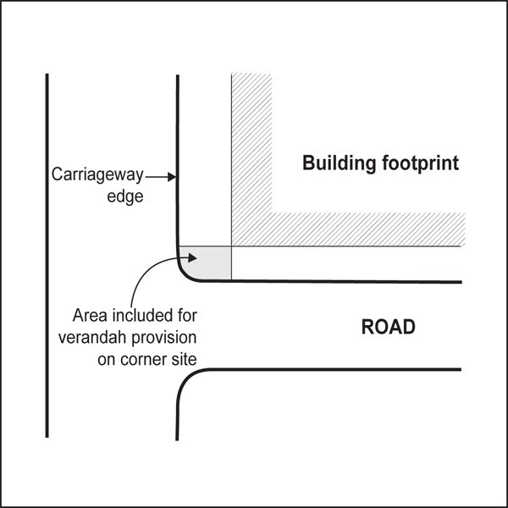

1. All verandahs must:
   1. have a minimum height of 3m and a maximum height of 4m above the footpath immediately below
   2. be no closer than 700mm in plan to the edge of the road carriageway notwithstanding any other requirement of this rule
   3. include drainage to control rain run­off
   4. where glazed, be opaque or patterned glass
   5. have a minimum width as follows:

Table 7

|  |  |
| --- | --- |
| Queen Street, north of Wakefield Street except the western side between Aotea Square and Wellesley  Street | 4m |
| Karangahape Road | 4m |
| Swanson Street between Mills Lane and Queen Street | 3m |
| Vulcan Lane, south side | 3m |
| Queen Street, west side between Aotea Square and  Wellesley Street | 5m |
| All other frontages identified on the plan | 3m or setback no further than 600mm in plan from the  edge of the road carriageway, whichever is the lesser |

1. Lighting outside daylight hours must be provided under a verandah to a minimum of 20 lux (light illumination) on the footpath, where the lux level is measured at ground level on a horizontal plane at 2m from the building adjoining the footpath. Lighting of the footpath must have a uniformity ratio of 0.5.
2. The lighting levels required above may be met by one or more of the following methods:
   1. providing lighting beneath a street verandah
   2. providing lighting within the shop/office that spills out through windows to the outside footpath
   3. the use of advertising signage of light colour which will spill light out onto the footpath
   4. providing downwardly directed lighting on the exterior of the building.

## Minimum floor to floor/ceiling height

Purpose: ensure that:

* + - commercial buildings are adaptable to a wide variety of uses over time
    - adequate sunlight and/or daylight is provided into the interior spaces of commercial and residential buildings.

1. The ground floor of a new building must have a minimum finished floor to floor height of 4.5m for a minimum depth of 10m where it adjoins a street or public open space.
2. The finished floor to floor height of new buildings above ground floor must be at least 3.6m where those floors will accommodate non­residential activities.
3. The finished floor to finished ceiling height of buildings above ground floor must be at least 2.55m where those floors will accommodate dwellings. This control applies to buildings that are converted to dwellings.

## Wind

Purpose: mitigate the adverse wind effects generated by high­rise buildings.

1. A new building must not cause:
   1. the mean wind speed around it to exceed the category for the intended use of the area as set out

in table 3 and Figure 8: Mean wind speed

* 1. the average annual maximum peak 3 second gust to exceed the dangerous level of 25m per second
  2. an existing wind speed which exceeds the controls below.

Table 8: Performance categories

|  |  |
| --- | --- |
| Category A: | Areas of pedestrian use containing significant formal elements and features intended to encourage longer term recreational or relaxation use, such as. major and minor public squares, parks and other open spaces, including. Aotea Square, Queen Elizabeth Square,  Albert Park, Myers Park, St Patrick’s Square, and Freyberg Place |
| Category B: | Areas of pedestrian use containing minor elements and features intended to encourage short term recreation or relaxation, such as minor pedestrian open spaces, pleasance areas in road reserves, streets with significant groupings of landscaped seating features, including  Khartoum Place, Mayoral Drive pleasance areas, and Queen Street |
| Category C: | Areas of formed footpath or open space pedestrian linkages, used primarily for pedestrian transit and devoid of significant or repeated recreational or relaxational features, such as  footpaths where not covered in categories A or B above |
| Category D: | Areas of road, carriage way, or vehicular routes, used primarily for vehicular transit and open storage, such as roads generally where devoid of any features or form which would include the  spaces in categories A ­ C above |
| Category E:c | Represents conditions which are dangerous to the elderly and infants and of considerable cumulative discomfort to others. Category E conditions are unacceptable and are not  allocated to any physically defined areas of the city |
| Note: All through­site links and other private land given over to public use as bonus features, or subject to  public access easements, must be subject to the wind environmental categories. | |

### Figure14: Mean wind speed

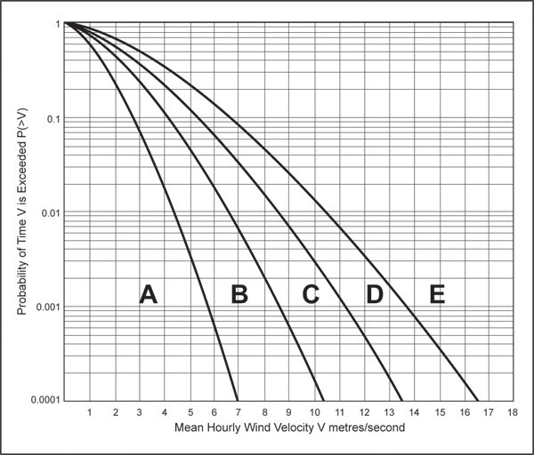

## Glare

Purpose: ensure non­reflective materials are used on buildings to avoid, remedy and mitigate the adverse effects of glare on pedestrians and motorists.

1. Buildings must be designed and built so that the reflectivity of all external surfaces does not exceed 20 per cent of white light. This means that glass and other materials with reflectivity values that exceed 20 per cent may only be used provided they are covered or screened in such a way that the external surfaces will still meet this rule.

## Special amenity yards

Purpose: avoid buildings locating in areas that would have a significant adverse effect on pedestrian and/or streetscape amenity.

1. A building must not be at or above ground level within the yards shown on Figures 15­17.
2. In the Freyberg Place amenity yard, the existing contour of the land and the existing Phoenix palms within the yard must be retained.

### Figure 15: Freyberg Place Special amenity yard

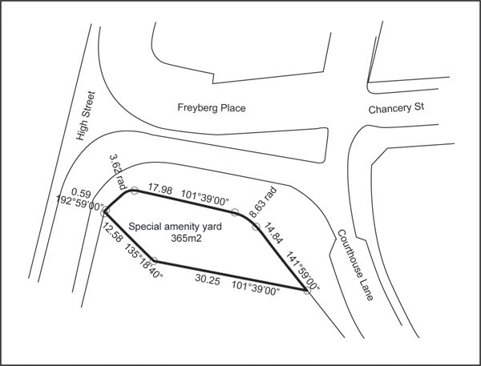

### Figure 16: Myers Park special amenity yard

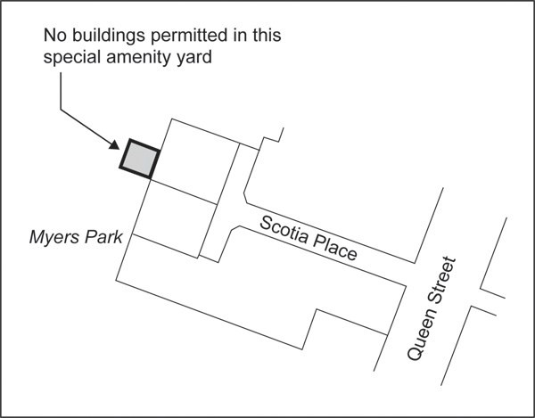

**Figure 17: Queen Street special amenity yard**

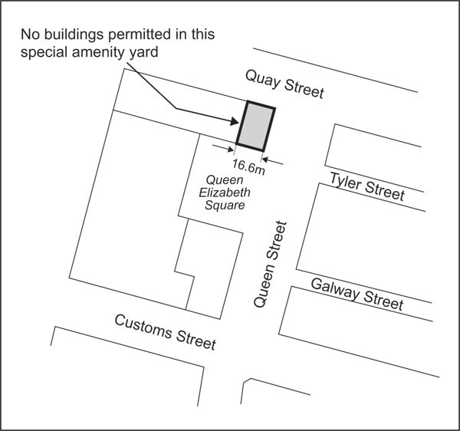

* 1. **Street sightlines**

Purpose: retain views from key locations in the city centre to significant landmarks and the harbour.

1. Views from public open space or along streets to the harbour to Rangitoto Island and to the North Shore or to other natural features and landmarks from within the city centre are protected as shown in appendix 7.2. Except for the eastern ray of Street Line No. 23 (which affects part of the Maritime Square site (being Lot 1A DP 198984), this control does not apply beyond the streets affected. Refer to appendix 7.2, where the sightlines are shown in detail.
2. Buildings or structures must not locate within the sightlines identified in appendix 7.2, except as otherwise provided in the Auckland­wide ­ network utility rules.

## Outlook space

Purpose:

* + - Ensure a reasonable standard of visual and acoustic privacy between different dwellings, including their outdoor living space, on the same or adjacent sites
    - Encourage the placement of habitable room windows to the site frontage or to the rear of the site in preference to side boundaries, to maximise both passive surveillance of the street and privacy, and to avoid overlooking of neighbouring sites.

1. The control below applies to new buildings containing dwellings and buildings that are converted to dwellings, visitor accommodation and boarding houses,
2. An outlook space must be provided from each face of the building containing windows to principal living areas or bedrooms of any dwelling. Where windows to a principal living area or bedroom are provided from two or more faces of a building, outlook space must be provided to the face with the greatest window area of outlook.
3. The minimum dimensions for outlook space are:
   1. for principal living areas, the dimensions of the outlook space, measured perpendicular to the exterior face of the building, must be in accordance with Figure 19, for the relative height of the floor above the average ground level along each building face.
   2. for bedrooms, the outlook space must be a minimum of 6m, measured perpendicular to the exterior face of the building.
4. The outlook space must extend from the exterior wall of the principal living room or bedroom and not the windows.
5. The outlook space may be over:

a.

b.

c.

d.

i.

ii.

the site on which the building is located, but not towards a side boundary if the building is within 10m of the site frontage (refer Figure 18)

the street

public open space another site, only if:

the outlook space is secured in perpetuity for the benefit of the building by a legal instrument to be put in place prior to the commencement of construction

the written approval of the owner of the adjoining site for the outlook space is provided when the application for resource consent is lodged.

1. In the situation where an outlook space is provided over a legal road narrower than the width specified in Figure 19, the street width is deemed to satisfy the minimum outlook space requirement.
2. More than one building on the site may share an outlook space.

### Figure 18: Outlook over the street

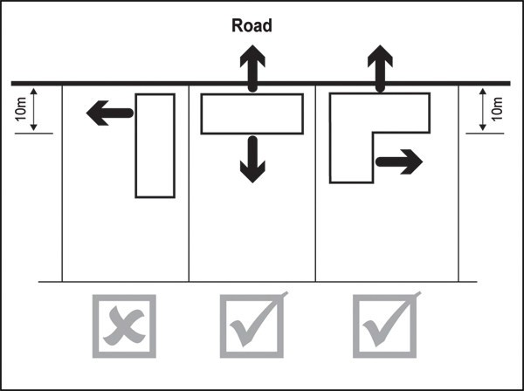

**Figure 19: Outlook space**

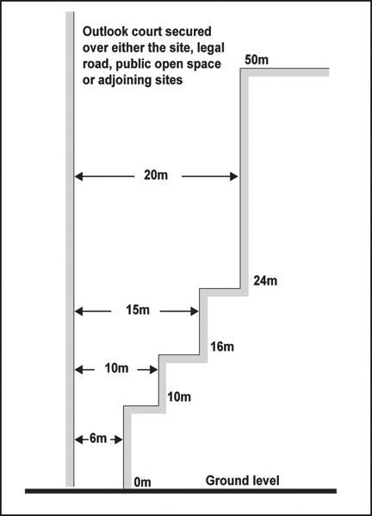

* 1. **Minimum dwelling size**

Purpose: ensure dwellings are of a sufficient size to provide a reasonable standard of amenity.

1. Dwellings must have a net internal floor area as follows:
   1. 30m² for studio dwellings.
   2. 40m² for one or more bedroom dwellings.

## Minimum dimension of principal living rooms and principal bedrooms

Purpose: principal living rooms and bedrooms are of a size sufficient to accommodate standard size furniture and circulation space.

1. The principal living room within a dwelling must have no dimension less than 3m, measured perpendicular from the internal walls of the room.
2. The principal bedroom within a dwelling must be at least 3m in width and 3.5m in length measured perpendicular from the internal walls of the room. Cupboards and other storage space may be included

in the minimum dimension.

## Daylight to dwellings

Purpose: ensure dwellings receive a good degree of daylight.

1. Principal living rooms must have external glazing that is at least 40 per cent of the floor area of that space.
2. Bedrooms must have external glazing that is at least 20 per cent of the floor area of that space.

## Servicing and waste

Purpose: dwellings within medium to large­scale residential development have sufficient space within the building to accommodate the storage of waste.

1. A building or development containing 10 or more dwellings must provide a communal storage area for waste. The size of the communal storage area must be an aggregate of the minimum areas specified for the dwelling types below:
   1. studio and one bedroom – 0.3m²
   2. two bedrooms – 0.5m²
   3. three bedrooms – 0.7m²
   4. four or more bedrooms – 1m².
2. An additional 30 per cent in area of floor area required above must be provided within the communal storage area for manoeuvring or sorting within the waste storage area.

## Dwelling mix

Purpose: large­scale residential development provides variety in dwelling types.

1. In a single development containing more than 20 dwellings, the combined number of studio and one bedroom dwellings must not exceed 70 per cent of the total number of dwellings within the development.

## Outdoor living space

Purpose: provide dwellings with an outdoor living space that is:

* + - usable
    - accessible
    - able to accommodate the number of occupants the dwelling is designed for.

1. Every dwelling must contain an outdoor living space in the form of a ground floor terrace, balcony, or roof terrace that:
   1. is at least 8m²
   2. has a minimum depth of 2.4m.

## Universal access for residential buildings

Purpose: ensure a proportion of residential development is designed to provide equal physical access for people of all ages and abilities.

1. Where a new building or development contains 10 or more dwellings, 20 per cent of those dwellings

must comply with the following:

* 1. doorways must have a minimum clear opening width of 810mm
  2. stairwells must have a minimum width of 900mm
  3. corridors must have a minimum width of 1050mm
  4. the principal means of access from the frontage, or the parking space serving the dwelling, to the principal entrance of the dwelling must have:

i.

ii. iii.

a minimum width of 1.2m a maximum slope of 1:20

a maximum cross fall of 1:50.

1. Where the calculation of the dwellings required to be universally accessible results in a fractional dwelling, any fraction that is less than one­half will be disregarded and any fraction of one­half or more will be counted as one dwelling.
2. All dwellings required to be universally accessible must provide at least one parking space for people with a disability. The dimensions and accessible route requirements for such parking spaces are detailed in Section 5.5 of the New Zealand Building Code D1/AS1 New Zealand Standard for Design for Access and Mobility – Buildings and Associated Facilities (NZS 4121­2001).

## Assessment ­ Controlled activities

### 5.1 Matters of control

The council will reserve its control to the matters below for the activities listed as controlled in the development controls.

* 1. The use or transfer of historic heritage and special character floor space
     1. recording the use/transfer of floor space on the certificate of title.

## Assessment ­ Restricted discretionary activities

### Matters of discretion

The council will restrict its discretion to the matters below for the activities listed as restricted discretionary in the activity table.

* + 1. Buildings and external alterations and additions to buildings not otherwise provided for
       1. building design and external appearance
       2. design and scale of buildings adjoining historic heritage places
       3. design of parking, access and servicing
       4. design and layout of dwellings, visitor accommodation and boarding houses.
    2. External alterations and additions to a special character building identified on Map 1
       1. building design and external appearance
       2. architectural style and retention of original building features
    3. Conversion of a building or part of a building to dwellings, visitor accommodation or boarding houses
       1. design and layout of dwellings, visitor accommodation and boarding houses.
    4. Retail (excluding department stores) between 1000m² and 5000m² GFA per site
       1. centre vitality.
    5. Demolition of buildings
       1. pedestrian amenity and safety
       2. re­use of building materials
       3. site condition post­demolition
       4. traffic generation.
    6. The total or substantial demolition (more than 30 per cent by volume), or any demolition of the front façade of a special character building identified on Map 1
       1. the matters of discretion identified in 5(a)­(d) above
       2. special character values.

### Assessment criteria

The council will consider the relevant assessment criteria below for the restricted discretionary activities listed above.

* + 1. Buildings and external alterations and additions to buildings not otherwise provided for
       1. Building design and external appearance

*Contributing to a sense of place*

i.

ii.

iii.

iv.

v.

vi.

vii.

viii.

The design of buildings should contribute to the local streetscape and sense of place by responding positively to the planned future form and character of the surrounding area and significant natural landforms and landscape features.

The silhouette of the building as viewed from areas surrounding the city centre should positively contribute to the city centre's skyline.

*Creating a positive frontage*

Buildings should have clearly defined public frontages that address the street and public open spaces to positively contribute to the public realm and pedestrian safety.

Pedestrian entrances should be located on the street frontage and be clearly identifiable and conveniently accessible from the street.

For mixed use buildings, separate pedestrian entrances should be provided for residential uses.

Where not required by a development control, activities that engage and activate streets and public spaces are encouraged at ground and first floor levels.

Internal space at all levels within buildings should be designed to maximise outlook onto street and public open spaces.

Dwellings should not locate on the ground floor of buildings fronting streets and public open spaces where they would:

* + - * + detract from the amenity and vitality of the street or public open space, such as on frontages that are subject to the glazing and verandah control
        + have a low standard of amenity in terms of noise and air quality effects, such as on streets that carry high volumes of vehicle traffic.

ix.

Where dwellings are considered to be appropriate at ground floor, they should be designed to enable passive surveillance of the street/public open space and provide privacy for residents. This could be achieved by:

* + - * + providing balconies over­looking the street or public open space
        + providing a planted and/or fenced setback where the site adjoins streets or public open

space Fences or landscaping iii. should be low enough to allow direct sight lines from a pedestrian in the public realm to the front of a balcony

* + - * + raising the balcony and floor plate of the ground floor dwellings above the level of the adjoining street or public open space to a height sufficient to provide privacy for residents and enable them to overlook the public realm.

*Variation in building form / visual interest*

x.

xi.

xii.

Buildings, including alterations and additions, should be designed as a coherent scheme and should demonstrate an overall design strategy that contributes positively to the visual quality of the development.

Where the proposed development is an addition or alteration to an existing building, it should be designed with consideration to the architecture to the original building and respond positively to the visual amenity of the surrounding area.

Buildings should be designed to:

* + - * + avoid long, unrelieved frontages and excessive bulk and scale when viewed from streets and public open spaces
        + visually break up their mass into distinct elements to reflect a human scale and the typical pattern of development in the area
        + differentiate ground, middle and upper level.

xiii.

xiv.

xv.

xvi.

xvii.

xviii.

xix.

Techniques to achieve this include the use of recesses, variation in building height and roof form, horizontal and vertical rhythms and facade modulation and articulation.

Blank walls should be avoided on all levels of building frontages to streets and public open spaces.

Side or rear walls without windows or access points should be used as an opportunity to introduce creative architectural solutions that provide interest in the facade including modulation, relief or surface detailing.

Buildings should provide a variety of architectural detail at ground and middle levels including maximising doors, windows and balconies overlooking the streets and public open spaces.

Roof profiles should be designed as part of the overall building form and contribute to the architectural quality of the skyline as viewed from both ground level and the surrounding area. This includes integrating plant, exhaust and intake units and other mechanical and electrical equipment into the overall rooftop design.

Colour variation and landscaping without the use of other design techniques should not be used to mitigate a lack of building articulation or design quality.

For residential development:

* + - * + the mechanical repetition of unit types should be avoided
        + balconies should be designed as an integral part of the building. A predominance of cantilevered balconies should be avoided
        + apartments above ground floor should be accessed from internal corridors or entrance way. External walkways/breezeways should generally be avoided.

*Materials and finishes*

xx.

xxi.

xxii.

Buildings should use quality, durable and easily maintained materials and finishes on the façade, particularly at street level.

Where provided, signs should be designed as an integrated part of the building facade.

*Cultural identity*

Encourage development to integrate mātauranga and tikanga into the design of new buildings and public open spaces.

* + - 1. Design and scale of buildings adjoining historic heritage places

1. Buildings adjoining or in close proximity to a scheduled historic heritage place:
   * should be located and designed to have regard to the significant historic heritage elements and built form of the place. This does not mean a rigid adherence to the height of the place, not does it reduce the development potential of the site, but it does require careful consideration in terms of the form and design of the building to minimise the effects of dominance
   * may not be required to adjoin the site frontage if a better design outcome could be achieved by respecting the setback and/or spatial location of the place
   * should use materials and/or design detail that respect rather than replicate any patterns or elements existing in the place, however new and contemporary interpretations in

form and detail

* + should generally avoid ground floor frontages entirely of glass, e. curtain­walling or continuous shop front glazing.
    - 1. Design of parking, access and servicing

i.

ii.

iii.

iv.

v.

vi.

vii.

Parking should be located, in order of preference, underground, to the rear of building or separated from the street frontage by uses that activate the street.

Where parking is provided at lower building levels it should be fully sleeved with active uses or activities that provide passive surveillance of the street and contribute to pedestrian interest and vitality. Above this, car parking should be fully screened on all sides of the building using design methods that present facades that are visually attractive and avoid

night time light spill, noise and air quality effects on nearby sites and streets and public open spaces.

Ventilation and fumes from car parking structures or other uses should not be vented into the adjacent pedestrian environment at ground level.

Vehicle crossings and access ways should be designed to reduce vehicle speed, be visually attractive and clearly signal to pedestrians the presence of a vehicle crossing or access way.

Pedestrian access between parking areas, building entrances/lobbies and the street should provide equal access for people of all ages and physical abilities, a high level of pedestrian safety and be visually attractive.

Separate vehicle and pedestrian access should be provided within parking areas. Shared pedestrian and vehicle access may be appropriate where a lane or street is proposed within a development site. The shared space should prioritise pedestrian movement.

Ramps where necessary should be minimal in length and integrated into the design of the building.

viii.

For commercial activities, suitable provision should be made for on­site rubbish storage and sorting of recyclable materials that:

* + - * + is a sufficient size to accommodate the rubbish generated by the proposed activity
        + is accessible for rubbish collection
        + for new buildings, is located within the building.

ix.

x.

xi.

For alterations or additions to existing buildings where it is not possible to locate the storage area within the building, they must be located in an area not visible from the street or public open spaces.

The development must be able to be adequately served by wastewater and transport infrastructure.

Servicing elements (including venting and air­conditioning units) should be located on the roof of the building or internal to the site and not on street­facing facades. Where this is not possible (e.g. alterations to a shop front), servicing should:

* + - * + form an integrated element of the building facade, and
        + be located so that it minimises adverse effects such as noise/odour on neighbouring sites and the public realm.
      1. Design and layout of dwellings, visitor accommodation and boarding houses

1. Dwellings should be located, proportioned and orientated within a site to maximise the amenity of future residents by:
   * clearly defining communal, semi­communal and private areas within a development
   * maximising passive solar access while balancing the need for buildings to front the street
   * providing for natural cross­ventilation by window openings facing different direction.

ii.

iii.

iv.

v.

Dwellings should be designed to provide a good standard of internal amenity by providing adequate circulation space around standard sized household furniture.

Adequate storage space for larger items such as bikes, gardening and cleaning equipment, should be provided either within each dwelling or within the building containing the dwellings. As a guide, the storage area should be at least 4m³.

Common areas within buildings containing dwellings, visitor accommodation and boarding houses should provide equal physical access for people of all ages and physical abilities, in particular by providing doorways, corridors and circulation spaces of sufficient dimension and minimising stairs where possible.

Visitor accommodation and boarding houses should be designed to achieve a reasonable standard of internal amenity. Consideration will be given to:

* + any specific internal design elements that facilitate the more efficient use of internal space
  + the relationship of windows or balconies to principal living rooms
  + the provision of larger indoor or outdoor living spaces whether communal or exclusive to the dwelling is more important for units that are not self­contained.
    1. External alterations and additions to special character buildings identified on Map 1
       1. Building design and external appearance

i. Refer to the assessment criteria in 1(a) above.

* + - 1. Architectural style and retention of original building features

1. Alterations and additions to special character buildings:
   * should be in keeping with the building’s architectural form, proportions and style and should use materials that are sympathetic to those originally used
   * should retain as much of the existing building façade as practicable by refurbishing, restoring and adapting parts of the building rather than replacing them
   * may be in a contemporary architectural style but should be designed to be sympathetic to the form, bulk, proportions and articulation of the existing building or buildings on the site
   * should avoid additional structures such as aerials and air­conditioning units on street­ facing facades of the special character building. However, where they are necessary they should be appropriately located and designed to reduce the appearance of visual clutter.
     1. Conversion of a building or part of a building to dwellings, visitor accommodation or boarding houses
        1. Design and layout of dwellings, visitor accommodation and boarding houses

i. Refer to the assessment criteria in 1(d) above.

* + 1. Retail (excluding department stores) between 1000m² and 5000² GFA per site
       1. Centre vitality

1. Retail greater than 1000m² and less than 5000m² GFA per site outside of the core retail area should:
   * not have a substantial adverse effect upon the amenity values and functions of the core retail area having regard to the activity’s proposed size, composition and characteristics
   * provide a net positive benefit in terms of the community’s convenient access to commercial activities and community services, including having regard to whether locating within the core retail area would result in adverse environmental effects on the form, function or capacity of the core retail area.
     1. Demolition of buildings
        1. Pedestrian amenity and safety
2. Sites containing buildings that are proposed to be demolished should not have significant adverse effects on the quality and amenity of the public realm and the safety and efficiency of the surrounding transport network. In particular:
   * a high­quality and safe temporary hard or landscaped edge should be provided along the site boundaries so that a defined boundary to streets and public open spaces is maintained. This should include the provision and maintenance of continuous pedestrian cover within areas subject to the verandah control.
   * an edge treatment designed to reduce its vulnerability to graffiti and vandalism should be maintained.
     + 1. Re­use of building materials

i. Demolished materials should be re­used and recycled as much as possible.

* + - 1. Site condition post­demolition

i. If the site is not developed following demolition, the site should be landscaped to provide a good standard of visual amenity and the site should not be used for temporary or permanent parking.

* + - 1. Traffic generation

i. With regard to the effects of building demolition on the transport network, consideration should be given to the proposed hours of operation, the frequency and timing of truck movements to and from the site and the location of vehicle access.

* + 1. The total or substantial demolition (more than 30 per cent by volume) or any demolition of the front façade of a special character building identified on Map 1
       1. The assessment criteria in 5(a)­(d) above apply in addition to the criteria below.
       2. Special character values

1. The total or substantial demolition (more than 30 per cent by volume) or any demolition of the front facade of a special character building should not significantly adversely affect the built form and streetscape character of the surrounding area. In considering this, the council will have regard to the following:
   * whether the building forms part of a cohesive group of buildings similar in age, scale, proportion or design and the extent to which the building’s demolition would detract from the shared contribution that group makes to streetscape, the unique historic character or the history and context of the area
   * whether the building makes a significant contribution to the historic context, character or cohesiveness of the surrounding streetscape
   * whether the building is a remnant example of a building type that reflects the history of the area
   * the extent of the building’s contribution to any adjoining or nearby scheduled places, either through the context and the relationship of the building to the scheduled place or through the building’s mass, height or rhythm of facades
   * whether demolition would adversely affect the historic heritage values of any neighbouring scheduled historic heritage places
   * whether the proposal has fully considered whether reasonable use of the site could be achieved through the adaptive re­use of the building rather than through demolition and replacement.

ii.

Notwithstanding the above, other factors will be considered and balanced when assessing an application for the demolition of a special character building, including:

* + whether the building is beyond rehabilitation in terms of poor structural or physical condition, and the costs of the repair work or upgrading necessary to extend the useful life of the building are prohibitive in comparison to the costs of a new building of similar size
  + whether the building is beyond rehabilitation to its original state and the costs of the rehabilitation to reproduce the qualities of the building and enhance the architectural qualities and special characteristics of the streetscape and the surrounding area, in comparison to the costs of a new building of a similar size.

## Assessment ­ Development control infringements

### 7.1 Matters of discretion

In addition to the general matters of discretion in clause 2.3 of the general provisions, the council will restrict its discretion to the matters below for the listed development control infringement.

* 1. Building height, maximum tower dimension and tower separation
     1. effects of additional building scale on neighbouring sites, streets and public open spaces (sunlight access, dominance, visual amenity)
     2. consistency with the planned future form and character of the area/zone.
  2. Glazing, minimum floor to floor height (ground floor), ground floor activities, building frontage alignment and height, verandahs ground floor at street level
     1. effects on the vitality and amenity of streets and public open spaces
     2. effects on historic heritage and historic character buildings and notable trees.
  3. Outlook space
     1. privacy and outlook for dwellings
     2. daylight access and ventilation for dwellings.
  4. Minimum dwelling size, minimum floor to floor height (dwellings), minimum dimension of principal living rooms and principal bedrooms, servicing and waste
     1. effects of reduced living and circulation space, sunlight/daylight access and storage on residential amenity.
  5. Universal access
     1. effects on accessibility.

### Assessment criteria

In addition to the general assessment criteria in clause 2.3 of the general provisions, the council will consider the relevant criteria below for the listed development control infringement.

* + 1. Building height, maximum tower dimension and tower separation
       1. Effects of additional building scale on neighbouring sites and streets and public open spaces (sunlight access, dominance, visual amenity)

i.

ii.

Minor height infringements may be appropriate where it would provide an attractive and integrated roof form that also meets the purpose of the control.

Minor height infringements may be appropriate on corner sites to reinforce the prominence of the corner where it meets the relevant development control infringement criteria and makes a positive contribution to the streetscape.

* + - 1. Consistency with the planned future form and character of the zone/area
         1. Where building height or bulk is infringed the proposal must demonstrate that Policies 16 and 17 of the City Centre zone are met.
    1. Glazing, minimum floor to floor height (ground floor), ground floor activities, building frontage alignment and height, verandahs ground floor at street level
       1. Effects on historic heritage and historic character buildings and notable trees
          1. The council will give priority to protecting important features of historic heritage and historic character building ground floor facades over compliance with the street frontage controls.
    2. Outlook space
       1. Privacy and outlook for dwellings
          1. Dwellings that infringe the outlook control mustr demonstrate that occupants will have a good standard of outlook and visual and acoustic privacy between principal living rooms and bedrooms on the same and adjacent sites and will not prevent a complying residential development on an adjoining site.
       2. Daylight access and ventilation for dwellings
          1. Dwellings that infringe the outlook control must also demonstrate that the dwellings will receive a good degree of natural light and ventilation, particularly those at lower building levels.
    3. Minimum dwelling size, minimum floor to floor height (dwellings), minimum dimension of principal living rooms and principal bedrooms, servicing and waste
       1. Effects of reduced circulation space, daylight access, storage etc on residential amenity
          1. Dwellings that do not comply with the minimum dwelling size or room dimension controls must demonstrate that:

the proposed dwelling size provides a good standard of amenity for the number of occupants the dwelling is designed for

there is adequate circulation around standard sized furniture.

ii.

iii.

Methods to achieve (i) may include use of built in furniture and mezzanine areas with good access and head height. Provision of a larger private outdoor space may provide amenity that mitigates a smaller dwelling size.

Dwellings that do not comply with the minimum floor to ceiling height must demonstrate that principal living rooms and bedrooms are provided with adequate daylight. Lower floor to ceiling heights may be appropriate within rooms that are not habitable rooms.

* + 1. Universal access
       1. Effects on accessibility

i.

ii.

For development that does not comply with the universal access control consideration will be given to whether meeting the control would cause a significant amount of land modification and adverse effects on the landscape or natural features of the site.

Consideration will also be given to whether other universal design features are incorporated into the development that would mitigate any adverse effects created by the infringement.

## Assessment ­ Bonus floor area

### 8.1 Matters of discretion

The council will restrict its discretion to the matters below for development seeking to obtain bonus floor space.

* 1. Public open space
     1. pedestrian safety, interest and amenity
     2. universal access
     3. sunlight access
     4. landscaping, lighting and materials.
  2. Through­site links
     1. pedestrian safety, interest and amenity
     2. universal access
     3. daylight access
     4. landscaping, lighting and materials.
  3. Works of art
     1. artistic quality
     2. public access.
  4. Securing historic heritage floor space
     1. effects on historic heritage.
  5. Securing historic character floor space
     1. effects on historic character.
  6. Dwellings
     1. internal and on­site amenity.

### Assessment criteria

* + 1. Public open space
       1. Pedestrian safety, interest and amenity

i.

ii.

Pedestrian desire lines should be provided to, from and within the public open space.

The design of the public open space should have a sense of order and proportion and have

regard to the human scale.

iii.

iv.

v.

vi.

Orientation and design should provide pedestrians with protection from the wind, particularly in those locations where seating is provided.

A significant area of the public open space should be visible from its entrance onto the street.

Buildings adjoining the public open space should be designed to provide for, or facilitate the establishment of, those activities which attract people, especially at night. For example upper level residential accommodation with windows or balconies overlooking the amenity area would be appropriate, as would adjoining cafes, restaurants or small shops. Blank facades, offices and activities with very large frontages, especially those which are traditionally closed at night and weekends should be avoided.

Good visibility to, from and within the public open space is required to ensure public safety.

* + - 1. Universal access
         1. All pedestrian spaces and facilities within the public open space must be universally accessible.
      2. Sunlight access
         1. Sunlight access into the space should be maximised. Seating areas should be located to avoid being shaded from 10am to 3pm in mid­winter where practical.
      3. Landscaping, lighting and materials

i.

ii.

iii. iv.

Areas of landscaping should not dominate any paved pedestrian area.

Seating and landscaping should be in pleasant, clearly visible, convenient and safe locations. Landscaping should comprise low shrubs and plants or tall open trees and shrubs which do not screen an area off.

High quality and durable materials should be used.

The public open space should be well lit. This lighting should provide a high vertical luminance so that shadows of people and indications of movement are easily seen, even at a distance.

* + 1. Through­site links
       1. The assessment criteria in clause 1(a)(v)­(vi), (b)(i) and (d)(iii) above apply.
       2. Pedestrian safety, interest and amenity

i.

ii.

iii.

iv.

Through­site links must provide a connection between two streets or other public areas to create interest in the city and have a clearly visible origin and destination.

The design of the through­site link should take the pedestrian's desired routes into consideration when determining location.

Lanes must be of a width proportionate to the scale of development to create a sense of enclosure with a ratio of 1:5 being encouraged.

Lanes should have active uses along at least one side.

* + - 1. Daylight access

i.

ii.

Arcades should be covered but have access to natural light for most of their length and be lined with active uses at the level of the arcade.

Arcades should be of sufficient height to allow daylight penetration to their interior.

* + 1. Works of art
       1. Artistic quality

i.

ii.

The work of art may be in any media adequate for the site such as a sculpture, mural, glass, or water feature.

The work of art should aesthetically enhance the public space to which it relates having regard to its artistic merit, scale and placement as adjudged by the council.

* + - 1. Public access
         1. Works of art should be freely accessible from public space during daylight hours by being incorporated as a feature into the development or on the facade of the building for which the bonus is claimed, or be in the form of a night time feature.
    1. Securing historic heritage floor space
       1. Refer to the relevant policies and assessment criteria in the historic heritage overlay.
    2. Dwellings
       1. Internal and on­site amenity

i.

ii.

Residential development should provide a high standard of internal amenity and on­site amenity for occupants of the dwellings. To demonstrate this, and in order for the bonus floor space to be awarded, dwellings must comply with all of the development controls applying to dwellings and be consistent with the assessment criteria for residential development.

In some circumstances it may be appropriate to award the bonus floor space where the development does not comply with the development controls for dwellings. In this instance, the development will need to demonstrate that an equal or better standard of amenity can be achieved when compared with a complying development.

## Special information requirements

### Design statement

A design statement is required for the activities specified in the table below. The design statement is required to include as a minimum the matters indicated within the table as set out in clause 2.7.2 of the general provisions. Drawings, illustrations and supporting written explanation should be proportionate to the complexity and significance of the development proposal. Refer to the ADM for guidance on the preparation of design statements.

Table 9: Design statement requirements

|  |  |  |  |
| --- | --- | --- | --- |
| **Activity** | | **Buildings and alterations and additions to buildings not**  **otherwise provided for** | **Any activity requiring consent that includes car parking,**  **access or servicing** |
| **A. CONTEXT ANALYSIS** | | | |
| 1. Site analysis | | | |
| a. | Existing site plan | X | X |
| b. | Streetscape character | X | X (f­i) |
| 2. Neighbourhood analysis | | | |
| a. | Natural and cultural environment | X |  |
| b. | Movement | X | X |
| c. | Neighbourhood character | X | X |
| d. | Use and activity |  | X |
| e. | Urban structure | X |  |

|  |  |  |  |
| --- | --- | --- | --- |
| 3. Opportunities and constraints analysis | | | |
| a. | Opportunities and constraints diagram | X | X |
| **B. DESIGN RESPONSE** | | | |
| a. | Concept design | X | X |
| b. | Proposed site plan | X | X |
| c. | Proposed elevations | X | X |
| d. | Sunlight access | X |  |
| e. | Landscape | X | X |
| f. | Streets, accessways & lanes | X | X |
| g. | Urban structure | X (c­f) | X (c­f) |
| h. | Public open space | X | X |

## Maps

### Map 1: Special character buildings

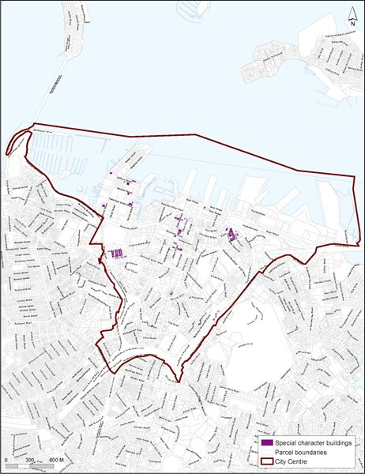

### Map 2: Core retail areas

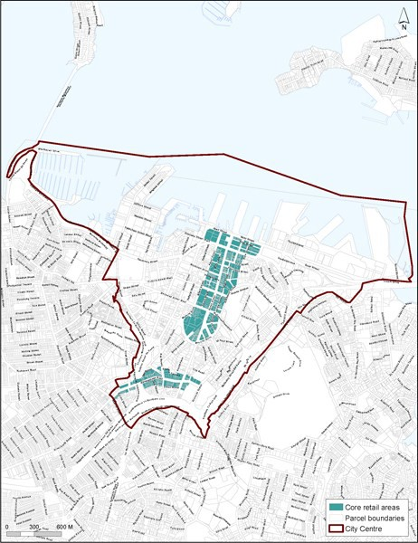

### Map 3: General height controls

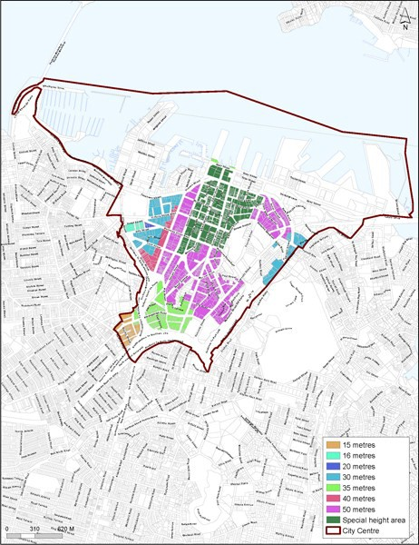

**Map 4: Special height controls**

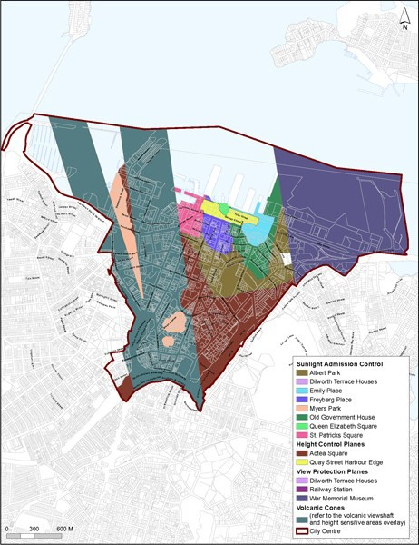

**Map 5: Minumum frontage height**

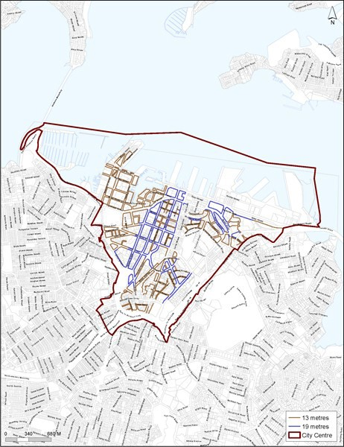

**Map 6: Glazing**

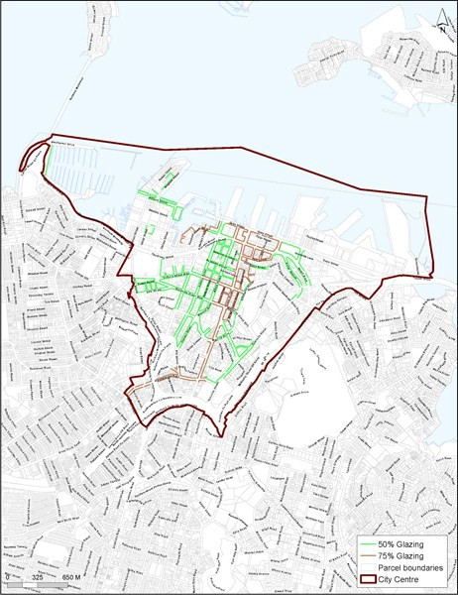

**Map 7: Ground floor activities**

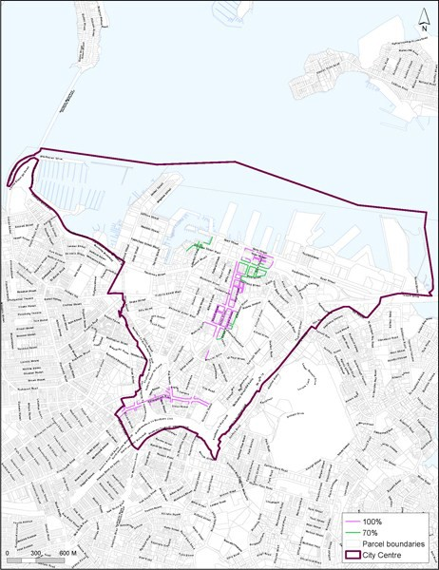

**Map 8: Verandahs**

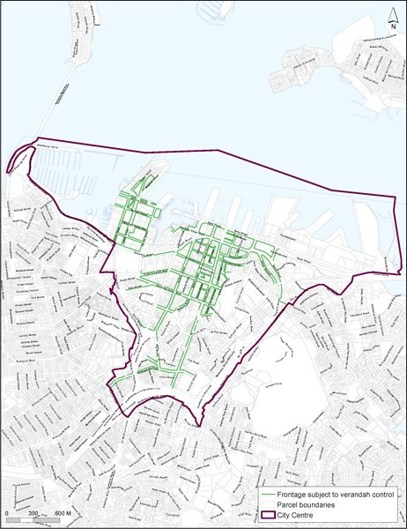

**Map 9: Site intensity**

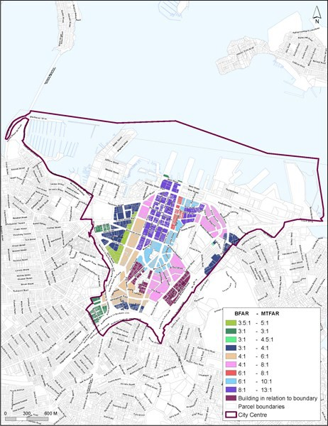

### Map 10: Bonus a-eas

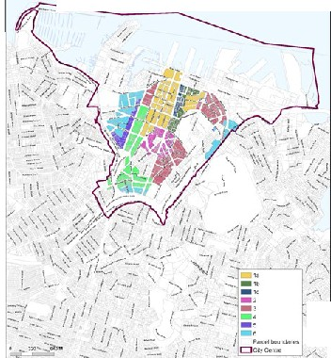

*I*

'

['](http://unitaryplan.aucklandcouncil.govt.nz/Images/September%202013%20version/Zones/Business%20and%20City%20Centre/CC%20Map%2010%20Bonus%20Areas%202013-09-04.pdf)

/

### Map 11: Additional through­site link bonus

