PART 3 ­ REGIONAL AND DISTRICT RULES»Chapter I: Zone rules»

**3 Business zones**

The following rules do not apply to the City Centre zone.

# Activity tables

The following table specifies the activity status of activities in the Metropolitan, Town, Local and Neighbourhood centre zones, Mixed Use zone, the General Business and Business Park zones.

# Centres and Mixed Use zones and the General Business and Business Park zones

|  |  |  |  |  |  |  |  |
| --- | --- | --- | --- | --- | --- | --- | --- |
| **Activity** | **Metro Centre**  **zone** | **Town Centre**  **zone** | **Local Centre**  **zone** | **Neighbourhood Centre zone** | **Mixed Use zone** | **General Business**  **zone** | **Business Park zone** |
| **Accommodation** | | | | | | | |
| Dwellings | P | P | P | P | P | NC | NC |
| Conversion of a building or part of a building to dwellings, visitor accommodation  or boarding houses | RD | RD | RD | RD | RD | NC | NC |
| Retirement villages | D | D | D | D | D | NC | NC |
| Supported residential  care | P | P | P | P | P | NC | NC |
| Visitor accommodation and  boarding houses | P | P | P | P | P | NC | RD |
| **Commerce** | | | | | | | |
| Commercial services | P | P | P | P | P | P | P |
| Commercial sexual  services | P | P | P | P | P | D | NC |
| Drive­through facilities | RD | RD | RD | D | P | P | NC |
| Entertainment  facilities | P | P | D | D | P | P | NC |
| Food and beverage | P | P | P | P | P | P | P |
| Funeral directors’  premises | P | P | P | D | P | D | NC |
| Garden centres | P | P | D | NC | D | RD | D |
| Marine retail | P | P | D | NC | D | RD | D |
| Motor vehicle sales | P | P | D | NC | D | RD | D |
| Offices up to 500m²  GFA per site | P | P | P | P | P | P | P |
| Offices greater than  500m² GFA per site | P | P | NC | NC | D | D | P |
| Retail up to 200m2  GFA per site | P | P | P | P | P | D | D |

|  |  |  |  |  |  |  |  |
| --- | --- | --- | --- | --- | --- | --- | --- |
| **Activity** | **Metro Centre**  **zone** | **Town Centre**  **zone** | **Local Centre**  **zone** | **Neighbourhood Centre zone** | **Mixed Use zone** | **General Business**  **zone** | **Business Park zone** |
| Retail up to 450m²  GFA per site | P | P | P | P | D | D | D |
| Retail greater than  450m² GFA per site | P | P | RD | NC | D | RD | D |
| Service stations | D | D | D | D | D | D | NC |
| Storage and lock­up  facilities | D | D | NC | NC | D | P | D |
| Supermarkets up to  4000m² GFA per site | P | P | RD | NC | D | D | NC |
| Supermarkets greater than 4000m² GFA per  site | P | P | RD | NC | D | NC | NC |
| Trade suppliers | P | P | D | NC | D | RD | D |
| **Community** | | | | | | | |
| Artworks | P | P | P | P | P | P | P |
| Care centres | P | P | P | P | P | D | P |
| Community facilities | P | P | P | D | P | P | D |
| Education facilities | P | P | P | D | P | P | D |
| Emergency services | D | D | D | NC | D | D | D |
| Healthcare facilities | P | P | P | P | P | D | D |
| Hospitals | D | D | NC | NC | D | D | NC |
| **Industry** | | | | | | | |
| Artisan industries | P | P | P | P | P | P | P |
| Industrial activities | NC | NC | NC | NC | NC | P | NC |
| Industrial laboratories | P | P | P | NC | P | P | P |
| Light manufacturing  and servicing | P | P | P | NC | P | P | P |
| Repair and  maintenance services | P | P | P | P | P | P | P |
| Waste management  facilities | NC | NC | NC | NC | NC | NC | NC |
| Warehousing and  storage | P | P | P | NC | P | P | P |
| **Mana Whenua** | | | | | | | |
| Marae complex | P | P | P | D | P | P | D |
| **Development** | | | | | | | |
| New buildings | RD | RD | RD | RD | RD | RD | RD |
| Demolition of buildings | RD | P | P | P | P | P | P |

|  |  |  |  |  |  |  |  |
| --- | --- | --- | --- | --- | --- | --- | --- |
| **Activity** | **Metro Centre**  **zone** | **Town Centre**  **zone** | **Local Centre**  **zone** | **Neighbourhood Centre zone** | **Mixed Use zone** | **General Business**  **zone** | **Business Park zone** |
| Alterations to building facades that are less than:  ­ 10 per cent of its total surface area, or  ­ 15m²  whichever is the lesser | P | P | P | P | P | P | P |
| Additions to buildings that are less than:  ­ 10 per cent of the existing GFA of the building, or  ­ 250m²  whichever is the lesser | P | P | P | P | P | P | P |
| Internal alterations to  buildings | P | P | P | P | P | P | P |
| Additions and alterations to buildings not otherwise provided  for | RD | RD | RD | RD | RD | RD | RD |

**Industrial zones**

2. The activity table below specifies the activity status of activities in the Industrial zones.

|  |  |  |
| --- | --- | --- |
| **Activity** | **Heavy Industry** | **Light Industry** |
| **Accommodation** |  |  |
| Workers accommodation ­ one per  site | P | P |
| Dwellings | Pr | NC |
| **Commerce** |  |  |
| Commercial services | NC | D |
| Dairies up to 100m² GFA | P | P |
| Drive­through facilities | NC | RD |
| Entertainment facilities | NC | D |
| Food and beverage up to 100m²  GFA | P | P |
| Garden centres | NC | RD |
| Large format retail | Pr | NC |
| Motor vehicle sales | NC | RD |

|  |  |  |
| --- | --- | --- |
| Offices that are accessory to an industrial activity on the site and:   1. the office GFA does not exceed 30 per cent of all buildings on the site or 2. the office GFA does not exceed   100m² | P | P |
| Offices that are accessory to an industrial activity on the site and the office GFA exceeds 30 per cent of  all buildings on the site | RD | RD |
| Offices not otherwise provided for | NC | NC |
| Retail accessory to an industrial activity on the site, where the goods sold are manufactured on site and the retail GFA does not exceed 10  per cent of all buildings on the site | P | P |
| Retail, up to 450m2, not otherwise  provided for | NC | NC |
| Service stations | P | P |
| Show homes | NC | P |
| Storage and lock­up facilities | NC | P |
| Trade suppliers | NC | RD |
| **Community** |  |  |
| Care centres | NC | D |
| Community facilities | NC | D |
| Education facilities that are accessory to an industrial activity on  the site | P | P |
| Education facilities not otherwise  provided for | D | D |
| Emergency services | D | P |
| Hospitals | NC | D |
| **Industry** |  |  |
| Industrial activities | P | P |
| **Rural** |  |  |
| Animal breeding or boarding | NC | P |
| Horticulture | NC | P |
| **Development** |  |  |
| Construction of buildings | P | P |
| Additions and alterations to  buildings | P | P |
| Demolition of buildings | P | P |

# Notification

* 1. The council will publicly notify resource consent applications for the following activities:
     1. office, retail and dwellings in the Light Industry zone specified as non­complying in the zone activity table
     2. dwellings in the General Business zone.
  2. Buildings that infringe the building height and height in relation to boundary development controls below are subject to the normal tests for notification under the relevant sections of the RMA.

# Land use controls

**3.1 Activities within 30m of a residential zone**

* 1. The following activities are restricted discretionary activities where they are located within 30m of a residential zone and are listed as a permitted activity in the zone activity table:
     1. taverns
     2. drive­through facilities
     3. outdoor eating areas accessory to restaurants
     4. entertainment facilities
     5. child care centres.

# Development Controls ­ Centres, Mixed Use, General Business and Business Park zones

The following development controls apply to the centres and mixed use zones and the General Business and Business Park zones.

# Development control infringements

* + 1. Buildings that infringe three or more of the following development controls are a discretionary activity:
       1. height
       2. height in relation to boundary
       3. building setback at upper floors
       4. maximum tower dimension and tower separation
       5. buildings fronting the street
       6. residential at ground floor
       7. yards
       8. outlook.

# Building height

Purpose:

* manage the effects of building height
* allow reasonable sunlight and daylight access to streets, public open space, the subject site and nearby sites
* avoid visual dominance effects
* provide for variations to the standard zone height through the Additional Zone Height Control overlay, to recognise the character and amenity of particular areas and provide a transition in building scale to lower density zones.
  + 1. Buildings must not exceed the height in metres and storeys specified for the relevant zone in the table below, unless otherwise specified in the Additional Zone Height Control overlay.
    2. All heights in the Town Centre zone are shown on the Additional Zone Height Control overlay.
    3. If the site is subject to the Additional Zone Height Control overlay, buildings must not exceed the height in:
       1. metres, as shown for the site on the planning maps, and
       2. storeys, calculated so that the first 4.5m of height shown on the planning maps is one storey, and every 4m after that is an additional storey.
    4. Other overlays and precincts may specify a different height control.

Table 1

|  |  |  |
| --- | --- | --- |
| **Zone** | **Building height in metres** | **Building height in**  **storeys** |
| Metropolitan centre | 72.5m | 18 storeys |
| Local centre | 16.5m | 4 storeys |
| Neighbourhood centre | 12.5m | 3 storeys |
| Mixed use | 16.5m | 4 storeys |
| General Business | 16.5m | 4 storeys |
| Business Park | 20.5m | 5 storeys |

# Height in relation to boundary

Purpose:

* manage the effects of building height
* allow reasonable sunlight and daylight access to streets, public open space, the subject site and nearby sites
* avoid visual dominance effects on neighbouring zones where lower height limits apply.

Table 2

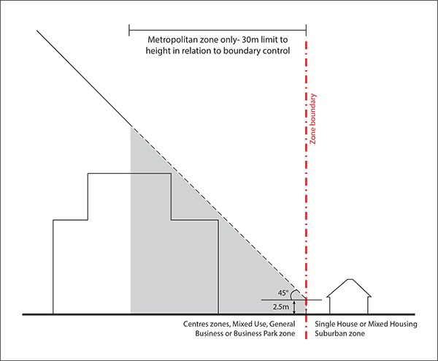

|  |  |
| --- | --- |
| **Height in relation to**  **boundary** | **Figures 1 ­ 8** |
| **Centres, Mixed Use, General Business or Business Park zone interface with the Single House or the Mixed Housing Suburban**  **zones**  Buildings must not project beyond a 45­degree recession plane measured from a point 2.5m vertically above ground level along the Single House or the Mixed Housing Suburban zone boundary.  In the Metropolitan Centre zone the recession plane extends for only 30m into the zone. | Figure 1a  Figure 1b |

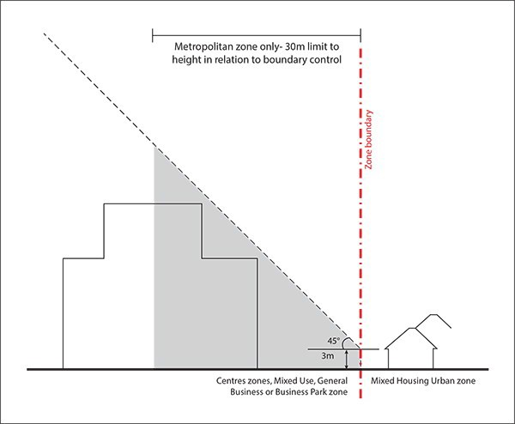

|  |  |
| --- | --- |
| **Height in relation to**  **boundary** | **Figures 1 ­ 8** |
| **Centres, Mixed Use, General Business or Business Park zone interface with the Mixed Housing Urban zone**  Buildings must not project beyond a 45 degree recession plane measured from a point 3m vertically above ground level along the Mixed Housing Urban zone boundary.  In the Metropolitan Centre zone the recession plane extends for only 30m into the zone. | Figure 2a  Figure 2b |

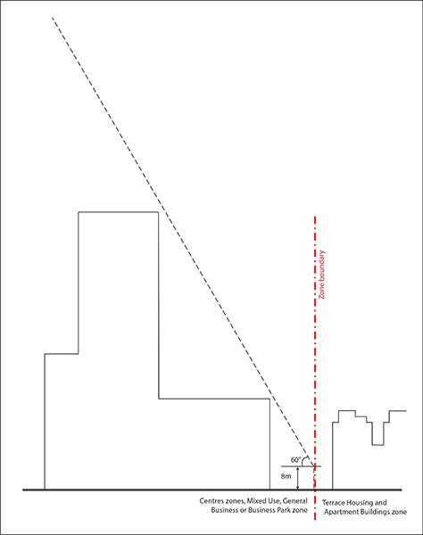

|  |  |
| --- | --- |
| **Height in relation to**  **boundary** | **Figures 1 ­ 8** |
| **Centres, Mixed Use, General Business or Business Park zone interface with the Terrace Housing and Apartment Building zone**  Buildings must not project beyond a 60 degree recession plane measured from a point 8m vertically above ground level along the Terrace Housing and Apartment Buildings zone boundary. | Figure 3a  Figure 3b |

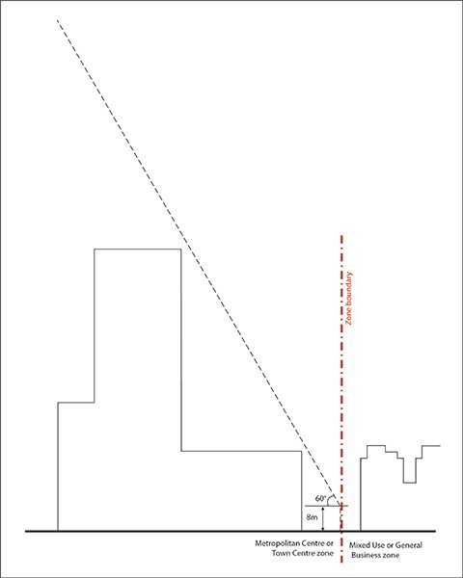

|  |  |
| --- | --- |
| **Height in relation to**  **boundary** | **Figures 1 ­ 8** |
| **Metropolitan Centre zone or Town Centre zone interface with Mixed Use or General Business zones**  In the Metropolitan or Town Centre zone, buildings must not project beyond a 60 degree recession plane measured from a point 8m vertically above ground level along the Mixed Use or General Business zone boundary. | Figure 4a  Figure 4b |

|  |  |
| --- | --- |
| **Height in relation to**  **boundary** | **Figures 1 ­ 8** |
| **Metropolitan Centre zone interface with Public Open Space zones**  In the Metropolitan Centre zone buildings located on the:   * northern boundary of the public open space zone must not project beyond a 45 degree recession plane measured from a point 8.5m vertically above ground level along the public open space zone boundary, or * eastern, western or southern boundary of the public open space zone must not project beyond a 45 degree recession plane measured from a point 16.5m vertically above ground level along the public open space zone. | Figure 5a  Figure 5b |

|  |  |
| --- | --- |
| **Height in relation to**  **boundary** | **Figures 1 ­ 8** |
|  | Figure 5c  Figure 5d |

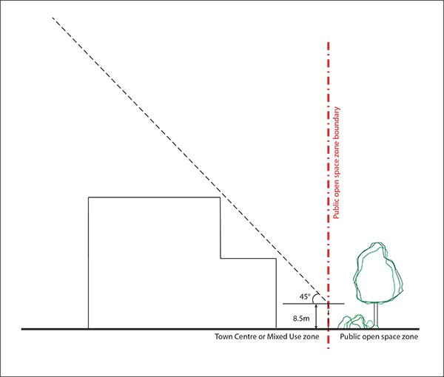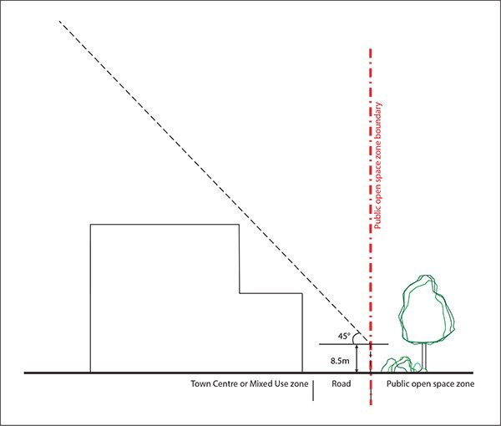

|  |  |
| --- | --- |
| **Height in relation to**  **boundary** | **Figures 1 ­ 8** |
| **Town Centre or Mixed Use zone interface with Public Open Space zones**  In the Town Centre or Mixed Use zone buildings must not project beyond a 45 degree recession plane measured from a point 8.5m vertically above ground level along the public open space zone boundary. | Figure 6a  Figure 6b |

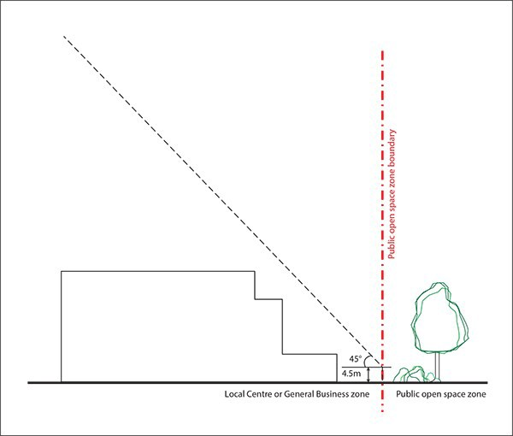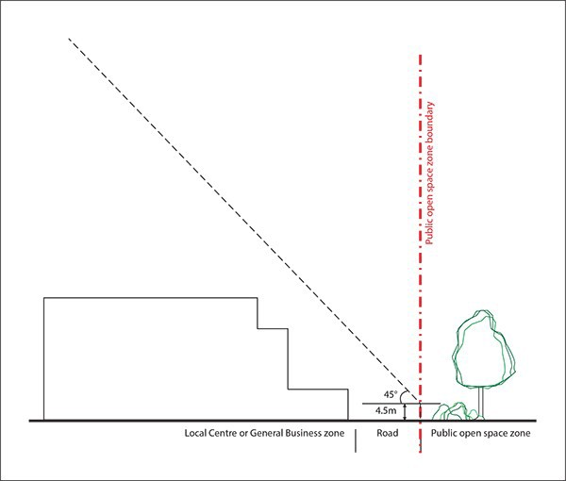

|  |  |
| --- | --- |
| **Height in relation to**  **boundary** | **Figures 1 ­ 8** |
| **Local Centre or General Business zone interface with Public Open Space zones**  In the Local Centre or General Business zone, buildings must not project beyond a 45 degree recession plane measured from a point 4.5m vertically above ground level along the public open space zone boundary. | Figure 7a  Figure 7b |

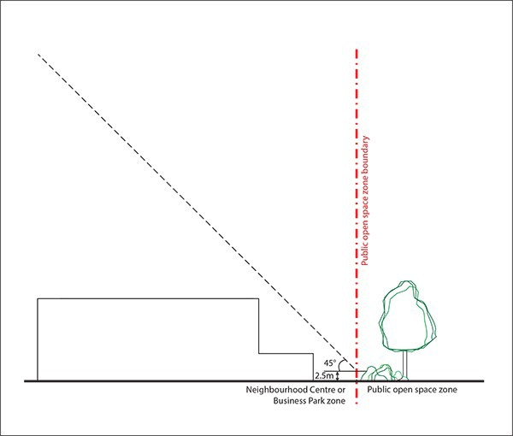

|  |  |
| --- | --- |
| **Height in relation to**  **boundary** | **Figures 1 ­ 8** |
| **Neighbourhood Centre or Business Park zone interface with Public Open Space zones**  In the Neighbourhood Centre or Business Park zone, buildings must not project beyond a 45 degree recession plane measured from a point 2.5m vertically above ground level along the public open space zone boundary. | Figure 8a  Figure 8b |

# Building setback at upper floors

Purpose:

* ensure that buildings form a consistent edge to the street
* optimise sunlight access to streets and public open spaces
* avoid visual dominance effects on streets and public open spaces
* mitigate adverse wind effects.
  + 1. A new building must be set back from the site frontage from the point where it exceeds the height listed in metres and storeys specified for the relevant zone in the table below.
    2. The frontage of a new building must not be set back from the road boundary below the height listed in metres and storeys specified for the relevant zone in the table below.

Table 3

|  |  |  |  |
| --- | --- | --- | --- |
| **Zone** | **Building height** | **Storeys** | **Minimum setback** |
| Metropolitan Centre | 24.5m | 6 | 6m |
| Town Centre | 16.5m | 4 | 6m |
| Mixed Use | 16.5m | 4 | 6m |

## Figure 9: Metropolitan Centre zone building setback at upper floors

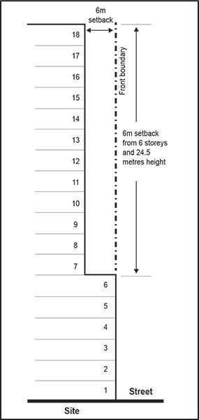

**Figure 10: Town Centre zone building set back at upper floors**

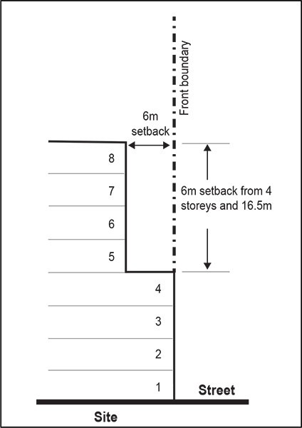

**Figure 11: Mixed Use zone building setback at upper floors**

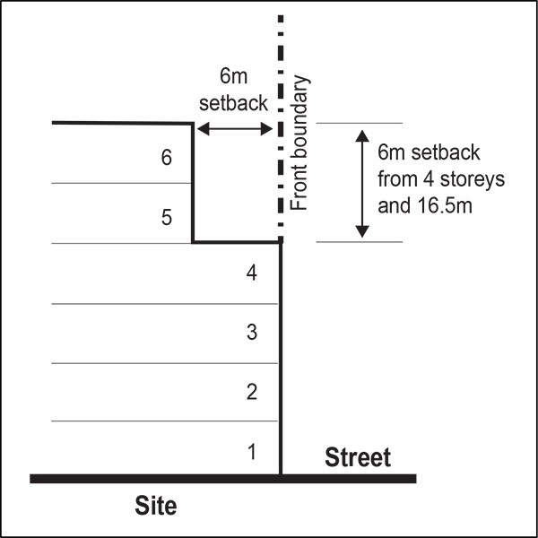

* 1. **Maximum tower dimension and tower separation**

Purpose: ensure that high­rise buildings ­

* are not overly bulky in appearance and avoid significant visual dominance effects
* allow reasonable sunlight and daylight access to streets, public open space, the subject site and nearby sites
* provide adequate sunlight and outlook around buildings
* mitigate adverse wind effects.
  + 1. The following controls apply to buildings within the Metropolitan Centre, Town Centre and Mixed Use zones
    2. The maximum plan dimension of that part of the building above the required set back in clause 4.4 above must not exceed 50m.
    3. The maximum plan dimension is the horizontal dimension between the exterior faces of the two most

separate points of the building.

* + 1. The part of a building above either 24.5m or six storeys must be located at least 6m from any side or rear boundary of the site.

## Figure 12: Maximum tower dimension at setback for the Metropolitan Centre zone

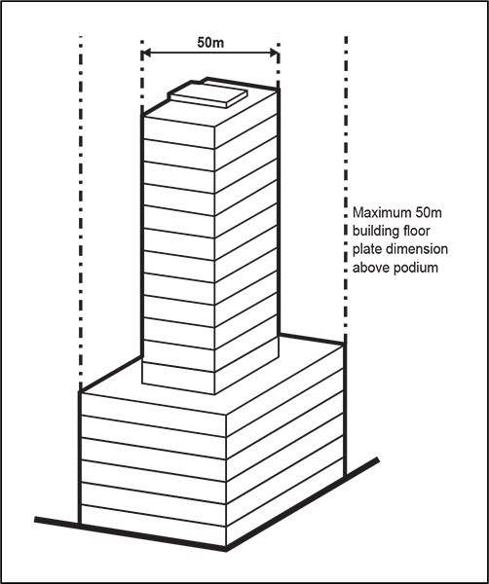

**Figure 13: Maximum tower dimension at setback for Town Centre and Mixed Use zone**

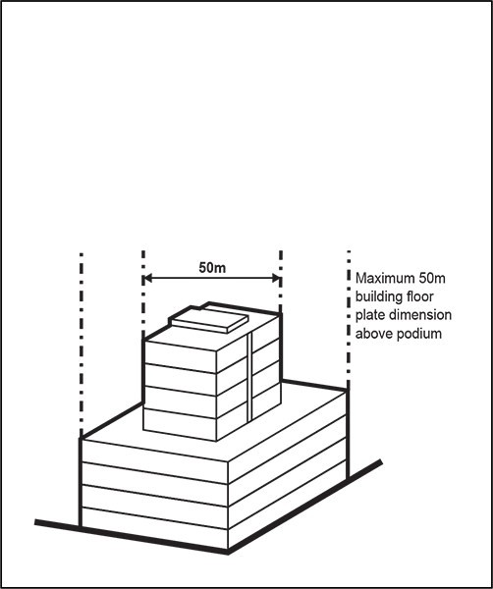

**Figure 14: Maximum tower dimension plan view**

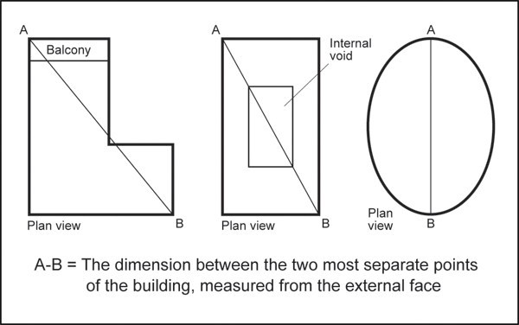

**Figure 15: Minimum tower separation**

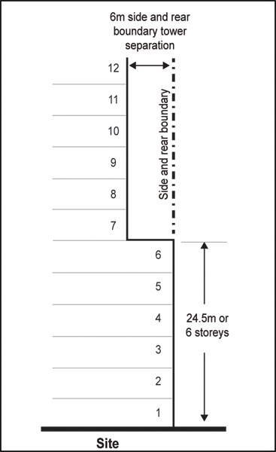

* 1. **Buildings fronting the street**

Purpose: ensure buildings define the street edge and contribute to ­

* providing an attractive streetscape by positively contributing to street definition and enclosure
* enhancing pedestrian amenity
* making buildings accessible by providing convenient and direct access between the street and building for people of all ages and abilities.
  + 1. A new building must adjoin the entire length of the site frontage in the following overlay and zones:
       1. Key Retail Frontage overlay
       2. Local Centre zone
       3. Neighbourhood Centre zone.
    2. Vehicle access areas are excluded from the requirements of clauses 1(b) and 1(c) above.
    3. A new building must adjoin at least 70 per cent of the site frontage in the General Commercial Frontage

overlay.

* + 1. A new building must adjoin at least 50 per cent of the site frontage in the following areas:
       1. Mixed Use zone
       2. General Business zone
       3. All areas of Metropolitan and Town Centre zones that are not subject to a Key Retail or General Commercial Frontage overlay.

## Figure 16: 50 per cent building frontage

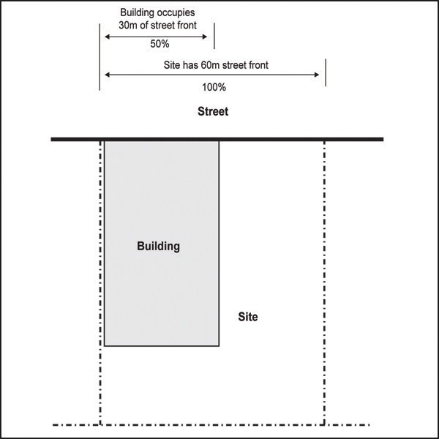

* 1. **Building entrances**

Purpose: ensure that pedestrian entrances ­

* are easily visible from the street
* are located sufficiently close to the street to reinforce pedestrian movement along the street
* provide convenient and direct access between the street and building for people of all ages and abilities.
  + 1. At least part of the main pedestrian entrance to a building must be on or within 3m of the site frontage.

This control does not apply in the Business Park zone.

## Figure 17: Building entrances

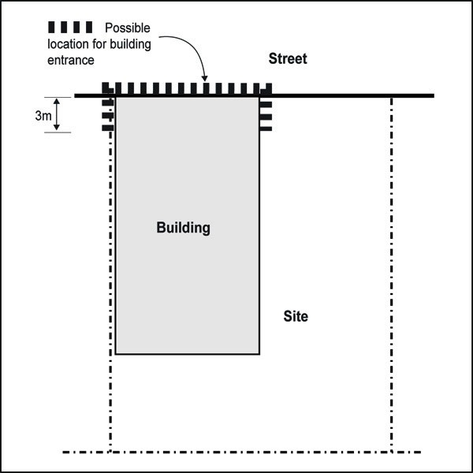

* 1. **Minimum floor to floor/ceiling height**

Purpose: buildings ­

* are adaptable to a wide variety of uses over time
* provide adequate sunlight and daylight access to buildings.
  + 1. The ground floor of a new building subject to a Key Retail Frontage or General Commercial Frontage overlay must have a minimum finished floor to floor height of 4.5m for a minimum depth of 10m.
    2. The ground floor of a new building must have a minimum finished floor to floor height of 4m for a minimum depth of 6m where it adjoins streets or public open spaces in the following zones:
       1. Local Centre
       2. Neighbourhood Centre
       3. Mixed Use
       4. General Business
       5. Business Park
       6. those parts of Metropolitan and Town Centre zones that are not subject to the Key Retail Frontage and General Commercial Frontage overlay.
    3. The finished floor to floor height of new buildings above ground floor must be at least 3.6m where those floors will accommodate non­residential activities.
    4. The finished floor to finished ceiling height of new buildings above ground floor must be at least 2.55m where those floors will accommodate dwellings.

# Glazing

Purpose: avoid blank walls at the ground floor to ­

* create an attractive streetscape environment and enhance the amenity of streets and public open space
* provide a high degree of visibility between the street / public open space and the building interior and positively contribute to pedestrian amenity
* enable passive surveillance of the street from the ground floor of buildings.
  + 1. The ground floor of a building subject to a Key Retail Frontage overlay must have clear glazing for at least 75 per cent of its width and 75 per cent of its height.
    2. The ground floor of a building must have clear glazing for:
       1. at least 50 per cent of its width and 50 per cent of its height where it fronts a street or public open space
       2. at least 30 per cent of its width and 75 per cent of its height where it fronts a public open space which is on the side or rear boundary
       3. this rule applies in the following areas:

i.

ii. iii. iv.

v.

vi. vii.

General Commercial Frontage overlay Local Centre zone

Neighbourhood Centre zone Mixed Use zone

Business Park zone General Business zone

those areas in the Metropolitan Centre and Town Centre zones not subject to a Key Retail Frontage overlay.

* + 1. Where a publicly accessible through­site link is provided through a site or block as part of a development, the ground floor of those buildings with facades facing the through­site link must have clear glazing for at least 30 per cent of the length of the ground floor building facade that faces the through­site link and 75 per cent of its height.

# Roller Doors

Purpose: integrate security devices (e.g. grills/roller doors) into the design of the building to ­

* create an attractive streetscape environment and enhance the amenity of streets and public open space
* provide a high degree of visibility between the street / public open space and the building interior and

contribute to pedestrian amenity and safety.

* + 1. Roller doors on street facing ground floor facades must be:
       1. located inside the building facade
       2. at least 75 per cent transparent.

# Residential at ground floor

Purpose:

* protect the ground floor of buildings within centres for commercial use
* avoid locating activities that require privacy on the ground floor of buildings.
  + 1. Dwellings in the Metropolitan Centre, Town Centre, Local Centre and Neighbourhood Centre zone must not locate on the ground floor of a building adjoining public open spaces and streets.

# Ground floor at street frontage level

Purpose:

* avoid blank walls at ground floor
* make buildings accessible by providing convenient and direct access between the street and building for people of all ages and abilities.
  + 1. Entrances to the ground floor of a building must be at grade with the adjoining street.
    2. The ground floor of a new building subject to the Key Retail or General Commercial Frontage overlay must be at the same level of the adjoining street for a minimum depth of 6m. Except where the adjoining street slopes along the site frontage, the ground floor must be no more than 1.2m above or below the level of the site frontage.
    3. The level of the site frontage must be measured at every point along that boundary.

## Figure 18: Required ground floor level of building frontages

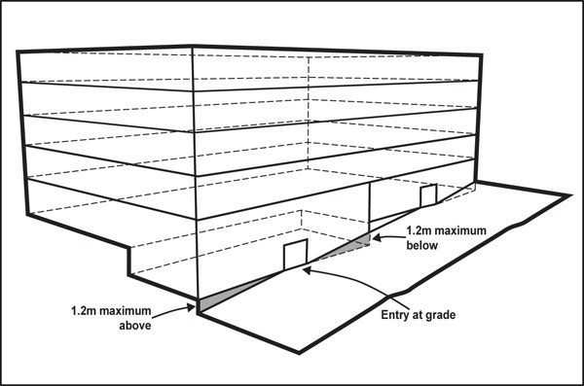

# Verandahs

Purpose:

* provide pedestrians with weather protection, safety and amenity on the frontages of sites subject to the Key Retail Frontage overlay.
  + 1. The ground floor of a building subject to the Key Retail Frontage overlay must provide a verandah along the full extent of the frontage. The verandah must:
       1. be related to its neighbours to provide continuous pedestrian cover of the footpath, excluding vehicle access
       2. have a minimum height of 3m and a maximum height of 4.5m above the footpath
       3. be set back at least 600mm from the kerb.
    2. Lighting outside daylight hours must be provided under a verandah to a minimum of 20 lux (light illumination) on the footpath, where the lux level is measured at ground level on a horizontal plane at 2m from the building adjoining the footpath. Lighting of the footpath must have a uniformity ratio of 0.5.
    3. Lighting levels required under verandahs may be met by one or more of the following methods, providing it also complies with the Auckland­wide lighting rules:
       1. providing lighting beneath a verandah
       2. providing lighting within the shop/office that spills out through windows to the outside footpath
       3. the use of advertising signage of light colour which will spill light out onto the footpath
       4. providing downwardly directed lighting on the exterior of the building.

# Building frontage height

Purpose: ensure buildings ­

* provide an attractive streetscape by positively contributing to street definition and enclosure
* enhance pedestrian amenity.
  + 1. A new building subject to the Key Retail Frontage overlay must have a minimum height of 8.5m or two storeys for a minimum depth of 10m from the site frontage.

# Yards

Purpose:

* provide a buffer and screening between commercial activities and neighbouring residential activities and public open space, to mitigate adverse visual and nuisance effects
* ensure the Business Park zone achieves a spacious landscaped character
* ensure buildings are adequately setback from lakes, streams and the coastal edge to maintain water quality, amenity, provide protection from natural hazards, and potential access to the coast.

Table 4

|  |  |  |
| --- | --- | --- |
| **Yard** | **Centres, Mixed Use and**  **General Business zones** | **Business Park** |
| Rear | 3m where the rear boundary adjoins a residential zone  and public open spaces | 5m where the rear boundary adjoins a residential zone or  public open spaces |
| Side | 3m where a side boundary  adjoins a Residential zone | 5m where a side boundary  adjoins a Residential zone |
| Riparian | 10m from the edge of all permanent and intermittent  streams | 10m from the edge of all permanent and intermittent  streams |
| Coastal protection yard | 25m, or as otherwise specified in appendix 6.7 | |

* + 1. Side and rear yards must be planted with trees, shrubs and ground cover plants within and along the full extent of the yard to provide a densely planted visual buffer for a depth of at least 3m. Landscape

planting must cover the full area of the specified yard and be capable of achieving a dense visual screen to a height of 5m within five years of planting.

# Building setback in Business Park zone

Purpose: enable buildings in the Business Park zone to be setback from the site frontage and achieve a spacious landscaped character in the zone.

* + 1. In the Business Park zone, buildings may be set back up to a maximum of 7.5m from the site frontage.
    2. Parking must not locate within a setback from the site frontage.
    3. A setback must be fully planted with trees, shrubs and ground cover plants along the frontage of sites not occupied by buildings or access points.

# Landscaping

Purpose: ensure ­

* the Business Park zone achieves a spacious landscaped character
* there is a buffer and screening between commercial activities and the street in the Mixed Use and General Business zone and some sites in the Metropolitan and Town Centre zones
* landscaping is of sufficient quality as to make a positive contribution to the amenity of the street.
  + 1. In the Business Park zone, at least 20 per cent of a site must be landscaped.
    2. Landscaping must be provided along the frontage of sites not occupied by buildings or access points

as allowed by clause 4.6 above, for a depth of 3m, for sites in:

* + - 1. the General Business zone
      2. the Mixed Use zone
      3. all areas of Metropolitan and Town Centre zones that are not subject to a Key Retail or General Commercial Frontage overlay.
    1. The required landscaping must comprise trees, shrubs and ground cover plants.

# Maximum impervious area in the General Business and Business Park zone

Purpose: manage the amount of stormwater runoff generated by a development in the General Business and Business Park zone.

* + 1. Maximum impervious area in the General Business and Business Park zone: 80 per cent.
    2. Maximum impervious area within a riparian yard in the centres, mixed use, Business Park and General Business zone: 10 per cent.

# Wind

Purpose: mitigate the adverse wind effects generated by tall buildings.

* + 1. A new building exceeding 25m in height must not cause:
       1. the mean wind speed around it to exceed the category for the intended use of the area as set out in Table 5 and Figure 19 below
       2. the average annual maximum peak 3­second gust to exceed the dangerous level of 25m/second
       3. an existing wind speed which exceeds the controls of 1a or 1b above to increase.

Table 5

|  |  |
| --- | --- |
| Category A | Areas of pedestrian use or adjacent dwellings containing significant formal elements and features intended to encourage longer term recreational or relaxation  use i.e. public open space and adjacent outdoor living space |
| Category B | Areas of pedestrian use or adjacent dwellings containing minor elements and features intended to encourage short term recreation or relaxation, including  adjacent private residential properties |
| Category C | Areas of formed footpath or open space pedestrian linkages, used primarily for pedestrian transit and devoid of significant or repeated recreational or relaxational  features, such as footpaths not covered in Categories A or B above |
| Category D | Areas of road, carriage way, or vehicular routes, used primarily for vehicular transit and open storage, such as roads generally where devoid of any features or form  which would include the spaces in Categories A ­ C above. |
| Category E | Category E represents conditions which are dangerous to the elderly and infants and of considerable cumulative discomfort to others, including residents in adjacent sites. Category E conditions are unacceptable and are not allocated to  any physically defined areas of the city |

## Figure 19: Mean wind speed

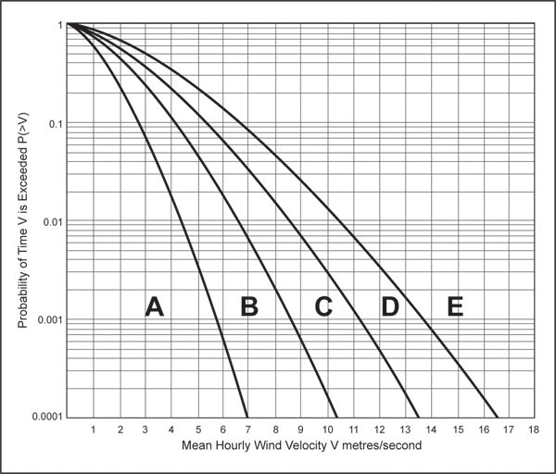

**Derivation of wind environment control graph**

The curves on the graph delineating the boundaries between the acceptable categories (A­D) and unacceptable

(E) categories of wind performance are described by the Weibull expression:

P(>V) = e‾(v/c)K

where C is a selected value on the horizontal axis, and P is the corresponding value of the vertical axis: and where:

P(>V) = Probability of a wind speed V being exceeded; e = The Naplerian base 2.7182818285

v = the velocity selected;

K = the constant 1.5; and

c = a variable dependant on the boundary being defined: A/B, c = 1.548

B/C, c = 2.322 C/D, c = 3.017 D/E, c = 3.715

# Dwellings, visitor accommodation and boarding houses

Purpose: ensure a good standard of amenity within and between dwellings and visitor accommodation dwellings.

* + 1. Dwellings must comply with the controls specified for the relevant zones below:
       1. in the Metropolitan Centre zone refer to City Centre zone rules:
          1. outlook space

ii. iii. iv.

v.

vi. vii.

minimum dwelling size

minimum dimension of principal living rooms and principal bedrooms daylight to dwellings

dwelling mix outdoor living space

universal access for residential buildings.

* + - 1. in the Town Centre, Local Centre, Neighbourhood Centre and Mixed Use zones, refer to the Terraced Housing and Apartment Building zone rules:

i.

ii. iii. iv.

v.

vi. vii. viii. ix.

x.

outlook space outdoor living space daylight to dwellings

minimum dwelling size

minimum dimension of principal living rooms and principal bedrooms servicing and waste

storage

separation between buildings on the same site dwelling mix

universal access.

* + 1. Visitor accommodation and boarding houses in the Metropolitan Centre zone must comply with the outlook control in the City Centre zone.
    2. Visitor accommodation and boarding houses in the Town Centre, Local Centre, Neighbourhood Centre and Mixed Use zones must comply with outlook space in the Terraced Housing and Apartment Building zone.

# Development Controls ­ Industrial zones

The following development controls apply to the Heavy Industry and Light Industry zones.

# Building height

Purpose:

* + - manage the effects of building height.
    - allow reasonable sunlight and daylight access to streets, public open space, the subject site and nearby sites
    - avoid visual dominance effects.

1. Buildings must not exceed 20m in height.

# Height in relation to boundary

Purpose:

* + - manage the effects of building height
    - allow reasonable sunlight and daylight access to streets, public open space, the subject site and nearby sites
    - avoid visual dominance effects on neighbouring zones where lower height limits apply.

Table 6

|  |  |
| --- | --- |
| **Height in relation to**  **boundary** | **Figure 20** |
| Buildings must not project beyond a 18 degree recession plane measured from a point 8m vertically above ground level along the residential or public open space boundary | Figure 20a  Figure 20b |

# Maximum impervious area

Purpose: manage the amount of stormwater runoff generated by a development.

1. Maximum impervious area: 80 per cent.
2. Maximum impervious area within a riparian yard: 10 per cent.

# Yards

Purpose:

* + - provide a buffer and screening between industrial activities and neighbouring residential activities and public open space, to mitigate adverse visual and nuisance effects
    - ensure buildings are adequately set back from lakes, streams and the coastal edge to maintain water quality, amenity, provide protection from natural hazards, and potential access to the coast.

Table 7

|  |  |
| --- | --- |
| **Yard** | **Heavy Industry and Light Industry** |
| Front | 3m  Yards are not required for internal roads or service lanes |
| Rear | 5m where the rear boundary adjoins a residential zone  or public open space |
| Side | 5m where the side boundary adjoins a residential zone  or public open space |
| Riparian | 10m from the edge of permanent and intermittent  streams |
| Coastal protection yard | 25m, or as otherwise specified in appendix 6.7 |

1. Front yards (excluding access points) must be planted with trees, shrubs and ground cover plants within and along the full extent of the yard. Planting must include specimen trees capable of achieving a height of 5m within five years of planting and spaced at a minimum of one every 5m along the full length of the yard.
2. Side and rear yards must be planted with trees, shrubs and ground cover plants within and along the full extent of the yard to provide a densely planted visual buffer for a depth of at least 3m. Landscape

planting must cover the full area of the specified yard and be capable of achieving a dense visual screen to a height of 5m within five years of planting.

# Storage and screening

Purpose: require rubbish and/or storage areas to be screened from neighbouring residential and rural zones and public open spaces.

1. Any outdoor storage or rubbish collection areas that directly face and are visible from a residential, rural or public open space zone adjoining a boundary with, or on the opposite side of the road from, an industrial zone, must be screened from those areas by a solid wall or fence at least 1.8m high.

# Assessment ­ Restricted discretionary activities

## Matters of discretion

The council will restrict its discretion to the matters below for the activities listed as restricted discretionary in the activity table.

1. Drive­through facilities, activities within 30m of a residential zone, supermarkets greater than 4000m² in the Local Centre zone
   1. intensity and scale
   2. noise, lighting and hours of operation
   3. design of parking, access and servicing.
2. Retail greater than 450m² in the General Business and Local Centre zone
   1. intensity and scale
   2. centre vitality
   3. design of parking, access and servicing.
3. Garden centres, motor vehicle sales and trade suppliers in the Light Industry and General Business zones
   1. intensity and scale
   2. reverse sensitivity and displacement of industrial activities
   3. design of parking, access and servicing.
4. Offices that are accessory to an industrial activity in the site and the GFA exceeds 30 per cent of all buildings on the site in the Heavy Industry and Light Industry zones
   1. centre vitality
   2. reverse sensitivity and the displacement of industrial activities.
5. New buildings and alterations and additions to buildings not otherwise provided for
   1. building design and external appearance
   2. design and scale of buildings adjoining historic heritage places
   3. design of public open space
   4. design of landscaping
   5. topography, earthworks and natural features
   6. design of parking, access and servicing
   7. design and layout of dwellings, visitor accommodation and boarding houses
   8. water sensitive design.
6. Conversion of a building or part of a building to dwellings, visitor accommodation and boarding houses
   1. design and layout of dwellings, visitor accommodation and boarding houses.
7. Demolition of buildings
   1. pedestrian amenity and safety
   2. re­use of building materials
   3. site condition post demolition
   4. traffic generation.

## Assessment criteria

The council will consider the relevant assessment criteria below for the restricted discretionary activities listed above.

1. Drive­through facilities, activities within 30m of a residential zone, supermarkets greater than 4000m² in the Local Centre zone
   1. Intensity and scale
      1. The intensity and scale of the land use activity, in particular, the number of people involved and traffic generated by the activity, should be compatible with the planned future form and character of the surrounding area.
   2. Noise, lighting and hours of operation
      1. Noise and lighting from the activity should not adversely affect the amenity of surrounding residential properties. In determining this, consideration will be given to the location of any

potentially noisy activities e.g. outdoor play areas associated with a care centre, and any proposed measures to mitigate noise including:

* + - * locating noisy activities away from neighbouring residential boundaries
      * screening or other design features
      * the proposed hours of operation.
  1. Design of parking, access and servicing

i.

ii.

iii.

iv.

v.

vi.

vii.

viii.

ix.

Parking should be located in order of preference, underground, to the rear of the building or separated from the street frontage by uses that activate the street. For industrial zones there is no preference for underground parking.

Vehicle crossings and access ways should be designed to reduce vehicle speed, be visually attractive and clearly signal to both vehicles and pedestrians the presence of a crossing or access way.

Surface parking should be softened with landscaping, including tree planting. As a guide, one tree should be planted every sixth parking bay.

Pedestrian access between parking areas, building entrances/lobbies and the street should provide equal physical access for people of all ages and physical abilities and provide a high level of pedestrian safety.

Separate vehicle and pedestrian access should be provided within parking areas, and between parking areas, buildings and the street. Shared pedestrian and vehicle access may be appropriate where a lane or street is proposed within a development site. The shared access should prioritise pedestrian movement.

Ventilation and fumes from parking structures or other uses should not be vented into the adjacent pedestrian environment at ground level.

In greenfield locations and large redevelopment sites, service lanes should be provided within urban blocks to allow access to the rear of buildings and to minimise gaps in the streetscape. Development in industrial zones is not required to provide service lanes.

Where ramps are necessary they should be minimal in length and integrated into the design of the building.

For commercial activities, suitable provision should be made for on­site rubbish storage and sorting of recyclable materials that:

* is a sufficient size to accommodate the rubbish generated by the proposed activity
* is accessible for rubbish collection. Kerbside collection is generally not appropriate
* for new buildings, is located within the building
* for alterations or additions to existing buildings where it is not possible to locate the storage area within the building, is located in an area not visible from the street or public open spaces.

x. The development must be able to be adequately served by wastewater and transport infrastructure.

1. Retail greater than 450m² in the General Business and Local Centre zone
   1. Intensity and scale
      1. Refer to the assessment criteria in 1(a) above.
   2. Centre vitality
      1. Retail and office activities should:
         * not have a substantial adverse effect upon the amenity values, vitality and functions of the city centre, metropolitan centres or town centres having regard to:
           + the activity’s proposed size, composition and characteristics
           + the centre's on­going ability to provide for the future needs of communities.
         * provide a net positive benefit in terms of the community’s convenient access to commercial activities and community services, including having regard to whether:
           + an in­centre location would result in adverse environmental effects on the form, function or on­going capacity of that centre
           + an out­of­centre location is likely to undermine the viability of in­centre community facilities.
   3. Design of parking, access and servicing
      1. Refer to the assessment criteria in 1(c) above.
2. Garden centres, motor vehicle sales and trade suppliers in the Light Industry and General Business zones
   1. Intensity and scale
      1. Refer to the assessment criteria in 1(a) above.
   2. Reverse sensitivity and displacement of industrial activities

i.

ii.

iii.

Non­industrial activities in the industrial zones should not reduce the ability of industrial activities to establish and operate within the zones.

Accessory offices in the industrial zones should not discourage or displace permitted activities. The scale and design of accessory offices should not be likely to attract further similar or supporting activities.

Consideration will be given to whether the accessory offices will increase the efficiency of the industrial activity by integrating supporting administration, services or clerical functions.

* 1. Design of parking, access and servicing.
     1. Refer to the assessment criteria in 1(c) above.

1. Offices that are accessory to an industrial activity in the site and the GFA exceeds 30 per cent of all buildings on the site in the Heavy Industry and Light Industry zones
   1. Centre vitality
      1. Refer to the assessment criteria in 2(b) above.
   2. Reverse sensitivity and the displacement of industrial activities
      1. Refer to the assessment criteria in 3(b) above.
2. New buildings and alterations and additions to buildings not otherwise provided for
   1. Building design and external appearance

*Contributing to sense of place*

i.

ii.

The design of buildings should contribute to the local streetscape and sense of place by responding to the planned future form and character of the surrounding area.

In the Metropolitan Centre zone, the silhouette of the building as viewed from areas surrounding the centre should positively contribute to the centre's skyline.

*Creating a positive frontage*

iii.

iv.

v.

vi.

vii.

viii.

ix.

Buildings should have clearly defined public frontages that address the street and public open spaces to positively contribute to the public realm and pedestrian safety.

Pedestrian entrances should be located on the street frontage and be clearly identifiable and conveniently accessible from the street.

For mixed use buildings, separate pedestrian entrances should be provided for residential uses.

Activities that engage and activate streets and public open spaces are encouraged at ground and first floor levels.

Internal space at all levels within buildings should be designed to maximise outlook onto street and public open spaces.

Servicing elements should be avoided on building facades unless integrated into the facade design.

Dwellings at ground floor in the Mixed Use zone must positively contribute to the public

realm while achieving privacy and a good standard of amenity for occupiers of the dwelling, in particular by:

* providing balconies over­looking the street or public open space
* providing a planted and/or fenced setback to the street or public open space for the part of the site that is not required to adjoin the street. Landscaping or fencing should be low enough to allow direct sightlines from a pedestrian in the street or public open space to the front of a balcony
* raising the balcony and floor plate of the ground floor dwellings above the level of the adjoining street or public open space to a height sufficient to provide privacy for residents and enable them to over­look the street or public open space.

*Visual interest and variation in building form*

x.

xi.

xii.

Buildings, including alterations and additions, should be designed as a coherent scheme and should demonstrate an overall design strategy that positively contributes to the visual quality of development.

Where the proposed development is an extension or alteration to an existing building, it should be designed with consideration to the architecture of the original building and respond positively to the visual amenity of the surrounding area.

Buildings should be designed to:

* avoid long, unrelieved frontages and excessive bulk and scale when viewed from streets and public open spaces
* visually break up their mass into distinct elements to reflect a human scale and the typical pattern of development in the area
* differentiate the ground level from upper levels and the roof
* Techniques to achieve this include the use of recesses, variation in building height and roof form, horizontal and vertical rhythms and facade modulation and articulation.

xiii.

xiv.

Blank walls should be avoided on all levels of building frontages to streets and public open spaces.

Side or rear walls without windows or access points should be used as an opportunity to

introduce creative architectural solutions that provide interest in the façade including modulation, relief or surface detailing.

xv.

xvi.

xvii.

xviii.

Buildings should provide a variety of architectural detail at ground and middle levels including maximising the use of entrances, and windows and balconies overlooking the streets and public open spaces.

Roof profiles should be designed as part of the overall building form and contribute to the architectural quality of the skyline as viewed from both ground level and the surrounding area. This includes integrating plant, exhaust and intake units and other mechanical and electrical equipment into the overall rooftop design.

Colour variation and landscaping, without the use of other design techniques, should not be used to mitigate a lack of building articulation or design quality.

For residential development:

* the unrelieved repetition of unit types should be avoided
* balconies should be designed as an integral part of the building. A predominance of cantilevered balconies should be avoided
* apartments above ground floor should be accessed from internal corridors or entrance ways. External walkways / breezeways should generally be avoided.

*Materials and finishes*

xix.

xx.

xxi.

Buildings should use quality, durable and easily maintained materials and finishes on the facade, particularly at street level.

Buildings should not use reflective materials that would adversely affect safety, pedestrian amenity or the amenity of surrounding properties.

Where provided, signage should be designed as an integrated part of the building facade.

* 1. Design and scale of buildings adjoining historic heritage places
     1. Buildings adjoining or in close proximity to a scheduled historic heritage place:
        + should be located and designed to have regard to the significant historic heritage elements and built form of the place. This does not mean a rigid adherence to the height of the place, not does it reduce the development potential of the site, but it does require careful consideration in terms of the form and design of the building to minimise the effects of dominance
        + may not be required to adjoin the site frontage if a better design outcome could be achieved by respecting the setback and/or spatial location of the place
        + should use materials and/or design detail that respects rather than replicates any patterns or elements existing in the place, however new and contemporary interpretations in form and detail may be used
        + should generally avoid ground floor frontages entirely of glass, i.e. curtain­walling or continuous shop front glazing.
  2. Design of public open space

i.

ii.

Where provided, through­site links and public open spaces should be designed to integrate with the existing or planned streets and public open spaces, be visually attractive and positively contribute to the streetscape and sense of place.

Through­site links should be publicly accessible preferably with 24 hour a day and seven day

a week access.

iii.

iv.

Public open spaces should provide a high level of pedestrian safety and prioritise pedestrian and cycle movement over vehicle and service traffic.

Where new publicly accessible open spaces are provided they should be designed and managed to be accessible to people of all ages and abilities.

* 1. Design of landscaping
     1. Where provided, landscaping should:
        + integrate the development into the surrounding area and contribute to the site and surrounding area amenity
        + maintain the personal safety of people and enhance pedestrian comfort
        + be designed for on­going ease of maintenance.

ii.

Where landscaping is provided for a visual buffer to an adjoining residential or open space zone it should form a continuous screen at all times of the year.

* 1. Topography, earthworks and natural features

i.

ii.

Building platforms, parking areas and vehicle entrances should be located and designed to respond to and integrate with the natural landform, landscape features and site orientation.

Earthworks should be minimised and retaining walls avoided where possible. However, where retaining walls or earthworks are required they should be incorporated as a positive landscape or site feature by:

* integrating retaining walls as part of the building design
* stepping and landscaping earthworks or retaining walls over 1m in height, to avoid dominance or overshadowing effects
* ensuring that earthworks or retaining walls visible to the public, including adjoining sites, provide visual interest through attractive design and by incorporating modulation, landscaping and quality materials.
* Where practicable retain mature vegetation and large trees on site. Retention of mature trees is particularly encouraged where their size, location or species makes a significant contribution to the streetscape or where they could be logically incorporated to enhance on­site amenity.
  1. Design of parking, access and servicing
     1. Refer to the assessment criteria in 1(c) above.
  2. Design and layout of dwellings, visitor accommodation and boarding houses
     1. Dwellings should be located, proportioned and orientated within a site to maximise the amenity of future residents by:
        + clearly defining communal, semi­communal and private areas within a development
        + maximising passive solar access while balancing the need for buildings to front the street
        + providing for natural cross­ventilation by window openings facing different directions.

ii.

iii.

Dwellings should be designed to provide a good standard of internal amenity by providing adequate circulation space around standard sized household furniture.

Adequate storage space for larger items such as bikes, gardening and cleaning equipment, should be provided either within each dwelling or within the building containing the dwellings.

iv.

v.

Common areas within buildings containing dwellings, visitor accommodation and boarding houses should provide equal physical access for people of all ages and physical abilities, in particular, by providing doorways, corridors and circulation spaces of sufficient dimension to allow ease of movement and minimising stairs where possible.

Visitor accommodation and boarding houses should be designed to achieve a reasonable standard of internal amenity. Consideration will be given to:

* + - * any specific internal design elements that facilitate the more efficient use of internal space
      * the relationship of windows or balconies to principal living rooms
      * the provision of larger indoor or outdoor living spaces whether communal or exclusive to the dwelling, especially in dwellings that are not self­contained.
  1. Water sensitive design
     1. All development should be designed to incorporate water sensitive design principles that use natural systems and processes for stormwater management to minimise adverse effects and protect and enhance the values and functions of natural ecosystems. This may include:
        + a water sensitive design approach that is appropriate to the scale of the proposed development
        + maximising localised water collection, retention and re­use
        + minimising stormwater run­off by maximising on­site management and disposal of stormwater
        + using ecologically sensitive techniques, integrated with site landscaping and other features to reduce and treat stormwater run­off.

1. Conversion of a building or part of a building to dwellings, visitor accommodation and boarding houses
   1. Design and layout of dwellings, visitor accommodation and boarding houses
      1. Refer to the assessment criteria in clause 5(g) above.
2. Demolition of buildings
   1. Pedestrian amenity and safety
      1. Sites containing buildings that are proposed to be demolished should not have significant adverse effects on the quality and amenity of the public realm and the safety and efficiency of the surrounding transport network. In particular:
         * a high­quality and safe temporary hard or landscaped edge should be provided along the site boundaries so that a defined boundary to streets and public open spaces is maintained. This should include the provision and maintenance of continuous pedestrian cover within areas subject to the Key Retail Frontage overlay
         * an edge treatment should be maintained that is designed to reduce its vulnerability to graffiti and vandalism.
   2. Re­use of building materials
      1. Demolished materials should be re­used and recycled as much as possible.
   3. Site condition post demolition
      1. If the site is not developed following demolition, the site should be landscaped to provide good standard of visual amenity and the site should not be used for temporary or permanent parking.
   4. Traffic generation
      1. With regard to the effects of building demolition on the transport network, consideration should be given to the proposed hours of operation, the frequency and timing of truck

movements to and from the site and the location of vehicle access.

# Assessment ­ Development control infringements

## 7.1 Matters of discretion

For new buildings or alterations and additions to existing buildings that involve a development control infringement, the council will consider the relevant matters set out above in addition to the matters set out in clause 2.3 of the general provisions and the following.

* 1. Building height, height in relation to boundary, building setbacks at upper floors, maximum tower dimension and tower separation
     1. effects of additional building scale on neighbouring sites, streets and public open spaces (sunlight access, dominance, visual amenity)
     2. consistency with the planned future form and character of the area/zone.
  2. Buildings fronting the street, building entrances, minimum floor to floor height (ground floor), glazing, roller doors, residential at ground floor, ground floor at street frontage level, verandahs, building frontage height
     1. effects on the vitality and amenity of streets and public open spaces
     2. effects on historic heritage and historic character buildings and notable trees.
  3. Yards, building setback in the Business Park zone, landscaping
     1. effects on amenity.
  4. Outlook space
     1. privacy and outlook for dwellings
     2. daylight access and ventilation for dwellings.
  5. Minimum dwelling size, minimum floor to floor height (dwellings), minimum dimension of principal living rooms and bedrooms, outdoor living space, storage servicing and waste, daylight to dwellings, dwelling mix
     1. effects of reduced living and circulation space, sunlight/daylight access and storage on residential amenity.
  6. Wind
     1. effects of development on wind conditions and amenity.
  7. Separation between buildings on the same site
     1. dominance effects
     2. effects of reduced daylight and sunlight access and ventilation.
  8. Maximum impervious area
     1. refer to clause 1.4 of the Auckland­wide ­ Stormwater management rules.

## Assessment criteria

For new buildings and alterations and additions to existing buildings that involve a development control infringement, the relevant assessment criteria above will apply in addition to the criteria in clause 2.3 of the general provisions and the specific criteria for the infringement below.

* + 1. Height, height in relation to boundary, building setbacks at upper floors, maximum tower dimension and tower separation
       1. Effects of additional building scale on neighbouring sites and streets and public open spaces (sunlight access, dominance, visual amenity)

i.

ii.

Significant height infringements should be avoided.

Buildings that infringe the controls should be of a very high standard of design and quality.

They should make a significant positive contribution to the visual amenity of the streetscape, the surrounding area, and the wider city.

iii.

iv.

Minor height infringements may be appropriate where it would provide an attractive and integrated roof form that also meets the purpose of the control.

Additional height and/or building mass may be appropriate on corner sites to reinforce the prominence of the corner.

* + - 1. Effects on the planned future form and character of the area/zone
         1. Buildings need to demonstrate that:

the bulk or height does not detract from the planned future character of the surrounding area

when located in the Metropolitan or Town centre zones, the infringement is consistent with the Business zones, Policy 3.3.1 or 3.4.1.

* + 1. Buildings fronting the street, building entrances, minimum floor to floor height, glazing, roller doors, residential at ground floor, ground floor at street frontage level, verandahs, building frontage height
       1. Effects on the vitality and amenity of streets and public open spaces

i.

ii.

iii.

iv.

On sites subject to the Key Retail Frontage overlay, buildings should adjoin the site frontage unless there are exceptional circumstances and the development achieves a better design outcome than a complying proposal.

Buildings, particularly those that infringe the Key Retail Frontage provisions, should enhance the appearance and integrity of the streetscape as a whole.

Buildings should have floor to floor heights that contribute to a sense of space within the building and provide a good standard of amenity for building occupants.

Dwellings should not locate on the ground floor of buildings fronting streets and public open spaces where they would:

* detract from the amenity and vitality of the street or public open space, such as on frontages that are subject to the glazing and verandah control
* have a low standard of amenity in terms of noise and air quality effects, such as on streets that carry high volumes of vehicle traffic
* discourage or displace commercial activity at the ground floor of buildings within centres, particularly on sites subject to the Key Retail Frontage overlay.

1. Where dwellings are considered to be appropriate at ground floor, they should be designed to enable passive surveillance of the street/public open space and provide privacy for residents. This could be achieved by:
   * providing balconies over­looking the street or public open space
   * providing a planted and/or fenced setback where the site adjoins streets or public open spaces. Fences or landscaping should be low enough to allow direct sightlines from a pedestrian in the street or neighbouring public open space to the front of a balcony
   * raising the balcony and floor plate of the ground floor dwellings above the level of the adjoining street or public open space to a height sufficient to provide privacy for residents and enable them to overlook the street or neighbouring public open space.
     + 1. Effects on historic heritage and historic character buildings and notable trees
          1. Priority will be given to protecting the important features on the ground floor facades of historic heritage and historic character buildings and notable trees over compliance with the street frontage controls.
     1. Yards, building setback in the Business Park zone, landscaping
        1. Effects on amenity

i.

ii.

Landscaping, structural tree planting and shrubs should be used to define the street edge, delineate pedestrian routes and mitigate adverse visual and pedestrian amenity and nuisance effects caused by infringements to amenity controls. Landscaping should be planted so as

to ensure sight lines to or from site entrances are not obscured.

Landscaped areas in the Business Park zone should be well integrated with building layouts and provide for a quality and quantity of planting, including using ground cover, shrubs and trees that achieve a high level of amenity within a park­like setting.

* + 1. Outlook space
       1. Privacy and outlook for dwellings
          1. Development that infringes the outlook space control will need to demonstrate that there will be a reasonable standard of visual and acoustic privacy between dwellings, including their outdoor living space. Methods to achieve this include, off­setting or changing the orientation of balconies and windows to avoid direct over­looking, the use of screening devices and landscaping.
       2. Effects of reduced daylight and sunlight access and ventilation
          1. Development that infringes this control will need to demonstrate that the dwellings will receive a good degree of daylight and ventilation, and will not reduce access to sunlight, particularly for dwellings at lower building levels.
    2. Minimum dwelling size, minimum floor to floor height (dwellings), minimum dimension of principal living rooms and bedrooms, outdoor living space, storage servicing and waste, daylight to dwellings and dwelling mix
       1. Effects of reduced circulation space, daylight access, storage etc on residential amenity
          1. Dwellings that do not comply with the minimum dwelling size or room dimension controls must demonstrate that:

the proposed dwelling size provides a good standard of amenity for the number of occupants the dwelling is designed for

there is adequate circulation around standard sized furniture.

ii.

iii.

Methods to achieve (i) may include use of built in furniture and mezzanine areas with good access and head height. Provision of a larger private outdoor space may provide amenity that mitigates a smaller dwelling size.

Dwellings that do not comply with the minimum floor to ceiling height must demonstrate that principal living rooms and bedrooms are provided with adequate daylight. Lower floor to ceiling heights may be appropriate within rooms that are not habitable rooms.

* + 1. Separation between buildings on the same site
       1. Dominance effects
          1. Development that infringes this control should not result in the building visually dominating the outdoor living space or windows to habitable rooms of dwellings on the same site.
       2. Effects of reduced daylight and sunlight access and ventilation
          1. Development that infringes this control will need to demonstrate that the dwellings will receive a good degree of daylight and ventilation, and will not reduce access to sunlight, particularly for dwellings at lower building levels.

# Assessment ­ Integrated retail developments, supermarkets, department stores, large format retail and trade suppliers

## Assessment criteria

In addition to the assessment criteria for new buildings stated above, the following criteria applies to:

* + - integrated retail developments, supermarkets, department stores and large format retail in the Centres, Mixed Use and General Business zones;
    - trade suppliers in the General Business zone.

Where the assessment criteria for new buildings above is inconsistent with any criteria listed above, the criteria below take precedence. Where relevant, the assessment criteria applies to development control infringements.

1. Building design and external appearance
   1. The preferred option for development is building up to the street boundary with no parking to the street.
   2. Buildings should address public open space, principal parking areas and in particular the street, by bringing visual activity, pedestrian amenity and activity to these edges. One or more of the following techniques should be used in order of importance, having regard to the context of the site:

i.

ii. iii.

iv.

sleeving street facing building elevations with smaller scale, active uses

providing a significant amount of ground floor glazing, particularly to street facing facades facade modulation that visually breaks up longer frontages. This may include use of

horizontal and vertical articulation to create a series of smaller elements, structural bays or other similar techniques

an alternative design solution which achieves the intent of this clause.

* 1. Frontages should be integrated with the prevailing rhythm and scale of existing or intended future frontages along streets, whichever is appropriate. The stepping of building mass should be used on street frontages where adjoining buildings are of a smaller scale.
  2. Where alterations and additions are proposed to buildings that are set back from the road with parking in front, the continuation of this form of site layout is acceptable.

1. Design of parking, access and servicing
   1. Loading bays and site storage should be located away from and/or appropriately screened from public open spaces, pedestrian paths, streets and adjoining residential zones.
   2. Where loading bays/service areas front a street, with the exception of service lanes, a high standard of design is expected in relation to that facade to contribute to streetscape and pedestrian amenity.
   3. Where loading bays/service areas are located internally to the site a lesser standard of design may be appropriate for that facade.
   4. High­quality pedestrian connections should be provided between the main building entrances and the street, and through the site where the site has two or more street frontages.
   5. High quality pedestrian connections through a site should be provided to main building entrances and the street and through the site where the site has two or more street frontages.
   6. The development should be designed to provide a high level of pedestrian safety and amenity, including movement through the parking area from street frontage to building entrance.
   7. Parking areas, including parking buildings or at grade parking areas, should be located away from the street frontage wherever practicable. However, where parking areas are located at or near the street frontage, then that parking building or area should be:
      1. designed to contribute to streetscape and pedestrian amenity

ii.

iii.

have landscaping, including tree planting, of a scale and amount that visually breaks up the parking area. As a guide, one tree should be planted every sixth parking bay

of a depth that minimises building setback from the street.

* 1. Where practicable, delivery vehicles should enter the site by way of a rear lane or access way which leads directly to loading and storage areas.
  2. Where a site adjoins or contains on its rear or side boundary a service lane or access way (whether private or public ownership) that serves a significant pedestrian role, that service lane or access way should be considered as a street for the purpose of assessment criteria and in regard to the appropriate level of pedestrian amenity.

1. Supermarkets and department stores in Metropolitan and Town Centre zones
   1. Supermarkets and department stores in the Metropolitan and Town Centre zones that do not comply with the street frontage development controls may be granted consent where it has been demonstrated that:

i.

ii.

iii.

the highest possible quality outcome has been proposed

the benefits of having that supermarket or department store locate within the centre outweigh the failure to fully implement the zone's design policies

the development is not located on a street that:

* is subject to a Key Retail Frontage overlay
* is an important part of the centre’s retail or pedestrian activity
* has an existing continuous built edge.

# Assessment ­ Drive­through facilities

## Assessment criteria

In addition to the assessment criteria for new buildings stated above, the following criteria apply to drive­through facilities, including service stations, in the Metropolitan Centre, Town Centre and Local Centre zones. Where the assessment criteria for new buildings is inconsistent with any criteria listed below, the criteria listed below take precedence.

Where relevant, the assessment criteria apply to development control infringements.

1. Building design and external appearance
   1. Where a drive­through facility is proposed on a site that is subject to a Key Retail Frontage overlay, the assessment criteria listed above for new buildings take precedence over the criteria below.
   2. In other areas, streetscape amenity and continuity of built form is still important and should be maintained by a combination of landscaping and built form.
   3. Buildings and site layout should be designed to ensure that the development does not detract from the amenities of the street or those of surrounding residential or business zoned sites.
   4. The preferred option for buildings is for a significant part of the principal building to align directly with the site frontage, with large areas of glazing addressing the street.
   5. Landscaping should be provided parallel to the site frontage in order to enhance the appearance of the site from the street and define the street edge. A width of approximately 3m is appropriate.
   6. Where the site adjoins a residential zone, landscaping and fencing should be provided along the common boundary to enhance amenity and provide screening and separation from the residential site.
   7. Mechanical plant and equipment, including that located on top of a building should be screened from view from the street, public open space and adjoining residential zoned sites.
2. Design of parking, access and servicing
   1. Drive­through ordering and collection points should be designed and located to avoid or mitigate any adverse effects of noise, light, glare and fumes on adjacent residential zoned sites, including any effects of vehicles stopping and starting on­site.
   2. The site should be designed to accommodate any queuing of vehicles within the site. Queuing should not be located in between the building and the street. On corner sites this applies to the single site frontage with the highest pedestrian movement.
   3. Outdoor storage and rubbish containers should be screened from the street, public open space and adjoining residential zoned sites by fencing or landscaping.

# Special information requirements

1. Design Statement
   1. A design statement is required for the activities specified in the tables below. The design statement is required to include as a minimum the matters indicated within the table as set out in clause 2.7.2 of the general provisions. Drawings, illustrations and supporting written explanation should be proportionate to the complexity and significance of the development proposal. Refer to the ADM for additional guidance and examples on the preparation of design statements.
   2. a design statement may be required for development within the Light Industry zone for development control infringement where there are significant adverse effects on the surrounding area. The information required will need to correspond with the scale and significance of the effects.

Table 8: Design statement requirements

|  |  |  |  |
| --- | --- | --- | --- |
| **Information requirements** | | **Buildings and alterations to buildings not otherwise**  **provided for** | **Any activity requiring consent that includes car parking,**  **access or servicing** |
| **A. CONTEXT ANALYSIS** | | | |
| 1. Site analysis | | | |
| a. | Existing site plan | X | X |
| b. | Streetscape  character | X | X (f ­ i) |
| 2. Neighbourhood analysis | | | |
| a. | Natural and cultural  environment | X |  |
| b. | Movement | X | X |
| c. | Neighbourhood  character | X | X |
| d. | Use and activity |  | X |
| e. | Urban structure | X |  |
| 3. Opportunities and constraints analysis | | | |
| a. | Opportunities and  constraints diagram | X | X |
| **B. DESIGN RESPONSE** | | | |

|  |  |  |  |
| --- | --- | --- | --- |
| a. | Concept design | X | X |
| b. | Proposed site plan | X | X |
| c. | Proposed elevations | X |  |
| d. | Solar access | X |  |
| e. | Landscape | X | X |
| f. | Streets, accessways  & lanes | X | X |
| g. | Urban Structure | X (c ­ f) |  |
| h. | Public open space | X | X |

1. Wind report
   1. any building greater than 20m in the Metropolitan Centre zone, Town Centre zone, Mixed Use zone or Business Park zone must submit a report by a registered engineer qualified in wind assessments.