PART 3 ­ REGIONAL AND DISTRICT RULES»Chapter H: Auckland­wide rules»1 Infrastructure»

1.2 Transport

- Activity table

The following table specifies the activity status of transport activities in all zones. A site may contain more than one of the listed activities.

Activity | Activity Status
Parking, loading and access which is an accessory activity and complies with the  development controls for parking, loading and access | P
Parking, loading and access which is an accessory activity but which does not comply with  the development controls for parking, loading and access | RD
Any activity or subdivision which exceeds the traffic generation threshold set out in clause 3.1 in any zone other than those listed below:  - City Centre  - Metropolitan Centre  - Town Centre  - Terrace Housing and Apartment Buildings | RD
Construction or use of a vehicle crossing where a Vehicle Access Restriction applies under  clause 3.4.1.2 and 3.4.1.3 | RD
Construction of a vehicle crossing where a Vehicle Access Restriction applies under clause  3.4.1.1 | NC
Any building or structure located within an area subject to sightline for level crossings as  identified on the planning maps | RD
Off­road pedestrian and cycling facilities | RD
Park­and­ride | RD
Public transport facilities | RD
Short­term parking (non­accessory) in these zones and locations:  - City Centre  - City Centre Fringe overlay  - Metropolitan Centre  - Town Centre  - Local Centre  - Mixed Use | D
Long­term parking (non­accessory) in these zones and locations:  - City Centre  - City Centre Fringe overlay | NC
Long­term parking (non­accessory) in these zones:  - Metropolitan Centre  - Town Centre  - Local Centre  - Mixed Use | D
Off­site parking | D

Notification

  - The following activities will be subject to the normal tests for notification under the relevant sections of the RMA:
    - applications to exceed the parking maximums specified in Table 2 for the City Centre zone

    - public transport facilities

    - park­and­ride exceeding 200 parking spaces

Development controls

  - Traffic Generation

    - In all zones, other than those listed in (c) below, resource consent as a restricted discretionary activity is required where:
      - total development on a site exceeds the following thresholds:

Table 1:

Activity |  | Threshold
Residential | Dwellings | 30 dwellings
 | Retirement villages | 30 units /  apartments
 | Visitor  Accommodation | 30 units
Education  facilities |  | 100 students
Office |  | 1250m2 GFA
Retail |  | 500m2 GFA
Industrial  activities | Warehousing and  storage | 5000m2 GFA
 | Other industrial  activities | 2500m2 GFA

‘Total development’ includes new development and existing development.

ii.

iii.
a proposed subdivision involves land which has capacity under the Unitary Plan to accommodate more than 30 additional dwellings.

this rule does not apply in the City Centre, Metropolitan Centre, Town Centre or Terrace Housing and Apartment Buildings zones.

Number of parking and loading spaces

Parking and loading spaces and associated manoeuvring and access must be provided for all activities in accordance with the minimum rates specified unless otherwise stated in the Unitary Plan. In some locations, maximum parking rates apply. For some activities, such as offices, both maximum and minimum rates apply in some locations.

    - Parking
      - the number of parking spaces required or permitted accessory to any activity are set out in Tables 2­4. These controls apply unless the Unitary Plan specifies otherwise. The number of parking spaces must:

i.

ii. iii.
not exceed the maximum rates specified in Tables 2­4 in the locations where these apply meet the minimum rates specified in Table 4 in the locations where these apply
meet the minimum rates and not exceed the maximum rates specified in Table 4 in locations where both apply.

      - Table 3 sets out the parking rates which apply in the following zones and locations:

i.

ii. iii.

iv.

v.

vi.
City Centre Fringe overlay (as identified on the planning maps by the Infrastructure overlay ­ Parking)

Metropolitan Centre zone

Town Centre zone ­ excluding the following town centres where Table 4 applies: Helensville, Kumeu­Huapai, Pukekohe, Warkworth and Wellsford.

Local Centre zone ­ excluding the following local centres where Table 4 applies: Karaka, Kaukapakapa, Leigh, Matakana, Riverhead, Snells Beach, Te Hana, Waimauku and Waiuku.

Mixed Use zone

Terrace Housing and Apartment Buildings zone.

      - where Table 4 applies and a site supports more than one activity, the parking requirement of each activity must be separately determined.

Table 2: Parking rates for City Centre zone

Activity/site |  | City Centre zone maximum rate
Sites subject to a Vehicle Access Restriction ­ general (as identified on  the planning maps) | All activities where vehicle access to the parking would be within a  Vehicle Access Restriction ­ general | No parking permitted
Dwellings | Dwellings  <75m2 GFA | 0.7 per dwelling
 | Dwellings  ≥75 and < 90m2 GFA | 1.4 per dwelling
 | Dwellings  ≥90m2 GFA | 1.7 per dwelling
 | Visitor spaces | 0.2 per dwelling
All other activities |  | 1:200 m2 GFA

Table 3: Parking rates for sites within the City Centre Fringe overlay and the Metropolitan, Town, Local Centres, Mixed Use and Terrace Housing and Apartment Buildings zones
Activity |  | Applies in the following zones: Metropolitan Centre, Town and Local Centre (other than those centres listed as excluded in clause 3.2.1b), Mixed Use, Terrace Housing and Apartment Buildings zone. Applies in the  City Centre Fringe overlay
 |  | Maximum rate
Sites subject to a Key Retail Frontage overlay | All activities where vehicle access to the parking would be within a Key  Retail Frontage overlay | No parking permitted
 | Dwellings ­ studio or 1 bedroom | 1 per dwelling
 | Dwellings ­ two or more bedrooms | 2 per dwelling
 | Visitor spaces | 0.2 per dwelling

Residential | Retirement villages | 1 per unit / apartment plus  - visitor space per unit / apartment plus  - per bed for rest home beds  within a retirement village
 | Supported residential care | 0.3 per bed
 | Visitor accommodation | 1 per unit.  Or, where accommodation is not provided in the form of units, 0.3 per bedroom
 | Boarding houses | 0.5 per bedroom
Offices |  | 1 per 60 m2 GFA within the City Centre Fringe overlay  1 per 30 m2 GFA elsewhere
Retail | Food and beverage (excluding  taverns) | 1 per 10m2 GFA and outdoor  seating area
 | All other retail (including taverns) | 1 per 20m2 GFA
Care centres |  | 0.10 per child or other person (other than employees) plus 0.5 per FTE  (full time equivalent) employee
Education facilities | Primary and secondary | 0.5 per FTE employee plus  1 visitor space per classroom
 | Tertiary | 0.5 per FTE employee plus  0.25 per EFT (equivalent full time) student the facility is designed to accommodate
Medical facilities | Hospital | 1 per 40 m2 GFA
 | Healthcare services | 1 per 20 m2 GFA
All other activities |  | 1 per 20 m2 GFA

Table 4: Parking rates ­ all other areas

Activity |  |  | All other areas (minimum rate unless otherwise  specified
Sites subject to a Key Retail Frontage overlay (applies only to identified sites in Helensville, Kumeu/Huapai, Pukekohe, Warkworth and  Wellsford Town Centres) | All activities where vehicle access to the parking would be within a Key Retail Frontage overlay |  | No parking required or permitted
Residential | Mixed Housing Suburban zone | Dwellings ­ studio or 1 and  2 bedroom | 1 per dwelling
 |  | Dwellings ­ three or more  bedrooms | 2 per dwelling
 | Mixed Housing Urban zone | Dwellings ­ studio or 1 bedroom | A minimum and maximum of 1 per  dwelling

Activity |  |  | All other areas (minimum rate unless otherwise  specified
 |  | Dwellings ­ two or more bedrooms | A minimum of 1 per dwelling  A maximum of 2 per  dwelling
 | All other areas | Dwellings ­ studio or 1  bedroom | 1 per dwelling
 |  | Dwellings ­ two or more  bedrooms | 2 per dwelling
 | Home occupations |  | 1 per dwelling except no additional space  is required where both of the following apply:  - all employees live on the site of the home occupation  - goods and services  are not sold from the site (except electronically or by mail/courier)
 | Retirement village |  | 0.7 per unit / apartment plus 0.2 visitor space per unit  / apartment plus  0.3 per bed for rest home beds within a retirement village
 | Supported residential care |  | 0.3 per bed
 | Visitor accommodation |  | 1 per unit Or, where  accommodation is not provided in the form of units, 0.3 per  bedroom
 | Boarding houses |  | 0.5 per bedroom (except that parking is not required for boarding houses which accommodate school students within the School  zone)
Offices |  |  | A minimum of one per 45 m2 GFA  A maximum of one  per 30 m2 GFA

Activity |  | All other areas (minimum rate unless otherwise  specified
Commercial services, excluding the following: veterinary clinics, storage and  lockup facilities |  | 1 per 25m2 GFA
Retail | Motor vehicle sales | 1 per 10 vehicle display spaces, plus 1 per additional 50m2  GFA
 | Taverns | 1 per 20m2 GFA
 | Trade suppliers | 1 per 50m2 GFA plus 1 per 100m2 of outdoor storage or  display areas
 | All other retail (including food and beverage) | 1 per 25m2 GFA
Industrial activities and storage and lock­up Facilities | Repair and maintenance services | 4 per repair / lubrication bay, plus 1 per additional 50m2  GFA
 | All other industrial activities and storage and lock­up facilities | 1 per 50m2 GFA, or 0.7 per FTE  employee (where the number of employees is known),  whichever is the  lesser.
Entertainment facilities, clubrooms and community  facilities |  | 0.2 per person the facility is designed to  accommodate
Care centres |  | 0.10 per child or other person, other than employees plus  0.5 per FTE  employee
Educational facilities | Primary and secondary | 0.5 per FTE employee plus  1 visitor space per  classroom

Activity |  | All other areas (minimum rate unless otherwise  specified
 | Tertiary | Massey University at Albany Campus:  0.32 per EFT student  Other tertiary education facilities:  0.5 per FTE employee plus  0.25 per EFT student the facility is designed to  accommodate
Medical facilities | Hospitals | 1 per 40m2 GFA
 | Healthcare services | 1 per 20m2 GFA
 | Veterinary clinics | 1 per 20m2 GFA
Land used for organised sport  and recreation |  | 12.5 spaces per  hectare
Water transport | Land adjacent to a public boat launching ramp | No minimum rate for accessory parking associated with boat  launching
 | Marinas | 0.35 per berth  provided
 | Minor ports at Gabador Place, Tamaki and Onehunga | 0.5 per employee intended to be working in or at the facility at any one  time
All other activities, except for  activities within rural zones |  | 1 per 50m2 GFA
All other activities where  located in rural zones |  | No minimum rate

    - Cycle parking (for bicycles)
      - the activities specified in Table 5 must provide the minimum number of cycle parking spaces specified.

Table 5: Required cycle parking rates

Activity |  | Visitor (short­stay) | Secure (long­stay)
Residential | Developments of 20 or more dwellings | 1 per 20 dwellings within a single  building | 1 per dwelling without a dedicated garage
 | Visitor accommodation | 1 per 20 rooms/beds | 1 per 10 rooms / beds
Offices |  | 1 per 1000m2 GFA of  office | 1 per 300m2 of office

Retail | Food and beverage | <350m2  GFA | Nil  required | 1 per 200m2 GFA
 |  | ≥350m2 GFA | 1 per 350m2  GFA
 | All other retail | <500m2  GFA | Nil  required | 1 per 300m2 GFA
 |  | ≥500m2 GFA | 1 per 500m2  GFA
Industrial activities and  storage and lockup facilities |  |  |  | 1 per 1000m2 GFA
Educational facilities | Primary and intermediate schools | 1 plus 1 space per  400 students and FTE employees |  | 1 per 30 students in Year 1  to 5 plus  1 per 15 students in Year 6  to 8 plus  1 per 20 employees
 | Secondary schools | 1 plus 1 space per  400 students and FTE employees |  | 1 per 15 students in Year 9  to 13 plus  1 per 20 FTE employees
 | Tertiary education facilities | 1 per 800 m2 GFA office, to be located outside the main entrance of each  department |  | 1 per 20 EFT students and FTE employees on site at the peak times  Spaces should be distributed  around the campus
Medical facilities | Hospitals | 1 per 30 beds |  | 1 per 15 beds
 | Healthcare services | 1 per 4 FTE  practitioners |  | 1 per 8 FTE practitioners
 | Veterinary clinics | ­ |  | 1 per 15 FTE employees
Entertainment and community facilities | Entertainment facilities | Either:  - per 50 seats Or:  - plus 1 per 1500m2  GFA |  | Either: 1 per 15 FTE employees  Or:  1 per 1500m2 GFA
 | Major recreation facility | 1 per 150 people (other than employees) at the facility at any one time,  up to a maximum of  200 spaces |  | 1 per 10 FTE employees
 | Community facilities | 1 per 200m2 GFA |  | 1 per 500 m2 GFA
      - all cycle parking must:

i.

ii.
be able to support the cycle without damaging it.

provide for the frame and rear wheel to be locked to the same stand, without removing the rear wheel

iii. iv.
v.

vi.
be secure

be located so that a parking or manoeuvring cycle does not block pedestrians

be located so that a parked or manoeuvring cycle in not impacted by a parking vehicle (eg opening a car door) or a moving vehicle

include enough manoeuvring space to allow a cycle to be moved without damaging other cycles.

      - in addition to (b) above, long stay cycle parking must:

i.

ii. iii.
be located in a secured area that is not open to the general public preferably behind a locked access gate or similar.

be located close to the employee entrance to the building.

be located where the cycle does not need to be carried up or down stairs.

      - in addition to (b) above, short stay cycle parking must:
        - be located close to the customer entrance.

Further guidance on cycle parking can be found in Auckland Transport’s Code of Practice.

    - End­of­trip facilities
      - the activities specified in Table 6 must provide end­of­trip facilities as listed below.

Table 6: Required end­of­trip facilities

Land use | Secure  lockers | GFA | No. of showers and changing  facilities required
Offices, education facilities, hospitals | 1 per long stay cycle park | ≤1000m2 | - one unisex shower where the shower and associated changing facilities are provided independently of gender separated toilets; or  - a minimum of two showers (one separate shower per gender) with associated gender separated  changing facilities
 |  | Every additional  7500m2 | One additional shower

    - Number of loading spaces
      - all activities must provide loading spaces as specified in Table 7.

Table 7: Minimum loading space requirements

Location | Activity | GFA | Minimum rate
Sites where all of the road frontages are subject to:  - a Vehicle Access Restriction ­ general in the City Centre zone  - a Key Retail Frontage overlay (as  identified on the planning maps) | All activities | ­ | No loading permitted
All other sites | Retail and industrial activities | <100m2 | No loading  required
 |  | ≥100 and <5000m2 | 1

 |  | ≥5000 and  <10,000m2 | 2
 |  | ≥10,000m2 | 3 plus 1 for every additional  7,500m2
 | All other activities | <5000m2 | No loading  required
 |  | ≥5000 and  <20,000m2 | 1
 |  | ≥20,000 and  <90,000m2 | 2
 |  | ≥90,000m2 | 3 plus 1 for every additional  40,000m2

    - Assessment of GFA
      - where provided within a building, the area of any of the following activities is excluded from the assessment of GFA for the purpose of calculating the total number of parking or loading spaces permitted or required:

i.

ii. iii.
any permitted or required parking space or spaces, vehicle accesses and manoeuvring area or aisle

any required cycle parking and end­of­trip facilities any required loading space or spaces.

    - Fractional spaces
      - where the calculation of the required or permitted parking results in a fractional space, any fraction that is less than one­half will be disregarded and any fraction of one­half or more will be counted
as one space. For example, if the number of parking spaces is between 12.1­12.4, the actual number of spaces required or permitted must be rounded down to 12. If the calculation is between 12.5­12.9 spaces, the number of spaces required or permitted will be rounded to 13. If there are different activities within a development, the parking required or permitted for each activity must be added together prior to rounding.

    - Accessible parking
      - where parking is provided, the Building Code requires parking spaces to be provided for people with disabilities and accessible routes from the parking spaces to the associated activity or road. The dimensions and accessible route requirements are detailed in the New Zealand Building Code D1/AS1 New Zealand Standard for Design for Access and Mobility – Buildings and Associated Facilities (NZS 4121­2001).

Design of parking and loading spaces

    - Size and location of parking spaces
      - every parking space must:
        - comply with the dimensions given in Table 8 and Figure 1.

Note ­ All dimensions are in metres (m)
      - be located on the same site as the activity to which it relates unless one of the following criteria is met:
        - the parking is located in a Public Open Space zone and the reserve, park or recreation area consists of more than one adjoining Certificate of Title. In that case, the parking must be located within the same reserve, park or recreation area as the activity to which it relates

ii.
resource consent is granted to an alternative arrangement, such as shared parking, off­site parking, or non­accessory parking

      - not be used for any other purpose

      - be kept clear and available at all times, except where stacked parking is permitted by clause
3.3.3.2 below

      - be located outside any:

i.

ii.
required yard on the site

area designated for road widening

      - not to be sold or leased separately from the activity for which it provides required or permitted parking.

Table 8: Car parking space and manoeuvring dimensions

Car parking angle | Width of parking  space | Depth of parking  space |  | Manoeuvring  space*** | Total
 |  | From  wall* | From  kerb**
90 degrees | 2.5m | 5.0m | 4.0m | 7.7m | 12.7m
 | 2.6 |  |  | 7.0 | 12.0
 | 2.7 |  |  | 6.7 | 11.7
75 degrees | 2.5 | 5.2 | 4.2 | 6.3 | 11.5
 | 2.6 |  |  | 5.2 | 10.4
 | 2.7 |  |  | 4.2 | 9.4
60 degrees | 2.5 | 5.2 | 4.2 | 4.1 | 9.3
 | 2.6 |  |  | 3.5 | 8.7
 | 2.7 |  |  | 3.3 | 8.5
45 degrees | 2.5 | 5.0 | 4.2 | 3.0 | 8.0
 | 2.6 |  |  | 3.0 | 8.0
 | 2.7 |  |  | 3.0 | 8.0
30 degrees | 2.5 | 4.0 | 3.4 | 2.8 | 6.8
 | 2.6 |  |  | 2.8 | 6.8
 | 2.7 |  |  | 2.8 | 6.8
0 degrees  (parallel)**** | 2.1 | 6.0 | ­ | 3.7 | ­

Notes
* Where a parking space adjoins a wall or high kerb that does not allow vehicles to overhang.
** Kerb overhang. Applies where a vehicle may overhang the end of a space, provided that the first 1m immediately behind the space is unobstructed and does not form part of another parking or loading space, or is not required as part of pedestrian walkway or footpath. Wheel stops are required where a parking space would otherwise overhang onto a pedestrian walkway or footpath.
*** The manoeuvring space dimensions are the minimum one way aisle width allowed for the particular angle of parking used.
**** Where a parallel end space has direct access through the end of the space, the depth of space can be reduced to 5.4m

Figure 1: Parking space and manoeuvring dimensions
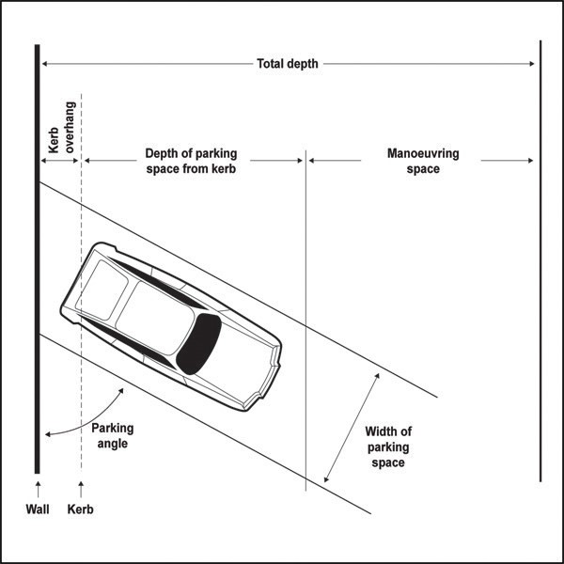

    - Size and location of loading spaces
      - Every loading space must:
        - comply with the dimensions given in Table 7.
Table 9: Loading space dimensions

Activity | Length of loading  space (m) | Width of loading  space (m)
Retail and industrial  activities | 11 | 3.5
All other activities | 8 | 3.5
All sites and developments designed to accommodate  articulated vehicles | 18 | 3.5

        - be located on the same site as the activity to which it relates, be available at all times, be located adjacent to an area for goods handling.

        - be located outside any:

i.

ii.
required yard on the site

area designated for road widening.

    - Access and manoeuvring
      - Every parking and/or loading space must:
        - have driveways and aisles for entry/exit of vehicles to/from the road, and for vehicle manoeuvring within the site. Access and manoeuvring areas must accommodate the 85 percentile car and 99 percentile truck tracking curves in Figure 2 and Figure 3 with the exception of:

i.

ii.
dwellings, where only the 85 percentile car tracking curve will apply.

in the Heavy Industry, Light Industry, and General Business zones where access and manoeuvring areas must accommodate a tracking curve for an appropriately sized truck for the type of activities to be carried out on the site. Tracking curves are set out in the following NZTA guidelines: RTS 18 New Zealand On Road Tracking Curves for Heavy Vehicles 2007.

      - Where dwellings provide more than one parking space, one space per dwelling may be stacked.
Stacked parking means access is required through another parking space.

    - Reverse manoeuvring
      - Sufficient space must be provided on the site so vehicles do not need to reverse off the site or onto or off the road from any:
        - rear site

        - other site where any of the following apply:

i.

ii. iii.
four or more parking spaces are served by a single access
there is more than 30m between the parking space and the road boundary of the site access would be from an arterial road or otherwise within a Vehicle Access Restriction
covered in clause 3.4.1.

    - Vertical clearance
      - To ensure vehicles can pass safely under overhead structures, the minimum overhead clearances to access any parking and loading spaces must be:
        - 2.3m where access and/or parking for cars is provided

        - 2.5m where access and/or accessible parking for people with disabilities is provided

        - 4.5m where access and/or loading for a heavy vehicle is required.

        - 2.1m above parking spaces for dwellings

    - Formation and gradient
      - Except for clause 2 below, the whole area of parking and loading spaces, and manoeuvring areas and aisles must be formed, drained, provided with an all­weather surface to prevent dust and nuisance, and be marked out or delineated. This must be done before the activity to which those parking and loading spaces relate commences, and maintained for as long as that activity is continued.

      - Parking and loading spaces and manoeuvring areas and aisles do not need to be provided with an all­ weather surface in the following zones:
        - Rural Conservation zone

        - Rural Coastal zone

        - Mixed Rural zone

        - Rural Production zone

      - The gradient for the surface of any parking space must not exceed:
        - 1 in 25 in any direction for accessible spaces for people with disabilities

        - 1 in 20 (5 per cent) in any direction for other spaces.

      - The gradient for the manoeuvring area must not exceed 1 in 8.

    - Lighting
      - Lighting is required where there are 10 or more parking spaces which are likely to be used during the hours of darkness. The parking and manoeuvring areas and associated pedestrian routes must be adequately lit during use in a manner that complies with Auckland­wide lighting rules.

Figure 2: 85 percentile car tracking curve
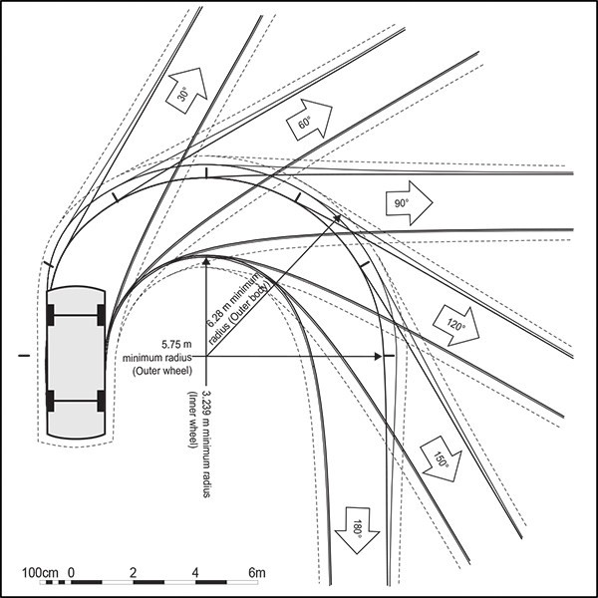
See following key

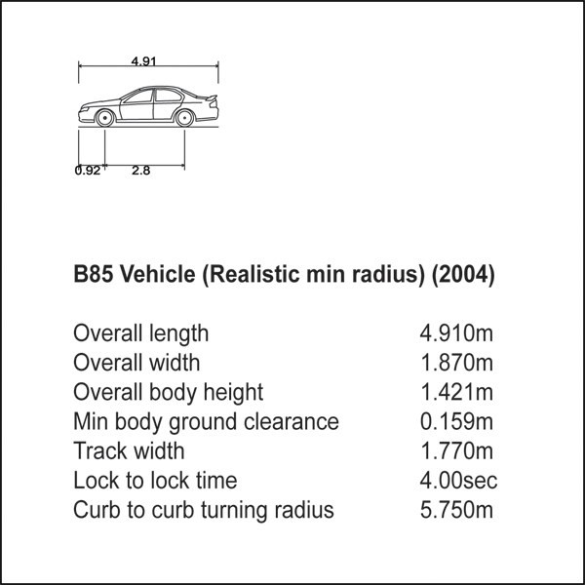
Key for 85 percentile car tracking curve

Figure 3: 99 percentile truck tracking curve
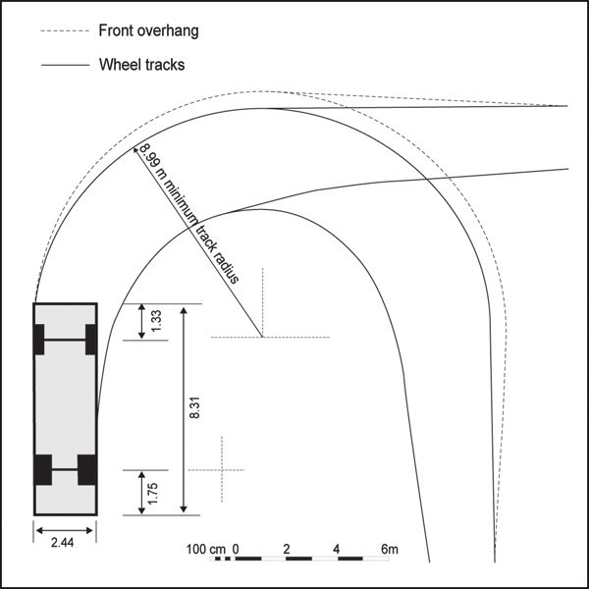

  - Access

    - Vehicle Access Restrictions
      - Vehicle Access Restrictions apply and vehicle crossings must not be constructed to provide vehicle access across any part of a site boundary which is subject to:
        - a Vehicle Access Restriction ­ General in the City Centre zone

        - a Key Retail Frontage overlay

Infringing this control is a non­complying activity.

      - Clause 3 below applies in any of the following circumstances:
        - a new vehicle crossing is proposed

        - an activity is established on a site

        - there is a change of activity

        - a building(s) is constructed, substantially reconstructed, altered or added to. Except that this does not apply in the case of a dwelling where the reconstruction, alteration or addition does not

increase the number of dwellings on a site

      - except where consent has been granted by means of a restricted discretionary activity, Vehicle Access Restrictions apply and vehicle crossings must not be constructed or used to provide vehicle access across that part of a site boundary which:
        - is located within 10m of any intersection, as illustrated in Figure 4

        - is subject to the following types of Vehicle Access Restriction (as identified on the planning maps) in the zones listed below:

Table 12:

Type of Vehicle Access  Restriction | Zone
Vehicle Access Restriction ­ General | All zones except the City Centre which is covered in clause  3.4.1.1(a)
Vehicle Access Restriction ­ Motorway  Interchange Control | All zones
Vehicle Access Restriction ­ Level  Crossing | All zones

- has frontage to a state highway other than a motorway and one of the following apply:
  - a new vehicle crossing is proposed

  - use of an existing vehicle crossing does not meet the development controls in clause 3.4.5 for access to a state highway

- has frontage to an arterial road as identified on the planning maps other than a state highway which is covered in clause (c) above.

Figure 4: Vehicle crossing restrictions ­ 10m
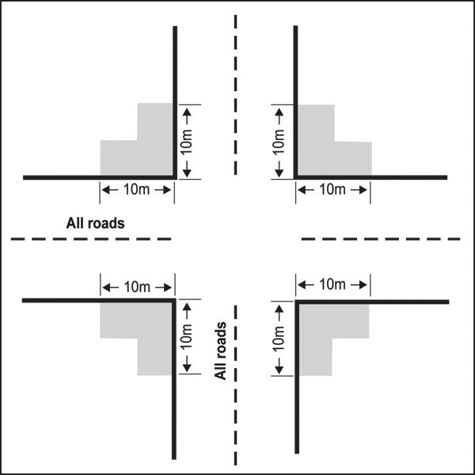

    - Width and number of vehicle crossings

      - The maximum number of vehicle crossings permitted for any site and separation distance between crossings is specified in Table 13 below.

Table 13: Maximum number of vehicle crossings and separation distance between crossings

Location | Maximum number of vehicle crossings per  site | Minimum separation from crossings serving  adjacent sites | Minimum separation between crossings  serving same site
Any part of a site subject to:  - a Vehicle Access Restriction ­ general in the City Centre zone  - a Key Retail Frontage  overlay | No crossings permitted | No crossings permitted | No crossings permitted
Any part of a site subject to:  - a Vehicle Access Restriction under clause  3.4.1.2 (see additional limitation below for site at 71­75 Grafton Road)  - a General Commercial  Frontage overlay | 1 | 2m | Only one crossing permitted
Site at 71­75 Grafton Road | 1 ­ located within the area  identified on Figure 5 | No limitation | Only one crossing  permitted
All other sites | 2 | 2m | 6m

Figure 5: Location of vehicle crossing at 71­75 Grafton Road
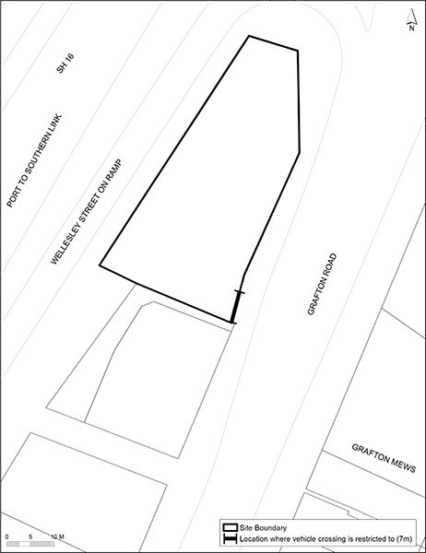

      - The width of a vehicle crossing(s) must meet the minimum width and not exceed the maximum width as specified in Table 15.

      - Where a site has frontage to both an arterial and non­arterial road, the vehicle crossing must be on the non­arterial road.

      - With the exception of vehicle crossings on unsealed roads, all vehicle crossings must be designed and constructed to maintain the level, colour, and materials of the footpath to clearly identify to vehicles that pedestrians have priority.

      - Vehicle crossings on unsealed roads:
        - where the vehicle crossing is served by an access steeper than 1 in 8, the vehicle crossing must be sealed for 6m between the site boundary and the unsealed road.

        - vehicle crossings not covered by (a) above must be formed using materials similar to the existing road surface or better.

      - Where a vehicle crossing is altered or no longer required, the crossing, or redundant section of crossing, must be reinstated as berm and/or footpath and the kerbs replaced. The cost of such work

will be borne by the owner of the site previously accessed by the vehicle crossing.

    - Width of vehicle access and queuing requirements
      - Every on­site parking and loading space must have vehicle access from a road, with the vehicle access complying with the following standards for width:
        - meeting the minimum formed access width specified in Table 15

        - passing bays are provided in accordance with Table 14 for any access which is:

i.

ii.
greater than 100m long, and less than 5.5m wide in a Rural zone, or greater than 50m long, and less than 5.5m wide in any other zone.

Table 14: Passing bay requirements

Zone | Length of access | Width of access | Minimum intervals between passing  bays | Passing bay width
Rural | Exceeds 100m | Less than 5.5.m | 100m | Increase formed width of access to 5.5m over a 15m length  (to allow two vehicles to safely pass each  other)
All other zones | Exceeds 50m |  | 50m

      - Access must be designed so that vehicles using or waiting to use fuel dispensers, ticket vending machines, remote ordering facilities and devices, entrance control mechanisms, or other drive­through facilities do not queue into the adjoining road reserve or obstruct entry to or exit from the site.

Table 15: Vehicle crossing and vehicle access widths

Location of site frontage | Minimum width of crossing at site  boundary | Maximum width of crossing at site  boundary | Minimum formed access width
Residential zone | 3.5m (for sites where access is from a state highway other than a motorway) 2.75m for other sites  (one way) | 3.5m (one way) | Serves nine or less parking spaces  or 1 – 5 dwellings | 2.5m provided it is contained within a corridor clear of buildings or parts of a building with a  minimum width of 3m
 | 5.5m (two­way) | 6.0m (two­way) | Serves ten or more car parking spaces or six or more  dwellings | 5.5m (providing for two­way movements) 1.5m pedestrian  access for rear sites
Centres, Mixed Use and all other zones not listed below | 3.5m (for sites where access is from a state highway other than a motorway) 3.0m for other sites  (one way) | 3.5m (one way) | Serves nine or less parking spaces  or two or less loading spaces | 2.5m provided it is contained within a corridor clear of buildings or parts of a building with a  minimum width of 3m
 | 5.5m (two­way) | 6.0m (two­way) | Serves ten or more parking spaces  or three or more  loading spaces | 5.5m (providing for two­way movements)

Location of site frontage | Minimum width of crossing at site  boundary | Maximum width of crossing at site  boundary | Minimum formed access width
General Business, Business Park or Industrial zone | 3.7m (one way) | 4.0m (one way) | Serves nine or less parking spaces  or two or less loading spaces | 2.5m provided it is contained within a corridor clear of buildings or parts of a building with a  minimum width of 3m
 | 5.5m (two­way) | 6.7m (two­way) | Serves ten or more parking spaces  or three or more  loading spaces | 5.5m (providing for two­way movements)
Rural zones | 3.5m (for sites where access is from a state highway other than a motorway)  3.0m for other sites | 6.0m | No minimum specified

    - Gradient of vehicle access

      - The gradient of the access must not be steeper than specified in Table 16.

Table 16: Gradient of vehicle access

Access type | Maximum gradient
Vehicle access serving  dwellings | 1 in 5 (20%)
Vehicle access serving all  other activities | 1 in 8 (12.5%)
Note
For curved ramps and driveways, the gradient is measured along the inside radius (refer to Figure 6).

      - To avoid the underside of the car striking the ground, as illustrated in Figure 7, access with a change in gradient exceeding 1 in 8 (greater than 12.5 per cent change) must include transition sections to achieve adequate ground clearance, refer to Figure 8. Typically, a transition section requires a
minimum length of 2m.

      - All vehicle access must be designed so that where the access adjoins the road there is sufficient space on­site for a platform so that vehicles can stop safely and check for pedestrians and other vehicles prior to exiting. This is illustrated in Figure 9. The platform must have a maximum gradient no steeper than 1 in 20 (5 per cent) and a minimum length of 6m.

Figure 6: Curved ramp diagram
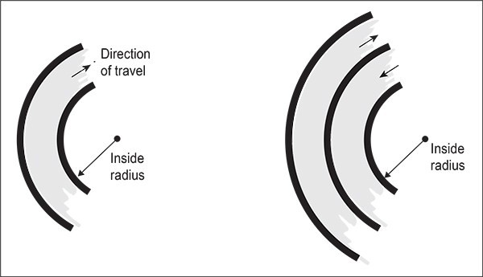

Figure 7: Illustrating the benefit of transitions
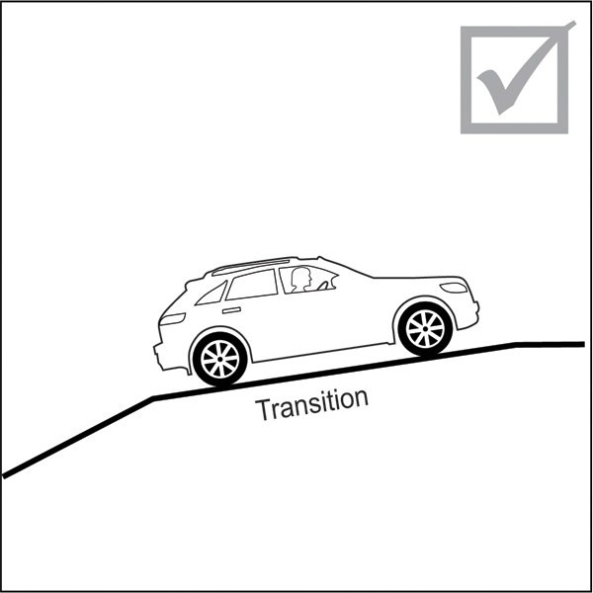
Correct

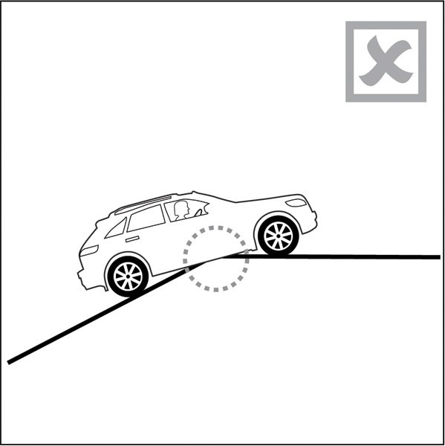
Incorrect

Figure 8: Gradient transition
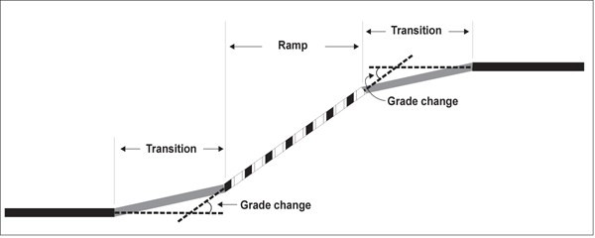

Note
The gradient change is determined by subtracting one gradient from the adjacent gradient, both expressed as

percentages; if this is greater than a 12.5 per cent change, then a gradient transition will be required.

Figure 9: Illustrating the benefits of a level platform
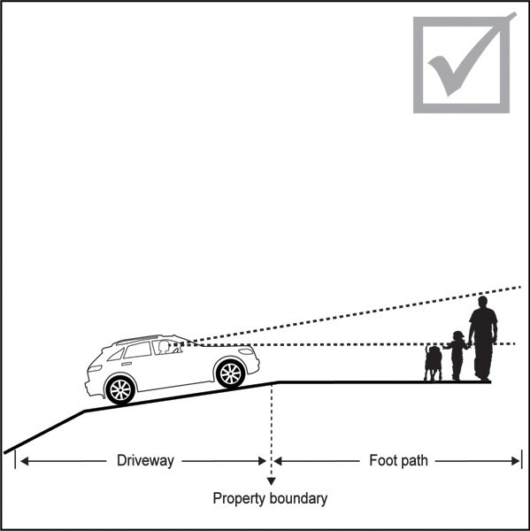
Correct

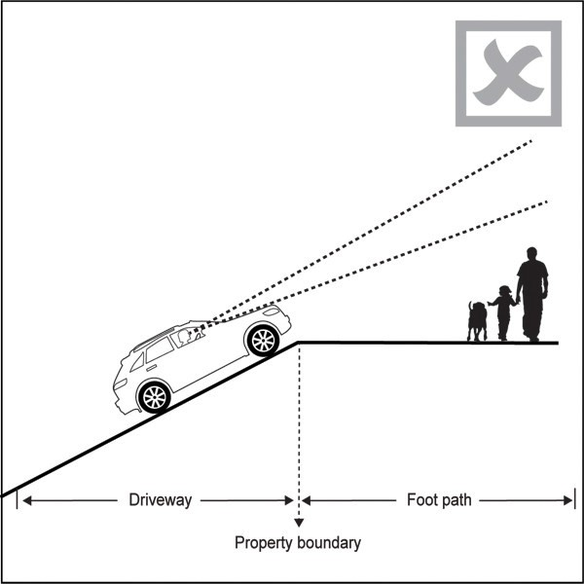
Incorrect

    - Vehicle crossings and access for state highways, excluding motorways

      - Vehicle access to a state highway, excluding motorways, is permitted where all of the following criteria are met:
        - the access is an existing authorised crossing place pursuant of s. 91 of the Government Roading Powers Act 1989

        - the access serves dwellings only

        - the access serves no more than three sites and no more than three dwellings

        - the vehicle crossing is constructed in accordance with Figure 10

        - the stopping sight distance is in accordance with Tables 17 and 18

        - compliance with (d) and (e) is confirmed in writing by a chartered professional engineer at the time of resource, subdivision or building consent application, whichever is lodged first.

Figure 10: Vehicle crossing standards for State highways
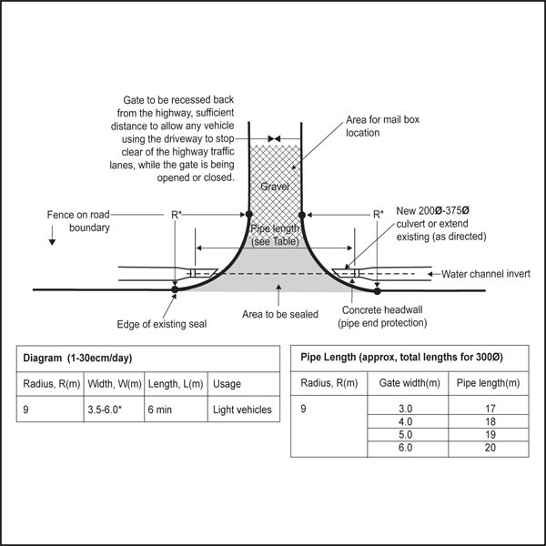

Notes for Figure 10:
- R* is the radius of the curve

- The dimension 3.5­6m refers to the width of the vehicle crossing. Appropriate width between these dimensions will depend on use.

Tables 17 and 18 must be used to determine whether a vehicle access to a state highway has safe stopping sight distances for approaching vehicles.

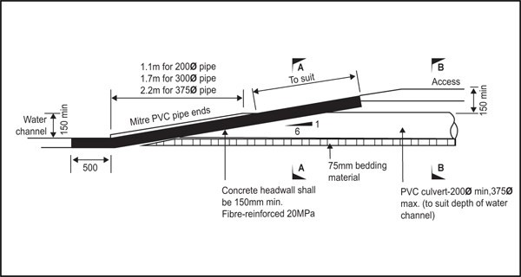
Access culvert headwall detail

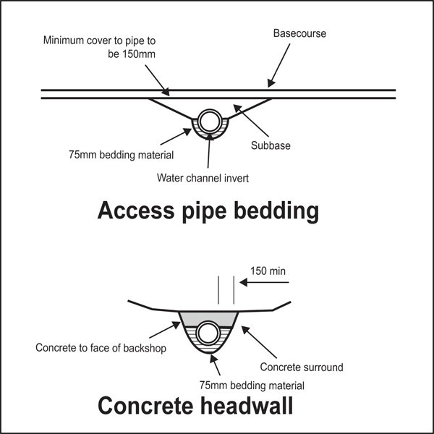
Note: Access pipe bedding shows the cross section for B ­ B in Access culvert headwall detail diagram above.
Concrete headwall shows the cross section for A ­ A in Access culvert headwall detail diagram above.

Table 17: Stopping sight distances for cars on state highways

Design speed (km/h)(1) | Minimum values(2) (stopping sight  distances measured in metres)
40 | 67
50 | 90
60 | 114
70 | 141
80 | 170
90 | 201
100 | 234
110 | 270

Notes

- The design speed is the 85th percentile approach operating speed. The default value for this is the speed limit.
- The minimum values in this table are based on a general minimum reaction time of two seconds.

Table 18: Corrections to stopping sight distances due to grade

Corrections due to  grade | ­8%  gradient | ­6%  gradient | ­4%  gradient | ­2%  gradient | 4%  gradient | 6%  gradient | 8%  gradient
40 km/h | 5m | 3m | 2m | 1m | ­2m | ­2m | ­3m
50 km/h | 8 | 5 | 3 | 2 | ­3 | ­4 | ­5
60 km/h | 11 | 8 | 5 | 2 | ­4 | ­6 | ­7
70 km/h | 15 | 11 | 7 | 3 | ­5 | ­8 | ­10
80 km/h | 20 | 14 | 9 | 4 | ­7 | ­10 | ­13
90 km/h | 25 | 18 | 11 | 5 | ­9 | ­13 | ­16
100 km/h | 31 | 22 | 14 | 6 | ­11 | ­16 | ­20
110 km/h | 38 | 26 | 17 | 8 | ­13 | ­19 | ­24
Note
This table sets out the distance (m) to be added or subtracted from the stopping sight distances in Table 17 to correct for gradient.

    - Sightlines for road/rail level crossings

      - Sites subject to sightlines for level crossings are identified on the planning maps by the Infrastructure overlay ­ Level crossings with sightline controls. Level crossings with sightline controls are controlled by Stop or Give Way signs, rather than by alarms and/or barrier arms. If alarms and/or barrier arms are subsequently installed at these locations, the rules below cease to apply.

      - Approach sight triangles (refer to Figure 11)
        - on sites adjacent to the level crossings with sightline controls, buildings or structures cannot be located within the approach sight triangles identified on the planning maps.

Figure 11: Approach site triangles for rail level crossings with “stop” or “give way” signs
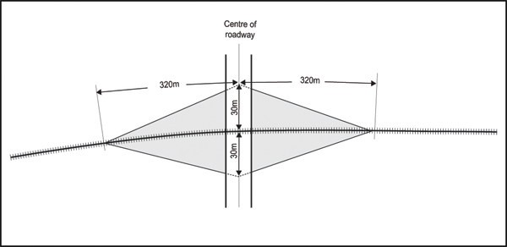

ii.

3.
the approach sight triangles are calculated by reference to Figure 11. For a single set of railway tracks, the sight triangles are defined by a triangle taken 30m from the outside rail and 320m along the railway track. For each additional set of tracks, 25m is added to the 320m along the railway track.

Restart sight triangles (see Figure 12)

a. on sites adjacent to the level crossing with sightline controls, buildings or structures cannot be located within the restart sight triangles identified on the planning maps.

Figure 12: Restart site triangles for rail level crossings
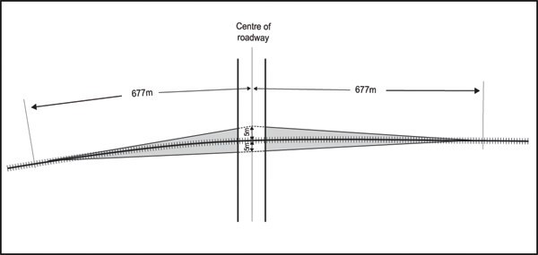

b) the restart sight triangles are calculated by reference to Figure 12. For a single set of tracks, the sight triangles are defined by a triangle taken 5m from the outside rail and 677m along the railway track. For each additional set of tracks, 50m is added to the 677m along the railway track.

Assessment ­ Restricted discretionary activities

4.1 Matters of discretion
The council will restrict its discretion to the matters in below for the activities listed as restricted discretionary in the activity table.

  - Off­road pedestrian and cycling facilities
    - Location, design and external appearance

    - Compatibility with surrounding activities

  - Park­and­ride
    - Effect on the transport network

    - Location, design and external appearance

    - Compatibility with surrounding activities

  - Public transport facility
    - Effect on the transport network

    - Location, design and external appearance

    - Compatibility with surrounding activities

Assessment criteria
The council will consider the relevant assessment criteria below for the restricted discretionary activities listed above.
    - Off­road pedestrian and cycling facilities
      - Location, design and external appearance
        - the location, design and external appearance of any off­road pedestrian and cycling facility:

- is legible and designed to provide for safe and convenient access for users, including safe connections with the existing road network

- creates minimal adverse effect on the vegetation, landform and character of the surrounding environment.

      - Compatibility with surrounding activities
        - the facility is compaftible with surrounding activities with particular regard to residential uses.
This includes:
          - ensuring that the design and operation of any lighting meets the Auckland­wide ­
Lighting rules.

    - Park­and­ride and public transport facility
      - Effect on the transport network
        - any proposed facility will be located and designed to support the public transport system by:
          - locating in close proximity to public transport stations, stops and terminals

          - growing public transport patronage, especially to assist in relieving congested corridors by encouraging commuters to shift to public transport for their travel

          - making public transport easier and more convenient to use, thereby attracting new users

          - improving the operational efficiency of the public transport system, particularly the Rapid and Frequent Service Network

          - extending the catchment for public transport into areas of low demand where it is not cost­effective to provide traditional services or feeders

          - reinforcing existing and future investments on the Rapid and Frequent Service Network

          - providing free, secure and covered parking for cycles.

ii.
the scale, design, management and operation of the facility and its access points will not

have an adverse effect on the effective, efficient and safe operation of the transport network, including:
          - the safety of pedestrians and cyclists

          - amenity for pedestrians

          - avoiding queuing onto the road and conflict at access points to the facility

          - avoiding generating high volumes of traffic onto local roads or areas with high pedestrian amenity

          - the operation of public transport services and related infrastructure

      - Location, design and external appearance
        - the location, design and external appearance of any park and ride or public transport facility:
          - complements adjacent uses and developments with any buildings or structures to be of similar or compatible scale to those existing or provided for in the surrounding area

          - meets the design outcomes identified in this Unitary Plan for the site and / or location generally

          - provides screening on the facade of any building so vehicles are not visible from the public realm

          - is accessible, safe and secure for users with safe and attractive pedestrian connections within the facility and to adjacent public footpaths

          - provides an attractive interface between any buildings, structures or at­grade parking areas and adjacent streets. Depending on location and scale, this includes:
            - maintaining an active frontage through sleeving and / or an interesting appearance through use of architectural treatments so that the facility contributes positively to the pedestrian amenity and to any retail, commercial or residential uses along the road it fronts

            - planting and other landscaping

            - provides for any buildings to be adapted for other uses if no longer required for parking. In particular, the floor to ceiling height of a parking building at street level should be capable of conversion to other activities provided for in the zone.

      - Compatibility with surrounding activities
        - the facility is compatible with surrounding activities with particular regard to residential uses.
This includes:
          - ensuring that the design and operation of any lighting meets the Auckland­wide lighting
rules.

          - ensuring that the design and operation of any park­and­ride or public transport facility meets the Auckland­wide noise rules.

Assessment ­ Development control infringements

5.1 Matters of discretion
In addition to the general matters of discretion in clause 2.3 of the general provisions, the council will restrict its discretion to the matters below for the listed development control infringement.
  - Any activity or development which provides more than the maximum permitted number of parking spaces under clause 3.2.1.
    - Adequacy for the site and the proposal

    - Effects on intensification

    - Effects on the transport network

  - Any activity or development which provides fewer than the required minimum number of parking spaces under clause 3.2.1.
    - Adequacy for the site and the proposal

  - Any activity or development which provides fewer than the minimum number of loading spaces under clause 3.2.4.
    - Adequacy for the site and the proposal

    - Effects on the transport network

  - Any activity or development which infringes the development controls for design of parking and loading areas or access under clause 3.3.
    - Adequacy for the site and the proposal

    - Design of parking, loading and access

    - Effects on pedestrian and streetscape amenity

    - Effects on the transport network

  - Construction or use of a vehicle crossing where a Vehicle Access Restriction applies under clause
3.4.1.2 and 3.4.1.3
- Adequacy for the site and the proposal

- Design and location of access

- Effects on pedestrian and streetscape amenity

- Effects on the transport network

  - Any building or structure located within a sightline area applying to a road/rail level crossing with sightline controls under clause 3.4.6.
    - Effects on the transport network

  - Any activity or subdivision which exceeds the traffic generation thresholds under clause 3.1
    - Effects on the transport network

Assessment criteria
When considering an application for a restricted discretionary activity for a proposal listed below, the council will consider the whether the proposal meets the criteria listed.
    - Providing more than the maximum permitted number of parking spaces:
      - the additional land used for parking will not undermine efficient use of land and the growth and intensification provided for in the Unitary Plan in the following zones and locations: City Centre, Metropolitan Centre, Town Centre, Local Centre, Mixed Use, Terrace Housing and Apartment Buildings zones; and the City Centre Fringe overlay.

      - the unique nature and/or operation of the proposed activities on the site requires additional parking spaces.

      - the vehicle movements associated with the additional parking spaces will not have a more than minor adverse effect on the safe and efficient operation of the adjacent transport network, including public transport and the movements of pedestrians, cyclists and general traffic. This includes considering the effect of additional parking on trip generation from the site during peak commuter times.

      - there is insufficient alternative parking in the surrounding area, including on street and public parking, to provide the additional parking sought for the proposal.

      - there is a lack of access to the Rapid and Frequent Service Network, because the site is not within walking distance of a stop or station on the Rapid and Frequent Service Network. Walking distance is generally considered to be 1km for a stop on the rapid transit network and 800m for other stops on the Rapid and Frequent Service Network. However, walking distance will vary depending on the slope, terrain, attractiveness of the pedestrian network, and the type of pedestrian

      - the applicant has demonstrated that it is not practicable to provide the additional parking by entering into a shared parking arrangement with another site or sites in the immediate vicinity

      - the applicant has demonstrated that the demand for the additional parking cannot be adequately addressed by management of existing or permitted parking. Depending on number of additional parking spaces proposed, the number of employees, and the location of the site, this may need to be supported by a detailed travel plan outlining measures and commitments for the activity or activities on­site will minimise the need for private vehicle use and make efficient use of any parking provided.

    - Providing fewer than the required minimum number of parking spaces
      - the amount of parking proposed is sufficient for the proposal due to:

i.

ii. iii.
the nature of the operation including the interaction between activities on the site the availability and accessibility of the site by public transport
the measures and commitments outlined in a detailed travel plan for the site which will reduce the need for vehicle use to a level where parking demands can be satisfactorily addressed through efficient use of the proposed parking.

      - the reduction in parking will not result in more than minor adverse effects from parking overspill on adjacent activities and the safe and efficient operation of the adjoining transport network.

      - there is public parking on­street or off­street in the immediate vicinity with capacity and availability at the times required to serve the proposal. The council must have a reasonable expectation that the parking will continue to be available to provide for the proposal.

      - whether the parking requirements of the proposal will be met by entering into a shared parking arrangement with another site in the immediate vicinity that has available parking spaces which are not required at the same time as the proposed activity. For example, the proposed activity operates outside of normal business hours and the activity on the other site only operates during normal business hours. In such a situation, the council will require a legal agreement between the applicant and owner and occupiers of the site confirming the arrangement.

    - Infringing the development controls for cycle parking and end­of­trip facilities
      - sufficient provision is made for cyclists and active modes and changes in demand for such facilities can be accommodated if the operation or use changes over time, having regard to:

i.

ii.

iii.
the nature of the operation and the likely demand for long and short­term cycle parking and end­of­trip facilities

the availability of adequate public cycle parking for short­stay use in the vicinity. The council must have a reasonable expectation that the public cycle parking will continue to be available.

the accessibility of the site to cyclists and pedestrians.

      - the provision made for cyclists and active modes is practicable and adequate given site limitations and layout, arrangement of buildings and activities, users and operational requirements.

    - Providing fewer than the required number of loading spaces
      - the loading arrangements proposed for the site will not adversely affect the safe and efficient

operation of adjacent transport network, including public transport and pedestrian, cycle and general traffic movements.

      - the specific business practice, operation or type of customer associated with the proposed activities mean that the site will not need the standard number of loading spaces.

      - an accessible and adequate on­street loading space is available nearby or can be created while having regard to other demands for kerbside use of the road. The council must have a reasonable expectation that the loading space will continue to be available to provide for the proposal.

      - loading can be provided on another site in the immediate vicinity that has available spaces which are not required at the same time as the proposed activity. In such a situation, the council will require a legal agreement between the applicant and the owner and occupiers of the other site confirming the arrangement.

      - the reduction in loading spaces will contribute to the efficient use of land and the growth and intensification provided for in the Unitary Plan in the following zones and locations: City Centre, Metropolitan Centre, Town Centre, Local Centre, Mixed Use, Terrace Housing and Apartment Buildings zones; and the City Centre Fringe overlay

    - Infringing the development controls for design of parking and loading areas or access
      - the modification will not have an adverse effect on the safe and efficient operation of the adjacent transport network, including public transport, pedestrians, cyclists and general traffic, having regard to:

i.

ii.

iii.

iv.
the effect of the modification on visibility and safe sight distances particularly the extent to which vehicles entering/exiting the site can see, and be seen by, pedestrians, cyclists and other vehicles on the footpath and road carriageway:

existing and future traffic conditions including speed, volume, type, current accident rate and the need for safe manoeuvring in all weathers

existing pedestrian numbers, and estimated future pedestrian numbers having regard to the level of development provided for in the Unitary Plan

existing community or public infrastructure located in the adjoining road, such as bus stops, bus lanes and cycleways.

      - the modification will not have an adverse effect on pedestrian amenity or the amenity of the streetscape, having regard to:

i.

ii.
the effect of additional crossings or crossings which exceed the maximum width

pedestrian amenity and the continuity of activities and pedestrian movement at street level in the City Centre, Metropolitan, Town and Local Centre zones.

      - the modification results in parking, loading and access arrangements which are practicable and adequate having regard to:

i.

ii.
site limitations and layout, and configuration of buildings and activities, users and operational requirements.

the ability of the access to accommodate the nature and volume of traffic and vehicle types expected to use the access. This may include considering whether a wider vehicle crossing is required to:

        - comply with the tracking curve applicable to the largest site anticipated to use the site regularly

        - accommodate the traffic volumes anticipated to use the crossing, especially where it is desirable to separate left and right turn exit lanes
          - the desirability of separating truck movements accessing a site from customer

vehicle movements

          - whether reduced manoeuvring and parking space dimensions can be accommodated because the parking will be used by regular users familiar with the layout, rather than by casual users.

iii.

iv.

any use of mechanical parking installation such as car stackers or turntables does not result in queuing beyond the site boundary.

any stacked parking where access is through another parking space and does not comply with the development controls, is:

        - for vehicles being serviced at a vehicle repair premises; or

        - within residential development where stacked parking spaces are held in common ownership, under a single title, and cannot be offered or allocated as individual parking spaces; or

        - for regular users such as staff, and are clearly marked, defined and separated from other parking; and

        - located so it does not compromise the operation of the remainder of the parking area.

    - Construction or use of a vehicle crossing where a Vehicle Access Restriction applies
      - This applies where a Vehicle Access Restriction is identified in 3.4.1.2 and 3.4.1.3, other than a Vehicle Access Restriction ­ Level Crossing.
- the location and design of the access will not have an adverse effect on the safe and efficient operation of the adjacent transport network, including public transport, pedestrians, cyclists and general traffic, having regard to:
  - visibility and safe sight distances particularly the extent to which vehicles entering/exiting site can see, and be seen by, pedestrians, cyclists and other vehicles on the footpath and road carriageway

  - existing and future traffic conditions including speed, volume, type, current accident rate, and the need for safe manoeuvring in all weathers

  - proximity to and operation of intersections

  - existing pedestrian numbers, and estimated future pedestrian numbers having regard to the level of development provided for in the Unitary Plan

  - existing community or public infrastructure located in the adjoining road, such as bus stops, bus lanes and cycleways.

ii.

iii.

the access will not have an adverse effect on pedestrian or streetscape amenity. This includes considering the continuity of activities and pedestrian movement at street level in the City Centre, Metropolitan, Town and Local Centre zones.

the access arrangements are practicable and adequate considering site limitations and layout, arrangement of buildings and activities, users and operational requirements, proximity to and operation of intersections, having regard to:

  - whether the site can reasonably served by different access arrangements including:
    - access from another road

    - shared or amalgamated access with another site or sites

    - via a frontage road, such as a slip lane or service road

  - whether the need for access can reasonably be avoided by entering into a shared parking and/or loading arrangement with another site or sites in the immediate vicinity.

iv.

for any proposed access within a Vehicle Access Restriction ­ Motorway Interchange Control, the intensity, scale and traffic generating nature of activities on the site are such that any adverse effects on the safe and efficient operation of the motorway interchange are

avoided, remedied or mitigated.

v. whether, when considered against other access opportunities for the site, comparable or better outcomes are achieved in terms of effects on the safe and efficient operation of the transport network, including public transport and the movements of cyclists, pedestrians and general traffic.

    - Construction or use of a vehicle crossing where a Vehicle Access Restriction ­ Level Crossing, applies
      - the access will not have an adverse effect on the safe and efficient operation of the adjacent transport network, particularly the road/rail crossing

      - the access arrangements are practicable and adequate having regard to site limitations and layout, arrangement of buildings and activities, users and operational requirements.

    - Buildings or structures within a sightline area applying to a level crossing with sightline controls
      - the proposal will not have an adverse effect on the safety of the level crossing for vehicles and pedestrians

      - the proposal will not adversely affect visibility and safe sight distances particularly to the extent vehicles entering/exiting the level crossing can see trains.

    - Exceeding the traffic generation threshold
      - the proposal integrates with the transport network and mitigates the adverse effects of traffic generated on that network by measures such as:

i.

ii. iii.
development and implementation of a travel plan which will reduce the need for vehicle use staging of development to match with improvements to the transport network
undertaking or funding local improvements to the transport network.

Special information requirements

  - Parking plans submitted to council must show:
    - the locations and dimensions of any pillars and/or other structures that may restrict parking space, or inhibit access and manoeuvring, as well as clearances between parking spaces and vehicle tracking curves and those pillars and/or other structures

    - the proposed gradients of parking, manoeuvring and access areas.

Parking Facilities Part 1: Off­street Car Parking (New Zealand Standard for Off­street Parking (AS/NZS 2890.1:2004) ) may assist applicants in designing parking areas.

  - Travel plan
    - a travel plan may be required as part of an assessment of environmental effects where a proposal exceeds the traffic generation threshold, provides more parking than the maximums specified or fewer than the minimums specified. A travel plan will not be required where the infringement of the parking standards is minor in relation to the scale of the activity and associated parking proposed.

  - Applications for off­site parking must include information to demonstrate that:
    - the proposal provides off­site parking which is related exclusively to the parking requirements associated with activities located on other donor site(s) in the area

    - the off­site parking arrangements will be formalized on the land titles of all sites involved, including extinguishing the ability to provide accessory parking on the donor site(s)

    - the parking has been transferred from the donor site(s) and the donor site(s) are required or permitted by the parking standards of the Unitary Plan to provide the number of parking spaces proposed.

  - The council may require applications which affect the transport system, including proposals which

exceed the traffic generation threshold, to include a transport assessment prepared by suitably qualified transport planner or traffic engineer.

