# The Proposed Auckland Unitary Plan (notified 30 September 2013)

PART 5 ­ APPENDICES»

**Appendix 5 Natural resources**

# Appendix 5.1 Schedule of Significant Ecological Areas ­ land

## [all provisions in this appendix are: rps/rp]

Click here for PDF

Page 1 of 40

**Appendix 5.1 Schedule of Significant Ecological Areas – Land**

|  |  |
| --- | --- |
| SEA_T_77 | 1, 2 |
| SEA_T_78 | 1, 2 |
| SEA_T_79 | 1, 2, 3 |
| SEA_T_80 | 1, 2 |
| SEA_T_81 | 1, 2 |
| SEA_T_85 | 2, 4 |
| SEA_T_86 | 1, 2 |
| SEA_T_90 | 1 |
| SEA_T_91 | 1, 2 |
| SEA_T_92 | 1, 2, 3 |
| SEA_T_93 | 1, 2, 3, 4 |
| SEA_T_94 | 1, 2 |
| SEA_T_95 | 1, 2, 3 |
| SEA_T_97 | 3, 4 |
| SEA_T_98 | 1, 2 |
| SEA_T_100 | 1 |
| SEA_T_101 | 1, 2, 3 |
| SEA_T_102 | 1 |
| SEA_T_103 | 1 |
| SEA_T_103a | 1, 2 |
| SEA_T_105 | 1, 2 |
| SEA_T_106 | 1 |
| SEA_T_107 | 1, 2 |
| SEA_T_108 | 1, 2 |
| SEA_T_109 | 1, 2 |
| SEA_T_110 | 1, 2 |
| SEA_T_111 | 1, 2 |
| SEA_T_112 | 1, 2 |
| SEA_T_113 | 1, 2 |
| SEA_T_114 | 1, 2 |
| SEA_T_115 | 1, 2 |
| SEA_T_116 | 1, 2 |
| SEA_T_117 | 2, 3 |
| SEA_T_118 | 1, 2 |

|  |  |
| --- | --- |
| SEA_T_119 | 1, 2 |
| SEA_T_121 | 1, 2 |
| SEA_T_122 | 1, 4 |
| SEA_T_123 | 1, 2, 3 |
| SEA_T_125 | 1, 2, 3 |
| SEA_T_127 | 1, 2, 4 |
| SEA_T_131 | 1, 2, 4 |
| SEA_T_132 | 1 |
| SEA_T_133 | 1, 2, 3 |
| SEA_T_136 | 2 |
| SEA_T_139 | 2, 4 |
| SEA_T_148 | 2 |
| SEA_T_150 | 2 |
| SEA_T_151 | 2, 4 |
| SEA_T_153 | 2 |
| SEA_T_154 | 2 |
| SEA_T_155 | 2 |
| SEA_T_156 | 2 |
| SEA_T_157 | 2, 3 |
| SEA_T_158 | 2 |
| SEA_T_159 | 1 |
| SEA_T_161 | 2, 3 |
| SEA_T_163 | 1, 2 |
| SEA_T_164 | 1 |
| SEA_T_168 | 2, 3, 4 |
| SEA_T_169 | 1 |
| SEA_T_170 | 3 |
| SEA_T_172 | 2, 3 |
| SEA_T_173 | 1, 2 |
| SEA_T_175 | 2 |
| SEA_T_176 | 2 |
| SEA_T_177 | 2 |
| SEA_T_179 | 2, 4 |
| SEA_T_180 | 2 |

|  |  |
| --- | --- |
| **Schedule ID** | **Criteria met**1 |
| SEA_T_25 | 2, 3 |
| SEA_T_29 | 1 |
| SEA_T_30 | 1, 2, 3, 4 |
| SEA_T_31 | 2, 3, 4, 5 |
| SEA_T_33 | 1, 2, 4 |
| SEA_T_34 | 2, 3 |
| SEA_T_38 | 2, 3, 4 |
| SEA_T_40 | 4 |
| SEA_T_41 | 3, 4 |
| SEA_T_43 | 2, 4 |
| SEA_T_44 | 3 |
| SEA_T_46 | 3, 4 |
| SEA_T_47 | 2 |
| SEA_T_48 | 4 |
| SEA_T_50 | 2, 4 |
| SEA_T_53 | 1, 2 |
| SEA_T_54 | 1, 2 |
| SEA_T_55 | 2, 3 |
| SEA_T_56 | 1, 2, 3 |
| SEA_T_59 | 3 |
| SEA_T_62 | 1, 2 |
| SEA_T_63 | 2 |
| SEA_T_65 | 1, 2, 4 |
| SEA_T_66 | 1, 2, 3 |
| SEA_T_68 | 1, 2 |
| SEA_T_69 | 2 |
| SEA_T_70 | 2 |
| SEA_T_71 | 2 |
| SEA_T_72 | 3, 4 |
| SEA_T_73 | 2 |
| SEA_T_74 | 2, 3 |
| SEA_T_75 | 1, 2, 4 |
| SEA_T_76 | 1, 2, 4 |

|  |  |
| --- | --- |
| SEA_T_231 | 1 |
| SEA_T_232 | 4 |
| SEA_T_233 | 1 |
| SEA_T_234 | 1, 2, 3 |
| SEA_T_236 | 1 |
| SEA_T_237 | 1, 3, 4 |
| SEA_T_240 | 1, 2, 4 |
| SEA_T_241 | 1, 2, 3 |
| SEA_T_244 | 2, 3 |
| SEA_T_245 | 3 |
| SEA_T_247 | 1, 2 |
| SEA_T_248 | 3, 4 |
| SEA_T_249 | 4 |
| SEA_T_250 | 3 |
| SEA_T_254 | 2 |
| SEA_T_259 | 1, 3 |
| SEA_T_262 | 1, 2, 3 |
| SEA_T_263 | 1 |
| SEA_T_266 | 1, 2, 3 |
| SEA_T_267 | 2, 3, 4 |
| SEA_T_268 | 2, 4 |
| SEA_T_269 | 1, 3, 4 |
| SEA_T_276 | 3, 4 |
| SEA_T_279 | 3, 4 |
| SEA_T_280 | 3 |
| SEA_T_284 | 3, 4 |
| SEA_T_288 | 1, 2 |
| SEA_T_289 | 1, 3 |
| SEA_T_305 | 3 |
| SEA_T_307 | 2, 3 |
| SEA_T_308 | 2, 3, 4 |
| SEA_T_309 | 2, 3, 4 |
| SEA_T_310 | 1, 2, 3 |
| SEA_T_313 | 2 |
| SEA_T_314 | 3 |

|  |  |
| --- | --- |
| SEA_T_316 | 3, 4 |
| SEA_T_319 | 2 |
| SEA_T_320 | 3, 4 |
| SEA_T_322 | 1, 2, 3 |
| SEA_T_323 | 1 |
| SEA_T_325 | 1, 3, 4 |
| SEA_T_326 | 2 |
| SEA_T_330A | 1 |
| SEA_T_331 | 4 |
| SEA_T_334 | 1, 3, 4 |
| SEA_T_336 | 2, 3, 4 |
| SEA_T_337 | 2, 3, 4 |
| SEA_T_339 | 1 |
| SEA_T_341 | 1, 2, 3, 4 |
| SEA_T_342 | 4 |
| SEA_T_357 | 4 |
| SEA_T_358 | 3 |
| SEA_T_361 | 3 |
| SEA_T_363 | 3 |
| SEA_T_364 | 3 |
| SEA_T_366 | 4 |
| SEA_T_367 | 2 |
| SEA_T_369 | 2, 3 |
| SEA_T_370 | 1, 2, 3 |
| SEA_T_371 | 1, 2 |
| SEA_T_372 | 2, 3 |
| SEA_T_374 | 1, 2, 3 |
| SEA_T_377 | 2 |
| SEA_T_378 | 2, 3 |
| SEA_T_379 | 3, 4 |
| SEA_T_380 | 1, 2 |
| SEA_T_381 | 1, 2 |
| SEA_T_383 | 4 |
| SEA_T_386 | 4 |
| SEA_T_389 | 3, 4 |

|  |  |
| --- | --- |
| SEA_T_181 | 4 |
| SEA_T_183 | 4 |
| SEA_T_184 | 4 |
| SEA_T_185 | 4 |
| SEA_T_193 | 2 |
| SEA_T_194 | 2 |
| SEA_T_196 | 2, 3, 4, 5 |
| SEA_T_197 | 1, 2, 3 |
| SEA_T_199 | 2 |
| SEA_T_201 | 1, 2 |
| SEA_T_202 | 2, 3, 4 |
| SEA_T_203 | 2, 3, 4 |
| SEA_T_204 | 1, 2, 3, 4 |
| SEA_T_205 | 1, 2, 3, 4 |
| SEA_T_206 | 1, 2, 3 |
| SEA_T_206a | 1, 2, 3 |
| SEA_T_207 | 1, 2, 3 |
| SEA_T_208 | 1, 2, 3, 4 |
| SEA_T_209 | 1, 2, 3, 4 |
| SEA_T_210 | 3, 4 |
| SEA_T_211 | 1, 2, 3, 4 |
| SEA_T_212 | 2, 3, 4 |
| SEA_T_213 | 1, 2, 3, 4 |
| SEA_T_215 | 1, 2, 3 |
| SEA_T_216 | 3 |
| SEA_T_217 | 1, 2 |
| SEA_T_219 | 1, 2, 4 |
| SEA_T_222 | 4 |
| SEA_T_223 | 2, 3, 4 |
| SEA_T_224 | 2, 3 |
| SEA_T_225 | 2, 3 |
| SEA_T_226 | 2 |
| SEA_T_227 | 2, 3 |
| SEA_T_229 | 2, 3 |
| SEA_T_230 | 1, 2, 3 |

|  |  |
| --- | --- |
| SEA_T_466 | 1, 2, 3 |
| SEA_T_468 | 2, 3 |
| SEA_T_469 | 3 |
| SEA_T_470 | 2, 3 |
| SEA_T_471 | 1, 2, 3 |
| SEA_T_472 | 2, 3 |
| SEA_T_474 | 1, 2, 3 |
| SEA_T_475 | 2, 3, 4 |
| SEA_T_476 | 2, 3, 4 |
| SEA_T_478 | 1, 2, 3 |
| SEA_T_479 | 2, 3, 4 |
| SEA_T_480 | 2, 3, 4 |
| SEA_T_483 | 2, 3 |
| SEA_T_485 | 1, 2, 3, 4, 5 |
| SEA_T_489 | 2 |
| SEA_T_491 | 2, 3 |
| SEA_T_492 | 2, 3 |
| SEA_T_493 | 4 |
| SEA_T_494 | 1, 2, 3 |
| SEA_T_500 | 3 |
| SEA_T_501 | 2, 3 |
| SEA_T_504 | 3 |
| SEA_T_505 | 4 |
| SEA_T_508 | 1, 2 |
| SEA_T_509 | 1, 2, 3 |
| SEA_T_509B | 2 |
| SEA_T_510 | 3 |
| SEA_T_513 | 3 |
| SEA_T_514 | 4 |
| SEA_T_519 | 2, 4 |
| SEA_T_521 | 2 |
| SEA_T_525 | 2, 4 |
| SEA_T_526a | 2, 4, 5 |
| SEA_T_529 | 4 |
| SEA_T_530 | 2, 4 |

|  |  |
| --- | --- |
| SEA_T_530b | 2 |
| SEA_T_531 | 1, 2 |
| SEA_T_532 | 1 |
| SEA_T_533 | 1, 2 |
| SEA_T_534 | 1, 2, 3 |
| SEA_T_535 | 1, 2 |
| SEA_T_536 | 1, 2 |
| SEA_T_538 | 1, 2 |
| SEA_T_538a | 1, 2, 4 |
| SEA_T_538b | 1, 2, 4 |
| SEA_T_538c | 1, 2, 4 |
| SEA_T_539 | 1, 2 |
| SEA_T_540 | 1 |
| SEA_T_540a | 1 |
| SEA_T_540c | 1 |
| SEA_T_540d | 2 |
| SEA_T_542 | 2, 4 |
| SEA_T_544 | 2 |
| SEA_T_545 | 1, 2 |
| SEA_T_559 | 3 |
| SEA_T_560 | 3, 4 |
| SEA_T_561 | 2, 3, 4 |
| SEA_T_562 | 2, 4 |
| SEA_T_564 | 2, 3 |
| SEA_T_565 | 2, 3 |
| SEA_T_567 | 4 |
| SEA_T_570 | 3 |
| SEA_T_572 | 4 |
| SEA_T_578 | 4 |
| SEA_T_581 | 1, 2, 3 |
| SEA_T_583 | 1, 2, 4, 5 |
| SEA_T_586 | 1, 2, 4 |
| SEA_T_587 | 2, 3, 4 |
| SEA_T_588 | 2, 3, 4 |
| SEA_T_589 | 2, 3, 4 |

|  |  |
| --- | --- |
| SEA_T_391 | 3, 4 |
| SEA_T_396 | 2, 4 |
| SEA_T_403 | 2, 4 |
| SEA_T_404 | 1, 2, 3 |
| SEA_T_405 | 2 |
| SEA_T_407 | 4 |
| SEA_T_409 | 1, 2, 3 |
| SEA_T_410 | 3, 4 |
| SEA_T_413 | 3 |
| SEA_T_414 | 2, 3 |
| SEA_T_415 | 2 |
| SEA_T_417 | 3, 4 |
| SEA_T_418 | 4 |
| SEA_T_419 | 4 |
| SEA_T_421 | 1, 2 |
| SEA_T_424 | 1, 2, 3, 4 |
| SEA_T_427 | 3 |
| SEA_T_428 | 2, 3 |
| SEA_T_430 | 2, 3 |
| SEA_T_431 | 2, 3 |
| SEA_T_432 | 2 |
| SEA_T_435 | 4 |
| SEA_T_436 | 2, 3, 4 |
| SEA_T_437 | 2, 3 |
| SEA_T_439 | 2 |
| SEA_T_443 | 3 |
| SEA_T_446 | 3 |
| SEA_T_448 | 2 |
| SEA_T_449 | 2, 3 |
| SEA_T_450 | 2, 3 |
| SEA_T_451 | 1, 2 |
| SEA_T_453 | 1 |
| SEA_T_454 | 2 |
| SEA_T_456 | 1 |
| SEA_T_464 | 1, 2, 3 |

|  |  |
| --- | --- |
| SEA_T_646 | 1, 2, 3 |
| SEA_T_647 | 4 |
| SEA_T_648 | 1, 2 |
| SEA_T_651 | 3 |
| SEA_T_661 | 1, 2, 5 |
| SEA_T_662 | 1, 2 |
| SEA_T_667 | 1, 3 |
| SEA_T_668 | 2, 3, 4 |
| SEA_T_670 | 1 |
| SEA_T_671 | 1 |
| SEA_T_672 | 2, 3 |
| SEA_T_672a | 5 |
| SEA_T_673 | 1, 2 |
| SEA_T_674 | 1, 2 |
| SEA_T_675 | 2, 4 |
| SEA_T_675a | 2, 3 |
| SEA_T_676a | 1, 4 |
| SEA_T_678a | 2, 3, 4 |
| SEA_T_679 | 1, 2, 5 |
| SEA_T_679a | 4 |
| SEA_T_683 | 2, 3, 4 |
| SEA_T_685 | 1, 2 |
| SEA_T_685a | 3 |
| SEA_T_686 | 2, 3 |
| SEA_T_686a | 1, 2, 3, 4 |
| SEA_T_687 | 1, 3, 4 |
| SEA_T_688 | 1 |
| SEA_T_688a | 1, 2, 3 |
| SEA_T_690 | 1, 2, 3 |
| SEA_T_690a | 1, 2, 3 |
| SEA_T_691 | 1, 2 |
| SEA_T_691a | 2, 3, 4 |
| SEA_T_691d | 4 |
| SEA_T_692 | 4 |
| SEA_T_693 | 3, 4 |

|  |  |
| --- | --- |
| SEA_T_693a | 2, 3 |
| SEA_T_695a | 1, 3 |
| SEA_T_696 | 1, 2 |
| SEA_T_696a | 1, 2, 3 |
| SEA_T_697 | 1, 2 |
| SEA_T_698 | 1, 2, 3, 4 |
| SEA_T_698a | 2, 3 |
| SEA_T_700 | 2 |
| SEA_T_701 | 2, 3, 4, 5 |
| SEA_T_703 | 3 |
| SEA_T_704 | 3 |
| SEA_T_705 | 3, 4 |
| SEA_T_706 | 1, 2 |
| SEA_T_707 | 2 |
| SEA_T_708 | 3 |
| SEA_T_712 | 3, 4, 5 |
| SEA_T_713 | 2 |
| SEA_T_715 | 2 |
| SEA_T_716 | 2 |
| SEA_T_717 | 2 |
| SEA_T_717a | 4 |
| SEA_T_717b | 2 |
| SEA_T_719 | 2 |
| SEA_T_725 | 1, 2 |
| SEA_T_726 | 1 |
| SEA_T_729 | 1, 2, 3 |
| SEA_T_735 | 1, 3, 4 |
| SEA_T_738 | 3, 4 |
| SEA_T_739 | 1, 3, 4 |
| SEA_T_741 | 1, 3 |
| SEA_T_745 | 1, 2, 3, 4, 5 |
| SEA_T_746 | 2, 4, 5 |
| SEA_T_747 | 1, 2, 5 |
| SEA_T_748 | 4 |
| SEA_T_750 | 1, 2 |

|  |  |
| --- | --- |
| SEA_T_590 | 2, 3 |
| SEA_T_592 | 1, 2, 3, 4 |
| SEA_T_593 | 1, 2, 3, 4 |
| SEA_T_594 | 2, 3 |
| SEA_T_595 | 2, 4 |
| SEA_T_596 | 2, 4 |
| SEA_T_597 | 2, 4 |
| SEA_T_598 | 2, 3, 4 |
| SEA_T_599 | 2, 3, 4 |
| SEA_T_600 | 4 |
| SEA_T_607 | 4 |
| SEA_T_611 | 4 |
| SEA_T_612 | 2, 4 |
| SEA_T_613 | 2 |
| SEA_T_622 | 4 |
| SEA_T_626 | 2, 3, 4 |
| SEA_T_626a | 2 |
| SEA_T_626b | 2 |
| SEA_T_627 | 2, 4 |
| SEA_T_627a | 2, 3, 4 |
| SEA_T_627b | 2, 4 |
| SEA_T_627c | 2, 4 |
| SEA_T_628 | 1, 4 |
| SEA_T_629 | 1, 2, 3 |
| SEA_T_631 | 3 |
| SEA_T_632 | 2, 3, 4 |
| SEA_T_633 | 2, 3, 4 |
| SEA_T_634 | 3 |
| SEA_T_635 | 2, 3 |
| SEA_T_636 | 1, 2 |
| SEA_T_637 | 2, 3 |
| SEA_T_638 | 1, 2, 3, 4 |
| SEA_T_639 | 4 |
| SEA_T_641 | 2, 3 |
| SEA_T_643 | 2 |

|  |  |
| --- | --- |
| SEA_T_817 | 1, 3 |
| SEA_T_821 | 1, 3, 4 |
| SEA_T_822 | 3 |
| SEA_T_824 | 4 |
| SEA_T_828 | 2 |
| SEA_T_829 | 2, 3 |
| SEA_T_831 | 2, 3 |
| SEA_T_832 | 1, 2 |
| SEA_T_835 | 2, 3, 4 |
| SEA_T_840 | 1, 2, 3 |
| SEA_T_842 | 2, 3 |
| SEA_T_844 | 2 |
| SEA_T_848 | 1, 2 |
| SEA_T_859 | 2, 4 |
| SEA_T_860 | 1, 2, 3, 4 |
| SEA_T_862 | 3 |
| SEA_T_863 | 3 |
| SEA_T_864 | 1, 2, 3 |
| SEA_T_866 | 2, 3 |
| SEA_T_870 | 4 |
| SEA_T_872 | 2, 3, 4 |
| SEA_T_873 | 1, 3, 4 |
| SEA_T_874 | 1, 2, 3, 4 |
| SEA_T_875 | 1, 2 |
| SEA_T_876 | 1, 2 |
| SEA_T_877 | 2 |
| SEA_T_878 | 1 |
| SEA_T_878a | 1, 3, 4 |
| SEA_T_879 | 3, 4 |
| SEA_T_880 | 3, 4 |
| SEA_T_881 | 3, 4 |
| SEA_T_882 | 1, 3, 4 |
| SEA_T_883 | 2, 3, 4 |
| SEA_T_886 | 1, 3 |
| SEA_T_887 | 1 |

|  |  |
| --- | --- |
| SEA_T_890 | 1, 2, 4 |
| SEA_T_892 | 1, 2 |
| SEA_T_893 | 3 |
| SEA_T_894 | 1 2 |
| SEA_T_894a | 1, 2 |
| SEA_T_894b | 1, 2 |
| SEA_T_895 | 2, 3, 4 |
| SEA_T_896 | 2, 3 |
| SEA_T_899 | 1, 4 |
| SEA_T_900 | 1 |
| SEA_T_901 | 1, 3, 4 |
| SEA_T_903 | 1, 2, 4 |
| SEA_T_905 | 2, 4 |
| SEA_T_906 | 1, 2 |
| SEA_T_907 | 1, 2, 3, 4 |
| SEA_T_908 | 1, 2, 3 |
| SEA_T_909 | 1, 2, 3 |
| SEA_T_909c | 1, 2 |
| SEA_T_910 | 1 2 3 4 |
| SEA_T_911 | 2 |
| SEA_T_914 | 2, 3 |
| SEA_T_915 | 2 |
| SEA_T_917 | 2, 3, 4, 5 |
| SEA_T_918 | 1, 2, 5 |
| SEA_T_920 | 2, 3, 4 |
| SEA_T_921 | 2, 4, 5 |
| SEA_T_922 | 2, 5 |
| SEA_T_923 | 2, 3, 4 |
| SEA_T_925 | 1 |
| SEA_T_926 | 2, 3 |
| SEA_T_927 | 2, 4 |
| SEA_T_928 | 1, 3 |
| SEA_T_929 | 1 |
| SEA_T_930 | 1, 2, 3, 4 |
| SEA_T_931 | 1, 3 |

|  |  |
| --- | --- |
| SEA_T_751 | 1, 2, 3 |
| SEA_T_752 | 1, 3 |
| SEA_T_753 | 3 |
| SEA_T_757 | 1, 2, 3 |
| SEA_T_758 | 1, 4 |
| SEA_T_759 | 1, 3, 4 |
| SEA_T_760 | 1, 2 |
| SEA_T_764 | 2, 3 |
| SEA_T_765 | 1, 2, 4 |
| SEA_T_766 | 2 |
| SEA_T_769 | 1 |
| SEA_T_770 | 2 |
| SEA_T_772 | 1, 2, 3 |
| SEA_T_774 | 2, 5 |
| SEA_T_776 | 2, 5 |
| SEA_T_777 | 2 |
| SEA_T_778 | 1, 2, 3, 5 |
| SEA_T_780 | 2, 3, 4 |
| SEA_T_781 | 2 |
| SEA_T_784 | 1 |
| SEA_T_785 | 1, 3 |
| SEA_T_786 | 3, 4 |
| SEA_T_790 | 2, 3 |
| SEA_T_794 | 2, 4 |
| SEA_T_796 | 1, 4 |
| SEA_T_798 | 4 |
| SEA_T_800 | 2 |
| SEA_T_801 | 2 |
| SEA_T_803 | 2, 3, 4 |
| SEA_T_805 | 1, 3 |
| SEA_T_808 | 3 |
| SEA_T_809 | 1, 3 |
| SEA_T_813 | 2, 5 |
| SEA_T_814 | 4 |
| SEA_T_816 | 1 |

|  |  |
| --- | --- |
| SEA_T_977a | 2, 3 |
| SEA_T_978 | 2 |
| SEA_T_980 | 2, 3 |
| SEA_T_981 | 2, 3 |
| SEA_T_985 | 1, 2, 3 |
| SEA_T_986 | 3, 4 |
| SEA_T_987 | 2 |
| SEA_T_990 | 2 |
| SEA_T_992 | 3 |
| SEA_T_994 | 2, 3 |
| SEA_T_1001 | 2, 3 |
| SEA_T_1005 | 2 |
| SEA_T_1006 | 1, 2, 3, 4 |
| SEA_T_1010 | 2, 3, 4 |
| SEA_T_1011 | 2, 3 |
| SEA_T_1012 | 2 |
| SEA_T_1015 | 2 |
| SEA_T_1017 | 1, 2, 4 |
| SEA_T_1018 | 2 |
| SEA_T_1019 | 1, 2 |
| SEA_T_1021 | 3 |
| SEA_T_1023 | 2, 3, 4 |
| SEA_T_1024 | 2, 3 |
| SEA_T_1025 | 3 |
| SEA_T_1026 | 2, 3 |
| SEA_T_1029 | 1, 2 |
| SEA_T_1030 | 3 |
| SEA_T_1031 | 3, 4 |
| SEA_T_1032 | 2, 3 |
| SEA_T_1033 | 2 |
| SEA_T_1037 | 1, 2 |
| SEA_T_1038 | 3 |
| SEA_T_1039 | 1, 2 |
| SEA_T_1040 | 3, 4 |
| SEA_T_1041 | 2 |

|  |  |
| --- | --- |
| SEA_T_1043 | 2, 3 |
| SEA_T_1045 | 3, 4 |
| SEA_T_1050 | 1, 2 |
| SEA_T_1052 | 3 |
| SEA_T_1056 | 3 |
| SEA_T_1057 | 1, 2 |
| SEA_T_1058 | 1, 3 |
| SEA_T_1061 | 2 |
| SEA_T_1062 | 1, 2 |
| SEA_T_1063 | 2, 3 |
| SEA_T_1067 | 3 |
| SEA_T_1069 | 1, 2 |
| SEA_T_1070 | 1, 3, 4 |
| SEA_T_1072 | 1, 2, 3 |
| SEA_T_1073 | 3, 4 |
| SEA_T_1073a | 1, 3 |
| SEA_T_1074a | 3 |
| SEA_T_1074b | 3 |
| SEA_T_1077 | 1, 2 |
| SEA_T_1078 | 2, 3 |
| SEA_T_1079 | 1, 2, 3 |
| SEA_T_1080 | 2, 3 |
| SEA_T_1083 | 2, 4 |
| SEA_T_1084 | 3 |
| SEA_T_1085 | 3 |
| SEA_T_1087a | 2, 3 |
| SEA_T_1088 | 2, 3 |
| SEA_T_1089 | 2, 3 |
| SEA_T_1090 | 2, 3 |
| SEA_T_1091 | 2, 3 |
| SEA_T_1096 | 3 |
| SEA_T_1097 | 1, 2, 3 |
| SEA_T_1098 | 2, 3 |
| SEA_T_1099 | 2, 3 |
| SEA_T_1101 | 2, 3 |

|  |  |
| --- | --- |
| SEA_T_932 | 1, 2 |
| SEA_T_937 | 1, 2, 3 |
| SEA_T_938 | 1, 2, 3 |
| SEA_T_940 | 1, 2, 3 |
| SEA_T_941 | 1, 2, 3 |
| SEA_T_942 | 1, 2, 3 |
| SEA_T_943 | 4 |
| SEA_T_944 | 1, 3, 4 |
| SEA_T_945 | 1, 3, 4 |
| SEA_T_946 | 2, 3 |
| SEA_T_947 | 4 |
| SEA_T_948 | 2, 3, 4 |
| SEA_T_949 | 2, 3, 4 |
| SEA_T_953 | 1, 2 |
| SEA_T_954 | 1, 2 |
| SEA_T_955 | 4 |
| SEA_T_956 | 2 |
| SEA_T_959 | 2, 3 |
| SEA_T_962 | 2, 3, 4 |
| SEA_T_963 | 1, 2, 3 |
| SEA_T_963b | 2 |
| SEA_T_964c | 2 |
| SEA_T_965 | 2, 3 |
| SEA_T_967 | 2, 3, 4 |
| SEA_T_968 | 2 |
| SEA_T_969 | 2, 3 |
| SEA_T_970 | 2 |
| SEA_T_971 | 2, 3 |
| SEA_T_972 | 4 |
| SEA_T_973 | 3, 4 |
| SEA_T_974 | 2 |
| SEA_T_974a | 2 |
| SEA_T_974b | 2 |
| SEA_T_974c | 2 |
| SEA_T_977 | 3 |

|  |  |
| --- | --- |
| SEA_T_1151 | 3 |
| SEA_T_1153 | 1, 2 |
| SEA_T_1154 | 1, 2, 4 |
| SEA_T_1156 | 4 |
| SEA_T_1158 | 4 |
| SEA_T_1159 | 4 |
| SEA_T_1160 | 4 |
| SEA_T_1161 | 4 |
| SEA_T_1162 | 2, 4 |
| SEA_T_1166 | 4 |
| SEA_T_1167 | 3 |
| SEA_T_1170 | 3, 4 |
| SEA_T_1172 | 1, 2 |
| SEA_T_1173 | 3 |
| SEA_T_1174 | 2 |
| SEA_T_1175 | 1, 2 |
| SEA_T_1177 | 2 |
| SEA_T_1178 | 2, 4 |
| SEA_T_1179 | 4 |
| SEA_T_1183 | 4 |
| SEA_T_1186 | 4 |
| SEA_T_1188 | 4 |
| SEA_T_1189B | 2 |
| SEA_T_1190 | 2 |
| SEA_T_1191 | 1, 2, 4 |
| SEA_T_1192 | 3, 4 |
| SEA_T_1193 | 4 |
| SEA_T_1194 | 2, 4 |
| SEA_T_1195 | 1, 2 |
| SEA_T_1197 | 1, 2 |
| SEA_T_1198 | 1, 2, 4 |
| SEA_T_1199 | 2, 3 |
| SEA_T_2000 | 3, 4 |
| SEA_T_2001 | 3 |
| SEA_T_2003 | 2 |

|  |  |
| --- | --- |
| SEA_T_2004 | 3 |
| SEA_T_2005 | 2 |
| SEA_T_2007 | 1, 2 |
| SEA_T_2010 | 3, 4 |
| SEA_T_2011 | 3, 4 |
| SEA_T_2013 | 2, 3, 4, 5 |
| SEA_T_2015 | 1, 4 |
| SEA_T_2016 | 2, 4 |
| SEA_T_2017 | 1, 4 |
| SEA_T_2018 | 2, 3, 4 |
| SEA_T_2019 | 4 |
| SEA_T_2020 | 2 |
| SEA_T_2021 | 2, 3 |
| SEA_T_2027 | 3 |
| SEA_T_2028 | 1, 2, 3 |
| SEA_T_2029 | 2, 3, 4 |
| SEA_T_2030 | 2, 3 |
| SEA_T_2031 | 3 |
| SEA_T_2032 | 2 |
| SEA_T_2033a | 1, 2, 3, 4 |
| SEA_T_2033b | 1, 2, 3, 4 |
| SEA_T_2034 | 2 |
| SEA_T_2037 | 3, 4 |
| SEA_T_2039 | 2 |
| SEA_T_2040 | 4 |
| SEA_T_2041 | 2 |
| SEA_T_2042 | 2 |
| SEA_T_2043 | 2 |
| SEA_T_2044 | 3, 4 |
| SEA_T_2047 | 2 |
| SEA_T_2049 | 2, 3 |
| SEA_T_2050 | 1, 2, 3, 4 |
| SEA_T_2056 | 2 |
| SEA_T_2057 | 3, 4 |
| SEA_T_2065 | 2, 4 |

|  |  |
| --- | --- |
| SEA_T_1105 | 2, 3 |
| SEA_T_1106 | 1, 2, 3 |
| SEA_T_1107 | 1, 2, 3 |
| SEA_T_1108 | 3 |
| SEA_T_1109 | 2, 3 |
| SEA_T_1110 | 2 |
| SEA_T_1111 | 2, 3, 4 |
| SEA_T_1112 | 2, 3, 4 |
| SEA_T_1113 | 2, 3 |
| SEA_T_1114 | 4 |
| SEA_T_1115 | 3, 4 |
| SEA_T_1116 | 4 |
| SEA_T_1117 | 2 |
| SEA_T_1119 | 2, 3 |
| SEA_T_1120 | 2, 3, 4 |
| SEA_T_1123 | 3 |
| SEA_T_1124 | 1, 2 |
| SEA_T_1128 | 1, 2, 3 |
| SEA_T_1130 | 1, 4 |
| SEA_T_1130a | 1, 4 |
| SEA_T_1131 | 4 |
| SEA_T_1132 | 2, 3 |
| SEA_T_1133 | 1 |
| SEA_T_1135 | 4 |
| SEA_T_1136 | 1, 3, 4 |
| SEA_T_1137 | 1 |
| SEA_T_1140 | 3 |
| SEA_T_1141 | 3 |
| SEA_T_1142 | 4 |
| SEA_T_1143 | 2, 3, 4 |
| SEA_T_1144 | 4 |
| SEA_T_1146 | 2 |
| SEA_T_1147 | 3 |
| SEA_T_1148 | 3, 4 |
| SEA_T_1149 | 2, 3 |

|  |  |
| --- | --- |
| SEA_T_2149 | 1, 2, 3, 4 |
| SEA_T_2150A | 2, 3, 4 |
| SEA_T_2150C | 2, 3, 4 |
| SEA_T_2151 | 1, 2, 3 |
| SEA_T_2153 | 1, 3, 4 |
| SEA_T_2157 | 3 |
| SEA_T_2159 | 1, 4 |
| SEA_T_2160 | 1, 4 |
| SEA_T_2161a | 2 |
| SEA_T_2161b | 2 |
| SEA_T_2162 | 2, 3 |
| SEA_T_2163 | 1, 2, 4 |
| SEA_T_2164 | 3 |
| SEA_T_2165 | 2, 3, 4 |
| SEA_T_2165A | 2 |
| SEA_T_2166 | 2, 3, 4 |
| SEA_T_2167 | 2, 4 |
| SEA_T_2167a | 2, 4 |
| SEA_T_2167b | 2, 4 |
| SEA_T_2168 | 2, 3 |
| SEA_T_2169 | 1, 2, 3, 4 |
| SEA_T_2170 | 3 |
| SEA_T_2171 | 2, 3, 4 |
| SEA_T_2172 | 1, 3 |
| SEA_T_2173 | 3 |
| SEA_T_2174 | 4 |
| SEA_T_2175 | 1, 2, 3 |
| SEA_T_2175a | 3 |
| SEA_T_2176 | 3 |
| SEA_T_2177 | 1, 3, 4 |
| SEA_T_2179 | 3 |
| SEA_T_2180 | 1, 2, 4, 5 |
| SEA_T_2181 | 1 |
| SEA_T_2182 | 1, 2, 3 |
| SEA_T_2184 | 1, 2, 3 |

|  |  |
| --- | --- |
| SEA_T_2184a | 2 |
| SEA_T_2184b | 2 |
| SEA_T_2188 | 1, 4 |
| SEA_T_2189 | 1, 3, 4 |
| SEA_T_2190 | 1, 2, 3, 4 |
| SEA_T_2191 | 2, 3, 4 |
| SEA_T_2192 | 2, 3 |
| SEA_T_2192a | 1, 2, 3, 4 |
| SEA_T_2193 | 3 |
| SEA_T_2194 | 1, 2, 3 |
| SEA_T_2195 | 1 |
| SEA_T_2196 | 2, 3 |
| SEA_T_2197 | 3 |
| SEA_T_2198 | 1, 3, 4 |
| SEA_T_2199 | 1, 2, 4 |
| SEA_T_2199a | 4 |
| SEA_T_2200 | 1, 2 |
| SEA_T_2201 | 1, 2, 3 |
| SEA_T_2202 | 1, 3 |
| SEA_T_2204 | 2 |
| SEA_T_2205 | 1, 3 |
| SEA_T_2206 | 3 |
| SEA_T_2207 | 1, 3, 4 |
| SEA_T_2208 | 1, 3 |
| SEA_T_2209 | 2, 3 |
| SEA_T_2212 | 2, 3 |
| SEA_T_2213 | 1, 3 |
| SEA_T_2214 | 3, 4 |
| SEA_T_2214a | 4 |
| SEA_T_2214b | 4 |
| SEA_T_2215 | 1 |
| SEA_T_2217 | 1 |
| SEA_T_2218 | 2 |
| SEA_T_2220 | 1, 2 |
| SEA_T_2222 | 1, 4 |

|  |  |
| --- | --- |
| SEA_T_2066 | 2, 3, 4 |
| SEA_T_2068 | 4 |
| SEA_T_2069 | 4 |
| SEA_T_2074 | 2, 3 |
| SEA_T_2075 | 3 |
| SEA_T_2077 | 2 |
| SEA_T_2078 | 1, 2, 3 |
| SEA_T_2080 | 2, 3 |
| SEA_T_2082 | 3 |
| SEA_T_2083 | 4 |
| SEA_T_2087 | 1, 3 |
| SEA_T_2089 | 3 |
| SEA_T_2097 | 1, 3 |
| SEA_T_2101 | 3, 4 |
| SEA_T_2103 | 5 |
| SEA_T_2105 | 4 |
| SEA_T_2106 | 3 |
| SEA_T_2113 | 2 |
| SEA_T_2114 | 4 |
| SEA_T_2115 | 4 |
| SEA_T_2117 | 1, 2, 3 |
| SEA_T_2118A | 4 |
| SEA_T_2118B | 3, 4 |
| SEA_T_2119 | 2, 3, 4 |
| SEA_T_2120 | 1, 3 |
| SEA_T_2121 | 1, 2, 4 |
| SEA_T_2123 | 3 |
| SEA_T_2124 | 3 |
| SEA_T_2125 | 2, 3 |
| SEA_T_2132 | 4 |
| SEA_T_2134 | 2 |
| SEA_T_2140 | 1, 3 |
| SEA_T_2141 | 1 |
| SEA_T_2143 | 4 |
| SEA_T_2147 | 4 |

|  |  |
| --- | --- |
| SEA_T_2273 | 1 |
| SEA_T_2274 | 2, 3 |
| SEA_T_2275 | 1 |
| SEA_T_2276 | 1, 4 |
| SEA_T_2277 | 1, 3 |
| SEA_T_2277a | 1 |
| SEA_T_2278 | 1, 4 |
| SEA_T_2279 | 1, 2 |
| SEA_T_2280 | 4 |
| SEA_T_2281 | 3 |
| SEA_T_2282 | 2 |
| SEA_T_2283 | 1 |
| SEA_T_2284 | 4 |
| SEA_T_2285 | 1, 2, 4 |
| SEA_T_2286 | 2, 4 |
| SEA_T_2287 | 1, 2 |
| SEA_T_2288 | 1 |
| SEA_T_2289 | 2, 3, 4 |
| SEA_T_2290 | 3 |
| SEA_T_2291 | 2, 4 |
| SEA_T_2292 | 4 |
| SEA_T_2294 | 2, 4, 5 |
| SEA_T_2295 | 1, 2, 3 |
| SEA_T_2296 | 2, 3, 4 |
| SEA_T_2297 | 2, 4 |
| SEA_T_2298 | 2, 3, 4, 5 |
| SEA_T_2299 | 1, 2, 3 |
| SEA_T_2301 | 1, 2, 4, 5 |
| SEA_T_2302 | 1, 2, 3 |
| SEA_T_2304 | 1, 2, 3, 4 |
| SEA_T_2305 | 1, 3, 4 |
| SEA_T_2306 | 1, 2, 4 |
| SEA_T_2310 | 3, 4, 5 |
| SEA_T_2311 | 1, 2, 3 |
| SEA_T_2316 | 1, 2 |

|  |  |
| --- | --- |
| SEA_T_2317 | 1, 3 |
| SEA_T_2318 | 4 |
| SEA_T_2319 | 3 |
| SEA_T_2320 | 1 |
| SEA_T_2326 | 2;4 |
| SEA_T_2328 | 4 |
| SEA_T_2329 | 2, 3 |
| SEA_T_2336 | 2 |
| SEA_T_2340 | 1 |
| SEA_T_2343 | 2 |
| SEA_T_2344 | 3, 4 |
| SEA_T_2346a | 1 |
| SEA_T_2348 | 1 |
| SEA_T_2349 | 1, 3 |
| SEA_T_2350 | 2, 3 |
| SEA_T_2352 | 4 |
| SEA_T_2353 | 2 |
| SEA_T_2355 | 2 |
| SEA_T_2356 | 2 |
| SEA_T_2357 | 1, 2, 3 |
| SEA_T_2358 | 2 |
| SEA_T_2359 | 2 |
| SEA_T_2364 | 2 |
| SEA_T_2366 | 4 |
| SEA_T_2367 | 1, 2, 3 |
| SEA_T_2368 | 1, 3, 4 |
| SEA_T_2368a | 1, 4 |
| SEA_T_2369 | 1 |
| SEA_T_2370 | 1, 4 |
| SEA_T_2371 | 1, 2 |
| SEA_T_2372 | 2 |
| SEA_T_2373 | 1 |
| SEA_T_2375 | 1, 2 |
| SEA_T_2377 | 1, 2 |
| SEA_T_2378 | 1, 4 |

|  |  |
| --- | --- |
| SEA_T_2223 | 1, 4 |
| SEA_T_2224 | 1, 2, 3 |
| SEA_T_2225 | 1, 2 |
| SEA_T_2226 | 1 |
| SEA_T_2226a | 4 |
| SEA_T_2226b | 4 |
| SEA_T_2241 | 4 |
| SEA_T_2242 | 3 |
| SEA_T_2244 | 2, 3 |
| SEA_T_2245 | 1, 2 |
| SEA_T_2246 | 1, 2, 3 |
| SEA_T_2247 | 4 |
| SEA_T_2248 | 1, 2 |
| SEA_T_2249 | 1 |
| SEA_T_2250 | 2 |
| SEA_T_2251 | 1, 2, 3 |
| SEA_T_2251a | 2 |
| SEA_T_2252 | 1, 2, 5 |
| SEA_T_2253 | 1, 2 |
| SEA_T_2254 | 1 |
| SEA_T_2255 | 2 |
| SEA_T_2256 | 2, 3 |
| SEA_T_2257 | 1 |
| SEA_T_2258 | 1, 2 |
| SEA_T_2259 | 3 |
| SEA_T_2260 | 1, 2, 4, 5 |
| SEA_T_2261 | 3, 4 |
| SEA_T_2262 | 1, 2 |
| SEA_T_2264 | 4 |
| SEA_T_2265 | 3, 4 |
| SEA_T_2266 | 1 |
| SEA_T_2267 | 3, 4 |
| SEA_T_2268 | 3 |
| SEA_T_2270 | 2 |
| SEA_T_2272 | 1, 2 |

|  |  |
| --- | --- |
| SEA_T_2425 | 2 |
| SEA_T_2426 | 2 |
| SEA_T_2428 | 4 |
| SEA_T_2429 | 4 |
| SEA_T_2430 | 3 |
| SEA_T_2431 | 1, 2, 3 |
| SEA_T_2431a | 2, 4 |
| SEA_T_2433 | 1, 4 |
| SEA_T_2434 | 4 |
| SEA_T_2435 | 1, 2, 3, 4 |
| SEA_T_2435a | 1 |
| SEA_T_2436 | 1, 2 |
| SEA_T_2437 | 1, 2, 3 |
| SEA_T_2438 | 1 |
| SEA_T_2439 | 1, 2, 3 |
| SEA_T_2439a | 1, 2 |
| SEA_T_2440A | 3, 4 |
| SEA_T_2440B | 3 |
| SEA_T_2440C | 3 |
| SEA_T_2440D | 3 |
| SEA_T_2441 | 1, 2, 3, 4 |
| SEA_T_2442 | 1 |
| SEA_T_2443 | 1, 2 |
| SEA_T_2444 | 1, 3, 4 |
| SEA_T_2444a | 1, 2 |
| SEA_T_2445 | 1, 2 |
| SEA_T_2446 | 1, 3, 4 |
| SEA_T_2447 | 1, 4 |
| SEA_T_2448 | 3 |
| SEA_T_2449 | 1, 4 |
| SEA_T_2450 | 2, 3 |
| SEA_T_2451 | 1, 3 |
| SEA_T_2452 | 2, 3 |
| SEA_T_2454 | 1 |
| SEA_T_2455 | 4 |

|  |  |
| --- | --- |
| SEA_T_2456 | 1 |
| SEA_T_2458 | 1, 3, 4 |
| SEA_T_2460 | 2, 4 |
| SEA_T_2460a | 1, 2, 3 |
| SEA_T_2461 | 2, 3 |
| SEA_T_2463 | 2, 4 |
| SEA_T_2464 | 1, 2, 3, 4 |
| SEA_T_2468 | 3 |
| SEA_T_2472 | 3, 4 |
| SEA_T_2475 | 1 |
| SEA_T_2476 | 1 |
| SEA_T_2478 | 2, 3 |
| SEA_T_2479 | 3 |
| SEA_T_2481 | 4 |
| SEA_T_2484 | 2, 4 |
| SEA_T_2485 | 2 |
| SEA_T_2491 | 3 |
| SEA_T_2492 | 2, 3, 4 |
| SEA_T_2493 | 1, 2, 3, 4 |
| SEA_T_2494 | 2, 3 |
| SEA_T_2495 | 1, 3, 4 |
| SEA_T_2496a | 2, 3 |
| SEA_T_2497 | 1, 2 |
| SEA_T_2500c | 4 |
| SEA_T_2502 | 1 |
| SEA_T_2503 | 1 |
| SEA_T_2504 | 3 |
| SEA_T_2506 | 2 |
| SEA_T_2507 | 4 |
| SEA_T_2511 | 1, 2 |
| SEA_T_2512 | 1 |
| SEA_T_2514 | 1 |
| SEA_T_2515 | 1, 3 |
| SEA_T_2516 | 1 |
| SEA_T_2518 | 1 |

|  |  |
| --- | --- |
| SEA_T_2379 | 2, 5 |
| SEA_T_2381 | 2 |
| SEA_T_2382 | 1 |
| SEA_T_2383 | 1 |
| SEA_T_2384C | 1, 2, 4 |
| SEA_T_2385 | 4 |
| SEA_T_2386 | 4 |
| SEA_T_2387 | 3, 4 |
| SEA_T_2388 | 4 |
| SEA_T_2391 | 4 |
| SEA_T_2392 | 4 |
| SEA_T_2393 | 4 |
| SEA_T_2395 | 4 |
| SEA_T_2396 | 3, 4 |
| SEA_T_2397 | 3 |
| SEA_T_2398 | 2, 3 |
| SEA_T_2399 | 2, 3 |
| SEA_T_2400 | 2, 4 |
| SEA_T_2402 | 1, 2 |
| SEA_T_2405 | 4 |
| SEA_T_2407 | 3, 4, 5 |
| SEA_T_2409 | 2 |
| SEA_T_2410 | 1, 2, 3 |
| SEA_T_2411 | 1, 3, 4 |
| SEA_T_2412 | 1, 3, 4 |
| SEA_T_2413 | 1, 2 |
| SEA_T_2414 | 3 |
| SEA_T_2415 | 2 |
| SEA_T_2416 | 2, 3, 4 |
| SEA_T_2417 | 3, 4 |
| SEA_T_2418 | 3, 4 |
| SEA_T_2419 | 3 |
| SEA_T_2422 | 1, 2 |
| SEA_T_2423 | 1, 2 |
| SEA_T_2424 | 2 |

|  |  |
| --- | --- |
| SEA_T_2573 | 4 |
| SEA_T_2574 | 3, 4 |
| SEA_T_2577 | 4 |
| SEA_T_2579 | 5 |
| SEA_T_2580 | 1, 4 |
| SEA_T_2583 | 2, 4 |
| SEA_T_2586 | 1, 3 |
| SEA_T_2587 | 1, 2 |
| SEA_T_2588 | 4 |
| SEA_T_2589 | 4 |
| SEA_T_2590 | 2 |
| SEA_T_2592 | 1, 2 |
| SEA_T_2592a | 2, 4 |
| SEA_T_2592b | 2, 4 |
| SEA_T_2592c | 2, 4 |
| SEA_T_2593 | 4 |
| SEA_T_2596 | 1 |
| SEA_T_2597 | 2 |
| SEA_T_2598 | 4 |
| SEA_T_2599A | 4 |
| SEA_T_2599B | 4 |
| SEA_T_2600 | 2, 3 |
| SEA_T_2601 | 2, 3, 4 |
| SEA_T_2602 | 4 |
| SEA_T_2603 | 1 |
| SEA_T_2606 | 2, 3, 4, 5 |
| SEA_T_2607 | 3, 4 |
| SEA_T_2608 | 4 |
| SEA_T_2609 | 1, 2 |
| SEA_T_2610 | 1, 3 |
| SEA_T_2613 | 4 |
| SEA_T_2614 | 3, 4 |
| SEA_T_2614a | 3, 4 |
| SEA_T_2617 | 2, 3 |
| SEA_T_2618 | 3, 4 |

|  |  |
| --- | --- |
| SEA_T_2621 | 1, 3 |
| SEA_T_2622 | 2, 3, 4 |
| SEA_T_2622a | 4 |
| SEA_T_2623 | 1, 2, 3, 4 |
| SEA_T_2624 | 3 |
| SEA_T_2625 | 2, 3, 4 |
| SEA_T_2626 | 2 |
| SEA_T_2626a | 2 |
| SEA_T_2628 | 3 |
| SEA_T_2629 | 4 |
| SEA_T_2630 | 1, 2, 4 |
| SEA_T_2631 | 2 |
| SEA_T_2632 | 2, 3 |
| SEA_T_2633 | 1, 3 |
| SEA_T_2634a | 1 |
| SEA_T_2635 | 2, 3, 4 |
| SEA_T_2636 | 3, 4 |
| SEA_T_2637 | 3, 4 |
| SEA_T_2638 | 1 |
| SEA_T_2639 | 3, 4 |
| SEA_T_2641 | 1 |
| SEA_T_2642 | 1, 4 |
| SEA_T_2643 | 1, 4 |
| SEA_T_2645a | 3, 4 |
| SEA_T_2647 | 2, 3, 4 |
| SEA_T_2648 | 4 |
| SEA_T_2649 | 1 |
| SEA_T_2650 | 1, 2 |
| SEA_T_2652 | 4 |
| SEA_T_2653 | 1, 3, 4 |
| SEA_T_2654 | 1, 2, 4 |
| SEA_T_2655 | 1 |
| SEA_T_2658 | 1, 2 |
| SEA_T_2661 | 1, 2, 3 |
| SEA_T_2661a | 3, 4 |

|  |  |
| --- | --- |
| SEA_T_2521 | 2, 4 |
| SEA_T_2522 | 1, 2 |
| SEA_T_2523 | 1 |
| SEA_T_2524 | 4 |
| SEA_T_2525 | 3 |
| SEA_T_2526 | 3, 4 |
| SEA_T_2527 | 2, 3, 4 |
| SEA_T_2528 | 1, 2, 3 |
| SEA_T_2529 | 3, 4 |
| SEA_T_2530 | 1 |
| SEA_T_2531 | 1, 2, 4 |
| SEA_T_2532 | 1, 2, 3, 4 |
| SEA_T_2533 | 1, 2, 3 |
| SEA_T_2534 | 1 |
| SEA_T_2535 | 2 |
| SEA_T_2538 | 1, 2, 3 |
| SEA_T_2539 | 2, 4 |
| SEA_T_2544 | 2, 4 |
| SEA_T_2545 | 1, 4 |
| SEA_T_2546 | 4 |
| SEA_T_2549 | 1, 4 |
| SEA_T_2550 | 1, 2, 3, 4 |
| SEA_T_2553 | 2 |
| SEA_T_2554 | 1, 2 |
| SEA_T_2555 | 2 |
| SEA_T_2557 | 2 |
| SEA_T_2558 | 2, 3 |
| SEA_T_2560 | 2, 3 |
| SEA_T_2561 | 3, 4 |
| SEA_T_2562 | 1, 2 |
| SEA_T_2565 | 1, 2, 3, 4 |
| SEA_T_2566 | 1, 2 |
| SEA_T_2569 | 1, 3 |
| SEA_T_2570 | 3 |
| SEA_T_2572 | 2, 3 |

|  |  |
| --- | --- |
| SEA_T_2708 | 2, 3, 4 |
| SEA_T_2709 | 2, 3, 4 |
| SEA_T_2710 | 2, 3, 4 |
| SEA_T_2711 | 2, 4 |
| SEA_T_2712 | 2, 4 |
| SEA_T_2713 | 2, 4 |
| SEA_T_2714 | 2, 4 |
| SEA_T_2715 | 2, 4 |
| SEA_T_2716 | 2, 4 |
| SEA_T_2717 | 2, 4 |
| SEA_T_2718 | 2, 4 |
| SEA_T_2719 | 2, 4 |
| SEA_T_2720 | 2, 4, 5 |
| SEA_T_2721 | 3, 4 |
| SEA_T_2722 | 1, 2, 3, 4 |
| SEA_T_2723 | 2, 3, 4 |
| SEA_T_2724 | 2 |
| SEA_T_2726 | 1, 2, 3 |
| SEA_T_2727 | 2, 4 |
| SEA_T_2734 | 1, 2, 3, 4 |
| SEA_T_2736 | 1, 2, 3, 4, 5 |
| SEA_T_2738 | 3, 4 |
| SEA_T_2739 | 2, 4 |
| SEA_T_2740 | 1, 2, 3, 4 |
| SEA_T_2741 | 2, 3 |
| SEA_T_2742 | 1, 2, 3, 4 |
| SEA_T_2742a | 1, 2, 3 |
| SEA_T_2743 | 1, 2, 3, 4 |
| SEA_T_2746 | 1, 2, 4 |
| SEA_T_2750 | 2, 3, 4 |
| SEA_T_2752 | 2 |
| SEA_T_2760 | 4 |
| SEA_T_2763 | 1, 2 |
| SEA_T_2765 | 1, 2, 3 |
| SEA_T_2767 | 2, 3 |

|  |  |
| --- | --- |
| SEA_T_2770 | 1, 2, 3 |
| SEA_T_2771 | 2, 3, 4 |
| SEA_T_2772 | 1, 2 |
| SEA_T_2774a | 2, 4 |
| SEA_T_2774b | 2, 4 |
| SEA_T_2780 | 1, 2 |
| SEA_T_2783 | 3 |
| SEA_T_2783A | 4 |
| SEA_T_2784 | 3, 4 |
| SEA_T_2785 | 3 |
| SEA_T_2787 | 3, 4 |
| SEA_T_2789 | 1, 2 |
| SEA_T_2789c | 1, 2 |
| SEA_T_2793 | 1, 2 |
| SEA_T_2794 | 1, 2 |
| SEA_T_2795 | 1, 2 |
| SEA_T_2797 | 1, 2 |
| SEA_T_2798 | 3, 4 |
| SEA_T_2799 | 2, 3 |
| SEA_T_2802 | 2 |
| SEA_T_2803 | 2, 3 |
| SEA_T_2804 | 2 |
| SEA_T_2805 | 2 |
| SEA_T_2809 | 1, 2, 3 |
| SEA_T_2810 | 1, 2 |
| SEA_T_2811 | 1, 2 |
| SEA_T_2812 | 1, 2 |
| SEA_T_2813 | 1, 2 |
| SEA_T_2814 | 1, 2 |
| SEA_T_2815 | 1, 2, 3 |
| SEA_T_2816 | 2, 3 |
| SEA_T_2817 | 1, 2 |
| SEA_T_2818 | 3, 4 |
| SEA_T_2820 | 4 |
| SEA_T_2821 | 3, 4, 5 |

|  |  |
| --- | --- |
| SEA_T_2664 | 1, 2 |
| SEA_T_2665 | 1, 2 |
| SEA_T_2666 | 4 |
| SEA_T_2666a | 4 |
| SEA_T_2667 | 4 |
| SEA_T_2669 | 1, 2, 3 |
| SEA_T_2678 | 1, 2, 3, 4 |
| SEA_T_2678a | 2, 3, 4 |
| SEA_T_2679 | 3, 4 |
| SEA_T_2680 | 4, 5 |
| SEA_T_2681 | 3, 4, 5 |
| SEA_T_2682 | 3, 4 |
| SEA_T_2682a | 1, 2, 3, 4 |
| SEA_T_2685 | 3, 4, 5 |
| SEA_T_2685a | 2, 3, 5 |
| SEA_T_2686 | 1, 2, 3, 4 |
| SEA_T_2690 | 3, 4 |
| SEA_T_2691 | 1, 2, 4 |
| SEA_T_2692 | 1, 2, 4 |
| SEA_T_2693 | 2, 3, 4 |
| SEA_T_2693a | 4 |
| SEA_T_2694 | 2, 3 |
| SEA_T_2694a | 1, 2, 3, 4 |
| SEA_T_2696 | 4 |
| SEA_T_2697 | 2, 3, 4 |
| SEA_T_2698 | 4 |
| SEA_T_2699 | 2, 3, 4 |
| SEA_T_2700 | 2, 4 |
| SEA_T_2701 | 2, 4 |
| SEA_T_2702 | 2, 3, 4 |
| SEA_T_2703 | 2, 3, 4 |
| SEA_T_2704 | 2, 3, 4 |
| SEA_T_2705 | 2, 3, 4 |
| SEA_T_2706 | 2, 3, 4 |
| SEA_T_2707 | 2, 3, 4 |

|  |  |
| --- | --- |
| SEA_T_3041 | 3, 4 |
| SEA_T_3043 | 2, 3, 4 |
| SEA_T_3047 | 4 |
| SEA_T_3078 | 2, 4 |
| SEA_T_3081 | 2, 3, 4, 5 |
| SEA_T_3084 | 4 |
| SEA_T_3089 | 2, 5 |
| SEA_T_3096 | 2, 5 |
| SEA_T_3106 | 2, 5 |
| SEA_T_3107 | 2, 5 |
| SEA_T_3108 | 2, 5 |
| SEA_T_3109 | 2, 5 |
| SEA_T_3111 | 2, 5 |
| SEA_T_3112 | 2, 5 |
| SEA_T_3116 | 2, 4, 5 |
| SEA_T_3117 | 2, 3, 4, 5 |
| SEA_T_3120 | 2, 5 |
| SEA_T_3124 | 2, 5 |
| SEA_T_3129 | 2, 3, 4 |
| SEA_T_3133 | 2, 4 |
| SEA_T_3137 | 2, 3, 4 |
| SEA_T_3140 | 4 |
| SEA_T_3144 | 2, 3, 4 |
| SEA_T_3145 | 3 |
| SEA_T_3146 | 2, 4 |
| SEA_T_3158 | 2, 3, 4, 5 |
| SEA_T_3161 | 2, 3, 4, 5 |
| SEA_T_3170 | 3 |
| SEA_T_3174 | 4 |
| SEA_T_3177 | 3, 4 |
| SEA_T_3181 | 2, 3, 4, 5 |
| SEA_T_3182 | 4 |
| SEA_T_3184 | 4 |
| SEA_T_3185 | 4 |
| SEA_T_3187 | 4 |

|  |  |
| --- | --- |
| SEA_T_3190 | 2, 3, 4 |
| SEA_T_3194 | 4 |
| SEA_T_3196 | 3, 4 |
| SEA_T_3206 | 2 |
| SEA_T_3230 | 5 |
| SEA_T_3237 | 2 |
| SEA_T_3238 | 3, 4 |
| SEA_T_3240 | 1, 2, 3, 4 |
| SEA_T_3248 | 2, 3, 5 |
| SEA_T_3262 | 2, 3 |
| SEA_T_3265 | 2, 3, 5 |
| SEA_T_3269 | 2, 3, 5 |
| SEA_T_3270 | 2, 3, 5 |
| SEA_T_3272 | 2, 4 |
| SEA_T_3274 | 2, 3, 5 |
| SEA_T_3277 | 2, 3, 5 |
| SEA_T_3281 | 2, 3, 5 |
| SEA_T_3285 | 2, 3, 5 |
| SEA_T_3312 | 2, 3, 5 |
| SEA_T_3339 | 2, 3, 5 |
| SEA_T_3339a | 2, 3, 5 |
| SEA_T_3341 | 2, 3, 4 |
| SEA_T_3352 | 4 |
| SEA_T_3356 | 2, 3, 4 |
| SEA_T_3364 | 2, 3, 4 |
| SEA_T_3370 | 4 |
| SEA_T_3377 | 2, 4 |
| SEA_T_3377a | 2, 3, 4 |
| SEA_T_3391 | 2, 4 |
| SEA_T_3406 | 2, 3, 4 |
| SEA_T_3407 | 1, 2, 4 |
| SEA_T_3409 | 2, 4 |
| SEA_T_3413 | 4 |
| SEA_T_3422 | 2, 3 |
| SEA_T_3429 | 2, 3 |

|  |  |
| --- | --- |
| SEA_T_2821a | 3, 4, 5 |
| SEA_T_2822 | 2, 3 |
| SEA_T_2823 | 2 |
| SEA_T_2828 | 1 |
| SEA_T_2829 | 1, 2 |
| SEA_T_2830 | 1, 3, 4 |
| SEA_T_2832 | 1, 2, 4 |
| SEA_T_2835 | 1, 2, 3, 4 |
| SEA_T_2836 | 2, 4 |
| SEA_T_2837 | 3 |
| SEA_T_2840 | 2, 3, 4 |
| SEA_T_2842 | 3, 4 |
| SEA_T_2845 | 2, 3 |
| SEA_T_2846 | 2, 4, 5 |
| SEA_T_2862 | 4 |
| SEA_T_2866 | 4 |
| SEA_T_2873 | 3, 4 |
| SEA_T_2878 | 1, 2, 3, 4 |
| SEA_T_2880 | 4 |
| SEA_T_2885 | 4 |
| SEA_T_2886 | 1, 4 |
| SEA_T_2925 | 2, 4 |
| SEA_T_2927 | 4 |
| SEA_T_2969 | 2, 3, 4, 5 |
| SEA_T_2974 | 2, 4 |
| SEA_T_2982 | 2, 3, 4 |
| SEA_T_2989 | 2, 3, 4, 5 |
| SEA_T_2991 | 3, 4 |
| SEA_T_2992 | 3, 4 |
| SEA_T_2994 | 3, 4 |
| SEA_T_3005 | 3, 4 |
| SEA_T_3009 | 3, 4 |
| SEA_T_3022 | 3 |
| SEA_T_3030 | 3 |
| SEA_T_3037 | 2, 3, 4 |

|  |  |
| --- | --- |
| SEA_T_3692 | 2 |
| SEA_T_3694 | 2, 3, 4 |
| SEA_T_3696 | 2, 4 |
| SEA_T_3714 | 2, 3, 4 |
| SEA_T_3715 | 2, 3, 4 |
| SEA_T_3718 | 4 |
| SEA_T_3719 | 2, 3, 4 |
| SEA_T_3721 | 3 |
| SEA_T_3725 | 2, 3, 4 |
| SEA_T_3731 | 4 |
| SEA_T_3735 | 2, 3, 4 |
| SEA_T_3737 | 2 |
| SEA_T_3738 | 2, 5 |
| SEA_T_3739 | 2, 3, 4, 5 |
| SEA_T_3752 | 2, 3, 4 |
| SEA_T_3754 | 2, 4 |
| SEA_T_3772 | 2, 4, 5 |
| SEA_T_3773 | 2, 3, 4 |
| SEA_T_3776 | 3 |
| SEA_T_3778 | 2, 3, 4 |
| SEA_T_3779 | 4 |
| SEA_T_3780 | 4 |
| SEA_T_3782 | 3, 4 |
| SEA_T_3802 | 2, 3, 4 |
| SEA_T_3815 | 3, 4 |
| SEA_T_3815a | 2, 4 |
| SEA_T_3854 | 2, 4 |
| SEA_T_3859 | 4 |
| SEA_T_3894 | 4 |
| SEA_T_3898 | 4, 5 |
| SEA_T_3900 | 2, 3, 4 |
| SEA_T_3919 | 2 |
| SEA_T_3920 | 2 |
| SEA_T_3924 | 2, 3, 5 |
| SEA_T_3940 | 2, 4 |

|  |  |
| --- | --- |
| SEA_T_3944a | 3 |
| SEA_T_3949 | 2 |
| SEA_T_3950 | 2, 4, 5 |
| SEA_T_3953 | 2, 3, 5 |
| SEA_T_3954 | 3 |
| SEA_T_3957 | 2, 3, 4 |
| SEA_T_3961 | 2, 4, 5 |
| SEA_T_3963 | 4 |
| SEA_T_3964 | 2, 3, 4, 5 |
| SEA_T_3966 | 2, 3, 4 |
| SEA_T_3972e | 2, 4, 5 |
| SEA_T_3997 | 2, 3, 4, 5 |
| SEA_T_3997a | 4 |
| SEA_T_4037 | 2 |
| SEA_T_4060 | 2, 4 |
| SEA_T_4074 | 2, 3, 4 |
| SEA_T_4090 | 2 |
| SEA_T_4097 | 2, 4 |
| SEA_T_4098 | 4 |
| SEA_T_4100 | 4 |
| SEA_T_4101 | 2, 4 |
| SEA_T_4102 | 2, 4 |
| SEA_T_4103 | 2 |
| SEA_T_4104 | 4 |
| SEA_T_4105 | 2 |
| SEA_T_4107 | 4 |
| SEA_T_4109 | 2 |
| SEA_T_4110 | 2, 4 |
| SEA_T_4112 | 2 |
| SEA_T_4117 | 2 |
| SEA_T_4120 | 4 |
| SEA_T_4122 | 4 |
| SEA_T_4123 | 2, 4 |
| SEA_T_4124 | 2 |
| SEA_T_4125 | 2, 4 |

|  |  |
| --- | --- |
| SEA_T_3431 | 2, 3, 4, 5 |
| SEA_T_3432 | 3, 4 |
| SEA_T_3433 | 4 |
| SEA_T_3435 | 2, 3, 5 |
| SEA_T_3436 | 2, 3, 4, 5 |
| SEA_T_3458 | 2, 3, 4 |
| SEA_T_3460 | 4 |
| SEA_T_3462 | 2, 4 |
| SEA_T_3467 | 2, 4, 5 |
| SEA_T_3470 | 2 |
| SEA_T_3490 | 2, 4 |
| SEA_T_3491 | 2, 4 |
| SEA_T_3493 | 2, 4 |
| SEA_T_3496 | 2, 4 |
| SEA_T_3497 | 2, 4 |
| SEA_T_3526 | 2, 3, 4, 5 |
| SEA_T_3540 | 3, 4 |
| SEA_T_3571 | 2, 3, 4 |
| SEA_T_3583 | 2, 3, 4 |
| SEA_T_3590 | 2, 3 |
| SEA_T_3601 | 2, 3, 4 |
| SEA_T_3605 | 3, 4 |
| SEA_T_3608 | 3, 4 |
| SEA_T_3624 | 2, 4, 5 |
| SEA_T_3626 | 2, 4 |
| SEA_T_3638 | 2, 4 |
| SEA_T_3652 | 2, 4 |
| SEA_T_3658 | 2, 4 |
| SEA_T_3668 | 4 |
| SEA_T_3669 | 3, 4 |
| SEA_T_3672 | 2, 4 |
| SEA_T_3673 | 4 |
| SEA_T_3676 | 4 |
| SEA_T_3680 | 2, 4 |
| SEA_T_3687 | 4 |

|  |  |
| --- | --- |
| SEA_T_4187 | 4 |
| SEA_T_4188 | 2 |
| SEA_T_4189 | 4 |
| SEA_T_4190 | 2, 3, 4 |
| SEA_T_4191 | 4 |
| SEA_T_4192 | 4 |
| SEA_T_4193 | 2 |
| SEA_T_4195 | 2 |
| SEA_T_4197 | 2 |
| SEA_T_4202 | 1, 2, 3, 4 |
| SEA_T_4203 | 4 |
| SEA_T_4204 | 4 |
| SEA_T_4205 | 2 |
| SEA_T_4206 | 4 |
| SEA_T_4208 | 2, 4 |
| SEA_T_4210 | 4 |
| SEA_T_4211 | 2 |
| SEA_T_4214 | 2 |
| SEA_T_4215 | 2, 4 |
| SEA_T_4219 | 2, 4 |
| SEA_T_4223 | 2, 4 |
| SEA_T_4225 | 4 |
| SEA_T_4226 | 1, 2, 3, 4 |
| SEA_T_4226a | 3, 4 |
| SEA_T_4227c | 4 |
| SEA_T_4227d | 2, 3 |
| SEA_T_4227e | 2, 3, 4 |
| SEA_T_4229 | 1, 2, 3, 4 |
| SEA_T_4232 | 3 |
| SEA_T_4235 | 2, 4 |
| SEA_T_4237 | 2, 3 |
| SEA_T_4239 | 2, 3, 4 |
| SEA_T_4239a | 2, 4 |
| SEA_T_4244 | 2 |
| SEA_T_4245 | 2, 4 |

|  |  |
| --- | --- |
| SEA_T_4245a | 2 |
| SEA_T_4246 | 2, 4 |
| SEA_T_4247 | 2, 4 |
| SEA_T_4249 | 2, 4 |
| SEA_T_4251 | 2, 4 |
| SEA_T_4253 | 4 |
| SEA_T_4254 | 2, 3, 4 |
| SEA_T_4255 | 4 |
| SEA_T_4257 | 4 |
| SEA_T_4258 | 2 |
| SEA_T_4263 | 4 |
| SEA_T_4264 | 4 |
| SEA_T_4274 | 4 |
| SEA_T_4275 | 4 |
| SEA_T_4279 | 4 |
| SEA_T_4280 | 4 |
| SEA_T_4285 | 2, 3, 4 |
| SEA_T_4286 | 2 |
| SEA_T_4287 | 2 |
| SEA_T_4291 | 4 |
| SEA_T_4294 | 2, 4 |
| SEA_T_4294a | 1, 2, 3, 4 |
| SEA_T_4296 | 4 |
| SEA_T_4297 | 2, 3 |
| SEA_T_4299 | 1, 2 |
| SEA_T_4300 | 4 |
| SEA_T_4301 | 2 |
| SEA_T_4303 | 2 |
| SEA_T_4303a | 2 |
| SEA_T_4304 | 4 |
| SEA_T_4306 | 3, 4 |
| SEA_T_4307 | 4 |
| SEA_T_4308 | 1, 2, 3, 4 |
| SEA_T_4310 | 2, 3, 4 |
| SEA_T_4311 | 4 |

|  |  |
| --- | --- |
| SEA_T_4126 | 2 |
| SEA_T_4127 | 2 |
| SEA_T_4130 | 2, 3, 4 |
| SEA_T_4131 | 2 |
| SEA_T_4132 | 4 |
| SEA_T_4136 | 2, 3 |
| SEA_T_4137 | 4 |
| SEA_T_4138 | 2, 3, 4 |
| SEA_T_4139 | 2, 4 |
| SEA_T_4140 | 4 |
| SEA_T_4143 | 2, 4 |
| SEA_T_4145 | 3 |
| SEA_T_4147 | 2 |
| SEA_T_4148 | 2 |
| SEA_T_4153 | 4 |
| SEA_T_4155 | 2 |
| SEA_T_4157 | 2 |
| SEA_T_4158 | 2, 3 |
| SEA_T_4159 | 2 |
| SEA_T_4161 | 4 |
| SEA_T_4164 | 4 |
| SEA_T_4166 | 1, 2 |
| SEA_T_4167 | 2, 4 |
| SEA_T_4169 | 2, 4 |
| SEA_T_4171 | 4 |
| SEA_T_4172 | 2, 3 |
| SEA_T_4173 | 2, 3 |
| SEA_T_4174 | 2, 3 |
| SEA_T_4176 | 2 |
| SEA_T_4178 | 2, 3, 4 |
| SEA_T_4178a | 2, 3, 4 |
| SEA_T_4180 | 2 |
| SEA_T_4181 | 2, 4 |
| SEA_T_4182 | 2, 4 |
| SEA_T_4186 | 2, 4 |

|  |  |
| --- | --- |
| SEA_T_4375 | 1, 2, 3 |
| SEA_T_4376 | 1, 2 |
| SEA_T_4377 | 1 |
| SEA_T_4378 | 1, 2 |
| SEA_T_4379 | 1, 2 |
| SEA_T_4380 | 1, 2 |
| SEA_T_4381 | 1, 2 |
| SEA_T_4382 | 1, 2 |
| SEA_T_4383 | 1, 2 |
| SEA_T_4384 | 1, 2 |
| SEA_T_4385 | 1, 2 |
| SEA_T_4386 | 1 |
| SEA_T_4387 | 1 |
| SEA_T_4388 | 1, 4 |
| SEA_T_4389 | 1 |
| SEA_T_4390 | 1 |
| SEA_T_4391 | 1 |
| SEA_T_4392 | 1 |
| SEA_T_4393 | 1, 2 |
| SEA_T_4394 | 1, 2 |
| SEA_T_4395 | 1, 2 |
| SEA_T_4396 | 1, 2 |
| SEA_T_4397 | 1, 2 |
| SEA_T_4398 | 1, 2 |
| SEA_T_4399A | 1, 2 |
| SEA_T_4400 | 1, 2 |
| SEA_T_4401 | 1, 2 |
| SEA_T_4402A | 1, 2, 3 |
| SEA_T_4403 | 1, 2, 3 |
| SEA_T_4404 | 1, 4 |
| SEA_T_4405 | 1, 2 |
| SEA_T_4406 | 1, 2 |
| SEA_T_4407 | 1 |
| SEA_T_4408 | 1, 2 |
| SEA_T_4409 | 1, 2 |

|  |  |
| --- | --- |
| SEA_T_4410 | 1, 2 |
| SEA_T_4411 | 1, 2, 4 |
| SEA_T_4412 | 1, 2 |
| SEA_T_4413 | 1, 2 |
| SEA_T_4414 | 1, 2 |
| SEA_T_4415 | 1, 2 |
| SEA_T_4416 | 1, 2 |
| SEA_T_4417 | 1, 2 |
| SEA_T_4418 | 1, 2 |
| SEA_T_4419 | 1, 2 |
| SEA_T_4420 | 1, 2 |
| SEA_T_4421 | 2, 4 |
| SEA_T_4422 | 2 |
| SEA_T_4423 | 1, 2 |
| SEA_T_4424 | 1, 2 |
| SEA_T_4425 | 1, 2 |
| SEA_T_4426 | 1, 2 |
| SEA_T_4427 | 2, 4 |
| SEA_T_4428 | 1, 2 |
| SEA_T_4429 | 1, 2, 3, 4 |
| SEA_T_4430 | 1, 2, 3, 4 |
| SEA_T_4431 | 1, 4 |
| SEA_T_4432 | 1, 2 |
| SEA_T_4433 | 1, 2, 4 |
| SEA_T_4434 | 1, 2, 4 |
| SEA_T_4435 | 1 |
| SEA_T_4436 | 1, 2 |
| SEA_T_4437 | 1, 2 |
| SEA_T_4438 | 1, 2, 3, 4 |
| SEA_T_4439 | 1, 2 |
| SEA_T_4440 | 1, 2, 3, 4 |
| SEA_T_4441 | 1, 2, 4 |
| SEA_T_4442 | 1, 2 |
| SEA_T_4443 | 1, 2, 3 |
| SEA_T_4444 | 1, 2 |

|  |  |
| --- | --- |
| SEA_T_4315 | 4 |
| SEA_T_4317 | 1, 2, 3 |
| SEA_T_4321 | 4 |
| SEA_T_4327 | 1, 2 |
| SEA_T_4330 | 2, 4 |
| SEA_T_4332 | 4 |
| SEA_T_4334 | 1, 2 |
| SEA_T_4345 | 4 |
| SEA_T_4345 | 4 |
| SEA_T_4346 | 2 |
| SEA_T_4347 | 4 |
| SEA_T_4348 | 2, 4, 5 |
| SEA_T_4350 | 2, 4 |
| SEA_T_4351 | 2, 4 |
| SEA_T_4352 | 2 |
| SEA_T_4353 | 2, 3, 4 |
| SEA_T_4356 | 1, 2 |
| SEA_T_4357 | 1, 2, 4 |
| SEA_T_4358 | 1, 2 |
| SEA_T_4359 | 1, 4 |
| SEA_T_4360 | 1 |
| SEA_T_4361 | 1, 2, 3 |
| SEA_T_4362 | 1, 2 |
| SEA_T_4363 | 1, 2 |
| SEA_T_4364 | 1, 2 |
| SEA_T_4365 | 1, 2 |
| SEA_T_4366 | 1, 2 |
| SEA_T_4367 | 1, 2 |
| SEA_T_4368 | 1, 2 |
| SEA_T_4369 | 1, 2 |
| SEA_T_4370 | 1, 2 |
| SEA_T_4371 | 1, 2 |
| SEA_T_4372 | 1 |
| SEA_T_4373 | 1 |
| SEA_T_4374 | 1, 2 |

|  |  |
| --- | --- |
| SEA_T_4489 | 1, 2 |
| SEA_T_4493 | 1 |
| SEA_T_4494 | 4 |
| SEA_T_4496 | 4 |
| SEA_T_4496a | 2 |
| SEA_T_4499 | 2, 4 |
| SEA_T_4500 | 2 |
| SEA_T_4501 | 1, 2, 3 |
| SEA_T_4503 | 1, 2, 3 |
| SEA_T_4504 | 1, 2 |
| SEA_T_4505 | 1, 2, 3 |
| SEA_T_4506 | 1 |
| SEA_T_4507 | 1 |
| SEA_T_4508 | 1 |
| SEA_T_4509 | 1, 2 |
| SEA_T_4510 | 2 |
| SEA_T_4511 | 1, 2, 3 |
| SEA_T_4512 | 2 |
| SEA_T_4513 | 1, 2 |
| SEA_T_4514 | 2 |
| SEA_T_4516 | 3 |
| SEA_T_4518 | 2, 3, 4 |
| SEA_T_4519 | 4 |
| SEA_T_4521 | 3 |
| SEA_T_4524 | 4 |
| SEA_T_4528 | 1, 2, 3, 4 |
| SEA_T_4529 | 3, 4 |
| SEA_T_4532 | 4 |
| SEA_T_4536 | 4 |
| SEA_T_4537 | 3, 4 |
| SEA_T_4539 | 2 |
| SEA_T_4541 | 1, 2 |
| SEA_T_4545 | 3 |
| SEA_T_4548 | 2, 3 |
| SEA_T_4549 | 2, 3 |

|  |  |
| --- | --- |
| SEA_T_4550 | 4 |
| SEA_T_4551 | 3 |
| SEA_T_4552 | 2, 3 |
| SEA_T_4554b | 3, 4 |
| SEA_T_4554c | 4 |
| SEA_T_4556 | 2, 3, 4 |
| SEA_T_4558 | 3, 4 |
| SEA_T_4559 | 2, 4 |
| SEA_T_4560 | 2 |
| SEA_T_4561 | 2, 3, 4 |
| SEA_T_4562 | 3, 4 |
| SEA_T_4563 | 3, 4 |
| SEA_T_4565 | 2 |
| SEA_T_4568 | 2, 3 |
| SEA_T_4569 | 3, 4 |
| SEA_T_4570 | 3, 4 |
| SEA_T_4571 | 2, 3, 4 |
| SEA_T_4573 | 3, 4 |
| SEA_T_4575 | 3, 4 |
| SEA_T_4576 | 2 |
| SEA_T_4577 | 3, 4 |
| SEA_T_4579 | 2, 3 |
| SEA_T_4584 | 3, 4, 5 |
| SEA_T_4585 | 3, 4 |
| SEA_T_4588 | 1, 2, 3, 4 |
| SEA_T_4589 | 3, 4 |
| SEA_T_4599 | 4 |
| SEA_T_4602 | 1, 2, 3 |
| SEA_T_4605 | 4 |
| SEA_T_4608 | 3 |
| SEA_T_4617 | 4 |
| SEA_T_4621 | 1, 3 |
| SEA_T_4625 | 1, 3 |
| SEA_T_4626 | 3 |
| SEA_T_4631 | 2, 4 |

|  |  |
| --- | --- |
| SEA_T_4445 | 1, 3 |
| SEA_T_4446 | 1, 2, 4 |
| SEA_T_4447 | 1, 2 |
| SEA_T_4449 | 1, 2, 3, 4, 5 |
| SEA_T_4450 | 1, 2 |
| SEA_T_4451 | 1, 2 |
| SEA_T_4452 | 1, 2, 3 |
| SEA_T_4453 | 1, 2 |
| SEA_T_4454 | 1, 2 |
| SEA_T_4456 | 2, 4 |
| SEA_T_4457 | 1, 2 |
| SEA_T_4458 | 1, 2 |
| SEA_T_4459 | 1, 2, 3, 4 |
| SEA_T_4461 | 1, 2 |
| SEA_T_4463 | 1, 2, 3 |
| SEA_T_4464 | 1 |
| SEA_T_4465 | 1, 4 |
| SEA_T_4466 | 1, 2 |
| SEA_T_4467 | 1, 2, 3, 4 |
| SEA_T_4468 | 1, 3 |
| SEA_T_4469 | 1 |
| SEA_T_4470 | 1, 2 |
| SEA_T_4471 | 1, 2 |
| SEA_T_4473 | 1, 2 |
| SEA_T_4477 | 2, 4 |
| SEA_T_4479 | 3 |
| SEA_T_4480 | 1, 2 |
| SEA_T_4481 | 1, 2, 3, 4 |
| SEA_T_4482 | 1, 2 |
| SEA_T_4483 | 4 |
| SEA_T_4484 | 1, 2, 3 |
| SEA_T_4485 | 1 |
| SEA_T_4486 | 1 |
| SEA_T_4487 | 2 |
| SEA_T_4488 | 1 |

|  |  |
| --- | --- |
| SEA_T_4765 | 2 |
| SEA_T_4774 | 4 |
| SEA_T_4779 | 2, 4 |
| SEA_T_4783 | 2, 4 |
| SEA_T_4784 | 3 |
| SEA_T_4787 | 2, 4 |
| SEA_T_4791 | 2, 4 |
| SEA_T_4803 | 4 |
| SEA_T_4811A | 2 |
| SEA_T_4814 | 2 |
| SEA_T_4822 | 4 |
| SEA_T_4825 | 2, 4 |
| SEA_T_4828 | 2, 4 |
| SEA_T_4830 | 4 |
| SEA_T_4849 | 4 |
| SEA_T_4866 | 4 |
| SEA_T_4867 | 1, 2, 3 |
| SEA_T_4870 | 1, 2, 3 |
| SEA_T_4872 | 2 |
| SEA_T_4874 | 2 |
| SEA_T_4875 | 4 |
| SEA_T_4877 | 2 |
| SEA_T_4878 | 2 |
| SEA_T_4882 | 1, 2, 3, 4, 5 |
| SEA_T_4891 | 1, 2, 3, 4 |
| SEA_T_4899 | 2 |
| SEA_T_4901 | 2 |
| SEA_T_4902 | 2 |
| SEA_T_4904 | 4 |
| SEA_T_4905 | 4 |
| SEA_T_4907 | 2, 3, 5 |
| SEA_T_4913 | 3, 4 |
| SEA_T_4916 | 2, 4 |
| SEA_T_4917 | 2, 4, 5 |
| SEA_T_4919 | 4 |

|  |  |
| --- | --- |
| SEA_T_4932 | 2, 4 |
| SEA_T_4938 | 3 |
| SEA_T_4946 | 4 |
| SEA_T_4950 | 4 |
| SEA_T_4951 | 4 |
| SEA_T_4959 | 2 |
| SEA_T_4960 | 2 |
| SEA_T_4961 | 2 |
| SEA_T_4963 | 4 |
| SEA_T_4965 | 4 |
| SEA_T_4969 | 4 |
| SEA_T_4974 | 2 |
| SEA_T_4975 | 2 |
| SEA_T_4976 | 4 |
| SEA_T_4978 | 2, 4 |
| SEA_T_4980 | 2 |
| SEA_T_4985 | 4 |
| SEA_T_4986 | 4 |
| SEA_T_4987 | 2, 4 |
| SEA_T_4989 | 2 |
| SEA_T_4990 | 2 |
| SEA_T_4995 | 2 |
| SEA_T_4997 | 2, 5 |
| SEA_T_4998 | 2, 4 |
| SEA_T_4999 | 2, 4 |
| SEA_T_5001 | 2, 5 |
| SEA_T_5007 | 4 |
| SEA_T_5012 | 2, 4, 5 |
| SEA_T_5020 | 4 |
| SEA_T_5032 | 2 |
| SEA_T_5045 | 4 |
| SEA_T_5049 | 4 |
| SEA_T_5072 | 2 |
| SEA_T_5074 | 2, 4 |
| SEA_T_5077 | 4 |

|  |  |
| --- | --- |
| SEA_T_4633 | 2, 4 |
| SEA_T_4636 | 2 |
| SEA_T_4637 | 3, 4 |
| SEA_T_4640 | 2 |
| SEA_T_4641 | 2 |
| SEA_T_4645 | 2, 3, 4 |
| SEA_T_4654 | 3 |
| SEA_T_4661 | 2, 4 |
| SEA_T_4665 | 3 |
| SEA_T_4670 | 1, 2, 3 |
| SEA_T_4671 | 1, 2, 3 |
| SEA_T_4672 | 1, 2, 3, 4 |
| SEA_T_4673 | 1, 2, 3 |
| SEA_T_4675 | 2 |
| SEA_T_4681 | 1, 2, 3 |
| SEA_T_4685 | 2, 4 |
| SEA_T_4686 | 2, 4 |
| SEA_T_4687 | 2 |
| SEA_T_4688 | 2, 4 |
| SEA_T_4689 | 2, 4 |
| SEA_T_4690 | 2, 4 |
| SEA_T_4691 | 2, 4 |
| SEA_T_4692 | 2, 4 |
| SEA_T_4711 | 2 |
| SEA_T_4712 | 2 |
| SEA_T_4726 | 2 |
| SEA_T_4729 | 2, 4 |
| SEA_T_4733 | 2, 4 |
| SEA_T_4735 | 2 |
| SEA_T_4740 | 2 |
| SEA_T_4743 | 2 |
| SEA_T_4744 | 2 |
| SEA_T_4747 | 2, 3 |
| SEA_T_4748 | 4 |
| SEA_T_4758 | 2 |

|  |  |
| --- | --- |
| SEA_T_5277 | 2, 3, 4 |
| SEA_T_5278 | 1, 2 |
| SEA_T_5280 | 1, 2 |
| SEA_T_5281 | 1, 2 |
| SEA_T_5282 | 1, 2 |
| SEA_T_5282a | 1, 2 |
| SEA_T_5283 | 1, 2, 3, 4 |
| SEA_T_5284 | 1, 2 |
| SEA_T_5285 | 1, 2 |
| SEA_T_5287 | 2, 3 |
| SEA_T_5288 | 2, 5 |
| SEA_T_5289 | 1, 2, 3 |
| SEA_T_5291 | 2 |
| SEA_T_5293 | 2, 4 |
| SEA_T_5294 | 1, 2, 4 |
| SEA_T_5295 | 1, 4 |
| SEA_T_5296 | 1, 2, 3, 4 |
| SEA_T_5297 | 1, 2, 3, 4 |
| SEA_T_5298 | 2 |
| SEA_T_5300 | 1, 2, 4 |
| SEA_T_5301 | 1, 2, 4 |
| SEA_T_5302 | 2, 4 |
| SEA_T_5303 | 1, 2, 3, 4 |
| SEA_T_5304 | 4, 5 |
| SEA_T_5305 | 2 |
| SEA_T_5306 | 2 |
| SEA_T_5308 | 2 |
| SEA_T_5309 | 2 |
| SEA_T_5310 | 1, 2, 3, 4 |
| SEA_T_5311 | 3 |
| SEA_T_5312 | 2, 3, 4 |
| SEA_T_5316 | 1, 2 |
| SEA_T_5317 | 2, 3 |
| SEA_T_5318 | 2, 3 |
| SEA_T_5320 | 2, 3, 4, 5 |

|  |  |
| --- | --- |
| SEA_T_5321 | 2 |
| SEA_T_5322 | 3 |
| SEA_T_5323 | 1, 2, 3, 4 |
| SEA_T_5324 | 3, 4 |
| SEA_T_5325 | 1, 2 |
| SEA_T_5326 | 1, 2 |
| SEA_T_5327 | 1, 2 |
| SEA_T_5328 | 1, 2 |
| SEA_T_5329 | 1, 2 |
| SEA_T_5330 | 1, 2 |
| SEA_T_5331 | 1, 2 |
| SEA_T_5332 | 1, 2, 4 |
| SEA_T_5333 | 1, 2, 4 |
| SEA_T_5334 | 1, 2, 3, 4 |
| SEA_T_5335 | 2, 4 |
| SEA_T_5336 | 1, 2, 4, 5 |
| SEA_T_5337 | 2 |
| SEA_T_5338 | 4 |
| SEA_T_5339 | 1, 2 |
| SEA_T_5340 | 1, 2 |
| SEA_T_5341 | 2 |
| SEA_T_5342 | 3 |
| SEA_T_5344 | 1, 2, 3 |
| SEA_T_5346 | 1, 2, 3, 4 |
| SEA_T_5347 | 1, 2, 3 |
| SEA_T_5348 | 1, 2, 3, 4 |
| SEA_T_5349 | 1, 2, 3 |
| SEA_T_5350 | 1, 2, 3 |
| SEA_T_5351 | 1, 2 |
| SEA_T_5352 | 1, 2 |
| SEA_T_5353 | 1, 2 |
| SEA_T_5354 | 1, 2 |
| SEA_T_5355 | 1, 2 |
| SEA_T_5356 | 2, 3, 4 |
| SEA_T_5357 | 2, 3 |

|  |  |
| --- | --- |
| SEA_T_5079 | 4 |
| SEA_T_5093 | 4 |
| SEA_T_5103 | 4 |
| SEA_T_5105 | 2, 4 |
| SEA_T_5114 | 1, 2, 3, 4 |
| SEA_T_5124 | 2, 4 |
| SEA_T_5241 | 1, 2, 3, 4 |
| SEA_T_5242 | 1, 2, 3, 4, 5 |
| SEA_T_5243 | 2, 4 |
| SEA_T_5244 | 2 |
| SEA_T_5245 | 4 |
| SEA_T_5246 | 1, 2, 3, 4 |
| SEA_T_5247 | 2, 4 |
| SEA_T_5248 | 1, 2 |
| SEA_T_5250 | 2, 3, 4 |
| SEA_T_5253 | 2 |
| SEA_T_5254 | 2 |
| SEA_T_5257 | 2 |
| SEA_T_5258 | 2, 4 |
| SEA_T_5259 | 1, 2, 3 |
| SEA_T_5261 | 1, 2 |
| SEA_T_5262 | 2, 4 |
| SEA_T_5263 | 2, 3 |
| SEA_T_5264 | 1, 2, 3 |
| SEA_T_5265 | 1, 2, 4 |
| SEA_T_5266 | 1, 2, 3, 4 |
| SEA_T_5267 | 1, 2, 3 |
| SEA_T_5268 | 1, 2, 3, 4 |
| SEA_T_5269 | 1, 2, 4 |
| SEA_T_5270 | 1, 2 |
| SEA_T_5271 | 1, 2, 4 |
| SEA_T_5272 | 1, 4 |
| SEA_T_5273 | 1, 3 |
| SEA_T_5274 | 2 |
| SEA_T_5276 | 2, 3, 4 |

|  |  |
| --- | --- |
| SEA_T_5409a | 4 |
| SEA_T_5410 | 1, 2 |
| SEA_T_5411 | 4 |
| SEA_T_5414 | 4 |
| SEA_T_5414a | 4 |
| SEA_T_5415 | 4 |
| SEA_T_5416 | 2, 5 |
| SEA_T_5417 | 4 |
| SEA_T_5419 | 3 |
| SEA_T_5419a | 4 |
| SEA_T_5420 | 4 |
| SEA_T_5421 | 2, 3, 4 |
| SEA_T_5421b | 4 |
| SEA_T_5422 | 4 |
| SEA_T_5423 | 1, 2, 3, 4 |
| SEA_T_5423a | 2, 3, 4 |
| SEA_T_5424 | 4 |
| SEA_T_5425 | 1, 3, 4 |
| SEA_T_5426a | 4 |
| SEA_T_5427 | 4 |
| SEA_T_5428 | 4 |
| SEA_T_5429 | 4 |
| SEA_T_5430 | 3, 4 |
| SEA_T_5431 | 1, 3, 4 |
| SEA_T_5432 | 4 |
| SEA_T_5433 | 4 |
| SEA_T_5434 | 2 |
| SEA_T_5435 | 4 |
| SEA_T_5436 | 4 |
| SEA_T_5437 | 3 |
| SEA_T_5438 | 4 |
| SEA_T_5439 | 2, 3 |
| SEA_T_5440 | 1, 2, 4 |
| SEA_T_5441 | 4 |
| SEA_T_5442 | 1, 2, 3, 4, 5 |

|  |  |
| --- | --- |
| SEA_T_5443 | 1, 2 |
| SEA_T_5446 | 4 |
| SEA_T_5447 | 1, 2 |
| SEA_T_5448 | 3 |
| SEA_T_5448a | 4 |
| SEA_T_5448b | 4 |
| SEA_T_5451 | 1, 3, 4 |
| SEA_T_5452 | 4 |
| SEA_T_5452a | 4 |
| SEA_T_5452b | 4 |
| SEA_T_5452c | 4 |
| SEA_T_5453 | 4 |
| SEA_T_5453a | 4 |
| SEA_T_5454 | 2, 3 |
| SEA_T_5454a | 3 |
| SEA_T_5454b | 3 |
| SEA_T_5454c | 4 |
| SEA_T_5454d | 4 |
| SEA_T_5454e | 2, 3 |
| SEA_T_5454f | 4 |
| SEA_T_5454g | 2, 3 |
| SEA_T_5455 | 4 |
| SEA_T_5456 | 2, 4 |
| SEA_T_5457 | 4 |
| SEA_T_5458 | 2, 3, 4 |
| SEA_T_5459 | 2, 3 |
| SEA_T_5460 | 2 |
| SEA_T_5461 | 1, 2, 4 |
| SEA_T_5462 | 4 |
| SEA_T_5462a | 4 |
| SEA_T_5462b | 4 |
| SEA_T_5462c | 4 |
| SEA_T_5466 | 1, 2, 3, 4 |
| SEA_T_5467 | 4 |
| SEA_T_5468 | 3, 4 |

|  |  |
| --- | --- |
| SEA_T_5357a | 2 |
| SEA_T_5357e | 4 |
| SEA_T_5357g | 2 |
| SEA_T_5357f | 1, 2, 3, 4 |
| SEA_T_5358 | 3 |
| SEA_T_5359 | 2, 3, 4 |
| SEA_T_5360 | 2, 3, 4, 5 |
| SEA_T_5361 | 2, 4 |
| SEA_T_5361a | 4 |
| SEA_T_5362 | 4 |
| SEA_T_5363 | 1, 2, 3 |
| SEA_T_5365 | 1, 2, 3 |
| SEA_T_5380 | 2, 3, 4 |
| SEA_T_5381 | 2, 3, 4 |
| SEA_T_5382 | 1, 2 |
| SEA_T_5383 | 1, 2, 3 |
| SEA_T_5384 | 1, 2 |
| SEA_T_5386 | 2, 4 |
| SEA_T_5388 | 2, 4 |
| SEA_T_5389 | 1, 2, 4 |
| SEA_T_5390 | 4 |
| SEA_T_5391 | 2, 4 |
| SEA_T_5393 | 3, 4 |
| SEA_T_5394 | 3, 4 |
| SEA_T_5395 | 1, 2, 3, 4 |
| SEA_T_5396 | 1, 2, 3, 4 |
| SEA_T_5397 | 2, 3, 4 |
| SEA_T_5398 | 4 |
| SEA_T_5404 | 4 |
| SEA_T_5405 | 1, 2, 3, 4 |
| SEA_T_5406 | 3, 4 |
| SEA_T_5407 | 2, 3, 4 |
| SEA_T_5408 | 2, 4 |
| SEA_T_5408a | 2, 4 |
| SEA_T_5409 | 4 |

|  |  |
| --- | --- |
| SEA_T_5507d | 2, 4 |
| SEA_T_5508 | 1, 2, 3, 4 |
| SEA_T_5509 | 2, 3, 4 |
| SEA_T_5510 | 2, 3, 4 |
| SEA_T_5516 | 2, 4 |
| SEA_T_5517 | 2 |
| SEA_T_5518 | 2, 4 |
| SEA_T_5519 | 2, 4 |
| SEA_T_5520 | 2, 4 |
| SEA_T_5521 | 1, 2, 3 |
| SEA_T_5522 | 2, 3, 4 |
| SEA_T_5524 | 1, 2, 3, 4, 5 |
| SEA_T_5525 | 1, 2, 3 |
| SEA_T_5526 | 1, 2, 3, 4 |
| SEA_T_5527 | 2, 4 |
| SEA_T_5529 | 4 |
| SEA_T_5530 | 1, 2 |
| SEA_T_5531 | 1, 2, 3 |
| SEA_T_5532 | 1 |
| SEA_T_5533 | 2, 3 |
| SEA_T_5534 | 1, 2 |
| SEA_T_5535 | 1, 2 |
| SEA_T_5536 | 2, 3 |
| SEA_T_5537 | 2, 3 |
| SEA_T_5539 | 1, 2, 3, 4, 5 |
| SEA_T_5539a | 2 |
| SEA_T_5540 | 1, 2, 3, 4 |
| SEA_T_5541 | 2, 3, 4 |
| SEA_T_5541a | 2 |
| SEA_T_5547 | 2, 4 |
| SEA_T_5548 | 2, 4, 5 |
| SEA_T_5548a | 2, 4 |
| SEA_T_5548b | 2, 4 |
| SEA_T_5548c | 1, 2, 3, 4 |
| SEA_T_5549 | 1, 2, 3, 4 |

|  |  |
| --- | --- |
| SEA_T_5549a | 2 |
| SEA_T_5552 | 4 |
| SEA_T_5562 | 1, 2, 3, 4 |
| SEA_T_5573 | 3, 4 |
| SEA_T_5576 | 2, 4 |
| SEA_T_5577 | 2, 3, 4 |
| SEA_T_5578 | 2 |
| SEA_T_5588 | 2, 3, 4 |
| SEA_T_5588b | 2, 3 |
| SEA_T_5589 | 2 |
| SEA_T_5592 | 1, 2, 3 |
| SEA_T_5596 | 2, 3 |
| SEA_T_5598 | 1, 2, 3 |
| SEA_T_5600 | 2, 3 |
| SEA_T_5601 | 2, 3 |
| SEA_T_5602 | 2, 3 |
| SEA_T_5603 | 2, 3 |
| SEA_T_5604 | 2, 3 |
| SEA_T_5605 | 2, 3 |
| SEA_T_5607 | 2, 3 |
| SEA_T_5608 | 2 |
| SEA_T_5609 | 2, 3 |
| SEA_T_5610 | 2, 3 |
| SEA_T_5611 | 2, 3 |
| SEA_T_5612 | 2 |
| SEA_T_5615 | 2 |
| SEA_T_5616 | 2, 4 |
| SEA_T_5617 | 2, 3 |
| SEA_T_5618 | 2, 3 |
| SEA_T_5620 | 2 |
| SEA_T_5621 | 2 |
| SEA_T_5624 | 2, 3 |
| SEA_T_5625 | 2, 3 |
| SEA_T_5626 | 2, 3 |
| SEA_T_5629 | 2, 3 |

|  |  |
| --- | --- |
| SEA_T_5469 | 4 |
| SEA_T_5470 | 4 |
| SEA_T_5473 | 1, 2, 3, 4, 5 |
| SEA_T_5475 | 2 |
| SEA_T_5476 | 2, 4 |
| SEA_T_5477 | 4 |
| SEA_T_5478 | 2, 4 |
| SEA_T_5479 | 2, 4, 5 |
| SEA_T_5480 | 1, 2, 4 |
| SEA_T_5482 | 3, 4 |
| SEA_T_5486 | 4 |
| SEA_T_5487 | 2, 3, 4 |
| SEA_T_5488 | 2, 4 |
| SEA_T_5490 | 2, 3, 4 |
| SEA_T_5492A | 1, 2, 3 |
| SEA_T_5492C | 1, 2, 3 |
| SEA_T_5492D | 2 |
| SEA_T_5493 | 1, 2, 3, 4 |
| SEA_T_5494 | 2, 3, 4 |
| SEA_T_5495 | 2, 3, 4 |
| SEA_T_5496 | 2, 3, 4 |
| SEA_T_5497 | 1, 2, 3, 4 |
| SEA_T_5498 | 2, 3, 4, 5 |
| SEA_T_5498a | 2, 3, 4 |
| SEA_T_5499 | 4 |
| SEA_T_5499a | 1, 2, 3, 4 |
| SEA_T_5501 | 2, 3, 4, 5 |
| SEA_T_5502 | 4 |
| SEA_T_5503 | 2, 4 |
| SEA_T_5504 | 4 |
| SEA_T_5505 | 2, 4 |
| SEA_T_5506 | 2, 3, 4 |
| SEA_T_5507 | 2, 4 |
| SEA_T_5507a | 2, 4 |
| SEA_T_5507c | 4 |

|  |  |
| --- | --- |
| SEA_T_5703 | 2, 4 |
| SEA_T_5704 | 2 |
| SEA_T_5705 | 2, 4 |
| SEA_T_5706 | 2, 4 |
| SEA_T_5707 | 2 |
| SEA_T_5708 | 2, 3 |
| SEA_T_5709 | 3 |
| SEA_T_5710 | 2, 3 |
| SEA_T_5711 | 2, 3 |
| SEA_T_5714 | 4 |
| SEA_T_5715 | 2, 3, 4 |
| SEA_T_5716 | 4 |
| SEA_T_5720 | 2, 4 |
| SEA_T_5721 | 2 |
| SEA_T_5722 | 2, 4 |
| SEA_T_5723 | 2 |
| SEA_T_5726 | 2, 4 |
| SEA_T_5727 | 2, 4 |
| SEA_T_5728 | 2, 4 |
| SEA_T_5729 | 2, 4 |
| SEA_T_5730 | 2, 4 |
| SEA_T_5731 | 4 |
| SEA_T_5733 | 3 |
| SEA_T_5734 | 3 |
| SEA_T_5735 | 4 |
| SEA_T_5737 | 4 |
| SEA_T_5739 | 3 |
| SEA_T_5748 | 2 |
| SEA_T_5753 | 2 |
| SEA_T_5763 | 2 |
| SEA_T_5768 | 2, 3, 4 |
| SEA_T_5769 | 2 |
| SEA_T_5772 | 2 |
| SEA_T_5773 | 2 |
| SEA_T_5774 | 2 |

|  |  |
| --- | --- |
| SEA_T_5775 | 2 |
| SEA_T_5776 | 2 |
| SEA_T_5790 | 2, 3, 4 |
| SEA_T_5813 | 1, 2, 3, 4 |
| SEA_T_5814 | 1, 2, 3, 4 |
| SEA_T_5815 | 2, 4 |
| SEA_T_5816 | 3, 4 |
| SEA_T_5817 | 1, 2, 4 |
| SEA_T_5818 | 1, 2 |
| SEA_T_5819 | 1, 2, 3, 4 |
| SEA_T_5820 | 2 |
| SEA_T_5821 | 3, 4 |
| SEA_T_5822 | 2 |
| SEA_T_5831 | 2 |
| SEA_T_5832 | 2 |
| SEA_T_5834 | 2, 3, 4 |
| SEA_T_5835 | 2, 3, 4 |
| SEA_T_5838 | 4 |
| SEA_T_5839 | 3 |
| SEA_T_5840 | 3 |
| SEA_T_5842 | 3 |
| SEA_T_5847 | 3, 4 |
| SEA_T_5848 | 3, 4 |
| SEA_T_5849 | 2 |
| SEA_T_5850 | 2, 3 |
| SEA_T_5854 | 4 |
| SEA_T_5858 | 2, 3 |
| SEA_T_5859 | 3 |
| SEA_T_5861 | 4 |
| SEA_T_5863 | 3 |
| SEA_T_5872 | 3 |
| SEA_T_5873 | 3 |
| SEA_T_5874 | 3 |
| SEA_T_5879 | 2 |
| SEA_T_5881 | 2 |

|  |  |
| --- | --- |
| SEA_T_5633 | 3 |
| SEA_T_5634 | 2, 3 |
| SEA_T_5635 | 2, 3 |
| SEA_T_5636 | 2, 3 |
| SEA_T_5637 | 1, 2, 3 |
| SEA_T_5638 | 2, 3 |
| SEA_T_5639 | 1, 2, 3 |
| SEA_T_5640 | 2, 3 |
| SEA_T_5646 | 2, 3 |
| SEA_T_5649 | 3 |
| SEA_T_5652 | 1 |
| SEA_T_5653 | 1, 3 |
| SEA_T_5654 | 3 |
| SEA_T_5655 | 3 |
| SEA_T_5656 | 3 |
| SEA_T_5660 | 2, 4 |
| SEA_T_5661 | 2 |
| SEA_T_5665 | 2, 3, 4 |
| SEA_T_5666 | 2 |
| SEA_T_5667 | 2 |
| SEA_T_5669 | 2, 3 |
| SEA_T_5670 | 2, 3 |
| SEA_T_5672 | 2 |
| SEA_T_5674 | 2 |
| SEA_T_5675 | 2, 3 |
| SEA_T_5676 | 2, 3 |
| SEA_T_5677 | 2, 3 |
| SEA_T_5679 | 2 |
| SEA_T_5680 | 2, 3 |
| SEA_T_5683 | 2 |
| SEA_T_5687 | 2 |
| SEA_T_5688 | 2 |
| SEA_T_5697 | 2 |
| SEA_T_5698 | 2 |
| SEA_T_5702 | 2 |

|  |  |
| --- | --- |
| SEA_T_5934 | 1, 2 |
| SEA_T_5940 | 1, 2 |
| SEA_T_5941 | 3 |
| SEA_T_5942 | 3 |
| SEA_T_5943 | 3 |
| SEA_T_5944 | 3 |
| SEA_T_5945 | 3 |
| SEA_T_5946 | 3 |
| SEA_T_5947 | 3 |
| SEA_T_5950 | 2 |
| SEA_T_5956 | 2, 3, 4 |
| SEA_T_5958 | 2 |
| SEA_T_5959 | 2 |
| SEA_T_5964 | 2, 3 |
| SEA_T_5966 | 2, 3 |
| SEA_T_5967 | 2 |
| SEA_T_5968 | 2 |
| SEA_T_5969 | 2 |
| SEA_T_5970 | 2 |
| SEA_T_5971 | 2 |
| SEA_T_5974 | 2, 3 |
| SEA_T_5975 | 2, 3 |
| SEA_T_5976 | 2, 3 |
| SEA_T_5982 | 2 |
| SEA_T_5983 | 2, 3 |
| SEA_T_5984 | 2, 3, 4 |
| SEA_T_5985 | 2, 3, 4 |
| SEA_T_5997 | 2, 3 |
| SEA_T_5998 | 2, 3 |
| SEA_T_5999 | 3 |
| SEA_T_6000 | 2, 3 |
| SEA_T_6001 | 2 |
| SEA_T_6002 | 4 |
| SEA_T_6003 | 2, 3 |
| SEA_T_6004 | 3 |

|  |  |
| --- | --- |
| SEA_T_6008 | 2 |
| SEA_T_6009 | 2, 4 |
| SEA_T_6011 | 2 |
| SEA_T_6016 | 5 |
| SEA_T_6017 | 2 |
| SEA_T_6020 | 2 |
| SEA_T_6022A | 4 |
| SEA_T_6025 | 1, 2 |
| SEA_T_6029 | 1, 2 |
| SEA_T_6032 | 1, 2 |
| SEA_T_6033 | 1, 2 |
| SEA_T_6034 | 2 |
| SEA_T_6037 | 1, 2 |
| SEA_T_6041 | 1, 2 |
| SEA_T_6045 | 2, 5 |
| SEA_T_6048 | 2 |
| SEA_T_6049 | 2, 4 |
| SEA_T_6050 | 2 |
| SEA_T_6051 | 2 |
| SEA_T_6052 | 4 |
| SEA_T_6055 | 2 |
| SEA_T_6059 | 2, 4 |
| SEA_T_6060 | 1, 2 |
| SEA_T_6062 | 4 |
| SEA_T_6063 | 2 |
| SEA_T_6064 | 2 |
| SEA_T_6065 | 1, 2 |
| SEA_T_6068 | 1, 2, 4 |
| SEA_T_6074 | 4, 5 |
| SEA_T_6088 | 3, 4 |
| SEA_T_6089 | 3, 4 |
| SEA_T_6096 | 2 |
| SEA_T_6097 | 2 |
| SEA_T_6098 | 2 |
| SEA_T_6103 | 2 |

|  |  |
| --- | --- |
| SEA_T_5882 | 2 |
| SEA_T_5883 | 2 |
| SEA_T_5884 | 2 |
| SEA_T_5887 | 2 |
| SEA_T_5889 | 2 |
| SEA_T_5892 | 2 |
| SEA_T_5896 | 2 |
| SEA_T_5898 | 2, 3 |
| SEA_T_5899 | 2, 3 |
| SEA_T_5900 | 2 |
| SEA_T_5901 | 2, 3 |
| SEA_T_5902 | 2, 3 |
| SEA_T_5903 | 3 |
| SEA_T_5904 | 2, 3 |
| SEA_T_5905 | 3 |
| SEA_T_5906 | 2, 3 |
| SEA_T_5907 | 2, 3 |
| SEA_T_5908 | 2, 3 |
| SEA_T_5909 | 2, 3 |
| SEA_T_5910 | 2, 3 |
| SEA_T_5911 | 2, 3 |
| SEA_T_5912 | 2, 3 |
| SEA_T_5913 | 2, 3 |
| SEA_T_5914 | 2 |
| SEA_T_5915 | 2, 4 |
| SEA_T_5916 | 4 |
| SEA_T_5919 | 4 |
| SEA_T_5921 | 2 |
| SEA_T_5922 | 2 |
| SEA_T_5923 | 2 |
| SEA_T_5924 | 2 |
| SEA_T_5926 | 2, 3 |
| SEA_T_5928 | 2, 3 |
| SEA_T_5929 | 2, 3 |
| SEA_T_5930 | 2 |

|  |  |
| --- | --- |
| SEA_T_6168 | 1, 2 |
| SEA_T_6169 | 1, 2, 3, 4 |
| SEA_T_6170 | 2 |
| SEA_T_6171 | 1, 4 |
| SEA_T_6171A | 3 |
| SEA_T_6172 | 4 |
| SEA_T_6173 | 1, 2 |
| SEA_T_6174 | 1, 2, 3 |
| SEA_T_6175 | 4 |
| SEA_T_6176 | 1, 2 |
| SEA_T_6177 | 1, 2 |
| SEA_T_6177a | 1, 2, 4 |
| SEA_T_6178 | 1, 2 |
| SEA_T_6179 | 1, 2, 5 |
| SEA_T_6180 | 1, 2 |
| SEA_T_6181 | 1, 2, 4 |
| SEA_T_6182 | 1, 2 |
| SEA_T_6183 | 1, 2, 4 |
| SEA_T_6184 | 2 |
| SEA_T_6186 | 2, 3 |
| SEA_T_6187 | 2 |
| SEA_T_6188 | 1, 2 |
| SEA_T_6189 | 1, 2, 3 |
| SEA_T_6190 | 1, 2, 4 |
| SEA_T_6191 | 2, 4 |
| SEA_T_6192 | 4 |
| SEA_T_6193 | 2, 4 |
| SEA_T_6202 | 2, 3, 4 |
| SEA_T_6205 | 1, 2 |
| SEA_T_6206 | 1, 2, 4 |
| SEA_T_6207 | 1, 2 |
| SEA_T_6209 | 2, 3, 4 |
| SEA_T_6211 | 3 |
| SEA_T_6213 | 2 |
| SEA_T_6214 | 1, 2 |

|  |  |
| --- | --- |
| SEA_T_6215 | 1, 2 |
| SEA_T_6216 | 1, 2 |
| SEA_T_6218 | 1, 2 |
| SEA_T_6221 | 1, 2 |
| SEA_T_6228 | 2 |
| SEA_T_6229 | 2 |
| SEA_T_6234 | 1, 2 |
| SEA_T_6235 | 1, 2 |
| SEA_T_6236 | 1, 2 |
| SEA_T_6237 | 1, 2, 4 |
| SEA_T_6238 | 1, 2 |
| SEA_T_6239 | 1, 2 |
| SEA_T_6243 | 4 |
| SEA_T_6244 | 2, 4 |
| SEA_T_6244a | 4 |
| SEA_T_6245 | 4 |
| SEA_T_6246 | 2 |
| SEA_T_6247 | 2 |
| SEA_T_6249 | 2, 5 |
| SEA_T_6257d | 1, 3 |
| SEA_T_6261 | 1, 3 |
| SEA_T_6261b | 1, 4 |
| SEA_T_6263 | 2, 4 |
| SEA_T_6264 | 2 |
| SEA_T_6268 | 2 |
| SEA_T_6270 | 2 |
| SEA_T_6272 | 2, 4 |
| SEA_T_6274 | 4 |
| SEA_T_6277A | 3, 4 |
| SEA_T_6277B | 3, 4 |
| SEA_T_6279 | 1, 2, 3 |
| SEA_T_6282 | 1 |
| SEA_T_6284 | 1 |
| SEA_T_6285 | 1, 2 |
| SEA_T_6289 | 1, 3 |

|  |  |
| --- | --- |
| SEA_T_6103a | 2, 4 |
| SEA_T_6104 | 4 |
| SEA_T_6111 | 2 |
| SEA_T_6113 | 2, 4 |
| SEA_T_6114 | 1, 2 |
| SEA_T_6116 | 1, 2 |
| SEA_T_6117 | 1, 2 |
| SEA_T_6117a | 1, 2 |
| SEA_T_6118 | 1, 2 |
| SEA_T_6119 | 2, 4 |
| SEA_T_6120 | 1, 2 |
| SEA_T_6121 | 1, 2, 4 |
| SEA_T_6122 | 1, 2 |
| SEA_T_6123 | 1, 2 |
| SEA_T_6124 | 1, 2 |
| SEA_T_6125 | 1, 2 |
| SEA_T_6126 | 1, 2 |
| SEA_T_6127 | 1, 2 |
| SEA_T_6128 | 1, 2 |
| SEA_T_6129 | 1, 2 |
| SEA_T_6130 | 1, 2 |
| SEA_T_6131 | 1, 2 |
| SEA_T_6132 | 2, 4 |
| SEA_T_6133 | 1, 2 |
| SEA_T_6134 | 1, 2 |
| SEA_T_6136 | 1, 2 |
| SEA_T_6137 | 1, 2 |
| SEA_T_6138 | 1, 2, 3 |
| SEA_T_6140 | 1, 2 |
| SEA_T_6146 | 1, 2, 3 |
| SEA_T_6149 | 2, 3 |
| SEA_T_6153 | 1, 2, 3 |
| SEA_T_6155 | 1, 2, 3 |
| SEA_T_6160 | 1, 2 |
| SEA_T_6165 | 1, 2 |

|  |  |
| --- | --- |
| SEA_T_6366a | 2, 4 |
| SEA_T_6370 | 2 |
| SEA_T_6370a | 3 |
| SEA_T_6370b | 2, 4 |
| SEA_T_6371 | 3, 4 |
| SEA_T_6372 | 1, 2, 3 |
| SEA_T_6373a | 2, 4 |
| SEA_T_6375 | 2, 4 |
| SEA_T_6376 | 2, 3, 4 |
| SEA_T_6377 | 2 |
| SEA_T_6378 | 1, 2, 3 |
| SEA_T_6379 | 1 |
| SEA_T_6380 | 2, 4 |
| SEA_T_6380a | 2, 3, 4, 5 |
| SEA_T_6381 | 2 |
| SEA_T_6382 | 2, 3, 4 |
| SEA_T_6383 | 1, 2, 3, 4 |
| SEA_T_6384 | 2 |
| SEA_T_6384a | 2 |
| SEA_T_6385 | 4 |
| SEA_T_6387 | 3, 4 |
| SEA_T_6388 | 4 |
| SEA_T_6388a | 3, 4 |
| SEA_T_6388c | 4 |
| SEA_T_6388e | 2, 4 |
| SEA_T_6389 | 1, 2, 3, 4 |
| SEA_T_6390 | 4 |
| SEA_T_6390a | 2, 4, 5 |
| SEA_T_6391 | 2, 3, 4 |
| SEA_T_6392 | 4 |
| SEA_T_6393 | 1, 2, 3, 4 |
| SEA_T_6395 | 2, 4 |
| SEA_T_6396C | 2 |
| SEA_T_6397 | 1 |
| SEA_T_6398 | 2, 3, 4 |

|  |  |
| --- | --- |
| SEA_T_6399 | 1, 2, 3, 4 |
| SEA_T_6401 | 2, 4 |
| SEA_T_6402 | 2, 3 |
| SEA_T_6403 | 2 |
| SEA_T_6404 | 3, 4 |
| SEA_T_6405 | 4 |
| SEA_T_6406 | 2, 4 |
| SEA_T_6407 | 1, 3, 4 |
| SEA_T_6409 | 1, 4 |
| SEA_T_6410 | 1, 3, 4 |
| SEA_T_6411 | 3, 4 |
| SEA_T_6412 | 1, 2, 4 |
| SEA_T_6414 | 2, 3, 4 |
| SEA_T_6416 | 1, 2, 3 |
| SEA_T_6416a | 4 |
| SEA_T_6418 | 3, 4 |
| SEA_T_6419 | 2, 3 |
| SEA_T_6420 | 4 |
| SEA_T_6420a | 4 |
| SEA_T_6421 | 4 |
| SEA_T_6422 | 4 |
| SEA_T_6423 | 4 |
| SEA_T_6424 | 4 |
| SEA_T_6425 | 2 |
| SEA_T_6426 | 2, 4 |
| SEA_T_6427 | 1, 3, 4 |
| SEA_T_6429 | 1, 3 |
| SEA_T_6431 | 1, 2, 3, 4, 5 |
| SEA_T_6432 | 3, 4, 5 |
| SEA_T_6435 | 2 |
| SEA_T_6436 | 1, 2, 3, 4 |
| SEA_T_6436a | 2 |
| SEA_T_6438 | 2, 3, 4 |
| SEA_T_6439 | 1, 2, 4 |
| SEA_T_6441 | 1, 2, 3, 4 |

|  |  |
| --- | --- |
| SEA_T_6290 | 2 |
| SEA_T_6293 | 3 |
| SEA_T_6298 | 1, 2, 4 |
| SEA_T_6301 | 4 |
| SEA_T_6303 | 1, 2, 3, 4 |
| SEA_T_6304 | 3 |
| SEA_T_6310 | 1, 2, 3 |
| SEA_T_6310a | 1 |
| SEA_T_6311 | 1, 3 |
| SEA_T_6319 | 3, 4 |
| SEA_T_6320 | 4 |
| SEA_T_6322 | 1, 4 |
| SEA_T_6323 | 3 |
| SEA_T_6324 | 4 |
| SEA_T_6325 | 1 |
| SEA_T_6327 | 1, 3 |
| SEA_T_6328a | 2, 3 |
| SEA_T_6328d | 2, 3 |
| SEA_T_6329 | 1, 2 |
| SEA_T_6334 | 2, 3 |
| SEA_T_6336 | 3 |
| SEA_T_6337 | 3 |
| SEA_T_6339 | 2, 3 |
| SEA_T_6345 | 3 |
| SEA_T_6346 | 2, 3 |
| SEA_T_6349 | 4 |
| SEA_T_6353 | 3 |
| SEA_T_6358 | 1, 2, 3 |
| SEA_T_6359 | 3 |
| SEA_T_6360 | 1, 2 |
| SEA_T_6361a | 2, 4, 5 |
| SEA_T_6363a | 2, 3, 4, 5 |
| SEA_T_6363b | 2, 4 |
| SEA_T_6364 | 1, 2, 3 |
| SEA_T_6364a | 2, 3, 4 |

|  |  |
| --- | --- |
| SEA_T_6483 | 4 |
| SEA_T_6484 | 3 |
| SEA_T_6486 | 2, 3, 4 |
| SEA_T_6490 | 4 |
| SEA_T_6491 | 1, 2, 4 |
| SEA_T_6492 | 1, 3, 4 |
| SEA_T_6493 | 2, 3 |
| SEA_T_6494 | 1, 2, 4 |
| SEA_T_6495 | 3 |
| SEA_T_6496 | 2, 4 |
| SEA_T_6498 | 1, 2 |
| SEA_T_6499 | 1, 2, 3, 4 |
| SEA_T_6500 | 2 |
| SEA_T_6501 | 1, 2, 4 |
| SEA_T_6502 | 4 |
| SEA_T_6503 | 1, 2, 3 |
| SEA_T_6504 | 1, 2, 3 |
| SEA_T_6505 | 1, 2, 4 |
| SEA_T_6507 | 1, 2 |
| SEA_T_6508 | 1, 2, 4 |
| SEA_T_6509 | 3 |
| SEA_T_6510 | 1, 3 |
| SEA_T_6511 | 1, 2 |
| SEA_T_6512 | 1, 2 |
| SEA_T_6513 | 1, 2, 3, 4 |
| SEA_T_6514 | 1, 2, 3, 4 |
| SEA_T_6515 | 2, 3, 4 |
| SEA_T_6517 | 3, 4 |
| SEA_T_6517a | 2, 3 |
| SEA_T_6518 | 1, 2, 4 |
| SEA_T_6519 | 1, 2, 3, 4 |
| SEA_T_6520 | 1, 2 |
| SEA_T_6521 | 1, 2, 3 |
| SEA_T_6522 | 1, 2, 3, 4 |
| SEA_T_6523 | 1, 2, 3, 4 |

|  |  |
| --- | --- |
| SEA_T_6524 | 2, 3, 4 |
| SEA_T_6525 | 2, 3, 4 |
| SEA_T_6526 | 2, 3, 4 |
| SEA_T_6527 | 1, 2, 3, 4 |
| SEA_T_6528 | 2, 4 |
| SEA_T_6529 | 1, 2, 3, 4 |
| SEA_T_6530 | 2, 3, 4 |
| SEA_T_6532 | 1, 2, 3 |
| SEA_T_6533 | 1, 2, 3 |
| SEA_T_6535 | 1, 2 |
| SEA_T_6536 | 2 |
| SEA_T_6537 | 1, 2, 3 |
| SEA_T_6539 | 2, 4 |
| SEA_T_6540 | 2, 4 |
| SEA_T_6543 | 1, 2, 3 |
| SEA_T_6544 | 2, 3, 4, 5 |
| SEA_T_6545 | 2, 3, 4, 5 |
| SEA_T_6551 | 1, 2 |
| SEA_T_6552 | 1, 2, 3, 4 |
| SEA_T_6553 | 1, 2, 4 |
| SEA_T_6553a | 1, 2 |
| SEA_T_6555 | 1, 2, 3 |
| SEA_T_6556 | 1, 2, 3 |
| SEA_T_6557 | 1, 4 |
| SEA_T_6558 | 1, 2, 3 |
| SEA_T_6563 | 2, 3, 4 |
| SEA_T_6564 | 2 |
| SEA_T_6565 | 1, 2, 3 |
| SEA_T_6567 | 1, 2, 3, 4 |
| SEA_T_6568 | 4 |
| SEA_T_6569 | 2, 3 |
| SEA_T_6570 | 1, 2, 3 |
| SEA_T_6571 | 2, 3, 4 |
| SEA_T_6572 | 1, 2, 4 |
| SEA_T_6573 | 1, 2 |

|  |  |
| --- | --- |
| SEA_T_6442 | 1, 4 |
| SEA_T_6444 | 2, 4 |
| SEA_T_6445 | 4 |
| SEA_T_6446 | 2 |
| SEA_T_6447 | 2, 3 |
| SEA_T_6448 | 4 |
| SEA_T_6449 | 2 |
| SEA_T_6450 | 2, 3 |
| SEA_T_6451 | 1, 2, 3, 4, 5 |
| SEA_T_6452 | 1, 3 |
| SEA_T_6453 | 1, 2, 3 |
| SEA_T_6454 | 2, 3 |
| SEA_T_6456 | 2, 3 |
| SEA_T_6458 | 2, 5 |
| SEA_T_6459 | 1, 2, 3, 4 |
| SEA_T_6459b | 2, 4 |
| SEA_T_6461 | 2 |
| SEA_T_6462 | 2, 3, 4 |
| SEA_T_6463 | 2, 3, 4, 5 |
| SEA_T_6464 | 2 |
| SEA_T_6466 | 2, 4 |
| SEA_T_6467 | 2, 4 |
| SEA_T_6468 | 2, 3, 4 |
| SEA_T_6469 | 2, 3, 4 |
| SEA_T_6469a | 2, 3, 4 |
| SEA_T_6470 | 2, 3, 4 |
| SEA_T_6471 | 2, 3, 4 |
| SEA_T_6473 | 2, 3, 4 |
| SEA_T_6474 | 1, 2, 4 |
| SEA_T_6475 | 1, 2 |
| SEA_T_6477 | 4 |
| SEA_T_6479 | 3 |
| SEA_T_6480 | 2, 3 |
| SEA_T_6481 | 4 |
| SEA_T_6482 | 4 |

|  |  |
| --- | --- |
| SEA_T_6616 | 3 |
| SEA_T_6617 | 4 |
| SEA_T_6618 | 2, 4 |
| SEA_T_6619a | 4 |
| SEA_T_6620 | 4 |
| SEA_T_6621 | 1, 3 |
| SEA_T_6622 | 1, 2, 3 |
| SEA_T_6623 | 1, 2, 3, 4 |
| SEA_T_6624 | 2 |
| SEA_T_6625 | 2, 3, 4 |
| SEA_T_6626 | 1, 2 |
| SEA_T_6627 | 1, 2, 3 |
| SEA_T_6628 | 4 |
| SEA_T_6629 | 2, 4 |
| SEA_T_6630 | 4 |
| SEA_T_6631 | 1, 2, 3 |
| SEA_T_6632 | 1, 2, 3, 4 |
| SEA_T_6634 | 2, 4, 5 |
| SEA_T_6635 | 2, 4, 5 |
| SEA_T_6636 | 1, 2, 3, 4, 5 |
| SEA_T_6637 | 2, 4 |
| SEA_T_6638 | 1, 2 |
| SEA_T_6639 | 1, 2, 3, 4 |
| SEA_T_6641 | 2, 3, 4 |
| SEA_T_6642 | 1, 2, 4 |
| SEA_T_6643 | 1, 2, 4 |
| SEA_T_6644 | 1, 2, 4 |
| SEA_T_6646 | 2, 4 |
| SEA_T_6647 | 1, 2, 3, 4 |
| SEA_T_6648 | 2, 3, 4 |
| SEA_T_6649 | 4 |
| SEA_T_6650 | 1, 2 |
| SEA_T_6651 | 1, 4 |
| SEA_T_6652 | 1, 2, 3, 4 |
| SEA_T_6652a | 1, 2 |

|  |  |
| --- | --- |
| SEA_T_6652b | 2 |
| SEA_T_6654 | 1, 2, 3, 4 |
| SEA_T_6655 | 1, 2, 3, 4 |
| SEA_T_6656 | 2, 3, 4 |
| SEA_T_6660 | 3 |
| SEA_T_6664 | 4 |
| SEA_T_6665 | 3, 4 |
| SEA_T_6669 | 1, 2, 3, 4 |
| SEA_T_6671 | 2, 3, 4 |
| SEA_T_6672 | 2, 4 |
| SEA_T_6673 | 3, 4 |
| SEA_T_6674 | 2 |
| SEA_T_6674a | 2, 3, 4 |
| SEA_T_6675 | 4 |
| SEA_T_6676 | 1, 2, 4 |
| SEA_T_6677 | 1, 2, 3 |
| SEA_T_6678 | 1, 2, 3, 4 |
| SEA_T_6680B | 2, 4 |
| SEA_T_6681 | 1, 2, 3 |
| SEA_T_6682 | 1, 2, 3, 4 |
| SEA_T_6683 | 2, 4 |
| SEA_T_6684 | 1, 2, 3, 4, 5 |
| SEA_T_6685 | 1, 2, 3 |
| SEA_T_6687 | 4 |
| SEA_T_6689 | 3 |
| SEA_T_6690 | 2, 3, 4 |
| SEA_T_6691 | 2, 4 |
| SEA_T_6692 | 2 |
| SEA_T_6693 | 1, 2, 3, 4 |
| SEA_T_6694 | 1, 2, 3, 4 |
| SEA_T_6695 | 1, 2, 3 |
| SEA_T_6698 | 1, 2, 3 |
| SEA_T_6699 | 1, 2 |
| SEA_T_6700 | 1, 2, 3 |
| SEA_T_6701 | 3 |

|  |  |
| --- | --- |
| SEA_T_6574 | 1, 2, 3 |
| SEA_T_6575 | 1, 2, 3, 4 |
| SEA_T_6576 | 1, 2, 3, 4 |
| SEA_T_6577 | 1, 2, 3 |
| SEA_T_6578 | 1, 2, 3 |
| SEA_T_6579 | 1, 2, 3 |
| SEA_T_6582 | 2, 3, 4 |
| SEA_T_6583 | 3, 4 |
| SEA_T_6584 | 1, 2, 3 |
| SEA_T_6585 | 1, 2 |
| SEA_T_6586 | 1, 2 |
| SEA_T_6587 | 1, 2, 4 |
| SEA_T_6588 | 1, 2 |
| SEA_T_6589 | 2, 3, 4 |
| SEA_T_6592 | 4 |
| SEA_T_6593 | 4 |
| SEA_T_6594 | 3, 4, 5 |
| SEA_T_6595 | 1, 2, 3, 4 |
| SEA_T_6597 | 3, 4 |
| SEA_T_6598 | 2, 3, 4 |
| SEA_T_6599 | 2, 3 |
| SEA_T_6600 | 1, 2, 3, 4 |
| SEA_T_6601 | 1, 2, 3, 4 |
| SEA_T_6602 | 1, 2, 3, 4 |
| SEA_T_6603 | 1, 2, 3, 4 |
| SEA_T_6605 | 2, 3 |
| SEA_T_6606 | 2, 3, 4 |
| SEA_T_6607 | 1, 2, 3 |
| SEA_T_6608 | 1, 2, 3 |
| SEA_T_6609 | 2, 3 |
| SEA_T_6610 | 3 |
| SEA_T_6612 | 1, 2, 3 |
| SEA_T_6613 | 1, 2, 3 |
| SEA_T_6614 | 3 |
| SEA_T_6615a | 4 |

|  |  |
| --- | --- |
| SEA_T_6741 | 3 |
| SEA_T_6743 | 1, 2, 3, 4, 5 |
| SEA_T_6743b | 2, 3 |
| SEA_T_6744 | 3 |
| SEA_T_6745 | 2, 4 |
| SEA_T_6746 | 1, 3, 4 |
| SEA_T_6746a | 4 |
| SEA_T_6747 | 2 |
| SEA_T_6747a | 2, 4 |
| SEA_T_6748 | 1, 2, 3, 4, 5 |
| SEA_T_6750 | 2, 4 |
| SEA_T_6751 | 3, 4 |
| SEA_T_6752 | 3 |
| SEA_T_6760 | 2 |
| SEA_T_6761 | 4 |
| SEA_T_6761a | 2 |
| SEA_T_6761b | 2 |
| SEA_T_6763 | 1, 2, 3 |
| SEA_T_6765 | 1, 3 |
| SEA_T_6766 | 1, 2, 3, 4 |
| SEA_T_6767 | 2 |
| SEA_T_6767a | 2, 3, 4 |
| SEA_T_6768 | 1, 2, 3 |
| SEA_T_6769 | 1, 2, 3 |
| SEA_T_6770 | 2, 3 |
| SEA_T_6771 | 4 |
| SEA_T_6773 | 1, 2, 3 |
| SEA_T_6774 | 1, 3 |
| SEA_T_6775 | 1, 2, 3 |
| SEA_T_6776 | 1, 2, 3 |
| SEA_T_6778 | 1, 4 |
| SEA_T_6779 | 2, 3 |
| SEA_T_6780 | 4 |
| SEA_T_6780a | 2 |
| SEA_T_6781 | 1, 2, 3 |

|  |  |
| --- | --- |
| SEA_T_6781a | 1 |
| SEA_T_6782 | 2, 4 |
| SEA_T_6783 | 2, 3 |
| SEA_T_6784 | 1 |
| SEA_T_6784b | 2, 4 |
| SEA_T_6788 | 2 |
| SEA_T_6791 | 4 |
| SEA_T_6792 | 4 |
| SEA_T_6793 | 4 |
| SEA_T_6800 | 3, 4 |
| SEA_T_6804 | 2 |
| SEA_T_6808 | 3, 4 |
| SEA_T_6813 | 3, 4 |
| SEA_T_6821 | 4 |
| SEA_T_6823 | 3, 4 |
| SEA_T_6824 | 1, 3 |
| SEA_T_6825 | 4 |
| SEA_T_6826 | 1, 2 |
| SEA_T_6830 | 4 |
| SEA_T_6834 | 4 |
| SEA_T_6835 | 3, 4 |
| SEA_T_6836a | 3, 4 |
| SEA_T_6840 | 2, 4 |
| SEA_T_6841 | 1, 2, 3 |
| SEA_T_6846 | 4 |
| SEA_T_6850 | 3, 4 |
| SEA_T_6851 | 1, 2, 3 |
| SEA_T_6852 | 1, 2 |
| SEA_T_6853 | 2 |
| SEA_T_6854 | 2 |
| SEA_T_6856 | 1, 2, 3 |
| SEA_T_6857 | 1, 2 |
| SEA_T_6858 | 1, 2, 4 |
| SEA_T_6859 | 1, 2 |
| SEA_T_6860 | 4 |

|  |  |
| --- | --- |
| SEA_T_6703 | 2 |
| SEA_T_6705 | 3 |
| SEA_T_6706 | 2, 3, 4 |
| SEA_T_6707 | 1, 2, 3, 4 |
| SEA_T_6708 | 1, 2, 3 |
| SEA_T_6709 | 1, 2 |
| SEA_T_6710 | 3 |
| SEA_T_6710a | 3, 4 |
| SEA_T_6712 | 1, 2 |
| SEA_T_6713 | 3 |
| SEA_T_6714 | 4 |
| SEA_T_6715 | 1, 3 |
| SEA_T_6716 | 2 |
| SEA_T_6717 | 1 |
| SEA_T_6718 | 1, 3 |
| SEA_T_6719 | 4 |
| SEA_T_6723 | 3, 4 |
| SEA_T_6724 | 3 |
| SEA_T_6725 | 1, 2, 3, 4 |
| SEA_T_6726 | 1, 2, 4 |
| SEA_T_6727A | 1, 2, 4 |
| SEA_T_6727B | 2 |
| SEA_T_6728 | 2, 4 |
| SEA_T_6729 | 2, 4 |
| SEA_T_6729a | 4 |
| SEA_T_6729d | 4, 2 |
| SEA_T_6730 | 1, 2 |
| SEA_T_6731 | 2, 4 |
| SEA_T_6732 | 1, 2, 3, 4 |
| SEA_T_6735 | 1, 2 |
| SEA_T_6736 | 1, 2 |
| SEA_T_6737 | 1, 2, 3, 4, 5 |
| SEA_T_6738 | 1, 2, 3 |
| SEA_T_6739 | 1, 3, 4 |
| SEA_T_6740 | 2, 3, 4 |

|  |  |
| --- | --- |
| SEA_T_6915 | 1, 2, 3, 5 |
| SEA_T_6916 | 2, 3, 4, 5 |
| SEA_T_6917 | 2, 3, 4 |
| SEA_T_6918a | 4 |
| SEA_T_6918b | 4 |
| SEA_T_6920 | 2, 3, 4 |
| SEA_T_6921 | 1, 3 |
| SEA_T_6922 | 4 |
| SEA_T_6923 | 3 |
| SEA_T_6926 | 1, 3 |
| SEA_T_6927 | 1, 2, 3, 4 |
| SEA_T_6928 | 3 |
| SEA_T_6929 | 1 |
| SEA_T_6930 | 4 |
| SEA_T_6931 | 1, 3 |
| SEA_T_6934 | 4 |
| SEA_T_6936 | 2 |
| SEA_T_6938 | 1, 2 |
| SEA_T_6939 | 1, 2 |
| SEA_T_6940 | 1, 2, 4 |
| SEA_T_6942 | 1, 2, 3, 4 |
| SEA_T_6943 | 2, 3 |
| SEA_T_6945 | 2, 3, 4 |
| SEA_T_6946 | 2, 3, 4 |
| SEA_T_6947 | 3 |
| SEA_T_6948 | 2, 3, 4 |
| SEA_T_6949 | 2, 3 |
| SEA_T_6951 | 2 |
| SEA_T_6952 | 1, 2, 3 |
| SEA_T_6953 | 3 |
| SEA_T_6954 | 3 |
| SEA_T_6955 | 3 |
| SEA_T_6961 | 2, 3, 4 |
| SEA_T_6961a | 4 |
| SEA_T_6962 | 4 |

|  |  |
| --- | --- |
| SEA_T_6966 | 1, 2 |
| SEA_T_6969 | 1, 2, 3 |
| SEA_T_6972 | 1, 2 |
| SEA_T_6974 | 2 |
| SEA_T_6975 | 2 |
| SEA_T_6979 | 1, 4 |
| SEA_T_6980 | 1, 4 |
| SEA_T_6981 | 2 |
| SEA_T_6984 | 2, 5 |
| SEA_T_6985 | 4 |
| SEA_T_6986 | 4 |
| SEA_T_6987 | 4 |
| SEA_T_6988 | 4 |
| SEA_T_6989 | 2, 3, 4 |
| SEA_T_6994 | 3, 5 |
| SEA_T_6995 | 2, 4 |
| SEA_T_6996 | 2, 4 |
| SEA_T_6997 | 2 |
| SEA_T_6998 | 3, 4 |
| SEA_T_6999l | 2, 4 |
| SEA_T_6999m | 2, 3, 4 |
| SEA_T_6999n | 2, 4 |
| SEA_T_7000 | 3, 4 |
| SEA_T_7000a | 2, 3 |
| SEA_T_7001 | 2, 3, 4 |
| SEA_T_7002 | 2 |
| SEA_T_7002a | 4 |
| SEA_T_7003 | 2, 4 |
| SEA_T_7004 | 2, 4 |
| SEA_T_7004a | 4 |
| SEA_T_7005 | 2 |
| SEA_T_7005a | 2 |
| SEA_T_7006 | 2, 4 |
| SEA_T_7007 | 2, 4 |
| SEA_T_7009 | 4 |

|  |  |
| --- | --- |
| SEA_T_6862 | 2, 3 |
| SEA_T_6863 | 2 |
| SEA_T_6865 | 2 |
| SEA_T_6866 | 1, 2, 3 |
| SEA_T_6867 | 2, 3 |
| SEA_T_6868 | 1, 2, 3 |
| SEA_T_6869 | 4 |
| SEA_T_6870 | 3, 4 |
| SEA_T_6871 | 3, 4 |
| SEA_T_6873 | 3, 4 |
| SEA_T_6875 | 4 |
| SEA_T_6876 | 2, 3, 4 |
| SEA_T_6881 | 2, 3 |
| SEA_T_6886 | 1, 2, 3 |
| SEA_T_6888 | 3 |
| SEA_T_6890 | 1, 2, 4 |
| SEA_T_6893 | 4 |
| SEA_T_6894 | 3, 4 |
| SEA_T_6895 | 3, 4 |
| SEA_T_6896 | 2, 3, 4 |
| SEA_T_6897 | 3, 4 |
| SEA_T_6898 | 1, 2, 4, 5 |
| SEA_T_6899 | 2, 3 |
| SEA_T_6900 | 1, 2, 3 |
| SEA_T_6901 | 1, 2, 4 |
| SEA_T_6902 | 2, 4 |
| SEA_T_6903 | 1, 2 |
| SEA_T_6904 | 2 |
| SEA_T_6905 | 1 |
| SEA_T_6906 | 1, 2 |
| SEA_T_6907 | 1, 2 |
| SEA_T_6911 | 4 |
| SEA_T_6912 | 3, 4 |
| SEA_T_6913 | 1, 2, 4 |
| SEA_T_6914 | 2, 3 |

|  |  |
| --- | --- |
| SEA_T_8028 | 2 |
| SEA_T_8029 | 4 |
| SEA_T_8030 | 1 |
| SEA_T_8032 | 1 |
| SEA_T_8035 | 1, 2, 4 |
| SEA_T_8036 | 1, 2 |
| SEA_T_8038 | 5 |
| SEA_T_8039 | 2 |
| SEA_T_8040 | 2 |
| SEA_T_8041 | 1, 2, 4 |
| SEA_T_8042 | 1, 2 |
| SEA_T_8045 | 4 |
| SEA_T_8047 | 2, 4 |
| SEA_T_8048 | 1, 2, 4 |
| SEA_T_8049 | 4 |
| SEA_T_8051 | 1, 2, 4 |
| SEA_T_8053 | 1, 2, 4 |
| SEA_T_8056 | 1, 2 |
| SEA_T_8057 | 1, 2 |
| SEA_T_8058 | 1, 2 |
| SEA_T_8064 | 4 |
| SEA_T_8065 | 2, 4 |
| SEA_T_8073 | 4 |
| SEA_T_8074 | 4 |
| SEA_T_8075 | 2 |
| SEA_T_8078 | 2, 4 |
| SEA_T_8079 | 2, 4 |
| SEA_T_8080 | 2, 3, 5 |
| SEA_T_8081 | 2, 4 |
| SEA_T_8082 | 2 |
| SEA_T_8084 | 2 |
| SEA_T_8087 | 4 |
| SEA_T_8090 | 4 |
| SEA_T_8091A | 3, 4 |
| SEA_T_8091B | 4 |

|  |  |
| --- | --- |
| SEA_T_8093 | 4 |
| SEA_T_8094 | 3, 4 |
| SEA_T_8097 | 4 |
| SEA_T_8100 | 1, 2, 3, 4 |
| SEA_T_8102 | 1, 2, 4 |
| SEA_T_8103 | 1, 2, 4 |
| SEA_T_8104 | 1, 2, 3, 4 |
| SEA_T_8105 | 2, 4 |
| SEA_T_8106 | 2, 4 |
| SEA_T_8107 | 2, 4 |
| SEA_T_8108 | 4 |
| SEA_T_8109 | 2 |
| SEA_T_8110 | 1, 2, 3, 4 |
| SEA_T_8111 | 1, 2 |
| SEA_T_8112 | 1 |
| SEA_T_8114 | 2, 3, 4 |
| SEA_T_8115 | 4 |
| SEA_T_8116 | 1, 2, 3 |
| SEA_T_8117 | 2, 5 |
| SEA_T_8119 | 1, 2, 3 |
| SEA_T_8120 | 2 |
| SEA_T_8124 | 2, 4 |
| SEA_T_8125 | 1 |
| SEA_T_8127 | 4 |
| SEA_T_8128 | 2, 3 |
| SEA_T_8129 | 4, 5 |
| SEA_T_8130 | 3, 4 |
| SEA_T_8131 | 3, 4, 5 |
| SEA_T_8132 | 4, 5 |
| SEA_T_8133 | 3 |
| SEA_T_8134 | 3 |
| SEA_T_8135 | 1, 2, 3 |
| SEA_T_8136 | 2, 3 |
| SEA_T_8137 | 4 |
| SEA_T_8139 | 4 |

|  |  |
| --- | --- |
| SEA_T_7010 | 2, 3, 4 |
| SEA_T_7011 | 2, 3, 4 |
| SEA_T_7012 | 2 |
| SEA_T_7013 | 2 |
| SEA_T_7014 | 2 |
| SEA_T_7015 | 2 |
| SEA_T_7016 | 2 |
| SEA_T_7017 | 2, 3 |
| SEA_T_7018 | 4 |
| SEA_T_7019 | 2 |
| SEA_T_7021 | 2 |
| SEA_T_7023 | 2 |
| SEA_T_7024 | 3, 4 |
| SEA_T_7029 | 3 |
| SEA_T_7030 | 2, 4 |
| SEA_T_7031 | 2, 3, 4 |
| SEA_T_7032 | 2, 3, 4 |
| SEA_T_7033 | 3 |
| SEA_T_7034 | 1, 2, 3 |
| SEA_T_7036 | 1, 2, 3 |
| SEA_T_7037 | 1 |
| SEA_T_7038 | 2, 3 |
| SEA_T_8001 | 1, 2 |
| SEA_T_8002 | 1, 2, 4 |
| SEA_T_8003 | 4 |
| SEA_T_8007 | 4 |
| SEA_T_8010 | 4 |
| SEA_T_8013 | 4 |
| SEA_T_8015 | 2 |
| SEA_T_8016 | 1, 2, 4 |
| SEA_T_8018 | 2 |
| SEA_T_8020 | 2, 4 |
| SEA_T_8022 | 2 |
| SEA_T_8023 | 2 |
| SEA_T_8027 | 2 |

|  |  |
| --- | --- |
| SEA_T_8200 | 4 |
| SEA_T_8201 | 1, 2, 3 |
| SEA_T_8203 | 4 |
| SEA_T_8204 | 1, 2 |
| SEA_T_8205 | 4 |
| SEA_T_8206 | 1, 2 |
| SEA_T_8207 | 1, 2 |
| SEA_T_8208 | 2 |
| SEA_T_8210 | 1, 2 |
| SEA_T_8212 | 1, 2 |
| SEA_T_8213 | 1 |
| SEA_T_8214 | 1, 2, 4 |
| SEA_T_8215 | 1, 2, 4 |
| SEA_T_8220 | 1, 2 |
| SEA_T_8221 | 1, 2 |
| SEA_T_8222 | 1, 2 |
| SEA_T_8223 | 1, 2 |
| SEA_T_8224 | 1, 2, 4 |
| SEA_T_8225 | 1, 2 |
| SEA_T_8226 | 1, 2 |
| SEA_T_8227 | 1, 2 |
| SEA_T_8228 | 1, 2 |
| SEA_T_8229 | 1, 2 |
| SEA_T_8230 | 2, 3 |
| SEA_T_8236 | 1, 2 |
| SEA_T_8237 | 1, 2 |
| SEA_T_8238 | 1, 2, 4 |
| SEA_T_8240 | 2 |
| SEA_T_8242 | 1, 2 |
| SEA_T_8245 | 1, 2 |
| SEA_T_8246 | 1, 2 |
| SEA_T_8247 | 1, 2 |
| SEA_T_8248 | 1, 2 |
| SEA_T_8249 | 1, 2 |
| SEA_T_8250 | 1, 2 |

|  |  |
| --- | --- |
| SEA_T_8251 | 1, 2 |
| SEA_T_8252 | 1, 2 |
| SEA_T_8253 | 1, 2, 4 |
| SEA_T_8254 | 1, 2 |
| SEA_T_8255 | 1, 2 |
| SEA_T_8256 | 1, 2, 4 |
| SEA_T_8259 | 4 |
| SEA_T_8268 | 1, 2, 3 |
| SEA_T_8269 | 4 |
| SEA_T_8278 | 4 |
| SEA_T_8284 | 4 |
| SEA_T_8285 | 2, 4 |
| SEA_T_8287 | 2, 3 |
| SEA_T_8289 | 3, 4 |
| SEA_T_8291 | 3, 4, 5 |
| SEA_T_8292 | 2, 4 |
| SEA_T_8293 | 3, 4 |
| SEA_T_8294 | 2, 3, 4 |
| SEA_T_8295 | 1, 2, 3, 4 |
| SEA_T_8296 | 1, 3 |
| SEA_T_8297 | 1, 2, 3 |
| SEA_T_8298 | 1, 2, 3 |
| SEA_T_8299 | 1, 2, 3 |
| SEA_T_8300 | 1, 2, 3, 4 |
| SEA_T_8301 | 4 |
| SEA_T_8302 | 1, 2 |
| SEA_T_8303 | 2, 4 |
| SEA_T_8305 | 2 |
| SEA_T_8306 | 1, 4 |
| SEA_T_8307 | 1, 2 |
| SEA_T_8308 | 1, 3 |
| SEA_T_8310 | 3 |
| SEA_T_8311 | 2, 4 |
| SEA_T_8312 | 2, 3 |
| SEA_T_8313 | 2, 4 |

|  |  |
| --- | --- |
| SEA_T_8140 | 1, 2, 4, 5 |
| SEA_T_8141 | 1, 2 |
| SEA_T_8142 | 1, 2 |
| SEA_T_8143 | 1, 2, 3 |
| SEA_T_8144 | 1, 2, 3 |
| SEA_T_8145 | 1, 3, 4 |
| SEA_T_8146 | 1 |
| SEA_T_8147 | 1 |
| SEA_T_8150 | 1, 2 |
| SEA_T_8151 | 1, 2, 4 |
| SEA_T_8152 | 1 |
| SEA_T_8153 | 1 |
| SEA_T_8155 | 1 |
| SEA_T_8156 | 1 |
| SEA_T_8157 | 1, 2, 3, 5 |
| SEA_T_8158 | 2 |
| SEA_T_8160 | 2, 4 |
| SEA_T_8161 | 1, 2, 3 |
| SEA_T_8162 | 1, 3 |
| SEA_T_8164 | 4 |
| SEA_T_8165 | 1, 2, 3 |
| SEA_T_8166 | 1, 2 |
| SEA_T_8169 | 1, 2, 3, 4, 5 |
| SEA_T_8170 | 1, 2, 3, 4, 5 |
| SEA_T_8171 | 1, 2, 3 |
| SEA_T_8172 | 2, 4 |
| SEA_T_8174 | 2 |
| SEA_T_8176 | 1, 2, 4 |
| SEA_T_8177 | 1, 2, 4 |
| SEA_T_8178 | 1, 2 |
| SEA_T_8179 | 1, 2 |
| SEA_T_8180 | 2, 3, 4, 5 |
| SEA_T_8183 | 1, 2 |
| SEA_T_8193 | 3, 4 |
| SEA_T_8198 | 1, 2 |

|  |  |
| --- | --- |
| SEA_T_8375 | 4 |
| SEA_T_8376 | 2, 3, 4 |
| SEA_T_8378 | 2 |
| SEA_T_8380 | 2, 4 |
| SEA_T_8384 | 4 |
| SEA_T_8385 | 4 |
| SEA_T_8387 | 2, 4 |
| SEA_T_8388 | 2, 4 |
| SEA_T_8389 | 4 |
| SEA_T_8392 | 2, 4 |
| SEA_T_8393 | 4 |
| SEA_T_8397 | 1, 2, 3, 4 |
| SEA_T_8398 | 2, 4 |
| SEA_T_8401 | 2 |
| SEA_T_8406 | 2, 4 |
| SEA_T_8409 | 3, 4 |
| SEA_T_8413 | 1, 2, 3, 4, 5 |
| SEA_T_8414 | 1, 2, 3, 4 |
| SEA_T_8415 | 2, 4, 5 |
| SEA_T_8416 | 2, 4 |
| SEA_T_8418 | 2, 4 |
| SEA_T_8422 | 4 |
| SEA_T_8425 | 2, 4 |
| SEA_T_8426 | 2 |
| SEA_T_8427 | 2, 4 |
| SEA_T_8428 | 4 |
| SEA_T_8429 | 4 |
| SEA_T_8431 | 4 |
| SEA_T_8433 | 4 |
| SEA_T_8437 | 2 |
| SEA_T_8438 | 2 |
| SEA_T_8443 | 2 |
| SEA_T_8900 | 2 |
| SEA_T_9001 | 4 |
| SEA_T_9002 | 3, 4 |

|  |  |
| --- | --- |
| SEA_T_9003 | 2, 3, 4 |
| SEA_T_9004 | 3, 4 |
| SEA_T_9005 | 4 |
| SEA_T_9006 | 4 |
| SEA_T_9007 | 2, 3, 4 |
| SEA_T_9008 | 4 |
| SEA_T_9009 | 4 |
| SEA_T_9010 | 4 |
| SEA_T_9011 | 4 |
| SEA_T_9012 | 2, 4, 5 |
| SEA_T_9013 | 2, 4 |
| SEA_T_9014 | 4 |
| SEA_T_9015 | 2, 4, 5 |
| SEA_T_9016 | 4 |
| SEA_T_9017 | 2, 4 |
| SEA_T_9018 | 2, 4, 5 |
| SEA_T_9019 | 2, 4 |
| SEA_T_9020 | 4 |
| SEA_T_9021 | 4 |
| SEA_T_9022 | 2, 4 |
| SEA_T_9023 | 2, 4 |
| SEA_T_9024 | 2, 4 |
| SEA_T_9025 | 2, 4 |
| SEA_T_9026 | 4 |
| SEA_T_9027 | 2, 4 |
| SEA_T_9028 | 2, 4 |
| SEA_T_9029 | 2, 4 |
| SEA_T_9030 | 4 |
| SEA_T_9031 | 4 |
| SEA_T_9032 | 4 |
| SEA_T_9033 | 2, 4 |
| SEA_T_9034 | 4 |
| SEA_T_9035 | 4 |
| SEA_T_9036 | 4 |
| SEA_T_9037 | 4 |

|  |  |
| --- | --- |
| SEA_T_8315 | 2, 3 |
| SEA_T_8316 | 3, 4, 5 |
| SEA_T_8317 | 1, 2 |
| SEA_T_8319 | 3, 4 |
| SEA_T_8320 | 2 |
| SEA_T_8321 | 2 |
| SEA_T_8322 | 2 |
| SEA_T_8323 | 2 |
| SEA_T_8324 | 4 |
| SEA_T_8327 | 1, 2 |
| SEA_T_8328 | 4 |
| SEA_T_8330 | 2 |
| SEA_T_8332 | 1, 2, 3 |
| SEA_T_8334 | 3, 4, 5 |
| SEA_T_8337 | 4 |
| SEA_T_8338 | 1, 2, 3 |
| SEA_T_8339 | 4 |
| SEA_T_8340 | 1, 2, 3 |
| SEA_T_8343 | 1, 2, 3 |
| SEA_T_8347 | 4 |
| SEA_T_8351 | 2, 4 |
| SEA_T_8352 | 2, 3, 4 |
| SEA_T_8353 | 4 |
| SEA_T_8354 | 2 |
| SEA_T_8355A | 1, 2, 3 |
| SEA_T_8355B | 1, 2, 3 |
| SEA_T_8355C | 1, 2, 3 |
| SEA_T_8356 | 2, 4 |
| SEA_T_8357 | 2 |
| SEA_T_8360 | 1, 2, 3, 5 |
| SEA_T_8362 | 1, 2, 3, 5 |
| SEA_T_8364 | 2, 4 |
| SEA_T_8365 | 2, 4 |
| SEA_T_8372 | 2, 4 |
| SEA_T_8374 | 4 |

|  |  |
| --- | --- |
| SEA_T_9040 | 4 |
| SEA_T_9041 | 2, 4 |

|  |  |
| --- | --- |
| SEA_T_9038 | 4 |
| SEA_T_9039 | 2, 4 |

# Appendix 5.2 River and stream minimum flow and availability

## [all provisions in this appendix are: rp]

Table 1 River and stream minimum flow and availability

|  |  |  |
| --- | --- | --- |
| **River or stream** | **Minimum flow** | **Availability** |
| Waitangi  (as measured at Glenbrook Rd recording site)* | 30 l/s | 20 l/s May­January  10 l/s February­April |
| Upper Mauku  (at Titi Rd site)* | 52 l/s | 35 l/s May­January  17.5 l/s February­April |
| Lower Mauku  (at Patullo Rd recording site)* | 50 l/s | 50 l/s May­January  50 l/s February­April |
| Upper Whangamaire  (as measured at Hunter Rd recording site)* | 40 l/s | 40 l/s |
| Whangamaire  (at Glenbrook Rd site)* | 55 l/s | 55 l/s |
| Whangapouri  (at Paerata Rd site)* | 65 l/s | 65 l/s |
| Whangapouri  (at Blackbridge Rd site)* | 100 l/s | 100 l/s |
| Upper Ngakaroa  (at 139b Mill Rd site)* | 12 l/s | 8 l/s May­January  4 l/s February­April |
| Lower Ngakaroa  (at Runciman Rd site)* | 48 l/s | 32 l/s May­January  16 l/s February­April |
| Hingia  (at Great South Rd site)* | 150 l/s | 100 l/s May­January  50 l/s February­April |
| Waihoihoi  (at Appleby Rd site)* | 8.2 l/s | 5.5 l/s May­January  2.75 l/s February­April |
| Tutaenui | Waikato Regional Plan continues to apply pursuant to s.81(1) of the  Resource Management Act 1991 | |
| Mahurangi  (at 6 Brown Rd site) | 35 l/s | ­ |
| Wairoa  (as measured at Tourist Rd recording site) | 340 l/s |  |
| Other rivers and streams | 85% of MALF | 30% of MALF |

Note*: Requires mitigation such as riparian planting to achieve the same environmental outcomes as for ‘Other rivers and streams’, otherwise the minimum flow and availability for ‘Other rivers and streams’ applies.

# Appendix 5.3 Schedule of wetland management areas

## [all provisions in this appendix are: rp]

**Introduction**

Wetlands have been identified as nationally threatened ecosystems that have been reduced significantly from their former extent. Wetlands are characterised as being permanently or intermittently wet areas of shallow water, with land/water margins that support a natural ecosystem of predominantly indigenous plants and animals that are adapted to wet conditions.

The wetlands listed in this schedule are identified in the Plan as Wetland Management Areas.

This schedule has been compiled from existing information on significant freshwater wetlands in Auckland identified in publicly available documents and existing databases. These information sources include:

* Auckland Department of Conservation Management Strategy;
* Department of Conservation Sites of Special Wildlife Interest Database (sites of outstanding, high, moderate­high or moderate ranking);
* WERI (Wetlands of Ecological and Representative Importance) database
* Regional and District Plans, including Appendix B of the Auckland Regional Policy Statement 1999;
* Protected Natural Area Programme survey reports;
* Local reports such as Waiheke Island Sites of Significance.

The schedule identification numbers are the same numbers used in Auckland Council’s Natural Heritage Information Database, to enable easy cross­referencing where further information is required for a wetland.

The schedule reflects the range of wetland types in Auckland, including raupo, cabbage tree, flax, and rush and sedge swamps, kahikatea swamp forest, wetlands associated with lakes, streams and volcanic systems, and wetlands associated with freshwater­estuarine ecological sequences. The schedule contains a number of wetlands that are associated with natural lakes. The wetlands associated with these lakes have been identified separately for their ecological and wildlife values.

The schedule also contains freshwater wetlands that are associated with significant estuarine ecosystems such as the Kaipara, Waitemata and Manukau Harbours.

## Schedule of wetland management areas

|  |  |  |  |
| --- | --- | --- | --- |
| **Scheduled ID** | **Name** | **Location** | **Ecological values** |
| *Kaipara Ecological Region* | | | |
| 222 | Okahukura Peninsula Wetland | Tapora | Swamp vegetation, cabbage tree, manuka, rushes and sedges. Ecological sequence from marine to freshwater. Threatened  species |
| 809 | Tapora Coast | Tapora | Rich variety of habitats including freshwater wetlands. Of national and international  significance. |
| 208 | Tapora Golf Course  Wetland | Tapora | Freshwater wetland formed by sand dunes.  Raupo, Baumea, threatened birds. |
| 221 | Gum Store Creek Freshwater Wetland | Tapora | Mangroves, mudflats, sand banks, freshwater wetland, rich assemblage of  habitats. |

|  |  |  |  |
| --- | --- | --- | --- |
| **Scheduled ID** | **Name** | **Location** | **Ecological values** |
| 211 | Hiki Creek Scenic Reserve | Tapora | Raupo and cabbage tree swamp on flood plain on lower slopes of area of broadleaved  podocarp forest. |
| 201 | Hiki Stream Wetland | Tapora | Raupo swamp with bordering manuka  scrub. Threatened species. |
| 241 | Papakanui Wetlands | South Head | Wetlands in the area have rich botanical associations and are of national significance. Rich diversity of bird life and  vegetation. |
| 242 | Waionui Inlet | South Head | An important estuarine habitat with succession of plant communities between tidal flats, freshwater wetlands and dune  areas. Threatened wetland birds. |
| 254 | Lagoon Road Wetland and Lake | South Head | Baumea, raupo, cabbage tree, manuka with buffer of kanuka. Habitat for threatened  birds. |
| 261 | South Head Swamp | South Head | Raupo­*Schoenoplectus* reedland. |
| 830 | Kaukapakapa River | Kaukapakapa | Scattered hill forest grading into alluvial areas of kaihikatea, cabbage tree, flax and native sedges and rushes, which grades into salt marsh and mangroves. Four main areas of wetland occur along river edges  and associated tributaries. |
| *Kaipara Dune Lakes*  Extensive system of lakes that provide habitat for a number of threatened wildlife species. These lakes are dynamic and continually changing in size and extent. The schedule includes the following lakes. | | | |
| 318 | Lake Kuwakatai | South Head | Lake with flax, raupo, *Schoenoplectus*  sedgeland |
| 470 | Lake Okaihau | Muriwai | Lake with swamp areas dominated by raupo, with flax, Juncus spp. and *Cyperus ustulatus*. Swamp is contiguous with  coastal forest. A valuable area for wildlife. |
| 372 | Lake Kereta | South Head | Lake with raupo reedland. |
| 387 | Lake Karaka South  (1a) | South Head | Lake with swamp vegetation. |
| 391 | Lake Karaka South  (2) | South Head | Lake with *Juncus­Cyperus ustulatus* rush­  sedgeland. |
| 802 | Lake Karaka South  (3) | South Head | Lake with *Juncus­Cyperus ustulatus* rush­  sedgeland. |
| 803 | Lake Karaka  Wetlands | South Head | Lake with *Juncus­Cyperus ustulatus* rush­  sedgeland. |
| 824 | Lake Karaka south ­  unnamed lake 4b | South Head | Lake with *Juncus­Cyperus ustulatus* rush­  sedgeland. |
| 416 | Lake Otakanini Topu  South | South Head | Lake with swamp vegetation. |
| 302 | Lake Ototoa | South Head | Lake with *Schoenoplectus* reedland. |
| 804 | Hedley's Lake 1 | South Head | Lake with swamp vegetation. |
| 808 | Lake Piripoua (South) | South Head | Lake with Juncus rushland. |

|  |  |  |  |
| --- | --- | --- | --- |
| **Scheduled ID** | **Name** | **Location** | **Ecological values** |
| 825 | Lake Te Kanae | South Head | Lake with swamp reedland. |
| 826 | Lake Kowhai | South Head | Lake with reedland. |
| 827 | Lake Poutoa | South Head | Lake with *Cyperus ustulatus­Carex virgata­*  *Juncus* sedgeland. |
| 392 | Loop Rd Closed  Game Area | South Head | Threatened wetland birds. |
| 404 | Otakanini Topu  Wetland | South Head | Diversity of wetland birds. |
| 418 | Fordyce Rd Swamp | Parakai | Raupo­*Baumea­Schoenoplectus* reedland.  Threatened species. High bird diversity. |
| 373 | Kaikore Creek  Wetland | South Head | Raupo­*Schoenoplectus* reedland. Habitat  for wetland. |
| 427 | Bradley Rd Swamp | Helensville | Large swamp with diverse vegetation communities. Manuka, cabbage tree, flax, hangehange, *Coprosma*, *Hebe*, raupo,  *Carex, Juncus.* |
| 348 | Waioneke Head  Swamp | South Head | Vegetation sequence from swamp to scrub,  threatened bird species. |
| 359 | Webber's Swamp (1) | South Head | Threatened bird species. |
| 353 | Webber's Swamp  Remnants (2) | South Head | Three small remnants. Threatened  species. |
| 369 | Wilson's Road  Swamp | South Head | Threatened species habitat. |
| 464 | Okiritoto Wetland | Muriwai | Large swamp. Diverse habitats. Nesting  area. |
| 480 | Taiapa Rd Bush and  Wetland | Muriwai | Habitat for threatened bird species. |
| *Rodney Ecological District* | | | |
| 41 | Tomarata Lake and  Wetland | Te Arai | Raupo, Baumea swamp, *Empodisma* peat  swamp. Threatened birds. |
| 34 and 28 | Spectacle Lake & Slipper Lake | Te Arai | Dune impounded lakes with freshwater wetland margin. Part of series of dune lakes  in Pakiri. |
| 24 | Little Shag Lake | Te Arai | Lake with sedgeland border. Regenerating  forest on margins. |
| 25 | Te Arai Point Little  Lake | Te Arai | Dune lake surrounded by shrubland.  Wetland birds. |
| 220 | Christian Bay  Wetland | Tawharanui | Flax, raupo, rushes and sedges, threatened  bird species. |
| 177 | Omaha Kahikatea Forest | Omaha | Rare intact sequence from salt marsh to forest. Only example of coastal kahikatea  forest on sand in region. Threatened birds. |
| 96 | Pakiri Valley Swamp  Forest | Pakiri | Remnant kahikatea wetland. Intact  ecotone. |
| 159 and 164 | Wayby Wetland | Wellsford | Raupo, kahikatea swamp. Threatened  birds. |
| 342 | Strakas Dam | Waiwera | Artificial dam with wetland vegetation,  threatened birds. |

|  |  |  |  |
| --- | --- | --- | --- |
| **Scheduled ID** | **Name** | **Location** | **Ecological values** |
| 389 | Te Haruhi Bay  Swamp | Whangaparoa | Raupo swamp in gully surrounded by  regenerating forest. Threatened birds. |
| 810 | Araparera Freshwater  Wetland | Makarau | Raupo­rush­flax swamp. Threatened birds. |
| 811 | Ingelton Road  Wetland | Wellsford | Swamp bordered by bush. |
| 409 | Peak Road Swamp | Helensville | Raupo, flax, manuka. Threatened birds. |
| *Waitakere Ecological District* | | | |
| 492 | Constabled Road  Swamp | Muriwai | Long strip of raupo. Threatened birds. |
| 478 | Goldies Bush Swamp | Waitakere | Small raupo swamp with kanuka margins.  Threatened bird habitat. |
| 563 | Pararaha Swamp and  Stream | Huia | Relatively large area of raupo, flax, rushes  and sedges. Threatened species. |
| 529 | Piha Stream Swamp | Piha | Raupo swamp. Threatened bird habitat. |
| 573 | Taranaki Bay Swamp | Huia | Part of dune lake system at foot of coastal  hills. Threatened bird species. |
| 504 and 509 | Te Henga Dunes and Lakes | Te Henga (Bethells Beach) | Large area of sand dunes with several dune impounded lakes. Sequences from raupo reedland to cabbage tree to young kauri forest. Incl. Lakes Kawaupaka and  Wainamu. |
| 509 | Lake Kawaupaka | Te Henga (Bethells Beach) | One of few dune lakes in region surrounded by native forest. Threatened birds. Wetland is located on margins of lake, which is also identified as a Natural Lake Management  Area. |
| 504 | Lake Wainamu | Te Henga (Bethells  Beach) | Deep dune lake in vegetated catchment.  Threatened birds. Freshwater fish. |
| 571 | Ohaka Head lake | Huia | Dune lake. Threatened birds. |
| 828 | Te Henga Wetland | Te Henga (Bethells Beach) | Largest freshwater swamp in mainland of region. High diversity of vegetation and  wildlife species. Threatened species |
| 576 | Whatipu Sands | Huia | Extensive area of vegetated sand flats, containing freshwater and saline wetlands,  impounding a stretch of cliffs. |
| *Tamaki Ecological District* | | | |
| 450 | Lake Pupuke | Takapuna | Small areas of raupo and rushes. Wetland birds Wetland is located on margins of Lake, which is also identified as an Urban  Lake Management Area. |
| 812 | Soldiers Bay | Birkenhead | Ecological sequence from mangrovessand flats­shell bank­salt marshfreshwater  swamp. |
| 813 | Chelsea reservoir | Birkenhead | Wetland vegetation on margins of reservoirs  including *Eleocharis sphacelata*. |
| 814 | Western Springs | Western Springs | Wetland vegetation associated with lake,  including *Carex secta* swamp |

|  |  |  |  |
| --- | --- | --- | --- |
| **Scheduled ID** | **Name** | **Location** | **Ecological values** |
| 815 | Tahuna­Torea | Glendowie | Complex of marine, intertidal, freshwater  and terrestrial habitats. |
| 816 | Onehunga Springs | Onehunga | Groundwater springs with wetland features.  Below One tree Hill lava flows. |
| 817 | Crater Hill Lake and  Wetland | Onehunga | Volcanic explosion crater with freshwater  lake and wetland vegetation. |
| 819 | Puhinui Reserve | Wiri | Coastal manuka, flax, cabbage tree, swamp coprosma in association with  extensive shoreline saltmarsh. |
| Waiheke Island ­ Inner Gulf Islanda | | | |
| 481 | Awaawaroa Bay | Waiheke Island | Vegetation sequence from mangrove­ saltmarsh­freshwater wetland. Large  number of wading birds. |
| 452 | Awaawaroa Stream  Wetlands | Waiheke Island | One of best raupo wetlands in island.  Threatened birds. |
| 469 | Putiki Bay | Waiheke Island | Ecological sequence from saline to  freshwater wetlands. Threatened birds. |
| 487 | Rocky Bay Wetland | Waiheke Island | One of best saline and freshwater wetlands on island. Vegetation sequence.  Threatened birds. |
| 482 | Te Matuku Bay | Waiheke Island | The most important wader habitat on island. Best vegetation sequence from saline­ freshwater­terrestrial on island. Threatened  birds. |
| 820 | Ponui Island | Ponui Island | Freshwater wetlands in gully systems.  Threatened birds. |
| *Great Barrier Island* | | | |
| 108 | Blackwells Creek | Great Barrier Island | Tidal stream and wetlands. Threatened  birds. |
| 101 | Claris South Swamp | Great Barrier Island | Manuka, raupo, tall sedge. Threatened  birds. |
| 97 | Grandstand Swamp | Great Barrier Island | Freshwater swamp enclosed with manuka.  Threatened birds. |
| 74 | Kaitoke Swamp | Great Barrier Island | Most significant and largest freshwater wetland in region. Vegetation sequences. Threatened species. Internationally  significant. |
| 111 | Sugarloaf Creek (Medlands Beach  North Creek) | Great Barrier Island | Freshwater and tidal stream and wetlands. Threatened birds. |
| 120 | Oruawharo Stream | Great Barrier Island | Stream margins, rushes, sedges, manuka,  threatened birds. |
| 22 | Mabeys Road  Swamp | Great Barrier Island | Raupo surrounded by manuka. Once more  extensive. Threatened birds. |
| 7 | Mabey's Farm  Stream | Great Barrier Island | Tidal stream with wetland vegetation.  Threatened birds. |
| 3 | Motairehe Bay and  Swamp | Great Barrier Island | Tidal stream linking with freshwater swamp.  Threatened birds. |

|  |  |  |  |
| --- | --- | --- | --- |
| **Scheduled ID** | **Name** | **Location** | **Ecological values** |
| 10 | Whangapoua Estuary | Great Barrier Island | One of least modified estuaries in NZ. Sequence from saline­freshwater wetland­ manuka scrub. High bird species richness.  Internationally significant. |
| 54 | Awana Stream | Great Barrier Island | Stream margins, kanuka, manuka,  threatened birds |
| 37 | Harataonga Stream | Great Barrier Island | Threatened birds. |
| 150 | Tryphena Stream | Great Barrier Island | Tidal stream. Threatened birds. |
| *Awhitu Ecological District* | | | |
| 591 | Boiler Gully Swamp | Manukau Heads | Raupo, swamp maire, manuka. Intact forest­wetland sequences. Threatened bird  habitat. |
| 691 | Lake Whatihua | Waiuku | Raupo, rushes and sedges. Threatened  birds. |
| 635 and 640 and 642 | Pehiakura Lakes | Pollock | Two lakes with raupo, *Baumea*. Wetland  birds. |
| 612 | Awhitu Regional Park  Wetlands | Awhitu | Saline­freshwater wetland sequences.  Threatened birds. |
| 581 | Big Bay Estuary and  Wetland | Manukau Heads | Manuka swamp in association with  estuarine ecosystem. Threatened birds. |
| 650 | Lake Pokorua | Pollock | Largest dune lake on peninsula. Significant  wetland vegetation. Threatened birds. |
| *Manukau Ecological District* | | | |
| 653 | Patumahoe Road  Swamp | Patumahoe | Diverse habitat. Raupo, *Carex*. |
| 616 | Don Urquarts Swamp | Karaka | Raupo swamp. Threatened bird habitat. |
| 627 | Whangapouri Pond | Karaka | Raupo swamp. Wetland bird habitat |
| 821 | Kidd Road Wetland | Karaka | Raupo swamp. Threatened bird habitat. |
| 829 | Hunter Road Wetland | Patumahoe | Raupo, flax, *Carex secta*, kahikatea  wetland. Threatened bird species. |
| *Hunua Ecological District* | | | |
| 823 | Hattaway Raupo | Whitford | Dense raupo backing onto mangrove  saltmarsh. Wildlife habitat. |
| 597 | Hunua Road Dam (Hay's Creek  Reservoir) | Hunua | Wetland bird habitat. |
| 562 | Harrison's Flax  Swamp | Clevedon | Flax swamp. Wetland plant diversity.  Threatened birds. |
| 559 | Sharpe's Raupo | Clevedon | Long thin raupo swamp. Wetland bird  habitat. |
| 588 | Oram's Road  Wetland | Clevedon | Best lowland raupo, kiokio wetland in  district. Threatened birds. |
| 822 | Whakatiwai Wetlands | Whakatiwai | Coastal cabbage tree­raupo­sedge wetland  vegetation associated with gravel ridges. |

**Appendix 5.3.1 Wetland management areas maps**

## Figure 1: Fitzroy­Okiwi Great Barrier Island

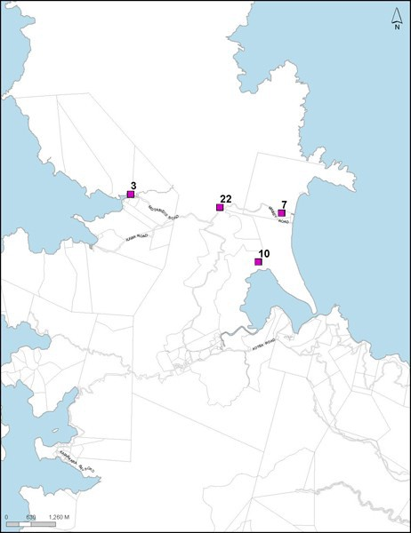

Numbers relate to schedule identification numbers.

## Figure 2: Awana­Claris Great Barrier Island

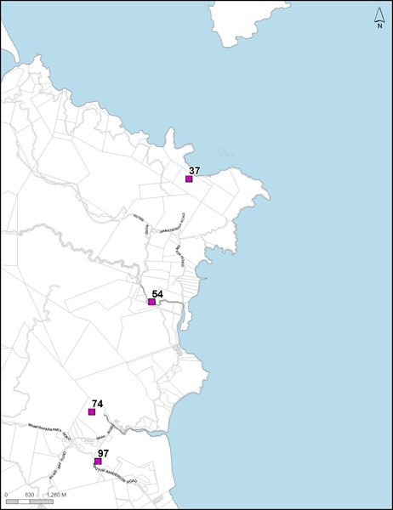

Numbers relate to schedule identification numbers.

## Figure 3: Medlands­Tryphena Great Barrier Island

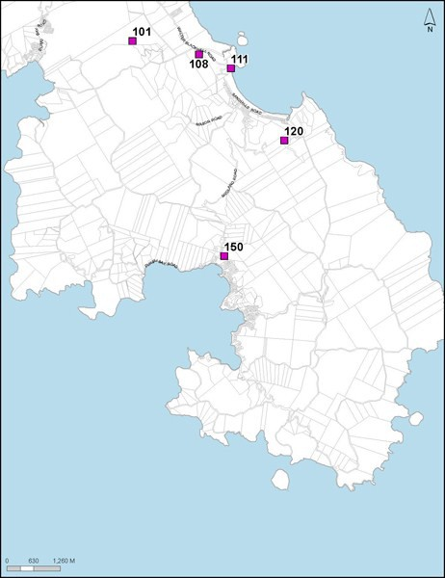

Numbers relate to schedule identification numbers.

## Figure 4: Te Arai ­ Tomarata

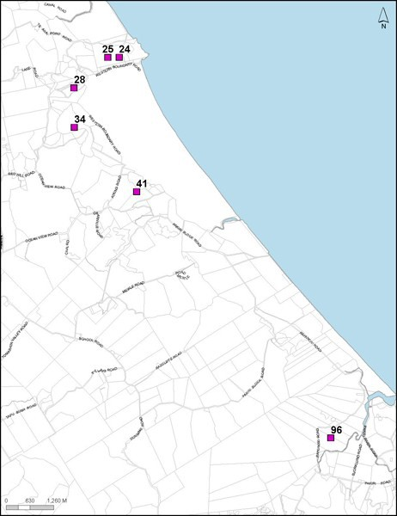

Numbers relate to schedule identification numbers.

## Figure 5: Tapora

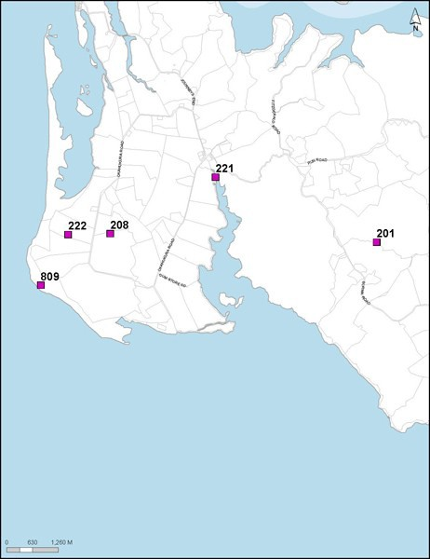

Numbers relate to schedule identification numbers.

## Figure 6: Tauhoa

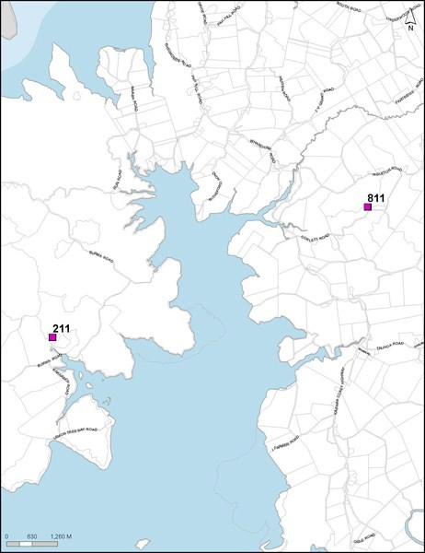

Numbers relate to schedule identification numbers.

## Figure 7: Wayby Valley Wellsford

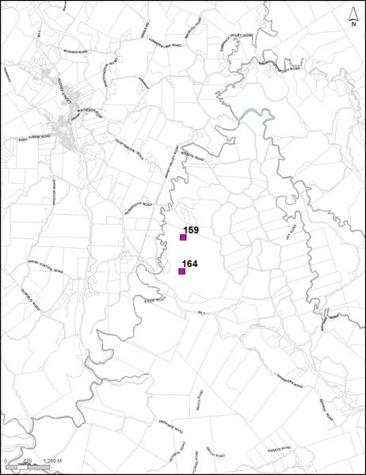

Numbers relate to schedule identification numbers.

## Figure 8: Omaha ­ Tawharanui

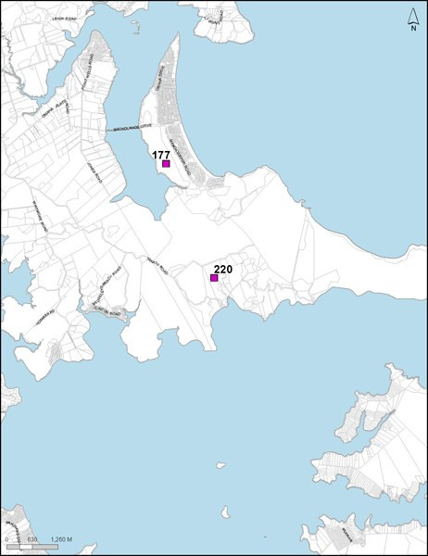

Numbers relate to schedule identification numbers.

## Figure 9: South Kaipara Head north

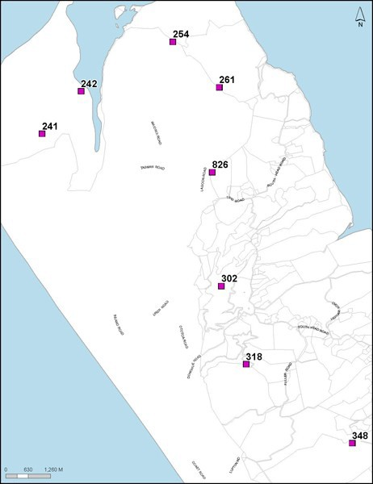

Numbers relate to schedule identification numbers.

## Figure 10: Araparera SH 16 Kaipara

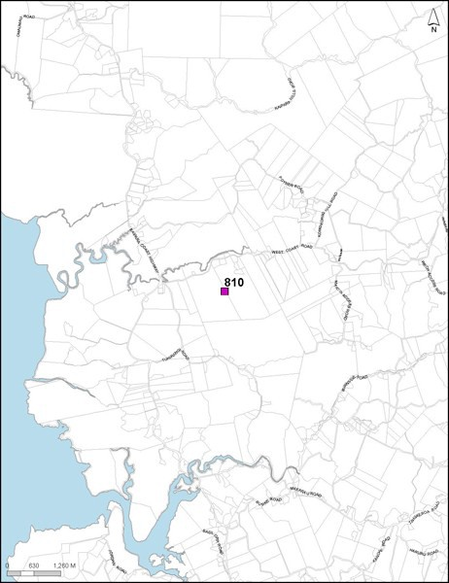

Numbers relate to schedule identification numbers.

## Figure 11: Waiwera

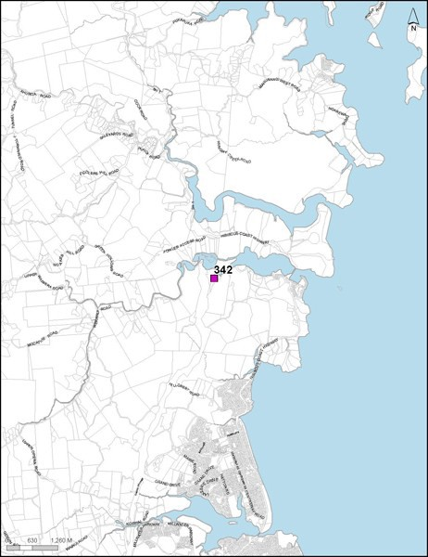

Numbers relate to schedule identification numbers.

## Figure 12: South Kaipara Head south

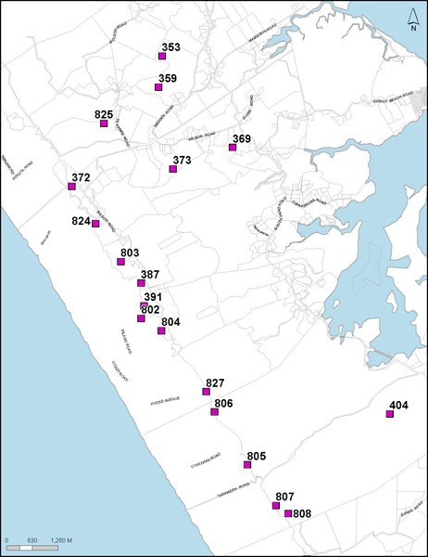

Numbers relate to schedule identification numbers.

## Figure 13: Peak Road Helensville

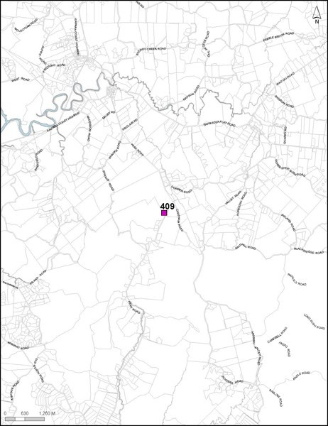

Numbers relate to schedule identification numbers.

## Figure 14: Shakespear Regional Park

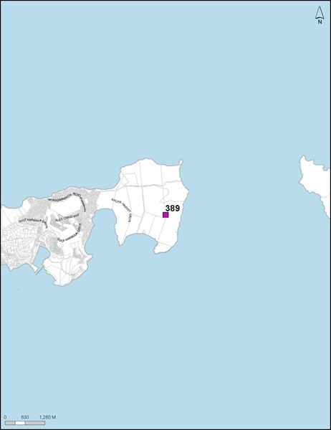

Numbers relate to schedule identification numbers.

## Figure 15: Woodhill

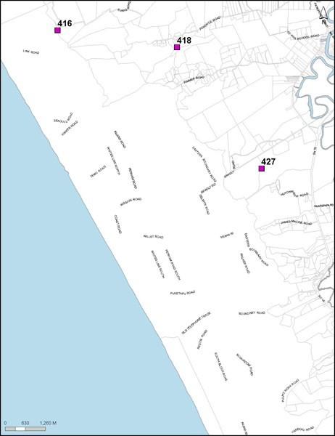

Numbers relate to schedule identification numbers.

## Figure 16: Te Henga ­ Muriwai

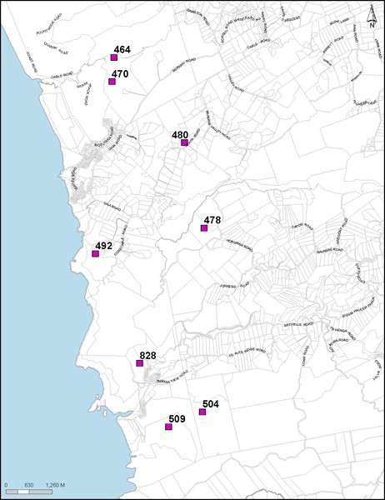

Numbers relate to schedule identification numbers.

## Figure 17: Auckland Central

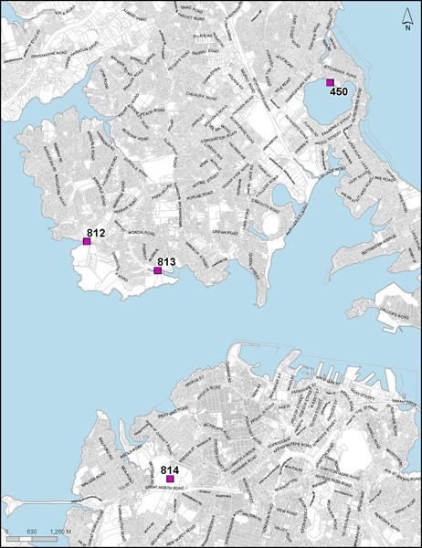

Numbers relate to schedule identification numbers.

## Figure 18: Piha ­ Whatipu Waitakere west coast

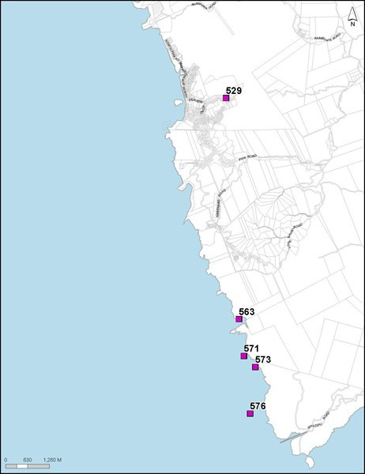

Numbers relate to schedule identification numbers.

## Figure 19: Onehunga ­ Mangere

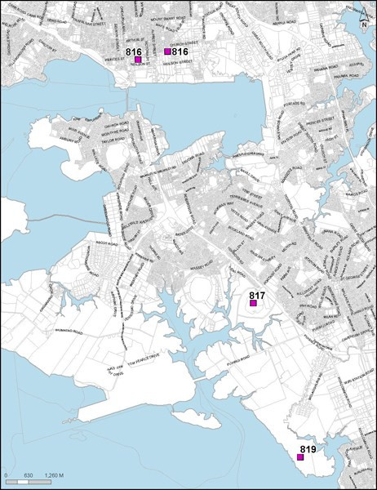

Numbers relate to schedule identification numbers.

## Figure 20: Tahuna Torea ­ Whitford

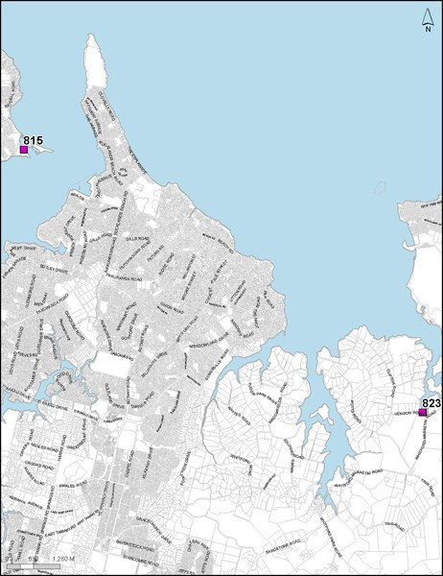

Numbers relate to schedule identification numbers.

## Figure 21: Onetangi Waiheke Island

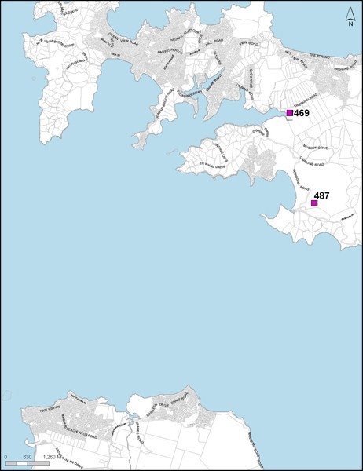

Numbers relate to schedule identification numbers.

## Figure 22: Eastern Waiheke Island and Ponui Island

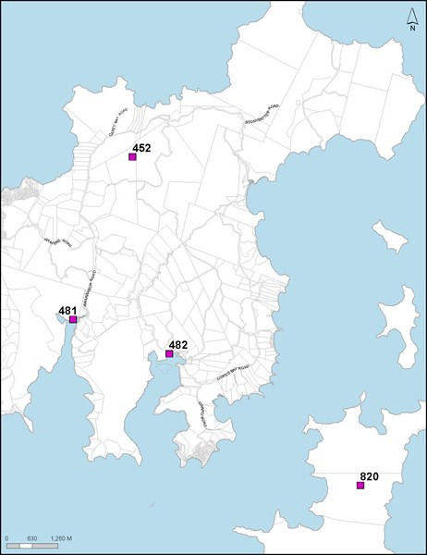

Numbers relate to schedule identification numbers.

## Figure 23: Awhitu north

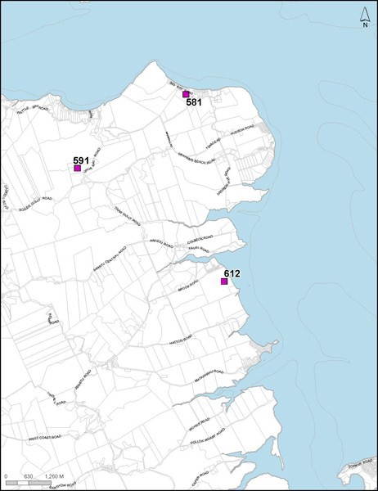

Numbers relate to schedule identification numbers.

## Figure 24: Karaka

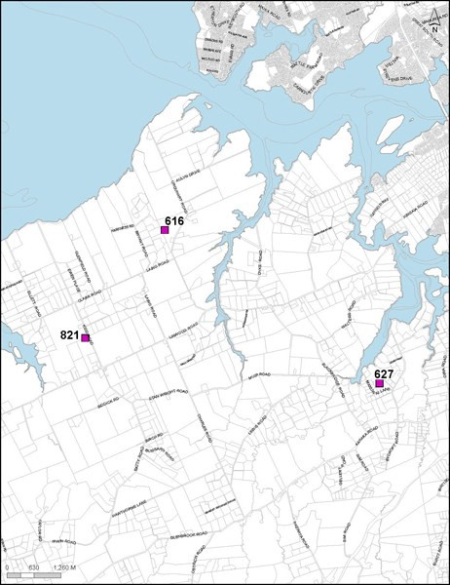

Numbers relate to schedule identification numbers.

## Figure 25: Ness Valley­west Hunua

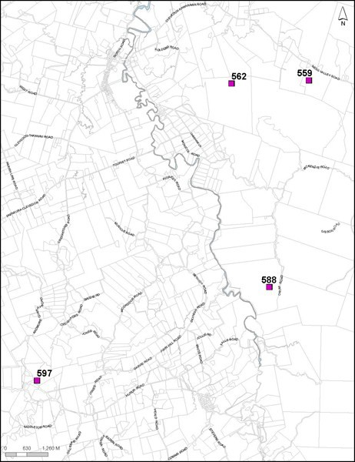

Numbers relate to schedule identification numbers.

## Figure 26: Central­South Awhitu

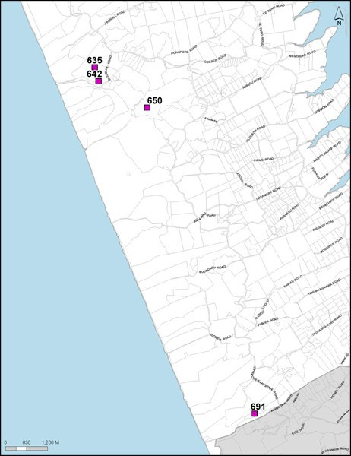

Numbers relate to schedule identification numbers.

## Figure 27: Patumahoe

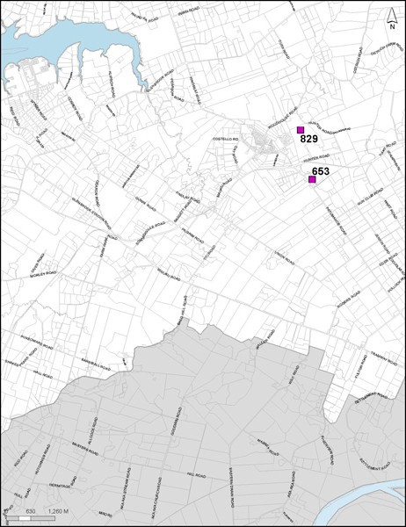

Numbers relate to schedule identification numbers.

# Appendix 5.4 Schedule of natural lake management areas

## [all provisions in this appendix are: rp]

|  |  |  |  |  |
| --- | --- | --- | --- | --- |
| **Schedule ID** | **Name** | **Location** | **AC Natural Heritage Information**  **Database ID** | **Ecological values and water quality** |
| Lake Spectacle | Lake Spectacle | Te Arai | 34 | Has the worst water quality of the seven lakes monitored by Auckland Council, consistent with its location entirely within a pastoral catchment. Suffers regular blooms of algae, particularly during summer. A narrow fringe of vegetation exists around the margin comprising raupö, tall spike sedge, mingimingi and swamp kiokio. Provides a refuge and feeding habitat for resident and  itinerant waterfowl. |
| Lake Slipper | Lake Slipper | Te Arai | 28 | Connected to Lake Spectacle by a drainage canal, with similar water quality. Prevalent algal blooms occur during summer. Some wetland vegetation occurs around the margin, which provides habitat for wetland  birds. |
| Lake Tomarata | Lake Tomarata | Te Arai | 41 | A small dune lake with extensive wetland areas along its north, west and southern shores. Water quality is moderate compared to other lakes Auckland Council monitors, though may be deteriorating. Raupo dominates the marginal vegetation with sedges, rushes and the umbrella fern found within the wetland. Provides a refuge and feeding habitat for resident and itinerant  waterfowl. |
| Lake Ototoa | Lake Ototoa | South Head | 302 | Has the best water quality of the seven lakes monitored by Auckland Council. The lake supports dense beds of native submerged aquatic plants dominated by Chara sp. Marginal emergent vegetation is diverse with three Baumea species dominating. Large populations of dwarf  inanga and bullies are present in the lake. |
| Lake Kuwakatai | Lake Kuwakatai | South Head | 318 | Has very poor water quality typical of a shallow waterbody located within a pastoral catchment. The weed hornwort dominates the aquatic plant communities and many exotic fish are present, including koi carp. Provides a refuge and feeding habitat for  resident and itinerant waterfowl. |
| Lake Te Kanae | Lake Te Kanae | South Head | 825 | No information available. |

|  |  |  |  |  |
| --- | --- | --- | --- | --- |
| **Schedule ID** | **Name** | **Location** | **AC Natural Heritage Information**  **Database ID** | **Ecological values and water quality** |
| Lake Kereta | Lake Kereta | South Head | 372 | A small turbid dune lake with poor water quality. High faecal bacteria counts indicate stock access to the water and large populations of resident waterfowl, including swans. The weed hornwort dominates the aquatic plant communities and many exotic  fish are present. |
| Lake Paekawau | Lake Paekawau | Waimauku | No wetland | A small lake located near Muriwai Beach.  Little information exists. |
| Lake Okaihau | Lake Okaihau | Waimauku | 470 | Also located near Muriwai Beach. Some  historic information available |
| Lake Wainamu | Lake Wainamu | Bethells Beach | 504 | Water quality has undergone recent deterioration following the loss of submerged aquatic plants in the mid 1990’s. A large amount of its catchment is native forest. Exotic fish are present including goldfish, perch, tench, rudd and catfish. A colony of black shag are also  present. |
| Lake Kawaupaka | Lake Kawaupaka | Bethells Beach | 509 | A small lake located entirely within a forested catchment. Water quality has declined recently following the introduction of exotic plants and fish during the past thirty years. A large colony of black shag  are present. |
| Pehiakura Lake | Pehiakura Lake | Awhitu | 635 | No information available. |
| Lake Pokorua | Lake Pokorua | Awhitu | 650 | A small dune lake located on the Awhitu Peninsula. Three threatened bird species are found at the lake, the Australasian bittern, New Zealand dabchick and the North Island fernbird. Waterfowl present include NZ scaup, paradise shelduck, black swan and shoveller duck. Other wetland, forest and coastal bird species present include: mallard duck, little shag, white fronted tern, black backed gulls, black  shag, white faced heron, pukeko, harrier  hawk and grey warbler. |
| Lake Whatihua | Lake Whatihua | Awhitu | 691 | No information available. |

The above listed lakes are identified as Natural Lake Management Areas. The management area includes the area of water within the lake itself and a 50 metre buffer surrounding the lake edge. This buffer distance is measured landward from the Mean Annual Water Level.

Many of these lakes also contain wetlands around their margins which are identified in Appendix 5.3: Schedule of Wetland Management Areas.

# Appendix 5.5 Aquifer water availabilities and levels

## [all provisions in this appendix are: rp]

Table 1: Aquifer water availabilities

|  |  |  |
| --- | --- | --- |
| **Aquifer name / Schedule ID** | **Location** | **Water availability (m3/year)** |
| **Waitemata Aquifer** | | |
| Orewa Waitemata | Orewa | 858,000 |
| Whangaparaoa Waitemata | Whangaparoa | 528,000 |
| Tomarata Waitemata | Tomarata | 638,000 |
| Omaha Waitemata | Omaha | 105,000 |
| Kumeu Waitemata | Kumeu | 1,559,000 |
| Mahurangi Waitemata | Mahurangi | 1,605,500 |
| Manukau Waitemata | Manukau | 660,000 |
| Clevedon East Waitemata | Clevedon | 379,400 |
| Clevedon West Waitemata | Clevedon | 964,400 |
| **Kaawa Aquifer** | | |
| Pukekohe Kaawa | Pukekohe | 1,860,000 |
| Karaka Kaawa | Karaka | 617,000 |
| Pukekohe West Kaawa | Pukekohe | 1,780,000 |
| Waiau Pa Kaawa | Pukekohe | 1,560,000 |
| Waiuku Kaawa | Waiuku | 2,450,000 |
| Bombay ­ Drury Kaawa | Drury | 718,000 |
| Manukau Southeast Kaawa | Manukau | 1,080,000 |
| **Volcanic Aquifer** | | |
| Pukekohe Central Volcanic | Pukekohe | 856,000 |
| Pukekohe South Volcanic (in  Auckland Council area only) | Pukekohe | 400,000 |
| Pukekohe West Volcanic | Pukekohe | 420,000 |
| Pukekohe North Volcanic | Pukekohe | 420,000 |
| Western Springs Volcanic | Western Springs | 9,600,000 |
| Onehunga Volcanic | Onehunga | 8,468,000 |
| Mt Wellington Volcanic | Mt Wellington | 6,570,000 |
| Mt Richmond Volcanic | Mt Wellington | 880,000 |
| **Aquifers not separately listed** | | |
| Shallow, coastal aquifers | 15% of average annual recharge as determined by the Auckland  Council | |
| All other aquifers with connection to a  surface water body | 35% of average annual recharge as determined by the Auckland  Council | |

|  |  |  |
| --- | --- | --- |
| **Aquifer name / Schedule ID** | **Location** | **Water availability (m3/year)** |
| All other aquifers not separately listed without connection to a surface water  body | 65% of average annual recharge as determined by the Auckland Council | |

Table 2: Interim aquifer groundwater levels

|  |  |  |
| --- | --- | --- |
| **Schedule ID/Name** | **Location** | **Interim level (metres above mean sea**  **level)** |
| Omaha Waitemata | Bore 25, Point Wells Rd | 3.25 (for any 11 months of the year) |
| Waiwera Geothermal | AC beachfront Deep Bore No. 74 | 0.5 averaged over any consecutive 12  months |
| Parakai Geothermal | AC Deep Bore No. 86 | 2.5 averaged over any consecutive 12  months |

# Appendix 5.6 Macroinvertebrate community index for landuse types

## [all provisions in this appendix are: rp]

**Map 1: Macroinvertebrate community index for landuse types**

