The Proposed Auckland Unitary Plan (notified 30 September 2013)

PART 5 ­ APPENDICES»

Appendix 12 Subdivision

Appendix 12.1 Receiver site exclusion area

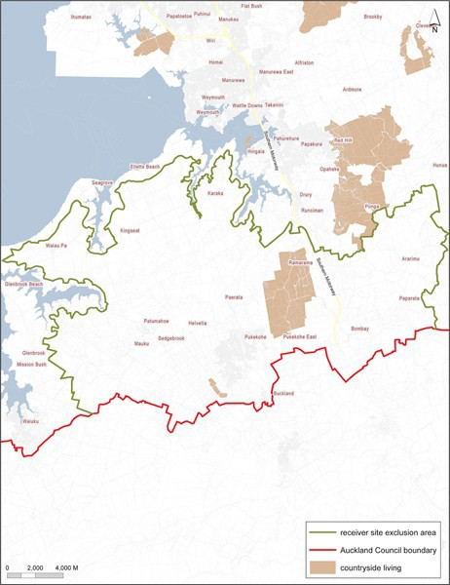

Page 1 of 1

