PART 7 ­ DESIGNATIONS»Schedules and Designations»

Counties Power Ltd

Designation Schedule ­ Counties Power Ltd

Number | Purpose | Location
3000 | Electricity supply purposes | 104 Manukau Road, Pukekohe
3001 | Electricity supply purposes | 125 Kitchener Road, Waiuku
3002 | Electricity supply purposes | Batty Road (Lot 1 DP 56769), Kingseat
3003 | Electricity supply purposes | Hillview Road (Lot 1 DP 109070), Ramarama
3004 | Electricity supply purposes | Cornwall Road (part of Lot 2 DP 384042), Waiuku
3005 | Electricity distribution ­ Pukekohe to Tuakau 110kV overhead electricity line | 104 Manukau Road to Buckland Road, Pukekohe
3006 | Electricity supply purposes | 9 Ponga Road, Opaheke
R3008 | Electrical supply infrastructure ... | Whitham Road (Lot 1 DP 175576), Glenbrook

3000 Pukekohe Substation

Designation Number | 3000
Requiring Authority | Counties Power Ltd
Location | 104 Manukau Road, Pukekohe
Rollover Designation | Yes
Legacy Reference | Designation 1, Auckland Council District Plan (Franklin Section) 2000
Lapse Date | Given effect to (i.e. no lapse date)

Purpose

Electricity supply purposes.

Conditions

No conditions.

Attachments

No attachments.

3001 Waiuku Substation

Designation Number | 3001
Requiring Authority | Counties Power Ltd
Location | 125 Kitchener Road, Waiuku
Rollover Designation | Yes

Legacy Reference | Designation 2, Auckland Council District Plan (Franklin Section) 2000
Lapse Date | Given effect to (i.e. no lapse date)

Purpose

Electricity supply purposes.

Conditions

No conditions.

Attachments

No attachments.

3002 Te Hihi Substation

Designation Number | 3002
Requiring Authority | Counties Power Ltd
Location | Batty Road (Lot 1 DP 56769), Kingseat
Rollover Designation | Yes
Legacy Reference | Designation 3, Auckland Council District Plan (Franklin Section) 2000
Lapse Date | Given effect to (i.e. no lapse date)

Purpose

Electricity supply purposes.

Conditions

No conditions.

Attachments

No attachments.

3003 Ramarama Substation

Designation Number | 3003
Requiring Authority | Counties Power Ltd
Location | Hillview Road (Lot 1 DP 109070), Ramarama
Rollover Designation | Yes
Legacy Reference | Designation 7, Auckland Council District Plan (Franklin Section) 2000
Lapse Date | Given effect to (i.e. no lapse date)

Purpose

Electricity supply purposes.

Conditions

No conditions.

Attachments

No attachments.

3004 Waiuku Substation

Designation Number | 3004
Requiring Authority | Counties Power Ltd
Location | Cornwall Road (part of Lot 2 DP 384042), Waiuku
Rollover Designation | Yes
Legacy Reference | Designation 150, Auckland Council District Plan (Franklin Section) 2000
Lapse Date | Five years from being operative in the Unitary Plan, unless given effect to prior

Purpose

Electricity supply purposes.

Conditions

Establishment of Substation on Site
The Outline Plan of Works for the establishment of the substation on the site must comply with the following:

  - The works to give effect to the designation must be undertaken in general accordance with the information submitted by Counties Power in support of the Notice of Requirement contained in the document titled: Notice of Requirement for a Designation for a New Electricity Substation in Waiuku, Notice of Requirement and assessment of Environmental Effects dated August 2007 prepared by Boffa Miskell and additional information dated 12 October 2007 (and any subsequent addenda or errata provided by the requiring authority at or before the hearing of the Notice of Requirement on 25 February 2008).

  - The Outline Plan of Works to be submitted pursuant to section 176A of the Resource Management Act 1991 to establish the substation on site shall include the following:
- Construction Management Plan;
- Traffic Management Plan;
- Property and Landscape Management Plan; and
- Design and layout of the substation.

  - The Construction Management Plan to be submitted pursuant to section 176A of the Resource Management Act 1991 and required by Condition 1.b.i. must include:
- Indicative plan/report for the sequence of activities (inclusive of earthworks and volumes) proposed;
- The timing of the activities;
- The name and contact details of project manager;
vi. The expected duration of the works;
- The requiring authority must also circulate the Construction Management Plan prior to construction commencing to all directly adjoining neighbours, Glenbrook Vintage Railway and occupiers of 121 Collingwood Road;
- An accidental discovery protocol for archaeological remains and a commitment to include site works

methodology incorporating the supervision of the earthworks by an iwi representative; and
- Silt, dust and sediment controls associated with earthworks.

  - The Traffic Management Plan to be submitted pursuant to section 176A of the Resource Management Act 1991 and required by Condition 1.b.ii. must be prepared by a suitably qualified person for the purposes of working on, or in close proximity to roads and public places.

  - The Property and Landscape Management Plan to be submitted pursuant to section 176A of the Resource Management Act 1991 and required by Condition 1.c.ii. shall detail species, gardening and maintenance specifications. The Property and Landscape Plan must incorporate the following elements:
- Identification of all hard and soft landscape works (including fences) and how landscaping will provide a buffer between the activity and adjacent Glenbrook Vintage Railway reserve, nearby dwellings and roads;
- Details of the intended species, preferably natives, plant sizes at the time of planting, their likely heights on maturity and how planting will be staged, established and maintained;
- A commitment to replacing planting if the initial work fails;
- Provisions and methods to ensure landscaping works do not undulyinterfere with any overland flow path;
- A water supply to ensure that all plantings are maintained in perpetuity;
- A colour scheme to mitigate adverse visual effects and ensure low reflectivity of external surfaces of structures on the site;
- Maintenance and upkeep of structures;
- Demonstrate evidence of consultation and input with Glenbrook Vintage Railway in the landscape design;
- Demonstrate evidence of consultation with the owner of 121 Collingwood Road on stormwater design and treatment;
- Plantings shall be designed so as to comply with Electricity (Hazards from Trees) Regulations 2003 or successor; and
- Substation compound and building shall be setback at least 3m from all boundaries.

The Property and Landscape Management Plan must be given effect to as soon as reasonably possible following the approval of the plan and no later than the first planting season following completion of the works on the site. The landscaping must be irrigated and maintained for the life of the substation.

  - The substation must be designed and constructed in such a manner as to comply with the following noise emission standards. The noise level measured within the notional boundary (a line 20m from the façade of any dwelling) or legal boundary (where this is closer) of any existing dwelling shall not exceed the following limits:

7.00 am – 8.00 pm | 50dBA L10
8.00 pm – 7.00 am | 40dBA L10
10.00 pm – 7.00 am | 65dBA

The noise levels must be measured and assessed in accordance with the requirements of NZS 6801:1991 Measurement of Sound and NZS 6802:1991 Assessment of Environmental Sound.

  - The requiring authority must submit, to Auckland Council within three months of commissioning the substation, an acoustic design certificate provided by a qualified acoustic engineer confirming that the design will ensure compliance with the performance standard set out in condition 1.f.

Timeframe of Designation
Pursuant to section 184(1)(c) of the Resource Management Act 1991, the expiry period for the designation for construction, operation and maintenance of an electricity substation at a nominal voltage of up to 110kV on part of a property legally described as Lot 2 DP 384042, shall be ten years.

Decommissioning Existing Substation
Within one year of the commencement of operation of the new substation, the existing substation on Kitchener Road shall be decommissioned and a decommissioning plan shall be submitted to Auckland Council pursuant to section 176A of the Resource Management Act 1991.

Earthworks Associated with any Site Development
  - Prior to commencing any earthworks the Requiring Authority must install all the necessary erosion and sediment control measures as shown in the Auckland Council's TP 90 and be responsible for preventing, controlling and stopping the loss of soil and silt and any damage caused by earthworks on adjacent properties. All necessary erosion and sediment measures once installed are to be maintained to ensure continual operation until the development has been completed and the site fully stabilized.

  - All earthworks must occur between the hours of 7.00 am and 6.00 pm Monday to Saturday.

Overland Flow
  - The finished land level and grade of the earthworks and land forming must be such that it does not impede, restrict or block the existing overland flow from adjacent properties and that an adequate flow path over the site shall be maintained.

  - The finished land level and grade of the earthworks and land forming must be such that it does not divert, redirect and concentrate runoff onto adjacent properties.

Noise during Construction
That the Requiring Authority must comply with the noise standards set out in Acoustic Construction Noise NZS 16803:1999 at all times while any construction works are being constructed on site.

Site Access
The site must be secure from unauthorised public access at all times during construction.

Lighting
All exterior on­site lighting must be positioned and aimed within the site, away from adjacent properties and public roads so as to minimise the level of spill light and glare.

Hazardous Substances
The Requiring Authority must ensure that any transformer oil storage areas are bunded. Bunds shall be sufficient capacity to contain the release from the total volume of all storage vessels located in each bunded area.

Surface Water
The Requiring Authority must maintain and regularly clean all stormwater catch pits, channels, grates, pipes and other stormwater collection systems to ensure they operate in an effective manner.

Electrical Interference
The Requiring Authority must make every reasonable effort to ensure that the electrical supply substation is operated, managed and controlled so that there is no electrical interference with television or radio reception at any adjacent property including complying with the requirements of the Radio Communications Regulations 2001, the Ministry of Economic Development’s Radio Spectrum Management “Compliance Guide” (November 2004) and relevant Gazetted Notices.

Advice Notes
- The Requiring Authority will need to obtain all other necessary resource consents and permits, including those under the Building Act 2004 and any resource consents required by Auckland Council under the regional

plans.

- The Requiring Authority is advised that once the designation has been formalised, any minor alteration or omissions to the designated area should be rectified through alterations of the designation pursuant to section 181 of the Resource Management Act 1991.

- The Requiring Authority is advised of its statutory obligations under section 172 of the Resource Management Act 1991, which include the following:
  - Within 30 working days of receiving Council’s recommendation, the Requiring Authority is required to advise Council whether it accepts or rejects the recommendation in whole or in part;
  - The Requiring Authority shall only modify the requirement if, and only if the modifications are recommended by Council or are not inconsistent with the requirement as notified; and
  - Where the Requiring Authority rejects the recommendation in whole or in part, or modifies the requirement, the authority shall give reasons for its decision.

- Counties Power should ensure that prior to construction, formal contact is made and permission or consents are obtained as required from the operators of any network utilities where their services and facilities may be affected by the construction works for the project.

- As soon as reasonably possible following its purchase of the site, Counties Power should carry out initial planting in line with the anticipated requirements of the Property and Landscape Management Plan, particularly near the boundary with the Glenbrook Vintage Railway. The purpose of this initial planting is to ensure that some screening is established on site before the substation is built. When the site is developed for its designated purpose, as far as reasonably possible these existing plants should be incorporated into the Property and Landscape Management Plan.

- That an Outline Plan of Works pursuant to section 176A of the Resource Management Act 1991 shall be submitted to Auckland Council prior to construction. These detailed plans will need to show the measures that will be implemented to avoid, remedy or mitigate any adverse effects on the environment. These details will also confirm whether any resource consents may be required.

- That pursuant to sections 35 and 36 of the Resource Management Act 1991 the actual and reasonable costs incurred by Council in monitoring conditions of this recommendation shall be paid by Counties Power.

Attachments

No attachments.

3005 Pukekohe to Tuakau Line

Designation Number | 3005
Requiring Authority | Counties Power Ltd
Location | 104 Manukau Road, Pukekohe to Buckland Road, Buckland (to Waikato District Council boundary)
Rollover Designation | Yes
Legacy Reference | Designation 151, Auckland Council District Plan (Franklin Section) 2000
Lapse Date | Five years from being operative in the Unitary Plan, unless given effect to prior

Purpose

Electricity distribution ­ Pukekohe to Tuakau 110kV overhead electricity line.

Conditions

Plan Information
That the works to give effect to the new Designation for the construction, operation, maintenance and modification of one overhead electricity line of up to 110kV nominal voltage, shall be in accordance with:
  - The Notice of Requirement;
  - The Assessment of Environmental Effects prepared by Boffa Miskell, titled Counties Power, Notice of Requirement for a Designation for 110kV Electricity Line from Pukekohe Substation to Proposed Tuakau Substation, Volumes I, II and III and the additional information supplied to Council dated 11 December 2007 and 24 January 2008 (and any subsequent addenda or errata provided by the requiring authority at or before the hearing of the Notices of Requirement on 18 and 19 February 2008);
  - The Designation plans prepared by Boffa Miskell titled ‘Counties Power, Proposed Corridor for New Electricity Line’, Drawings 01104­000 to 01104­013, 01104­017 to 01104­018 provided as further information but
superseded by Drawings 01104_19 and 01104_20 presented at the hearing. NB Drawings 01104­000 (providing an overview of the route), 01104 019 and 01104 020 are appended as Figures 1­3;
  - The designation is to provide for the construction, operation, maintenance and modification of one overhead electricity line of up to 110kV nominal voltage comprising a maximum of three conductors (i.e. lines), one earth wire and one fibre optic cable, and local electricity distribution lines where it would be appropriate and promote efficiency of the network, these supported above ground level by poles spaced at an average of at least 80m apart plus all necessary ancillary fixtures and fittings; and
  - Subject to any amendments required by the following conditions and any other minor alterations proposed by Counties Power to the satisfaction of Auckland Council.

Buckland Screen Planting
Counties Power, when formulating the Outline Plan, shall liaise with Ontrack, Auckland Council and the Buckland Community Centre to ascertain an appropriate and practical extent of screen planting through Buckland village alongside the poles and will provide detail of such planting in the Outline Plan. The purpose of such planting will be to supplement the mitigation provided by undergrounding of the local lines and the extent and placement of screen planting shall also take into account the requirements of Ontrack to ensure the safe and efficient operation of the railway corridor.

Maximum Number of Pylons
The maximum number of pylons used as part of the support structures for the line shall be restricted to two (2) to overcome topographical features.

Nuisance Mitigation
That Counties Power and its contractors take all reasonable steps to prevent or mitigate any nuisance to adjacent properties during construction.

Construction Management Plan
Prior to the commencement of any earthworks or construction activity on the designated site excluding site investigations, Counties Power shall prepare a Construction Management Plan and submit that plan for the approval of the Auckland Council. The Construction Management Plan shall include the procedures, methods and measures to be applied to address the following:
  - Exclusion of the public from the construction site;
  - Dust arising due to construction;
  - Prior notification to landowners of the use of machinery likely to generate vibration effects to dwellings, where such vibrations may be felt in the process to be followed to ensure that such effects are addressed;
  - Maintenance of road, rail and property access during construction;
  - Movement of construction traffic on local roads;
  - Hours of operation of trucks and service vehicles;

  - A single point of contact to field general enquiries and complaints from the public; h.The control of stormwater, runoff, sediment and contaminants during construction;
- Methods for earthworks, stormwater control, sediment control, replanting of any exposed areas; and
- Traffic management around the local roads during construction.

Liaison Person
That a permanent liaison person shall be immediately appointed by Counties Power for the duration of the works and be a readily accessible point of contact for persons affected by the designation and construction works. Counties Power shall advise the liaison person’s name and contact details to affected parties. This person must be available for ongoing consultation on all matters of concern to affected persons and provide a timetable as to the construction works to adjoining property owners and occupiers.

Maximum Capacity of Transmission Line
The electricity line is to comprise a maximum of one 110kV circuit (comprising 3 conductor wires and an earth wire) plus lower voltage circuits where required and a maximum of one fibre optic cable, supported on poles generally as described in section 4.2 of the Assessment of Environmental Effects submitted with the application, or on pylons if required to cross the gully at grid reference V11 on Drawing 01104­006 to X12 on Drawing 01104­007.

Width of the Designation
The width of the designation is generally to be in accordance with the representations shown on Drawings 01104­000 to 01104­013 submitted as part of the application.

Written Approval
Counties Power is to grant its written approval (as requiring authority) under sections 176(1)(b) and 178(1) of the Resource Management Act 1991 to enable the New Zealand Railways Corporation, or any other party authorised by New Zealand Railways Corporation, to undertake any activity on the land that is authorised by the existing rail designation and / or to undertake any other activity on the land that will not prejudice Counties Power’s rights under its occupancy agreement with New Zealand Railways Corporation.

Removal of Local Transmission Lines
Counties Power shall mitigate the visual impact of the new line by removing some existing local transmission lines as follows:
- The removal of the existing 400V overhead local lines on the eastern side of Station Road (adjacent to the A and P showgrounds) within 1 year of the commissioning of the Pukekohe ­ Tuakau 110kV line;
- Unless removed earlier, the second set of overhead local lines (currently at 11kV but planned to be upgraded to 22kV) on the eastern side of Station Road and adjacent to the A and P Showgrounds shall be removed within 2 years of the zoning of the A and P Showgrounds land for high density urban intensification being notified as part of a Plan Change;
- The existing local lines on the eastern side of Station Road from alongside Lot 1 DP 101010 to alongside Lot 2 DP 91559 shall be removed within 2 years of the zoning of this land for Residential use being notified as part of a Plan Change.
- Removal of the existing lines where the route passes Residential zoned land in Buckland, generally as shown on Drawing 01104_019 (supplied at the hearing) – refer appended Figure 2;
- Removal of the existing lines in the vicinity of the War Memorial in Buckland;
- Removal of the existing lines where the route passes Residential zoned land in Tuakau, generally as shown on Drawing 01104_20 (supplied at the hearing) – refer appended Figure 3; and
- Removal of the existing lines in Ryders Road not marked for removal on Drawing 01104_20 (refer appended Figure 3) once development plans for the area are sufficiently clear.

Note:
Conditions a., b. and c. seek to ensure that over time, both sets of local overhead lines are removed from

Station Road adjacent to the land mentioned in them, given the potential for this land to be subject to urban intensification in the future as shown in the Franklin District Growth Strategy 2051;

Colour of Poles
Counties Power shall provide, as part of the Outline Plan of Works, details of pole placement and provide an assessment of whether a darker coloured pole is appropriate given the location and background of the poles. Council shall audit these details as part of the Outline Plan process to ensure that the use of darker poles in the locations stated is the most appropriate way to reduce the visual impact of the line when viewed within its visual catchment.

Archaeological Assessment
That an archaeological site inspection be carried out along the notified designation corridor as part of the detailed design and Outline Plan of Works process. This inspection should:
- locate on the ground all recorded cultural heritage sites in the vicinity of the designation;
- dentify any previously unrecorded archaeological or other cultural heritage sites within and adjacent to the designation; identify what if any effect(s) the construction of the power line and associated works will have on these sites, and how any effects can be avoided;
- Identify any original or pre 1900 features of the railway within the designation; identify what if any effect(s) the construction of the power line and associated works will have on these features and how any effects can be avoided. Embankments, cuts and any structures such as bridges and culverts constructed prior to 1900 could be considered archaeological, and as such, could require an Authority to Modify from the New Zealand Historic Places Trust if they are affected;
- Make any further relevant recommendations in relation to the requirements of the Historic Places Act 1993 and the Resource Management Act 1991 based on the results of the site inspection;
- Counties Power shall consult with the New Zealand Historic Places Trust on the findings of the archaeological site inspection so that the New Zealand Historic Places Trust can confirm the need for any Authority/Authorities to Modify under the Historic Places Act 1993; and
- A copy of the archaeological site inspection shall be provided to the Council as part of any Outline Plan of Works required by section 176A of the Resource Management Act 1991.

Iwi Consultation
- Counties Power shall consult with iwi regarding the possible existence of archaeological sites within the proposed designation corridor before detailed design work commences and as part of the archaeological site inspection of the transmission line route.

- The outcome of such consultation shall be provided to the Council as part of any Outline Plan of Works required by section 176A of the Resource Management Act 1991.

Review of Designation Width
Within three months of the construction and successful commissioning of the electricity line, Counties Power shall review the area of land subject to the designation, taking into account the location of the line as constructed, and the access agreements with landowners along the route. Where appropriate, Counties Power will seek to alter the location and the width of the designation corridor so as to provide reasonably for the safe and efficient operation, maintenance and modification of electricity line. Alterations to the location and width of the designation corridor shall recognise that the designation originally sought may be wider than necessary to provide for the safe and efficient operation, maintenance and modification of the electricity line.

Term of Designation
For the purposes of section 184(1)(c) Resource Management Act 1991, the term during which the Designations shall not lapse unless given effect to is ten (10) years commencing from the end of the appeal period on the decision of Counties Power or the determination of any appeals on this designations for a 110kV transmission line.

Advice Notes
- The requiring authority will need to obtain all other necessary resource consents and permits, including those under the Building Act 2004 and any regional consents required from Environment Waikato and Auckland Council.

- The requiring authority is advised that once the Designations have been formalised, any minor alterations or omissions to the designated areas should be rectified through alterations to the Designations pursuant to section 181 of the Resource Management Act 1991.

- The requiring authority is advised of their statutory obligations under section 172 of the Resource Management Act 1991, which include the following:
  - Within 30 working days of receiving the Council’s recommendation, the requiring authority is required to advise the Council whether it accepts or rejects the recommendation in whole or in part;
  - The requiring authority shall only modify the requirements if, and only if, the modifications are recommended by the Council or are not inconsistent with the requirements as notified; and
  - Where the requiring authority rejects the recommendation in whole or in part, or modifies the requirements, the authority shall give reasons for its decision.

- Counties Power should ensure that prior to construction, formal contact is made, and permission or consents are obtained as required, from the operators of any network utilities where their services and facilities may be affected by the construction works for the project.

- An Outline Plan of Works, pursuant to section 176A of the Resource Management Act 1991, shall be submitted to Auckland Council prior to construction. These detailed plans will need to show the final route and measures that will be implemented to avoid, remedy or mitigate any adverse effects on the environment. These details will also confirm whether any resource consents may be required.

- Pursuant to sections 35 and 36 of the Resource Management Act 1991 the actual and reasonable costs incurred by Council in monitoring conditions of this recommendation shall be paid by Counties Power.

- Counties Power shall work with other parties involved in Plan Change 22 (to the Franklin District Plan) process to ascertain whether an alternative route for the line is possible through the plan change area.

Attachments

Figure 1: Overview of Route – from NOR as lodged with Franklin District Council

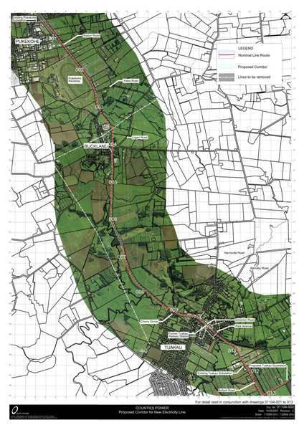

Figure 2: Drawing 01104 019

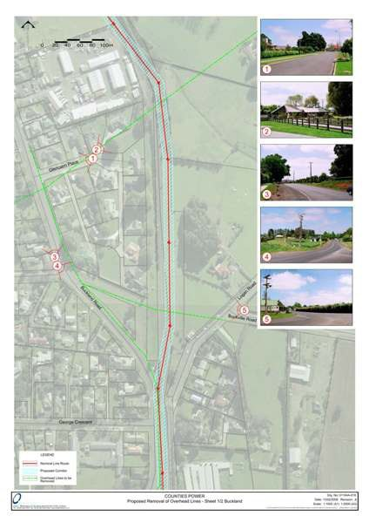

Figure 3: Drawing 01104 020

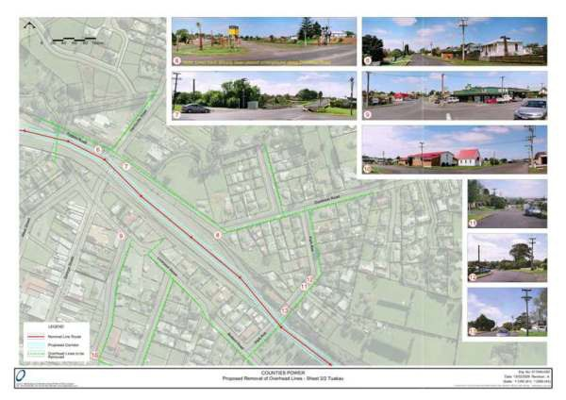

3006 Opaheke Substation

Designation Number | 3006
Requiring Authority | Counties Power Ltd
Location | 9 Ponga Road, Opaheke
Rollover Designation | Yes
Legacy Reference | Designation 13, Auckland Council District Plan (Papakura Section) 1999
Lapse Date | Given effect to (i.e. no lapse date)

Purpose

Electricity supply purposes.

Conditions

Sutton Road Future Road Widening
- The Substation security fence shall be set back at least 14m from the Sutton Road / western boundary (being the location of this boundary as it existed in the Notice of Requirement).

Note:
In the future the Council may require up to 12m of the site to widen Sutton Road of which 4m can be landscaped (refer to Figure 1 prepared by the former Papakura District Council).

Noise
- The substation must be operated in such a manner as to comply with the following noise emission standards. The noise level measured within the notional boundary of any existing dwelling shall not exceed the

following limits:
  - Daytime 0700­2000 L10 = 50dBA
  - Night­time 2000­0700 L10 = 40dBA
The noise levels must be measured and assessed in accordance with the requirements of NZ6801:1991 Measurement of Sound and NZS6802:1991 Assessment of Environmental Sound.

Earthworks Associated with any Site Development
- All retaining walls, earthworks, reinforcements and stability works must be constructed and completed immediately after cutting and or prior to filling to minimize the likelihood of any instability.

- Prior to commencing any earthworks the requiring authority must install all the necessary erosion and sediment control measures as shown in the Auckland Council's TP 90 and be responsible for preventing, controlling and stopping the loss of soil and silt and any damage caused by the earthworks on adjacent properties. All necessary erosion and sediment measures once installed are to be maintained to ensure continual operation until the development has been completed and the site fully stabilized.

- The requiring authority must control runoff, mitigate and prevent soil erosion, sediment loss and trap pollutants from entering adjacent lands, street curb and channels/ natural and artificial water bodies.

- All existing drainage systems must be protected from any release of silt, accidental or otherwise from the site. This also involves measures to prevent soil being spread onto the road and access way.

- All earthworks and areas of bare earth shall be re­vegetated or re­grassed within 3 months of completion of the earthworks. Where regeneration of the grass is not sufficient, areas of bare soil shall be “hydro­seeded” or otherwise sown with the appropriate ground cover vegetation.

- The requiring authority must limit the dispersal of dust from the earthworks to adjacent sites by implementing a watering regime in order to ensure that the areas of bare soil are dampened (up until the bare soil is revegetated).

- In the event of any excavated material being spilled on a public road, the requiring authority must take immediate action at their cost to clean/repair the road or reimburse the Auckland Council the expenses of cleaning and/or reinstating the damaged road.

- All earthworks must occur between the hours of 7.00am and 6.00pm Monday to Saturday.

Overland Flow
- The finished land level and grade of the earthworks and land forming must be such that it does not impede, restrict or block the existing overland flow from adjacent properties and that an adequate flow path over the site shall be maintained.

- The finished land level and grade of the earthworks and land forming must be such that it does not divert, redirect and concentrate runoff onto adjacent properties.

Lighting
- All exterior on­site lighting must be positioned and aimed within the site, away from adjacent properties and public roads so as to minimise the level of spill light and glare.

Hazardous Substances
- The requiring authority must ensure that any transformer oil storage areas are bunded. Bunds shall be sufficient capacity to contain the release from the total volume of all storage vessels located in each bunded area.

Surface Water
- The requiring authority must maintain and regularly clean all storm water catch pits, channels, grates, pipes and other storm water collection systems to ensure they operate in an effective manner.

Electrical Interference
- The requiring authority must make every reasonable effort to ensure that the electrical supply substation is operated, managed and controlled so that there is no electrical interference with television or radio reception at any adjacent property including complying with the requirements of the Radiocommunications Act 1989, the Radiocommunications Regulations 2001, the Ministry of Economic Development’s Radio Spectrum Management “Compliance Guide” (November 2004), and relevant Gazetted Notices.

Advice Note
- It is noted that the submitted and approved Outline Plan of Works for the establishment of the substation includes a landscape plan that identifies the possible need for the alteration or removal of trees at 9 Ponga Road in a specified area and such work can be undertaken as part of the designated works to enable emergency maintenance or for the planned installation, upgrade or replacement of equipment which cannot be installed for the existing vehicle entrance.

Attachments

Figure 1 ­ Diagram prepared by former Papakura District Council to record the Council’s proposed road widening and the impact of this on the layout of substation fencing and landscaping

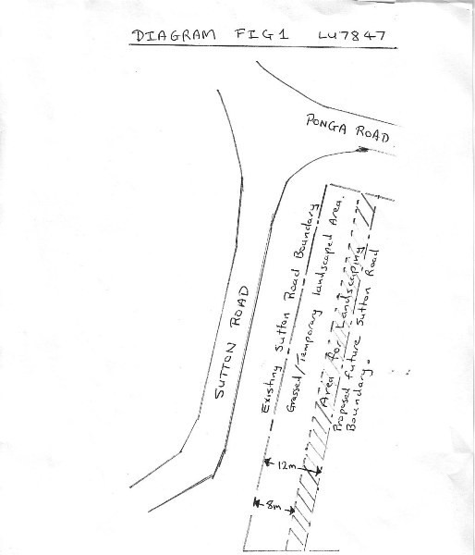

R3008 Glenbrook Substation

Designation Number | R3008
Requiring Authority | Counties Power Ltd
Location | Whitham Road (Lot 1 DP 175576), Glenbrook
Rollover Designation | No
Legacy Reference | N/A
Lapse Date | 10 years from being operative in the Unitary Plan

Purpose

The purpose of the proposed designation is to provide for existing and future electrical supply infrastructure. The proposed designation scope is:
  - The operation, maintenance and upgrading of an existing substation and associated ancillary structures and activities required for electricity supply and distribution.
  - The provision of works required for electricity supply and distribution.

Conditions

General
    - A period of 10 years will be sought to implement the works.

    - Any additional consents/approvals (for example, National Environmental Standard for Assessing and Managing Contaminants in Soil to Protect Human Health, matters requiring regional consent) will be obtained prior to works commencing.

    - Unless Section 176A(2) applies, an Outline Plan of Works shall be submitted to the territorial authority to allow the territorial authority to request changes before construction commences. The Outline Plan of Works will include:
      - The height, shape, and bulk of the public work, project, or work; and
      - the location on the site of the public work, project, or work; and
      - The likely finished contour of the site; and
      - the vehicular access, circulation, and the provision for parking; and
      - The landscaping proposed; and
      - any other matters to avoid, remedy, or mitigate any adverse effects on the environment

    - In addition to the matters set out in Condition 2, the Outline Plan will also include, commensurate to the scale of works proposed, a Construction Management Plan which addresses the following:
      - The proposed earthworks methodology including (as applicable) storage and reuse of topsoil; on­ and off­site disposal of soil and silt and dust control;
      - Traffic management for delivery of equipment, materials and general construction activities;
      - Any temporary equipment storage;
      - Methods of complying with the National Environmental Standard for Assessing and Managing Contaminants in Soil to Protect Human Health; and
      - In relation to the Glenbrook site; a liaison plan formulated to advise New Zealand Steel Limited of the nature and duration of works.

Transpower
    - Counties Power shall obtain the written approval of Transpower as Requiring Authority under Section 176 of the Act prior to works commencing.

    - Counties Power shall liaise with Transpower during the detailed design and subsequent construction processes prior to undertaking any work pursuant to this designation to ensure that the proposed works are integrated and managed in a manner suitable to both parties.

Accidental Discovery Protocols
    - If any archaeological sites, urupa, traditional sites, taonga (significant artefacts), or koiwi (human remains) are exposed during site works, then the following procedures shall apply:
      - Works in the immediate vicinity of the site that has been exposed shall cease;
      - The site supervisor shall immediately secure the area in a way that ensures that any remains or artefacts are untouched;
      - The site supervisor shall notify representatives of relevant tangata whenua, the New Zealand Historic Places Trust, the Auckland Council and, in the case of human remains, the New Zealand Police; and
      - The notification in (c) above shall allow such persons being given a reasonable time to record and recover archaeological features discovered before work may recommence on the exposed site.
      - Works shall not commence in the immediate vicinity of the archaeological site until any approval required from the NZ Historic Places Trust is obtained

Amenity

    - The works shall be designed and constructed to limit the EMF exposure at or beyond the secure boundary of the substation site to the International Commission on Non­Ionising Radiation Protection Guidelines for limiting exposure to time­varying electric, magnetic, and electromagnetic fields (up to 300 GHz) (Health Physics, 1998, 74(4): 494–522) (ICNIRP Guidelines) public reference levels of 5 kV/m for electric fields and 100 μT for magnetic flux density at the designation boundary under maximum normal operating conditions (ie, when there are no faults in the transmission system).

    - All works shall be designed to comply with NZS 6869:2004 Limits and Measurement Methods of Electromagnetic Noise from High­Voltage a.c. Power Systems, 0.15 to 1000 MHz.

    - Any masts, antennas, aerials and the other radiocommunication facilities shall at all times comply with NZS
2772.1 1999 and any subsequent amendments to that standard

    - Bulk and Location controls to be determined in Area A and Area B.

Operational Noise
    - Any new equipment (such as transformers, fans and circuit breakers) shall be designed and operated to ensure that the following noise limits shall not be exceeded:
a. LAeq(15 min) 70dB at the boundary of Lot 1 DP 202203 and Allotment 363 and 343, Parish of Waiuku, East Blocks X XIII Awhitu SD.

All noise levels must be measured in accordance with the New Zealand Standard on the Measurement of Environmental Sound (NZS 6801: 2008) and assessed in accordance with the New Zealand Standard on Acoustic ­ Environmental Noise (NZS 6802: 2008).

Construction Noise
    - All construction and maintenance work shall be designed, managed and conducted to ensure that construction and maintenance noise from the site does not exceed the limits in NZS6803:1999 Acoustics– Construction Noise at locations set out in section 6.2 of that standard.

    - The noise limits set out in Condition 13 above shall not apply to emergency work required to re­establish continuity of supply, work urgently required to prevent loss of life or other personal injury, or commissioning works at the substation site, but all practicable steps shall be undertaken to control noise and to avoid adverse noise effects.

Attachments

Counties Power Glenbrook Designation Diagram

CountiPower Glenbcoot: Designa11or. D1agr=m

Oa1e: 31July 2013 1 ;evision:0

Area A
I

I
I
III
I
1/

I'"-
I' II
I
I II I I
II

\ r---::::---..16{Ill \
--\ ,.,..• '! \
--

----
----...._-- \

1' c:::J Proposed cxt<:r.t of des gr<ltiofl
u
!0Parcel
----
f l..
II

