PART 7 ­ DESIGNATIONS»Schedules and Designations»

Ardmore Airport Ltd

Designation Schedule ­ Ardmore Airport Ltd

Number | Purpose | Location
200 | Airport purposes ... | Vicinity of Harvard Lane, Ardmore and an area surrounding Ardmore Airport

200 Ardmore Airport

Designation Number | 200
Requiring Authority | Ardmore Airport Ltd
Location | Vicinity of Harvard Lane, Ardmore and an area surrounding Ardmore Airport
Rollover Designation | Yes
Legacy Reference | Designations 9, 38 and 39, Auckland Council District Plan (Papakura Section) 1999; and Designation 234, Auckland Council District Plan (Manukau Section) 2002
Lapse Date | Given effect to (i.e. no lapse date)

Purpose

Airport purposes ­ the purpose of this designation is to provide for the efficient operation and growth of Ardmore Airport by enabling airport activities and flights while defining airport approach and landuse controls.

The extent of the designation is described in detail within the wording included as Attachment 1 and is illustrated on:
- Ardmore Airport Designation Plan WP47, Attachment 2;
- Ardmore Airport Ltd Protection Areas WP49, Attachment 3; and
- Airport Height Surfaces, Attachment 4.

Specific definitions relating to this designation are included as Attachment 5.

Conditions and Restrictions

Height Restriction
No building, structure, mast, pole, tree or other object shall penetrate any of the approach surfaces, transitional surfaces, horizontal surface or conical surface as defined in this designation and illustrated on the Airport Height Surfaces drawing (Attachment 4). Provided that where there is any conflict between these height control limits and the Auckland International Airport height controls, the lower height restriction shall apply.

If developments and land uses within the area below the horizontal surface or conical surface are proposed to penetrate either of these two surfaces, and will also be higher than 9m above the terrain, then under Section 176 of the Resource Management Act 1991, the proposal shall be referred for consent to the Airport Authority.

Land Use Restriction: Rural Aerodrome Protection Areas (Fixed Wing Aircraft Operation)
The Rural Aerodrome Protection Areas are located under each of the flight paths. The areas are illustrated on the Ardmore Airport Ltd Protection Areas drawing WP49 (Attachment 3). The Rural Aerodrome Protection Area extends from the runway bases P, Q, R and S for a distance of 900m.

The land use restriction is essential as aircraft pass over the Rural Aerodrome Protection Areas on landing and take­off at low altitudes. These areas are subject to a high level of aircraft noise and there is also a relatively greater risk of aircraft accident in these areas than elsewhere.

Land uses within the Rural Aerodrome Protection Areas which may be adversely affected by aircraft noise or which may detrimentally affect the safe operation of aircraft should be avoided.

Within the Rural Aerodrome Protection Areas, any new proposals for buildings or solid structures exceeding 4m in height above ground level shall be referred for consent to the Airport Authority. This specific height restriction overrides the general height restriction in (Height Restriction) above.

In assessing buildings and structures that exceed 4m in the Rural Aerodrome Protection Areas, the Airport Authority will consider the need for the proposal, siting, height and construction materials.

In considering other land uses, the Airport Authority will take into account possible height intrusion, the likelihood of dust, glare, electrical interference and the possibility of the proposal attracting birds to the area or promoting the gathering of people in the area.

Sound Emissions – Air Noise Boundary /Inner Control Boundary and Outer Control Boundary
The Air Noise Contours are shown on planning maps as a Noise Notification Area Overlay.

The Airport shall be managed to ensure that the noise emissions from Aircraft Movement shall not exceed Ldn 65 dBA outside the Air Noise Boundary, Ldn 60 dBA outside the Inner Control Boundary and Ldn 55 dBA outside the Outer Control Boundary. Noise levels shall be calculated as stated in NZS6805:1992 Airport Noise Management and Land Use Planning as a 3 month rolling logarithmic average using the FAA Integrated Noise Model (INM) and records of actual aircraft operations.

The following operations are excluded from compliance with this rule:
    - Aircraft landing in an emergency;
    - Emergency flight operations;
    - One Airshow per calendar year as defined in Condition 9; and
    - Use of sealed runways 07/25 for maintenance purposes for seven days per calendar year.

Rules to control activities establishing within the Air Noise Contours are included within 4.4.1.2 Airfield noise notification areas of the Unitary Plan.

Explanation:
Council considers that it is important to ensure that the effects associated with aircraft operational noise are managed, as far as practicable, at the source of these emissions. The noise contours define the locations at which the maximum sound exposure, expressed in Ldn dBA, must not be exceeded. This condition places a requirement on aircraft operations associated with the Airport to comply with this limit specified at the Air Noise Boundary, Inner Control Boundary and Outer Control Boundary.

Maximum Noise Level from any Aircraft
Except for aircraft listed in a. and b. below, the maximum permissible noise level from any aircraft operating from the Airport shall not exceed SEL 115 dBA at the measurement point specified as on runway centre line, 1700m from commencement of the take­off roll:
    - Aircraft based at the Airport on 1 July 2004. The Hawker Hunter aircraft based at the Airport on 1 July 2004 will be permitted up to maximum of 58 movements per annum out of the limit of 180 movements per annum specified in condition 6.b.; and
    - Aircraft brought to the Airport for maintenance/restoration that have the potential to exceed SEL 115dBA as specified above are permitted to operate for the sole purpose of undertaking essential flight checks and

departure from the Airport. Any such operations will not exceed a total of 16 takeoffs per annum. These takeoffs and subsequent landings are included in the total number of 180 Ex­military jet movements per annum specified in condition 6.b.

To confirm compliance with this rule, Council may request the Airport Authority to provide a certificate from a person with appropriate acoustic qualifications for aircraft with noise outputs that have the potential to exceed the maximum permissible noise level. Such certificate shall be provided to Council within 6 weeks of the request and shall confirm that the aircraft complies with the requirements of this Condition.

Explanation:
To control the single event noise exposure to the local community Council considers that it is important to set a maximum permissible noise level for aircraft operating from the Airport. The maximum SEL noise level is based on noise measurements of existing aircraft at the Airport. However, any new aircraft operated from Ardmore must comply with the maximum SEL noise level. This provision allows Council to request a certificate confirming compliance with the maximum permissible noise level.

Restricted Flight Hours
The following restricted flight hours apply to specific aircraft operations from Ardmore Airport:
    - Circuit training and scheduled flights are not permitted between the hours of 10pm (extended to 10.30pm in daylight savings) and 7am New Zealand Local Time (NZLT) Monday – Saturday and between the hours of 8pm Sunday night and 7pm Monday morning;
    - Ex Military Jet Aircraft operations are not permitted between the hours of 8pm and 7am New Zealand Local Time (NZLT);
    - Jet aircraft that do not meet the International Civil Aviation Organisation noise standard contained in ICAO Annex 16, Volume 1, Chapter 3 or the equivalent ‘Stage 3’ United States Federation Aviation Administration noise limits contained in CFR 14 Part 36, are not permitted to operate between the hours of 10pm and 7am New Zealand Local Time (NZLT);
    - Except as permitted by by Condition 9 Aerobatic Flight over the Airport shall be limited to a maximum of 12 hours per annum and shall be conducted between the hours of 9am to 4pm Monday to Saturday and 9am to 12 noon on Sunday New Zealand Local Time (NZLT);
    - Hover training practice shall only take place between the hours of 8am and 7pm Monday to Friday and 9am and 1pm on Saturdays New Zealand Local Time (NZLT) provided that hover training may take place on Saturdays between 1pm and 5pm NZLT and on Sundays between 9am NZLT and 4pm NZLT where the activity takes place no closer than 150m from any external boundary of the Airport. Notwithstanding the above, no hover training practice shall take place on Public Holidays; and
    - Variations to the restricted hours on night training under clause a. of this condition may be approved under limited circumstances by the Ardmore Airport Noise Consultative Committee, but in any event, operation will not be permitted after 11pm New Zealand Local Time (NZLT).

Explanation:
This condition has been included after extensive consultation between the Airport Authority and local residents in order to minimise disturbance during noise sensitive hours. This condition together with Conditions 3 and 4 and the Noise Management Plan will have the effect of minimising noise from aircraft during noise sensitive hours.

Ex­Military Jet Aircraft Movements
Except as permitted by condition 9, Ex Military Jet Aircraft movements shall be restricted to:
    - 170 movements per calendar year averaged over a three year period;
    - 180 movements in any one calendar year;
    - 10 movements in any one seven day period; and
    - No simultaneous or parallel take­offs.

Explanation:
The purpose of this condition is to safeguard against any potential for significant increases in annual and weekly Ex Military Jet Aircraft movements due to noise emission space becoming available within the Air Noise Boundary in the event of an unlikely significant reduction in General Aviation activity.

General Sound Emissions
    - Sound emissions from sources other than Aircraft Movement, Aircraft Taxiing, Aircraft Engine Testing, and one Airshow per calendar year as defined under condition 9 shall be restricted to the following limits set out in Table 1 measured at or within the boundary of any residential zone or at or within the notional boundary of any residential dwelling existing as at 19 September 2001 (and which is not under the ownership of the Airport Authority).

Table 1:

Monday to Friday 7am ­ 10pm and Saturday 7am ­ 5pm | L10 55 dBA
All other times | L10 45 dBA
Additionally, every day 10pm ­ 7am | Lmax 75 dBA

Notes:
- Measurements shall be taken at or within the boundary of any residential zone or at or within the Notional Boundary of any residential dwelling.
- Measurement and assessment of noise shall be in accordance with the standards prescribed in NZS6801: 1991 Measurement of Sound and NZS 6802:1992 Assessment of Environmental Sound.
- The noise shall be measured using a sound level meter complying with the international standards IEC 651 (1979) Sound level meters Type 1 and IEC 804 (1985) Integrating­averaging sound level meters Type 1.

Explanation:
Given the level of activity within the Airport (Special Purpose) Zone associated, for example, with the servicing of aircraft, there is potential for adverse noise effects. The noise limits in Table 1 are based on the guidelines contained in New Zealand Standard 6802:1992 – Assessment of Environmental Noise. The provisions have been included to protect residents within close proximity to the Airport from noise generated by activities other than those exceptions specified.

Engine Testing
    - All aircraft engine testing undertaken within the Airport (Special Purpose) Zone shall be restricted to the following noise limits set out in Table 2 below measured at or within the boundary of any residential zone or at or within the notional boundary of any dwelling existing as at 19 September 2001 (and which is not under the ownership of the Airport Authority):

Table 2:

7am ­ 10pm (7 day rolling average) | Leq 55 dBA
10pm ­ 7am (7 night rolling average) | Leq 45 dBA and Lmax 75 dBA

    - Aircraft engine testing is required to be undertaken within the appropriate engine testing enclosure, where it is safe to do so.

    - Ten testing sessions per year undertaken between 9.00am and 4.00pm Monday to Friday are exempt from the requirements of Condition 8.a. and b. (a session being a series of engine test events carried out on the same day with a total duration of no more than 20 minutes).

Explanation:
This Condition recognises that there is operational necessity for testing aircraft engines as a core function of the

Airport, while limiting the potential for adverse effects on the amenity of surrounding residences, particularly at night. The rule allows up to 10 tests per year during working hours for engines with particularly noisy characteristics.

Airshow
Notwithstanding anything to the contrary in condition 4, one Airshow within the MBZ shall be permitted within any calendar year based on the following limitations:
    - The flying programme for the Airshow shall be limited to a period of not more than 3 days plus 2 specified days' practice, with alternate days if unable to practice because of poor weather conditions;
    - The hours permitted for the Airshow and practices shall be between the hours as specified in Table 3:

Table 3:

Monday to Thursday inclusive | 7am ­ 8pm
Friday and Saturday | 7am ­ 8pm (except that one only of these days may extend to 10pm)
Sunday | 7am ­ 6.30pm

    - Practice for the Airshow shall be permitted only in the 2 weeks preceding the Airshow;
    - The noise and environmental aspects of the flying programme for the Airshow and Airshow practice ("the flying programme") shall be reviewed by Council, which may request changes necessary to avoid unreasonable noise exposure on the community; and
    - The flying programme shall be submitted to the Council no later than 90 days prior to the Airshow taking place. Both the Council and the Airport Authority are to consult with each other as to the noise issues and proposed changes to the flying programme. Comments are to be provided by Council within 10 working days of receipt of the proposed flying program.

Explanation:
Annual Airshows at the Airport are an integral part of the Airport operations and provide social and economic benefits to the local and wider community. This rule provides for annual Airshows at Ardmore to continue with limitations on the show duration and practice times and requires the Airport Authority and Council to work together to achieve best practice noise management.

Noise Management Plan
The operation of the Airport shall be in accordance with the current Ardmore Aerodrome Noise Management Plan. With the exception of those provisions contained in Appendix A of that Plan, the Ardmore Aerodrome Noise Management Plan shall be reviewed on a 12 monthly basis or as necessary to ensure Best Practicable Options in terms of noise management are achieved, in accordance with the document amendment procedures contained in that Plan.

Explanation:
Council recognises that there are many aspects of airport operations which are best controlled through a Noise Management Plan as opposed to specific rules due to potential conflict with other regulations and the need to allow aspects of Airport operations to be continually modified and improved in response to industry changes and to achieve best practice noise management. The objectives of the Noise Management Plan are to:
- Provide the basis for ongoing noise management and mitigation at the Airport;
- Establish the Ardmore Airport Noise Consultative Committee, as set out in the Noise Management Plan, which replaces the Environmental Working Group;
- Define roles and responsibilities in relation to airport noise management;
- Provide a repository of agreed noise abatement procedures; and
- Encourage the parties to work together co­operatively, sharing information and reaching decisions by consensus and agreement.

Affected Dwellings
The Airport Authority shall, if so required by the owners of the Affected Dwellings defined in b. below, pay for any remedial or supplementary works that are considered necessary to ensure that the internal acoustic environment of habitable rooms in those dwellings does not exceed a maximum of Ldn 45 dBA with all external doors and windows closed as the result of aircraft movements represented in the Air Noise Boundary noise contour as shown on Unitary Plan maps.

Where compliance with the design level relies on doors and windows being closed, alternative approved mechanical ventilation in accordance with the Building Code shall be provided. This condition is subject to the following:
- Notice of such requirement must be given in writing to the Registered Office of the Airport Authority within 3 months of the receipt by the owners of written notice from the Airport Authority advising the owners of the operative date of this condition and the rights conferred by this condition;
- The Affected Dwellings are deemed to be those existing habitable dwellings located within the Ldn 65dBA Air Noise Boundary contour as at 19 September 2001. In any case where any existing habitable dwelling is in the course of completion, extension or repair as at 19 September 2001, then the notice to the Airport Authority referred to above must be given within 3 months following the date on which the dwelling is certified as complete by the Council pursuant to the Building Act 2004, or the date of written notice from the Airport Authority advising the Owners of the operative date of this rule, whichever is the later; and
- For the purposes of this condition engineers with appropriate qualifications appointed by the Airport Authority and engineers with appropriate qualifications appointed by Council shall act as the certifiers for the purpose of determining the nature and extent of the remedial or supplementary works required pursuant to this rule and their determination shall bind the Airport Authority, the Council and the Owners respectively in relation to their various interests pursuant to this rule.

Subject to the foregoing, the obligations of the Airport Authority under this rule shall not extend to any subsequent structures, alterations or additions to any of the Affected Dwellings commenced after 19 September 2001.

Explanation:
This condition has been included to allow those persons living within the Air Noise Boundary to seek compensation from the Airport Authority to ensure that the internal acoustic environment of habitable rooms in those dwellings does not exceed a maximum of Ldn 45 dBA with all external doors and windows closed.

Best Practicable Option
In administering the conditions of this designation, the Airport Authority shall adopt the best practicable options including, but not limited to, management procedures and Operational Controls to reduce the exposure of the community to noise from Aircraft and Airport activities.

Monitoring
The Airport Authority shall be responsible for monitoring and reporting of noise (without limiting Council’s powers) associated with the Airport and flight activity. Such monitoring shall include:
- Calculation of aircraft noise as stated in NZS6805: 1992 (s1.4.2.2) using the FAA Integrated Noise Model (INM) and records of actual aircraft operations and calculated as a 3 month rolling logarithmic average. The results of this calculation together with underlying inputs shall be reported to the Council annually once the Airport has reached 220,000 movements. The INM Study is to developed by a recognised user of the INM with strict adherence to the policies and procedures specified in the INM User’s Guide. An executable version of the Study shall be provided to Council via CD­ROM or other suitable electronic means. The use of substitution or surrogate aircraft within the model will be notified in the reporting procedure and will be as agreed between the Airport Authority and Council experts. The INM model used to assess compliance is to the version used to develop the Unitary Plan contours. The contours may be updated with later versions of the INM in future reviews of the Unitary Plan. When the calculated 3 month average reaches Ldn 64.5 dBA, physical noise monitoring

shall be undertaken to confirm compliance with condition 4;
- The recording of Ex Military Jet Aircraft movements on a monthly basis with any records kept to be provided to Council in collated form within 48 hours upon request by the Council;
- The administration and logging of all engine testing activity, with records to be provided to Council in collated form within 48 hours upon request by the Council; and
- Further such contingency monitoring as required by the Council if the Council becomes aware of significant changes to Airport operations.

Noise from the following operations shall be excluded from the compliance calculations set out in a. to b. above:
- Aircraft landing in an Emergency;
- Emergency Flight operations; and
- One airshow per year as defined within condition 3.

Attachments

Attachment 1: Description of Designation

Location of Runway Centrelines
At the outer ends of the approach surfaces, the extended centrelines for the two sealed runways pass through the following co­ordinates:

Runway 03/21 | Northeast End (A) | 685622.19N785 805.46mN  321337.19E 421 368.93mE
 | Southwest End (C) | 680398.65N 780 644.15mN  315993.55E 416 087.12mE
Runway 07/25 | East End (B) | 683323.04N 783 508.44mN  322309.31E 414 878.32mE
 | West End (D) | 683322.82N 783 505.83mN  314843.93E 414 878.32mE

The above co­ordinates are in terms of the NZGD 2000 Mt Eden Meridional Circuit Mount Eden Grid (Central Meridian Scale Factor 0.9999).

The co­ordinates for Runways 03/21 and 07/25 are based on surveyed fixes of the threshold centreline markings extended for 3000m outward from the two bases.

The centreline for the grass runway 03/21 is parallel to and 150m from the centreline of the sealed runway 03/21.

Location of Bases
For Ardmore Airport, the bases for the approach surfaces for the sealed runways are each 90m long, i.e. extending for 45 m at each side of the runway centreline. The bases are perpendicular to the runway centrelines, are horizontal, and the elevation of each base is the ground level of the highest ground level on the runway centreline at the base location.

The centres of the bases are located at the following co­ordinates:

Runway 03/21 | Northeast End (R) | 783 708.98mN  419 223.51mE
 | Southwest End (S) | 782 740.83mN  418 232.76mE

Runway 07/25 | East End (P) | 783 507.40mN  419 340.86mE
 | West End (Q) | 783 500.88mN  417 877.99mE

The above co­ordinates are in terms of the NZGD 2000 Mt Eden Meridional Circuit Mount Eden Grid (Central Meridian Scale Factor 0.9999).

Bases P, Q and R coincide with the physical ends of the sealed runways. Base S is inset 25m from the southwest end of the runway.

The level for Base S is R.L. 32.32 and for Base R is R.L 32.87 The level for Base Q is R.L. 29.79 and for Base P is R.L 33.71
The bases for the grass 03/21 runway lie 30m beyond the ends of the runway and are 80m long, extending for 40m at each side of the runway centreline.

Approach Surfaces
The Approach surfaces defined in this specification include take­off/climb requirements. Each approach surface rises from a base.

Approach surfaces for the sealed runways rise from P, Q, R and S respectively at a gradient of 2.5 percent (1 in
40) and continue upwards and outwards for a horizontal distance of 3000m from their respective bases. Each approach surface is symmetrically disposed about the extended centreline and its sides diverge uniformly outwards at a rate of 10 percent.

Approach surfaces for the grass runway rise from the bases defined for the runway at a gradient of 2.5 percent (1in 40) for a horizontal distance of 2600m. These approach surfaces are symmetrically disposed about the extended centreline of the runway strip and their sides each diverge uniformly outwards at a rate of 10 percent.

Side Clearances (Transitional Slopes)
Side clearances rise upwards and outwards from the sides of the approach surfaces for the sealed runways at a gradient of 1 in 7 to intercept the horizontal surface at 80m AMSL.

For the grass runway, side clearances rise upwards and outwards from the sides of the approach surfaces at a gradient of 1 in 5 to intercept the horizontal surface at 80m AMSL.

Horizontal Surface
The horizontal surface overlays the airport and extends from above the airport for a radius of 4000m from bases P and Q. This flat horizontal surface is at 80m AMSL. The airport level is 35m AMSL. This corresponds to a level 1.5 metres above reference mark “J” on S.O. 49594.

Colonial Surface
The sloping conical surface rises upwards and outwards from the periphery of the horizontal surface at a gradient of 5 percent (1 in 20) for a further 2100m until it reaches a height of 185m AMSL.

Attachment 2: Ardmore Airport Designation Plan WP47

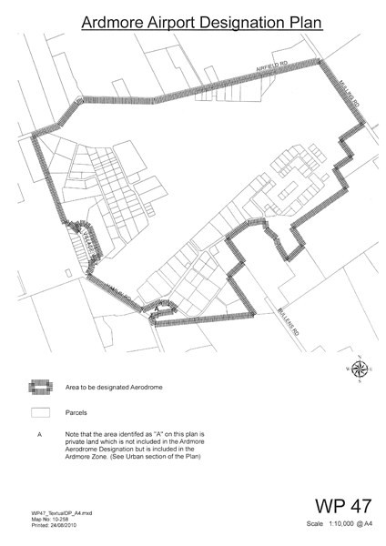

Attachment 3: Ardmore Airport Ltd Protection Areas drawing WP49

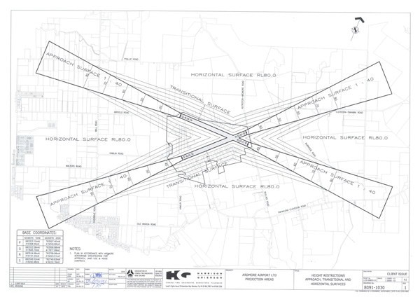

Attachment 4: Airport Height Surfaces

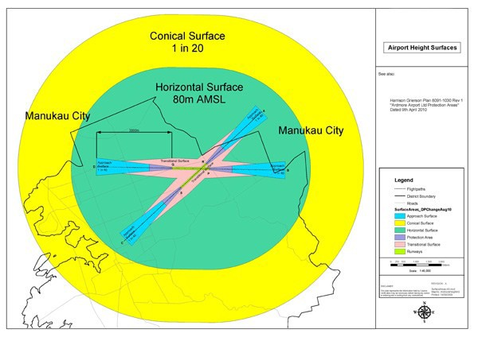

Attachment 5: Definitions

Activities Sensitive to Aircraft Noise (ASAN)
means household units, residential activities, camping grounds, comprehensive residential development, studio warehousing, temporary household units, bed and breakfast accommodation, farmstays, rehabilitation facilities, pre­school/education facilities, schools, other educational facilities, child care centres and other care centres, hospitals, other health care facilities, rest homes and other homes for the aged, traveller’s accommodation.

Aerobatic Flight
- an intentional manoeuvre in which the aircraft is in sustained inverted flight or is rolled from upright to inverted or from inverted to upright position; or,
- manoeuvres such as rolls, loops, spins, upward vertical flight culminating in a stall turn, hammerhead or whip stall, or a combination of such manoeuvres

Aerodrome
means Ardmore Aerodrome as defined by land contained within the Aerodrome boundary.

Aerodrome Boundary
means the boundary of the land designated by the Airport Authority for aerodrome purposes.

Air Noise Boundary
is a line formed by the outer extremity of the 65dBA Ldn noise contour.

Air Noise Boundary Area
means the area identified as an Air Noise Boundary on the Noise Notification Areas ­ airports overlay by a line formed by the outer extremity of the Ldn 65dBA noise contour.

Aircraft
in terms of the Civil Aviation Act 1990, means any machine that can derive support in the atmosphere from the reactions of the air otherwise than by the reactions of the air against the surface of the earth.

Aircraft Engine Testing Noise
means aircraft testing for the purposes of engine maintenance and does not include normal operational aircraft engine run­ups. (i.e.: aircraft warming up prior to take­off) or any noise generated by the taxiing or towing of aircraft to or from the designated engine testing location.

Aircraft Movement
means one aircraft take­off, landing, touch­and­go, or missed approach. A "Touch­and­go" shall be deemed to be two aircraft movements.

Airport Authority
means Ardmore Airport Limited or any person appointed in place of Ardmore Airport Limited as the requiring authority for Ardmore Aerodrome pursuant to section 180 of the Resource Management Act 1991.

Airshow
means the event referred to in condition 9 of Designation 200.

Aviation activities
Means runways, taxiways and navigational equipment, passenger terminals, maintenance workshops, aircraft testing facilities and any residential, commercial or industrial activity ancillary to the operational function of the airport such as warehousing for freight collection and despatch and storage of aviation and other fuels and hazardous substances which are necessary for the operation of the Aerodrome.

Best practicable option

in relation to an emission of noise means the best method for preventing or minimising the adverse effects on the environment having regard, among other things, to:
- the nature of the emission and the sensitivity of the receiving environment to adverse effects;
- the financial implications and the effects on the environment of that option when compared with others; and
- the current state of technical knowledge and the likelihood that the option can be successfully applied.

CAA
CAA means the Civil Aviation Authority of New Zealand.

CAR
means Civil Aviation Rule.

Circuit training
means the use of the Fixed Wing Circuit or the Helicopter Circuit for training purposes.

Commercial activities
Means those activities such as real estate offices, banks, post office, shoe repairs, tourist agencies, hairdressers, dry cleaners, self service laundries and other similar uses whose functions are similar in character to shops in respect to their effect on the neighbourhood.

dBA
is a measurement of sound pressure level which has its frequency characteristics modified by a filter so as to more closely approximate the frequency bias of the human ear.

Ex­Military Jet aircraft (“EMJ”).
means any Fixed wing aircraft designed for military purposes propelled other than by a propeller.

Fixed Wing Circuit
means that pattern, located on the southern side of the Aerodrome flown by fixed wing aircraft for the purpose of sequencing themselves to or from runways 03/21 and/or 07/25 grass.

General Aviation
is defined by the Civil Aviation Authority (CAA) as all aviation activity at civil aerodromes other than regular passenger flights scheduled by international and domestic airlines.

Habitable Room
means a room used for activities normally associated with domestic living, but excludes any bathroom, laundry, water closet, pantry, walk­in wardrobe, corridor, hallway, lobby, clothes drying room, garage.

Helicopter Circuit
means that pattern located on the northern side of the Aerodrome flown by helicopters.

Inner Control Boundary
Is a line formed by the outer extremity of the 60 dBA Ldn noise contour.

Inner Control Boundary Area
means the area identified as Inner Control Boundary Area on the Noise Notification Areas ­ airport overlay by a line formed by the outer extremity of the Ldn 60dBA noise contour and the outer extremity of the Ldn 65dBA noise contour.

L10
means the noise level which is equalled or exceeded for 10% of the measurement period. L10 is an indicator of

the mean maximum noise level and is used in New Zealand as the descriptor for intrusive noise (in dBA).

Ldn (Day/Night Level)
means the day night noise level which is calculated from the 24 hour Leq with a 10 dBA penalty applied to the night­time (2200­0700 hours) Leq.

Lmax (Maximum sound pressure level)
means the maximum sound pressure level measured during the sampling period.

Leq (Time­average sound level)
means the time averaged noise level (on a logarithmic, energy basis).

MBZ
means that area denominated under Civil Aviation Rules as the Ardmore Mandatory Broadcast Zone or MBZ.

NZS 6805:1992
refers to the New Zealand Standard NZS 6805: 1992 “Airport Noise Management and Land Use Planning”.

Obstacle Limitation Surfaces (OLS)
means those defined areas about and above an aerodrome intended for the protection of aircraft in the vicinity of an aerodrome.

Outer Control Boundary
is a line formed by the outer extremity of the 55 dBA Ldn noise contour.

Outer Control Boundary Area
means the area identified as Outer Control Boundary Area on the Noise Notification Areas ­ overlay map by a line formed by the outer extremity of the Ldn 55dBA noise contour and the outer extremity of the Ldn 60dBA noise contour.

Scheduled Flight
means freight or passenger flights that are established on a permanent timetable basis.

SEL (Sound Exposure Level)
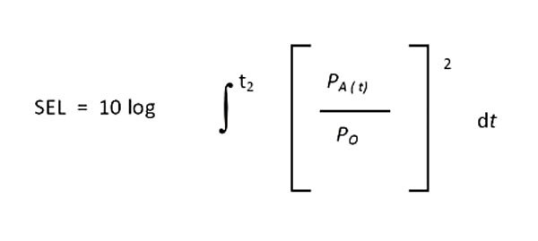means the A­weighted sound level which if maintained constant for a period of 1 second, would convey the sound energy as is actually received from a given noise event.

Note:
Where p is in pascals and t is in seconds, po is the reference sound pressure of 20 micropascals.

