PART 7 ­ DESIGNATIONS»Schedules and Designations»

Wiri Oil Services Ltd

Designation Schedule ­ Wiri Oil Services Ltd

Number | Purpose | Location
9700 | Jet fuel transmission purposes | 149 Roscommon Road (Wiri Oil Terminal) to the intersection of Orrs Road and Puhinui Road (Auckland International Airport), Wiri

9700 Wiri to Auckland International Airport Jet Fuel Pipeline

Designation Number | 9700
Requiring Authority | Wiri Oil Services Ltd
Location | 149 Roscommon Road (Wiri Oil Terminal) to the intersection of Orrs Road and Puhinui Road (Auckland International Airport), Wiri
Rollover Designation | Yes
Legacy Reference | Designation 309, Auckland Council District Plan (Manukau Section) 2002
Lapse Date | Given effect to (i.e. no lapse date)

Purpose

Jet fuel transmission purposes.

Conditions

General
- For the purpose of these conditions:
  - Renewal means the replacement of above ground components and the excavation and renewal of sections of the pipe up to 200 mm in diameter. Where practicable the requiring authority shall endeavour to limit excavation and renewal of pipelines to a maximum of 20 lineal metres of pipeline per 14 calendar day period;
  - Upgrade means adding aboveground components relating to existing isolation valves, cathodic protection terminals, surface markers and warning signage, that are of a similar scale and character; and
  - Road has the same meaning as in section 2 of the Resource Management Act 1991 (“the RMA”).

- The stated purpose of the designation shall be included in Part 7 of the Auckland Unitary Plan as follows: jet fuel transmission purposes.

- The works undertaken to give effect to the designation shall be generally in accordance with the plans and information submitted by Wiri Oil Services Limited (“the Requiring Authority”) including Proposal 36647, pipeline route maps, Sheets No 1 – No 11 included as attachment B to the Notice of Requirement.

- The designation corridor shall be a 12 m wide strip on land other than roads, and a 6 m wide strip on land comprising road, as shown on the pipeline route maps ­ Sheets No 1 ­ No 11 included as Attachment B to the Notice of Requirement.

- For the avoidance of doubt, where the designation applies to road corridors the designation shall not extend across any adjacent private property unless that private property is subject to an easement in relation to the WAP.

- The Requiring Authority shall respond within 15 working days of receiving any request for its written approval under Sections 176 or 177 of the RMA.

- Prior to the commencement of any physical works within the Designation, the Requiring Authority shall submit to Council an Outline Plan of Works pursuant to Section 176A of the RMA unless condition 27 applies.

- In the event of archaeological features being uncovered (e.g. shell midden, hangi, oven stones, pit depressions, defensive ditches, artefact material, or koiwi tangata [human skeletal remains]), non­emergency works shall cease within a 10 m radius of the discovery and the council, the New Zealand Historic Places Trust and the appropriate iwi authorities shall be contacted within 72 hours so that appropriate action can be taken. In the event of emergency works, all reasonable steps shall be taken to protect archaeological features and all parties shall be contacted as soon as practicable.

- The Requiring Authority shall meet all its own costs associated with reviewing any proposal by council to undertake roading works or activities.

- Access to overhead electricity transmission lines, poles or supporting structures is permitted at all times in accordance with the Electricity Act 1992.

Land Comprising Roads
11.
- On land comprising roads the maximum width of the designation shall be 6 m.
- On land comprising roads within the designation corridor, no person other than the Requiring Authority shall disturb the soil below a depth of 0.4 m from the surface without the prior written approval of the Requiring Authority or its authorised agent pursuant to sections 176 and/or 177 of the RMA.
- Within the designation corridor no person shall undertake road opening, trenching, excavation or drilling (including micro drilling and directional drilling), or lay underground high voltage power lines, either in parallel with or intersecting the Requiring Authority’s pipeline, without first obtaining the latter’s written approval.
- The Requiring Authority’s approval is not required under sections 176 or 177 of the RMA for the following works or activities:
- Road widening or associated works in accordance with an existing road designation;
- Repair, maintenance or upgrading of an existing road surface;
- Repair, maintenance or upgrading of any existing network utility infrastructure where a Road Opening Notice (“RON”) has been obtained from the Council, provided in all cases that:
Soil is not disturbed below a depth of 0.4 m from the surface; and
The finished surface level is not reduced below the pre­existing surface datum; and No structure is erected or tree or shrub planted within the designated corridor.
- Emergency works may be performed in line with the Vector advice booklet (dated 2004) by excavation to
0.4m depth below the surface and thereafter the use of hand tools only. Emergency operations should be notified immediately to Vector Gas Ltd or their agent who provide an on­call service outside of normal working hours.

Land other than Roads
12.
- For land other than roads the maximum width of the designation shall be 12 metres.
- Within the designation corridor no person other than the Requiring Authority shall:
- Erect any structure;
- Plant any tree or shrub;
- Disturb the soil below a depth of 0.4 m; or
- Do anything on or to land which may damage or endanger the pipeline without the prior written approval of the Requiring Authority or its authorised agent pursuant to sections 176 and/or 177 of the RMA.
- For the avoidance of doubt, such written approval is not required for ordinary cultivation, digging, or

excavating, tilling and working soil to a depth of less than 0.4 m.

- A minimum of 1.5 m cover shall remain above the top of the pipe after any ordinary cultivation, digging or excavation has taken place.

Pipeline Works
- All pipeline maintenance, repair, upgrade and renewal works or activities that involve excavation on land comprising road within the designation corridor shall be done pursuant to a RON, shall be subject to the RON requirements of council, and shall be carried out in accordance with the Code of Practice for Working in the Road, SNZ HB 2002:2003.

- All pipeline maintenance, repair, upgrade, and renewal works or activities that involve excavation on land other than road within the designation corridor shall be in general accordance with section 5 “Notice of Entry and Programme of Works” pages 29­30 of Federated Farmers’ Guide to Land Access for the Oil and Gas Industry and Landowners: 2002.

- The Requiring Authority shall at all times ensure that access between parts of any property held in single ownership temporarily severed by works or activities is maintained to a level that will, as far as is practicable, enable normal activities on the property to continue.

- On land comprising road within the designation corridor:
- Scheduled maintenance, repair, upgrade or renewal and associated activities shall take place between the hours of 7am and 7pm Monday to Saturday (excluding public holidays) except:
- where otherwise approved in a Traffic Management Plan (“TMP”) submitted under the RON process to the satisfaction of Council; or
- in the event of an emergency; or
- with the prior written approval of Council; and
- Non­emergency works or associated activities shall take place between 7am to 9am and 4pm to 6pm weekdays on all arterial roads except:
- with the prior written permission of Council; or
- in the event of an emergency.
- The above restrictions do not apply to site works and trenches which may remain open, subject to approved provisions of the TMP required by Condition 18.

- The Requiring Authority shall submit a detailed TMP to the satisfaction of the Council at least 30 working days prior to commencing major programmed maintenance, repair, upgrade or renewal works.

- Specific areas to be addressed in the TMP required by condition 18 must include:
- the temporary diversion of traffic during construction;
- traffic safety;
- control at intersections;
- hours of work for heavily trafficked roads;
- maintenance of road and property access;
- movement of construction traffic on local roads; and
- ensuring that access between parts of any property temporarily severed by works is maintained to a level that will enable, as far as is practicable, normal operations on the property to continue.

- All traffic and pedestrian control measures detailed in the TMP must conform to the New Zealand Transport Agency’s manual: Code of Practice for Temporary Traffic Management 2004 (“CoPTTM”).

- All works or activities related to the designation shall be undertaken in compliance with the New Zealand Electrical Code of Practice for Electrical Safe Distances 2001 (NZECP 34:2001).

- The noise from works shall be measured, assessed and controlled in accordance with the procedures and limits set out in NZC6803:1999 Acoustics – Construction Noise.

- Where excavation activities are undertaken pursuant to the designation, appropriate sediment and erosion control measures shall be employed, in accordance with Technical Publication 90 ­ TP90 Erosion and Sediment Control Guideline for Land Disturbing Activities in the Auckland Region.

Consultation
- The Requiring Authority shall consult with the New Zealand Transport Agency at least 30 working days prior to carrying out any works or activities on, in or under State Highway 20B, except in emergency situations.

- The Requiring Authority shall consult with Council at least 30 working days prior to carrying out any works or activities on, in or under Council controlled roads, except in emergency situations or as otherwise agreed with the Council.

- The Requiring Authority shall consult with and obtain Section 177 RMA approval from the NZ Refining Company Ltd (“NZRC”) at least 30 working days prior to carrying out any proposed works or activities within designation 6501 RAP Petroleum Pipeline (Urban Section) ­ except in emergency situations where excavation below 0.4 m shall be performed by hand. The Requiring Authority shall notify NZRC or its authorised agent of any emergency works undertaken as soon as practicable.

- Prior to undertaking any works within 10 metres of the centreline of the Puhinui Stream the Requiring Authority shall either submit an Outline Plan of Works or seek the agreement of Council – Stormwater Policy and comply with all their relevant conditions at no cost to Council.

- The Requiring Authority shall consult with and provide written notice to all directly affected landowners regarding any proposed excavation works or activities on, in or under land within the designation corridor at least 21 working days prior to carrying out any such works or activities, except in emergency situations or as otherwise agreed with the landowners.

- The Requiring Authority shall advise Council and any potentially affected landowner as soon as practicable following any WAP leak or spillage of fuel that may affect land either within or outside of the designation corridor.

Attachments

Pipeline Route Maps ­ Sheets No. 1­11

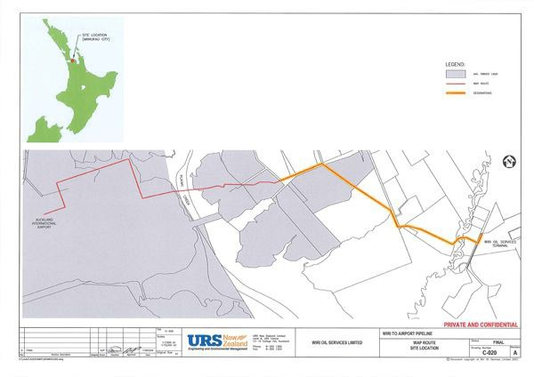

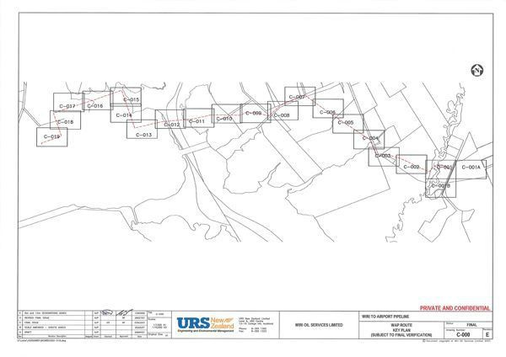

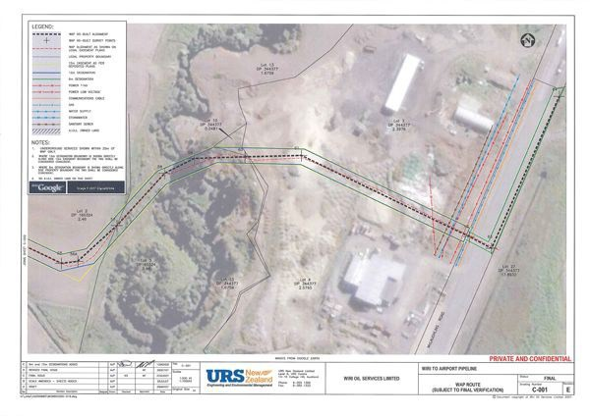

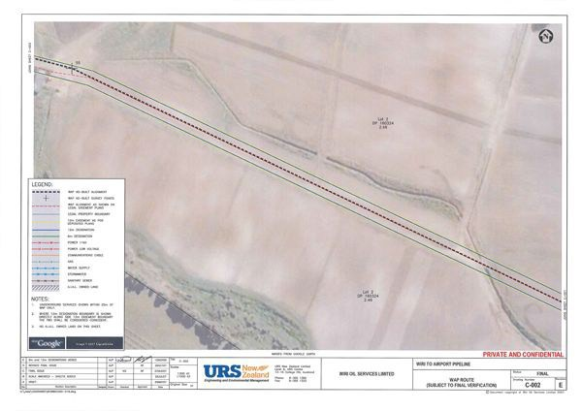

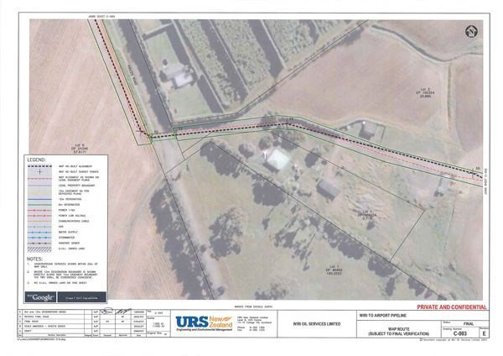

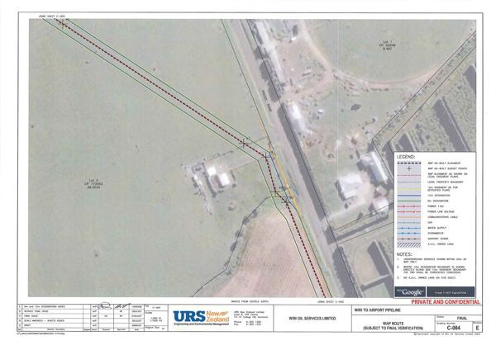

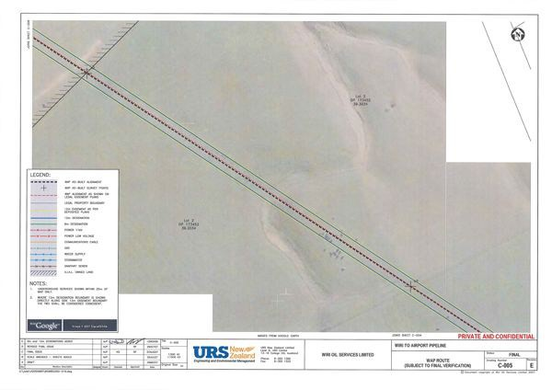

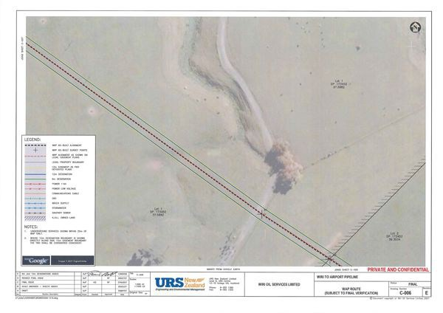

-·---
.:·n.tr" 4

l
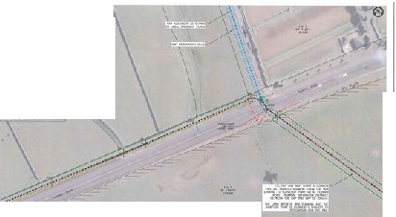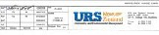I•

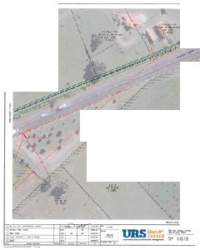'::::---

-.
---
':.!:"

--.-.·--.-

•
0
•

--

