PART 7 ­ DESIGNATIONS»Schedules and Designations»

Prime Minister

Designation Schedule ­ Prime Minister

Number | Purpose | Location
7100 | Government House ... | 119 Mountain Road, Epsom

7100 Government House

Designation Number | 7100
Requiring Authority | Prime Minister
Location | 119 Mountain Road, Epsom
Rollover Designation | Yes
Legacy Reference | Designation D08­24, Auckland Council District Plan (Isthmus Section) 1999
Lapse Date | Given effect to (i.e. no lapse date)

Purpose

Government House is used for vice regal purposes, as the Auckland residence of the Governor General.

The following is a list of activities that fall within in the designation of Government House:
- Uses associated with the general functioning of the official residence of the Governor General and their household including staff;
- Official receptions, charity functions and garden parties;
- Accommodation and provision of facilities for official guests;
- Office accommodation of a sufficient nature and scale to ensure the operation of the office of Governor General;
- Garaging and parking of vehicles associated with the operational use of Government House; and
- The conservation of the amenities of the site and the maintenance of the concept of the garden.

Conditions

  - Any new buildings, activities or works that are not described in the original notice of requirement will need either:
    - A new notice of requirement; notified to the public under section 168 of the RMA; or
    - A notice to alter the designation, under section 181 of the RMA.

  - The rules within the Unitary Plan regarding scheduled trees will apply to this designation.

  - The rules within the Unitary Plan regarding significant ecological areas will apply to this designation.

Attachments

Site Plan

Page 1 of 2

I' lfi"=··
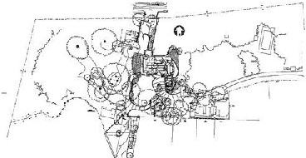WI

'I..

-
·
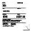I

