PART 7 ­ DESIGNATIONS»Schedules and Designations»

Minister for Tertiary Education, Skills and Employment

Designation Schedule ­ Minister for Tertiary Education, Skills and Employment

Number | Purpose | Location
6100 | Construction, undertaking, establishment, management, operation and maintenance of a tertiary educational facility ... | St Pauls Street, Wellesley Street, Governor Fitzroy Place and Mount Street, Auckland Central
6101 | Construction, undertaking, establishment, management, operation and maintenance of a tertiary educational facility ... | 42 and 72 Akoranga Drive, Northcote

6100 AUT City Campus

Designation Number | 6100
Requiring Authority | Minister for Tertiary Education, Skills and Employment
Location | St Pauls Street, Wellesley Street, Governor Fitzroy Place and Mount Street, Auckland Central
Rollover Designation | Yes
Legacy Reference | Designation 291, Auckland Council District Plan (Central Area Section) 2005
Lapse Date | Given effect to (i.e. no lapse date)

Purpose

The public work authorised by the designation is the construction, undertaking, establishment, management, operation and maintenance of a tertiary educational facility and every use of the land for educational and ancillary purposes.

Note:
Ancillary activities includes activities, structures and buildings supporting tertiary education such as (but not limited to) administration, research and development needs, accommodation, meeting and assembly area, commercial, retail and services.

Conditions

No conditions.

Attachments

Auckland University of Technology City Campus Designation Plan

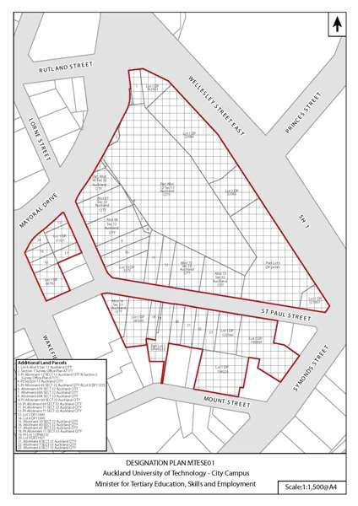

6101 AUT North Shore Campus

Designation Number | 6101
Requiring Authority | Minister for Tertiary Education, Skills and Employment
Location | 42 and 72 Akoranga Drive, Northcote
Rollover Designation | Yes
Legacy Reference | Designation 181, Auckland Council District Plan (North Shore Section) 2002
Lapse Date | Given effect to (i.e. no lapse date)

Purpose

The public work authorised by the designation is the construction, undertaking, establishment, management, operation and maintenance of a tertiary educational facility and every use of the land for educational and ancillary purposes.

Note:
Ancillary activities includes activities, structures and buildings supporting tertiary education such as (but not limited to) administration, research and development needs, accommodation, meeting and assembly area, commercial, retail and services.

Conditions

- That the proposed intersections and access arrangements on Akoranga Drive be designed and located in accordance with the following principles as far as practicable:
  - Be designed and located to optimise safety and efficiency; and
  - Provide for public transport, cyclists, pedestrians and visually and mobility impaired people, in terms of the reasonably foreseeable needs of AUT; and
  - Consider the views of the following directly affected parties: Northbridge Retirement Home and Awataha Marae.

- That all new buildings on the site shall not exceed a height of 16m within 20m of the current boundary of Akoranga Drive and 30m elsewhere on the site.

- Where practicable, at least one pedestrian entrance to the new buildings shall be located facing the street.

- The Requiring Authority shall prepare a Campus Development Plan (CDP) for the site. The purpose of the CDP is to provide for the general design framework and direction for the ongoing development of the site and activities. The CDP will address matters of urban design, major building areas, parking, access and overall site landscaping. As part of the preparation of the CDP, the Requiring Authority will liaise with council’s Urban Design Team. The CDP will be used as a framework for future Outline Plan of Works to be submitted to council under section 176A of the RMA. The CDP will be revised by the Requiring Authority to reflect ongoing developments for the site as they occur.

Attachments

Auckland University of Technology North Shore Campus Designation Plan





