PART 7 ­ DESIGNATIONS»Schedules and Designations»

Minister for Social Development

Designation Schedule ­ Minister for Social Development

Number | Purpose | Location
5900 | Care and protection residential centre ­ Upper North... | 398 Weymouth Road, Weymouth
5901 | Child welfare institution | 26­28 Normandy Place, Henderson
5902 | The Youth Justice Centre ­ Upper North ... | 21­24 Kiwi Tamaki Road, Wiri
5903 | Child welfare institution | 116­118 Wharf Road, Te Atatu Peninsula

5900 Care and Protection Residential Centre

Designation Number | 5900
Requiring Authority | Minister for Social Development
Location | 398 Weymouth Road, Weymouth
Rollover Designation | Yes
Legacy Reference | Designation 283, Auckland Council District Plan (Manukau Section) 2002
Lapse Date | Given effect to (i.e. no lapse date)

Purpose

Care and protection residential centre ­ Upper North being a residence in terms of section 364 of the Children, Young Persons, and Their Families Act 1989 for:
- The placement of up to 20 children and young persons for the purpose of providing care (including secure care), protection, control and treatment;
- Ancillary educational, recreational, rehabilitative, administrative, visitor accommodation and cultural facilities; and
- Activities consistent with and ancillary to the establishment, operation and maintenance of the Care and Protection Residential Centre — Upper North, including buildings, fixed plant and service infrastructure, fencing, landscaping, earthworks, outdoor recreation areas, access and car parking.

Conditions

  - That the Care and Protection Residential Centre ­ Upper North shall provide residential care for up to 20 children and young persons at any one time.

  - A Community Liaison Committee shall be established to assist in the promotion of a positive relationship between the Care and Protection Residential Centre ­ Upper North and the local community. The Community Liaison Committee shall be kept informed of current and proposed programmes at the Care and Protection Residential Centre ­ Upper North and include two representatives of the local community.

  - A Security Management Plan for the Care and Protection Residential Centre ­ Upper North shall be formulated and implemented in consultation with relevant emergency services and the Community Liaison Committee.

  - Activities (other than construction) on the site shall be so conducted as to ensure that noise from the site shall not exceed the following noise limits at any point within the boundary of any neighbouring residential site:

Monday to Sunday (inclusive)
7am to 10pm | L10 55 dBA
10pm to 7am | L10 45 dBA
10pm to 7am | Lmax 75 dBA

Noise (other than construction noise) shall be measured and assessed in accordance with the requirements of the New Zealand Standards NZS6801:2008 “Acoustics ­ Measurement of Environmental Sound”.

  - The site shall be landscaped generally in accordance with the landscape concept plan prepared by Opus International Consultants marked ACC116.00 (September 2002) contained within Appendix B of the Notice of Requirement. All planting associated with this landscape concept shall be maintained regularly and kept in a tidy condition.

  - The lighting on site shall be sufficient for operational and security purposes and shall be designed to prevent the intrusion of direct light into neighbouring properties.

Attachments

Proposed Care and Protection Centre ­ Upper North Landscape Concept

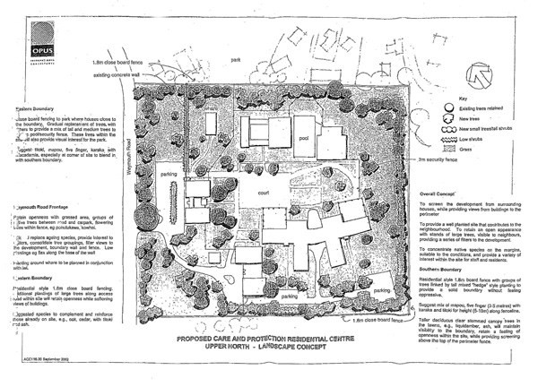

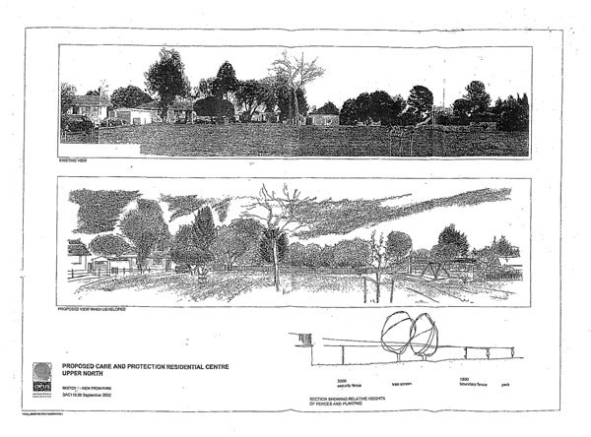

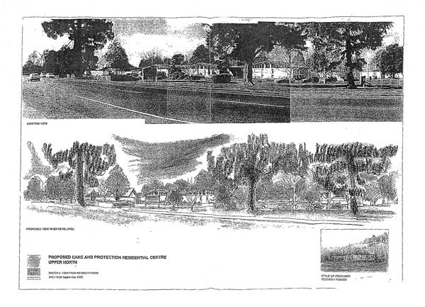

5901 Child Welfare Institution (Henderson)

Designation Number | 5901
Requiring Authority | Minister for Social Development
Location | 26­28 Normandy Place, Henderson
Rollover Designation | Yes
Legacy Reference | Designation MSW1, Auckland Council District Plan (Waitakere Section) 2003
Lapse Date | Given effect to (i.e. no lapse date)

Purpose

Child welfare institution.

Conditions

1. New buildings and structures shall not exceed a height of 10m as measured from the average ground level at the base of the building, provided that any masts poles and radio and television aerials which are attached to the building and do not project more than 6m above the part of the building to which they are attached shall not be included in the calculation of height.

Attachments

No attachments.

5902 Youth and Justice Centre – Upper North

Designation Number | 5902
Requiring Authority | Minister for Social Development
Location | 21­24 Kiwi Tamaki Road
Rollover Designation | Yes
Legacy Reference | Designation 278, Auckland Council District Plan (Manukau Section) 2002
Lapse Date | Given effect to (i.e. no lapse date)

Purpose

The Youth Justice Centre — Upper North being a residence under section 364 of the Children Young Persons and Their Families Act (1989) for the care and control of children and young persons under the youth justice provisions of that Act and the Criminal Justice Act (1985) (if agreed by the chief executive for the time being responsible for the administration of the Children Young Persons and Their Families Act) at 21­24 Kiwi Tamaki Road, Manurewa.

Conditions

- That the proposed facility shall provide residential care and control for up to a maximum of 46 children and young persons at any one time. This is to be inclusive of not more than 6 children and young persons held under the provisions of the Criminal Justice Act (1985) at any one time.

- That the Department of Child, Youth and Family Services, through the Manager of the facility, shall formulate and implement a Security Management Plan for the proposed facility in consultation with key stakeholders including the council, the NZ Police and relevant emergency services, neighbouring property owners, local iwi

and community groups.

- That the Manager of the proposed facility shall convene a Community Liaison Committee in accordance with the Children, Young Persons, and Their Families (Residential Care) Regulations 1996.

- That the parts of the proposed facility comprising the sleeping , living and learning areas shall be designed and constructed to comply with the following internal noise limits:

 | Ldn | Lmax
Internal Noise Limits | 45dBA | 55dBA

Attachments

No attachments.

5903 Child Welfare Institution (Te Atatu)

Designation Number | 5903
Requiring Authority | Minister for Social Development
Location | 116­118 Wharf Road, Te Atatu Peninsula
Rollover Designation | Yes
Legacy Reference | Designation MSW2, Auckland Council District Plan (Waitakere Section) 2003
Lapse Date | Given effect to (i.e. no lapse date)

Purpose

Child welfare institution.

Conditions

1. New buildings and structures shall not exceed a height of 10m as measured from the average ground level at the base of the building, provided that any masts poles and radio and television aerials which are attached to the building and do not project more than 6m above the part of the building to which they are attached shall not be included in the calculation of height.

Attachments

No attachments.

