PART 7 ­ DESIGNATIONS»Schedules and Designations»

Minister of Defence

Designation Schedule ­ Minister of Defence

Number | Description | Location
4300 | Defence purposes (as defined by section 5 of the Defence Act 1990) ­ military training area | Approximately 720ha of land bound by Ardmore Quarry Road to the northeast and Hunua Road to the south, Ardmore
4301 | Defence purposes (as defined by section 5 of the Defence Act 1990) ­ military camp | 129­143 Porchester Road, 100 Grove Road and 119 Walters Road, Papakura
4302 | Defence purposes (as defined by section 5 of the Defence Act 1990) ­ army centre (administration and operational) | 204­234 Great North Road, Arch Hill
4303 | Defence purposes (as defined by section 5 of the Defence Act 1990) ­ military camp | Whangaparaoa Road, Army Bay, Whangaparoa Peninsula
4305 | Defence purposes (as defined by section 5 of the Defence Act 1990) ­ ammunition depot | 51 Onetaunga Road and Pt Allotment 157 PSH of Takapuna, Chatswood
4306 | Defence purposes (as defined by section 5 of the Defence Act 1990) ­ naval base | 142 Vauxhall Road, Narrow Neck
4307 | Defence purposes (as defined by section 5 of the Defence Act 1990) ­ naval base | 64 King Edward Parade, Torpedo Bay, Devonport
4308 | Defence purposes (as defined by section 5 of the Defence Act 1990) ­ naval base | South of Calliope Road, and west of Spring Street, Devonport.
4309 | Defence purposes (as defined by section 5 of the Defence Act 1990) ­ naval base | West of Jim Titchener Parade and Cautley Street, Devonport
4310 | Defence purposes (as defined by section 5 of the Defence Act 1990) ­ air base | Brigham Creek Road, Kowhai Road, Kauri Road and Bristol Road, Whenuapai
4311 | Defence purposes (as defined by section 5 of the Defence Act 1990) ­ protection of approach and departure paths | Vicinity of Whenuapai Airfield
4312 | Defence purposes (as defined by section 5 of the Defence Act 1990) ­ air weapons range danger template | Tasman Road, Woodhill (Kaipara South head)
4313 | Defence purposes (as defined by section 5 of the Defence Act 1990) ­ administration and operations | 29­59 Clark Road and 415­419 Hobsonville Road, Hobsonville

4300 Ardmore Training Area

Designation Number | 4300
Requiring Authority | Minister of Defence
Location | Approximately 720ha of land bound by Ardmore Quarry Road to the northeast and Hunua Road to the south, Ardmore (refer to Figure 1 below)
Rollover Designation | Yes

Legacy Reference | Designation 2, Auckland Council District Plan (Papakura Rural Section) 1999
Lapse Date | Given effect to (i.e. no lapse date)

Description

Defence purposes (as defined by section 5 of the Defence Act 1990) ­ military training area.

The Defence Areas are administered by the New Zealand Defence Force (NZDF) and are currently occupied by NZDF, its contractors and licensees. The Areas are a Defence Work and may be utitlised for any or every purpose required by section 5 of the Defence Act 1990, which are as follows:
- The defence of New Zealand, and of any area for the defence of which New Zealand is responsible under any Act;
- The protection of the interests of New Zealand, whether in New Zealand or elsewhere;
- The contribution of forces under collective security treaties, agreements or arrangements;
- The contribution of forces to, or for any of the purposes of, the United Nations, or in association with other organisations or States and in accordance with the principles of the Charter of the United Nations;
- The provision of assistance to the civil power either in New Zealand or elsewhere in time of emergency; and
- The provision of any public service.

The Governor­General of New Zealand, continues to raise and maintain Armed Forces on behalf of Her Majesty the Queen. Given the obligations placed on the New Zealand Defence Force by the Crown to meet the Crown’s military defence needs, including those imposed by any enactment or by the policies of the government, the function of the Defence Areas include, at all times, to provide for the following functions of the New Zealand Defence Force (including visiting forces and third parties contracted to the New Zealand Defence Force):
- Defence Force command, land operations, sea operations, air operations, training, logistic support, ship berthing and docking, construction, repair, maintenance, munitions handling and storage, administration, and communication, and for the acquisition and improvement of the skills necessary for such functions;
- Resources, accommodation and facilities for these functions;
- Accommodation for members of the New Zealand Defence Force and any visiting force, training, recreational, welfare and medical facilities for them;
- Facilities for the storage of matériel, food and fuel, and the conservation and display of historic material;
- Facilities for the construction, repair and maintenance of vessels, aircraft, vehicles and other equipment, including the vessels, aircraft, vehicles and equipment of forces of other nations;
- To provide for the rapid and efficient deployment of the New Zealand Defence Force; and
- Any other activity required in the delivery of New Zealand Defence Force outputs as described annually in the Departmental Forecast Report: New Zealand Defence Force.

Conditions

- Works and projects that comply with the permitted activity rules of the underlying zoning are incorporated into this designation and, in accordance with section 176A(2)(b) of the Resource Management Act 1991, no outline plan is required for those activities.

- For the avoidance of doubt, maintenance activities do not require an outline plan.

Attachments

Figure 1 ­ Designation NZDF Ardmore Site Plan

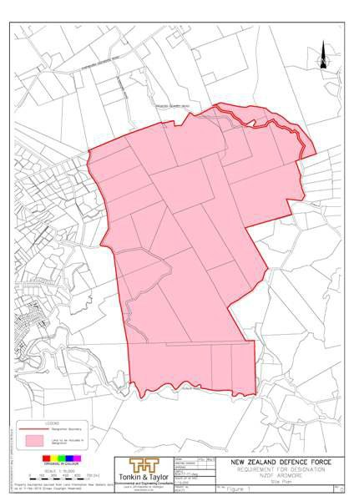

4301 Papakura Military Camp

Designation Number | 4301
Requiring Authority | Minister of Defence
Location | 129­143 Porchester Road, and 100 Grove Road and 119 Walters Road, Papakura (refer to Figure 2 below)
Rollover Designation | Yes
Legacy Reference | Designation 205, Auckland Council District Plan (Papakura Urban Section) 1999
Lapse Date | Given effect to (i.e. no lapse date)

Description

Defence purposes (as defined by section 5 of the Defence Act 1990) ­ military camp.

The Defence Areas are administered by the New Zealand Defence Force (NZDF) and are currently occupied by NZDF, its contractors and licensees. The Areas are a Defence Work and may be utitlised for any or every

purpose required by section 5 of the Defence Act 1990, which are as follows:
  - The defence of New Zealand, and of any area for the defence of which New Zealand is responsible under any Act;
  - The protection of the interests of New Zealand, whether in New Zealand or elsewhere;
  - The contribution of forces under collective security treaties, agreements or arrangements;
  - The contribution of forces to, or for any of the purposes of, the United Nations, or in association with other organisations or States and in accordance with the principles of the Charter of the United Nations;
  - The provision of assistance to the civil power either in New Zealand or elsewhere in time of emergency; and
  - The provision of any public service.

The Governor­General of New Zealand, continues to raise and maintain Armed Forces on behalf of Her Majesty the Queen. Given the obligations placed on the New Zealand Defence Force by the Crown to meet the Crown’s military defence needs, including those imposed by any enactment or by the policies of the government, the function of the Defence Areas include, at all times, to provide for the following functions of the New Zealand Defence Force (including visiting forces and third parties contracted to the New Zealand Defence Force):
- Defence Force command, land operations, sea operations, air operations, training, logistic support, ship berthing and docking, construction, repair, maintenance, munitions handling and storage, administration, and communication, and for the acquisition and improvement of the skills necessary for such functions;
- Resources, accommodation and facilities for these functions;
- Accommodation for members of the New Zealand Defence Force and any visiting force, training, recreational, welfare and medical facilities for them;
- Facilities for the storage of matériel, food and fuel, and the conservation and display of historic material;
- Facilities for the construction, repair and maintenance of vessels, aircraft, vehicles and other equipment, including the vessels, aircraft, vehicles and equipment of forces of other nations;
- To provide for the rapid and efficient deployment of the New Zealand Defence Force; and
- Any other activity required in the delivery of New Zealand Defence Force outputs as described annually in the Departmental Forecast Report: New Zealand Defence Force.

Conditions

- Works and projects that comply with the permitted activity rules of the underlying zoning are incorporated into this designation and, in accordance with section 176A(2)(b) of the Resource Management Act 1991, no outline plan is required for those activities.

- For the avoidance of doubt, maintenance activities do not require an outline plan.

Attachments

Figure 2 ­ Designation NZDF Papakura Site Plan

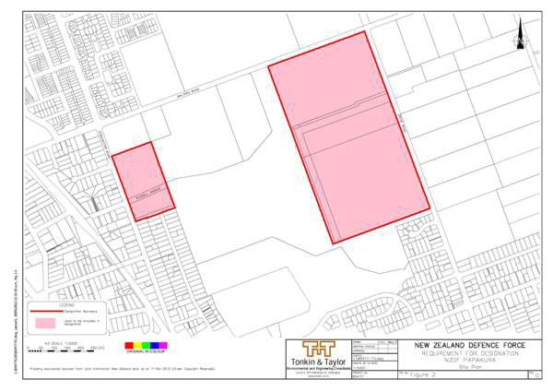

4302 Arch Hill Centre

Designation Number | 4302
Requiring Authority | Minister of Defence
Location | 204­234 Great North Road, Arch Hill (refer to Figure 3 below)
Rollover Designation | Yes
Legacy Reference | Designation C07­16, Auckland Council District Plan (Isthmus Section) 1999
Lapse Date | Given effect to (i.e. no lapse date)

Description

Defence purposes (as defined by section 5 of the Defence Act 1990) ­ army centre (administration and operational).

The Defence Areas are administered by the New Zealand Defence Force (NZDF) and are currently occupied by NZDF, its contractors and licensees. The Areas are a Defence Work and may be utitlised for any or every purpose required by section 5 of the Defence Act 1990, which are as follows:
  - The defence of New Zealand, and of any area for the defence of which New Zealand is responsible under any Act;
  - The protection of the interests of New Zealand, whether in New Zealand or elsewhere;
  - The contribution of forces under collective security treaties, agreements or arrangements;
  - The contribution of forces to, or for any of the purposes of, the United Nations, or in association with other organisations or States and in accordance with the principles of the Charter of the United Nations;
  - The provision of assistance to the civil power either in New Zealand or elsewhere in time of emergency; and
  - The provision of any public service.

The Governor­General of New Zealand, continues to raise and maintain Armed Forces on behalf of Her Majesty the Queen. Given the obligations placed on the New Zealand Defence Force by the Crown to meet the Crown’s military defence needs, including those imposed by any enactment or by the policies of the government, the function of the Defence Areas include, at all times, to provide for the following functions of the New Zealand Defence Force (including visiting forces and third parties contracted to the New Zealand Defence Force):
- Defence Force command, land operations, sea operations, air operations, training, logistic support, ship berthing and docking, construction, repair, maintenance, munitions handling and storage, administration, and communication, and for the acquisition and improvement of the skills necessary for such functions;
- Resources, accommodation and facilities for these functions;
- Accommodation for members of the New Zealand Defence Force and any visiting force, training, recreational, welfare and medical facilities for them;
- Facilities for the storage of matériel, food and fuel, and the conservation and display of historic material;
- Facilities for the construction, repair and maintenance of vessels, aircraft, vehicles and other equipment, including the vessels, aircraft, vehicles and equipment of forces of other nations;
- To provide for the rapid and efficient deployment of the New Zealand Defence Force; and
- Any other activity required in the delivery of New Zealand Defence Force outputs as described annually in the Departmental Forecast Report: New Zealand Defence Force.

Conditions

- Works and projects that comply with the permitted activity rules of the underlying zoning are incorporated into this designation and, in accordance with section 176A(2)(b) of the Resource Management Act 1991, no outline plan is required for those activities.

- For the avoidance of doubt, maintenance activities do not require an outline plan.

Attachments

Figure 3 ­ Designation NZDF Arch Hill Site Plan

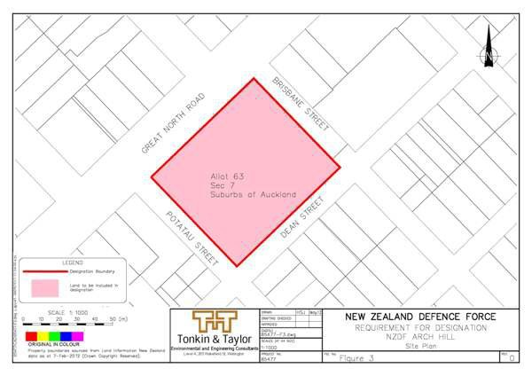

4303 Whangaparaoa Training Camp

Designation Number | 4303
Requiring Authority | Minister of Defence
Location | Whangaparaoa Road, Army Bay, Whangaparoa (refer to Figure 4 below)
Rollover Designation | Yes
Legacy Reference | Designation 922, Auckland Council District Plan (Rodney Section) 2011
Lapse Date | Given effect to (i.e. no lapse date)

Description

Defence purposes (as defined by section 5 of the Defence Act 1990) ­ military camp.

The Defence Areas are administered by the New Zealand Defence Force (NZDF) and are currently occupied by NZDF, its contractors and licensees. The Areas are a Defence Work and may be utitlised for any or every purpose required by section 5 of the Defence Act 1990, which are as follows:
  - The defence of New Zealand, and of any area for the defence of which New Zealand is responsible under any Act;
  - The protection of the interests of New Zealand, whether in New Zealand or elsewhere;
  - The contribution of forces under collective security treaties, agreements or arrangements;
  - The contribution of forces to, or for any of the purposes of, the United Nations, or in association with other organisations or States and in accordance with the principles of the Charter of the United Nations;
  - The provision of assistance to the civil power either in New Zealand or elsewhere in time of emergency; and
  - The provision of any public service.

The Governor­General of New Zealand, continues to raise and maintain Armed Forces on behalf of Her Majesty

the Queen. Given the obligations placed on the New Zealand Defence Force by the Crown to meet the Crown’s military defence needs, including those imposed by any enactment or by the policies of the government, the function of the Defence Areas include, at all times, to provide for the following functions of the New Zealand Defence Force (including visiting forces and third parties contracted to the New Zealand Defence Force):
- Defence Force command, land operations, sea operations, air operations, training, logistic support, ship berthing and docking, construction, repair, maintenance, munitions handling and storage, administration, and communication, and for the acquisition and improvement of the skills necessary for such functions;
- Resources, accommodation and facilities for these functions;
- Accommodation for members of the New Zealand Defence Force and any visiting force, training, recreational, welfare and medical facilities for them;
- Facilities for the storage of matériel, food and fuel, and the conservation and display of historic material;
- Facilities for the construction, repair and maintenance of vessels, aircraft, vehicles and other equipment, including the vessels, aircraft, vehicles and equipment of forces of other nations;
- To provide for the rapid and efficient deployment of the New Zealand Defence Force; and
- Any other activity required in the delivery of New Zealand Defence Force outputs as described annually in the Departmental Forecast Report: New Zealand Defence Force.

Conditions

- Works and projects that comply with the permitted activity rules of the underlying zoning are incorporated into this designation and, in accordance with section 176A(2)(b) of the Resource Mangement Act 1991, no outline plan is required for those activities.

- For the avoidance of doubt, maintenance activities do not require an outline plan.

Attachments

Figure 4 ­ Designation NZDF Whangaparoa Site Plan

4305 Kauri Point Storage Facility

Designation Number | 4305
Requiring Authority | Minister of Defence
Location | 51 Onetaunga Road and Pt Allot 157 PSH of Takapuna, Chatswood (refer to Figure 5 below)
Rollover Designation | Yes
Legacy Reference | Designation 90, Auckland Council District Plan (North Shore Section) 2002
Lapse Date | Given effect to (i.e. no lapse date)

Description

Defence purposes (as defined by section 5 of the Defence Act 1990) ­ ammunition depot.

The Defence Areas are administered by the New Zealand Defence Force (NZDF) and are currently occupied by NZDF, its contractors and licensees. The Areas are a Defence Work and may be utitlised for any or every purpose required by section 5 of the Defence Act 1990, which are as follows:
  - The defence of New Zealand, and of any area for the defence of which New Zealand is responsible under any Act;
  - The protection of the interests of New Zealand, whether in New Zealand or elsewhere;
  - The contribution of forces under collective security treaties, agreements or arrangements;

  - The contribution of forces to, or for any of the purposes of, the United Nations, or in association with other organisations or States and in accordance with the principles of the Charter of the United Nations;
  - The provision of assistance to the civil power either in New Zealand or elsewhere in time of emergency; and
  - The provision of any public service.

The Governor­General of New Zealand, continues to raise and maintain Armed Forces on behalf of Her Majesty the Queen. Given the obligations placed on the New Zealand Defence Force by the Crown to meet the Crown’s military defence needs, including those imposed by any enactment or by the policies of the government, the function of the Defence Areas include, at all times, to provide for the following functions of the New Zealand Defence Force (including visiting forces and third parties contracted to the New Zealand Defence Force):
- Defence Force command, land operations, sea operations, air operations, training, logistic support, ship berthing and docking, construction, repair, maintenance, munitions handling and storage, administration, and communication, and for the acquisition and improvement of the skills necessary for such functions;
- Resources, accommodation and facilities for these functions;
- Accommodation for members of the New Zealand Defence Force and any visiting force, training, recreational, welfare and medical facilities for them;
- Facilities for the storage of matériel, food and fuel, and the conservation and display of historic material;
- Facilities for the construction, repair and maintenance of vessels, aircraft, vehicles and other equipment, including the vessels, aircraft, vehicles and equipment of forces of other nations;
- To provide for the rapid and efficient deployment of the New Zealand Defence Force; and
- Any other activity required in the delivery of New Zealand Defence Force outputs as described annually in the Departmental Forecast Report: New Zealand Defence Force.

Conditions

Yards
- The following yards shall apply in respect of designation boundaries except the boundary with the Coastal Marine Area (where no yard shall apply):
All boundaries: 3m

Building height
- 9m

Height in Relation to Boundary
- Buildings must not project beyond a 45 degree recession plane measured from a point 2.5 m vertically above ground level where the designation boundary adjoins a residential zoned site.

Building length
- Where sites adjoining the designation boundary are zoned residential, those parts of any building which exceed a height of 5 metres and are within 10 metres of the designation boundary are to be wholly confined within the arms of a 130 degree angle formed by two lines intersecting any point on an adjacent residential boundary such that each line forms an angle of 25 degrees with that boundary.

Exceptions and notes for conditions 1­4:
Building height, bulk and location controls apply only in respect of new buildings and additions to existing buildings.
The following structures are excluded from all building height, bulk and location controls:
  - Perimeter security fencing up to a height of 4m;
  - Flagpoles; and
  - Lighting standards up to a maximum height of 12.5m, and lighting standards exceeding a height of 12.5m subject to an outline plan.

Noise limits

- The LAeq(15 min) noise level and maximum noise level (LAFmax) arising from any activity within the designated area, other than noise from construction, demolition or maintenance, measured at or within the boundary of a property in the residential zones outside the designated area, must not exceed the following limits:

Monday to Saturday 7am­10pm | LAeq(15 min) 55dB
Sunday 9am­6pm | LAeq(15 min) 55dB
All other times | LAeq(15 min) 45dB  Leq(15 min) 60dB at 63 Hz Leq(15 min) 55dB at 125 Hz LAFmax 75dB

Construction, demolition and maintenance noise limits
- Noise from construction and demolition activities must meet the requirements of Tables 2 and 3 of New Zealand Standard on Acoustics – Construction Noise (NZS 6803: 1999). The measurement and assessment of construction noise must be in accordance with New Zealand Standard on Acoustics – Construction Noise (NZS 6803: 1999) and the requirements of annex A of New Zealand Standard on Acoustics – Construction Noise (NZS 6803: 1999) must be used if it is necessary to assess the measured Leq levels in high background noise areas.

Exceptions to noise limits:
  - Military helicopter operations except that:
- There shall not be more than 50 landings and 50 take­offs per calendar year;
- Over­flying of dwellings by landing helicopters is to be avoided;
- Military helicopter landings and take­offs will be limited to between the hours of 0700 – 2200; and
- Landing shall take place at the maximum practical distance from nearby residences (this will be dependent upon ground conditions).
  - Emergency helicopter operations;
  - Parade ground activities, gun salutes and other activities for ceremonial occasions, including preparation for such occasions;
  - Noise from safety signals, warning devices or emergency pressure relief valves, provided they do not sound for more than a reasonable period; and
  - Noise associated with outdoor recreational activities and sporting events.

Lighting
- Lighting in all areas shall conform to the following:
  - At no time between the hours of 10pm and 7am shall any outdoor lighting be used in a manner that the use
of such lighting causes an added illuminance in excess of 20 lux measured horizontally or vertically at any point along any boundary of any adjoining site which is zoned Residential (and outside the designated area); and
  - All outdoor lighting shall be shielded in such a manner that light emitted by the fixture is projected below a horizontal plane running through the lowest point in the fixture where that light is emitted, or is shielded in such a manner that the lowest edge of the shield is at or below the centre line of the light source.

Aerials and Antennae
- Telecommunication and radio communication aerials and antennae that comply with the limits prescribed in NZS 2772.1 (1999) New Zealand Standard for radiofrequency fields – maximum exposure levels between 3 kHz and 300 GHz shall be permitted in all parts of the designated area. Where aerials and antennae are attached to buildings, their height plus that of any support structure shall not exceed the height limit of the area by more than five metres.

Administration
- Works and projects that comply with the permitted activity rules of the underlying zoning are incorporated into this designation and, in accordance with s176A(2)(b) RMA, no outline plan is required for those activities.

- For the avoidance of doubt, maintenance activities do not require an outline plan.

Attachments

Figure 5 ­ Designation NZDF Kauri Point Site Plan

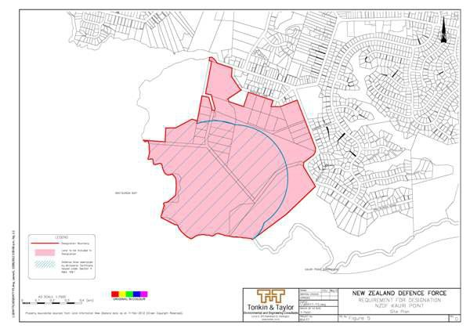

4306 Narrow Neck Facility

Designation Number | 4306
Requiring Authority | Minister of Defence
Location | 142 Vauxhall Road, Narrow Neck (refer to Figure 6 below)
Rollover Designation | Yes
Legacy Reference | Designation 88, Auckland Council District Plan (North Shore Section) 2002
Lapse Date | Given effect to (i.e. no lapse date)

Description

Defence purposes (as defined by section 5 of the Defence Act 1990) ­ naval base.

The Defence Areas are administered by the New Zealand Defence Force (NZDF) and are currently occupied by NZDF, its contractors and licensees. The Areas are a Defence Work and may be utitlised for any or every purpose required by section 5 of the Defence Act 1990, which are as follows:
- The defence of New Zealand, and of any area for the defence of which New Zealand is responsible under any Act;
- The protection of the interests of New Zealand, whether in New Zealand or elsewhere;

- The contribution of forces under collective security treaties, agreements or arrangements;
- The contribution of forces to, or for any of the purposes of, the United Nations, or in association with other organisations or States and in accordance with the principles of the Charter of the United Nations;
- The provision of assistance to the civil power either in New Zealand or elsewhere in time of emergency; and
- The provision of any public service.

The Governor­General of New Zealand, continues to raise and maintain Armed Forces on behalf of Her Majesty the Queen. Given the obligations placed on the New Zealand Defence Force by the Crown to meet the Crown’s military defence needs, including those imposed by any enactment or by the policies of the government, the function of the Defence Areas include, at all times, to provide for the following functions of the New Zealand Defence Force (including visiting forces and third parties contracted to the New Zealand Defence Force):
- Defence Force command, land operations, sea operations, air operations, training, logistic support, ship berthing and docking, construction, repair, maintenance, munitions handling and storage, administration, and communication, and for the acquisition and improvement of the skills necessary for such functions;
- Resources, accommodation and facilities for these functions;
- Accommodation for members of the New Zealand Defence Force and any visiting force, training, recreational, welfare and medical facilities for them;
- Facilities for the storage of matériel, food and fuel, and the conservation and display of historic material;
- Facilities for the construction, repair and maintenance of vessels, aircraft, vehicles and other equipment, including the vessels, aircraft, vehicles and equipment of forces of other nations;
- To provide for the rapid and efficient deployment of the New Zealand Defence Force; and
- Any other activity required in the delivery of New Zealand Defence Force outputs as described annually in the Departmental Forecast Report: New Zealand Defence Force.

Conditions

Yards
- The following yards shall apply in respect of designation boundaries except the boundary with the Coastal Marine Area (where no yard shall apply):
All boundaries: 3m

Building height
- 9m

Height in Relation to Boundary
- Buildings must not project beyond a 45 degree recession plane measured from a point 2.5 m vertically above ground level where the designation boundary adjoins a residential zoned site.

Building length
- Where sites adjoining the designation boundary are zoned residential, those parts of any building which exceed a height of 5 metres and are within 10 metres of the designation boundary are to be wholly confined within the arms of a 130 degree angle formed by two lines intersecting any point on an adjacent residential boundary such that each line forms an angle of 25 degrees with that boundary.

Exceptions and notes for conditions 1­4:
Building height, bulk and location controls apply only in respect of new buildings and additions to existing buildings.
The following structures are excluded from all building height, bulk and location controls:
  - Perimeter security fencing up to a height of 4m;
  - Flagpoles; and
  - Lighting standards up to a maximum height of 12.5m, and lighting standards exceeding a height of 12.5m subject to an outline plan.

Noise limits
- The LAeq(15 min) noise level and maximum noise level (LAFmax) arising from any activity within the designated area, other than noise from construction, demolition or maintenance, measured at or within the boundary of a property in the residential zones outside the designated area, must not exceed the following limits:

Monday to Saturday 7am­10pm | LAeq(15 min) 55dB
Sunday 9am­6pm | LAeq(15 min) 55dB
All other times | LAeq(15 min) 45dB  Leq(15 min) 60dB at 63 Hz Leq(15 min) 55dB at 125 Hz LAFmax 75dB

Construction, demolition and maintenance noise limits
- Noise from construction and demolition activities must meet the requirements of Tables 2 and 3 of New Zealand Standard on Acoustics – Construction Noise (NZS 6803: 1999). The measurement and assessment of construction noise must be in accordance with New Zealand Standard on Acoustics – Construction Noise (NZS 6803: 1999) and the requirements of annex A of New Zealand Standard on Acoustics – Construction Noise (NZS 6803: 1999) must be used if it is necessary to assess the measured Leq levels in high background noise areas.

Exceptions to noise limits:
  - Military helicopter operations except that:
- There shall not be more than 50 landings and 50 take­offs per calendar year;
- Over­flying of dwellings by landing helicopters is to be avoided;
- Military helicopter landings and take­offs will be limited to between the hours of 0700 – 2200; and
- Landing shall take place at the maximum practical distance from nearby residences (this will be dependent upon ground conditions).
  - Emergency helicopter operations;
  - Parade ground activities, gun salutes and other activities for ceremonial occasions, including preparation for such occasions;
  - Noise from safety signals, warning devices or emergency pressure relief valves, provided they do not sound for more than a reasonable period; and
  - Noise associated with outdoor recreational activities and sporting events.

Tree Protection
- Pohutukawa trees over 3m in height shall be removed or pruned only for the reasons of:
  - Adverse tree health;
  - Human safety; and
  - Risk of property damage, including to buildings, vehicles, roads, and underground services.

- Trimming and maintenance of pohutukawa trees over 3 m in height is to be undertaken by a qualified arborist.

Lighting
- Lighting in all areas shall conform to the following:
  - At no time between the hours of 10pm and 7am shall any outdoor lighting be used in a manner that the use
of such lighting causes an added illuminance in excess of 20 lux measured horizontally or vertically at any point along any boundary of any adjoining site which is zoned Residential (and outside the designated area); and
  - All outdoor lighting shall be shielded in such a manner that light emitted by the fixture is projected below a horizontal plane running through the lowest point in the fixture where that light is emitted, or is shielded in such a manner that the lowest edge of the shield is at or below the centre line of the light source.

Aerials and Antennae
- Telecommunication and radio communication aerials and antennae that comply with the limits prescribed in NZS 2772.1 (1999) New Zealand Standard for radiofrequency fields – maximum exposure levels between 3 kHz and 300 GHz shall be permitted in all parts of the designated area. Where aerials and antennae are attached
to buildings, their height plus that of any support structure shall not exceed the height limit of the area by more than 5m.

Administration
- Works and projects that comply with the permitted activity rules of the underlying zoning are incorporated into this designation and, in accordance with s176A(2)(b) RMA, no outline plan is required for those activities.

- For the avoidance of doubt, maintenance activities do not require an outline plan.

Attachments

Figure 6 ­ Designation NZDF Narrow Neck Site Plan

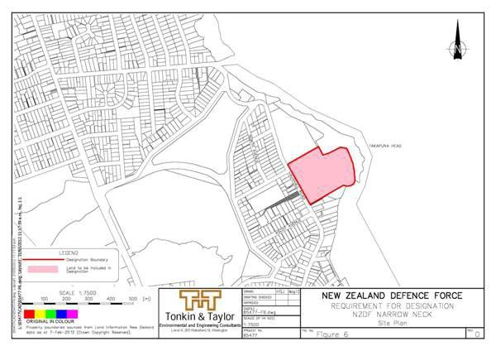

4307 Torpedo Bay Facility

Designation Number | 4307
Requiring Authority | Minister of Defence
Location | 64 King Edward Parade, Torpedo Bay, Devonport (refer to Figure 7 below)
Rollover Designation | Yes
Legacy Reference | Designation 89, Auckland Council District Plan (North Shore Section) 2002
Lapse Date | Given effect to (i.e. no lapse date)

Description

Defence purposes (as defined by section 5 of the Defence Act 1990) ­ naval base.

The Defence Areas are administered by the New Zealand Defence Force (NZDF) and are currently occupied by NZDF, its contractors and licensees. The Areas are a Defence Work and may be utitlised for any or every purpose required by section 5 of the Defence Act 1990, which are as follows:
- The defence of New Zealand, and of any area for the defence of which New Zealand is responsible under any Act;
- The protection of the interests of New Zealand, whether in New Zealand or elsewhere;
- The contribution of forces under collective security treaties, agreements or arrangements;
- The contribution of forces to, or for any of the purposes of, the United Nations, or in association with other organisations or States and in accordance with the principles of the Charter of the United Nations;
- The provision of assistance to the civil power either in New Zealand or elsewhere in time of emergency; and
- The provision of any public service.

The Governor­General of New Zealand, continues to raise and maintain Armed Forces on behalf of Her Majesty the Queen. Given the obligations placed on the New Zealand Defence Force by the Crown to meet the Crown’s military defence needs, including those imposed by any enactment or by the policies of the government, the function of the Defence Areas include, at all times, to provide for the following functions of the New Zealand Defence Force (including visiting forces and third parties contracted to the New Zealand Defence Force):
- Defence Force command, land operations, sea operations, air operations, training, logistic support, ship berthing and docking, construction, repair, maintenance, munitions handling and storage, administration, and communication, and for the acquisition and improvement of the skills necessary for such functions;
- Resources, accommodation and facilities for these functions;
- Accommodation for members of the New Zealand Defence Force and any visiting force, training, recreational, welfare and medical facilities for them;
- Facilities for the storage of matériel, food and fuel, and the conservation and display of historic material;
- Facilities for the construction, repair and maintenance of vessels, aircraft, vehicles and other equipment, including the vessels, aircraft, vehicles and equipment of forces of other nations;
- To provide for the rapid and efficient deployment of the New Zealand Defence Force; and
- Any other activity required in the delivery of New Zealand Defence Force outputs as described annually in the Departmental Forecast Report: New Zealand Defence Force.

Conditions

Building height
- 9m
Exceptions and notes for conditions 1­4:
Building height, bulk and location controls apply only in respect of new buildings and additions to existing buildings.
The following structures are excluded from all building height, bulk and location controls:
  - Flagpoles; and
  - Lighting standards up to a maximum height of 12.5m, and lighting standards exceeding a height of 12.5m subject to an outline plan.

Noise limits
- The LAeq(15 min) noise level and maximum noise level (LAFmax) arising from any activity within the designated area, other than noise from construction, demolition or maintenance, measured at or within the boundary of a property in the residential zones outside the designated area, must not exceed the following limits:

Monday to Saturday 7am­10pm LAeq(15 min) 55dB

Sunday 9am­6pm | LAeq(15 min) 55dB
All other times | LAeq(15 min) 45dB  Leq(15 min) 60dB at 63 Hz Leq(15 min) 55dB at 125 Hz LAFmax 75dB

Construction, demolition and maintenance noise limits
- Noise from construction and demolition activities must meet the requirements of Tables 2 and 3 of New Zealand Standard on Acoustics – Construction Noise (NZS 6803: 1999). The measurement and assessment of construction noise must be in accordance with New Zealand Standard on Acoustics – Construction Noise (NZS 6803: 1999) and the requirements of annex A of New Zealand Standard on Acoustics – Construction Noise (NZS 6803: 1999) must be used if it is necessary to assess the measured Leq levels in high background noise areas.

Exceptions to noise limits:
  - Military helicopter operations except that:
- There shall not be more than 50 landings and 50 take­offs per calendar year;
- Over­flying of dwellings by landing helicopters is to be avoided;
- Military helicopter landings and take­offs will be limited to between the hours of 0700 – 2200; and
- Landing shall take place at the maximum practical distance from nearby residences (this will be dependent upon ground conditions).
  - Emergency helicopter operations;
  - Parade ground activities, gun salutes and other activities for ceremonial occasions, including preparation for such occasions;
  - Noise from safety signals, warning devices or emergency pressure relief valves, provided they do not sound for more than a reasonable period; and
  - Noise associated with outdoor recreational activities and sporting events.

Lighting
- Lighting in all areas shall conform to the following:
  - At no time between the hours of 10pm and 7am shall any outdoor lighting be used in a manner that the use
of such lighting causes an added illuminance in excess of 20 lux measured horizontally or vertically at any point along any boundary of any adjoining site which is zoned Residential (and outside the designated area); and
  - All outdoor lighting shall be shielded in such a manner that light emitted by the fixture is projected below a horizontal plane running through the lowest point in the fixture where that light is emitted, or is shielded in such a manner that the lowest edge of the shield is at or below the centre line of the light source.

Aerials and Antennae
- Telecommunication and radio communication aerials and antennae that comply with the limits prescribed in NZS 2772.1 (1999) New Zealand Standard for radiofrequency fields – maximum exposure levels between 3 kHz and 300 GHz shall be permitted in all parts of the designated area. Where aerials and antennae are attached
to buildings, their height plus that of any support structure shall not exceed the height limit of the area by more than five metres.

Administration
- Works and projects that comply with the permitted activity rules of the underlying zoning are incorporated into this designation and, in accordance with s176A(2)(b) RMA, no outline plan is required for those activities.

- For the avoidance of doubt, maintenance activities do not require an outline plan.

Attachments

Figure 7 ­ Designation NZDF Torpedo Bay Site Plan

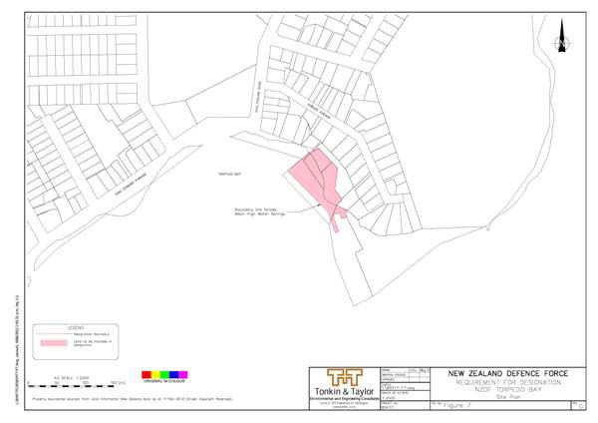

4308 Devonport Naval Base ­ South Yard

Designation Number | 4308
Requiring Authority | Minister of Defence
Location | South of Calliope Road, and west of Spring Street, Devonport.(refer to Figure 8 below)
Rollover Designation | Yes
Legacy Reference | Designation 91, Auckland Council District Plan (North Shore Section) 2002
Lapse Date | Given effect to (i.e. no lapse date)

Description

Defence purposes (as defined by section 5 of the Defence Act 1990) ­ naval base.

The Defence Areas are administered by the New Zealand Defence Force (NZDF) and are currently occupied by NZDF, its contractors and licensees. The Areas are a Defence Work and may be utitlised for any or every purpose required by section 5 of the Defence Act 1990, which are as follows:
  - The defence of New Zealand, and of any area for the defence of which New Zealand is responsible under any Act;
  - The protection of the interests of New Zealand, whether in New Zealand or elsewhere;
  - The contribution of forces under collective security treaties, agreements or arrangements;
  - The contribution of forces to, or for any of the purposes of, the United Nations, or in association with other organisations or States and in accordance with the principles of the Charter of the United Nations;
  - The provision of assistance to the civil power either in New Zealand or elsewhere in time of emergency; and

  - The provision of any public service.

The Governor­General of New Zealand, continues to raise and maintain Armed Forces on behalf of Her Majesty the Queen. Given the obligations placed on the New Zealand Defence Force by the Crown to meet the Crown’s military defence needs, including those imposed by any enactment or by the policies of the government, the function of the Defence Areas include, at all times, to provide for the following functions of the New Zealand Defence Force (including visiting forces and third parties contracted to the New Zealand Defence Force):
- Defence Force command, land operations, sea operations, air operations, training, logistic support, ship berthing and docking, construction, repair, maintenance, munitions handling and storage, administration, and communication, and for the acquisition and improvement of the skills necessary for such functions;
- Resources, accommodation and facilities for these functions;
- Accommodation for members of the New Zealand Defence Force and any visiting force, training, recreational, welfare and medical facilities for them;
- Facilities for the storage of matériel, food and fuel, and the conservation and display of historic material;
- Facilities for the construction, repair and maintenance of vessels, aircraft, vehicles and other equipment, including the vessels, aircraft, vehicles and equipment of forces of other nations;
- To provide for the rapid and efficient deployment of the New Zealand Defence Force; and
- Any other activity required in the delivery of New Zealand Defence Force outputs as described annually in the Departmental Forecast Report: New Zealand Defence Force.

Conditions

Yards
- DNB ­ South Yard: Calliope Road
  - The following yards shall apply in respect of designation boundaries except the boundary with the Coastal Marine Area (where no yard shall apply):
Calliope Road and Spring Street: 3m All other boundaries: 1.2m; and
  - The following yard shall apply in respect of the cliff top: 10m

For the purposes of this control, cliff top is defined as the point at which the gradient of the slope (as approached from the top of the slope) reaches a gradient steeper than 1 in 0.5.

- DNB ­ South Yard: Philomel
The following yard shall apply in respect of the designation boundary with Spring Street: 5m

Building height
- DNB ­ South Yard: Calliope Road 9m

- DNB ­ South Yard: Philomel and DNB ­ South Yard: Dockyard 18m

Height in Relation to Boundary
- DNB ­ South Yard: Calliope Road and DNB ­ South Yard: Philomel Buildings must not project beyond a 45 degree recession plane measured from a point 2.5 m vertically above ground level where the designation boundary adjoins a residential zoned site.

Building length
- DNB ­ South Yard: Calliope Road Where sites adjoining the designation boundary are zoned residential, those parts of any building which exceed a height of 5 metres and are within 10 metres of the designation

boundary are to be wholly confined within the arms of a 130 degree angle formed by two lines intersecting any point on an adjacent residential boundary such that each line forms an angle of 25 degrees with that boundary.

Exceptions and notes for conditions 1­6:
Building height, bulk and location controls apply only in respect of new buildings and additions to existing buildings.

The following structures are exempt from the following building height, bulk and location controls:
  - Perimeter security fencing up to a height of 3 m is exempt from all height, bulk and location controls. Flagpoles are exempt from:
- yard control at DNB ­ South Yard: Philomel;
- building height control at DNB ­ South Yard: Calliope Road, Philomel, and Dockyard; and
- height in relation to boundary at DNB ­ South Yard: Calliope Road and Philomel;
  - Lighting standards up to a maximum height of 12.5m, and lighting standards exceeding a height of 12.5m subject to an outline plan, are exempt from:
- yard control at DNB ­ South Yard: Calliope Road and Philomel;
- building height control at DNB ­ South Yard: Calliope Road, Philomel, and Dockyard;
- height in relation to boundary control at DNB ­ South Yard: Calliope Road, and Philomel; and
- building length at DNB – South Yard: Calliope Road;
  - Structures in the DNB ­ South Yard: Calliope Road that provide pedestrian or vehicular access to or from the cliff are exempt from yard and building height controls;
  - Structures associated with the operation of any Main Gate at DNB – South Yard: Philomel, including but not limited to offices and security features, are exempt from yard and height controls;
  - Lift motors, fly towers, machinery rooms, water towers, towers, turrets, provided they do not exceed 3m above permitted height and do not exceed 10% of the area of the roof to the storey below are exempt from all building height, bulk and location controls at DNB – South Yard: Philomel and Dockyard;
  - Cranes and derricks, and structures necessary to accommodate cranes and derricks and ship superstructures, up to 25m are exempt from building height control at DNB – South Yard: Dockyard; and
  - Structures that are necessary to provide for access from the cliff top to buildings below, in not more than three locations, are exempt from the building height control at DNB – South Yard: Philomel.

Noise limits
- The LAeq(15 min) noise level and maximum noise level (LAFmax) arising from any activity within the designated area, other than noise from construction, demolition or maintenance, measured at or within the boundary of a property in the residential zones outside the designated area, must not exceed the following limits:

Monday to Saturday 7am­10pm | LAeq(15 min) 55dB
Sunday 9am­6pm | LAeq(15 min) 55dB
All other times | LAeq(15 min) 45dB  Leq(15 min) 60dB at 63 Hz Leq(15 min) 55dB at 125 Hz LAFmax 75dB

Construction, demolition and maintenance noise limits
- Noise from construction and demolition activities must meet the requirements of Tables 2 and 3 of New Zealand Standard on Acoustics – Construction Noise (NZS 6803: 1999). The measurement and assessment of construction noise must be in accordance with New Zealand Standard on Acoustics – Construction Noise (NZS 6803: 1999) and the requirements of annex A of New Zealand Standard on Acoustics – Construction Noise (NZS 6803: 1999) must be used if it is necessary to assess the measured Leq levels in high background noise areas.

Exceptions to noise limits:
  - Military helicopter operations except that:
- There shall not be more than 50 landings and 50 take­offs per calendar year;
- Over­flying of dwellings by landing helicopters is to be avoided;
- Military helicopter landings and take­offs will be limited to between the hours of 0700 – 2200; and
- Landing shall take place at the maximum practical distance from nearby residences (this will be dependent upon ground conditions).
  - Emergency helicopter operations;
  - Parade ground activities, gun salutes and other activities for ceremonial occasions, including preparation for such occasions;
  - Noise from safety signals, warning devices or emergency pressure relief valves, provided they do not sound for more than a reasonable period; and
  - Noise associated with outdoor recreational activities and sporting events.

Tree Protection
- DNB ­ South Yard: Calliope Road
Pohutukawa trees over 3 m in height on the cliff top shall be removed or pruned only for the reasons of:
  - Adverse tree health;
  - Human safety;
  - Cliff stability; and
  - Risk of property damage, including to buildings, vehicles, roads, and underground services.

- Trimming and maintenance of all native trees on the cliff top is to be undertaken by a qualified arborist. For the purposes of this control, cliff top is defined as the point at which the gradient of the slope (as approached from the top of the slope) reaches a gradient steeper than 1 in 0.5, plus the first 10m back from the top of the cliff top.

Lighting
- Lighting in all areas shall conform to the following: a. At no time between the hours of 10pm and 7am shall any outdoor lighting be used in a manner that the use of such lighting causes an added illuminance in excess of 20 lux measured horizontally or vertically at any point along any boundary of any adjoining site which is zoned Residential (and outside the designated area); and b. All outdoor lighting shall be shielded in such a manner
that light emitted by the fixture is projected below a horizontal plane running through the lowest point in the fixture where that light is emitted, or is shielded in such a manner that the lowest edge of the shield is at or below the centre line of the light source.

Aerials and Antennae
- Telecommunication and radio communication aerials and antennae that comply with the limits prescribed in NZS 2772.1 (1999) New Zealand Standard for radiofrequency fields – maximum exposure levels between 3 kHz and 300 GHz shall be permitted in all parts of the designated area. Where aerials and antennae are attached
to buildings, their height plus that of any support structure shall not exceed the height limit of the area by more than 5m.

Administration
- Works and projects that comply with the permitted activity rules of the underlying zoning are incorporated into this designation and, in accordance with s176A(2)(b) RMA, no outline plan is required for those activities.

- For the avoidance of doubt, maintenance activities do not require an outline plan.

Attachments

Figure 8 ­ Designation NZDF Devonport Site Plan

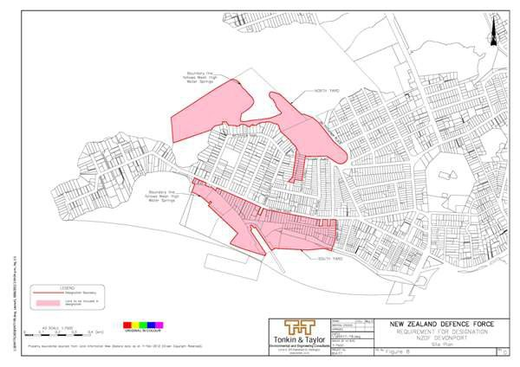

Figure 8A ­ Designation NZDF Devonport North Yard & South Yard Sub­Areas
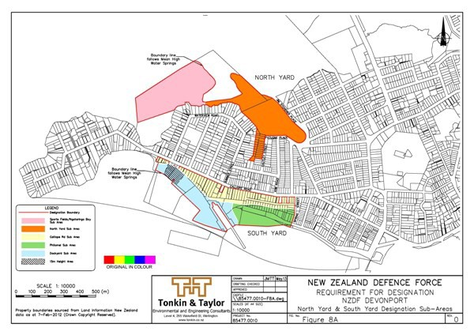

4309 Devonport Naval Base ­ North Yard

Designation Number | 4309
Requiring Authority | Minister of Defence
Location | West of Jim Titchener Parade and Cautley Street, Devonport (refer to Figure 8 below)
Rollover Designation | Yes
Legacy Reference | Designation 92, Auckland Council District Plan (North Shore Section) 2002
Lapse Date | Given effect to (i.e. no lapse date)

Description

Defence purposes (as defined by section 5 of the Defence Act 1990) ­ naval base.

The Defence Areas are administered by the New Zealand Defence Force (NZDF) and are currently occupied by NZDF, its contractors and licensees. The Areas are a Defence Work and may be utitlised for any or every purpose required by section 5 of the Defence Act 1990, which are as follows:
- The defence of New Zealand, and of any area for the defence of which New Zealand is responsible under any Act;
- The protection of the interests of New Zealand, whether in New Zealand or elsewhere;
- The contribution of forces under collective security treaties, agreements or arrangements;
- The contribution of forces to, or for any of the purposes of, the United Nations, or in association with other organisations or States and in accordance with the principles of the Charter of the United Nations;
- The provision of assistance to the civil power either in New Zealand or elsewhere in time of emergency; and
- The provision of any public service.

The Governor­General of New Zealand, continues to raise and maintain Armed Forces on behalf of Her Majesty the Queen. Given the obligations placed on the New Zealand Defence Force by the Crown to meet the Crown’s military defence needs, including those imposed by any enactment or by the policies of the government, the function of the Defence Areas include, at all times, to provide for the following functions of the New Zealand Defence Force (including visiting forces and third parties contracted to the New Zealand Defence Force):
- Defence Force command, land operations, sea operations, air operations, training, logistic support, ship berthing and docking, construction, repair, maintenance, munitions handling and storage, administration, and communication, and for the acquisition and improvement of the skills necessary for such functions;
- Resources, accommodation and facilities for these functions;
- Accommodation for members of the New Zealand Defence Force and any visiting force, training, recreational, welfare and medical facilities for them;
- Facilities for the storage of matériel, food and fuel, and the conservation and display of historic material;
- Facilities for the construction, repair and maintenance of vessels, aircraft, vehicles and other equipment, including the vessels, aircraft, vehicles and equipment of forces of other nations;
- To provide for the rapid and efficient deployment of the New Zealand Defence Force; and
- Any other activity required in the delivery of New Zealand Defence Force outputs as described annually in the Departmental Forecast Report: New Zealand Defence Force.

Conditions

Yards
1. The following yards shall apply in respect of designation boundaries except the boundary with the Coastal Marine Area (where no yard shall apply):
All boundaries: 3m

Building height
2. 12.5m

Height in Relation to Boundary
- Buildings must not project beyond a 45 degree recession plane measured from a point 2.5 m vertically above ground level where the designation boundary adjoins a residential zoned site.

Building length
- Where sites adjoining the designation boundary are zoned residential, those parts of any building which exceed a height of 5 metres and are within 10 metres of the designation boundary are to be wholly confined within the arms of a 130 degree angle formed by two lines intersecting any point on an adjacent residential boundary such that each line forms an angle of 25 degrees with that boundary.

Maximum site coverage
- North Yard: Sports fields The maximum permitted site coverage or cumulative total area of buildings must not exceed 35%.

Minimum permeable area
- DNB ­ North Yard: Sports fields The minimum permeable area must not be less than 25%.

Exceptions and notes for conditions 1­6:
Building height, bulk and location controls apply only in respect of new buildings and additions to existing buildings.

The following structures are excluded from all building height, bulk and location controls:
  - Perimeter security fencing up to a height of 4m;
  - Flagpoles; and
  - Lighting standards up to a maximum height of 12.5m, and lighting standards exceeding a height of 12.5m subject to an outline plan.

Noise limits
- The LAeq(15 min) noise level and maximum noise level (LAFmax) arising from any activity within the designated area, other than noise from construction, demolition or maintenance, measured at or within the boundary of a property in the residential zones outside the designated area, must not exceed the following limits:

Monday to Saturday 7am­10pm | LAeq(15 min) 55dB
Sunday 9am­6pm | LAeq(15 min) 55dB
All other times | LAeq(15 min) 45dB  Leq(15 min) 60dB at 63 Hz Leq(15 min) 55dB at 125 Hz LAFmax 75dB

Construction, demolition and maintenance noise limits
- Noise from construction and demolition activities must meet the requirements of Tables 2 and 3 of New Zealand Standard on Acoustics – Construction Noise (NZS 6803: 1999). The measurement and assessment of construction noise must be in accordance with New Zealand Standard on Acoustics – Construction Noise (NZS 6803: 1999) and the requirements of annex A of New Zealand Standard on Acoustics – Construction Noise (NZS 6803: 1999) must be used if it is necessary to assess the measured Leq levels in high background noise areas.

Exceptions to noise limits:

  - Military helicopter operations except that:
- There shall not be more than 50 landings and 50 take­offs per calendar year;
- Over­flying of dwellings by landing helicopters is to be avoided;
- Military helicopter landings and take­offs will be limited to between the hours of 0700 – 2200; and
- Landing shall take place at the maximum practical distance from nearby residences (this will be dependent upon ground conditions).
  - Emergency helicopter operations;
  - Parade ground activities, gun salutes and other activities for ceremonial occasions, including preparation for such occasions;
  - Noise from safety signals, warning devices or emergency pressure relief valves, provided they do not sound for more than a reasonable period; and
  - Noise associated with outdoor recreational activities and sporting events.

Lighting
- Lighting in all areas shall conform to the following:
  - At no time between the hours of 10pm and 7am shall any outdoor lighting be used in a manner that the use of such lighting causes an added illuminance in excess of 20 lux measured horizontally or vertically at any point along any boundary of any adjoining site which is zoned Residential (and outside the designated area); and
  - All outdoor lighting shall be shielded in such a manner that light emitted by the fixture is projected below a horizontal plane running through the lowest point in the fixture where that light is emitted, or is shielded in such a manner that the lowest edge of the shield is at or below the centre line of the light source.

Aerials and Antennae
- Telecommunication and radio communication aerials and antennae that comply with the limits prescribed in NZS 2772.1 (1999) New Zealand Standard for radiofrequency fields – maximum exposure levels between 3 kHz and 300 GHz shall be permitted in all parts of the designated area. Where aerials and antennae are attached
to buildings, their height plus that of any support structure shall not exceed the height limit of the area by more than 5m.

Administration
- Works and projects that comply with the permitted activity rules of the underlying zoning are incorporated into this designation and, in accordance with s176A(2)(b) RMA, no outline plan is required for those activities.

- For the avoidance of doubt, maintenance activities do not require an outline plan.

Attachments

Figure 8 ­ Designation NZDF Devonport Site Plan

Figure 8A ­ Designation NZDF Devonport North Yard & South Yard Sub­Areas

4310 Whenuapai Airbase

Designation Number | 4310
Requiring Authority | Minister of Defence
Location | Brigham Creek Road, Kowhai Road, Kauri Road and Bristol Road, Whenuapai (refer to Drawing 9A­1 below)
Rollover Designation | Yes
Legacy Reference | Designation MD1, Auckland Council District Plan (Waitakere Section) 2003
Lapse Date | Given effect to (i.e. no lapse date)

Description

Defence purposes (as defined by section 5 of the Defence Act 1990) ­ air base.

The Defence Areas are administered by the New Zealand Defence Force (NZDF) and are currently occupied by NZDF, its contractors and licensees. The Areas are a Defence Work and may be utitlised for any or every purpose required by section 5 of the Defence Act 1990, which are as follows:
- The defence of New Zealand, and of any area for the defence of which New Zealand is responsible under any Act;
- The protection of the interests of New Zealand, whether in New Zealand or elsewhere;
- The contribution of forces under collective security treaties, agreements or arrangements;
- The contribution of forces to, or for any of the purposes of, the United Nations, or in association with other organisations or States and in accordance with the principles of the Charter of the United Nations;
- The provision of assistance to the civil power either in New Zealand or elsewhere in time of emergency; and
- The provision of any public service.

The Governor­General of New Zealand, continues to raise and maintain Armed Forces on behalf of Her Majesty the Queen. Given the obligations placed on the New Zealand Defence Force by the Crown to meet the Crown’s military defence needs, including those imposed by any enactment or by the policies of the government, the function of the Defence Areas include, at all times, to provide for the following functions of the New Zealand Defence Force (including visiting forces and third parties contracted to the New Zealand Defence Force):
- Defence Force command, land operations, sea operations, air operations, training, logistic support, ship berthing and docking, construction, repair, maintenance, munitions handling and storage, administration, and communication, and for the acquisition and improvement of the skills necessary for such functions;
- Resources, accommodation and facilities for these functions;
- Accommodation for members of the New Zealand Defence Force and any visiting force, training, recreational, welfare and medical facilities for them;
- Facilities for the storage of matériel, food and fuel, and the conservation and display of historic material;
- Facilities for the construction, repair and maintenance of vessels, aircraft, vehicles and other equipment, including the vessels, aircraft, vehicles and equipment of forces of other nations;
- To provide for the rapid and efficient deployment of the New Zealand Defence Force; and
- Any other activity required in the delivery of New Zealand Defence Force outputs as described annually in the Departmental Forecast Report: New Zealand Defence Force.

Conditions

Aircraft Noise
- Aircraft operations on the RNZAF Airbase shall not exceed a day/night (Ldn) level of:
  - 65dBA outside the Airnoise Boundary (Ldn 65 dBA Contour) shown on the Airbase Noise map; and
  - 55dBA outside the Outer Control Boundary (Ldn 55 dBA Contour) shown on the Airbase Noise map.

For the purpose of this control noise will be measured in accordance with the NZS 6805:1992 and calculated, as stated in NZS 6805:1992, using FAA Integrated Noise Model (INM) and records of actual aircraft operations and calculated as a 90 day rolling logarithmic average.

Exceptions to noise limits:
- The aircraft is landing in an emergency;
- The aircraft is landing at the Airbase as an alternative in adverse weather conditions; or
- The aircraft is using the airfield as part of a search and rescue operation or civil emergency.

Administration
- Works and projects that comply with the permitted activity rules of the underlying zoning are incorporated into this designation and, in accordance with s176A(2)(b) RMA, no outline plan is required for those activities.

- For the avoidance of doubt, maintenance activities do not require an outline plan.

Attachments

Drawing 9A­1 ­ Notice of Requirement Whenuapai Site Plan
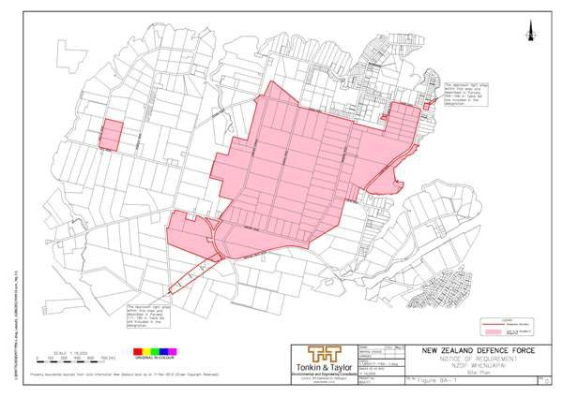

Drawing 9A­2 ­ Noise Control Area Whenuapai Site Plan

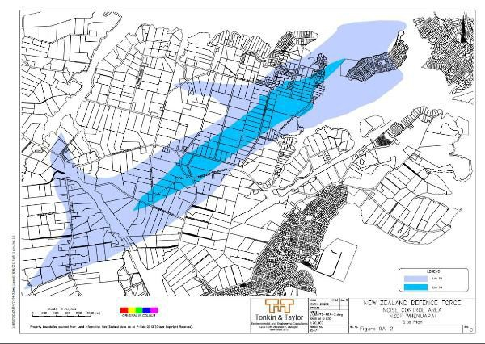

4311 Whenuapai Airfield Approach and Departure Path Protection

Designation Number | 4311
Requiring Authority | Minister of Defence
Location | Vicinity of Whenuapai Airfield
Rollover Designation | Yes
Legacy Reference | Auckland Council District Plan (Waitakere Section) 2003; and Auckland Council District Plan (North Shore Section) 2002
Lapse Date | Given effect to (i.e. no lapse date)

Description

Defence purposes (as defined by section 5 of the Defence Act 1990) ­ protection of approach and departure paths.

The Defence Areas are administered by the New Zealand Defence Force (NZDF) and are currently occupied by NZDF, its contractors and licensees. The Areas are a Defence Work and may be utitlised for any or every purpose required by section 5 of the Defence Act 1990, which are as follows:
  - The defence of New Zealand, and of any area for the defence of which New Zealand is responsible under any Act;
  - The protection of the interests of New Zealand, whether in New Zealand or elsewhere;
  - The contribution of forces under collective security treaties, agreements or arrangements;
  - The contribution of forces to, or for any of the purposes of, the United Nations, or in association with other organisations or States and in accordance with the principles of the Charter of the United Nations;
  - The provision of assistance to the civil power either in New Zealand or elsewhere in time of emergency; and
  - The provision of any public service.

The Governor­General of New Zealand, continues to raise and maintain Armed Forces on behalf of Her Majesty the Queen. Given the obligations placed on the New Zealand Defence Force by the Crown to meet the Crown’s military defence needs, including those imposed by any enactment or by the policies of the government, the function of the Defence Areas include, at all times, to provide for the following functions of the New Zealand Defence Force (including visiting forces and third parties contracted to the New Zealand Defence Force):
- Defence Force command, land operations, sea operations, air operations, training, logistic support, ship berthing and docking, construction, repair, maintenance, munitions handling and storage, administration, and communication, and for the acquisition and improvement of the skills necessary for such functions;
- Resources, accommodation and facilities for these functions;
- Accommodation for members of the New Zealand Defence Force and any visiting force, training, recreational, welfare and medical facilities for them;
- Facilities for the storage of matériel, food and fuel, and the conservation and display of historic material;
- Facilities for the construction, repair and maintenance of vessels, aircraft, vehicles and other equipment, including the vessels, aircraft, vehicles and equipment of forces of other nations;
- To provide for the rapid and efficient deployment of the New Zealand Defence Force; and
- Any other activity required in the delivery of New Zealand Defence Force outputs as described annually in the Departmental Forecast Report: New Zealand Defence Force.

Conditions

Restrictions Relating to Approach Paths

- The approval in writing of the New Zealand Defence Force is required prior to the erection of any building, change in use of any land or building, or any subdivision of land, and prior to any building or resource consent application for such works/activities, within the areas of the designation shown on the planning maps as ‘land use and subdivision subject to NZDF approval’. These areas are generally within 1,000 metres of the runways.

- No obstacle shall penetrate the approach and departure path obstacle limitation surfaces shown on the planning maps and explained by the text “Explanation of Protection Surfaces Whenuapai Airfield” and Diagram MD1A below without the prior approval in writing of the New Zealand Defence Force. This restriction shall not apply to any building being erected which has a height of not more than 9.0 metres above natural ground level.

Explanation of Surfaces

The protection surfaces have been developed in accordance with NZ Civil Aviation Circulars (AC) 139­6 and AC 139­10. Where two or more surfaces (whether takeoff, approach, transitional, horizontal or conical surfaces) coincide, the lower shall apply.

1. Takeoff, Approach and Transitional Surfaces

The Takeoff and Approach surfaces coincide and commence at 60 metres from the end of the runway threshold. The width of the start of the surface is 300 metres for Runways 03 and 21 and 180 metres for Runways 08 and
26. Each surface diverges in width each side at a rate of 1:6.6 (15%) and extends at a gradient of 1 in 50 (2%) for a total distance of 15 kilometres. As a result, maximum permitted building altitude increases with distance from the Airfield.

The Transitional Side Surfaces, which restrict building altitudes either side of the runway, are imposed either side of the aerodrome strip. The Transitional Side Surface slopes upward from the edge of the aerodrome strip at a gradient of 1:7 (14.3%) to the inner edge of the Inner Horizontal Surface at a height of 45 metres above the Aerodrome Elevation and at an elevation of 76.3 metres above mean sea level (AMSL). The effect of these surfaces on maximum building altitude is illustrated in Diagram MD1A.

Inner Horizontal and Conical Surfaces.

The Inner Horizontal Surface is a horizontal “near circular” plane extending 4000 metres out from the edge of the aerodrome strip at a height of 45 metres above the Aerodrome Elevation and at an elevation of 76.3 metres above mean sea level (AMSL). The Conical Surface is an upward sloping surface that extends outwards from
the outer edge of the Inner Horizontal Surface at a gradient of 5% to an elevation of 150m above the Aerodrome Elevation and at an elevation of 181.3 metres above mean sea level (AMSL). The effect of these surfaces on maximum permitted altitude of buildings and other objects is illustrated in Diagram MD1A.

Attachments

Drawing 9B­1 ­ Protection Measures Whenuapai Airfield
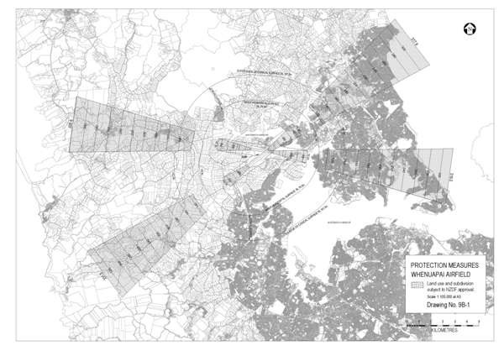

Drawing 9B­2­6 ­ Protection Measures Whenuapai Airfield

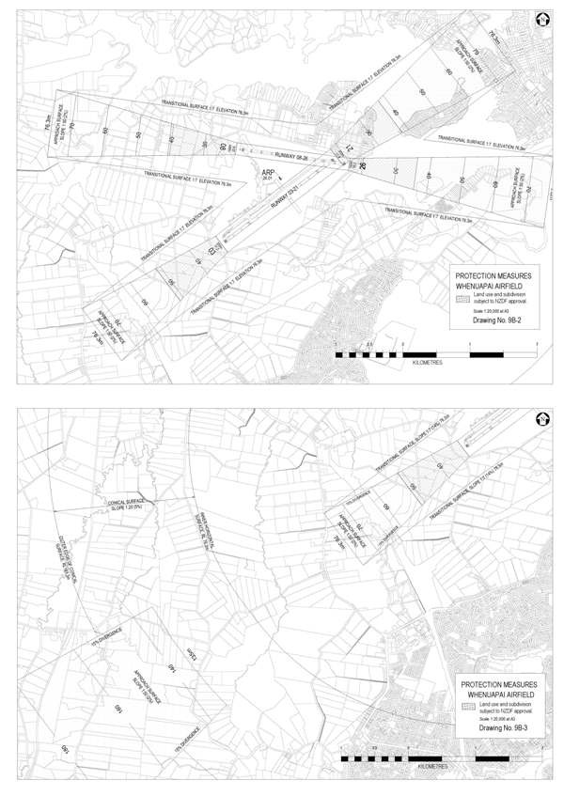

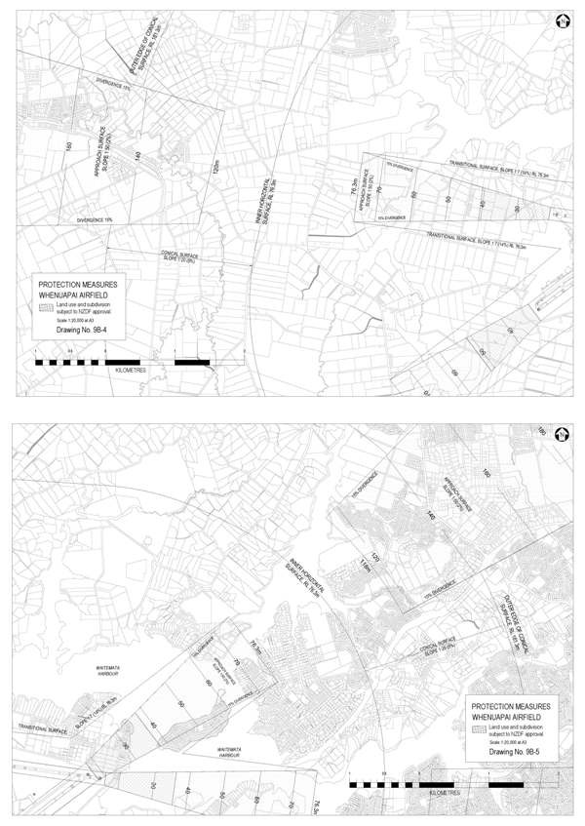

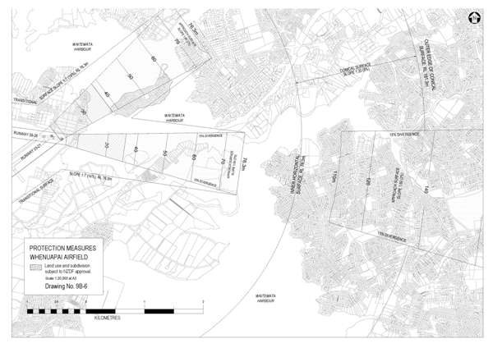

Diagram MD1A ­ Typical Cross Sections and Plan view
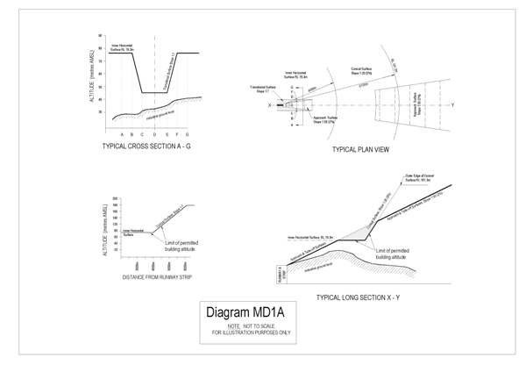

4312 South Head Weapons Range

Designation Number 4312

Requiring Authority | Minister of Defence
Location | Vicinity of Tasman Road, Woodhill (Kaipara South head) ­ All that area of land within a circle of radius 5486 metres, centred on a point at Latitude 360 28' 45.3" South, Longitude 174009' 38" East positioned on a bearing of  227.50 (T) at a distance of 4.8 nautical miles from South Kaipara Head light, as defined on Figure 10 and covering the parcels described in Table 10 (refer to Figure 10 below)
Rollover Designation | Yes
Legacy Reference | Designation 920, Auckland Council District Plan (Rodney Section) 2011
Lapse Date | Given effect to (i.e. no lapse date)

Description

Defence purposes (as defined by section 5 of the Defence Act 1990) ­ air weapons range danger template.

The Defence Areas are administered by the New Zealand Defence Force (NZDF) and are currently occupied by NZDF, its contractors and licensees. The Areas are a Defence Work and may be utitlised for any or every purpose required by section 5 of the Defence Act 1990, which are as follows:
  - The defence of New Zealand, and of any area for the defence of which New Zealand is responsible under any Act;
  - The protection of the interests of New Zealand, whether in New Zealand or elsewhere;
  - The contribution of forces under collective security treaties, agreements or arrangements;
  - The contribution of forces to, or for any of the purposes of, the United Nations, or in association with other organisations or States and in accordance with the principles of the Charter of the United Nations;
  - The provision of assistance to the civil power either in New Zealand or elsewhere in time of emergency; and
  - The provision of any public service.

The Governor­General of New Zealand, continues to raise and maintain Armed Forces on behalf of Her Majesty the Queen. Given the obligations placed on the New Zealand Defence Force by the Crown to meet the Crown’s military defence needs, including those imposed by any enactment or by the policies of the government, the function of the Defence Areas include, at all times, to provide for the following functions of the New Zealand Defence Force (including visiting forces and third parties contracted to the New Zealand Defence Force):
- Defence Force command, land operations, sea operations, air operations, training, logistic support, ship berthing and docking, construction, repair, maintenance, munitions handling and storage, administration, and communication, and for the acquisition and improvement of the skills necessary for such functions;
- Resources, accommodation and facilities for these functions;
- Accommodation for members of the New Zealand Defence Force and any visiting force, training, recreational, welfare and medical facilities for them;
- Facilities for the storage of matériel, food and fuel, and the conservation and display of historic material;
- Facilities for the construction, repair and maintenance of vessels, aircraft, vehicles and other equipment, including the vessels, aircraft, vehicles and equipment of forces of other nations;
- To provide for the rapid and efficient deployment of the New Zealand Defence Force; and
- Any other activity required in the delivery of New Zealand Defence Force outputs as described annually in the Departmental Forecast Report: New Zealand Defence Force.

Conditions

- Works and projects that comply with the permitted activity rules of the underlying zoning are incorporated into this designation and, in accordance with section 176A(2)(b) of the Resource Management Act 1991, no outline plan is required for those activities.

- For the avoidance of doubt, maintenance activities do not require an outline plan.

Attachments

Figure 10 ­ Designation NZDF South Kaipara Head Site Plan

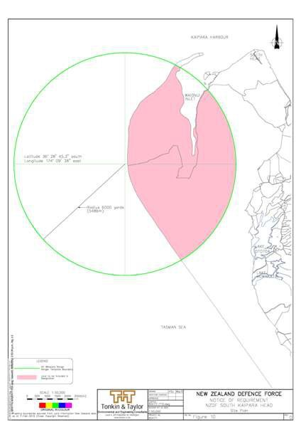

4313 Hobsonville Base

Designation Number | 4313
Requiring Authority | Minister of Defence
Location | 29­59 Clark Road and 415­419 Hobsonville Road, Hobsonville (refer to Figure 11 below)
Rollover Designation | Yes
Legacy Reference | Designation MD1, Auckland Council District Plan (Waitakere Section) 2003
Lapse Date | Given effect to (i.e. no lapse date)

Description

Defence purposes (as defined by section 5 of the Defence Act 1990) ­ administration and operations.

The Defence Areas are administered by the New Zealand Defence Force (NZDF) and are currently occupied by NZDF, its contractors and licensees. The Areas are a Defence Work and may be utitlised for any or every purpose required by section 5 of the Defence Act 1990, which are as follows:
  - The defence of New Zealand, and of any area for the defence of which New Zealand is responsible under any Act;
  - The protection of the interests of New Zealand, whether in New Zealand or elsewhere;
  - The contribution of forces under collective security treaties, agreements or arrangements;
  - The contribution of forces to, or for any of the purposes of, the United Nations, or in association with other organisations or States and in accordance with the principles of the Charter of the United Nations;
  - The provision of assistance to the civil power either in New Zealand or elsewhere in time of emergency; and
  - The provision of any public service.

The Governor­General of New Zealand, continues to raise and maintain Armed Forces on behalf of Her Majesty the Queen. Given the obligations placed on the New Zealand Defence Force by the Crown to meet the Crown’s military defence needs, including those imposed by any enactment or by the policies of the government, the function of the Defence Areas include, at all times, to provide for the following functions of the New Zealand Defence Force (including visiting forces and third parties contracted to the New Zealand Defence Force):
- Defence Force command, land operations, sea operations, air operations, training, logistic support, ship berthing and docking, construction, repair, maintenance, munitions handling and storage, administration, and communication, and for the acquisition and improvement of the skills necessary for such functions;
- Resources, accommodation and facilities for these functions;
- Accommodation for members of the New Zealand Defence Force and any visiting force, training, recreational, welfare and medical facilities for them;
- Facilities for the storage of matériel, food and fuel, and the conservation and display of historic material;
- Facilities for the construction, repair and maintenance of vessels, aircraft, vehicles and other equipment, including the vessels, aircraft, vehicles and equipment of forces of other nations;
- To provide for the rapid and efficient deployment of the New Zealand Defence Force; and
- Any other activity required in the delivery of New Zealand Defence Force outputs as described annually in the Departmental Forecast Report: New Zealand Defence Force.

Conditions

- Works and projects that comply with the permitted activity rules of the underlying zoning are incorporated into this designation and, in accordance with section 176A(2)(b) of the Resource Management Act 1991, no outline plan is required for those activities.

- For the avoidance of doubt, maintenance activities do not require an outline plan.

Attachments

Figure 11 ­ Designation NZDF Hobsonville Site Plan

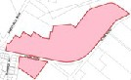

----------------
-"-

\
.---­l ,/' '\.
' -
. • n

