PART 7 ­ DESIGNATIONS»Schedules and Designations»

Minister for Courts

Designation Schedule ­ Minister for Courts

Number | Purpose | Address
4100 | Judicial, court, tribunal and related purposes ... | 65­71 Albert Street, AucklandCentral
4101 | Judicial, court, tribunal and related purposes ... | 24 Waterloo Quadrant, Auckland Central
4102 | Judicial, court, tribunal and related purposes ... | 250­260 Great South Road, Papakura
R4103 | Judicial, court, tribunal and related purposes ... | 415­421 Great North Road, Henderson
4104 | Manukau District Courthouse ... | 30 Manukau Station Road, Manukau City Centre
4105 | Judicial, court, tribunal and related purposes ... | 25 Stadium Drive, Pukekohe

4100 Auckland District Courthouse

Designation Number | 4100
Requiring Authority | Minister for Courts
Location | 65­71 Albert Street, Auckland Central
Rollover Designation | Yes
Legacy Reference | Designation 294, Auckland Council District Plan (Central Area Section) 2005
Lapse Date | Given effect to (i.e. no lapse date)

Purpose

Judicial, court, tribunal and related purposes including collection of fines and reparation, administration, support, custodial services, and ancillary activities. Works include development and operation of land and buildings for the aforementioned purposes.

Conditions

- Development of the site shall be in accordance with the underlying development controls for the site except in the following circumstances:
  - The maximum Floor Area Ratio can be sought without requiring the inclusion of bonus features within the development; and
  - Future development of the site is not subject to any development control related to the provision of glazing on road frontages.

Attachments

No attachments.

4101 Auckland High Court

Designation Number | 4101
Requiring Authority | Minister for Courts
Location | 24 Waterloo Quadrant, Auckland Central

Rollover Designation | Yes
Legacy Reference | Designation 295, Auckland Council District Plan (Central Area Section) 2005
Lapse Date | Given effect to (i.e. no lapse date)

Purpose

Judicial, court, tribunal and related purposes including collection of fines and reparation, administration, support, custodial services, and ancillary activities. Works include development and operation of land and buildings for the aforementioned purposes.

Conditions

    - Development of the site shall be in accordance with the underlying development controls for the site except in the following circumstances:
      - The maximum Floor Area Ratio can be sought without requiring the inclusion of bonus features within the development; and
      - Future development of the site is not subject to any development control related to the provision of glazing on road frontages.

    - No alteration shall be made to the interior or exterior of the original courthouse building other than in accordance with an outline plan submitted and processed in terms of Section 176A of the Resource Management Act 1991.

    - In light of the fact that security remains a paramount consideration within the Courthouse, nothing in these conditions shall preclude the alterations and works necessary for maintaining security except that with respect to the original courthouse building, early consultation with the Council is required in order that the heritage impact of the alterations and works may be determined.

Attachments

No attachments.

4102 Papakura District Courthouse

Designation Number | 4102
Requiring Authority | Minister for Courts
Location | 250­260 Great South Road, Papakura
Rollover Designation | Yes
Legacy Reference | Designation 30, Auckland Council District Plan (Papakura Section) 1999
Lapse Date | Given effect to (i.e. no lapse date)

Purpose

Judicial, court, tribunal and related purposes including collection of fines and reparation, administration, support, custodial services, and ancillary activities. Works include development and operation of land and buildings for the aforementioned purposes.

Conditions

No conditions.

Attachments

No attachments.

R1403 Henderson Courthouse

Designation Number | R4103
Requiring Authority | Minister for Courts
Location | 415­421 Great North Road, Henderson
Rollover Designation | No
Legacy Reference | N/A
Lapse Date | 10 years from being operative in the Unitary Plan unless given effect to prior

Purpose

Judicial, court, tribunal and related purposes including collection of fines and reparation, administration, support, custodial services, and ancillary activities. Works include development and operation of land and buildings for the aforementioned purposes.

Conditions

General
- Where conditions of consent reference particular design or construction standards these may be updated with the agreement of the requiring authority to reflect changes in standards applying at the time of submission of Outline Plan under section 176A of the Resource Management Act 1991 or construction.

Built Form
- Buildings must not exceed the 72.5m in height or 18 storeys.

- With reference to Figure 1, development on site must not project beyond:
  - A 45 degree recession plane measured from a point 8.5m vertically above ground level along the northern boundary of identified public open space zones; and
  - A 45 degree recession plane measured from a point 16.5m vertically above ground level along the western boundaries of identified public open space zones.

- Any part of the new courthouse building projecting above 24.5m (or 6 storeys) in height must be setback from the road, side and rear façades by a minimum of 6m.

- Prior to the submission of an Outline Plan for redevelopment of the site, concept plans shall be submitted to Council’s Urban Design Team for comment.

Yards
- No building shall be located closer than 10m from the Opanuku Stream site boundary as shown in Figure 2.

- No building shall be located within the side (5m) and rear yards (10m) as shown in Figure 2.

Transportation
- A Comprehensive Integrated Transport Assessment (ITA) shall be submitted with any Outline Plan of Works for any major buildings or works on the site that generate a significant additional transport demand. At a

minimum, the following shall be provided:
  - Forecasts of future travel demand over time by mode of travel and recommendations for an appropriate mix of parking, travel management measures, pedestrian, cycle and passenger transport facilities to meet this demand;
  - An indication of the form, timing and manner in which the above will be provided;
  - Measures to:
- Monitor travel demand and patterns against those forecast and to revise as necessary forecast travel demand by mode;
- Review the effectiveness of the measures proposed within the ITA including the travel plan;
- Review and confirm the appropriateness of parking, travel management measures, pedestrian, cycle and passenger transport facilities provided pursuant to these conditions of consent; and
  - An assessment of how parking demand and the requirement for off­site parking may reduce over time as the provision and uptake of public transport and other measures to reduce travel by private vehicle increases.

- Prior to any construction works commencing on site, a Temporary Traffic Management Plan (TTMP) shall be submitted to the Council’s Manager, for approval. The TTMP must be prepared by a qualified and experienced Site Traffic Management Supervisor and shall be approved in writing prior to works commencing. No work shall commence on site until written approval of the Traffic Management Plan is provided by Council.

Construction
- Prior to the redevelopment of the site into a courthouse, the Requiring Authority must submit a Construction Management Plan (“CMP”) to Council for approval. At a minimum, the CMP shall include the following:
- Details of the site or project manager, including their contact details;
- An outline construction programme of works;
- Measures to be adopted to maintain the land in a tidy conditions in terms of disposal and storage of rubbish, storage and unloading of construction materials and similar construction activities;
- Location of workers offices and conveniences;
- Procedures for controlling sediment run­off and dust mitigation measures;
- Measures to protect riparian vegetation along the Opanuku Stream during construction activities; and
- In the event of the discovery of any unrecorded archaeological features, an Accidental Discovery Protocol; The approved CMP is to be implemented and maintained for the duration of the project.
- The Requiring Authority must prepare, and submit for approval with the CMP, a Communications Plan that details procedures for communicating with the public and the owners and occupiers of properties in the immediate vicinity of the construction area throughout the construction period. The Communications Plan must include a copy of the TTMP prepared under condition 7 as well as procedures for:
- Giving notice of the commencement of construction activities;
- Providing information about the expected duration of work, including a programme of works; and
- Giving notice of any changes to the programme of works.

The approved Communications Plan is to be implemented and maintained for the duration of the project.

Noise & Vibration
- Prior to the commencement of works, the Requiring Authority will submit a Construction Noise & Vibration Management Plan (CNVMP) to the Council’s Manager for approval. The approved CNVMP must be implemented and maintained throughout the entire demolition and construction periods.

- The CNVMP must describe the measures to be adopted, as far as practicable, to meet the requirements of NZS6803:1999 Acoustics — Construction Noise. The CNVMP must refer to noise management measures set out in Annexure E of NZS6803:1999, and as a minimum
must address the following:

- Construction sequence;
- Machinery and equipment to be used, including the use of non—percussive machinery where practicable;
- Hours of operation, including times and days when noisy construction work would occur;
- The design of noise mitigation measures such as temporary barriers or enclosures;
- Construction noise and vibration limits for specific areas;
- Development of alternative strategies where full compliance withNZS6803:1999 cannot be achieved, including consultation with residents and other occupiers to achieve acceptance outcomes;
- Vibration Monitoring Measures;
- Methods for monitoring and reporting on construction noise & vibration;
- Methods for receiving and responding to complaints about construction; and
- Reporting procedures.

Public Utilities
- Adequate provision shall be made for the disposal of wastewater and the provision of water supply.

Attachments

Henderson Courthouse Designation Plan

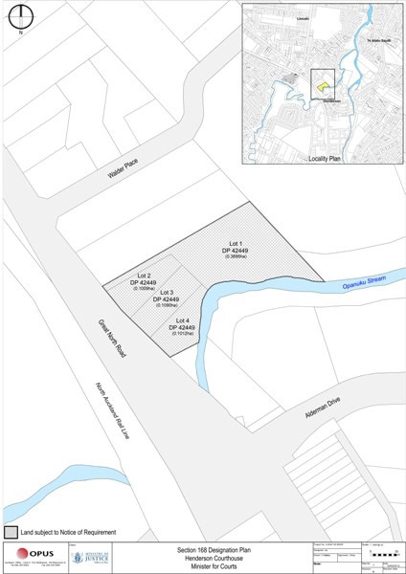

Figure 1 – Height in Relation to Boundary Interfaces

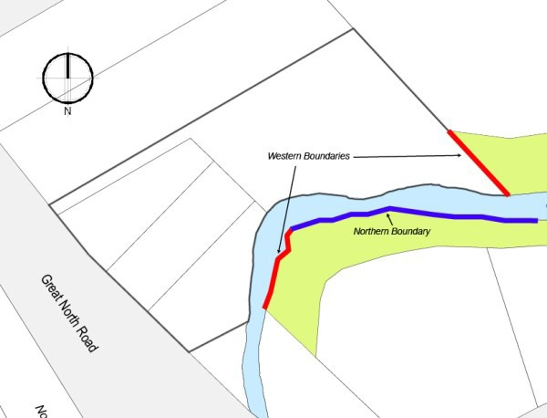

Figure 2 –Yards (Not to Scale)

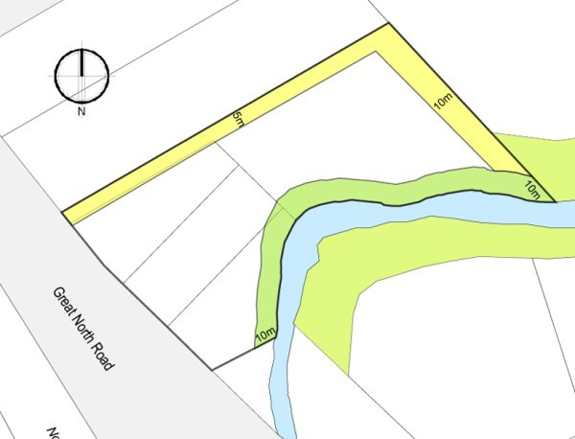

4104 Manukau Courthouse

Designation Number | 4104
Requiring Authority | Minister for Courts
Location | 30 Manukau Station Road, Manukau City Centre
Rollover Designation | Yes
Legacy Reference | Designation 179, Auckland Council District Plan (Manukau Section) 2002
Lapse Date | Given effect to (i.e. no lapse date)

Purpose

Manukau District Courthouse: judicial, court, tribunal and related purposes including collection of fines and reparation, administration and support services, and ancillary activities (for example food and beverage kiosk). Works include development and operation of land and buildings for the aforementioned purposes.

Conditions

General
An outline plan of works for any development that triggers additional parking demand, loading or access requirements to the site will be assessed against the relevant assessment criteria under Rule 4.2.1.2.4.1 of the Proposed Unitary Plan.

Access to the Primary Road Network
No direct vehicular access to Manukau Station Road shall be allowed.

Assessment Criteria — Parking and Vehicle Circulation

  - General
When assessing an Outline Plan of Works, Council will have regard to the extent to which the proposed development or redevelopment meets the criteria set out in this condition.

Provision of Parking
As part of an Integrated Transport Assessment (ITA) provided in terms of condition 6 any Outline Plan of Works shall provide a robust assessment of the parking demand to be generated by a proposed development or redevelopment and demonstrate the parking provision to meet the estimated demand:
- On the site;
- On a site sufficiently close to it for constant use by vehicles in connection with the site; and/or
- In accordance with condition 3.5.

Assessment of Number of Parking Spaces to be Provided
The extent to which the proposed development or redevelopment provides an adequate number of parking spaces on the site, on a site sufficiently close to it for constant use by vehicles in connection with the site, and in accordance with clauses 4.5 and 9.2 to accommodate the estimated parking demand.

Diminution of Land Available
The extent to which the total parking area that is made available in respect of a new building in compliance with the requirements for off — road parking is not diminished by the subsequent construction of any structure by the storage of goods, or by any other activity.

Allocation of Parking Spaces
The extent to which the requiring authority or other occupier of the site allocates or manages the parking spaces so as to prevent staff, fleet vehicles, visitors or particular occupiers associated with that site from utilising the parking.

3.3 Provision of Loading Space
The extent to which adequate provision is made for loading space for any activity within the designation which generates delivery trips by heavy vehicles

Design of Parking and Circulation Areas

Vehicle Dimensions
The extent to which each new parking space to be provided in terms of this Section is in accordance with the dimensions specified in accepted standards.

Reverse Manoeuvring
The extent to which parking areas are designed to ensure that vehicles are not required to reverse either onto or off the site; and are not required to execute more than a three point turn to exit the site.

Design and Constructional Details
The extent to which new public and private parking areas comply with the following requirements:
- The new parking spaces and access drives and aisles required in respect of the site in question shall, before the commencement of the corresponding new activity on that site, be formed, sealed and permanently marked or laid out in accordance with approved plans to the Council’s satisfaction;
- The new parking areas shall be maintained at all times so as not to create a dust nuisance;
- Stormwater drainage from the parking area shall be constructed to the satisfaction of the Council;
- Provision shall be made to illuminate access driveways and pedestrian areas within new public parking areas used during the hours of darkness. Illumination shall not be directed towards any adjacent residentially zoned

land;
- New parking areas and signs and markings shall be maintained so that at all times they remain legible and available for use by vehicles; and
- The design and layout of new parking areas shall be such that vehicles are not required to reverse a distance greater than 30m to enter or exit any right angled parking space (or 10m for any other angled or parallel parking space) or to exit any parking aisle in the event that the parking spaces within the aisle are occupied.

Acceptance of Cash in Lieu of Parking Spaces
- Where it is not reasonable or practicable to make provision for the new parking requirement in respect of new or redeveloped buildings on the designated site, on the site or sufficiently close to it for constant use by vehicles in connection with the site, the Minister may with the agreement of the Council instead of providing the required number of carparks, make payment to the Council of a sum of money not exceeding the cost including land value, of providing the parking requirement on that site. Alternatively the Minister may, with the agreement of Council make payment of a sum based on the cost of providing any parking shortfall on land in the vicinity of the site or the cost of providing parking on a nearby site set aside for carparking purposes, providing that this sum does not exceed
that specified above.

- Any payment made under subsection (a) of this rule shall contribute to satisfying the parking provision in respect of the new or redeveloped buildings on the site, and shall be kept in a separate account in the Council’s name and applied by the Council from time to time as opportunity offers in
the acquisition of land and the making of provision for parking as close as, is reasonable and practicable to the site in respect of which the parking area was required to be provided.

- Notwithstanding the above Council may apply not more than half of any payment made under Section (a) of this rule on passenger transport infrastructure in the vicinity of the site provided that the site and use of the site in question would benefit from the provision of this infrastructure. When the cash in lieu of parking is used by Council to provide parking spaces, a number of parking spaces equivalent to their respective contribution to the cost of formulation will be made available for use by the owners of the designated sites for which cash in lieu of parking has been accepted.

Traffic Management Works
Any outline plan of works submitted by the requiring authority for any development or redevelopment that is likely to have an impact on the transportation network of the designated site shall be assessed having regard to the potential transportation related effects of the development or redevelopment proposed to be undertaken pursuant to the designation.

The requiring authority shall include in its outline plan of works its proposals for dealing with the potential transportation related effects of the development or redevelopment and any off­site works or contribution to off site works it proposes to deal with those effects.

The requiring authority shall be required to meet the reasonable costs of all new access and traffic management works (including any additional land required to accommodate these works) associated with the development or redevelopment to the extent that such works are required to meet safety, access, egress, or amenity considerations related to the development or redevelopment or where the works are required to mitigate the
likely adverse effects from the development or redevelopment on the safety or operation of the transport network.

Travel Plan
- A Travel Plan shall be developed for the Manukau Courthouse with any major buildings or works on the site that generate a significant additional transport demand. This Plan shall be designed to reduce dependency on private car travel, and manage staff and visitor travel to achieve travel mode split targets developed as part of the travel planning process.

- The Travel Plan and its implementation shall include the provision of infrastructure, initiatives and facilities to support the use of travel alternatives. At a minimum, the following shall be provided:
- Covered, secure cycle parking to meet demand identified within the ITA and located in a convenient location and designed in accordance with current standards (e.g. Australian Standard AS 2890.3­1993 parking facilities part 3 Bicycle parking facilities);
- Changing facilities and lockers appropriate for walkers, cyclists and motorbike users;
- Ongoing educational and information advising and encouraging staff and visitors of how to access and use alternative forms of travel to motorcar and car pooling opportunities for staff; and
- Any management practices designed to reduce travel demand to the Court and in particular demand for car parking spaces.

- The Travel Plan shall be maintained and reviewed over time at not less than 3 year intervals and at the time of outline plan of works for significant extension to buildings, and updated as necessary. The recommendations of each updated travel plan must be implemented.

Integrated Transport Assessment (ITA)
An ITA shall be submitted with any outline plan of works for any major buildings or works on the site that generate a significant additional transport demand. At a minimum, the following shall be provided:
- Forecasts of future travel demand by mode of travel and recommendations for an appropriate mix of parking, travel management measures, pedestrian, cycle and passenger transport facilities to meet this demand;
- An indication of the form, timing and manner in which the above will be provided;
- Measures to:
- Monitor travel demand and patterns against those forecast and to revise as necessary forecast travel demand by mode;
- Review the effectiveness of the measures proposed within the ITA including the travel plan; and
- Review and confirm the appropriateness of parking, travel management measures, pedestrian, cycle and passenger transport facilities provided pursuant to these conditions of consent; and
- An assessment of whether off­site parking may be reduced, taking into account surveyed data about the modal share of court users at the time of the ITA being prepared.

Parking to be Provided
No occupation or use of any expansion to the Courthouse shall take place until the parking identified within any approved outline plan has been provided.

Built Form
When assessing an outline plan, Council will have regard to the following matters taking into account the role and function of a courthouse and associated needs including security:
a. The extent to which the proposed design provides for informal surveillance of public and semi­public areas within and adjacent to the development, including streets, walkways and open spaces, by:
- Designing the proposal in accordance with good practice for Crime Prevention Through Environmental Design (CPTED) and in particular, facilitating passive surveillance of public spaces;
- The use of lighting design to provide security for buildings and enhance the safety of public spaces; and
- Avoiding blind corners and concealed alcoves near lifts, stairwells, car parks and walkways.

Landscaping
Any outdoor storage or rubbish collection area shall be screened from public view by landscape design and/or the erection of a fence, and maintained in a tidy condition when viewed from the public open space zone or public road.

Advice Notes
- It is recommended that a Memorandum of Understanding or other appropriate agreement be prepared between Auckland Transport and the requiring authority documenting their mutual understanding in respect of:

  - The timing, procurement processes for work that the Ministry of Justice will contribute towards, and design of any road works that may affect or facilitate access to the site; and
  - Liaison and support relating to development and maintenance of a travel plan and associated initiatives.

- All works within the legal road corridor (boundary to boundary) require a ‘Corridor Access Request (CAR) approved by Auckland Transport. All works include inter alia open cut trenching and trenchless techniques for utility installations.

- Application for a CAR is made online to www.beforeudig.co.nz where relevant background details are required including Notice of Requirement /OPW or certificate of compliance, traffic management plans etc.

- Please note that a CAR may require up to 15 days to process and construction hours may be restricted on Level 2 or 3 roads, as defined in the Code of Practice for Temporary Traffic Management, (“COPTTM” of NZTA) to those that may be permitted under this consent.

- The Requiring Authority will be required to submit a Temporary Traffic Management Plan (TTMP) for the Project or the relevant Project stage where construction activities are likely to have a significant effect on the safety and operation of the adjoining road network. This shall be prepared by a suitably qualified person in accordance with the Code of Practice for Temporary Traffic Management (COPTTM).

Attachments

No attachments.

4105 Pukekohe District Courthouse

Designation Number | 4105
Requiring Authority | Minister for Courts
Location | 25 Stadium Drive, Pukekohe
Rollover Designation | Yes
Legacy Reference | Designation 82, Auckland Council District Plan (Franklin Section) 2000
Lapse Date | Given effect to (i.e. no lapse date)

Purpose

Judicial, court, tribunal and related purposes including collection of fines and reparation, administration, support, custodial services, and ancillary activities. Works include development and operation of land and buildings for the aforementioned purposes.

Conditions

No conditions.

Attachments

No attachments.

